UIT UNIVERSITY
BACHELOR OF SCIENCE (COMPUTER SCIENCE / SOFTWARE ENGINEERING)
CSC-204 DATABASE SYSTEMS
PROJECT REPORT
TITLE:
NextWaterConnect — An On-Demand Water Supplier Booking System
GROUP MEMBERS:
(NAME) (ROLL NO)
(NAME) (ROLL NO)
(NAME) (ROLL NO)
(NAME) (ROLL NO)

Contents

ABSTRACT
NextWaterConnect is a full-stack, web-based platform that connects consumers who need clean water with registered water suppliers operating in their area. The system addresses a common real-world problem in regions with irregular municipal water supply, where households and businesses rely on private tanker and gallon suppliers but lack a reliable, transparent way to discover, compare, and book them. The application provides role-based access for three actors — Consumer, Supplier, and Administrator — and manages the complete service lifecycle, from supplier discovery and recommendation through booking, payment, and post-service rating.
This report documents the database-centric design of the system. It presents the entities and their relationships through an Entity Relationship Diagram (ERD), models the movement of data through the system using Data Flow Diagrams (Context Level 0 and Level 1), and describes how the design was implemented using a relational schema on PostgreSQL with the Prisma ORM and a Next.js application layer. The result is a normalized, referentially consistent database that supports searching, recommendation, transactional bookings, and a feedback loop, while preserving data integrity through well-defined primary and foreign key constraints.

1. INTRODUCTION
Access to clean water is an essential daily need, yet in many areas the formal supply is unreliable, forcing consumers to depend on private water suppliers. The traditional process of finding a supplier is informal and inefficient: consumers rely on word of mouth, phone numbers written on walls, or repeated calls, with no visibility into price, availability, vehicle type, or the quality of past service. Suppliers, in turn, have no organized channel to receive and manage orders. This lack of structure leads to delays, inconsistent pricing, and a poor experience for both sides.
NextWaterConnect was built to digitize and streamline this process. It is a database-driven web application in which suppliers register and publish their service details (vehicle number, water category, and price per gallon), and consumers search or receive recommendations for nearby suppliers, place bookings, pay for accepted orders, and rate the service once it is completed. An administrator oversees the platform, managing users and monitoring overall activity through a dashboard.
The purpose of this project is to apply the principles of database systems — entity modeling, normalization, relationship design, and integrity constraints — to a realistic application. The scope of this report is limited to the analysis, design, and implementation of the underlying database and the data flows it supports, rather than the visual front-end design. The following sections describe the system's features, its database design through an ERD, the data flow through Level 0 and Level 1 DFDs, the implementation details, and a concluding summary.

2. FEATURES
The system provides a distinct set of features for each of its three user roles, all backed by a shared relational database. The key features are:
- Role-based registration and authentication: A single user table stores credentials, with each account linked to either a consumer or a supplier profile. Administrators have elevated privileges. Passwords are stored securely and sessions are validated on every protected request.
- Supplier profile management: Suppliers create a profile (supplier_type) that records their vehicle number, water category, and price per gallon, which consumers can then browse.
- Search and recommendation: Consumers can search for suppliers by type or query, and the system can recommend suppliers based on attributes such as price and rating, helping consumers make informed choices.
- Booking lifecycle management: A consumer places a booking against a supplier. The booking moves through a clear set of states — PENDING when created, ACCEPTED or REJECTED by the supplier, and COMPLETED once the service is delivered.
- Payment processing: When a booking is accepted, a payment record is generated that captures the method, status, and amount, and links the consumer, supplier, and booking together for a complete transaction trail.
- Rating and feedback: After a booking is completed, the consumer can rate the supplier. Ratings are stored and aggregated to influence future recommendations and build supplier reputation.
- Administrative dashboard: Administrators can view platform statistics, manage user accounts, and monitor bookings and payments across the system.

3. DATABASE DESIGN
The database is designed as a normalized relational schema consisting of seven core entities: user, consumer, supplier, supplier_type, bookings, payment, and rating. The design separates authentication data (user) from role-specific profile data (consumer, supplier) using one-to-one relationships, and captures transactional activity (bookings, payment, rating) through one-to-many relationships. This separation reduces redundancy, keeps each table focused on a single concept, and enforces integrity through primary and foreign key constraints. The entities and their relationships are described below and illustrated in the Entity Relationship Diagram.
The principal relationships in the schema are as follows:
Relationship | Type | Description
user — consumer | 1 : 1 | Each user account may have one consumer profile.
user — supplier | 1 : 1 | Each user account may have one supplier profile.
supplier — supplier_type | 1 : 1 | Each supplier defines one service profile (vehicle, category, price).
consumer — bookings | 1 : N | A consumer can place many bookings.
supplier — bookings | 1 : N | A supplier can fulfil many bookings.
bookings — payment | 1 : 1 | Each accepted booking generates one payment.
consumer — rating | 1 : N | A consumer can write many ratings.
supplier — rating | 1 : N | A supplier can earn many ratings.

3.1. Entity Relationship Diagram (ERD)
The ERD below presents all seven entities with their primary keys (PK), foreign keys (FK), and key attributes, using crow's-foot notation to express cardinality. It shows how a user record anchors either a consumer or a supplier, how suppliers expose their service through supplier_type, and how bookings act as the central transactional entity linking consumers and suppliers, with payment and rating branching off from the service interaction.
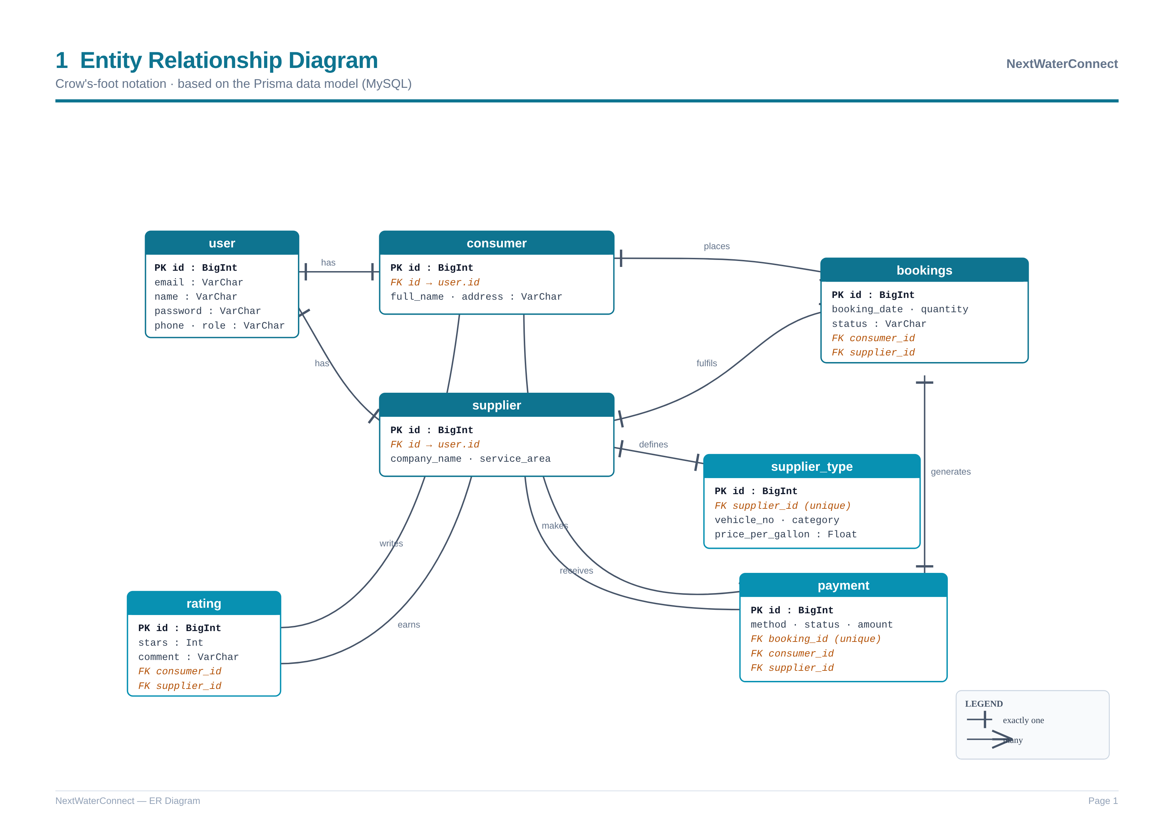
Figure 1: Entity Relationship Diagram (ERD) for NextWaterConnect

4. Data Flow Diagram (DFD)
Data Flow Diagrams model how information moves through the system between external entities, processes, and data stores. The Context Diagram (Level 0) presents the system as a single process interacting with its external actors, while the Level 1 DFD decomposes that single process into the major sub-processes and shows the data stores each one reads from and writes to.

4.1. Context Diagram (Level 0)
The Context Diagram treats NextWaterConnect as one process and identifies three external entities: the Consumer, the Supplier, and the Administrator. Consumers send registration details, search criteria, booking requests, payments, and ratings, and receive supplier listings, recommendations, and booking confirmations. Suppliers send their profile and accept/reject decisions, and receive booking notifications and payment records. The Administrator sends management commands and receives platform statistics and reports.
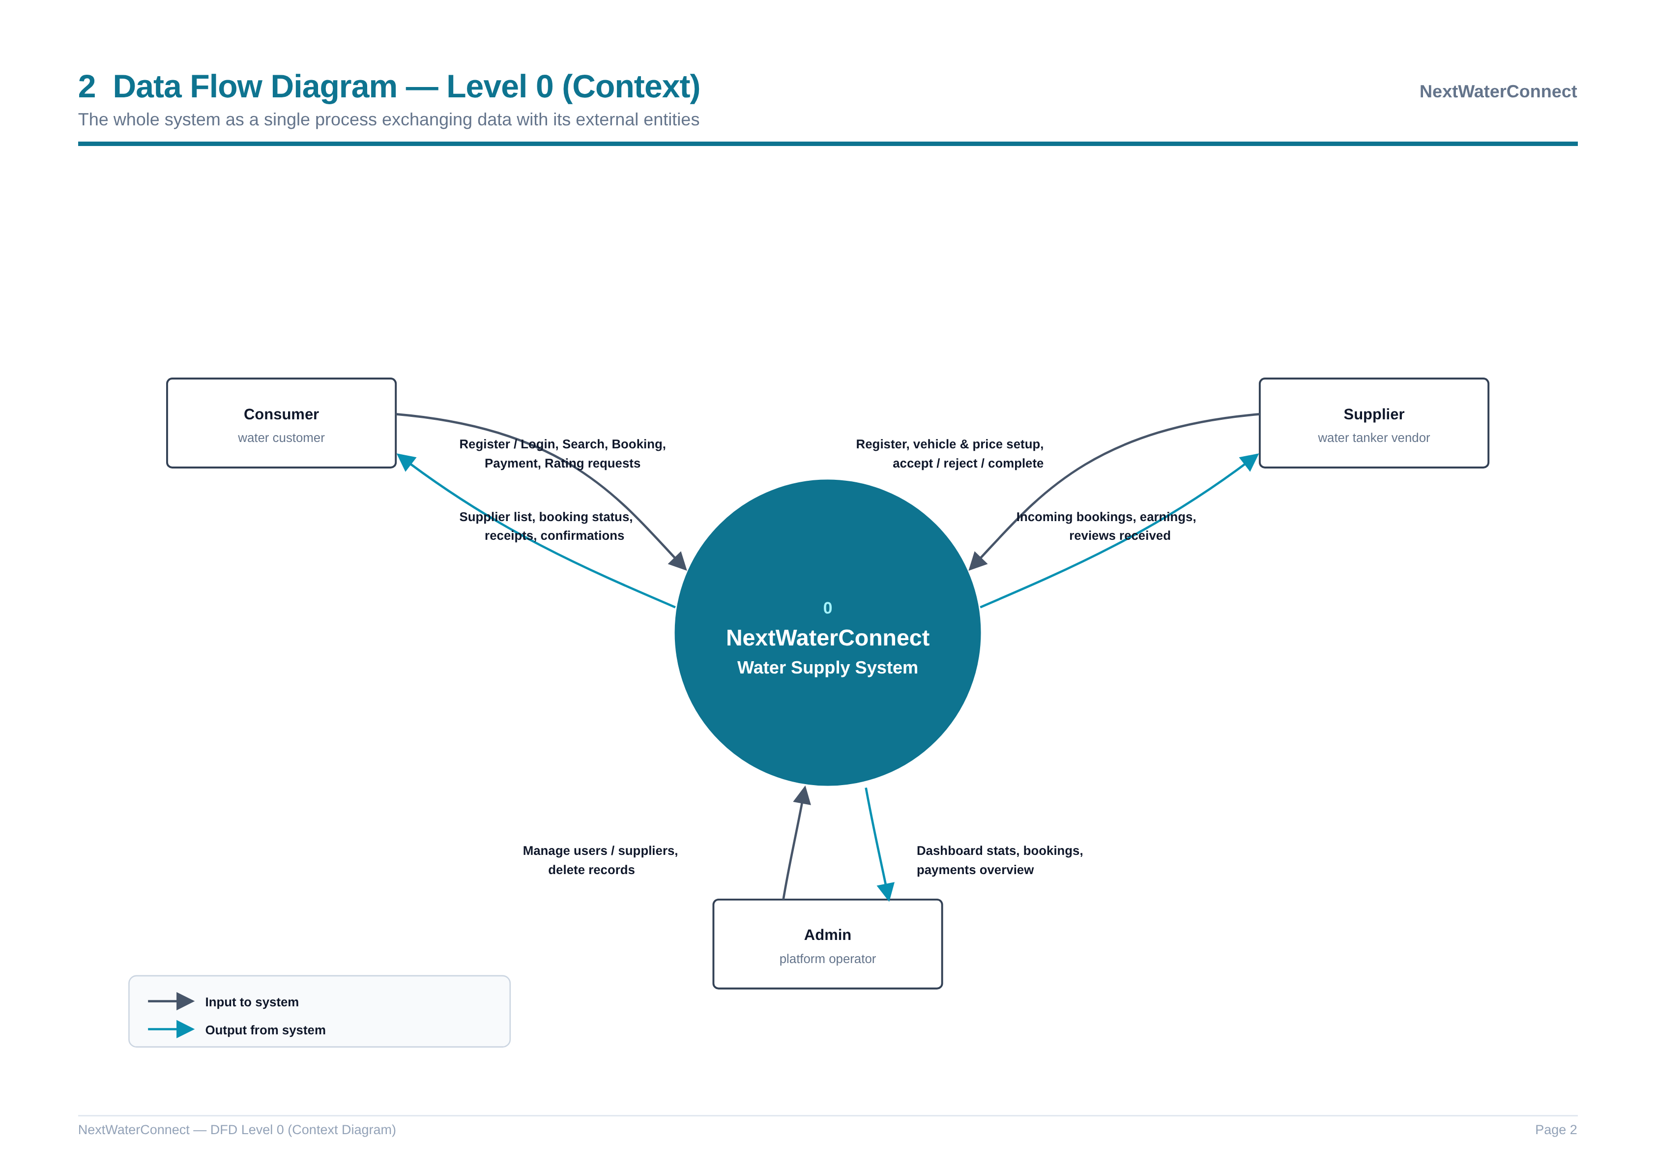
Figure 2: Context Diagram (DFD Level 0)

4.2. Level 1 DFD
The Level 1 DFD breaks the single context process into seven sub-processes: Authentication & Registration, Search & Recommendation, Booking Management, Payment Processing, Supplier Profile Management, Rating & Feedback, and Administration. These processes interact with seven data stores corresponding to the database tables (D1 User, D2 Consumer, D3 Supplier, D4 Supplier Type, D5 Bookings, D6 Payment, and D7 Rating). The diagram traces, for example, how a booking request flows from the consumer into the Booking Management process, is written to the Bookings store, triggers Payment Processing on acceptance, and ultimately enables the Rating & Feedback process after completion.
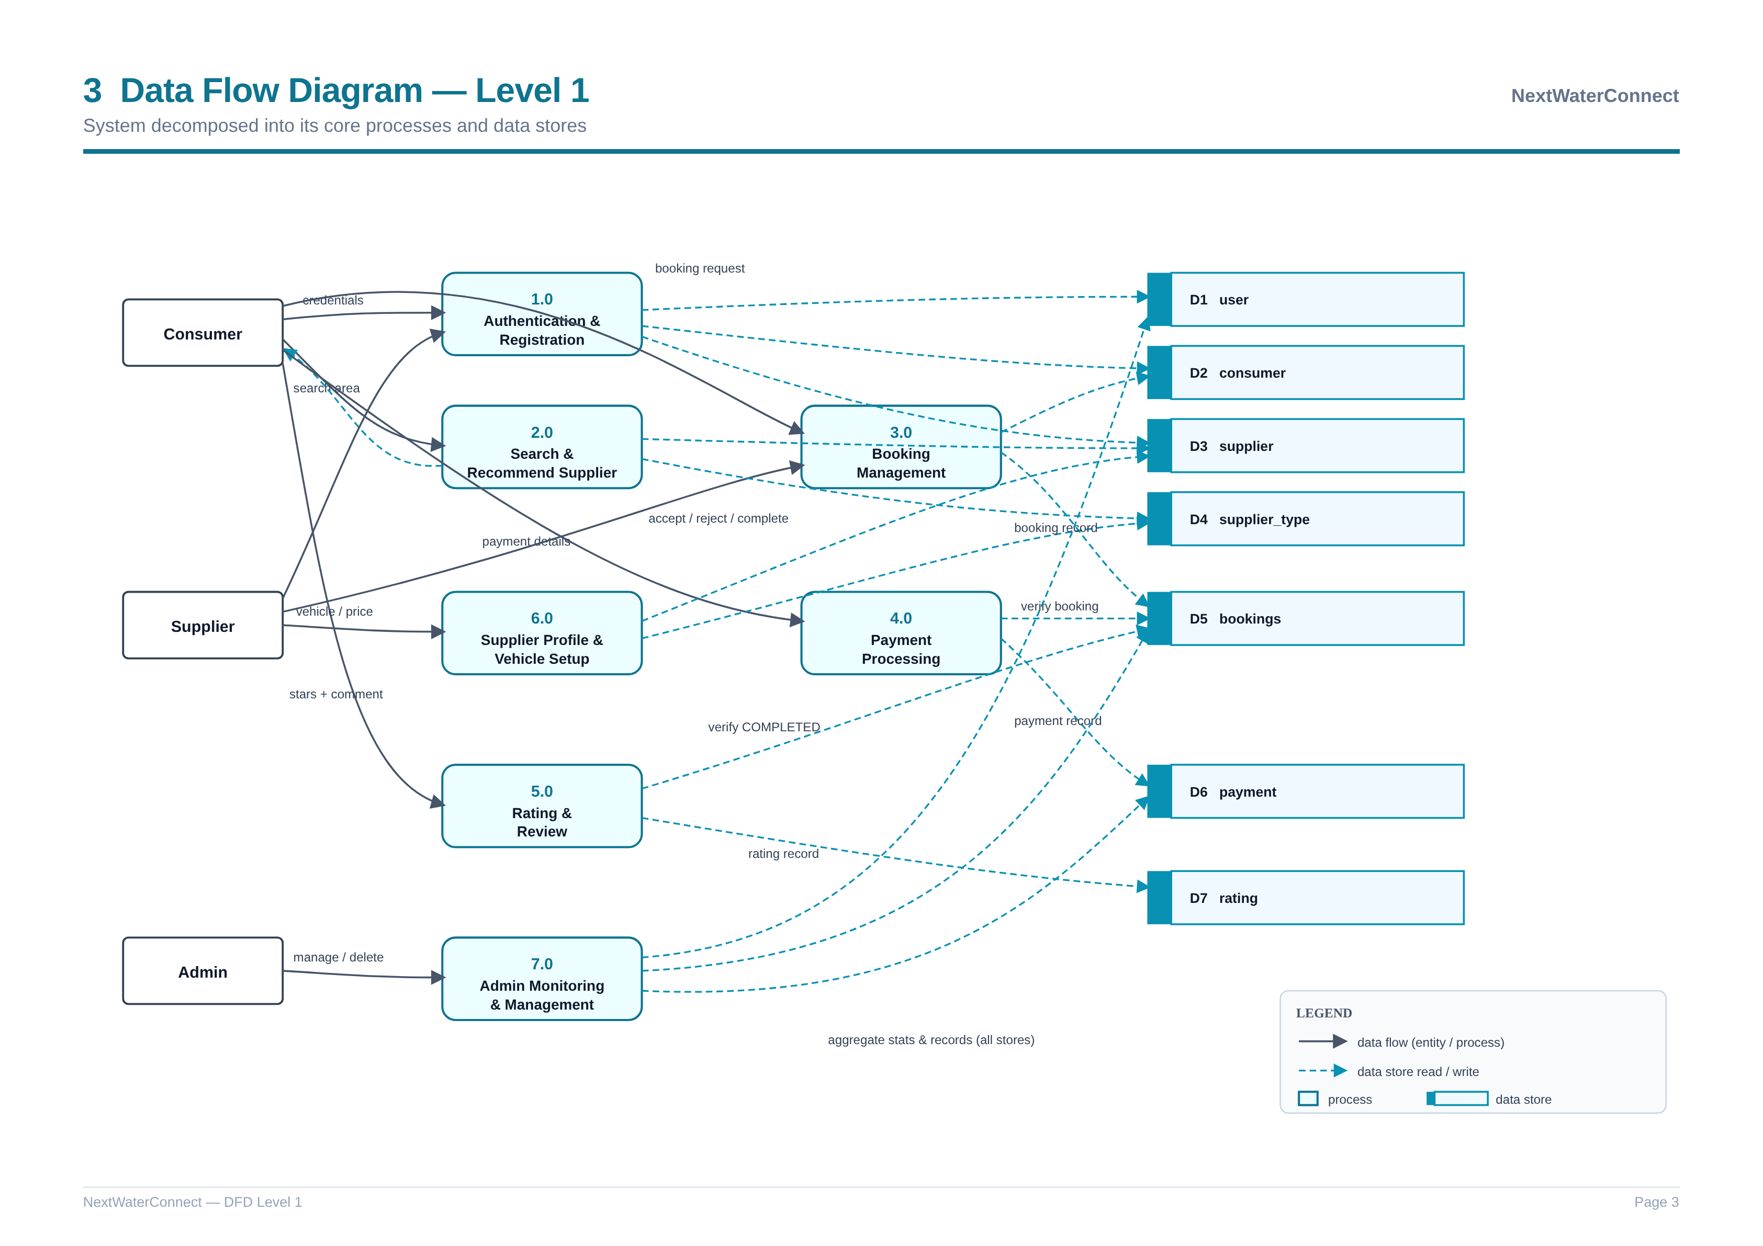
Figure 3: Level 1 Data Flow Diagram

5. IMPLEMENTATION
NextWaterConnect was implemented as a full-stack web application using Next.js (App Router) for both the client interface and the server-side API routes. The relational database runs on PostgreSQL, and the Prisma ORM is used to define the schema, generate a type-safe query client, and manage migrations. Server-side API route handlers implement the application logic, validate sessions on every protected request, and translate user actions into database operations through Prisma.
The data model is expressed as Prisma models that map directly to the entities described in Section 3. A simplified outline of the core schema is shown below:
model user {
id BigInt @id @default(autoincrement())
email String @unique
password String
role Role
consumer consumer?
supplier supplier?
}

model supplier_type {
id BigInt @id @default(autoincrement())
supplier_id BigInt @unique
vehicle_no String
category String
price_per_gallon Float
}

model bookings {
id BigInt @id @default(autoincrement())
consumer_id BigInt
supplier_id BigInt
status Status @default(PENDING)
payment payment?
}

The application exposes a set of RESTful API routes that operate on these models. The most important endpoints and their responsibilities are summarized below:
API Route | Method | Responsibility
/api/auth/register/[role] | POST | Create a user and a consumer or supplier profile.
/api/auth/login | POST | Authenticate a user and establish a session.
/api/suppliertype | POST/GET | Create and retrieve supplier service profiles.
/api/consumer/search/[type]/[query] | GET | Search suppliers by type or query.
/api/consumer/recommend | GET | Recommend suppliers by price and rating.
/api/booking | POST/GET | Create a booking and list a user's bookings.
/api/booking/[bookingId]/[action] | POST | Accept, reject, or complete a booking.
/api/payment | POST | Generate a payment for an accepted booking.
/api/rating | POST | Submit a rating for a completed booking.
/api/admin/dashboard | GET | Return platform statistics for the admin.
/api/admin/users/[id] | GET/DELETE | View or remove a user account.

Key implementation details include the use of database-level constraints to guarantee integrity: unique constraints ensure a supplier has exactly one service profile and a booking has exactly one payment, while foreign keys enforce that every booking, payment, and rating references valid consumers and suppliers. The booking status is constrained to a fixed set of values (PENDING, ACCEPTED, REJECTED, COMPLETED), and business rules in the API enforce the correct order of operations — for instance, a payment can only be generated for an accepted booking, and a rating can only be submitted once a booking is completed. This combination of schema-level and application-level validation keeps the data consistent and the workflow reliable.

6. CONCLUSION
NextWaterConnect demonstrates how the core principles of database systems can be applied to solve a tangible, everyday problem — the unreliable and disorganized process of obtaining clean water from private suppliers. By modeling the domain as seven well-defined entities and capturing their relationships through a normalized relational schema, the project achieves a design that is free of unnecessary redundancy, enforces integrity through primary and foreign key constraints, and cleanly supports the complete service lifecycle of discovery, booking, payment, and feedback.
The ERD and the Level 0 and Level 1 Data Flow Diagrams together provide a complete picture of the system: what data is stored, how the entities relate, and how information flows between the consumers, suppliers, and administrator. The implementation on PostgreSQL with Prisma and Next.js validates the design in practice, showing how the abstract data model translates into working API routes and transactional behavior. Overall, the project meets its objective of delivering a robust, normalized, and practically useful database-driven application, and it lays a solid foundation for future enhancements such as live location tracking, dynamic pricing, and richer analytics.

