Learn AI,
starting with you.
  - Product vision and implementation handoff
Prepared for Prasad Raghojiwar | Specification v1.0

The product promise
Upload a CV or describe your experience. Choose what you want to achieve with AI. Begin a learning journey that uses familiar situations to explain concepts and your actual work to decide what comes next.
This is an AI learning product. Career trajectory, job matching, salaries, recruitment, professional networking and Cooper integration are outside the scope of every release in this package.

What this handoff contains
The accompanying ZIP contains the full vision, end-to-end experience, screen contracts, ten use cases, curriculum and adaptation rules, 14 detailed PRDs, 91 traceable functional requirements, architecture, launch criteria, golden lessons and staged prompts for Claude or Cursor.
This illustrated document is the reading overview. The Markdown specifications and PRDs contain the detailed implementation authority. No new application has been built. The earlier rejected product is optional reference material, not the design to reproduce.

Read next
Begin with START_HERE.md and PRODUCT_DECISIONS.md. Review the example journeys and screen specifications, then give prompts/00_MASTER_BUILD_PROMPT.md to your coding tool with access to the full spec directory.

01 / The experience to create
The system can be sophisticated behind the scenes. The learner should experience a clear idea, a meaningful task and one useful next action. Personalisation has to change learning, not merely the greeting.

Two primary onboarding steps
First, upload a CV or describe experience. Extract a small set of useful, source-backed facts such as comparing bids, managing campaigns or building APIs. Avoid unnecessary personal details and speculative biographies.
Second, choose an AI goal in ordinary language. Show the proposed first milestone and a small editable context summary. Session length is optional. The primary action is “Start my first lesson”. A lengthy assessment or account form must not interrupt this moment.

Learning begins immediately
Open a structured lesson with a relevant example and a useful task. An operations professional might compare a confident AI answer with the source quote and identify a promise the source never made. The explanation should make the concept precise and invite an independent attempt.
Feedback names the exact move that worked or the gap that remains. If the learner understood the source check, move to supplying good context. If they missed uncertainty, practise that distinction with another example. Make the reason for the next step visible.

Returning should be effortless
Today offers one primary next activity and resumes saved work. My path explains the destination and milestones. My work shows what the learner made, the feedback and the evidence of improvement. The tutor stays available inside the work.
Offer account creation after useful feedback, when there is something worth saving. Let learners correct context, change goals, ask for depth and pause without losing progress.

02 / Different people, different learning

Operations professional
Use supplier coordination to teach task framing, source checking and human control. Output: a reusable AI task brief and a checked comparison. A fictional scenario must never be described as a real project from the learner’s life.

CEO
Teach capabilities, limitations, evaluation and operational trade-offs through an AI pilot decision. Output: a one-page memo with baseline, success criteria, failure conditions and an accountable owner. Business seniority does not prove AI knowledge.

Marketer
Teach evidence, context, variation and evaluation through a campaign brief. Output: sourced claims, two creative variants and a measurement plan. A simulated campaign must not claim real conversion gains.

Software developer
Check existing coding familiarity, then focus on context, retrieval, structured outputs, evaluations and tool boundaries. Output: an assistant evaluation with normal and failure cases. A successful API response does not establish a correct answer.

Nontechnical aspiring researcher
Preserve the research destination. Begin with prediction, baselines and a fair test, then add programming and mathematics where needed. Output: an explained experiment. Published foundations and planned advanced milestones must be visibly distinct.
The full use-case file also covers experienced practitioners, people without CVs, returning learners, goal changes, privacy controls and accessibility.

03 / How the product knows what comes next

Keep four records separate
Experience supplies meaningful context. Goal defines desired capabilities and depth. Evidence records what the learner demonstrated and with what assistance. Preferences control session size, example choices and accessibility. A CV is a starting hypothesis, not a proficiency certificate.

Use explicit evidence
Initial policy: conceptual demonstration requires two independent passing tasks from different item families, including transfer or explanation. Applied capabilities additionally require relevant work or simulation evidence. These are proposed product rules to calibrate, not scientific constants.
A correct answer after a worked solution is valuable learning but remains assisted. A fresh task is needed for independent evidence. Reading, clicking Continue and self-reported confidence do not establish capability.

Adapt the right dimension
Change abstraction, explanation size, jargon, mathematical detail, code complexity, scaffolding or example context independently. A strong developer may need a simple explanation of leakage. A nontechnical learner may demonstrate rigorous reasoning.
A failure should trigger a specific repair, not a permanent downgrade. An absence triggers a manageable retrieval check, not erasure of past work. A changed goal carries compatible evidence forward while exposing new prerequisites.

Make uncertainty visible
Models can draft explanations and criterion-level feedback, but server policy validates outputs and commits learning state. Ambiguous grades remain provisional and can be challenged. Unsupported or unpublished content stays visibly unavailable.
Detailed rules: 04_PERSONALISATION_AND_ADAPTATION.md and PRDs 06, 07 and 13.

04 / Today: one useful next step
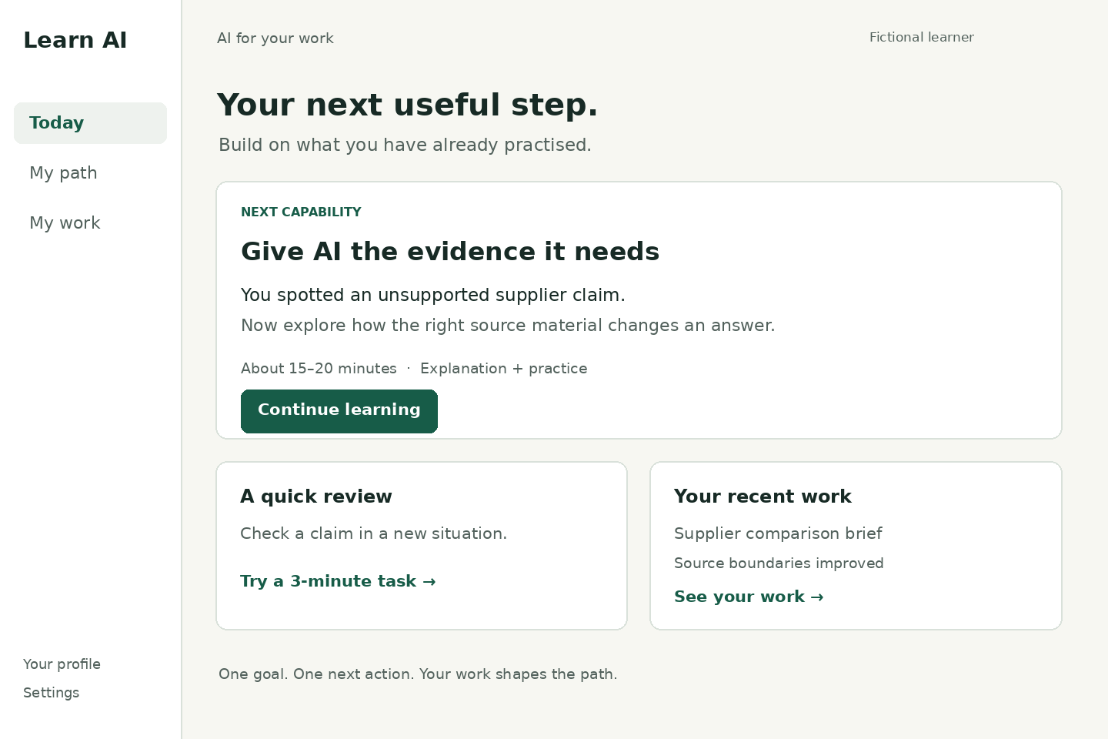
Static design reference using fictional learner content.
The primary activity dominates the screen. A review and recent work support continuity without creating a competing dashboard. Keep the reason for the next step short and grounded in actual evidence. On mobile, preserve the same hierarchy with three bottom-navigation destinations.
Detailed dimensions, tokens, states and accessibility requirements: 03_UX_AND_SCREEN_SPEC.md.

05 / Learn, try, understand
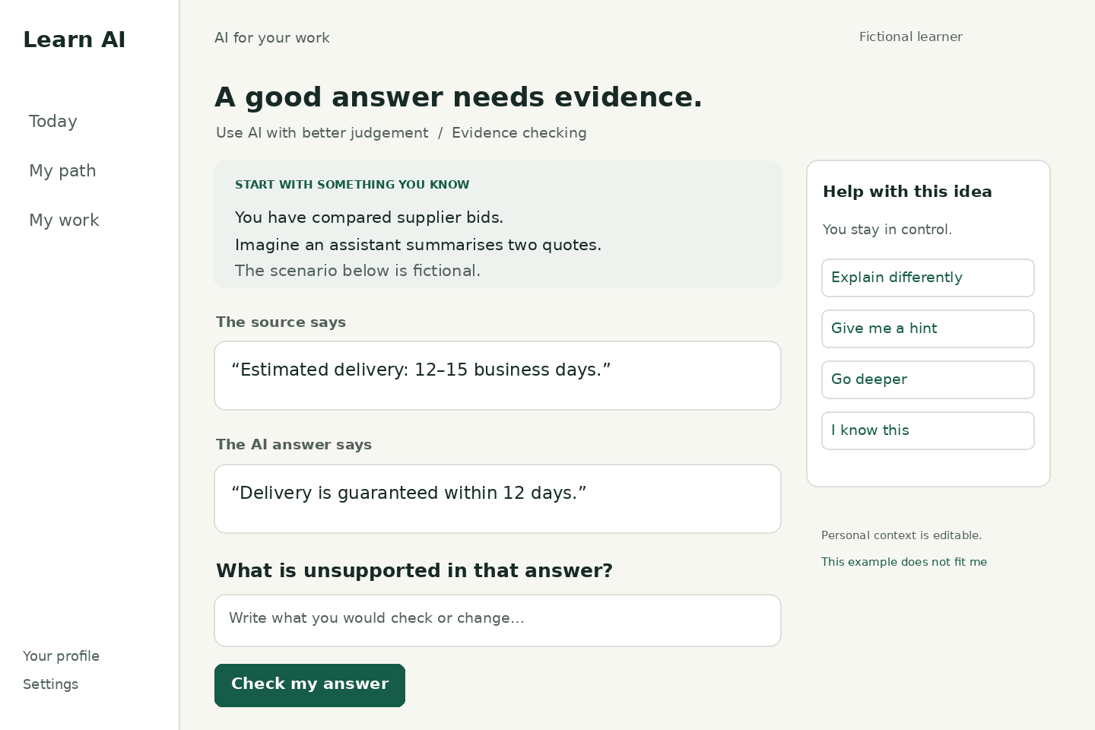
Static design reference; controls are illustrative.
The personal bridge leads into an exact source comparison and a meaningful task. Help is contextual and optional. The learner can ask for another explanation, a hint or greater depth. A rejected personal example can be replaced without restarting onboarding. Assessment keys remain server-side.
Detailed dimensions, tokens, states and accessibility requirements: 03_UX_AND_SCREEN_SPEC.md.

06 / A path that stays understandable
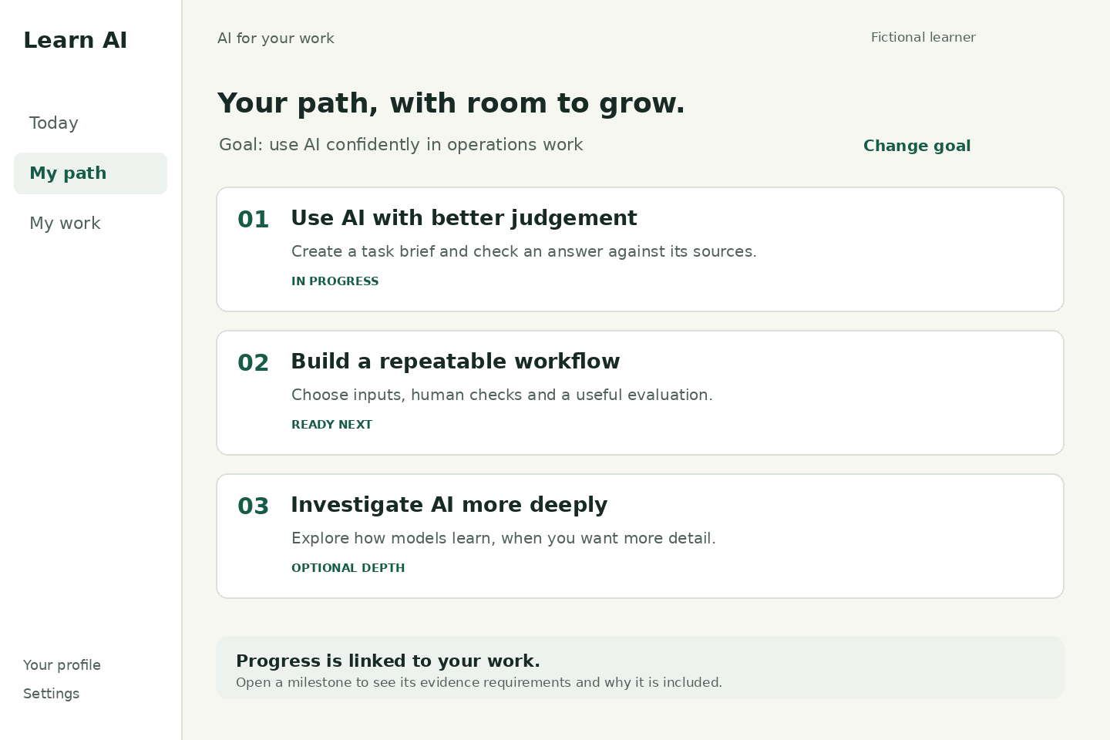
Static design reference; availability must reflect published content.
Show milestones as outcomes, not an intimidating concept graph. The learner can inspect why a milestone exists and what evidence completes it. Optional exploration must be supported by published content. Any unavailable advanced content needs an explicit Planned label and cannot be launched as a real lesson.
Detailed dimensions, tokens, states and accessibility requirements: 03_UX_AND_SCREEN_SPEC.md.

07 / Aha moments and the build contract

The moments to design for
“This understands my experience”: a supported action-level example feels relevant. “I get it now”: the learner transfers the idea into a new situation. “It noticed where I was stuck”: feedback repairs a precise misconception. “I can do something useful”: a work comparison shows concrete improvement. “It grows with me”: the next activity respects demonstrated knowledge and curiosity.
Validate those moments through tasks and observation. A relevance rating does not prove learning; a share count does not prove growth. The proposed north star is weekly learners independently demonstrating a goal-relevant capability, with transfer, retention and false-pass guardrails.

Build in complete stages
Review the first-session design. Implement a persistent learning slice. Add CV understanding and contextual AI. Add evidence-based adaptation. Add useful work and constrained simulations. Harden for a real pilot. Test sharing only after the learning loop is useful, and consider billing after value and cost are understood.
Use the master prompt and one stage prompt at a time. Ask the builder to map implementation to the 91 requirement IDs and distinguish implemented, fixture-only, provider-unverified, planned and production-ready behaviour.

The quality gate
The first release must preserve work, isolate users, ground personal facts, distinguish assisted from independent evidence, handle provider failure honestly and work on mobile and with keyboard navigation. Four short outcome bundles and the research starter need complete reviewed evidence paths. A large set of screens is not completion.
External reference notes in SOURCES_AND_ASSUMPTIONS.md cover the IES instructional guide, WCAG 2.2, OWASP prompt-injection guidance and current Claude/Cursor project instructions. Product thresholds, pacing, retention policies and growth ideas remain proposals to test.

