Predictive Modeling and Risk Scoring for Bank Customer Churn
Prepared By
Neelam Raghu Babu

Introduction
Customer churn represents one of the most critical business challenges faced by modern retail banks. The loss of customers not only impacts revenue generation but also affects customer lifetime value, brand trust, cross-selling opportunities, and long-term market competitiveness.
Traditional churn analysis methods mainly focus on identifying historical reasons for customer attrition. However, in today’s highly competitive banking environment, organizations require predictive systems capable of identifying potential churners before they leave.
This project develops an AI-powered predictive analytics system that forecasts customer churn probabilities using machine learning algorithms and explainable AI techniques. The solution provides quantitative risk scores and business-oriented insights that support proactive customer retention strategies.
The project also includes an interactive Streamlit dashboard capable of generating real-time churn predictions and risk analysis.

System Architecture

Dataset
↓
Preprocessing
↓
Feature Engineering
↓
ML Models
↓
Risk Scoring
↓
SHAP Explainability
↓
Streamlit Dashboard

Problem Statement
Banks possess large volumes of customer-level data, yet many institutions still lack:
- Accurate customer churn prediction systems
- Quantitative churn risk scoring mechanisms
- Explainable machine learning insights
- Proactive retention intelligence
As a result:
- Retention efforts become reactive instead of proactive
- Customer engagement campaigns become inefficient
- High-risk customers are identified too late
- Operational and marketing costs increase significantly
The primary challenge addressed in this project is the development of an intelligent machine learning system capable of predicting customer churn before it occurs and generating actionable churn risk scores.

Project Objectives
Primary Objectives
- Predict customer churn using machine learning algorithms
- Generate churn probability scores for customers
- Identify major churn-driving factors
- Build an explainable AI-based analytics system
Secondary Objectives
- Improve customer retention strategies
- Reduce false-positive churn predictions
- Support proactive customer engagement
- Enable business-oriented risk analysis
- Develop an interactive AI-powered dashboard

Dataset Description
The dataset used in this project contains customer demographic, financial, and engagement-related information collected from retail banking operations.
Important Features
Feature | Description
CreditScore | Customer creditworthiness score
Geography | Customer location (France, Germany, Spain)
Gender | Customer gender
Age | Customer age
Tenure | Number of years with the bank
Balance | Account balance
NumOfProducts | Number of banking products
HasCrCard | Credit card ownership status
IsActiveMember | Customer activity indicator
EstimatedSalary | Estimated annual salary
Target Variable
Variable | Meaning
Exited = 1 | Customer churned
Exited = 0 | Customer retained
The dataset was used to build a supervised machine learning classification system.

Data Preprocessing
Data preprocessing is one of the most important phases in any machine learning workflow. The dataset was cleaned and transformed before model training.
Preprocessing Steps Performed
1. Removal of Non-Informative Features
The following columns were removed because they do not contribute meaningful predictive value:
- Customer_Id
- Surname
2. Handling Categorical Variables
Categorical variables such as:
- Geography
- Gender
were converted into numerical form using one-hot encoding.
3. Feature Scaling
Numerical features were standardized using StandardScaler to improve model learning performance.
4. Train-Test Split
The dataset was divided into:
- 80% training data
- 20% testing data
using stratified sampling to preserve churn class distribution.

Feature Engineering
Feature engineering was performed to create additional behavioral indicators capable of improving predictive performance.
Engineered Features
1. BalanceSalaryRatio
Measures the relationship between customer balance and estimated salary.
2. TenureAgeRatio
Represents customer loyalty relative to customer age.
3. ProductsPerBalance
Captures banking product utilization relative to account balance.
Importance of Feature Engineering
These engineered features helped:
- Improve model learning capability
- Capture hidden customer behavior patterns
- Enhance churn prediction accuracy
- Generate better business insights

Exploratory Data Analysis (EDA)
EDA was conducted to understand customer behavior patterns and identify relationships influencing churn.
Key Visual Analyses
- Customer churn distribution
- Age distribution analysis
- Balance vs churn analysis
- Active membership analysis
- Geography-based churn analysis
- Correlation heatmap analysis
Major Insights
- Older customers demonstrated higher churn tendencies
- Inactive customers showed significantly higher churn probability
- Customers with higher account balances were more likely to churn
- Product utilization strongly influenced retention behavior
- Customer engagement was highly correlated with retention
EDA provided valuable business-oriented insights for retention strategy development.

TOOLS & TECHNOLOGIES

Technology | Purpose
Python | Programming
Pandas | Data preprocessing
Scikit-learn | Machine learning
SHAP | Explainable AI
Streamlit | Web dashboard
Matplotlib/Seaborn | Visualization
Joblib | Model saving/loading

Machine Learning Models
Multiple machine learning models were developed and evaluated.
Logistic Regression
Logistic Regression was used as the baseline interpretable classification model.
Advantages
- Simple and interpretable
- Fast training
- Good baseline performance
Random Forest Classifier
Random Forest was selected as the primary predictive model due to its strong ability to capture non-linear relationships and complex feature interactions.
Advantages
- High predictive capability
- Robust performance
- Reduced overfitting
- Strong feature importance analysis
The Random Forest model demonstrated superior predictive performance compared to Logistic Regression.

Model Evaluation
Several evaluation metrics were used to assess model performance.
Evaluation Metrics
Metric | Purpose
Accuracy | Overall correctness
Precision | False positive control
Recall | Churn detection capability
F1-Score | Balance between precision and recall
ROC-AUC Score | Classification discrimination capability
Final Model Results
Metric | Score
Accuracy | 87%
ROC-AUC Score | 0.86
Confusion Matrix Analysis
The confusion matrix demonstrated:
- Strong retained-customer prediction capability
- Effective churn classification performance
- Balanced predictive behavior
The Random Forest model achieved strong predictive performance suitable for practical churn analysis.

Explainable AI using SHAP
To improve transparency and interpretability, SHAP (SHapley Additive exPlanations) was implemented.
Purpose of SHAP
SHAP helps explain:
- Why the model predicts churn
- Which features influence predictions most strongly
- How individual features contribute to risk scores
Key SHAP Insights
- Age was one of the strongest churn indicators
- Product utilization significantly affected retention
- Customer engagement strongly influenced churn probability
- Financial behavior patterns impacted customer loyalty
Importance of Explainability
Explainable AI is essential for:
- Business trust
- Regulatory compliance
- Transparent decision-making
- Responsible AI deployment
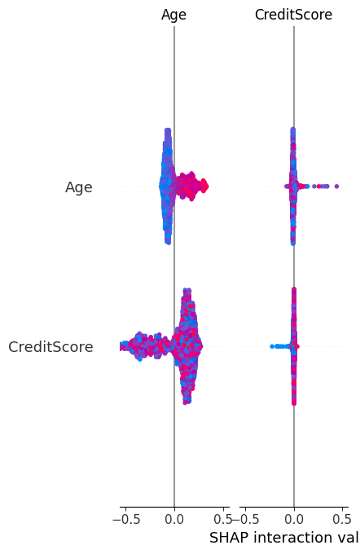

Fig: SHAP Graph

Risk Scoring System
The developed system generates churn probability scores between 0 and 1 for every customer.
Risk Categories
Probability Range | Risk Level
< 30% | Low Risk
30% – 60% | Medium Risk
> 60% | High Risk
Benefits of Risk Scoring
- Enables proactive customer retention
- Supports personalized engagement campaigns
- Helps prioritize high-risk customers
- Improves operational efficiency
The risk scoring framework transforms traditional churn analysis into predictive business intelligence.

Streamlit Dashboard
An interactive Streamlit dashboard was developed to provide real-time churn prediction and customer risk analysis.
Dashboard Features
- Customer churn prediction
- Churn probability scoring
- Risk category generation
- Feature importance visualization
- Customer profile analytics
- Interactive input system
User Capabilities
Users can:
- Enter customer information
- Modify engagement metrics
- Generate churn predictions instantly
- Analyze risk probability scores
- Explore feature importance insights
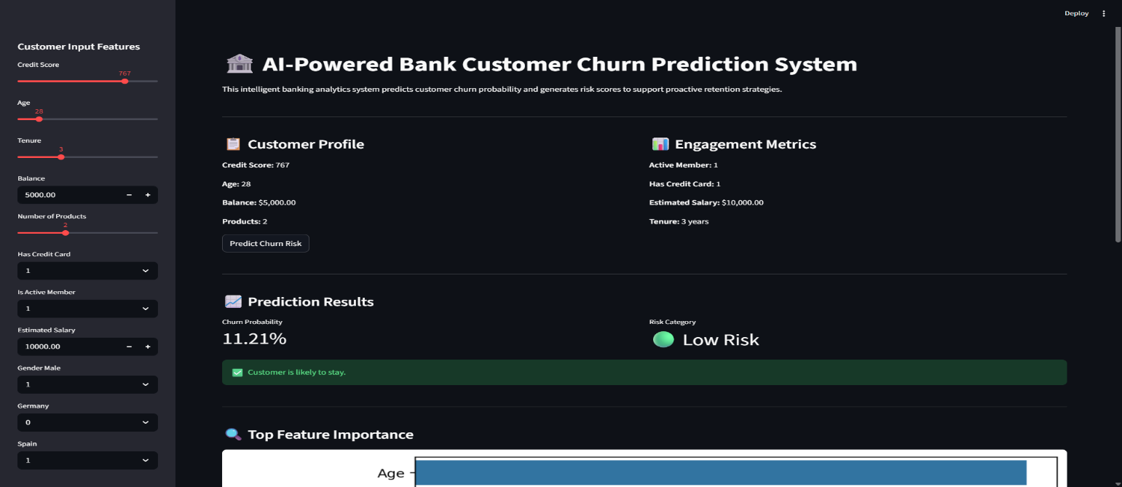
The dashboard converts the machine learning solution into a practical AI-powered business application.
Fig: Dashboard of the web application
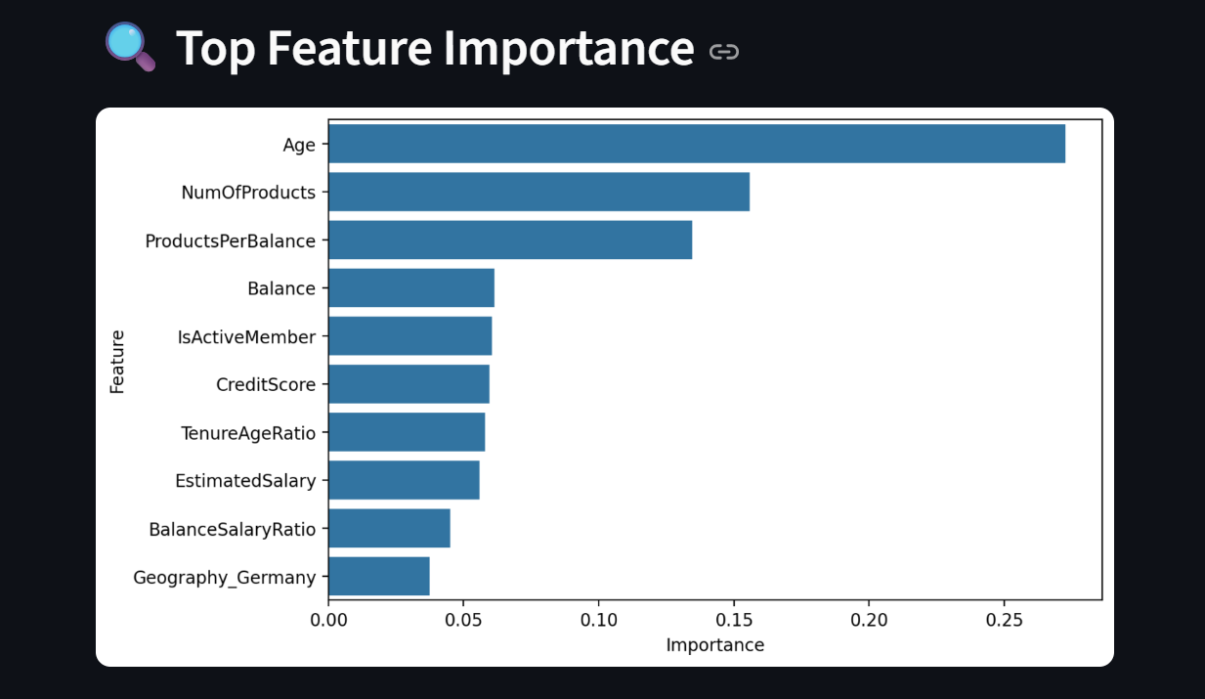
Fig: Feature Importance Graph
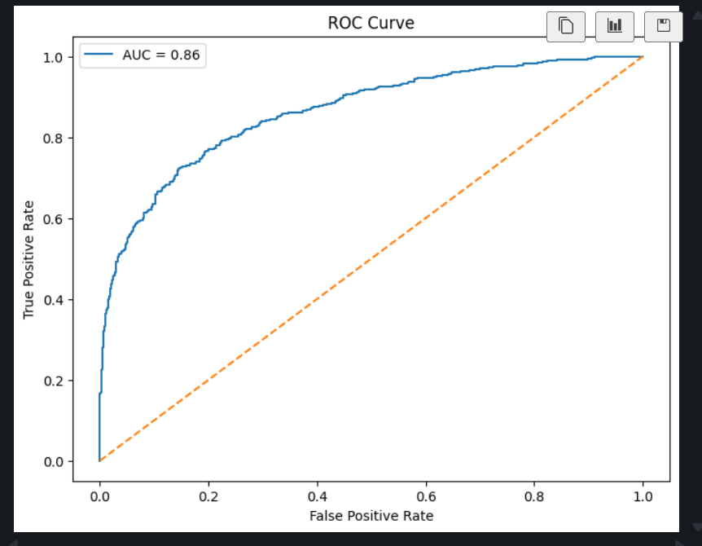
Fig: Roc Curve

Business Recommendations
Based on analytical findings, the following business recommendations are proposed:
1. Improve Customer Engagement
Focus on increasing engagement among inactive customers.
2. Monitor High-Risk Customers
Develop specialized retention campaigns for high-risk customer segments.
3. Personalized Product Strategies
Offer personalized banking products and loyalty incentives.
4. Strengthen Relationship Management
Improve customer communication and satisfaction strategies.
5. Data-Driven Retention Planning
Use predictive analytics to guide future customer retention initiatives.
These recommendations can significantly improve customer retention and operational efficiency.

Future Enhancements
1. Integration with Real-Time Banking Systems
The current system operates using historical banking datasets. In future implementations, the model can be integrated with real-time banking infrastructure to continuously monitor customer activities and transaction behavior. This would allow banks to identify high-risk customers instantly and initiate proactive retention strategies automatically.
2. Deep Learning–Based Churn Prediction
Although the current machine learning models achieved strong predictive performance, future work can explore advanced deep learning architectures such as Artificial Neural Networks (ANNs) and Long Short-Term Memory (LSTM) networks. These models may capture more complex behavioral patterns and improve prediction accuracy for large-scale banking environments.
3. Advanced Customer Segmentation
Future enhancements may include customer segmentation techniques using clustering algorithms such as K-Means or DBSCAN. This would enable banks to group customers based on financial behavior, engagement level, and churn tendencies, allowing more personalized retention campaigns and targeted marketing strategies.
4. Cloud Database Integration
The system can be integrated with cloud-based databases and cloud computing platforms such as AWS, Azure, or Google Cloud Platform. This would improve scalability, enable centralized data management, support large-scale deployments, and allow secure access to real-time customer analytics.
5. Real-Time Monitoring Dashboard
The Streamlit dashboard can be enhanced into a real-time monitoring system capable of continuously tracking customer churn trends, risk distributions, and retention campaign effectiveness. Advanced dashboards may include live alerts, dynamic analytics, automated reporting, and executive-level monitoring features for banking decision-makers.

Conclusion
This project successfully developed an AI-powered predictive modeling and risk scoring system for bank customer churn analysis.
The solution combined:
- Machine learning
- Explainable AI
- Feature engineering
- Risk scoring
- Interactive dashboard deployment
to transform traditional churn analysis into proactive customer retention intelligence.
The Random Forest model achieved strong predictive performance and generated actionable business insights capable of supporting data-driven banking strategies.
The deployed Streamlit application provides a practical, interactive, and scalable AI-powered analytics solution suitable for real-world banking environments.
This project demonstrates the practical application of machine learning and explainable AI in solving critical business problems within the financial sector.

GitHub Repository:
https://github.com/raghu-3113/bank-customer-churn-prediction

Live Streamlit Dashboard:
https://bank-customer-churn-prediction-zehbhebulm3jrxfhnstjvy.streamlit.app/

