AI-Powered Employee Attrition Prediction & Workforce Risk Intelligence System
Unified Mentor Internship Project Report
Submitted By
N. Raghu Babu
B.Tech – Artificial Intelligence & Data Science
Internship Organization
Unified Mentor Pvt. Ltd.
Project Domain
Machine Learning | Explainable AI | Workforce Analytics
Technologies Used
Python, Scikit-learn, XGBoost, SHAP, Streamlit, Plotly
Submission Year
2026

ABSTRACT
Employee attrition is one of the major challenges faced by organizations as it directly affects productivity, workforce stability, and operational efficiency. Traditional HR analytics approaches are often reactive and fail to identify employees at risk before resignation occurs. To address this problem, this project presents an AI-Powered Employee Attrition Prediction and Workforce Risk Intelligence System that leverages machine learning and explainable AI techniques for proactive workforce analysis.
The project involves data preprocessing, exploratory data analysis, feature engineering, predictive modeling, and explainable AI implementation using SHAP (SHapley Additive exPlanations). Multiple machine learning models were evaluated, including Logistic Regression, Random Forest, and XGBoost Classifier. Among these, XGBoost achieved the best predictive performance and was selected for deployment.
An interactive Streamlit dashboard was developed to provide workforce analytics, employee risk prediction, attrition monitoring, explainable AI insights, and downloadable workforce reports. The dashboard enables organizations to identify high-risk employees and make proactive retention decisions using data-driven insights.
This project demonstrates the practical application of machine learning and explainable AI in workforce intelligence systems and highlights how predictive analytics can support strategic HR decision-making.

INTRODUCTION
Employee attrition is one of the major challenges faced by organizations because it affects productivity, workforce stability, employee morale, and operational efficiency. Traditional HR systems mainly rely on reactive analysis and often fail to identify employees who are at risk of leaving the organization.
With the advancement of Artificial Intelligence and Machine Learning, predictive workforce analytics has become an effective solution for improving employee retention strategies. Machine learning models can analyze historical workforce data, identify hidden patterns, and generate predictive insights for HR decision-making.
This project focuses on developing an AI-Powered Employee Attrition Prediction and Workforce Risk Intelligence System using machine learning and explainable AI techniques.
Key Highlights of the Project
- Predict employee attrition risk using machine learning
- Analyze workforce trends and employee behavior
- Identify major attrition drivers
- Implement explainable AI using SHAP
- Develop an interactive Streamlit dashboard
- Generate business intelligence insights for HR teams
- Support proactive employee retention strategies

PROBLEM STATEMENT
Organizations frequently face challenges due to unexpected employee resignations and increasing attrition rates. High employee turnover can lead to productivity loss, increased recruitment expenses, operational disruption, and reduced organizational efficiency.
Traditional HR analytics systems mainly focus on historical reporting instead of predictive workforce intelligence. As a result, organizations often fail to identify high-risk employees before attrition occurs.
Major Challenges
- Lack of proactive attrition prediction systems
- Limited workforce visibility and risk monitoring
- Difficulty identifying key attrition drivers
- Increased recruitment and training costs
- Reduced employee retention efficiency
This project aims to solve these challenges by developing a predictive and explainable workforce intelligence system using machine learning and explainable AI techniques.

OBJECTIVES
The primary objectives of this project are:
- To analyze employee workforce data for attrition-related patterns and trends.
- To preprocess and transform workforce data for machine learning applications.
- To build predictive machine learning models for employee attrition prediction.
- To compare multiple machine learning algorithms and identify the best-performing model.
- To implement explainable AI techniques using SHAP for model interpretability.
- To develop an interactive Streamlit dashboard for workforce analytics and risk monitoring.
- To generate employee-level risk scores and business intelligence insights.
- To support proactive employee retention and strategic HR decision-making.

DATASET DESCRIPTION
The dataset used in this project contains employee workforce information related to job roles, work environment, employee satisfaction, compensation, and organizational factors. The dataset was utilized to analyze employee attrition patterns and build predictive machine learning models.
Dataset Characteristics
- Structured tabular dataset
- Supervised machine learning problem
- Binary classification task
- Target variable: Employee Attrition
Important Features in the Dataset
- Age
- Department
- Job Role
- Monthly Income
- Job Satisfaction
- Work-Life Balance
- Overtime
- Years at Company
- Years Since Last Promotion
- Distance From Home
- Environment Satisfaction
Target Variable
- Attrition = 1 → Employee likely to leave organization
- Attrition = 0 → Employee likely to stay in organization
Dataset Usage
The dataset was used for:
- Workforce trend analysis
- Employee attrition prediction
- Feature engineering
- Explainable AI implementation
- Dashboard analytics and risk scoring

DATA PREPROCESSING
Data preprocessing is an essential step in machine learning because raw workforce data may contain inconsistencies, categorical values, and imbalance issues that can affect model performance.
Several preprocessing techniques were applied to prepare the dataset for predictive modeling.
Data Preprocessing Steps
1. Missing Value Analysis
- Checked dataset for null and missing values
- Verified dataset completeness before modeling
2. Duplicate Record Validation
- Identified and removed duplicate employee records if present
3. Categorical Encoding
- Converted categorical features into numerical format
- Applied encoding techniques suitable for machine learning models
4. Feature Scaling
- Standardized numerical features where necessary
- Improved model learning consistency
5. Class Imbalance Handling
- Employee attrition data was imbalanced
- Applied SMOTE (Synthetic Minority Oversampling Technique)
- Balanced the target classes to improve prediction accuracy
6. Train-Test Split
- Divided dataset into training and testing datasets
- Enabled unbiased model evaluation
Outcome of Preprocessing
The preprocessing pipeline improved:
- Data quality
- Model stability
- Prediction performance
- Feature consistency

EXPLORATORY DATA ANALYSIS
Exploratory Data Analysis (EDA) was performed to understand workforce trends, employee behavior patterns, and attrition-related insights. Various visualizations were generated to identify relationships between employee attributes and attrition probability.
Key EDA Insights
1. Attrition Distribution Analysis
- Analyzed overall employee attrition distribution
- Identified imbalance between attrition classes
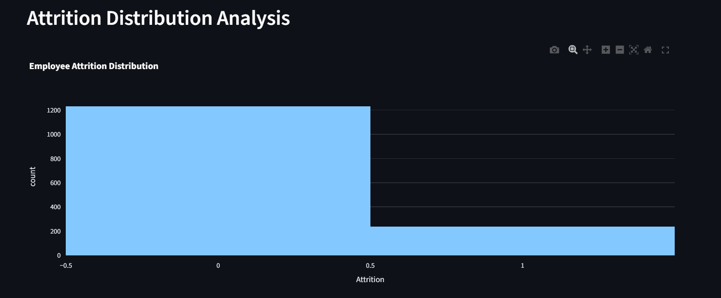
Figure 1: Attrition Distribution Analysis

2. Department-wise Attrition Analysis
- Compared attrition trends across departments
- Identified departments with higher employee turnover
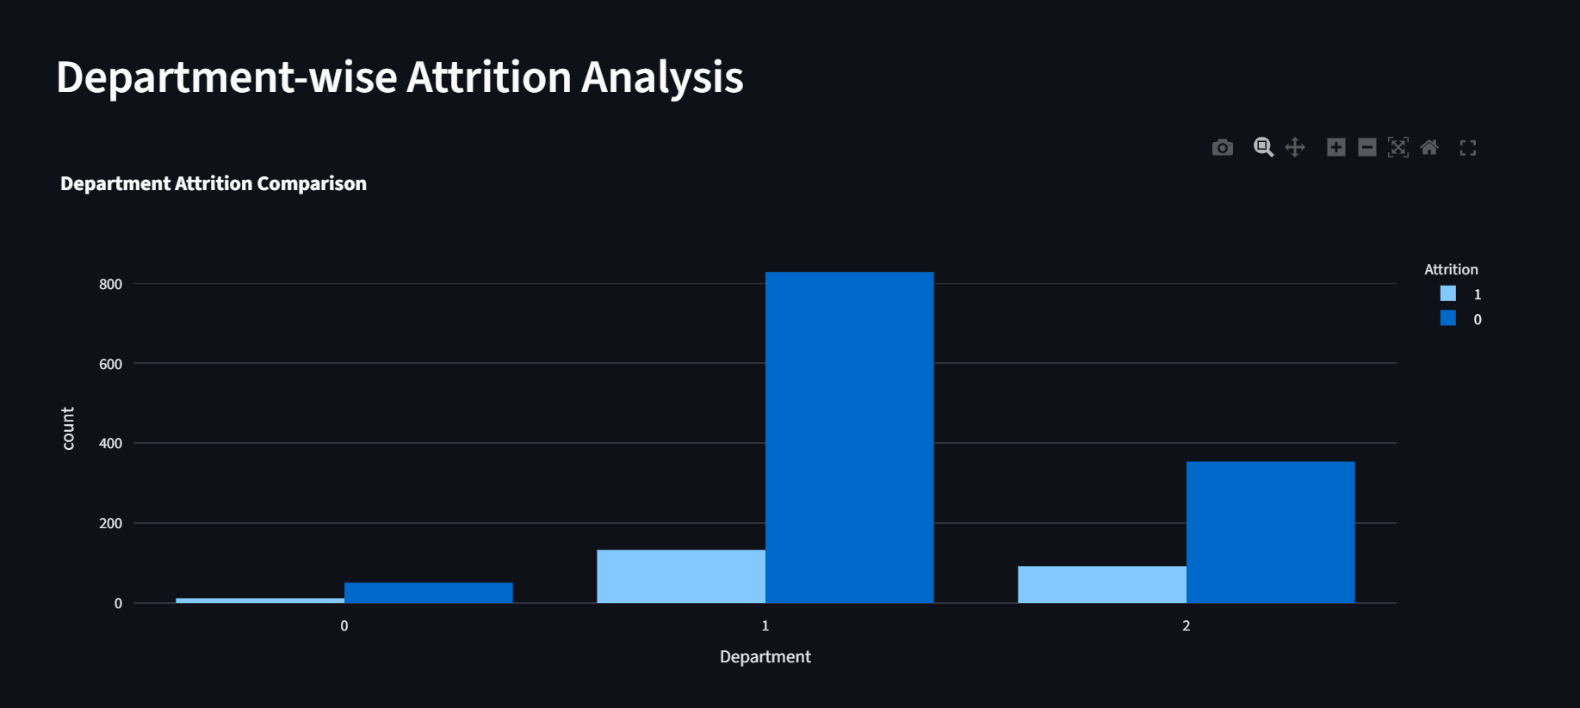
Figure 2: Department wise Attrition Analysis

3. Overtime Impact Analysis
- Evaluated relationship between overtime and employee attrition
- Observed higher attrition among employees working overtime
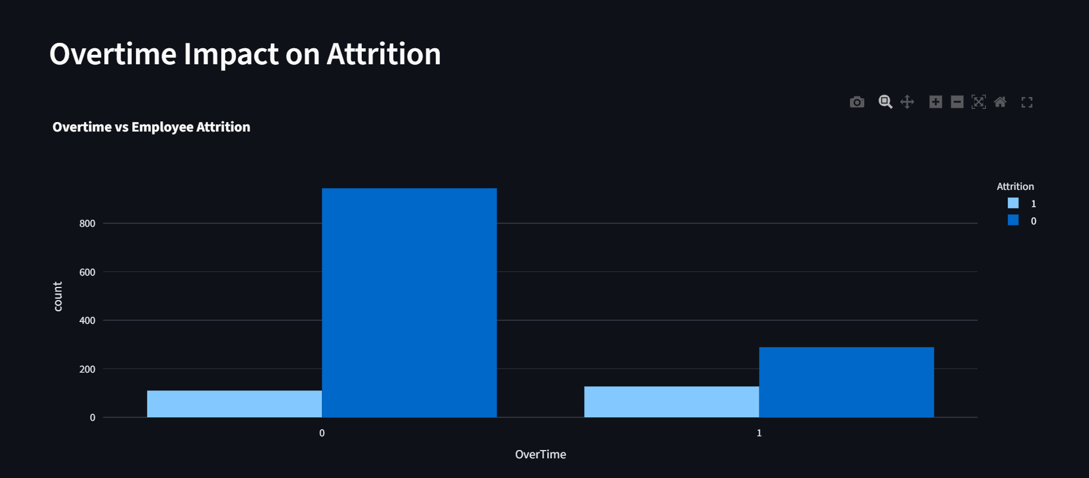
Figure 3: Overtime Impact Analysis
4. Workforce KPI Monitoring
- Evaluated workforce statistics and business metrics
- Included employee count, attrition rate, and income analysis
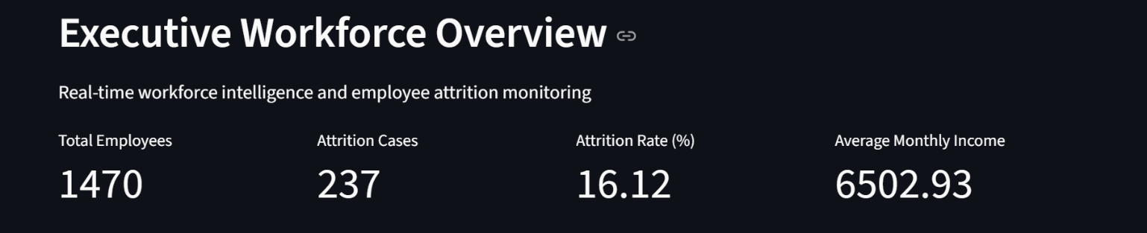
Figure 4: Workforce KPI Monitoring

EDA Outcome
The analysis revealed that factors such as overtime, job satisfaction, work-life balance, and promotion delays significantly influence employee attrition patterns.

FEATURE ENGINEERING
Feature engineering was performed to improve model learning capability and enhance workforce intelligence analysis. New features were derived from existing workforce attributes to capture hidden behavioral and organizational patterns related to employee attrition.
Feature Engineering Techniques Applied
1. Income-to-Experience Ratio
- Created a feature representing employee compensation relative to work experience
- Helped analyze compensation satisfaction trends
2. Promotion Delay Indicator
- Derived feature based on years since last promotion
- Assisted in identifying employees with potential career stagnation
3. Employee Engagement Indicators
- Combined satisfaction-related variables to analyze workforce engagement patterns
4. Workload Stress Indicators
- Evaluated overtime-related employee stress patterns
- Helped improve attrition risk analysis
Benefits of Feature Engineering
- Improved predictive capability of machine learning models
- Enhanced workforce behavior analysis
- Increased model interpretability
- Improved attrition risk identification

MODEL BUILDING
Multiple machine learning algorithms were implemented and evaluated to identify the most effective model for employee attrition prediction.
Machine Learning Models Used
1. Logistic Regression
- Baseline classification algorithm
- Used for comparison and interpretability
2. Random Forest Classifier
- Ensemble learning algorithm
- Improved prediction stability using multiple decision trees
3. XGBoost Classifier
- Advanced gradient boosting algorithm
- Delivered superior predictive performance
- Selected as the final deployment model
Model Training Process
The following workflow was followed during model development:
- Data preprocessing and feature transformation
- Train-test dataset splitting
- Class imbalance handling using SMOTE
- Model training and validation
- Performance comparison across multiple algorithms
- Final model selection based on evaluation metrics
Final Model Selection
XGBoost Classifier demonstrated the best overall predictive performance and was selected as the final production model for deployment within the Streamlit dashboard.

MODEL EVALUATION
Model evaluation was performed to measure predictive performance, classification accuracy, and workforce risk prediction capability.
Multiple evaluation metrics were used to compare machine learning models and identify the most effective algorithm.
Evaluation Metrics Used
- Accuracy Score
- Precision Score
- Recall Score
- F1 Score
- ROC-AUC Score
Model Comparison Summary
The XGBoost Classifier achieved the strongest overall performance compared to Logistic Regression and Random Forest models.
Key Evaluation Outcomes
- Improved attrition prediction accuracy
- Better identification of high-risk employees
- Enhanced class imbalance handling
- Stronger workforce intelligence capability
Performance Benefits of XGBoost
- Higher predictive stability
- Better handling of complex workforce patterns
- Improved classification performance
- Efficient ensemble learning capability
The final trained XGBoost model was deployed within the Streamlit dashboard for real-time workforce risk prediction and employee attrition analysis.
SHAP EXPLAINABILITY
Explainable AI techniques were implemented in this project using SHAP (SHapley Additive exPlanations) to improve model transparency and interpretability.
SHAP helps explain how different workforce-related features contribute to employee attrition predictions generated by the machine learning model.
Purpose of SHAP in the Project
- Improve AI transparency
- Explain model predictions
- Identify major attrition drivers
- Support HR decision-making
- Increase trust in predictive analytics systems
SHAP Analysis Performed
1. Employee-Level Explanation
- Generated SHAP waterfall plots for individual employee predictions
- Visualized how specific features influenced attrition risk
2. Global Feature Importance
- Identified the most influential workforce factors across the dataset
- Evaluated overall feature contribution patterns
Major Attrition Drivers Identified
- Overtime
- Job Satisfaction
- Work-Life Balance
- Monthly Income
- Promotion Delays
Benefits of Explainable AI
- Better workforce intelligence interpretation
- Improved HR decision support
- Increased model transparency
- Enhanced business understanding of attrition patterns
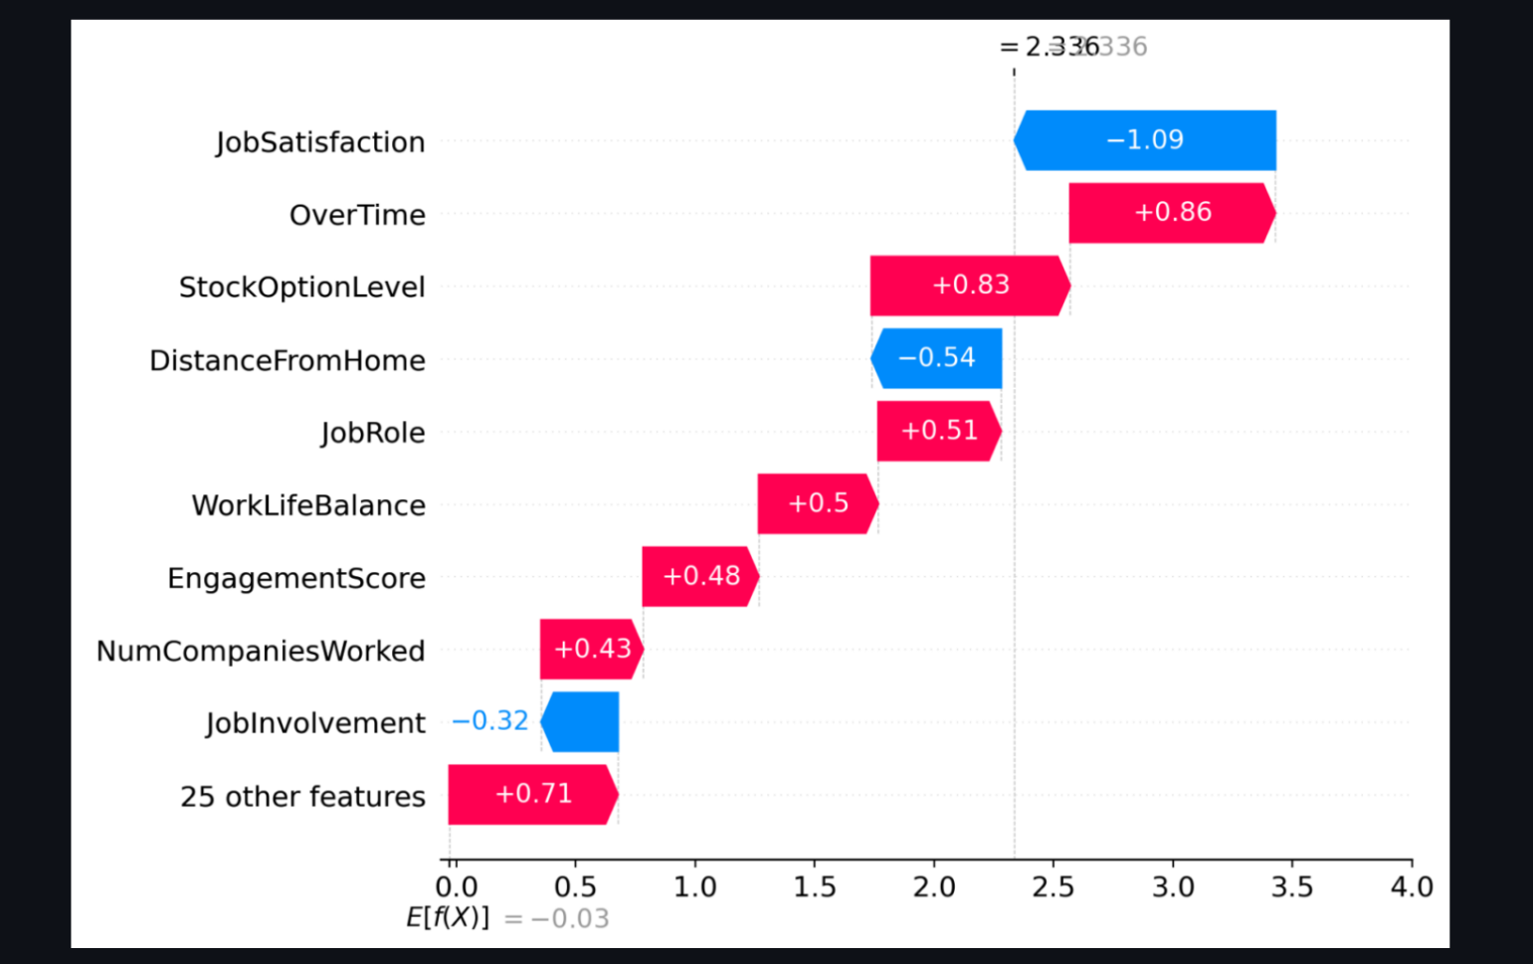

STREAMLIT DASHBOARD
An interactive Streamlit dashboard was developed to provide real-time workforce analytics, employee attrition monitoring, explainable AI insights, and predictive risk assessment.
The dashboard enables HR teams and business stakeholders to interact with workforce intelligence data through a user-friendly interface.
Dashboard Features
1. Executive Workforce Overview
- Employee count monitoring
- Attrition rate analysis
- Workforce KPI tracking
2. Attrition Analytics
- Department-wise attrition analysis
- Overtime impact analysis
- Workforce trend visualization
3. Employee Risk Prediction
- Individual employee attrition prediction
- Risk scoring system
- Risk category identification
4. Explainable AI Visualization
- SHAP-based prediction explanation
- Feature importance visualization
5. Workforce Intelligence Reporting
- High-risk employee analysis
- Downloadable workforce reports
Dashboard Benefits
- Real-time workforce intelligence
- Interactive HR analytics
- Improved decision-making support
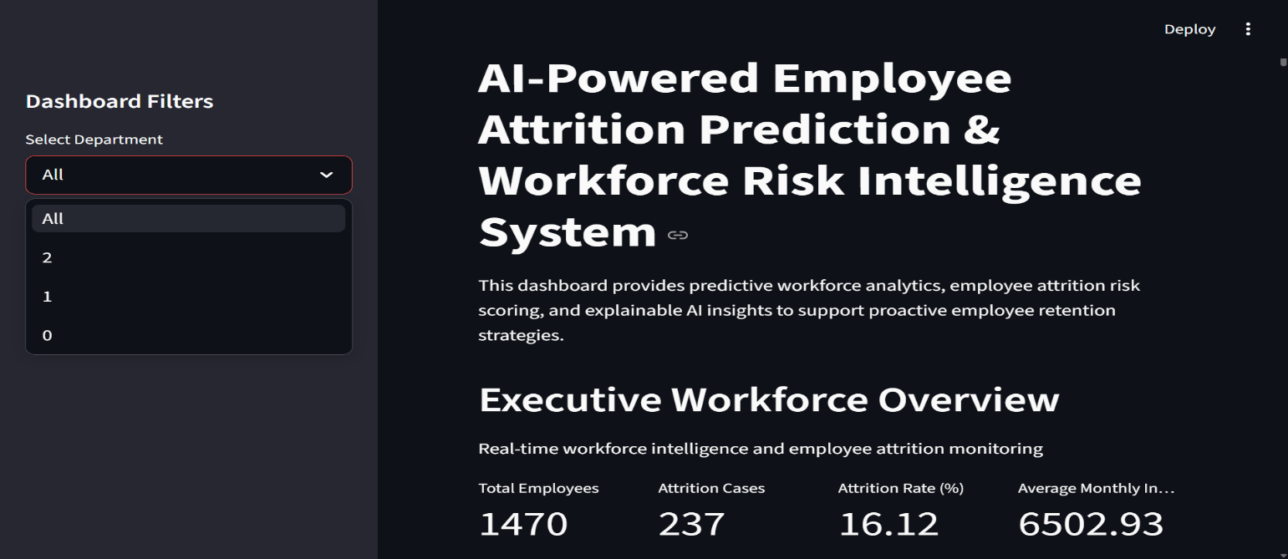
- Proactive employee retention planning
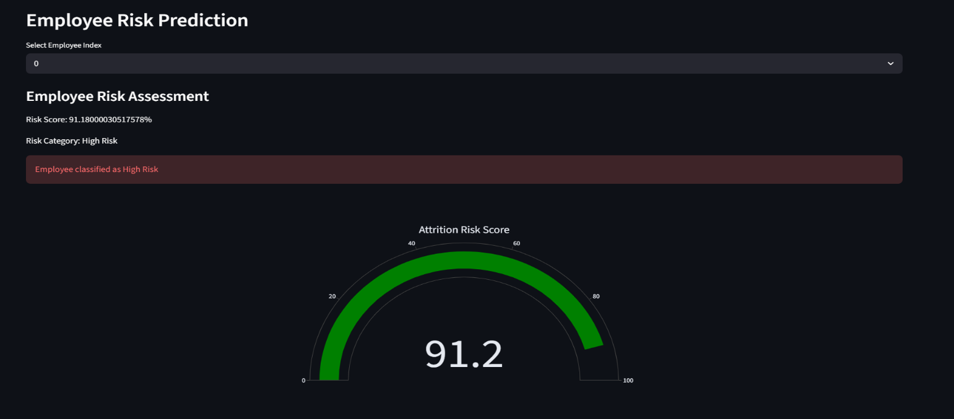
BUSINESS INSIGHTS
The project generated several workforce intelligence insights that can help organizations improve employee retention strategies and workforce management.
Major Business Insights
1. Overtime and Attrition
- Employees working excessive overtime demonstrated higher attrition probability.
2. Job Satisfaction Impact
- Lower job satisfaction levels were strongly associated with employee turnover.
3. Work-Life Balance Influence
- Employees with poor work-life balance showed elevated attrition risk.
4. Promotion Delays
- Employees experiencing delayed promotions demonstrated increased workforce dissatisfaction.
5. Compensation Trends
- Monthly income and compensation-related factors influenced retention behavior.
Recommended Business Actions
- Reduce excessive overtime workloads
- Improve employee wellness initiatives
- Strengthen career growth opportunities
- Enhance employee engagement programs
- Implement proactive workforce retention strategies

CONCLUSION
This project successfully developed an AI-Powered Employee Attrition Prediction and Workforce Risk Intelligence System using machine learning and explainable AI techniques.
The system demonstrated how predictive analytics can be applied to workforce intelligence and employee retention analysis. Multiple machine learning models were evaluated, and XGBoost Classifier achieved the best predictive performance for employee attrition prediction.
The integration of SHAP explainability improved model transparency by identifying key workforce factors contributing to attrition risk. Additionally, the interactive Streamlit dashboard enabled real-time workforce analytics, employee risk monitoring, and business intelligence visualization.
Overall, the project highlights the practical application of machine learning, explainable AI, and interactive dashboards in solving real-world HR analytics challenges and supporting proactive workforce decision-making.

FUTURE SCOPE
The project can be further enhanced with several advanced features and improvements in future development stages.
Future Enhancements
- Integration with real-time HR databases
- Deployment using cloud infrastructure services
- Deep learning-based workforce prediction models
- Automated employee retention recommendation systems
- Advanced workforce forecasting analytics
- Role-based HR dashboard access
- Real-time workforce monitoring pipelines
- Integration with enterprise HR management systems

