Exility Test Case Executor

Date | Version | Author | Comments
14 – Mar- 2013 | 1.0.0 | Ashwini Ramachandra | First Release

Table of contents

1. Introduction 3
1.1. Purpose 3
1.2. Strategy, Goals and Principles 3
2. An Introduction to TestCase Executor 4
3. Recording Test Case 5
4. Execute Test Case 6
5. Test Report analysis: 7

Introduction

Purpose
The purpose of this document is to describe the test strategy, goals and principles applied to test the Exility components or services API’s. This document will not have details of each modules of the application that have been developed using Exility application framework.

This document will act as a reference for:-
- Framework/Application designers
- Developers
- Project leads.

Strategy, Goals and Principles
The strategy used for testing Exility Application framework is by using test automation framework with two approaches viz. Recorded test and by scripting.

The goals or high level objective that applies to Exility Application Framework:
- To improve quality
- To reduce risk
- Easy to write, maintain and execute Test case
- Easy to evolve as the framework adds new feature

The principles documented here are to enable and support test automation and quality of the Exility application framework. These principles very well apply to any other application that is being developed.
- Design for testability
- Write test first
- Communicate Intention

An Introduction to TestCase Executor
The term TestCase is referred as any member of the family of TestCase Executor ( Test Automation Framework). The executor framework is used to test non-interactive and interactive (UI) based functions or services in a consistent manner. The following diagram depicts the overall planning and structure of test case that is required to create and maintain the test cases.

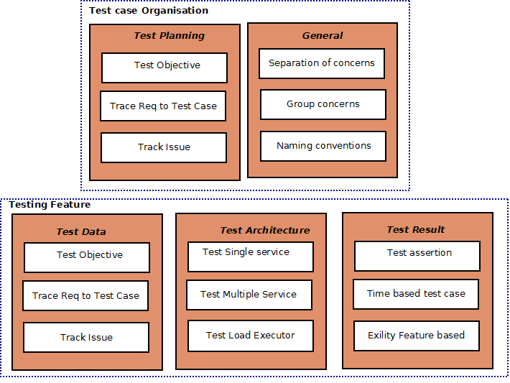

The Exility Application framework is a Model-View-Architecture (MVC) which applies separation of concerns to presentation layer where a view is isolated from the domain or business logic. The domain components are self-sufficient, and are unaware of how the information is presented to the end-user. Therefore it is possible to test the service component independently or by grouping the set of services to test as complete function.
The following diagram depicts how the service test can be categorized or separated.

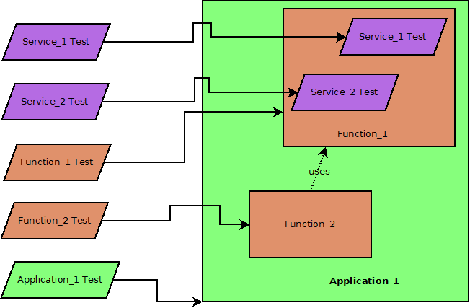

Recording Test Case
This section describes the step to record a test case.

- Run the Ezapp application.

- On the top menu there is a green tick icon which when clicked starts capturing all of the services being executed in the application as test cases. (Figure 1.1)

Figure 1.1

    - To stop capturing test cases click on the cross icon. (Figure 1.2)

Figure 1.2

- The test cases generated are saved under the resource folder. A folder is present under resource folder called test which will contain one folder for each service. The folder name will be same as the service name.
Eg: apache-tomcat-7.0.27/webapps/Ezapp/WEB-INF/resource/test/getFolders

- The test cases can be tweaked and input data can be changed to ensure that all possible test cases are taken care of.

Execute Test Case
This section describes the test case execution and verifying the test results.

- The test case tool is provided as a jar file. This takes two inputs : Resource folder and the folder name which contains the service test cases.

- The test tool runs for each service.
Eg: java -jar TestCaseGen.jar "/Users/harshabhat/Desktop/apache-tomcat-7.0.27/webapps/Ezapp/WEB-INF/resource/test/getFiles" "/Users/harshabhat/Desktop/apache-tomcat-7.0.27/webapps/Ezapp/WEB-INF/resource"

- The test tool runs through each of the service test cases inside the service folder and creates two output folders :
    - An output folder which contains output files for each of the service tested.
    - A summary folder which contains one summary file for all the test cases within the service folder.

Test Report analysis:

The generated report contains data about the test cases that have been executed. Reports are generated in three ways :
- Individual report for each test case : This contains data about each test case under the service folder.
- What was the expected time for the service to complete?
- What was the actual time taken?
- Did the test pass?
- Error message if any
- Result of the service is presented in a separate sheet

- Summary report for each service : This report will give information about all the testCases related to a service.
- What was the expected time for the service to complete?
- What was the actual time taken?
- Did the test pass?
- Error message if any.

- Function test reports : This report will give information about all the services under the test folder.
- Expected time for each test case
- Actual time for each test case
- Did the test pass
- Error message if any
- Number of test cases that were tested for each service.

