Exility
Server-only Mode Manual
EXILANT Technologies Pvt. Ltd.
Concord@mantri,  No.10, Richmond Road,  Bangalore - 560 025  INDIA | 256, Gibraltar Drive, Suite #105  Sunnyvale, CA 94089  USA
 |  |  | Version 3.0
 |  |  | Dated: 07-October-2013
 |  |  | Reference Exility Version : 3.0
Web site: www.exilant.com |  |  1-408-747-0000 |  1-408-716-2891

Revision History

Document Version | Exility Version | Date | Description | Prepared by | Reviewed by
3.0 | Exility 3.0 | 07 Oct 2013 | Exility in server only mode. | Anant and Vinay

Exility application is designed as a combination of a client and server application.

EXILITY APPLICATION

Client Application

Interface b/w

Server Application

So an application can use either one or both modules of exility.

If an application is using only server application of exility then it is called server only mode of exility.
Following steps should be followed for using exility in server only mode:

Case I: For Web application( html and AJAX based client)

- Include exilityAgent.js into client application to make/receive AJAX request/response to/from server.

- Application client has to implement rendering API. This API should extract data from DataCollection provided by ExilityAgent.js and vice versa. DataCollection has methods to populate data from server. Please refer to DataCollection interface for more detail.

Case II: For Native Client application(like cocoa as a client)
In this case an application has to implement following steps.
1. Develop an interface which must have below components:
a) An Interface to make/receive request/response to/from server along with serialized/deserialized DC.
b) Exility DataCollection Interface implementation. Please refer to DataCollection interface for more detail.

Before diving into depth have a brief look onto the DataCollection interface.
DataCollection(DC) is an interface(or data structure) which holds the application data.

DataCollection Interface:
DC contains following below components(data members/data structures)
- Lists.
- Grids.
- Values: in the key and value form.
- Messages.

And it also has methods to operate upon to data members.
Methods:
- adMessage(type, msg)
- addValue(name, value);
- addGrid(name, grid)
- addList(name, valueList)
- getMessages()
- getValues()
- getGrids()
- getLists()
- getValue(name)
- getGrid(name)
- getList(name)
- removeValue(name)
- removeGrid(name)
- removeList(name)
- hasValue(name)
- hasGrid(name)
- hasList(name)

Apart from DC interface, client application has to implement ServerAgent interface which will make/receive request/response to/from the server.

ServerAgent Interface:
ServerAgent should have following methods:
1. serve(serviceName, DC, callBackObject)
- serializeDC(DC).
- deSerializeDC(DC)
- setUrl(absoluteUrlOfServiceJsp)

ServerAgent should follow the serialize/deSerialize protocols of exility.
In simple words exility has its own way to serialization/deSerialization
of DataCollection so client application also has to follow same.
Data serialization/deserialization will be shown in below example in detail.

Problem statement: How to use exility server application with HTML and AJAX based
application(lets say:Request Leave system).

Solution:
As given that Leave Request System is an HTML and AJAX based application and
want to use only exility server application.

We have an Interface to make a request for leave.
See the below form:
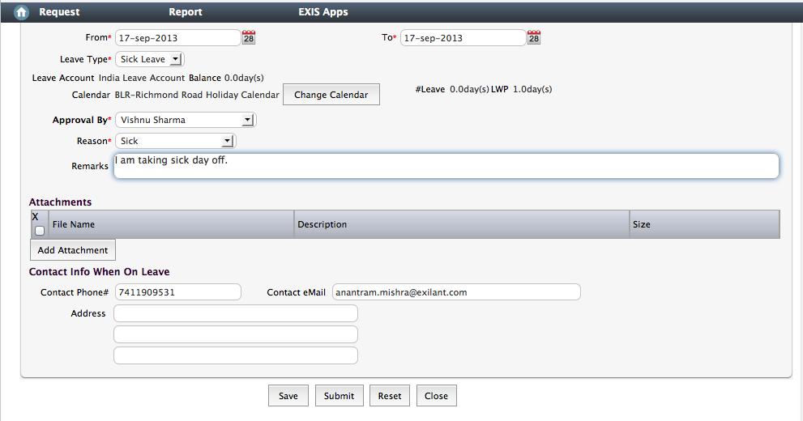

Figure1: Employee Leave Request Form(Interface)

Once we have client interface ready then follow below steps to make call for exility server.

Step1: Develop ServerAgent and DataCollection API.

Once client application is ready with nice UI and want to send/receive its data to/from server then first step is to develop ServerAgent Interface to make/receive request/response to/from the exility server application.

ServerAgent Implementation: Here we are using javascript object literal to develop ServerAgent.

Please refer to ServerAgent.js file.
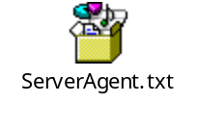

Once we are ready with ServerAgent then next we need to develop DataCollection API.
@Note: serializeDC/deSerializeDC can be implemented by either DC itself or ServerAgent.

So in this application DC itself has serialization and deSerialization methods.

DataCollection Implementation: Here we are using javascript to develop DataCollection(DC).

Please refer in DataCollection.js file
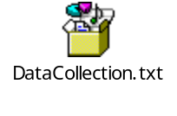

In this implementation DC has other utility methods like fromDc(dc) etc. Which can be remove or keep based on client application requirement.

Step2: Once you have done step1 then include ServerAgent and DataCollection API into
the client application page(or in UI) which requires to interact with exility server application.
In our Leave Request System we have an Interface(Form/Page as html) which has save and submit button(Please see in Figure1.).

What we are trying to do?
Once user will submit the form we will make server application call from a function makeCall() defined in leaveForm.js like:

//Below function will be invoked on click of submit button
function makeCall()
{
var dc = new DataCollection();
var name = document.getElementById('name').value;
//add form data to DC
dc.addValue("name",name);
//Similarily you can add all form data into dc
/*Set the server url for Service.jsp. This is the absolute path/url*/
ServerAgent.setUrl('http://localhost:9090/ServerOnlyMode/jsp/Service.jsp');
//Call the service
ServerAgent.serve("common.makeLeaveRequest", mycallback, dc);
}

Now only thing that we need to define mycallback object which must have following
below methods in our page js file(in our example leaveForm.js):

var mycallback = {
serviceReturned:function(dc){
//This method will be called by ServerAgent after executing the service
without fail along with DataCollection object.

var leaveSatus = dc.getValue('leaveSatus');
alert(“Employee leave status from server==>”+leaveSatus);

}
,serviceFailed: function(errorCode, msg){

//This method will be called if service will be failed.In case of any error.
alert(msg);
}
}

