# Introduction

The Stress Utility add-in for the MS Excel is developed to improve the productivity while processing the FE loads and preparing the Structural Calculation/Certification reports. The utility supports the post processing of the FE results with the innovative load case table concept, translates the excel formulas into mathematical equations and prepares the MS Word the report showing calculations steps.

The utility also produces Table of Contents, List of References and Include Cross References to the equations provided the references are identified in the calculation sheet.

The usage of the Stress utility requires no additional training. However, the calculation tables need to be prepared in the prerequisite format and the top left cell of the table must be a Named Cell with a prefix “TableCXX”. The addin includes the feature to create the required table format at the location picked by the user and automatically assign a name to the cell which acts as an anchor to the table.

The utility supports 2 types of calculation table formats.

1. Row wise arrangement of the calculations
2. Column wise arrangement of the calculations

The table format required for the *Row wise arrangement of the calculations* is produced by the tool as shown below [*Insert Calc Table (Row)*]. The table can be expanded horizontally and vertically to fulfil the need of the calculation. The identifiers “TBLDESCR”, “PARAMETER”,”SYMBOL”,”UNIT” are mandatory and should not be altered. In order to have cross reference feature enabled for the report, a row containing the identifier “REFERENCE” needs to be filled by the user. The “REFERENCE” row is an option, it can be deleted if necessary

An example of the Table with the cross reference feature enabled is presented below. Please note that the units and Reference numbers can be entered with or without the square brackets **“[]”. It is must that the row “REFERENCE” appear right after the “UNIT”.**



In the rows containing the identifiers SYMBOL and the UNIT, the text must be entered such that the math equation editor can recognize those symbols and translate them to the equation format. Some of the examples are shown overleaf.

F_x will be translated to Fx

\sigma will be translated to σ

\pi will be translated to π

\tau_xy will be translated to τxy

mm^4 will be translated to mm4

y\bar will be translated to y̅

F_x^’ will be translated to Fx’

F_(n 2) will be translated to Fn 2  (It is necessary to use parenthesis when space is required in the suffix)

User can make use of Math AutoCorrect options to identify the code required for the symbol they are interested in. The Math AutoCorrect option can be accessed as below in MS word or in MS Excel.

File🡪Options🡪Proofing🡪 AutoCorrect Options🡪Math AutoCorrect

Similarly, if the calculation needs to be arranged column wise, the button *Insert Calc Table (Column)* produce the table. The table can be extended as desired. An example is shown below.



Please note that, any number of columns can be inserted between (not necessarily) the columns “SYMBOL” and “UNIT” to have multiple calculations (example one each for BOLT 1, BOLT 2 etc).

. The identifiers “DESCRIPTION”, “PARAMETER”,”SYMBOL”,”UNIT” are mandatory, should not be altered.

# Capabilities and Limitations of the Utility

The utility supports all the operations performed by excel together with majority of the excel built in functions. The utility supports the data from any of the sheet in the workbook. **However, the formulas containing the links to another workbook is not supported**. If the data from other workbook is needed, then the data needs to be linked to a separate worksheet so that the tool can work with the data.

Below is the list of excel functions supported by the Stress Utility Add-in. The unsupported excel functions can be used outside the calculation table and they can be linked to the calculation table. Including the unsupported equations in the excel formula will result in the reproduction of the same excel formulas. Below is the list of excel built-in functions supported by the utility. The equivalent functions in German and French are provided in the Appendix A.

**List of Supported Functions with formula conversion**

**MATH AND TRIGONOMETRY :** "ABS", "ACOS", "ACOSH", "ASIN", "ASINH", "ATAN", "ATANH", "COS", "COSH""DEGREES", "EXP", "LN", "LOG", "LOG10", "MDETERM", "MINVERSE", "MMULT, "PI", "POWER", "PRODUCT", "RADIANS", "ROUND", "ROUNDDOWN", "ROUNDUP", "SIGN", "SIN", "SINH", "SQRT", "SUM", "SUMPRODUCT", "SUMSQ", "TAN", "TANH", "TRUNC"

STATISTICAL🡪"AVERAGE", "COUNT", "COUNTIF", "MAX", "MIN"

LOGICAL🡪"IF", "AND", "OR"

**List of supported functions with direct evaluation (without formula support)**

***LOOKUP FUNCTIONS:*** "ADDRESS", "COLUMN", "HLOOKUP", "INDEX", "LOOKUP", "MATCH", "ROW", "TRANSPOSE", "VLOOKUP", “XLOOKUP”

***DATABASE:*** "DGET"

The utility is generated based on the assumption that the analysis process involves the calculation itself and the data processing to aid the calculation. It is a common practice to use error checking functions like IFERROR, ISBLANK, ISNUMBER etc. in the data processing stage. The data processing (load processing) functions are generally not required for the calculation itself. Therefore, the tool does not consider the functions which are used to suppress the errors in the data processing (load processing) stage.

The utility works with all the language settings. However, the help document and the interface language is only in English and it’s the tasks of the future to develop all the language settings.

# Ribbon

The Stress utility tool comes with the a ribbon with different buttons under 6 groups. More features will be added in the near future.

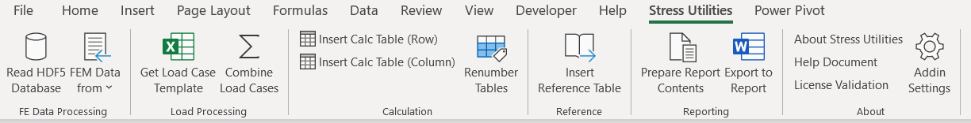

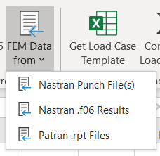

## FE Data Processing

The following formats for the FE loads are supported by the stress utilities.

* NH5RDB (Nastran HDF5 Result Database)
* Nastran Punch File Reading
* Nastran f06 Reading
* MSC Patran rpt files reading

“*Read HDF5 Database*” supports importing the Nastran results directly into the activesheet of the MS Excel. As shown the figure below. The ‘Add DB’ button loads the HDF5 tree. The user needs to select the Dataset from the tree view. On clicking the dataset in the treeview, the DATASET field (textbox) display the full path. Start Cell where the data needs to be extracted can be selected interactively by clicking the grid icon on the right side of the “Start Cell” text box. The elemental results can be extracted at the centroid of the element or at the gauss points. The database results can be extracted by clicking on the “Extract” button.

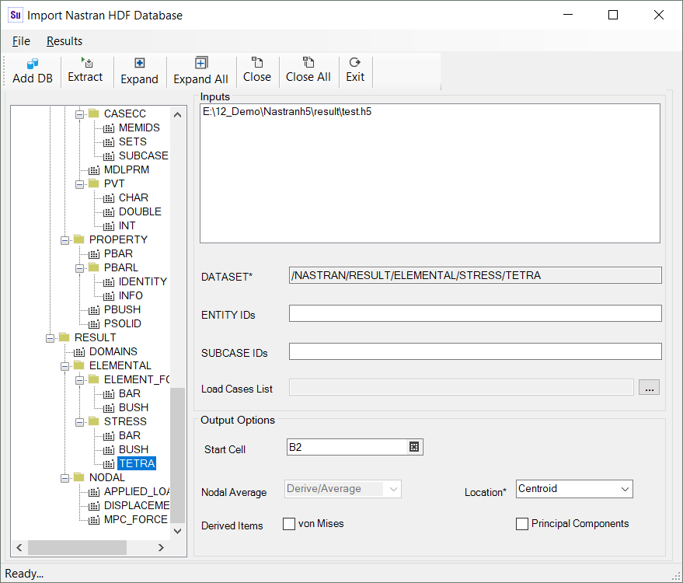

The drop down menu “FEM Data from” has 3 options described below.

“*Nastran Punch File(s)*” button display a windows form with the option to list the punch files and to select the result data to be processed.

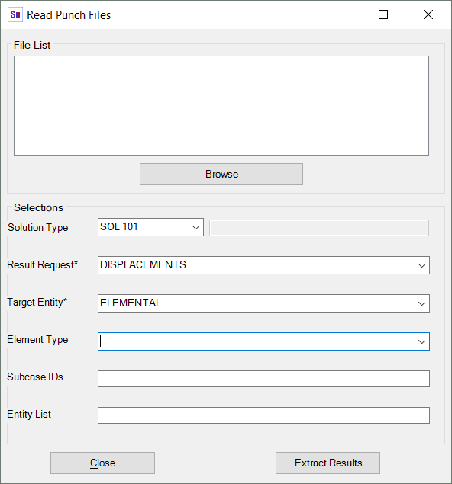

The *“Nastran .f06 Results”* button extracts the results from the Nastran *.f06 files. With this feature, the element forces, Element Stresses at centroid, Strains at Centroid, Displacements and SPC Forces can be imported for the selected set of elements. By clicking the “Add *.f06 Files” button, the *.f06 files can be added to the File List. The file can be removed by double clicking the file name listed in the File List box. The entity list can follow standard MSC Patran format (Range of elements can be entered with the format StartElement:EndElement[:Inrement] ).

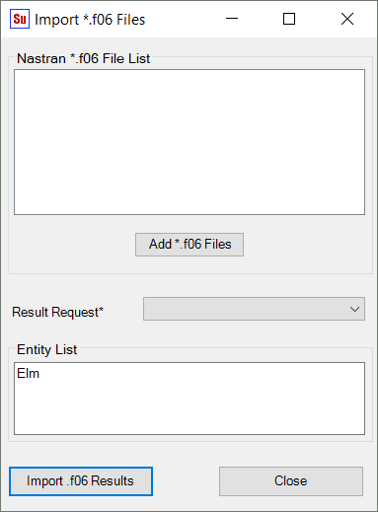

The *“Patran .rpt Files”* button imports the patran rpt files which are sorted either by entity or by load cases. This feature reads all the rpt files and arrange the loads and the load case in the same row. It even arrange the translation and rotation forces of bar elements in the same row provided both the files are selected together. Similarly for the shell forces/stresses, the Z1 and Z2 layer data are arranged in the same row, the Z1 and Z2 layer of stresses can be in the same or different files.

The *“Get load Case Template”* button prepares the template for the load case table which is required for the Load combination option shown below. The current release supports up to 4 load cases and 5 thermal profiles. The load cases can be Ultimate cases, limit cases, flap, pylon or any other interface loads. Each load type needs to be mapped with associated ultimate/limit cases, where applicable, it can be left empty. However, no empty cells are allowed in the column 1, 2 and 3 as shown in the table below. The 0 degree delta temperature can be entered as either 0 or “RT”

It is advised that the load case table needs to be prepared once for the program so that the same table can be used for many calculation as the utility supports to combine the specific loads.



**Note:** Please do not change the sheet name in the load case table workbook. File Name can be anything.

The *“Combine Load Cases”* button opens a user form which helps in combining the load cases based on the relation presented in the load case template table. The user form for the load combination is shown in the next page consists of options to identify the elements, operation, data source, load sources, result files etc.

The Load sources are the sources of loads identified in the Load case table. They are input as digit (1, 2 etc) identifying the load source (LC1, LC2 etc.). To consider load cases LC1, LC3, LC4 the input needs to be entered as 1,3,4 (or 1,3:4 or 1 3:4 etc). The acceptable list separators are “,”, “;”, Tab, Space and “:” is used for ranges. Similarly, thermal input is entered as 1 or 2 or 3 etc (Maximum 1 thermal profile).

The selection of Thermal Load checkbox enables the pick cells option for the unit thermal loads. The thermal load is calculated as simply multiplying the unit thermal load with the delta temperature for each load component. **Therefore, it is the responsibility of the user to ensure the direction of the thermal load being combined is appropriate with the mechanical loads.**

The cells which represent the unit loads/stresses in each load component can be easily selected. User can select the range of cells at once or select the ranges separately (using ctrl key).

The Data Source can be Patran rpt files or .csv files. The tool is developed to consider the .csv inputs from Nastran H5 Reader ([www.i4desktop.com](http://www.i4desktop.com)). The headings in the .csv files are based on the headings in the HDF5 database (NH5RDB). If the headings are different from that the Nastran NH5RDB then the Mapping file can be used to relate the Headings of NH5RDB with the actual .csv files. The format of the mapping file is presented in Appendix A. The .csv files format is being replaced to work directly with the NH5RDB Database.

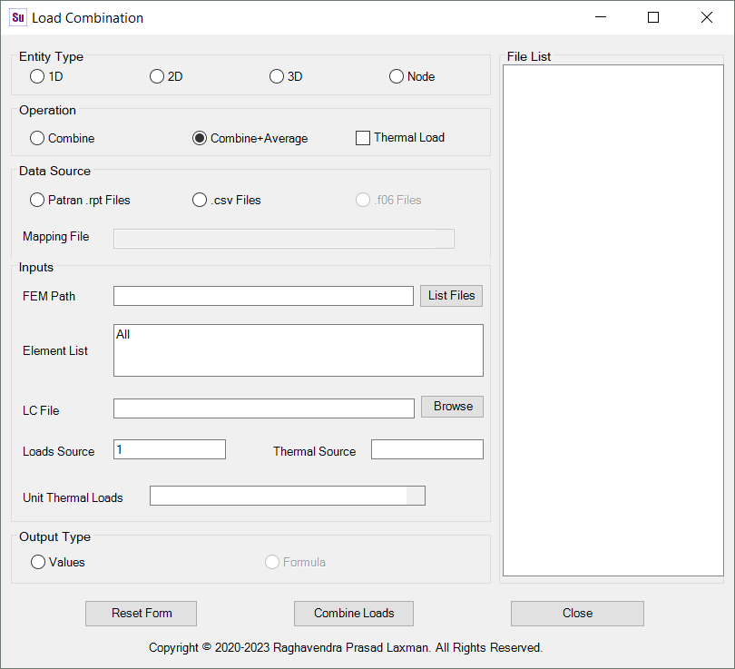

The output from the load combination option will be the combined loads along with the loads from different sources.

**Notes:**

* In this release, the utility requires that the unit thermal loads in the same sheet where the combined loads are being populated. It is recommended to use the blank sheet for the combination.
* The large files may take some time to complete the process. The status bar display the actual progress.
* The individual files in the File list can be removed by double clicking the same.

## Report Utility

The *“Insert Reference Table”* button helps in creating a table format for the List of References. This feature helps in preparing the “LIST OF REFERENCES” and associated cross references in the body of the report. It is advised to add the complete list of references required for the report writing so that the utility includes them once in the report and cross reference them automatically. In order to use the cross reference feature, the user must insert a reference table and include the reference id in the row with the identifier “REFERENCE” in the calculation table. The row “REFERENCE” is optional.

The *“Insert Calc Table (Row)”* and *“Insert Calc Table (Column)”* button helps in creating table formats required to work with the utility. Please note that it is mandatory that the tables needs to be created in the necessary format as described in the introductory section of this document and the first cell of the table needs to be names with a Prefix “Table”. The “Insert Calculation Table” button automatically create the name for the table. User need not worry about typing the name.

The *“Renumber Tables”* button helps in the renumbering the tables. This option is useful if one of the table is deleted or names are deleted using the “*Delete Table Names*” button in the user form described in section 5 or the user prefer to keep sequential numbers for the tables.

The button “*Prepare Report Contents*” open the user form described in section 5. This form is necessary to prepare the bulk of the data to be exported into the report.

The “*Export to Report”* button pops up a user form to enter the options required for the report. The details of the user form is described under section 5. The “Stress Utility” bar requires a worksheet with the name “ReportOptions” to work with the options. The sheet “*Prepare Report Contents*” is automatically created by the utility if the sheet is not present as soon as the “*Prepare Report Contents*” button is clicked.

Note: If you are not intending to produce the report, please do not click “*Prepare Report Contents*” button to avoid creation of the sheet “ReportOptions”

Should the user prefer to change the request for the font name, it can be done in the “ReportOptions” sheet.

# User Form (GUI)

The user form is created to help the user to fill out the data required for the generation of the report. The GUI is designed to prepare a summary of information in the spreadsheet to the “ReportOptions” sheet. The information in the sheet “ReportOptions” is used to prepare the report.

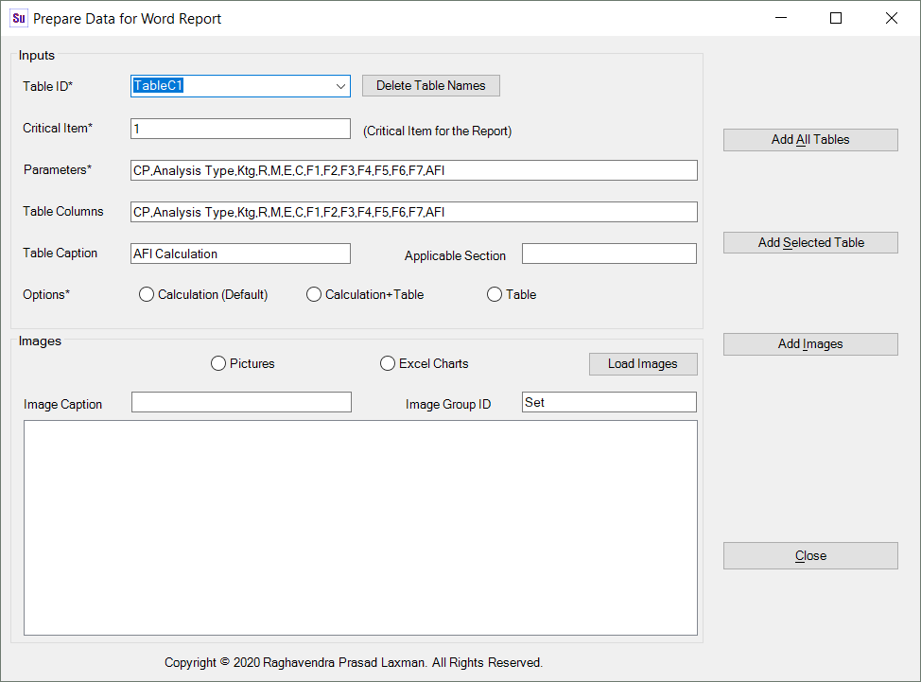

The drop down menu “*Table ID*” list all the calculations tables following the standard format.

Changing the Table ID, list all the identifiers in the calculation table and place them in the “*Parameters*” text box. The calculation steps will be written only for the listed identifiers in the “*Parameters*” text box.

The button “*Delete Table Names*” delete all the names beginning with “Table”. This option also cleanup the unreferenced names (names refer to #REF).

The text box “*Critical Item*” selects the item to which the calculation steps to be written. **If the calculation is performed using table in the column wise format, then the column headings like “BOLT 1” etc should be entered.**

The user can select the options regarding the contents to be exported to the report.

The parameter for the summary table option exports the table with the with only the listed parameters. The parameters are delimited by comma (,) or equivalent depending on the language settings. It there are more parameters, they needs to be separated by the vertical bar (|) and in such case the table will be split by the utility.

The report writing feature also feature the option to include the pictures to the report. The User need to add the pictures to the list box associated with drawing and the FE plots or the embedded graphs in the excel spreadsheet. Captions will be added automatically in the report. The caption will be the name of the file without the extension.

User can delete the files from the list box by double clicking on the file name. The order in which the pictures are required to appear needs to be taken care by the user by inserting the pictures multiple times. Only PNG, TIFF and JPEG formats are supported.

# Note and Warnings

The utility is capable of handling the matrix equations. However some care needs to be taken such that the matrices such as rotation matrices should be entered into excel without any texts on the immediate left side column the matrix (not even =). If the text is entered on the immediate the left of the matrix, then the formulae will appear incorrectly.

# Disclaimer

The “Stress Utility” performs no calculation, it only picks and drops the data in the desired format. Therefore, the copyright owner of the “Stress Utility” assumes no responsibility for the errors arise out of calculation. For the aircraft certification, the responsibility of checking and validating the contents of the calculation lies with owner of the report. The owner of the report generated by this utility is the Author or Approver or Authorizers of the calculation depending on the structure of the individual organization. The copyright owner of the “Stress Utility” is not the owner of the report produced by the utility.

# Limitations and Future Work

The utility supports the import and combination of the rpt files containing the averaged results data at the centroidal position. Unfortunately, the utility does not support the importing of the results extracted at nodal or gauss point locations.

The same applies for the combination of the stress/strain results. In this case bot the patran .rpt and the .cvs files should contain the results averaged per element. Development is ongoing to support the combination of the elemental results at nodal or gauss points.

Accessing Nastran HDF5 database requires MS Excel 64bit Application.

# Support

For the help, please contact

info@i4desktop.com

Appendix A

The equivalent functions supported by the Tool in German and French are presented below. For other language equivalents will be made available in the next issue of this document.

**German Language Settings - List of Supported Functions.**

**Mathematische und trigonometrische Funktionen:** "ABS", " ARCCOS", " ARCCOSHYP", " ARCSIN", " ARCSINHYP", " ARCTAN", " ARCTANHYP", "COS", " COSHYP", " GRAD", "EXP", "LN", "LOG", "LOG10", " MDET", "MINV", "MMULT, "PI", " POTENZ", " PRODUKT", " BOGENMASS", " RUNDEN", "ABRUNDEN", " AUFRUNDEN", " VORZEICHEN", "SIN", "SINHYP", " WURZEL", "SUMME", " SUMMENPRODUKT", " QUADRATESUMME", "TAN", "TANHYP", " KÜRZEN"

**Statistische Funktionen**🡪" MITTELWERT", "ANZAHL", "ZÄHLENWENN", "MAX", "MIN"

**Logische Funktionen**🡪" WENN", "UND", " ODER"

**List of supported functions with direct evaluation (without formula support)**

***Nachschlage- und Verweisfunktionen:*** "ADRESSE", "SPALTE", "HVERWEIS", "INDEX", "VERWEIS", "VERGLEICH", "ZEILE", "MTRANS", "SVERWEIS"

***Datenbankfunktionen:*** "DBAUSZUG"

**French Language Settings - List of Supported Functions.**

**Fonctions mathématiques et trigonométriques:** "ABS", "ACOS", "ACOSH", "ASIN", "ASINH", "ATAN", "ATANH", "COS", "COSH"" DEGRES", "EXP", "LN", "LOG", "LOG10", " DETERMAT", " INVERSEMAT", "PRODUITMAT”, "PI", " PUISSANCE", " PRODUIT", "RADIANS", " ARRONDI", " ARRONDI.INF", " ARRONDI.SUP", " SIGNE", "SIN", "SINH", " RACINE", " SOMME", " SOMMEPROD", " SOMME.CARRES", "TAN", "TANH", "TRONQUE"

**Fonctions statistiques**🡪" MOYENNE", " NB", " NB.SI", "MAX", "MIN"

**Fonctions logiques**🡪"SI", "ET", "OU"

**List of supported functions with direct evaluation (without formula support)**

**Fonctions de recherche et de référence*:*** "ADRESSE", " COLONNE", " RECHERCHEH", "INDEX", "RECHERCHE", " EQUIV", " LIGNE", "TRANSPOSE", " RECHERCHEV"

**Fonctions de base de données*:*** " BDLIRE"

**Appendix A : Mapping File Format**

Below is the format of the .csv mapping file. This shows the result supported for the load combination. The Source parameter “STRESSX1” shown in the example below is the Heading as found in the .cvs file, X1 is the heading as used in the database for the X component of stress/strain. The user needs to fill required parameters and the rest can be left blank. The vertical bar “|” to separate the parameter is a must and the column 3 is optional. When more than one source parameter is associated with the parameter in column 1, all the parameters needs to be input under Source parameter and separated by comma (“,”) (Example Plane 1(node 1) and Plane 2(Node 2) information of Bar elements).

#####################################################################################

#Mapping File (Mapping parameter can be left empty when not needed)

#The Stress Utilities is developed to work with Nastran NH5RDB (HDF5 database)

#If the extract from different database is used, the key parameters needs to be mapped

#to match the parameters of HDF5 database, Enter the Source parameters between "|"

# Comments are entered using #

######################################################################################

#2D Stresses/Strains

#Parameter |Source parameter |Description(Optional)

EID | |Element ID (EID or ID is used in the program)

SUBCASE | |Load Case or Sub Case ID

X1 |STRESSX1 |Normal in x at Z1

Y1 | |Normal in y at Z1

TXY1 | |Shear in xy at Z1

X2 | |Normal in x at Z2

Y2 | |Normal in y at Z2

TXY2 | |Shear in xy at Z2

#GRID/3D Stresses/Strains

EID | |Element ID (EID or ID is used in the program)

SUBCASE | |Load Case or Sub Case ID

X | |Normal X

Y | |Normal Y

Z | |Normal Z

TXY | |Shear xy

TYZ | |Shear yz

TZX | |Shear zx

#Beam Forces

EID | |Element ID (EID or ID is used in the program)

SUBCASE | |Load Case or Sub Case ID

BM1 | |Bending moment plane 1

BM2 | |Bending moment plane 2

TS1 | |Shear plane 1

TS2 | |Shear plane 2

AF | |Axial force

TTRQ | |Total Torque

WTRQ | |Warping Torque

#2D Stresses/Strains Complex

EID | |Element ID (EID or ID is used in the program)

SUBCASE | |Load Case or Sub Case ID

X1R | |Normal in x at Z1 - real part

X1I | |Normal in x at Z1 - imaginary part

Y1R | |Normal in y at Z1 - real part

Y1I | |Normal in y at Z1 - imaginary part

TXY1R | |Shear in xy at Z1 - real part

TXY1I | |Shear in xy at Z1 - imaginary part

X2R | |Normal in x at Z2 - real part

X2I | |Normal in x at Z2 - imaginary part

Y2R | |Normal in y at Z2 - real part

Y2I | |Normal in y at Z2 - imaginary part

TXY2R | |Shear in xy at Z2 - real part

TXY2I | |Shear in xy at Z2 - imaginary part

#GRID/3D Stresses/Strains Complex

EID | |Element ID (EID or ID is used in the program)

SUBCASE | |Load Case or Sub Case ID

XR | |Normal x - real part

YR | |Normal y - real part

ZR | |Normal z - real part

TXYR | |Shear xy - real part

TYZR | |Shear yz - real part

TZXR | |Shear zx - real part

XI | |Normal x - imaginary part

YI | |Normal y - imaginary part

ZI | |Normal z - imaginary part

TXYI | |Shear xy - imaginary part

TYZI | |Shear yz - imaginary part

TZXI | |Shear zx - imaginary part

#

#

####################################################################################################

#The Below information is required only for cross cultural information exchange

#List separators used in some countries(e.g. Continental European countries) is ";" and in the

#the rest of the world List Separator is comma (","). Similarly, comma is used as a decimal

#separator in some countries. If the text file produced by one culture needs to be used in a

#different language setting of MS excel, then the following information of the source text

#files need to be provided.

####################################################################################################

LSEP | |List Separator in the source file. ( ; or ,)