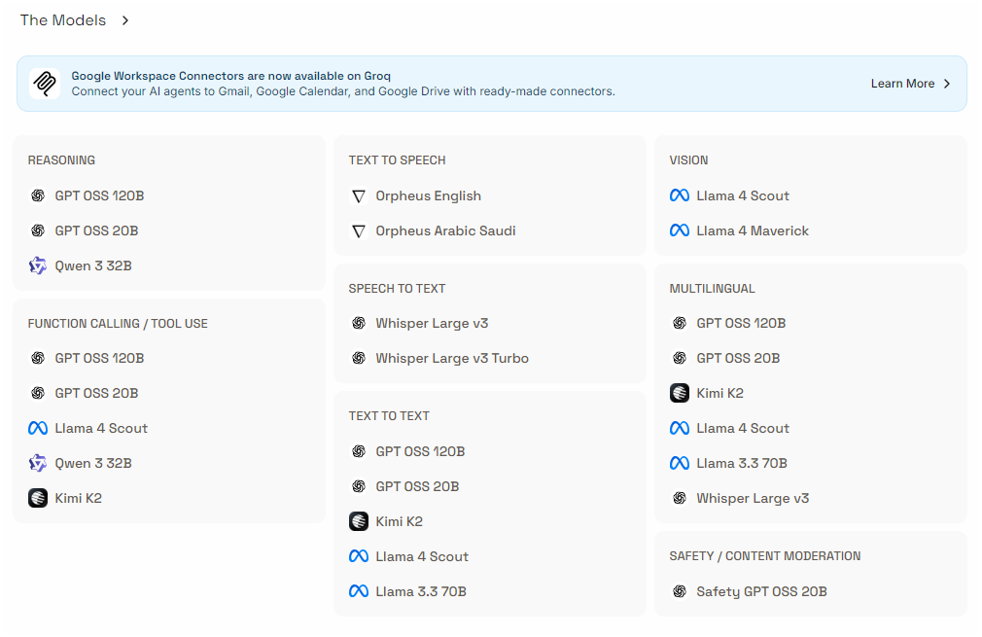
Orpheus English | Converts any text document to speech with better tone.
Orpheus Arabic Saudi | Converts any text document to speech with better native arabic like tone.
Whisper Large v3 | This model helps to covert any speech or audion files to text. It supports multiple languges.
Whisper Large v3 Turbo | For more faster conversion and also used for realtime transcripts.
Llama 4 Scout | Used to read through any images and texts inside the images. Used to generate documents from images like guide or user manuals.  Can be used for anutomating work flows in daily tasks.  Text generation in multi lanugages.
Llama 4 Maverick | Performs better job in analysing the medical scans as well. Also used for identfying information in videos.
GPT OSS 120B, GPT OSS 20B, Qwen 3 32B | Used for complex problem solvings. Can create agents for day to day analysis.  Used for case studies.
Llama 3.3 70B | Produces very fluent writing, used for content like blogs, documents etc
Safety GPT OSS 20B | Useful for Filtering social media posts or filtering harmful comments.

