DE410175

<https://hr-services.it.staging.ehc.adp.com/whrm>

**ITAIHCM2_HRADMIN**

**Adp*1234**

HR Admin user in Italy has the following bank details screen:

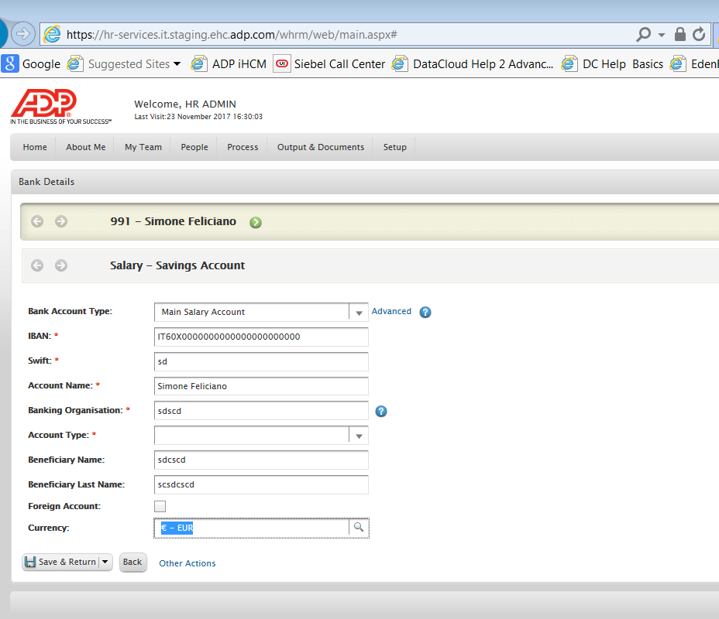

This seems to relate to the following data source:

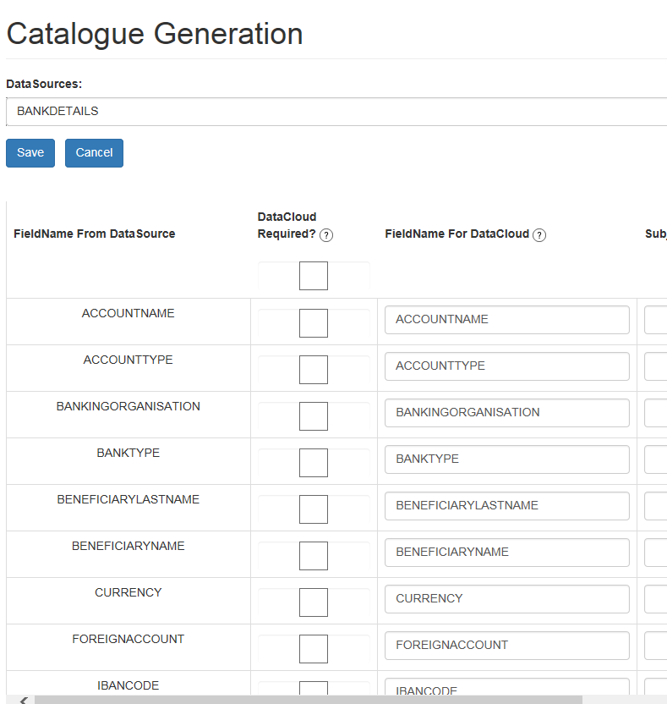

Note – this data source isn’t in catalogue yet.

BUT the user can see Bank Details file in DataCloud:

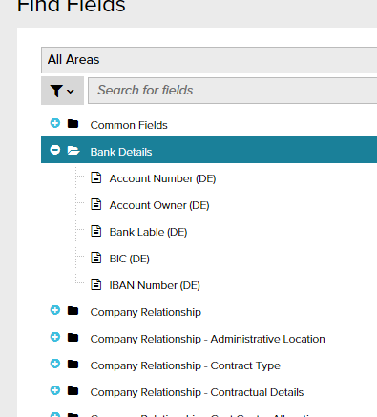

This file links to this Datasource:

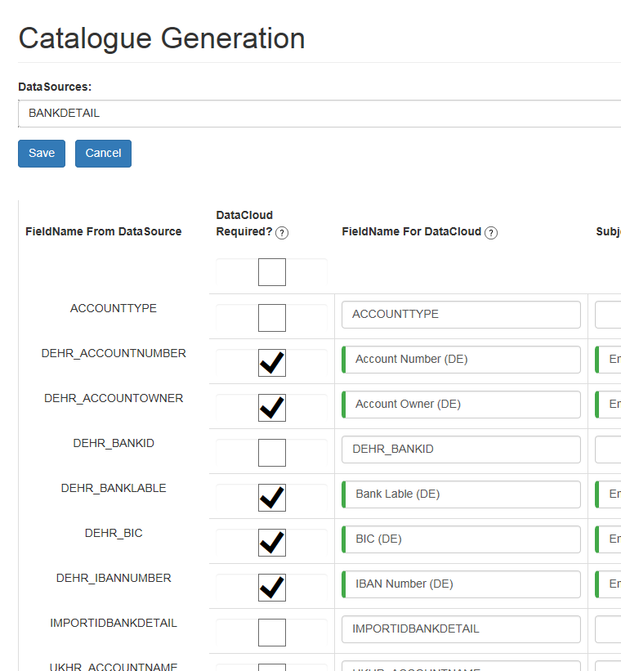

So the BANKDETAIL and BANKDETAILS data sources are totally separate entities, with separate screens. Why can my Italian user see the bank file??