Hollywood in your hand.



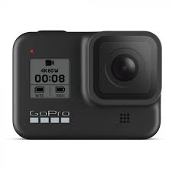
Summary:

- What is the Product?
- How are they selling it?
- How is it priced?
- What promotions are they using?
- What datasets do you think you will need to build these services?
- How frequently will data change?
- How would you store these datasets?
- How is the company tracking visitors?

GoPro, Inc. is an American technology company founded in 2002 by Nick Woodman. It manufactures action cameras and develops its own mobile apps and video-editing software. Founded as Woodman Labs, Inc, the company eventually focused on the connected sports genre, developing its line of action cameras and, later, video editing software. It is based in San Mateo, California.

- What are the Products?

Cameras:

Hero10 Black Creator Edition:

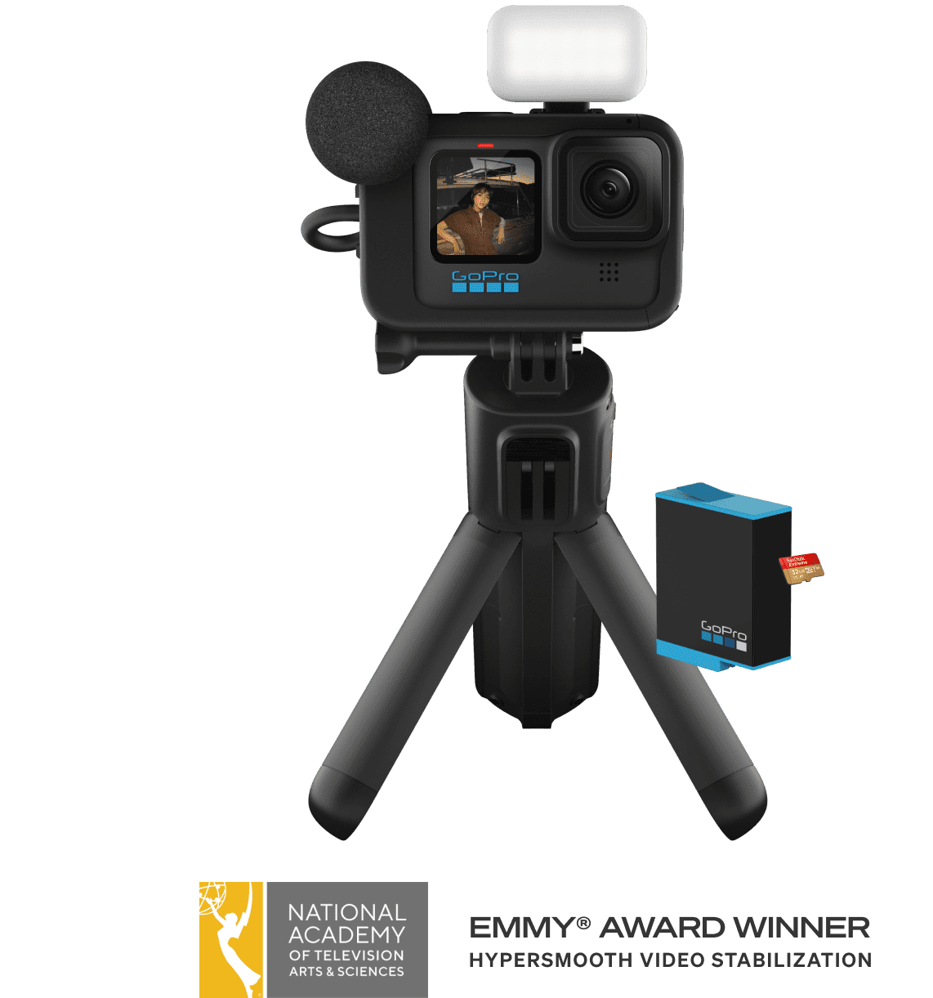
The HERO10 Black Creator Edition is an all-in-one content capturing powerhouse that makes vlogging, filmmaking and live streaming easier than ever. This complete system features pro-quality 5.3K video, Emmy® award-winning Hyper Smooth 4.0 video stabilization, enhanced audio, powerful LED lighting and 4 hours of 4K recording per charge.

Hero8 Black:
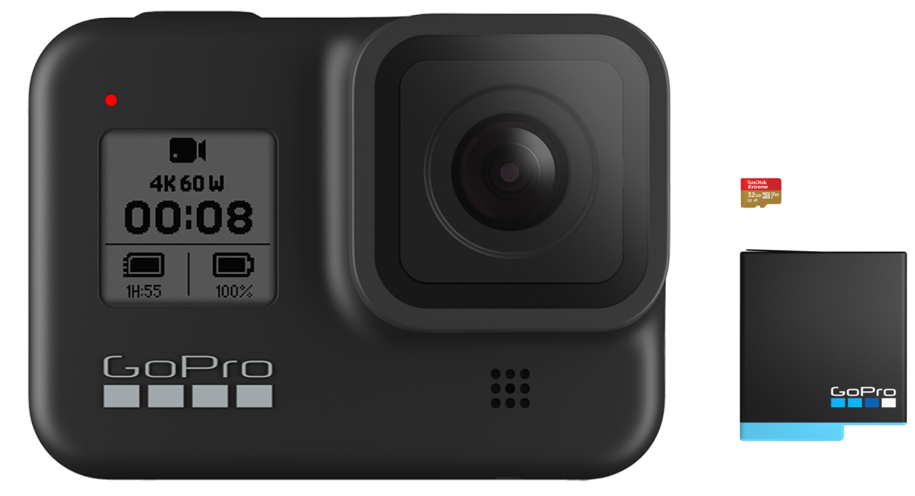

Amazing Hyper Smooth 2.0 video stabilization combines with a tough waterproof design to make this a super versatile action camera. Capture killer 4K videos 12MP photos and customize your setup with mods.

Accessories:
Volta Tripod: 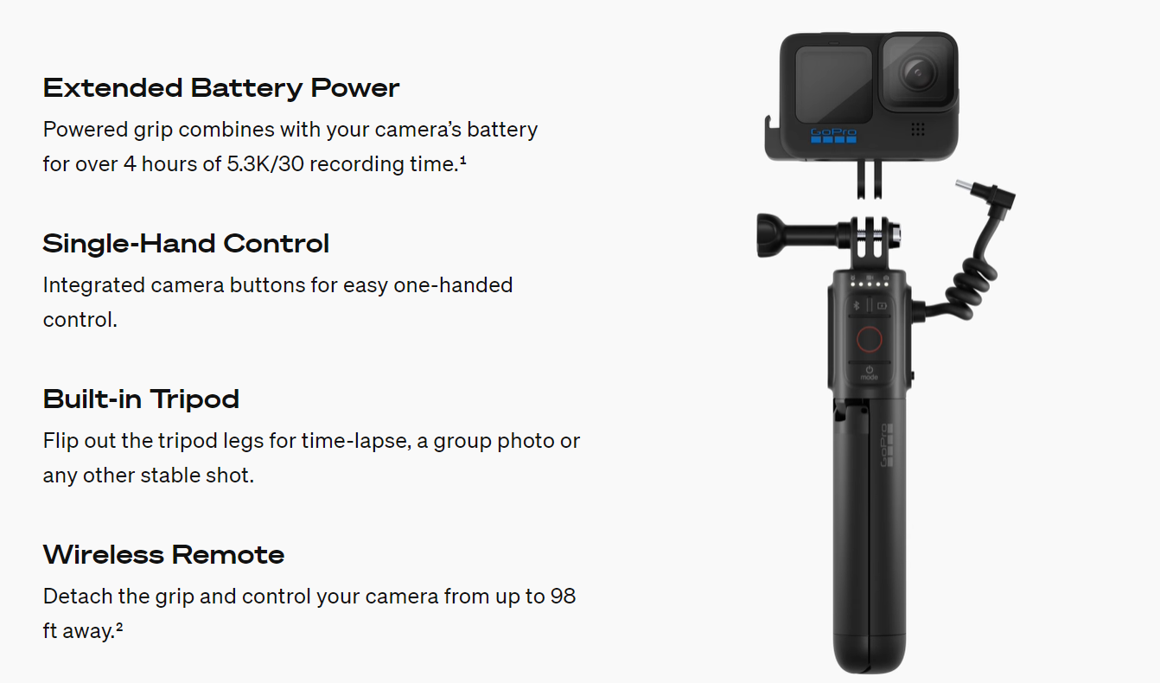

HERO10 & HERO9 Protective Housing + Waterproof

Product Details
- Protects your HERO10 Black & HERO9 Black from mud, dirt and debris during extreme activities
- Front LCD screen remains accessible for viewing
- Waterproof down to 196ft (60m)—perfect for deep-water diving
- Includes a skeleton backdoor for improved audio capture1 and easy access to the camera’s touch screen
- A flat glass lens makes for sharp, high-quality images above and below water
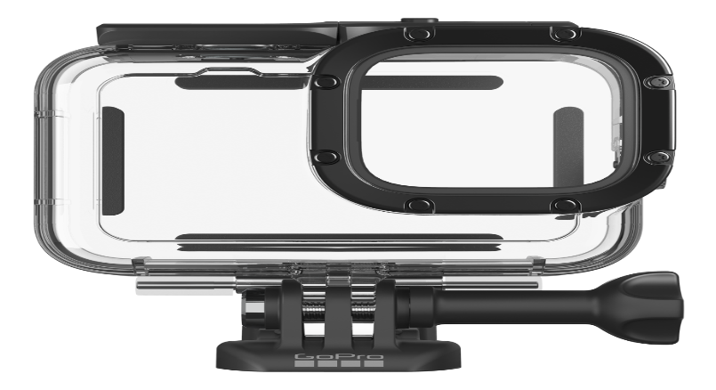

- How are they selling it?

Online Website and Authorised sellers.
The website is https://gopro.com/en/us/
All the products are delivered within the time period of 10-14 business days.

