
Bangalore Institute of Technology
K.R. ROAD, BENGALURU-560004.
Department of Computer Science and Engineering

DBMS Mini Project Synopsis
<BUS PASS MANAGEMENT SYSTEM>
USN | NAME | BATCH | PHONE NO | E-MAIL
1BI24CS153 | PRAKHAR KASHYAP | C1 | 8544402641 | Prakharkashyap0220512@gmail.com
1BI24CS158 | PRIYA H | C1 | 7892885792 | Priyapriyah350@gmail.com
1BI24CS160 | RAGHAVENDRA S K | C1 | 8105750732 | raghavendrakarkanaller@gmail.com
1BI24CS171 | SACHIN AMBALI | C2 | 6363572469 | Sachinambali07@gmail.com

Lab In-Charges: Prof. SUMA L
Prof. ASHWINI T N
< 29-05-2026 >
2025-2026

For office use only:
Accepted:

To be modified :

Rejected:

Signature of the Lab In-Charges

Introduction
A Bus Pass Management System is a database application designed to manage and maintain all activities related to bus pass issuance, renewal, passenger records, route management, and pass verification in transport departments and city bus services. The system helps in storing passenger information, maintaining pass validity details, handling renewal requests, and managing route and operator records efficiently.
Traditionally, bus pass operations were maintained manually using registers and paper-based forms, which often led to errors, data redundancy, and difficulty in searching records during audits or disputes. The Bus Pass Management System overcomes these problems by providing a computerized and automated solution for managing bus pass operations.
The system stores details such as passenger information, pass type and validity, payment records, route details, operator information, and renewal requests in a centralized database. It allows administrators to quickly search for passenger records, update pass status after renewal, and manage pass requests effectively.
This system plays an important role in day-to-day public transport operations by helping transport departments and bus operators provide passes quickly to commuters in need. It also improves coordination between passengers, operators, and the transport authority while reducing manual work and maintaining data accuracy.
The Bus Pass Management System is useful for:
- Managing passenger records
- Maintaining pass validity and status
- Processing pass issuance and renewal requests
- Generating reports
- Ensuring secure data management

Overall, the Bus Pass Management System provides an efficient, reliable, and secure way to manage public transport pass activities and helps save valuable time for commuters and administrative staff alike.

Problem Statement
Urban and semi-urban commuters across India depend heavily on public bus transport for their daily travel. Managing bus passes for thousands of passengers — including students, employees, senior citizens, and daily commuters — involves significant administrative challenges:
- Manual application processes for issuing new passes or renewals are time-consuming and error-prone
- Lack of real-time validation of pass authenticity leading to misuse and fare evasion
- Absence of a centralised database to track pass holders, routes, and expiry records
- Poor grievance and complaint handling with no digital audit trail
- No digital payment gateway integration, forcing passengers to visit counters in person
- Difficulty in generating reports for route-wise passenger load and revenue analysis
Existing systems are either paper-based or fragmented across departments. There is a clear need for a unified, database-driven Bus Pass Management System that:
- Allows passengers to register, apply for, and renew passes online
- Enables administrators to issue, verify, and revoke passes through a central dashboard
- Tracks route assignments, pass validity, and payment history in a structured database
- Sends automated renewal reminders and status alerts to registered users
Front-end and Back-end Tool Details
Category | Tool / Technology | Purpose
Frontend Framework | Python Flask (Jinja2) | Dynamic HTML rendering and routing
Styling | HTML5 & CSS3 | Responsive page layout and visual design
Charting | Chart.js / Matplotlib | Monthly bar charts and route-wise pie charts
Backend Language | Python 3.x | Business logic, query execution, session management
Database | MySQL 8.0 | Persistent storage, triggers, stored procedures
ORM / Connector | mysql-connector-python | Flask to MySQL database connectivity
Development IDE | VS Code / PyCharm | Code development and debugging
Version Control | Git & GitHub | Source code management

ER-Diagram
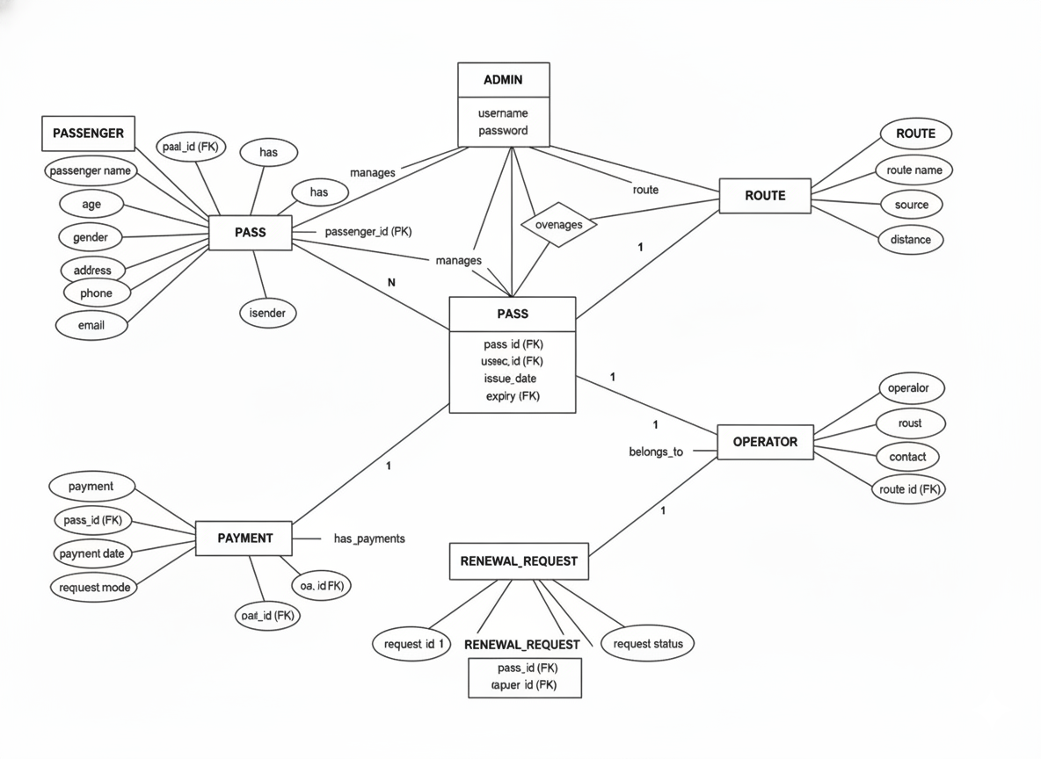

ER to Relational Mapping
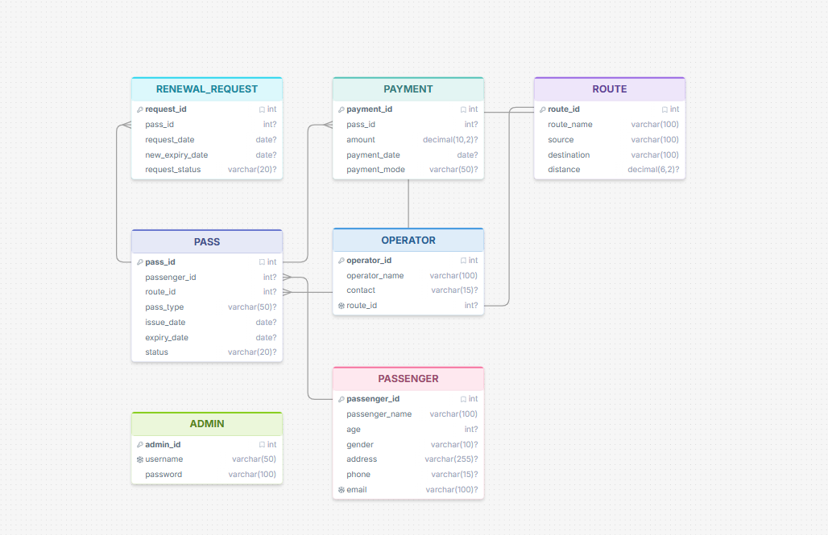

Modules
1. Passenger Management Module
- Add new passenger details
- Update passenger information
- Search passenger records
- Maintain passenger contact and address details
2. Pass Issuance Module
- Issue new bus passes to passengers
- Store pass type and validity period
- Link passenger with pass records
3. Pass Validity Management Module
- Maintain active and expired pass details
- Update pass status after renewal
- Deactivate pass after expiry
- Check pass validity instantly
4. Route Management Module
- Add and manage route details
- Maintain source and destination records
- Associate passes with specific routes
5. Operator Management Module
- Add operator details
- Manage operator contact and route assignment
- Associate operators with routes
6. Renewal Request Module
- Raise renewal requests for existing passes
- Check renewal eligibility
- Approve or reject renewal requests
- Track renewal request status
7. Payment Module
- Record payment details for pass issuance and renewal
- Store payment mode and date
- Link payment with corresponding pass

8. Admin Module
- Secure admin login
- Manage all system records
- Monitor passengers, passes, and payments
- Generate reports
9. Report Generation Module
- Generate passenger reports
- Generate pass validity and status reports
- Generate renewal request reports
- View route-wise and operator-wise records
Applications
1. Public Transport Pass Management
Transport departments use the system to manage bus pass issuance, renewal, and validation for daily commuters across various routes and services.
2. Passenger Record Management
The system stores passenger details such as name, age, address, contact number, and pass history for easy access and maintenance.
3. Pass Validity Tracking
It helps transport authorities maintain accurate records of active and expired passes and updates status automatically after renewal or expiry.
4. Emergency Pass Allocation
During urgent travel needs or emergencies, the system quickly identifies and issues the required pass type, saving valuable time for commuters.
5. Reduction of Manual Work
The application reduces paperwork and manual calculations by storing all information digitally in a centralized database.
6. Renewal Tracking
It keeps track of previous renewals, renewal dates, and pass validity periods, helping in maintaining passenger travel history properly.
7. Operator and Transport Authority Coordination
The system improves communication between bus operators and transport authorities for faster pass approvals and renewals.
8. Quick Pass Search
Users can easily search for passenger pass details and check validity status instantly through the system.
9. Report Generation
The application generates reports related to passengers, pass status, payments, and renewal requests for administrative purposes.
10. Secure Data Management
It provides secure storage of sensitive passenger and payment information and ensures proper data management and accuracy.
Backend Design
1. Backend Tool Used
- Language: Python 3.x
- Framework: Flask (Micro Web Framework)
- Database: MySQL 8.0
- Connector: mysql-connector-python (connects Flask to MySQL)

2. Database Design
The backend database consists of 7 interrelated tables designed and normalised up to Third Normal Form (3NF).

Table Name | Purpose
Passenger | Stores registered passenger credentials and profile
Route | Lookup table for available bus routes and stops
Pass_Application | Records every pass application submitted by a passenger
Payment | Stores payment transaction details for passes
Pass | Stores issued pass details including validity and category
Concession_Category | Stores concession rates for each passenger category
Alert | Stores automated system-generated renewal reminders and notifications

3. Fare Calculation Logic
The core backend logic for fare calculation is:
final_fare = base_fare × (1 - concession_rate)
- When a passenger applies for a pass, Flask fetches the base_fare from the Route table based on the selected route and the concession_rate from the Concession_Category table based on the passenger category.
- The result is computed at the application layer and stored in the Pass_Application table as final_fare.
Example:
Student applies for a monthly pass on Route 500C (base fare ₹600), concession 50% → final_fare = 600 × (1 − 0.50) = ₹300
4. Triggers (Automated Backend Logic)
Trigger Name | Event | Purpose
trg_renewal_reminder | AFTER UPDATE ON Pass | Automatically inserts a renewal alert into the Alert table when pass expiry is within 7 days
trg_pass_status_update | AFTER UPDATE ON Pass_Application | Automatically creates a Pass record when application status changes to Approved
5. Stored Procedures
Procedure Name | Purpose
GetPassengerHistory (passenger_id) | Returns complete pass application history, payment records, and active pass details for a given passenger
GetRouteSummary (route_id, month, year) | Returns total passes issued, revenue collected, and category-wise passenger count for a route in a given month
6. Flask Application Structure
Component | Role
Routes (app.py) | Handles all HTTP GET and POST requests
Jinja2 Templates | Renders dynamic HTML pages with data from MySQL
Session Management | Maintains user login state across pages
mysql-connector | Executes SQL queries and stored procedures from Flask
7. Data Integrity Measures
- Primary Keys on every table ensure unique record identification
- Foreign Keys enforce referential integrity between related tables
- NOT NULL constraints prevent incomplete data entry
- ENUM fields restrict status and category fields to valid values only
- UNIQUE constraint on passenger email prevents duplicate registrations
- CHECK constraint ensures pass validity end_date is after start_date
- Triggers automate critical operations without relying on application logic

