BANGALORE INSTITUTE OF TECHNOLOGY
(Autonomous Institution under VTU)
K.R. Road, V.V.Puram, Bangalore – 560 004
DEPARTMENT OF COMPUTER SCIENCE & ENGINEERING
DATABASE MANAGEMENT SYSTEM MINI PROJECT – BCS403
"BUS PASS MANAGEMENT SYSTEM"
Submitted By
USN | NAME | BATCH | PHONE NO | E-MAIL
1BI24CS153 | PRAKHAR KASHYAP | C1 | 8544402641 | Prakharkashyap0220512@gmail.com
1BI24CS158 | PRIYA H | C1 | 7892885792 | Priyapriyah350@gmail.com
1BI24CS160 | RAGHAVENDRA S K | C1 | 8105750732 | raghavendrakarkanaller@gmail.com
1BI24CS171 | SACHIN AMBALI | C2 | 6363572469 | Sachinambali07@gmail.com

Lab In-Charges: Prof. SUMA L & Prof. ASHWINI T N
Academic Year: 2025-2026

BANGALORE INSTITUTE OF TECHNOLOGY
(Autonomous Institution under VTU)
K.R. Road, V.V.Puram, Bangalore – 560 004
Department of Computer Science & Engineering
C E R T I F I C A T E
This is to certify that the DBMS Mini Project entitled "BUS PASS MANAGEMENT SYSTEM" has been successfully completed by the following students of IV Semester B.E. for partial fulfillment of the Bachelor's Degree in Computer Science & Engineering under Visvesvaraya Technological University during the academic year 2025-2026.
USN | Name
1BI24CS153 | PRAKHAR KASHYAP
1BI24CS158 | PRIYA H
1BI24CS160 | RAGHAVENDRA S K
1BI24CS171 | SACHIN AMBALI

Lab In-Charges:

Prof. SUMA L
Assistant Professor
Department of CS&E
Bangalore Institute of Technology, Bangalore

Prof. ASHWINI T N
Assistant Professor
Department of CS&E
Bangalore Institute of Technology, Bangalore

ACKNOWLEDGEMENT

We sincerely thank the Head of the Department of Computer Science & Engineering, Bangalore Institute of Technology, for providing the necessary infrastructure and resources to carry out this project.
We are deeply grateful to our Lab In-Charges, Prof. SUMA L and Prof. ASHWINI T N, for their invaluable guidance, constant encouragement, timely suggestions, and unwavering support throughout the course of this DBMS Mini Project.
We extend our gratitude to all the teaching and non-teaching staff members of the Department of CS&E for their continuous moral support and motivation.
Finally, we thank our family and friends for their encouragement and support during the completion of this project.

PRAKHAR KASHYAP (1BI24CS153)
PRIYA H (1BI24CS158)
RAGHAVENDRA S K (1BI24CS160)
SACHIN AMBALI (1BI24CS171)

CONTENTS

 | Front Sheet | i
 | Certificate | ii
 | Acknowledgement | iii
 | Contents | iv
Chapter 1 | Introduction | 1
1.1 | Problem Statement | 2
1.2 | Front-End and Back-End Tool Details | 3
Chapter 2 | Back End Design | 5
2.1 | Conceptual Database Design (ER Diagram) | 6
2.2 | Logical Database Design (ER Mapping) | 8
2.3 | Normalization up to 3NF | 11
2.4 | Triggers | 13
2.5 | Stored Procedures | 14
Chapter 3 | Front End Design | 15
3.1 | Screen Layout Design for WebPages & Forms | 16
3.2 | Connectivity (Frontend and Backend) | 18
Chapter 4 | Major Modules with Description | 19
Chapter 5 | Implementation using Python / MySQL | 25
Chapter 6 | Snapshots | 33
Chapter 7 | Applications | 38
Chapter 8 | Conclusion | 40

CHAPTER-1
INTRODUCTION

1.1 Introduction
A Bus Pass Management System is a database application designed to manage and maintain all activities related to bus pass issuance, renewal, passenger records, route management, and pass verification in transport departments and city bus services. The system helps in storing passenger information, maintaining pass validity details, handling renewal requests, and managing route and operator records efficiently.
Traditionally, bus pass operations were maintained manually using registers and paper-based forms, which often led to errors, data redundancy, and difficulty in searching records during audits or disputes. The Bus Pass Management System overcomes these problems by providing a computerized and automated solution for managing bus pass operations.
The Bus Pass Management System is useful for:
- Managing passenger records
- Maintaining pass validity and status
- Processing pass issuance and renewal requests
- Generating reports
- Ensuring secure data management
1.2 Problem Statement
Urban and semi-urban commuters across India depend heavily on public bus transport. Managing passes for thousands of passengers involves significant administrative challenges:
- Manual application processes for issuing new passes or renewals are time-consuming and error-prone
- Lack of real-time validation of pass authenticity leading to misuse and fare evasion
- Absence of a centralised database to track pass holders, routes, and expiry records
- Poor grievance handling with no digital audit trail
- No digital payment gateway integration forcing passengers to visit counters in person
- Difficulty in generating reports for route-wise passenger load and revenue analysis
The proposed system addresses all the above challenges by providing:
- Allows passengers to register, apply for, and renew passes online
- Enables administrators to issue, verify, and revoke passes through a central dashboard
- Tracks route assignments, pass validity, and payment history in a structured database
- Sends automated renewal reminders and status alerts to registered users
1.3 Front-End and Back-End Tool Details
Category | Tool / Technology | Purpose
Frontend Framework | Python Flask (Jinja2) | Dynamic HTML rendering and routing
Styling | HTML5 & CSS3 | Responsive page layout and visual design
Charting | Chart.js / Matplotlib | Monthly bar charts and route-wise pie charts
Backend Language | Python 3.x | Business logic, query execution, session management
Database | MySQL 8.0 | Persistent storage, triggers, stored procedures
ORM / Connector | mysql-connector-python | Flask to MySQL database connectivity
Development IDE | VS Code / PyCharm | Code development and debugging
Version Control | Git & GitHub | Source code management

CHAPTER-2
BACK END DESIGN

2.1 Conceptual Database Design (ER Diagram)
The Entity-Relationship (ER) diagram below represents the conceptual structure of the Bus Pass Management System database. It shows all major entities, their attributes, and the relationships between them.
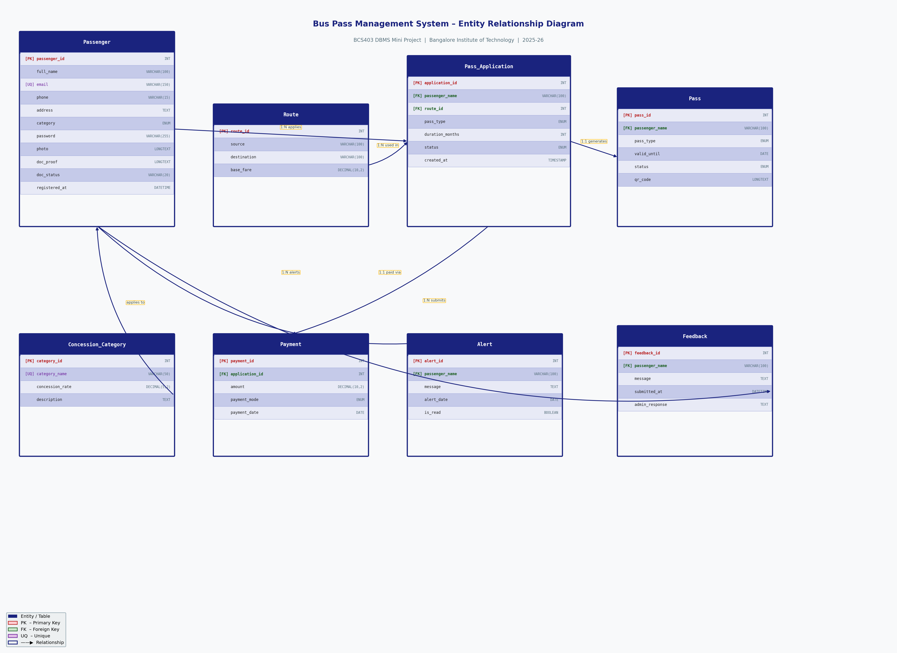
Figure: Entity-Relationship Diagram – Bus Pass Management System

Key Entities:
- Passenger
- Route
- Pass_Application
- Pass
- Payment
- Concession_Category
- Alert
- Feedback
Key Relationships:
- A Passenger APPLIES FOR zero or more Pass_Applications (1:N)
- A Route is associated with many Pass_Applications and Passes (1:N)
- A Pass_Application GENERATES one Pass on approval (1:1, trigger-driven)
- A Pass_Application has one Payment record (1:1)
- A Passenger receives many Alerts and submits many Feedbacks (1:N)

2.2 Logical Database Design (ER Mapping)
Each entity from the ER diagram maps to a relational table. Relationships are implemented using foreign keys. All tables use surrogate integer primary keys with AUTO_INCREMENT.
Table: Passenger
Column | Definition
passenger_id | INT PK AUTO_INCREMENT
full_name | VARCHAR(100) NOT NULL
email | VARCHAR(150) UNIQUE NOT NULL
phone | VARCHAR(15)
address | TEXT
category | ENUM('Student','Employee','Senior Citizen','General')
password_hash | VARCHAR(255)
registered_at | DATETIME
Table: Route
Column | Definition
route_id | INT PK AUTO_INCREMENT
route_name | VARCHAR(100)
source | VARCHAR(100)
destination | VARCHAR(100)
base_fare | DECIMAL(10,2)
distance_km | FLOAT
Table: Concession_Category
Column | Definition
category_id | INT PK AUTO_INCREMENT
category_name | VARCHAR(50) UNIQUE
concession_rate | DECIMAL(5,2)
description | TEXT
Table: Pass_Application
Column | Definition
application_id | INT PK AUTO_INCREMENT
passenger_name | VARCHAR(100) FK
route_id | INT FK
category | VARCHAR(50)
pass_type | ENUM
application_date | DATE
status | ENUM('Pending','Approved','Rejected')
final_fare | DECIMAL(10,2)
Table: Pass
Column | Definition
pass_id | INT PK AUTO_INCREMENT
passenger_name | VARCHAR(100) FK
route_id | INT FK
start_date | DATE
end_date | DATE CHECK(end>start)
pass_type | ENUM
category | VARCHAR(50)
status | ENUM('Active','Expired','Revoked')
qr_code_data | TEXT
Table: Payment
Column | Definition
payment_id | INT PK AUTO_INCREMENT
application_id | INT FK
amount | DECIMAL(10,2)
payment_mode | ENUM
payment_date | DATE
transaction_ref | VARCHAR(100)
Table: Alert
Column | Definition
alert_id | INT PK AUTO_INCREMENT
passenger_name | VARCHAR(100) FK
message | TEXT
alert_date | DATE
is_read | BOOLEAN
Table: Feedback
Column | Definition
feedback_id | INT PK AUTO_INCREMENT
passenger_name | VARCHAR(100) FK
message | TEXT
submitted_at | DATETIME
admin_response | TEXT

2.3 Normalization up to 3NF with Justification
First Normal Form (1NF)
All attributes contain atomic values. Each table has a unique primary key. No repeating groups or multi-valued attributes exist. Example: phone is stored as VARCHAR(15), not as a list; category is a single ENUM value per row.
Second Normal Form (2NF)
All non-key attributes are fully functionally dependent on the entire primary key. Since every table uses a single-column surrogate primary key (INT AUTO_INCREMENT), there are no partial dependencies by definition.
Third Normal Form (3NF)
No transitive dependencies exist. The Concession_Category table was extracted to eliminate the transitive dependency: application_id → category → concession_rate. Route details are stored only in the Route table and are never duplicated in Pass or Pass_Application.
Fare Calculation Logic (computed at application layer):
final_fare = base_fare × (1 − concession_rate)
Example: Student – Route 500C (base_fare ₹600) – Concession 50% → final_fare = ₹300

2.4 Triggers
Trigger Name | Event | Purpose
trg_renewal_reminder | AFTER UPDATE ON Pass | Inserts a renewal alert when pass expiry ≤ 7 days
trg_pass_status_update | AFTER UPDATE ON Pass_Application | Creates a Pass record automatically when status → Approved
2.5 Stored Procedures
Procedure Name | Purpose
GetPassengerHistory(passenger_id) | Returns complete pass history, payment records, and active pass details for a passenger
GetRouteSummary(route_id, month, year) | Returns total passes issued, revenue collected, and category-wise count for a route in a given month

CHAPTER-3
FRONT END DESIGN

3.1 Screen Layout Design for WebPages & Forms
• Login / Registration Page:
Allows passengers and the admin to log into the system. New passengers register by providing full name, email, phone, address, and category.
• Passenger Dashboard:
Displays current active pass with QR code, pass expiry date, renewal alerts, application status, and quick action buttons.
• Apply for Pass Form:
Passengers select a route and pass type. The system automatically computes the final fare using the concession rate for their category.
• Admin Dashboard:
Shows total passengers, active passes, pending applications, revenue collected, monthly bar charts, and route-wise pie charts.
• Manage Applications:
Admins view all pending applications and Approve or Reject them. Approval triggers automatic Pass creation via database trigger.
• Manage Routes:
Admins add new routes, update base fares, and delete inactive routes.
• QR Code Verification Page:
Conductors enter a QR code to instantly verify a passenger's pass — shows name, route, validity period, and current status.
• Feedback & Alerts Page:
Passengers submit feedback to the admin. Admins post responses. Automated renewal alerts appear here when a pass expires within 7 days.
3.2 Connectivity (Frontend and Backend)
The frontend (Jinja2 HTML templates) communicates with the backend (Python Flask) through HTTP GET and POST requests:
Step | Description
1. User Action | User submits a form or clicks a navigation link
2. HTTP Request | Browser sends GET/POST to a Flask route in app.py
3. Flask Route Handler | Validates session, executes SQL via mysql-connector
4. MySQL Database | Processes query and returns result set
5. Jinja2 Template | Flask renders HTML with injected data variables
6. HTTP Response | Browser displays the updated page to the user

CHAPTER-4
MAJOR MODULES WITH DESCRIPTION

4.1 Passenger Management Module
Manages all passenger-related operations including registration, profile updates, and record search.
- Add new passenger details during registration with hashed password storage
- Update passenger profile information (phone number, address)
- Search passenger records by name, USN, or email address
- Secure password hashing using Werkzeug generate_password_hash

4.2 Pass Issuance Module
Handles the full lifecycle of bus pass creation.
- Issue new bus passes automatically upon application approval (via trigger)
- Store pass type (Monthly/Quarterly/Annual) and computed validity period
- Generate unique QR code data for each pass using UUID
- Link passenger with pass records using full_name as reference key

4.3 Pass Validity Management Module
Tracks and manages pass status over time.
- Maintain active and expired pass records in the Pass table
- Update pass status automatically after renewal request approval
- Database CHECK constraint ensures end_date is always after start_date
- Instant pass status lookup via QR code verification

4.4 Route Management Module
Manages all bus routes available in the system.
- Add new routes with source, destination, distance, and base fare
- Update base fare for existing routes through admin panel
- Delete routes that are no longer operational
- Associate passes and applications with specific routes via route_id FK

4.5 Renewal Request Module
Handles the complete pass renewal workflow.
- Passengers raise renewal requests from their dashboard
- Admin reviews and approves or rejects renewal applications
- System automatically creates a new Pass record upon approval
- Track renewal request status: Pending / Approved / Rejected

4.6 Payment Module
Records all financial transactions for pass issuance and renewals.
- Record payment details including amount, mode, and date
- Support multiple payment modes: Online, Cash, UPI, Card
- Link each payment with the corresponding Pass_Application record
- Store transaction reference numbers for audit and reconciliation

4.7 Admin Module
Central control panel for system administrators.
- Secure admin login with Flask session management
- Manage passengers, passes, routes, applications from one dashboard
- Real-time statistics: passes issued, revenue, pending applications
- Bar charts for monthly issuance trends, pie charts for category distribution

4.8 Feedback & Alert Module
Handles passenger communication and automated notifications.
- Passengers submit feedback messages to the admin panel
- Admins view all feedback and post written responses
- Automated renewal alerts triggered by trg_renewal_reminder
- Alerts displayed on passenger dashboard 7 days before pass expiry

4.9 QR Code Verification Module
Real-time pass validation at the point of travel.
- Each approved pass carries a UUID-based unique QR code
- Conductors enter QR code to verify pass validity instantly
- System displays passenger name, route, validity dates, and status
- Clearly identifies and reports Expired or Revoked passes

CHAPTER-5
IMPLEMENTATION USING PYTHON / MySQL

5.1 Database Schema (SQL)
The following SQL statements create the complete database schema:
Passenger Table
CREATE TABLE Passenger (
passenger_id INT AUTO_INCREMENT PRIMARY KEY,
full_name VARCHAR(100) NOT NULL,
email VARCHAR(150) UNIQUE NOT NULL,
phone VARCHAR(15),
address TEXT,
category ENUM('Student','Employee','Senior Citizen','General') NOT NULL,
password_hash VARCHAR(255) NOT NULL,
registered_at DATETIME DEFAULT CURRENT_TIMESTAMP
);
Route Table
CREATE TABLE Route (
route_id INT AUTO_INCREMENT PRIMARY KEY,
route_name VARCHAR(100) NOT NULL,
source VARCHAR(100),
destination VARCHAR(100),
base_fare DECIMAL(10,2),
distance_km FLOAT
);
Pass_Application Table
CREATE TABLE Pass_Application (
application_id INT AUTO_INCREMENT PRIMARY KEY,
passenger_name VARCHAR(100),
route_id INT,
category VARCHAR(50),
pass_type ENUM('Monthly','Quarterly','Annual'),
application_date DATE,
status ENUM('Pending','Approved','Rejected') DEFAULT 'Pending',
final_fare DECIMAL(10,2),
FOREIGN KEY (route_id) REFERENCES Route(route_id)
);
Pass Table
CREATE TABLE Pass (
pass_id INT AUTO_INCREMENT PRIMARY KEY,
passenger_name VARCHAR(100),
route_id INT,
start_date DATE,
end_date DATE,
pass_type ENUM('Monthly','Quarterly','Annual'),
category VARCHAR(50),
status ENUM('Active','Expired','Revoked') DEFAULT 'Active',
qr_code_data TEXT,
CONSTRAINT chk_dates CHECK (end_date > start_date),
FOREIGN KEY (route_id) REFERENCES Route(route_id)
);
Payment Table
CREATE TABLE Payment (
payment_id INT AUTO_INCREMENT PRIMARY KEY,
application_id INT,
amount DECIMAL(10,2),
payment_mode ENUM('Online','Cash','UPI','Card'),
payment_date DATE,
transaction_ref VARCHAR(100),
FOREIGN KEY (application_id) REFERENCES Pass_Application(application_id)
);
Trigger: trg_renewal_reminder
DELIMITER //
CREATE TRIGGER trg_renewal_reminder
AFTER UPDATE ON Pass FOR EACH ROW
BEGIN
IF NEW.end_date <= DATE_ADD(CURDATE(), INTERVAL 7 DAY)
AND NEW.status = 'Active' THEN
INSERT INTO Alert (passenger_name, message, alert_date)
VALUES (NEW.passenger_name,
CONCAT('Your pass expires on ', NEW.end_date, '. Please renew.'),
CURDATE());
END IF;
END //
DELIMITER ;
Trigger: trg_pass_status_update
DELIMITER //
CREATE TRIGGER trg_pass_status_update
AFTER UPDATE ON Pass_Application FOR EACH ROW
BEGIN
IF NEW.status = 'Approved' AND OLD.status != 'Approved' THEN
INSERT INTO Pass (passenger_name, route_id, start_date, end_date,
pass_type, category, qr_code_data)
VALUES (NEW.passenger_name, NEW.route_id, CURDATE(),
CASE NEW.pass_type
WHEN 'Monthly' THEN DATE_ADD(CURDATE(), INTERVAL 1 MONTH)
WHEN 'Quarterly' THEN DATE_ADD(CURDATE(), INTERVAL 3 MONTH)
WHEN 'Annual' THEN DATE_ADD(CURDATE(), INTERVAL 1 YEAR)
END,
NEW.pass_type, NEW.category, UUID());
END IF;
END //
DELIMITER ;
5.2 Flask Route Implementation (app.py sample)
Sample Flask route for pass application submission:
@app.route('/apply_pass', methods=['GET', 'POST'])
def apply_pass():
if 'user' not in session:
return redirect(url_for('login'))
conn = get_db_connection()
cursor = conn.cursor(dictionary=True)
if request.method == 'POST':
route_id = request.form['route_id']
pass_type = request.form['pass_type']
category = session['category']
cursor.execute(
'SELECT concession_rate FROM Concession_Category WHERE category_name=%s',
(category,))
conc = cursor.fetchone()
concession = float(conc['concession_rate']) if conc else 0
cursor.execute(
'SELECT base_fare FROM Route WHERE route_id=%s', (route_id,))
route = cursor.fetchone()
base_fare = float(route['base_fare']) if route else 0
final_fare = base_fare * (1 - concession)
cursor.execute(
'INSERT INTO Pass_Application (passenger_name, route_id, category,'
' pass_type, application_date, status, final_fare)'
' VALUES (%s,%s,%s,%s,CURDATE(),\'Pending\',%s)',
(session['user'], route_id, category, pass_type, final_fare))
conn.commit()
flash('Application submitted successfully!', 'success')
return redirect(url_for('dashboard'))
cursor.execute('SELECT *, base_fare AS fare FROM Route')
routes = cursor.fetchall()
return render_template('apply_pass.html', routes=routes)

CHAPTER-6
SNAPSHOTS

6.1 Login Page
Login Page – Citizen authentication portal for bus pass services
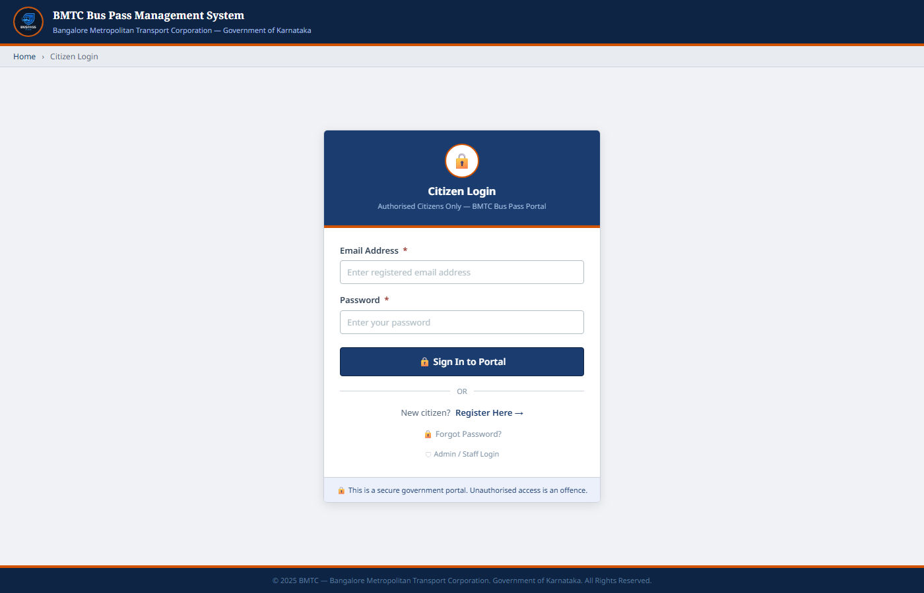
Figure: Login Page – Citizen authentication portal for bus pass services

6.2 Registration Page
Registration Page – New passenger account creation with category selection
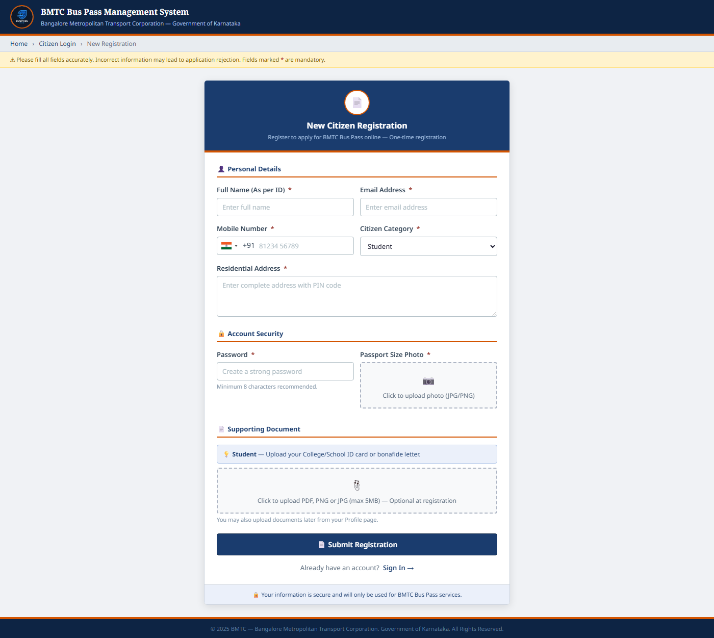
Figure: Registration Page – New passenger account creation with category selection

6.3 Passenger Dashboard
Passenger Dashboard – Applications, quick actions, and pass status
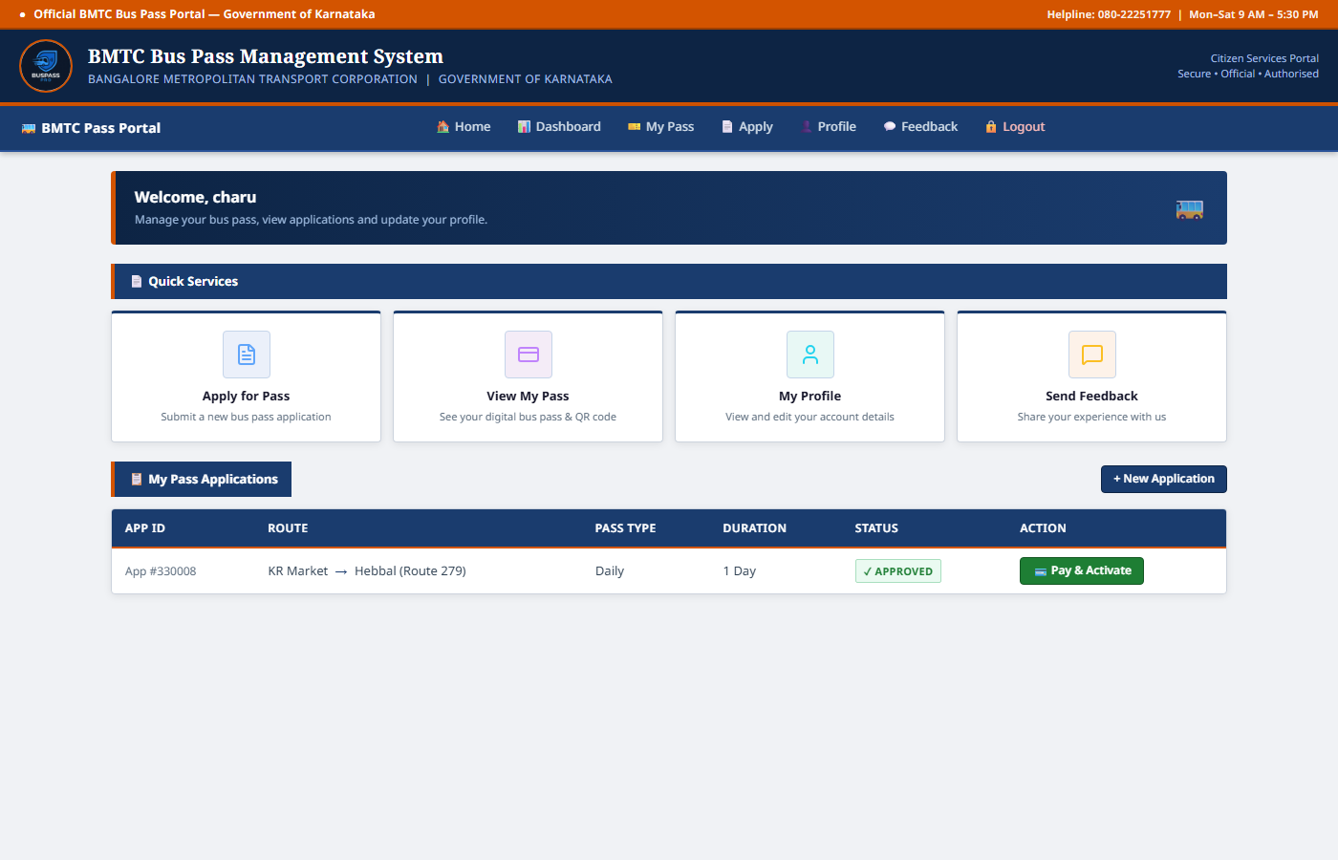
Figure: Passenger Dashboard – Applications, quick actions, and pass status

6.4 Apply for Pass Form
Apply for Pass Form – Route selection and concession-based fare preview
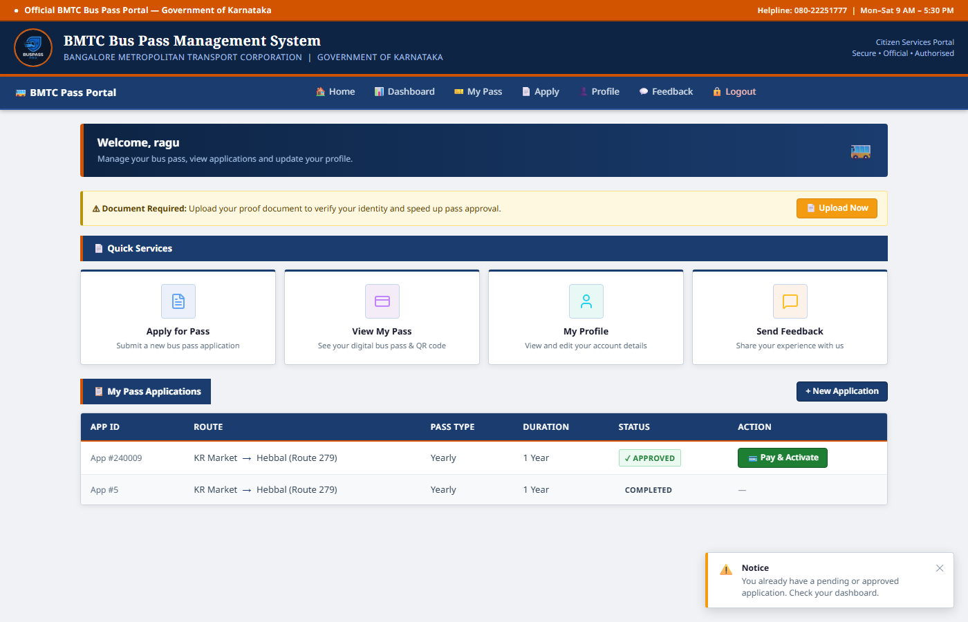
Figure: Apply for Pass Form – Route selection and concession-based fare preview

6.5 View Digital Pass & QR Code
View Digital Pass & QR Code – Active pass card with scan-to-verify QR
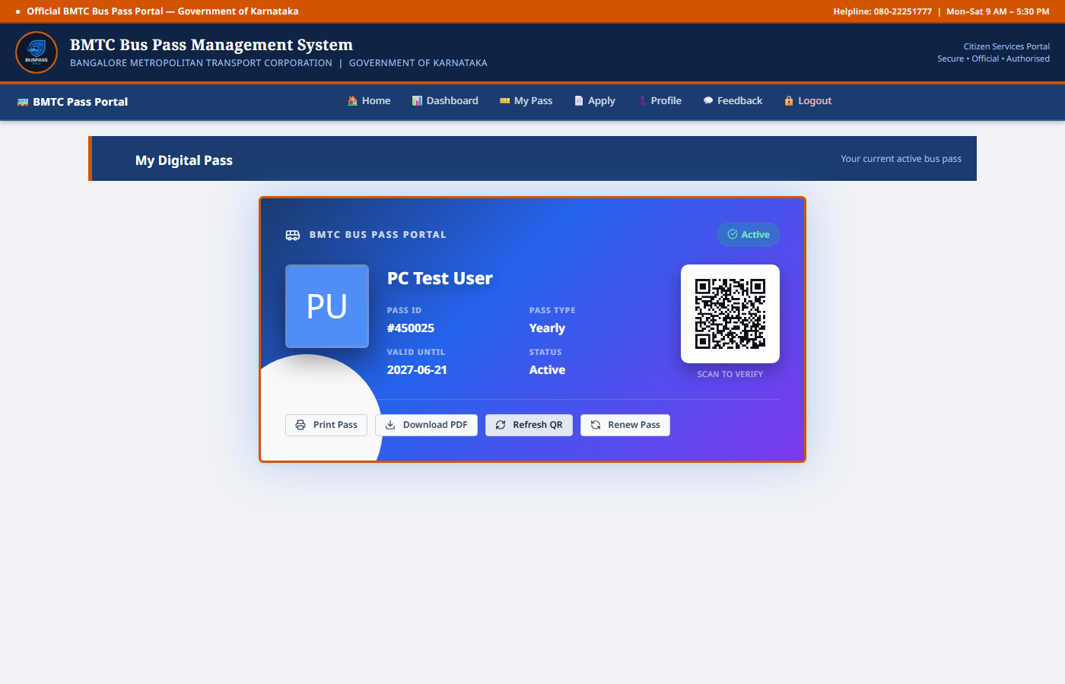
Figure: View Digital Pass & QR Code – Active pass card with scan-to-verify QR

6.6 Alerts Page
Alerts Page – Renewal reminders and expiry notifications
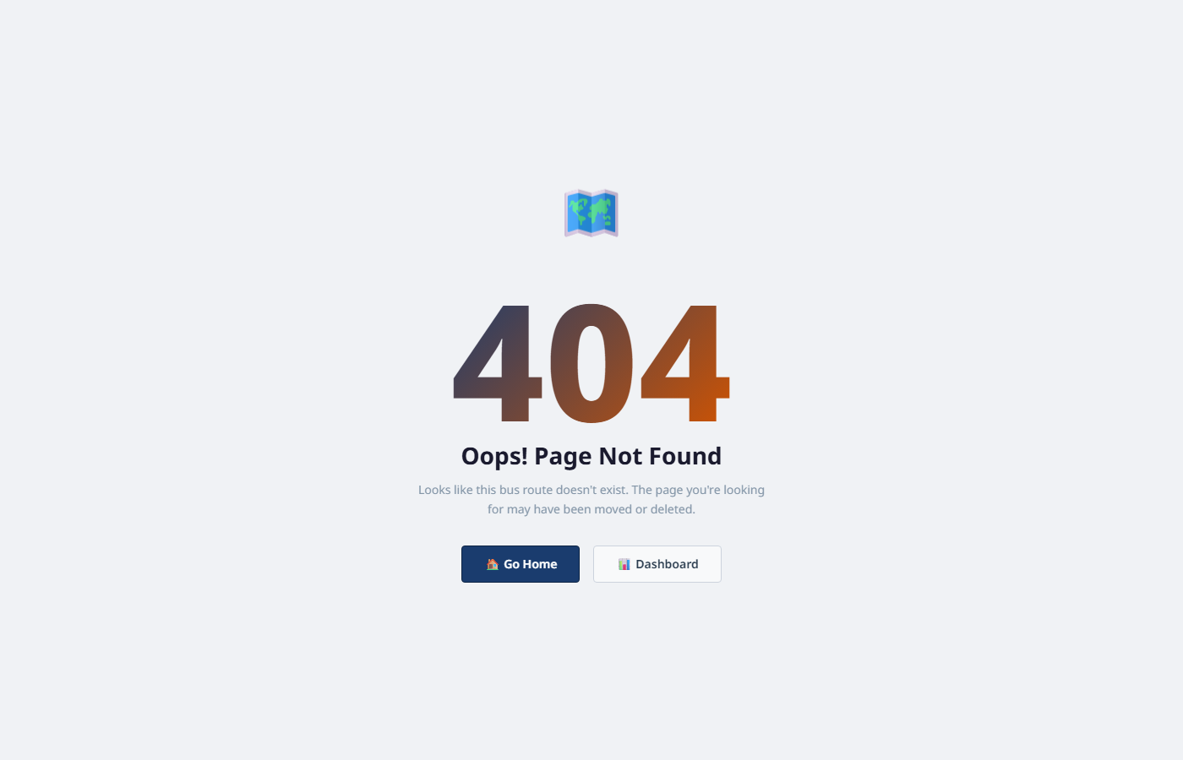
Figure: Alerts Page – Renewal reminders and expiry notifications

6.7 Feedback Page
Feedback Page – Passenger feedback submission and topic selection
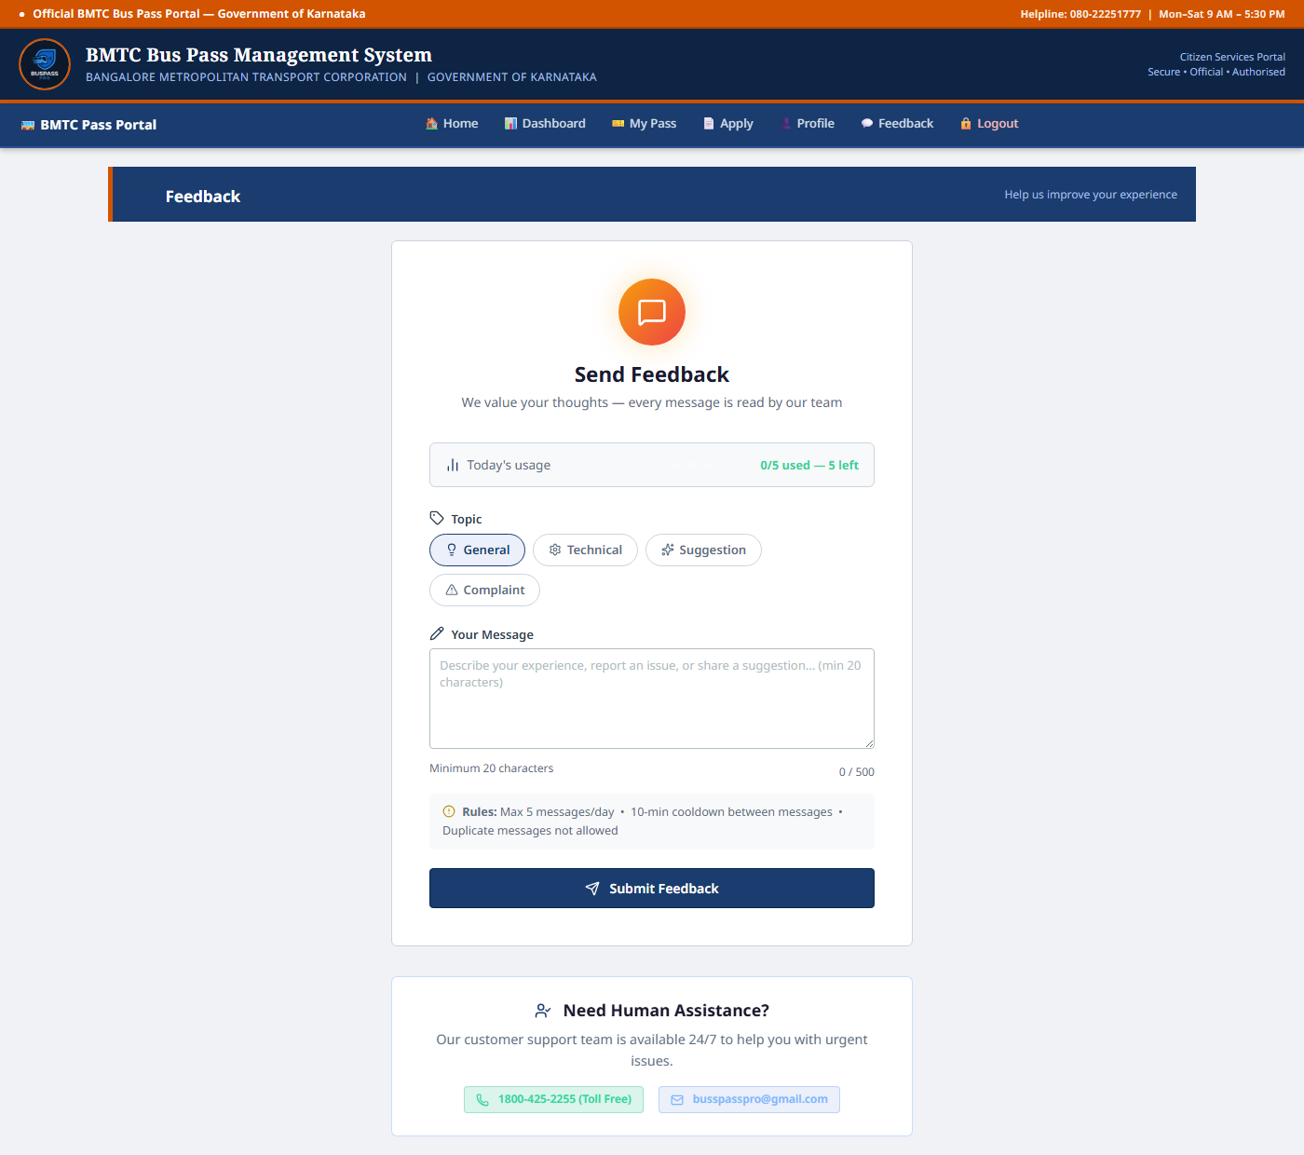
Figure: Feedback Page – Passenger feedback submission and topic selection

6.8 Pass History
Pass History – Complete application and travel pass history log

Figure: Pass History – Complete application and travel pass history log

6.9 QR Code Verification
QR Code Verification – Real-time pass validation for bus conductors
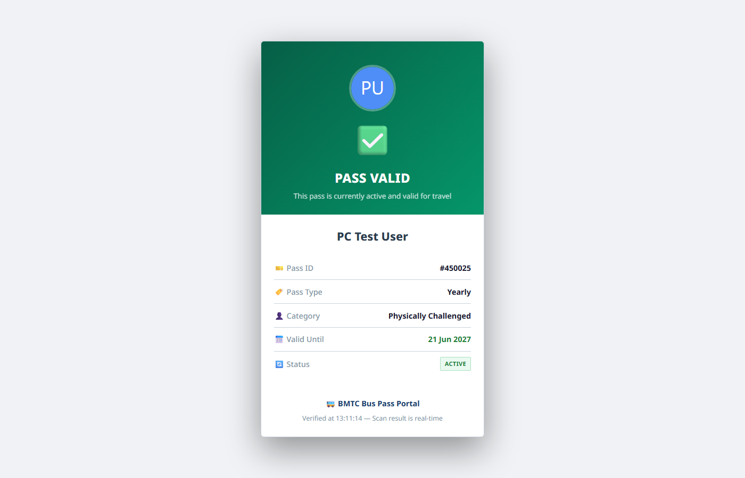
Figure: QR Code Verification – Real-time pass validation for bus conductors

6.10 Profile Page
Profile Page – Passenger profile with document upload and verification
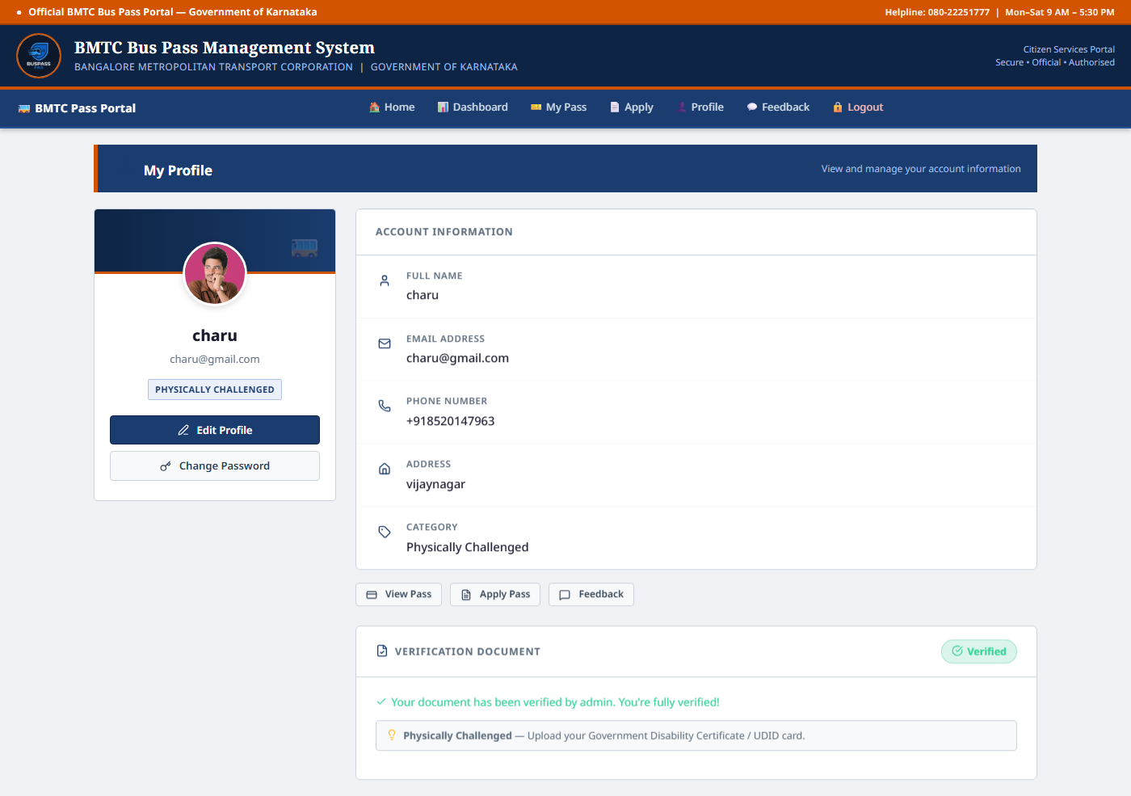
Figure: Profile Page – Passenger profile with document upload and verification

6.11 Admin Login Page
Admin Login Page – Secure admin authentication portal
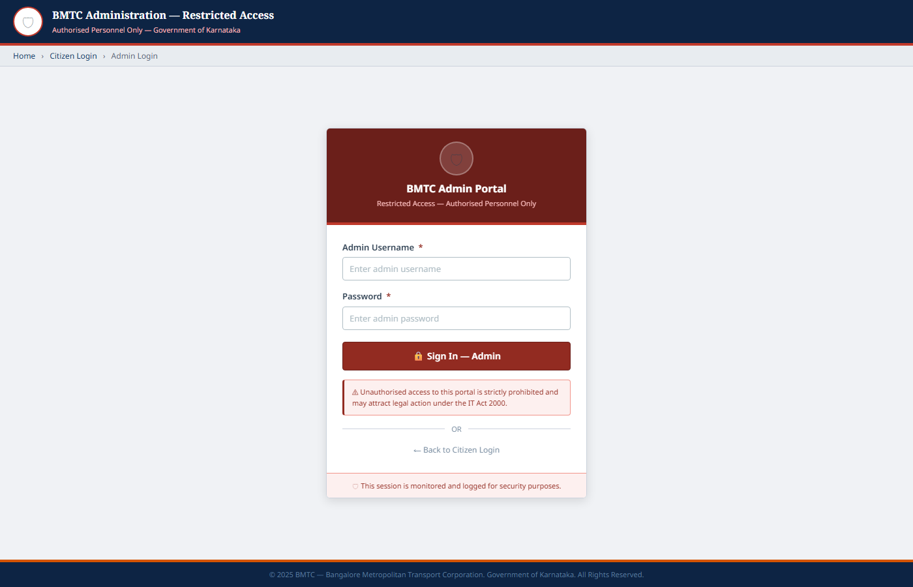
Figure: Admin Login Page – Secure admin authentication portal

6.12 Admin Dashboard
Admin Dashboard – All applications with approve/revoke actions
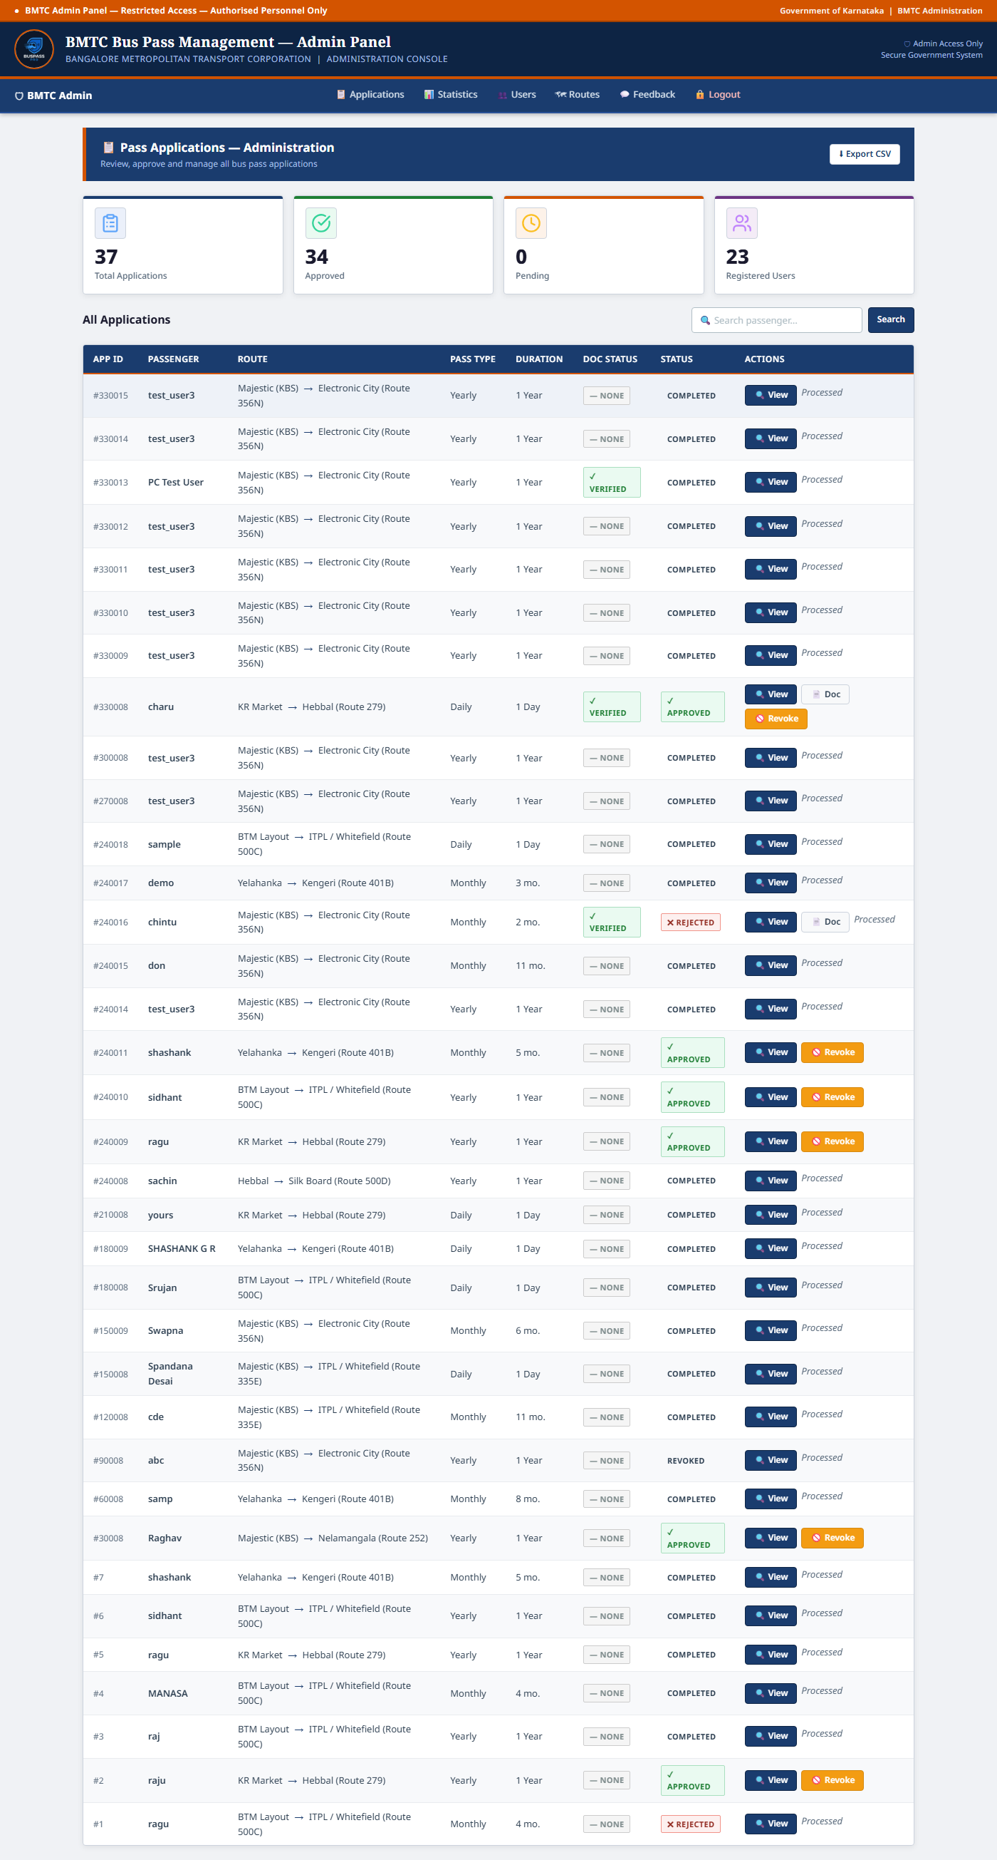
Figure: Admin Dashboard – All applications with approve/revoke actions

6.13 Manage Applications
Manage Applications – Full pass application management panel

Figure: Manage Applications – Full pass application management panel

6.14 Manage Routes
Manage Routes – Add, update, and delete BMTC bus routes
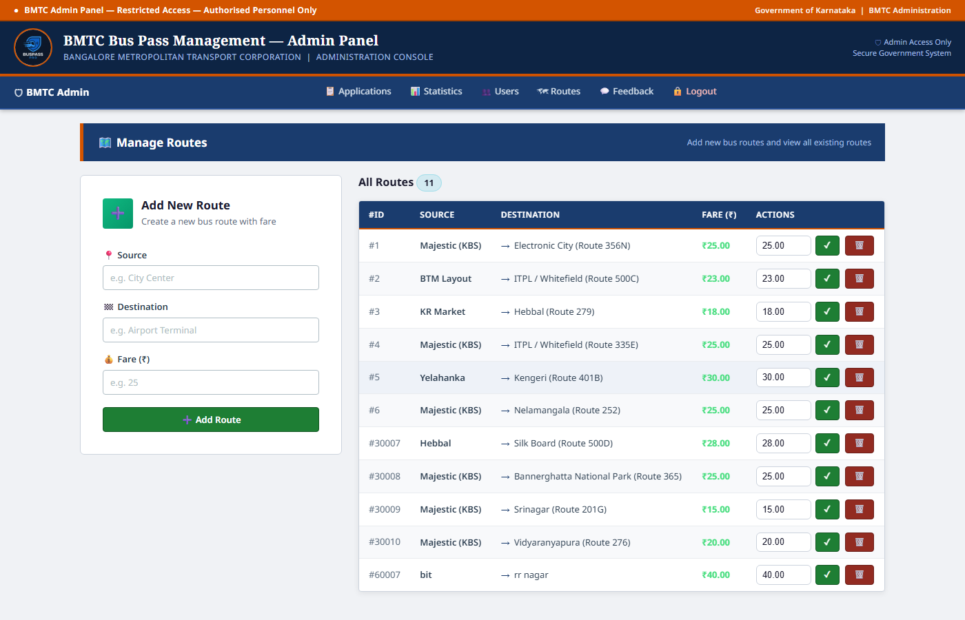
Figure: Manage Routes – Add, update, and delete BMTC bus routes

6.15 Manage Users
Manage Users – View and manage all registered passengers
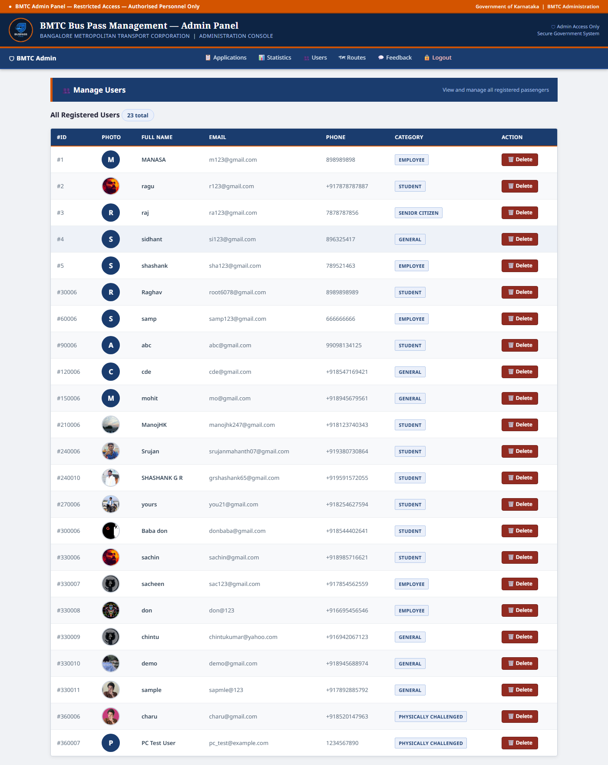
Figure: Manage Users – View and manage all registered passengers

6.16 Statistics & Analytics
Statistics & Analytics – System KPIs, charts and route popularity
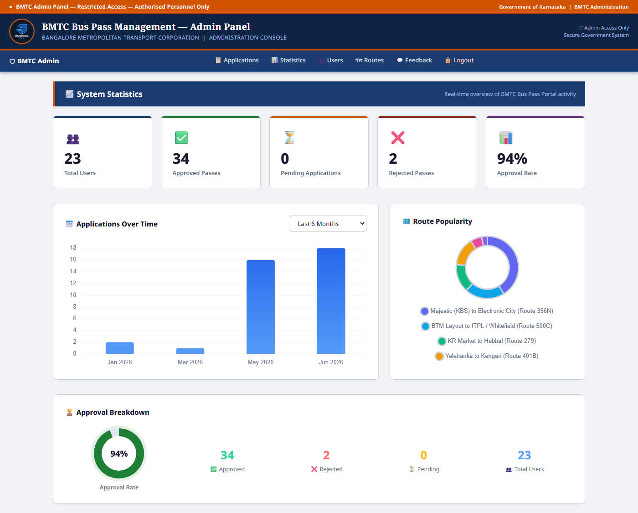
Figure: Statistics & Analytics – System KPIs, charts and route popularity

6.17 Admin Feedback Panel
Admin Feedback Panel – View all passenger feedback submissions
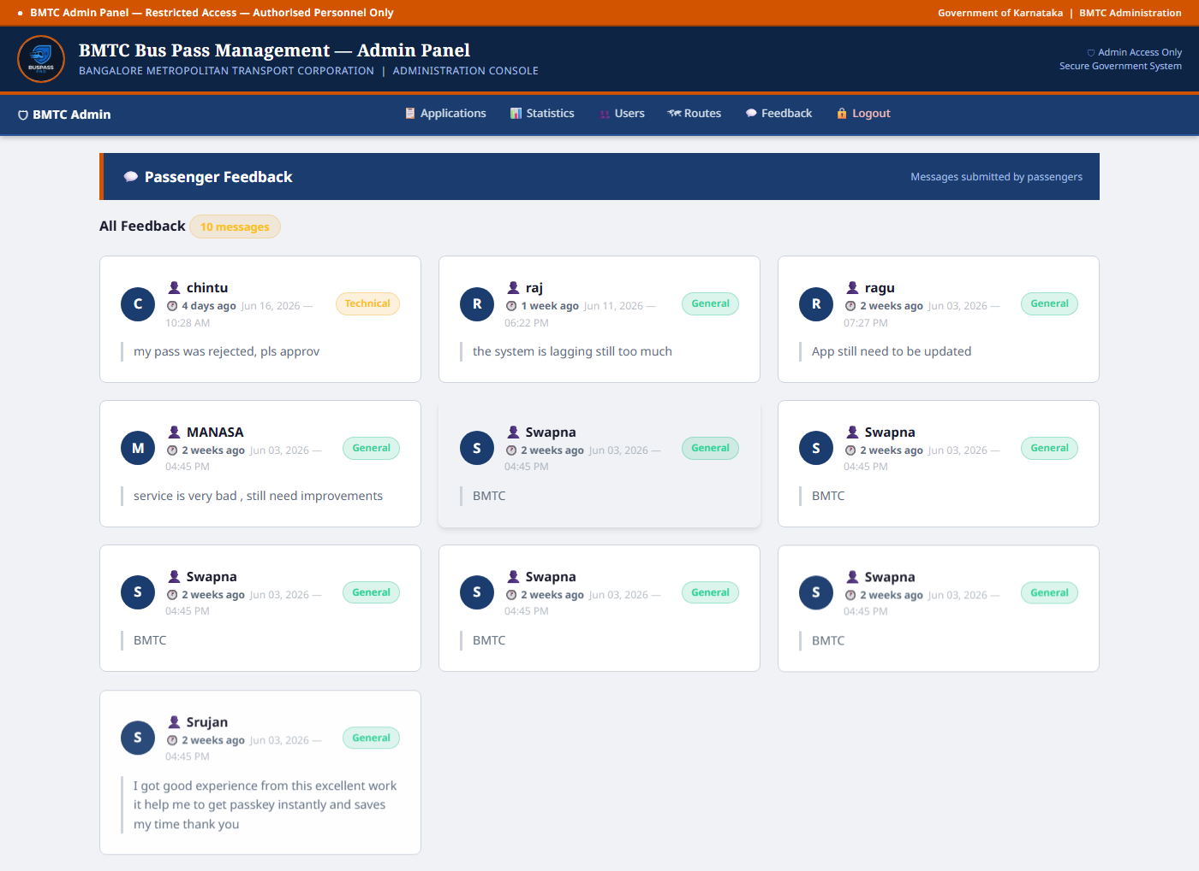
Figure: Admin Feedback Panel – View all passenger feedback submissions

CHAPTER-7
APPLICATIONS

1. Public Transport Pass Management
Transport departments use the system to manage bus pass issuance, renewal, and validation for daily commuters across various routes and services.
2. Passenger Record Management
The system stores passenger details such as name, category, address, contact number, and pass history for quick access and efficient maintenance.
3. Pass Validity Tracking
Transport authorities maintain accurate records of active and expired passes. Pass status updates automatically after renewal or expiry through database triggers.
4. Emergency Pass Allocation
During urgent travel needs or emergencies, the system quickly identifies eligible passengers and issues the required pass type, reducing wait time for commuters.
5. Reduction of Manual Work
The application eliminates paperwork and manual calculations by storing all information digitally in a centralized MySQL database with automated workflows.
6. Renewal Tracking
The system tracks previous renewals, renewal dates, and pass validity periods, maintaining a complete travel history for each passenger.
7. Operator and Authority Coordination
The system improves coordination between bus operators and transport authorities, enabling faster pass approvals, renewals, and dispute resolution.
8. Quick Pass Search
Administrators and conductors can instantly search for passenger pass details and validate pass status through the QR code verification feature.
9. Report Generation
The system generates comprehensive reports related to passengers, pass status, payment records, and renewal requests for administrative use and audits.
10. Secure Data Management
Sensitive passenger and payment information is stored securely with hashed passwords, session-based authentication, and MySQL data integrity constraints.

CHAPTER-8
CONCLUSION

The Bus Pass Management System developed as part of the DBMS Mini Project (BCS403) successfully demonstrates the power of a well-designed relational database in solving real-world administrative problems in the public transport domain.
The system implements a fully normalized relational database (up to 3NF) using MySQL 8.0, consisting of 8 interrelated tables: Passenger, Route, Pass_Application, Pass, Payment, Concession_Category, Alert, and Feedback. The backend was implemented using Python 3.x with the Flask micro-framework, and the frontend was rendered dynamically using Jinja2 templates with HTML5 and CSS3.
Key achievements of this project include an end-to-end digital workflow for bus pass application, approval, and issuance; automated pass creation and renewal alerts using MySQL triggers; QR code-based pass verification for real-time validation; concession-based fare calculation for multiple passenger categories; a comprehensive admin dashboard with statistical graphs and charts; and data integrity enforced through primary keys, foreign keys, NOT NULL, UNIQUE, and CHECK constraints.
Future enhancements could include integration with real-time payment gateways, mobile applications for commuters, GPS-based route tracking, Aadhaar-linked passenger verification, and multi-city transport authority support.
Overall, this project has provided valuable hands-on experience in database design, SQL programming, web development with Flask, and the application of database management concepts to solve practical problems in the real world.

