Pattern Recognition
Assignment -1

T. Raghu Bharadwaj
18MCMT03
Question 1:
Libraries Used:
import numpy as np
import math
import pandas as pd
import matplotlib.pyplot as plt

Dataset Used:
Synthetic data(given in the assignment)

Generating random samples in normal distribution:
Use the multivariate.normal function in the numpy random method to generate different random samples for the data provided the mean and covariance matrix of the data.

Finding out the Euclidian Distance:
Find out the euclidian distance by the samples and their mean values to find how far are they from a certain mean of the samples found out by the average formula.

Finding out the Mahalanobis distance:
Find out the covariance matrix, samples and their mean so that you can get the mahalanobis distance from the input.

Difference between Mahalanobis distance and Euclidian distance:
If the euclidian distance is multiplied by the covariance matrix, it becomes the mahalanobis distance.

Output:
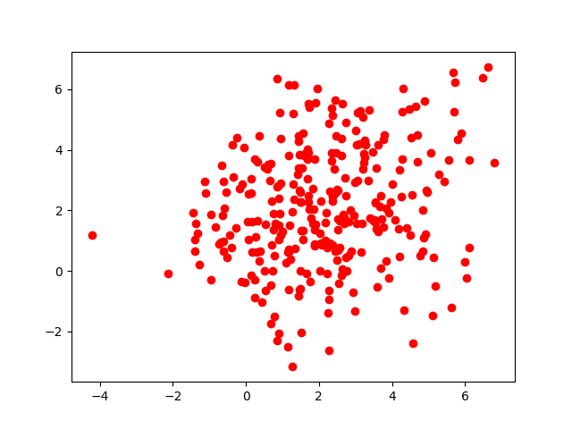
Disciminant Function
[[[4.53985524]]

[[5.05612023]]

[[4.74008991]]

[[5.31887171]]

[[3.39678947]]

[[4.77174043]]

[[4.59848428]]

[[4.98971256]]

[[4.35638413]]

[[4.98292548]]]

Mahalanobis distance
[[[1764.33618441]]

[[ 838.25890088]]

[[ 227.96093973]]

[[ 281.77983588]]

[[1386.3639634 ]]

[[1602.83596611]]

[[ 196.86546705]]

[[ 922.22717283]]

[[1170.26866418]]

[[ 542.89636987]]]

Question 2:

Libraries Used:
import numpy as np
import math
import pandas as pd
import matplotlib.pyplot as plt

Dataset Used:
Synthetic data(given in the assignment)

Output:

Considering only one feature x1
Accuracy = 0.6
Considering two features x1, x2
Accuracy = 0.7
Considering three features x1, x2, x3
Accuracy = 0.9
Equal probabilities
[1. 2. 1. 1.]
Probabilities 0.8, 0.1, 0.1
[0. 2. 0. 0.]

Question 3:

Libraries Used:
import numpy as np
import math
import pandas as pd
import matplotlib.pyplot as plt

Dataset Used:
IRIS dataset

Case1:
When variance for all the samples is the same.
Case2:
When the covariance matrix for all the classes is same
Case3:
When the covariance matrix of each sample of class is different.

Output:
We will get the discriminant equations which we have to solve so that we get the points of intersection.

