Date:23/08/2018 Assignment 2
Operating Systems Lab 2

1.
(a)ps:

PID TTY TIME CMD
1847 pts/0 00:00:00 bash
1885 pts/0 00:00:00 ssh
2569 pts/0 00:00:00 ps
2570 pts/0 00:00:00 cat

(b)pstree:

systemd-+-ModemManager---2*[{ModemManager}]
|-NetworkManager-+-dhclient
| `-2*[{NetworkManager}]
|-accounts-daemon---2*[{accounts-daemon}]
|-acpid
|-avahi-daemon---avahi-daemon
|-bluetoothd
|-boltd---2*[{boltd}]
|-colord---2*[{colord}]
|-cron
|-cups-browsed---2*[{cups-browsed}]
|-cupsd
|-dbus-daemon
|-firefox-+-Web Content---31*[{Web Content}]
| |-Web Content---34*[{Web Content}]
| |-Web Content---17*[{Web Content}]
| `-69*[{firefox}]
|-fwupd---4*[{fwupd}]
|-gdm3-+-gdm-session-wor-+-gdm-wayland-ses-+-gnome-session-b-+-gnome-shell-+-Xwayland---4*[{Xwayland}]
| | | | | |-ibus-daemon-+-ibus-dconf---3*[{ibus-dconf}]
| | | | | | |-ibus-engine-sim---2*[{ibus-engin+
| | | | | | `-2*[{ibus-daemon}]
| | | | | `-12*[{gnome-shell}]
| | | | |-gsd-a11y-settin---3*[{gsd-a11y-settin}]
| | | | |-gsd-clipboard---2*[{gsd-clipboard}]
| | | | |-gsd-color---3*[{gsd-color}]
| | | | |-gsd-datetime---2*[{gsd-datetime}]
| | | | |-gsd-housekeepin---2*[{gsd-housekeepin}]
| | | | |-gsd-keyboard---3*[{gsd-keyboard}]
| | | | |-gsd-media-keys---3*[{gsd-media-keys}]
| | | | |-gsd-mouse---2*[{gsd-mouse}]
| | | | |-gsd-power---3*[{gsd-power}]
| | | | |-gsd-print-notif---2*[{gsd-print-notif}]
| | | | |-gsd-rfkill---2*[{gsd-rfkill}]
| | | | |-gsd-screensaver---2*[{gsd-screensaver}]
| | | | |-gsd-sharing---3*[{gsd-sharing}]
| | | | |-gsd-smartcard---4*[{gsd-smartcard}]
| | | | |-gsd-sound---3*[{gsd-sound}]
| | | | |-gsd-wacom---2*[{gsd-wacom}]
| | | | |-gsd-xsettings---3*[{gsd-xsettings}]
| | | | `-3*[{gnome-session-b}]
| | | `-2*[{gdm-wayland-ses}]
| | `-2*[{gdm-session-wor}]
| |-gdm-session-wor-+-gdm-x-session-+-Xorg---{Xorg}
| | | |-gnome-session-b-+-deja-dup-monito---4*[{deja-dup-monito}]
| | | | |-gnome-shell-+-ibus-daemon-+-ibus-dconf---3*[{ibus-dconf}]
| | | | | | |-ibus-engine-sim---2*[{ibus-engine-+
| | | | | | `-2*[{ibus-daemon}]
| | | | | `-12*[{gnome-shell}]
| | | | |-gnome-software---3*[{gnome-software}]
| | | | |-gsd-a11y-settin---3*[{gsd-a11y-settin}]
| | | | |-gsd-clipboard---2*[{gsd-clipboard}]
| | | | |-gsd-color---3*[{gsd-color}]
| | | | |-gsd-datetime---3*[{gsd-datetime}]
| | | | |-gsd-disk-utilit---2*[{gsd-disk-utilit}]
| | | | |-gsd-housekeepin---3*[{gsd-housekeepin}]
| | | | |-gsd-keyboard---3*[{gsd-keyboard}]
| | | | |-gsd-media-keys---3*[{gsd-media-keys}]
| | | | |-gsd-mouse---3*[{gsd-mouse}]
| | | | |-gsd-power---3*[{gsd-power}]
| | | | |-gsd-print-notif---2*[{gsd-print-notif}]
| | | | |-gsd-rfkill---2*[{gsd-rfkill}]
| | | | |-gsd-screensaver---2*[{gsd-screensaver}]
| | | | |-gsd-sharing---3*[{gsd-sharing}]
| | | | |-gsd-smartcard---4*[{gsd-smartcard}]
| | | | |-gsd-sound---3*[{gsd-sound}]
| | | | |-gsd-wacom---2*[{gsd-wacom}]
| | | | |-gsd-xsettings---3*[{gsd-xsettings}]
| | | | |-nautilus-deskto---3*[{nautilus-deskto}]
| | | | |-ssh-agent
| | | | |-update-notifier---3*[{update-notifier}]
| | | | `-3*[{gnome-session-b}]
| | | `-2*[{gdm-x-session}]
| | `-2*[{gdm-session-wor}]
| `-2*[{gdm3}]
|-gnome-keyring-d-+-ssh-agent
| `-3*[{gnome-keyring-d}]
|-gsd-printer---2*[{gsd-printer}]
|-2*[ibus-x11---2*[{ibus-x11}]]
|-irqbalance---{irqbalance}
|-2*[kerneloops]
|-networkd-dispat---{networkd-dispat}
|-packagekitd---2*[{packagekitd}]
|-polkitd---2*[{polkitd}]
|-pulseaudio---2*[{pulseaudio}]
|-rsyslogd---3*[{rsyslogd}]
|-rtkit-daemon---2*[{rtkit-daemon}]
|-snapd---10*[{snapd}]
|-systemd-+-(sd-pam)
| |-at-spi-bus-laun-+-dbus-daemon
| | `-3*[{at-spi-bus-laun}]
| |-at-spi2-registr---2*[{at-spi2-registr}]
| |-dbus-daemon
| |-ibus-portal---2*[{ibus-portal}]
| `-pulseaudio---2*[{pulseaudio}]
|-systemd-+-(sd-pam)
| |-at-spi-bus-laun-+-dbus-daemon
| | `-3*[{at-spi-bus-laun}]
| |-at-spi2-registr---2*[{at-spi2-registr}]
| |-dbus-daemon
| |-dconf-service---2*[{dconf-service}]
| |-evolution-addre-+-evolution-addre---5*[{evolution-addre}]
| | `-4*[{evolution-addre}]
| |-evolution-calen-+-evolution-calen---8*[{evolution-calen}]
| | `-4*[{evolution-calen}]
| |-evolution-sourc---3*[{evolution-sourc}]
| |-gnome-shell-cal---5*[{gnome-shell-cal}]
| |-gnome-terminal--+-bash-+-cat
| | | |-pstree
| | | `-ssh
| | `-3*[{gnome-terminal-}]
| |-goa-daemon---4*[{goa-daemon}]
| |-goa-identity-se---3*[{goa-identity-se}]
| |-gvfs-afc-volume---3*[{gvfs-afc-volume}]
| |-gvfs-goa-volume---2*[{gvfs-goa-volume}]
| |-gvfs-gphoto2-vo---2*[{gvfs-gphoto2-vo}]
| |-gvfs-mtp-volume---2*[{gvfs-mtp-volume}]
| |-gvfs-udisks2-vo---2*[{gvfs-udisks2-vo}]
| |-gvfsd-+-gvfsd-trash---2*[{gvfsd-trash}]
| | `-2*[{gvfsd}]
| |-gvfsd-fuse---5*[{gvfsd-fuse}]
| |-gvfsd-metadata---2*[{gvfsd-metadata}]
| `-ibus-portal---2*[{ibus-portal}]
|-systemd-journal
|-systemd-logind
|-systemd-resolve
|-systemd-timesyn---{systemd-timesyn}
|-systemd-udevd
|-thermald---{thermald}
|-udisksd---4*[{udisksd}]
|-upowerd---2*[{upowerd}]
|-whoopsie---2*[{whoopsie}]
`-wpa_supplicant

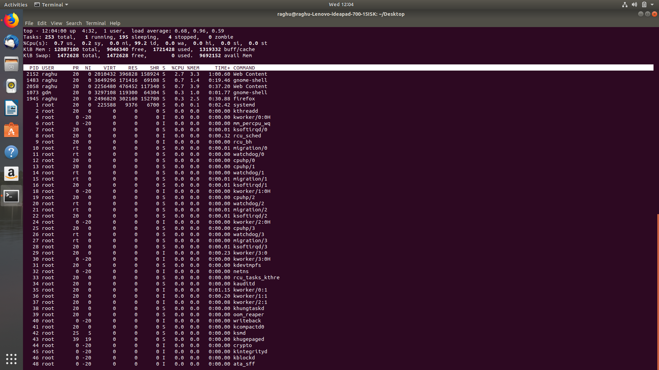
(c)top:

(d)renice:

PID COMMAND NI
284 2055 bash 5
285 2055 (process ID) old priority 5, new priority 10

(e)pgrep:

8
9
11
12
13
14
19
20
25
26
33
40
41
44
46
50
52
56
99
103
134
183
184
185
186
187
188
189
190
224
361
777
779
803
808
816
1075
1202
1223
1226
1240
1247
1541
1553
1566
1599
1605
1617
1630
1633
1710
1753
1760
2511
2512
2601
2639
2758

(f)kill:

It kills the process that’s with the specified process id.

(g)xkill:

It kills the screen over which the mouse cursor is placed. Else it stucks the whole mouse cursor until the operation is carried out.

2.program to create a child using fork() call

1 #include<stdio.h>
2 void main(){
3 printf("1.%d\n",getpid());//1
4 int n1=fork();//2
5 int n2=fork();//3
6 if(n1==0)//4
7 printf("2.%d\n",getppid());
8 if(n2==0)//5
9 printf("3.%d\n",getppid());
10 }
11

3.program to create a child using exec() call and showing the difference between exec() and fork()

parent.c

#include <stdio.h>
#include <stdlib.h>
#include <string.h>
#include <sys/wait.h>

int main (int argc, char **argv)
{
int pid;
int ret;
printf ("P: Hello\n");
pid = fork ();
if (pid == 0) {
execvp ("./child", NULL);
}
if (ret == pid)
printf ("P: Child created\n");
}

child.c

#include <stdio.h>
#include <stdlib.h>
#include <string.h>
int main (int argc, char **argv)
{
printf ("C: Hello\n");
printf ("C: Exit\n");
exit (0);
}

4.program to find out the number of processes, memory usage, time taken, states and all the information about the process.

Enter the command top and all the processes and their information will be shown onto the screen.

Command : top
To print into a file : top | cat>>filename

5.program to find out the number of resources that has been allocated to the process and the number of requests that it is currently making

Enter the command top and all the processes and their information will be shown onto the screen.

Command : top
To print into a file : top | cat>>filename

