Date: 24/01/2026

EXP NO 11: CHANGE HARDWARE COMPATIBILITY OF A VM (EITHER BY CLONE/CREATE NEW ONE) WHICH IS ALREADY CREATED AND CONFIGURED, USING VIRTUAL BOX.

AIM
To change the hardware compatibility/configuration of an already created and configured virtual machine by cloning the VM or creating a new VM using Oracle VirtualBox.

PROCEDURE
- Creating a Snapshot of a Virtual Machine
  - Open Oracle VirtualBox.
  - Select the virtual machine you want to work with from the left panel.
  - Ensure the VM is either:
    - Powered off, or
    - Running (snapshots can also be taken while running).
  - Click on the ☰ (three lines) / Machine Tools → select Snapshots, OR right-click the VM → click Snapshots.
  - Click Take Snapshot.
  - Enter:
    - Snapshot Name (e.g., Initial State)
    - Description (optional)
  - Click OK.
  - The snapshot is now saved and listed in the snapshot tree.

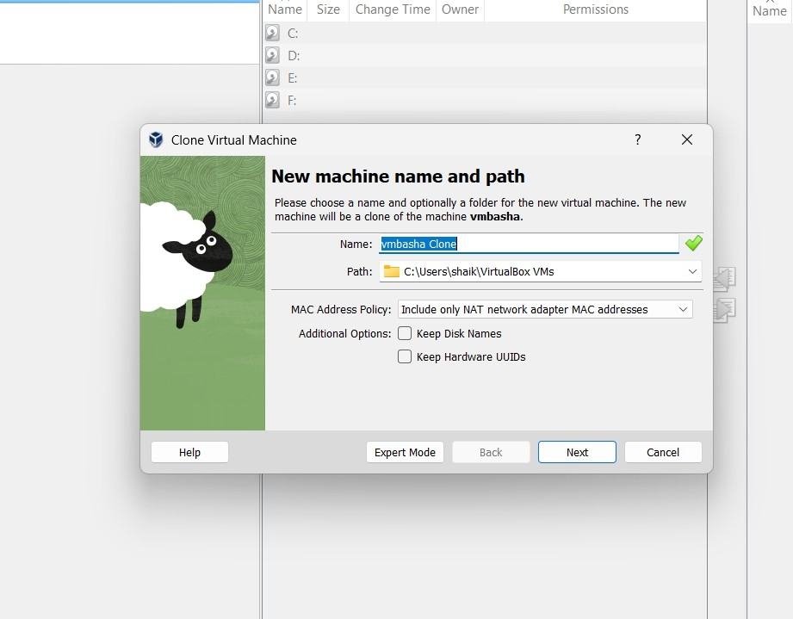

Modifying the VM (for Testing Purpose)
  - Start the VM.
  - Make some changes, such as:
    - Install new software
    - Change system settings
    - Create or delete files
  - Shut down or keep the VM running after changes.

Restoring / Loading the Previous Version (Snapshot)
  - Open VirtualBox Manager.
  - Select the VM → click Snapshots.

  - Choose the previously created snapshot (e.g., Initial State).
  - Click Restore.
  - If prompted, select:
    - Restore Snapshot (and optionally create a snapshot of current state).
  - Start the VM.
  - Verify that:
    - The VM has reverted to the earlier state
    - Changes made after the snapshot are no longer present
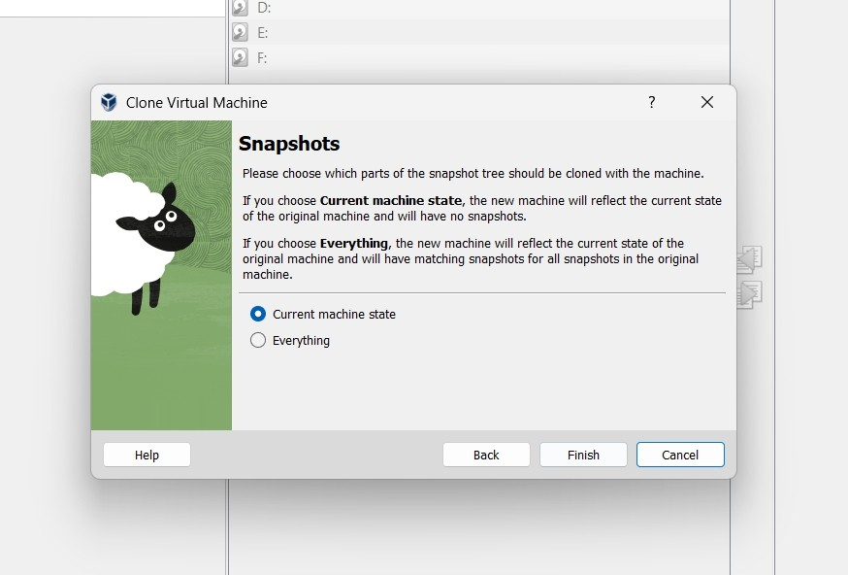

Testing by Cloning the VM (Optional Method)
  - Right-click the VM → select Clone.
  - Enter a new VM name.
  - Choose:
    - Linked Clone (uses snapshot, faster)

    - Full Clone (independent copy)
  - Select Current Machine State or Specific Snapshot.
  - Click Finish.
  - Start the cloned VM and verify it works independently.

OUTPUT:

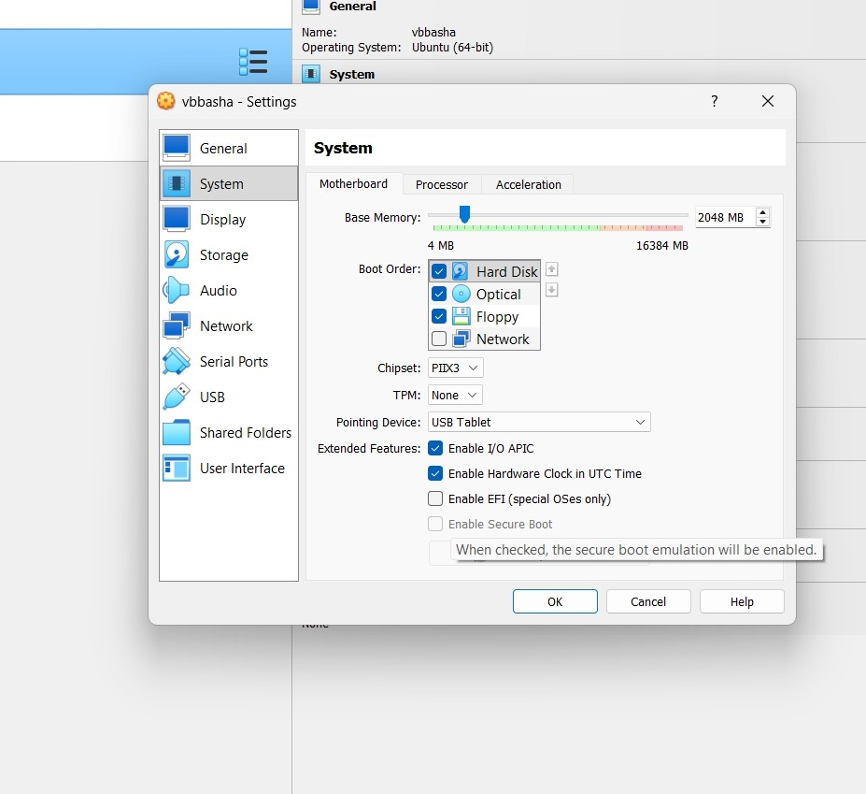

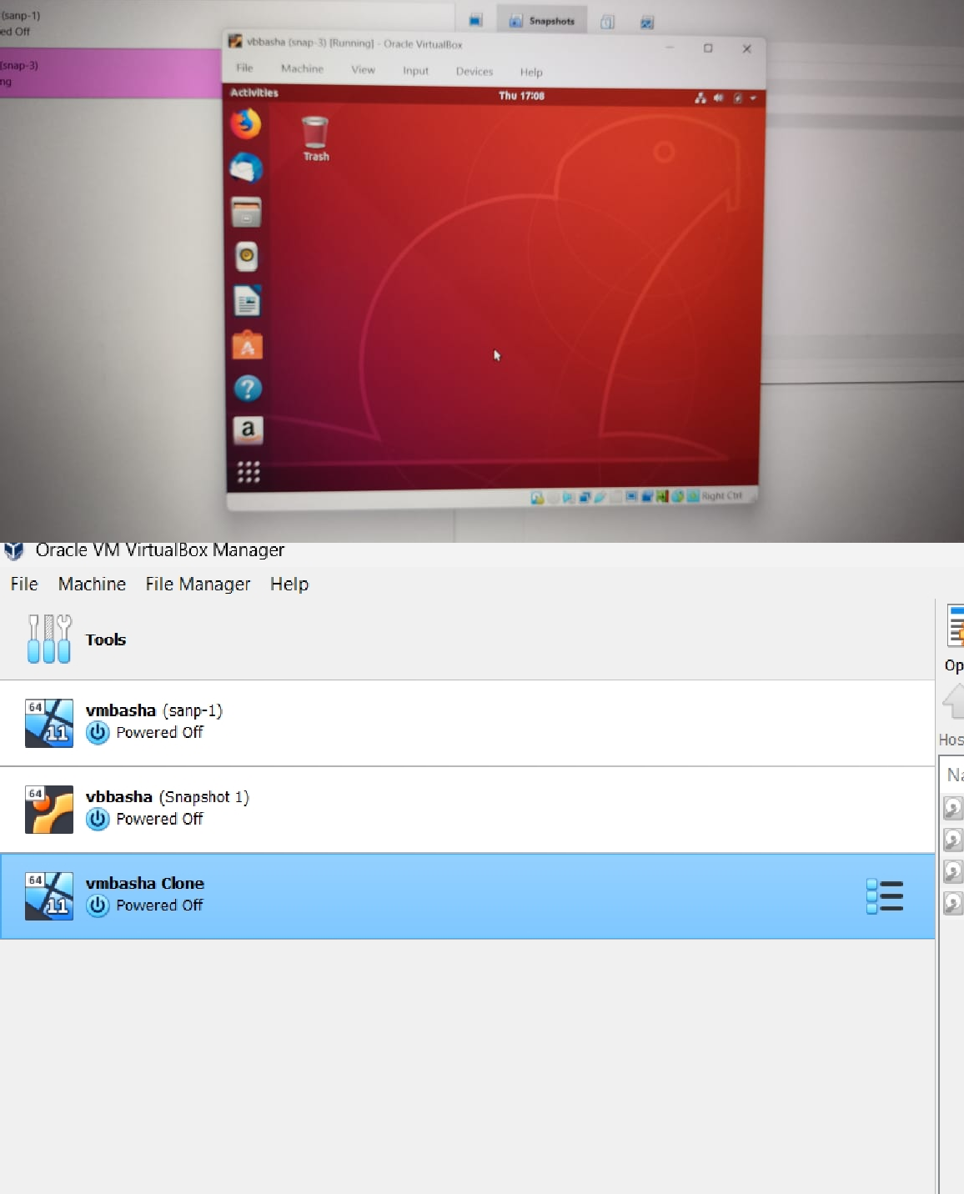

RESULT:
The virtual machine was successfully created and tested by restoring the previous version and/or loading a cloned VM using Oracle VirtualBox.

