Date:24/01/2026

EXP-14: Create a Virtual Hard Disk and allocate the storage using Vmware Workstation.

AIM
To Create a Virtual Hard Disk and allocate the storage using Vmware Workstation..

PROCEDURE
- Launch VMware Workstation
  - Open VMware Workstation on the host system.
  - Ensure the software is properly installed and licensed.

Create a New Virtual Machine
- Click on File → New Virtual Machine.
- Select Typical (recommended) and click Next.

Select Installation Media
  - Choose one of the following:
    - Installer disc (ISO image file) – if you have an OS ISO file.
    - I will install the operating system later – to create a blank VM.
  - Click Next.

Select Guest Operating System
  - Choose the appropriate Guest Operating System (e.g., Linux or Windows).
  - Select the correct Version.
  - Click Next.

Name the Virtual Machine
  - Enter a Virtual Machine Name.
  - Choose a Location to store VM files.
  - Click Next.

Configure Disk Capacity
- Set Maximum disk size to 15 GB.
- Choose Store virtual disk as a single file (recommended).
- Click Next.

Customize Hardware
- Click Customize Hardware.
- Set the following:
  - Memory (RAM): 2048 MB (2 GB)
  - Processors: 1 CPU
- Verify other hardware settings if required.
- Click Close.

Finish Virtual Machine Creation
  - Review the configuration details.
  - Click Finish to create the virtual machine.

Power On the Virtual Machine
  - Select the newly created virtual machine.
  - Click Power on this virtual machine.
  - Proceed with operating system installation if required.

OUTPUT:
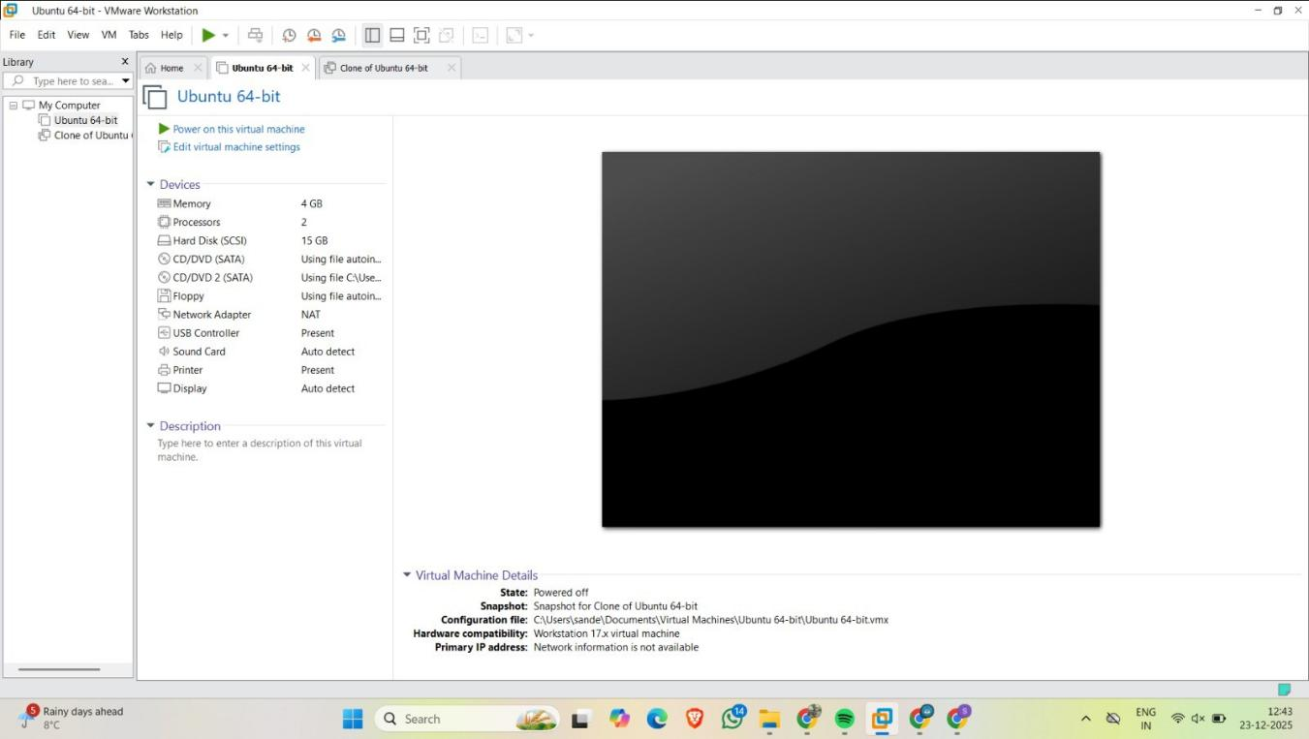

RESULT:
A virtual machine with 1 CPU, 2 GB RAM, and 15 GB storage was successfully created using VMware Workstation, a Type 2 Virtualization Software.

