Cloud Software System
Aim: To Develop a cloud Software system by using Zoho CRM
https://creatorapp.zoho.in/https://github.com/raghu337/Cloud-computing-CSA1527

Procedure:
- Define three user roles: User, Manager, and Admin.
- Design separate pages for Users, Managers, and Admin.
- Assign login and access permissions to each role using Zoho IAM.
- Allow Users to submit requests and use cloud services through the application.
- Allow Managers to review, approve, and monitor user activities.
- Allow Admin to manage all users, data, and application settings.
- Restrict access so each role can view only its own dashboard and pages.

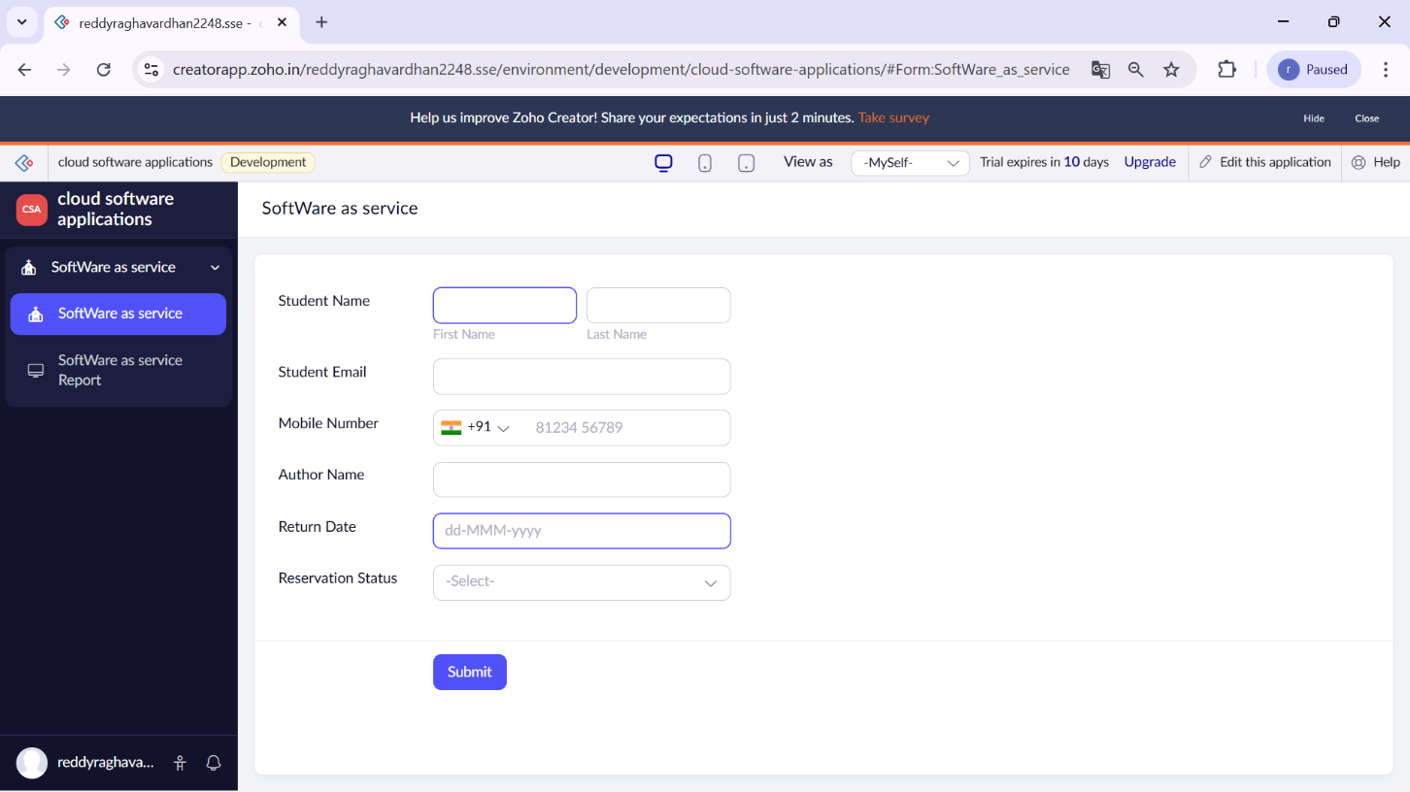

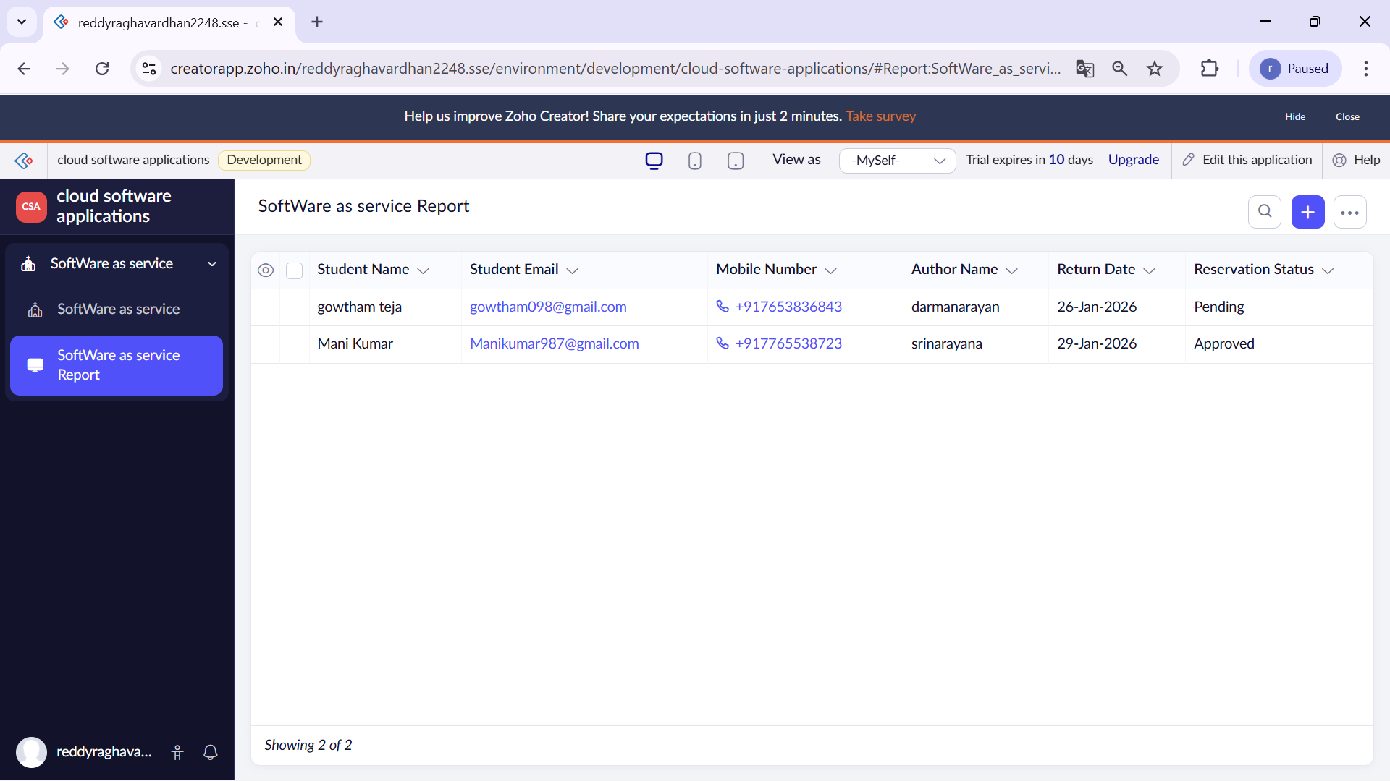

Result:
The cloud-based SaaS application was successfully created and deployed using Zoho Creator. Users were able to access the software through a web browser without installing anything, while managers could monitor and process requests, and the admin had full control over users, data, and system settings

