Armis Precision Vehicle Tracking
ARMIS
Deployment Architecture Plan
PID: 01-01446
Version:0.1
Date: 02-May-2018
Armis_precision Vehicle Tracking
Digital
Sasken Technologies Ltd.

Document Control
The authorized version of this document is an electronic master stored in the Document Repository (https://kenpoint.sasken.com/OE/SMS/default.aspx).  Be aware that if you are reading a hard copy of this document, it is to be considered an uncontrolled. It is advised that the version of the document in the repository be matched with the hard copy before using it. | The information contained in this document is proprietary to Sasken Technologies Ltd.  ©All rights to this information are reserved.  Disclosure without authorizing is prohibited.

Template used: SEP V11.0: PRIPP1

Revision History
Version | Approval Date | Description of change(s) | Author(s)
0.1 | 03/05/18 | Draft version of Deployment Architecture Plan prepared |  | Raghu
0.2 | 04/05/18 | AWS instance type, Deployment diagram, review comments |  | Maheshgouda Patil

Setup VPC:

For Production cloud set up has 3 tire layered architecture divided into two VPC.
  - Shared_service_vpc
  - prod_armis_vpc.

Front Web Layer
Public

Middle Layer
Data base Layer
Private

In Shared_service_vpc created 3 sub-nets to follow the tree tier architecture, In 3 sub-net one sub-net is public facing and other two is private sub-net.

  - Front web layer 1a - Public
  - Front web layer 1b - Public
  - Middle layer 1a - Private
  - Middle layer 1b - Private
  - Data base layer 1a - Private
  - Data base layer 1b - Private

PROD Deployment Diagram

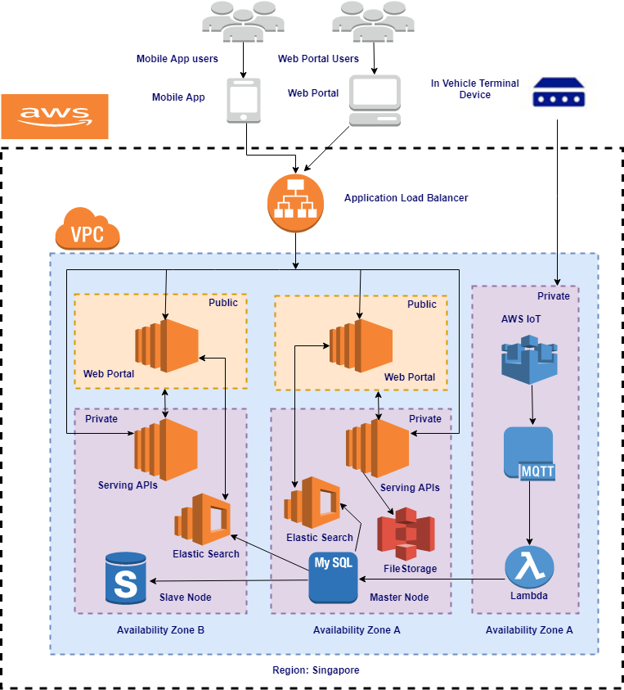
Deployment Diagram

Connectivity and Access

Shared Services

Development Cluster

PROD/UAT

QA

In public facing sub-net we are install Jenkins and Nagios for monitoring purpose and this sub-net acts like a jump server, we keep pem keys in this sub-net we can't directly ssh to the private sub-net first we have to log in to shared public sub-net and then do ssh to the private sub-net with in the vpc or outside the other vpc.

In prod_armis_vpc also Three tire architecture, here we create 3 sub-net one is for public facing because in this sub-net we deploy web_portal build and other two is private. In private, one sub-net is used for DB purpose and another private sub-net for web_services(Back-end).

We attach route table for both public and private sub-net. For public route table we attached Internet gateway(IGW) for to connect outside the world and for private route table attached the Nat gateway.

Shared_service_vpc and prod_armis_vpc are two different vpc so, two vpc as talk to each other otherwise we can't ssh from shared_service to prod_armis_vpc so we have to create VPC Peering between shared and prod vpc and attach this peering in both the route table along with proper CIDR blocks.

VPC - PROD -10.16.32.0/20 |  |  |  |  |  | Routing Table |  | Internet gateway/NAT Gateway
1a | Front end | 10.16.32.0/25 | 123 | ap-southeast-1a |  | prod _armis_public_rt |  | igw-dd5a3fb9
1b | Front end | 10.16.32.128/25 | 123 | ap-southeast-1b |  | prod_armis_public_rt |  | igw-dd5a3fb9
1a | App server | 10.16.33.0/25 | 123 | ap-southeast-1a |  | prod_armis_mid |  | nat-02c7216cd6fe2b5ac
1b | App server | 10.16.33.128/25 | 123 | ap-southeast-1b |  | prod_armis_mid |  | nat-02c7216cd6fe2b5ac
1a | DB | 10.16.34.0/25 | 123 | ap-southeast-1a |  | prod_armis_db |  | nat-02c7216cd6fe2b5ac
1b | DB | 10.16.34.128/25 | 123 | ap-southeast-1b |  | prod_armis_db |  | nat-02c7216cd6fe2b5ac
 |  | VPC peering | pcx-3c9e6f54
VPC - SS -10.16.16.0/20 |  |  |  |  |  |  | Routing Table | Internet gateway/NAT Gateway
1a | Front end | 10.16.16.0/25 | 123 |  | ap-southeast-1a |  |  | igw-e2c4a186
1b | Front end | 10.16.16.128/25 | 123 |  | ap-southeast-1b |  |  | igw-e2c4a186
1a | App server | 10.16.17.0/25 | 123 |  | ap-southeast-1a |  |  | nat-024365c840ee54850
1b | App server | 10.16.17.128/25 | 123 |  | ap-southeast-1b |  |  | nat-024365c840ee54850
1a | DB | 10.16.18.0/25 | 123 |  | ap-southeast-1a |  |  | nat-024365c840ee54850
1b | DB | 10.16.18.128/25 | 123 |  | ap-southeast-1b |  |  | nat-024365c840ee54850

DB creation:
We are using Mysql RDS instances, we created db in multiple availability zone and it acts as a master and slave. Once the master become down slave acts as a master,so db never goes down it always up and running.

Master DB: Multi availability zone
Slave DB: Read Replica of Master DB

ELB Creation:
We are using Application load blancer(ALB). First we have to create a target groups two instances in two availability zone and continuously health check configured. Only healthy instances its point to incoming traffic. We added a rule in ALB some of the traffic coming from specific path we diverted to the one instances and default path diverted to other instances. ALB end-point we get, using that end point we have to create a domain name in Route 53.

Instances are using :

Web service: Red Hat Enterprise Linux on m4.2xlarge
DB instances: m4.large

Front web portal : Red Hat Enterprise Linux on m4.2xlarge

Review comments:

- Use Cloud Formation for creating VPC structure
- RDS Dedicated server
- Security checks via tools

