“ **.** period ” “ **/** forward slash ” “ **~** tild key ” “ <!-- comment -->*"*“clear / ctrl + l”

**File Commands**

**./ :** current directory.

**../ :** one directory up.

**~ :** home directory.

**cd :** change directory.

**ls :** lists the contents of the directory.

**ls -al :** lists the contents in long way (detailed).

**ls -r :** going to list in reverse alphabetical order.

**ls -p :** defines the file types.

**ls -s :** it will sort based on file size.

**ls -d :** will show all the directories.

**ls ~/ Documents** **:** shows all the contents in documents.

**pwd :** present working directory.

**mkdir :** make a directory.

**head file :** shows the first 10 lines of the file.

**tail file :** shows the last 10 lines of the file.

**more file :** lists the entire contents of the file.

**touch file :** its going to create a file.

**rm :** to delete a file **rm -r :** to delete a directory.

**rm -f :** force remove a file **rm -rf :** force remove a directory.

**cp file1 file 2 :** copy contents of file1 to file 2.

**cp -r dir1 dir2 :** copy directory 1 to directory 2, create directory 2 if not present.

**mv file1 file2 :** rename or move file1 to file2 if it exists.

**find / -name filename :** it will find the file with filename in all the directories.

**Administrative Privileges**

**sudo :** super user do.

**sudo su :** changes to root user account $ -- #

**sudo !! :** which does the previous command executed

**visudo** to give anyone the root access, we do it here

**date** it is going to show the date when it is created

**Package Manager**

**apt-get install :** used to install applications.

**apt-get remove :** used to uninstall applications.

**apt-get update:** to update.

**apt-get upgrade:** to upgrade.

**File permissions / ownership**

**chown user:group filename :** to change the ownership (user:root group:user)

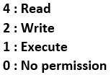**chmod 400 filename :** to change the file permissions for the owners & users

**chmod +rwx/-rwx filename :** to change file permissions

**chmod ugo +x/-x filename:** u : user g : group o : other

**chgrp a b :** to change file ownership to groups

**Process Management**

**ps :** to display the current working process.

**top :** display all running processes.

**kill pid :** to kill a process with a specific process id.

**killall abc :** kill all the processes with name abc.

**SSH Connect**

**ssh-keygen** (to generate the ssh keypair)

**ssh-copy-id** ipaddress (to copy the ssh key to specific ip address)

**ssh** ipaddress (to login in to the system)

**mkdir -p :** creates subdirectory of a directory (it will create parent directory first, if it doesn’t exist) ex: mkdir -p office/client/raj/data (without this you must create each and everything individually).

**tar -xvzf :** to extract a file (when you download a compressed file, then to unzip that file we use this command)

**ps -ef | grep process name :** ps- list processes, -e show all processes of all users, -f show processes in full format, -> | <- pass -> as input to <-, grep – find lines containing a pattern.

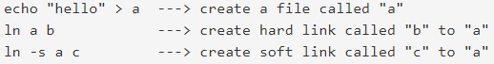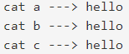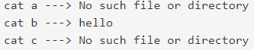**ln -s , ln** (soft link and hard link) : soft link is a pointer to the original file, when it is deleted soft link will not point anything. where as hard link is like mirror to original file