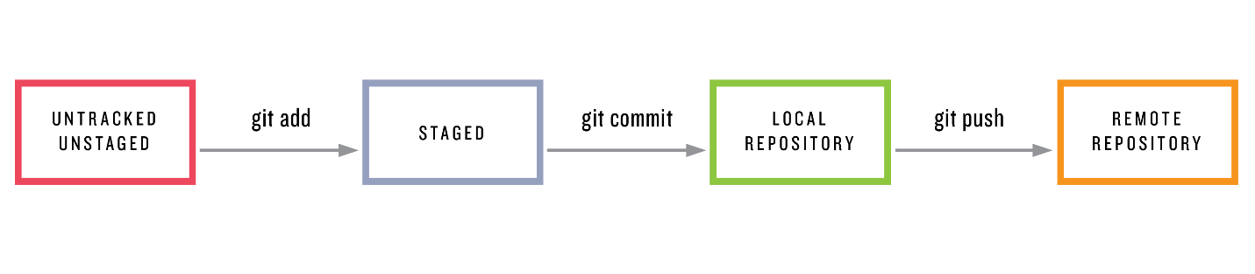**GIT**

**Git/GitHub basic commands**

**1. $git init**

To initialize a git local repository

**2. $git status**

To check the status of the files

**3. $git add .**

To add files to the staging area

**4. $git commit -m “message”**

To add files to the local repository

**5. $git remote add origin “https URL”**

To link remote repository and local repository

**6. $git clone “clone URL”**

To clone a remote repository to a local repository

**7. $git push origin master**

To push files in to the remote repository

**8. $git pull origin master**

To pull files from the remote repository

**To delete a file from GitHub**

**1. $git rm file name $git rm -r folder name**

To delete a file/folder from local repository

**2. $git status**

To see the status of the changes we made

**3. $git commit -m “message”**

To commit the made changes

**4. $git push origin master**

To push the committed changes to the remote repository

**Branching commands**

**1. $git branch**

It shows all the branches

**2. $git branch <branch name>**

To create a branch with name <branch name>

**3. $git branch -D <branch name>**

To delete a branch with name <branch name>

**4. $git checkout <branch name>**

To switch from master branch to <branch name>

**5. $git merge <source> <destination>**

To merge two branches

**6. $git push origin <branch name>**

To create same branch of local repository in remote repository

**7. $git log**

To see the history of the repository

**Stashing commands**

**1. $git stash**

To undo the previous change, you made

**2. $git stash list**

To see the list of all the stashes done in order

**3. $git stash apply $git stash apply stash@{#}**

First: will apply recent stash Second: will apply the stash #

**4. $git stash apply --index**

Undo all the previous stash made

**5. $git stash drop**

Drop the stash

**Git Reset**

**1. $git reset --hard**

To reset the previous commit

**2. $git reset --mixed**

To reset the previous commit

**3. $git reset --soft**

To reset the previous commit