AI FinOps POC
Langfuse Observability
Status: POC validated; real-time instrumentation is next

Executive Summary
Langfuse, an open-source LLM observability platform, is running self-hosted via Docker Compose, so no data leaves our environment. The Telemetry Spec's task / step / call hierarchy has been mapped onto it, and the cost engine has been built and unit-tested.
Using a simulated workload, the full contract was validated end to end. Any task can be reconstructed from its ID, and cost is reproducible from stored telemetry plus the price-book version.
8  Task attempts | 6  Accepted | 75%  Acceptance rate | $0.30 / ₹24.96  Cost per accepted task
Results from one session; all figures reproduced purely from stored telemetry. Total cost: $1.80 / ₹149.74.
Next: wire real agent traffic through an OpenTelemetry collector and formalise cost computation and AWS bill reconciliation.

1. What is Langfuse
Langfuse is an open-source LLM observability and tracing platform, effectively “APM for AI workloads.” It captures every model, tool and retrieval call an AI system makes, groups them into traces and sessions, and attaches usage, cost, latency, user and custom metadata.
It provides dashboards, trace drill-down, user and session views, cost-by-model breakdowns, and quality / evaluation scores.

Architecture
Langfuse runs as a small set of containers:
Component | Role
Web | UI and API / ingestion endpoint
Worker | Asynchronous processing of ingested events
Postgres | Application metadata: users, projects, API keys
ClickHouse | High-volume analytics store for traces, observations and scores
Redis | Queue and cache
MinIO | S3-compatible blob storage for event payloads
Data flow: Application SDK → Web ingestion → Worker → ClickHouse; the UI reads back from ClickHouse.

2. How Langfuse is Used in Our Process
Our spec’s four-level accounting hierarchy is mapped directly onto Langfuse’s data model using the Langfuse Python SDK:
Spec level | Meaning | Langfuse mapping
Session | Session / conversation | Langfuse session
Task | Unit of accounting (accepted / rejected) | One trace, joined by task.id
Step | One agent-loop iteration | Span
Call | Model, tool, retrieval, rerank, guardrail | Observation

Telemetry attributes
Every call is stamped with the exact attributes from the Telemetry Spec:
- OTel GenAI fields: gen_ai.operation.name, gen_ai.provider.name, gen_ai.request / response.model, and token usage including cache read / write and reasoning.
- Custom fields: tenant.id, task.id, task.type, task.attempt, task.parent_id, cost.component, cost.price_book_version, pricing.tier, aws.bedrock.inference_profile_arn.
- Acceptance: task.accepted / accepted_by is recorded as a late-arriving score, joined back by task.id, as the spec requires.

Cost computation
Cost is computed in a collector module from a versioned price book and is never hard-coded in the application. It produces cost.usd_computed and cost.inr_computed under the spec’s design rules: cache tokens are not double-counted, and reasoning tokens are treated as a subset of output.
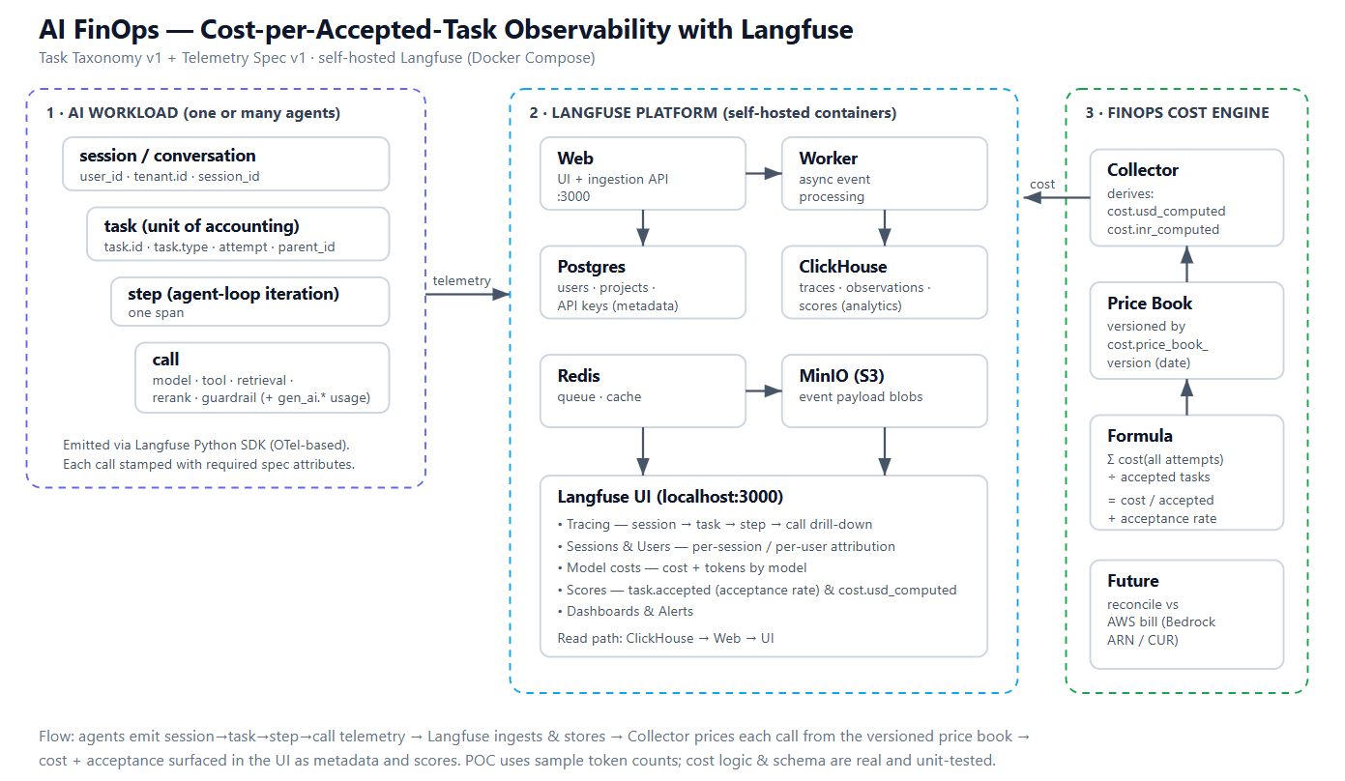

3. POC Results: Task and Trace Accounting

Test approach
The workload is simulated. A Python script generates a representative mix of all task types: SIMPLE_QA, RAG_QA, AGENT_TOOL_TASK, CODE_GENERATION and EVALUATION_JUDGE. It includes failed and retried attempts, which correctly stay in the cost numerator, and different pricing tiers.
The telemetry schema and cost logic are real and unit-tested. Only the token counts are canned sample values rather than live model responses, which allowed the full contract to be validated deterministically.

Verified result
- Across one session: 8 task attempts, 6 accepted, giving an acceptance rate of 0.75.
- Total cost: $1.80 / ₹149.74. Cost per accepted task: approximately $0.30 / ₹24.96.
- This meets the spec’s acceptance criteria: a task can be reconstructed from its ID, and cost is reproducible from telemetry and price-book version.

3.1 Home dashboard (overview)
Shows the model cost for the window ($0.19), user consumption (token cost), error and default observation counts, and the Scores panel plotting task.accepted and cost.usd_computed. The dashboard also shows 18 traces, 124 observations and 16 scores. Model costs are broken down by model (Claude 3.5 Sonnet, Claude 3 Haiku, Titan Embed) with tokens and USD, and a traces-by-type chart covers RAG_QA, CODE_GENERATION, SIMPLE_QA, AGENT_TOOL_TASK and EVALUATION_JUDGE.

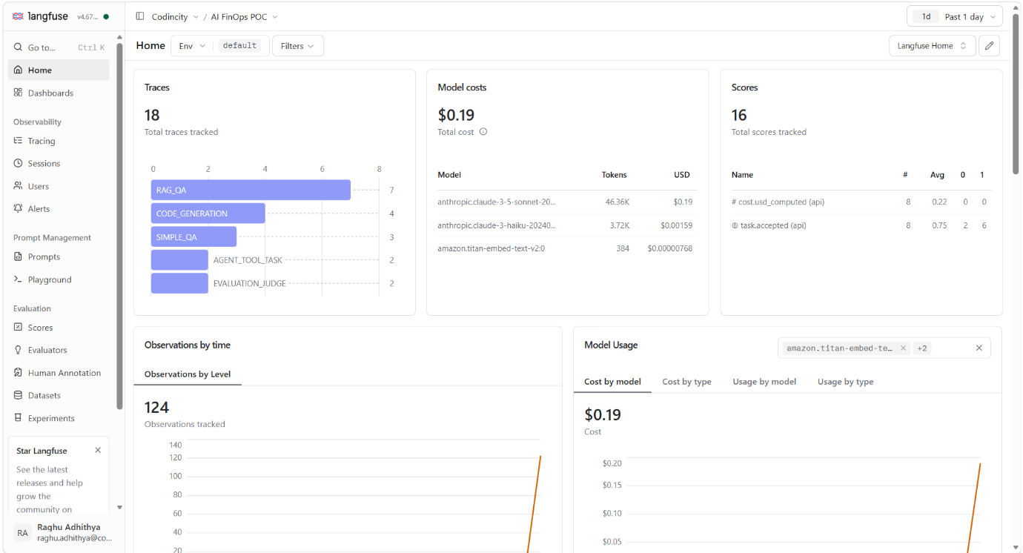
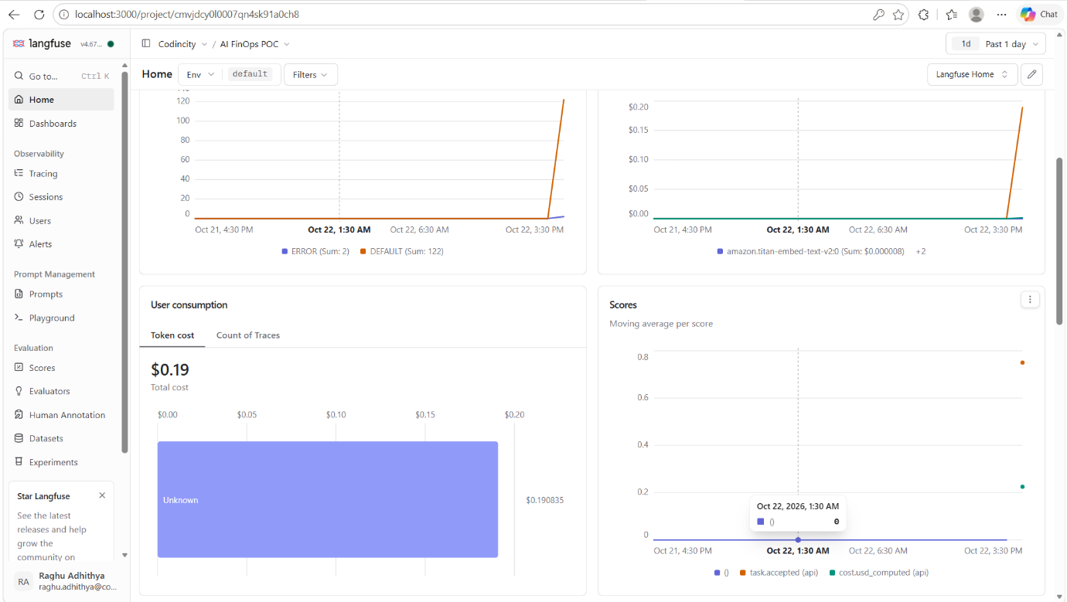
Figure 1: Langfuse home dashboard

3.2 Users view
User demo-user@codincity is shown with its observations, traces and active window, which confirms per-user attribution is working.
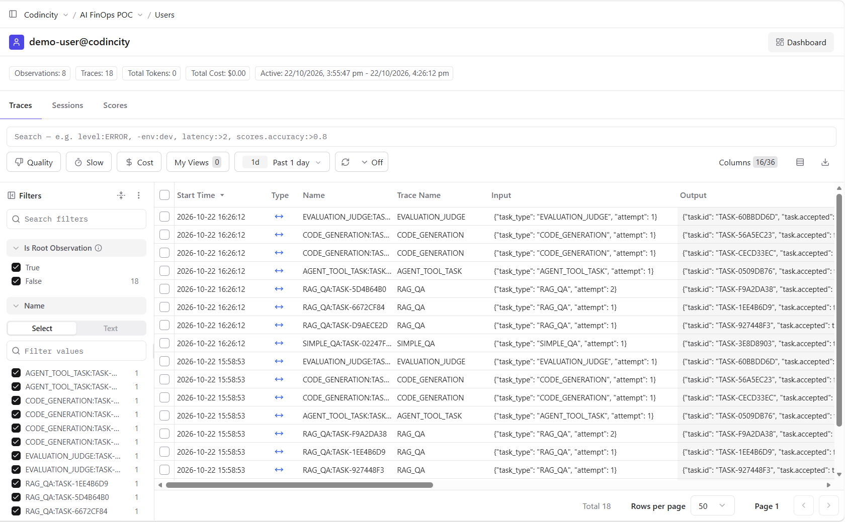
Figure 2: Per-user attribution

3.3 Session and trace detail
Session session-187f7cdd (8 traces, user attributed) with a drill-down into llm.answer. The Metadata panel shows the full Telemetry Spec contract live: gen_ai.usage.* tokens, aws.bedrock.inference_profile_arn, gen_ai.provider / request / response.model, cost.usd_computed / cost.inr_computed, cost.component, cost.price_book_version, pricing.tier and task.*.
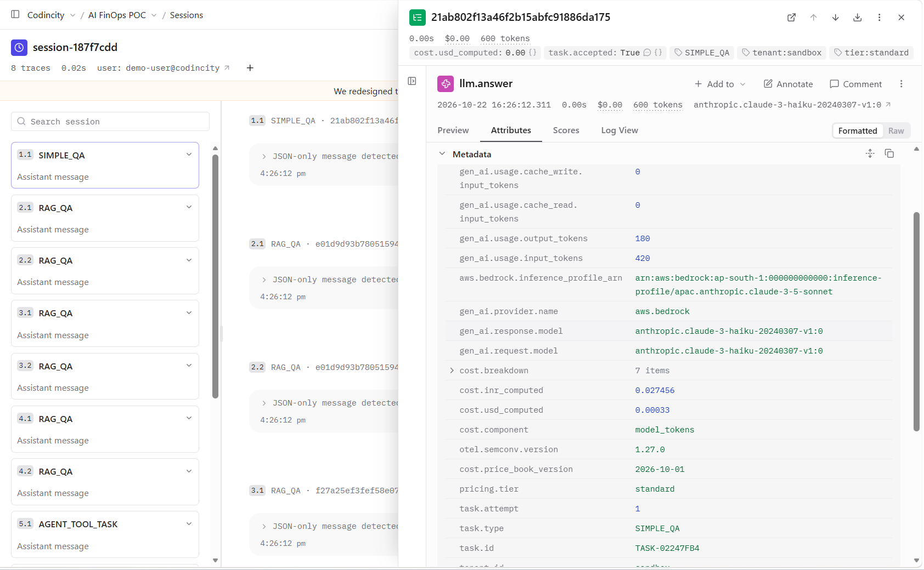
Figure 3: Session drill-down with metadata attributes

3.4 Sessions list
Sessions are grouped with user IDs and trace counts, demonstrating the session → task rollup.
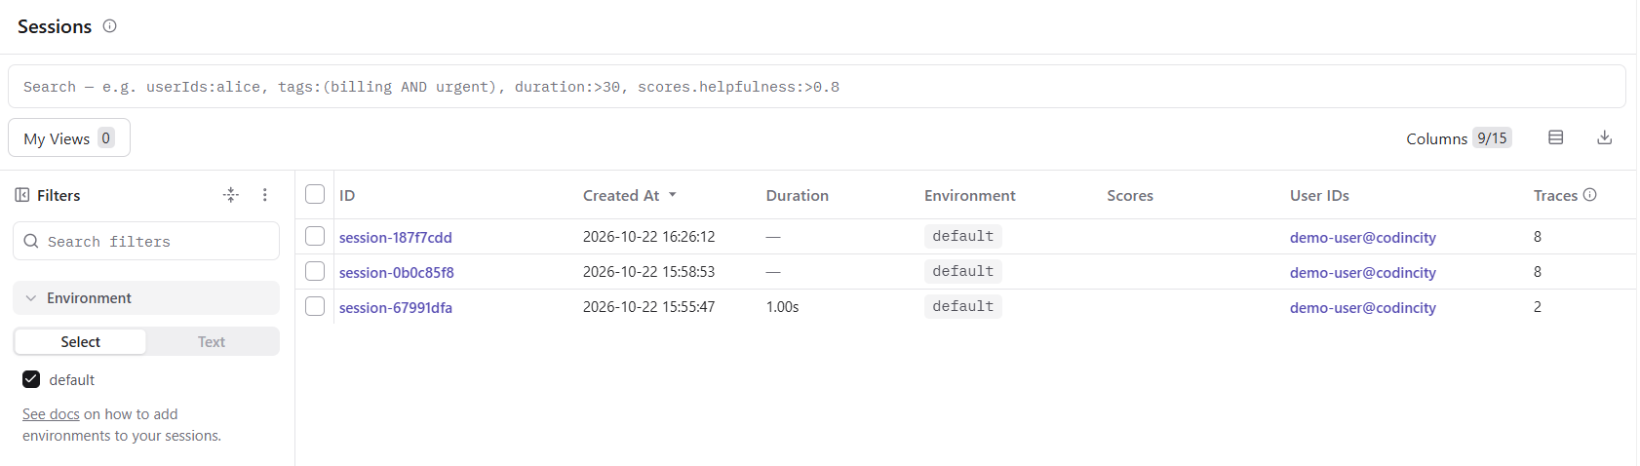
Figure 4: Sessions list

3.5 Tracing table (calls)
All call types (llm.answer, llm.plan, embed.query, vector.search, rerank, tool.call, ci.run_tests, guardrail, human.review, overhead) appear with per-call cost and metadata, confirming the step / call decomposition and cost components.
Every task is one trace, and each row carries task.id, task_type and attempt in the input / output, demonstrating one trace per task joinable by task.id.

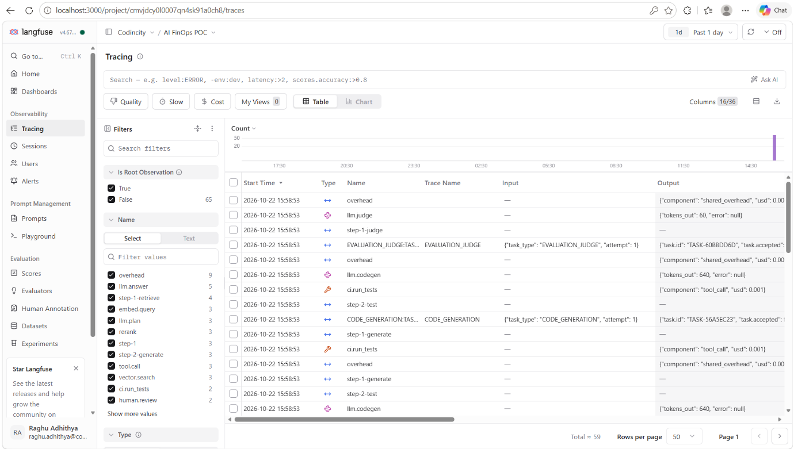
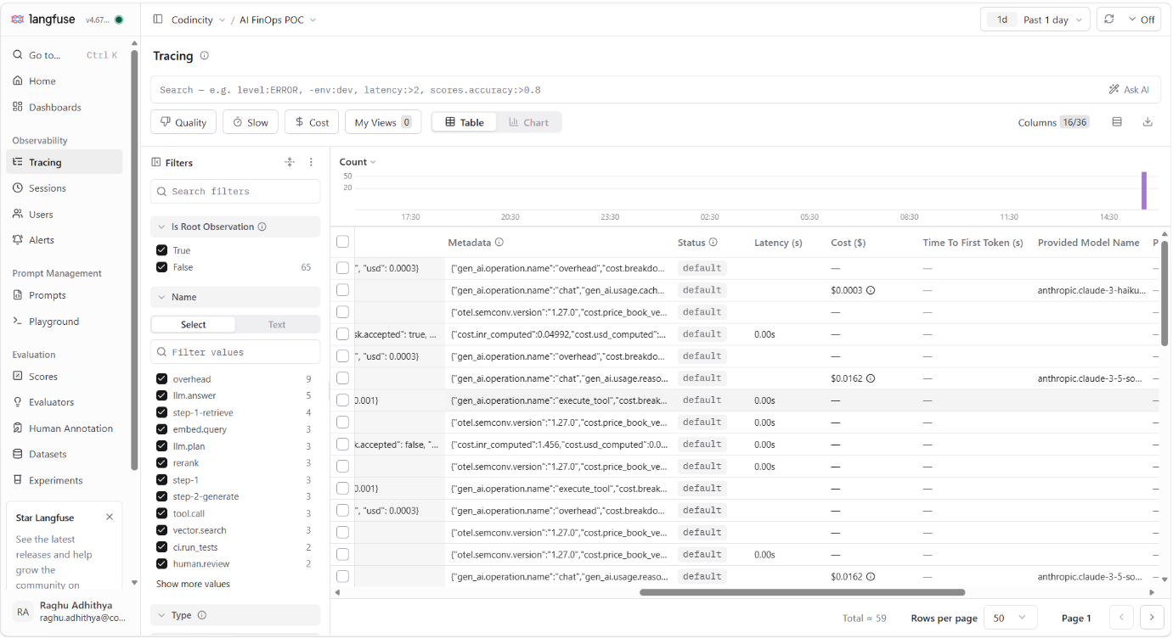

Figure 5: Tracing table, call-level

4. Next Steps: Real-Time Enterprise Instrument
To evolve the POC into production-grade instrumentation that records each task, its real cost, and session and user details across one or many live AI agents: (the following can/will be tried and further implemented)
- Instrument real model calls. Wrap actual AWS Bedrock (and other provider) calls so token counts and model IDs come from live responses, not sample values. The SDK captures usage automatically and our collector prices it.
- Standardise via an OpenTelemetry layer. Emit OTel GenAI spans from every agent and route them through a shared collector, pinning the semantic-convention version (spec design rule 5). This decouples agents from Langfuse and future-proofs the schema.
- Compute cost downstream in the collector. Move cost computation out of the apps into a collector or batch job that reads raw usage, applies the versioned price book, and writes cost.usd / inr_computed back, as the spec prescribes.
- Multi-agent support. Each agent sets tenant.id, a stable session_id and user_id, and propagates task.id / task.parent_id across hand-offs, so sub-tasks become child traces of the parent. This gives a single joined view of cost and acceptance when several agents collaborate on one task.
- Reconciliation and governance. A scheduled job reconciles cost.usd_computed against the actual AWS bill (via Bedrock inference-profile ARNs / CUR), plus Langfuse alerts on cost and acceptance-rate thresholds and dashboards per tenant and team.
- Shared SDK wrapper / middleware. Package the task / step / call helpers and the collector as an internal library or sidecar, so any team can add FinOps telemetry to a live agent with minimal code.

Summary
The taxonomy, telemetry contract and cost engine are proven and working against Langfuse. The remaining work is wiring real agent traffic through an OTel collector and formalising cost computation and AWS reconciliation, to make this a real-time, multi-agent enterprise instrument.

