**Points:-**

1. Project structure created as per given document and tried use this structure.
2. CRUD Operation Implemented.
3. Three API Controller Created (Course, Program, Student).
4. Access of program API need to pass authToken with dummy data in header.
5. For Student view model created.
6. Swagger definition added.
7. Dependency injection used to inject services.
8. Logger enable for azure-app-insight.
9. Token based authentication enabled.
10. Git repository created with master and feature branch.
11. For development Database created in local server.
12. Azure database created for production.
13. Postman used to test API’s.
14. Unit Test project Created.

Site URL: <https://ibbusinessserviceapi.azurewebsites.net/swagger/index.html>

Git Repo: <https://github.com/raghubar84/IBBuisnessService>

**Project Structure:**

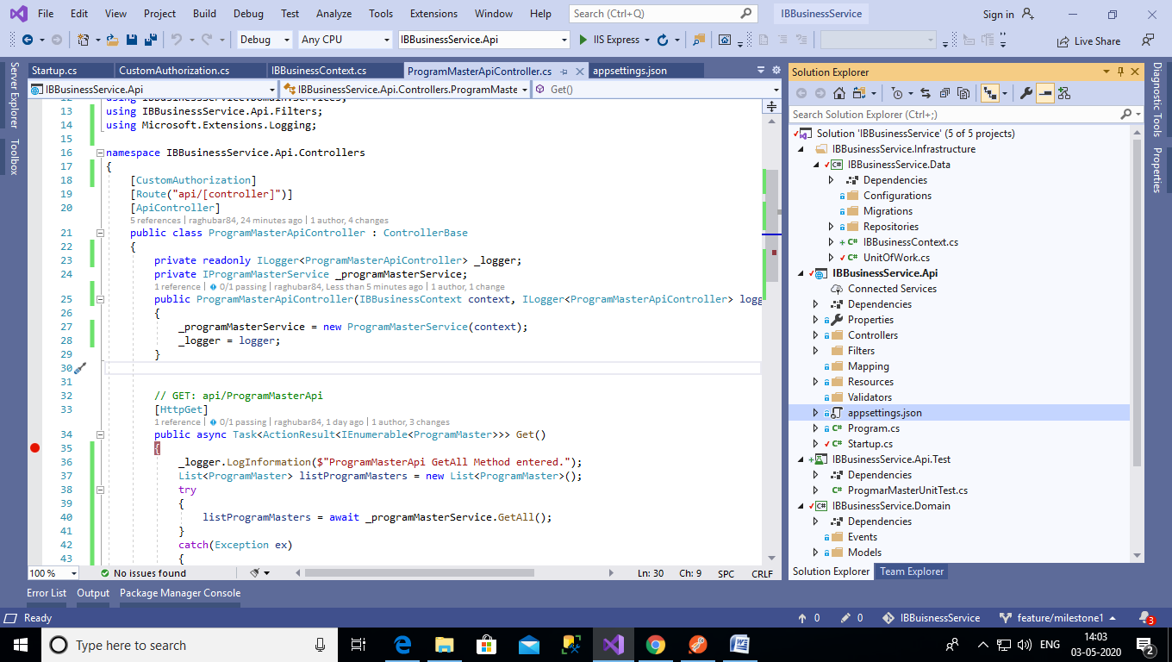

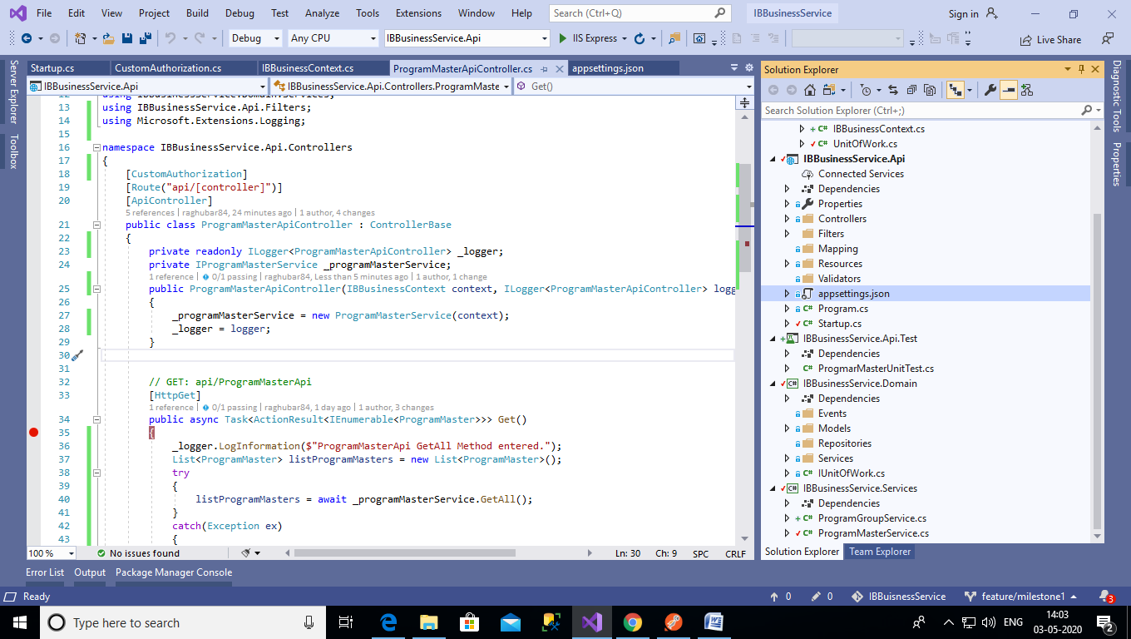

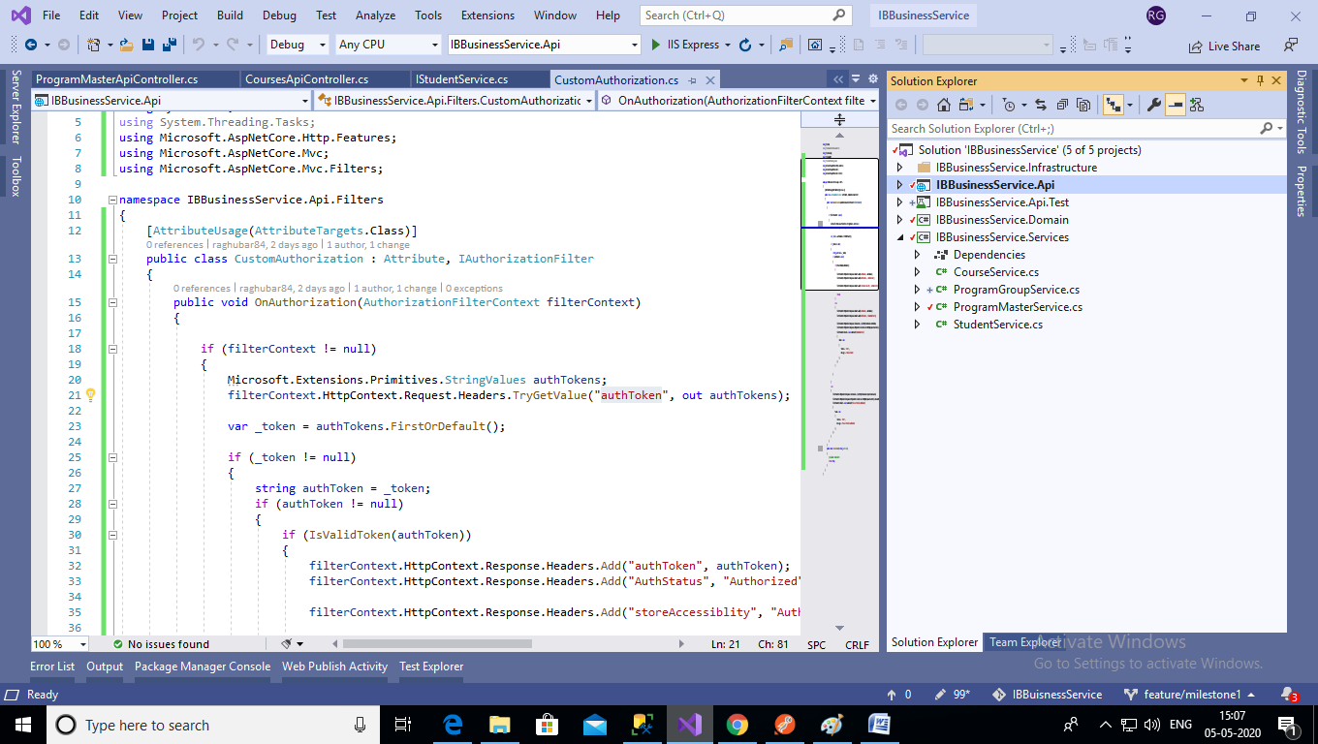

**Created two API Controller:**

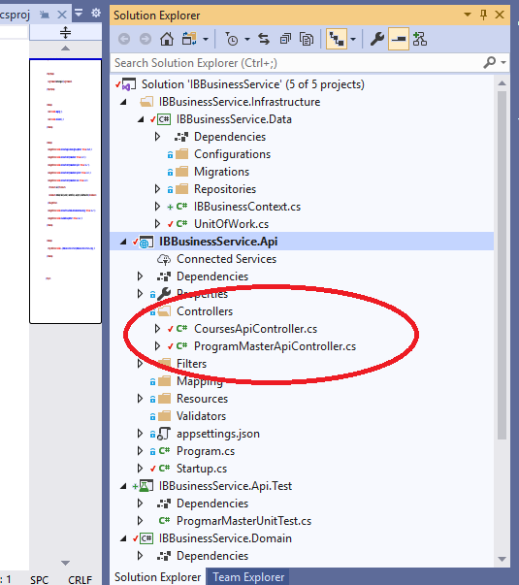

**BusinessData:** (GenericRepository, UnityOfwork, DbContext Class)

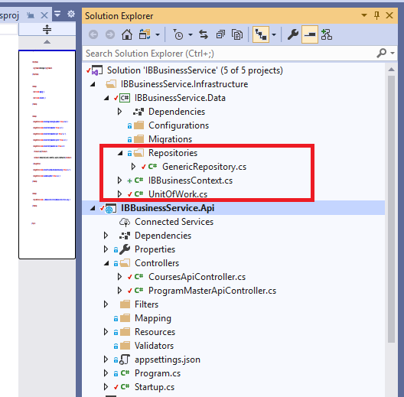

**GenericRepository.cs**

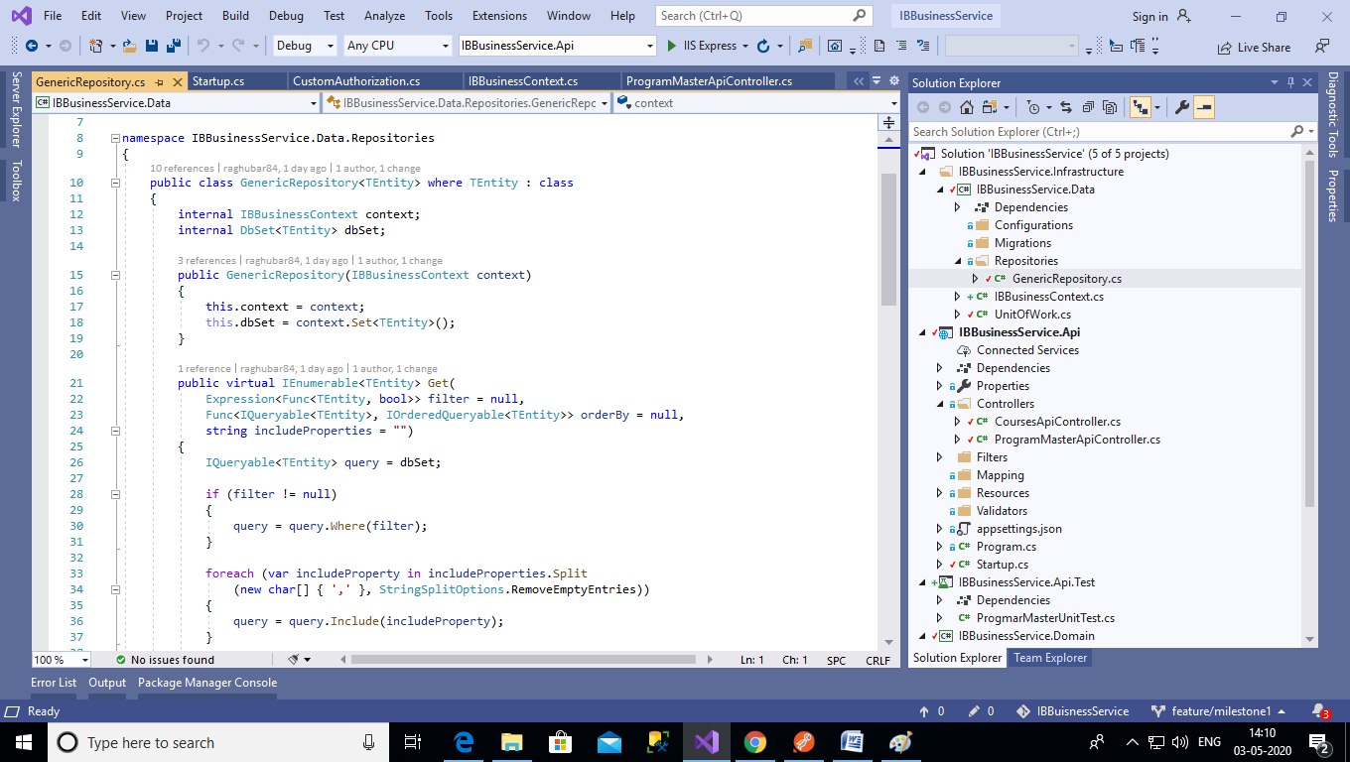

**UnityOfWork.cs**

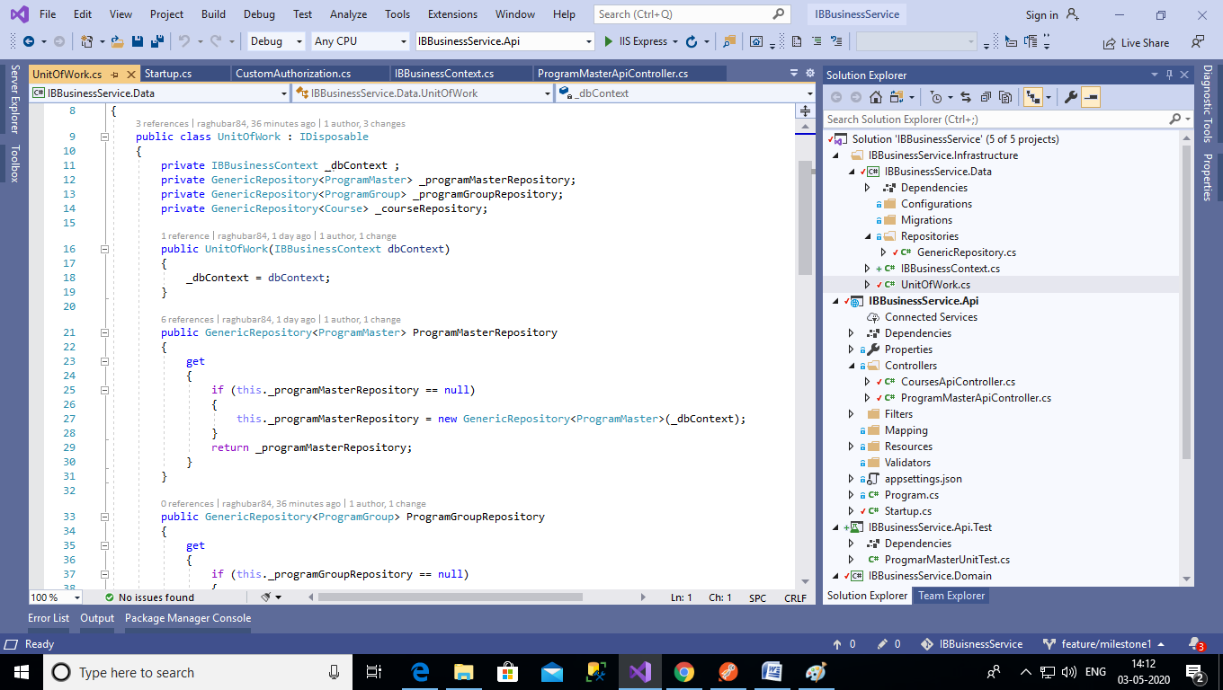

**IBBusinessContext.cs**

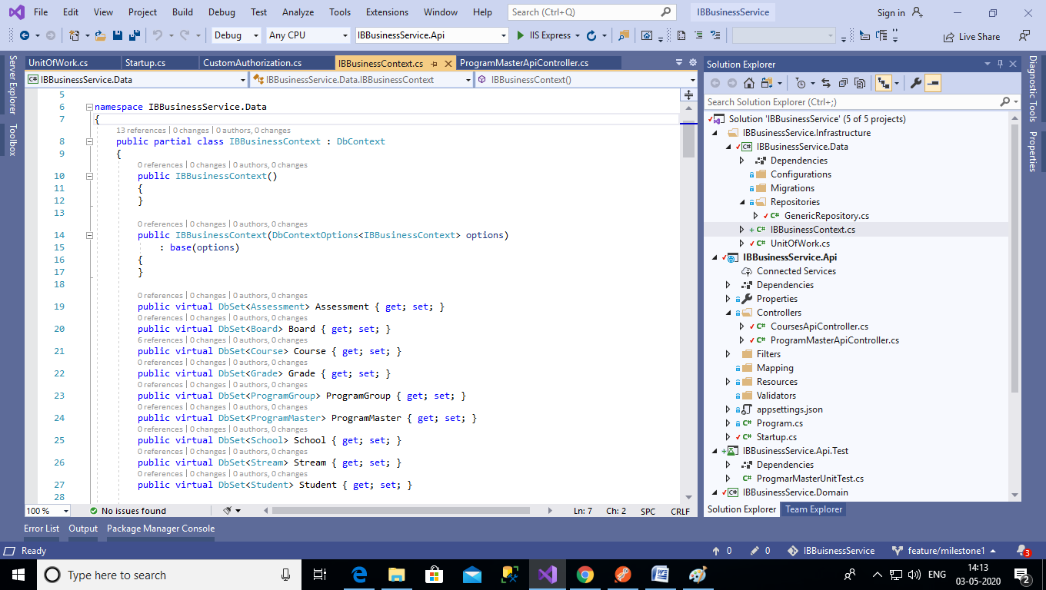

**IBBusinessService.Domain:** (Models)

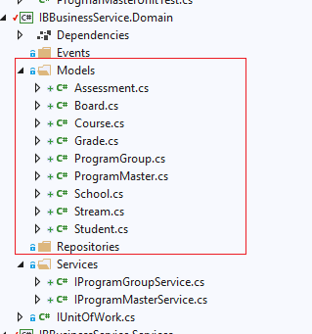

**IBBusinessService.Services:** (ProgramGroupService, ProgramMasterService)

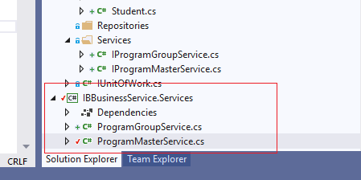

ProgramMasterService.cs

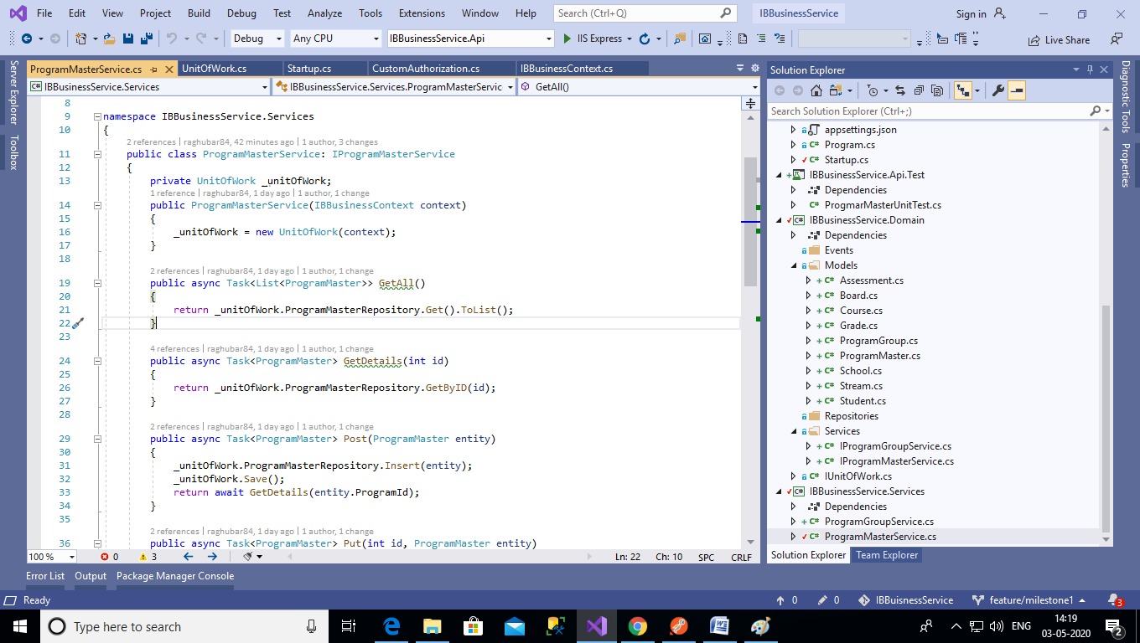

**Simple CRUD Operation for Course using entity framework and scaffolding :-**

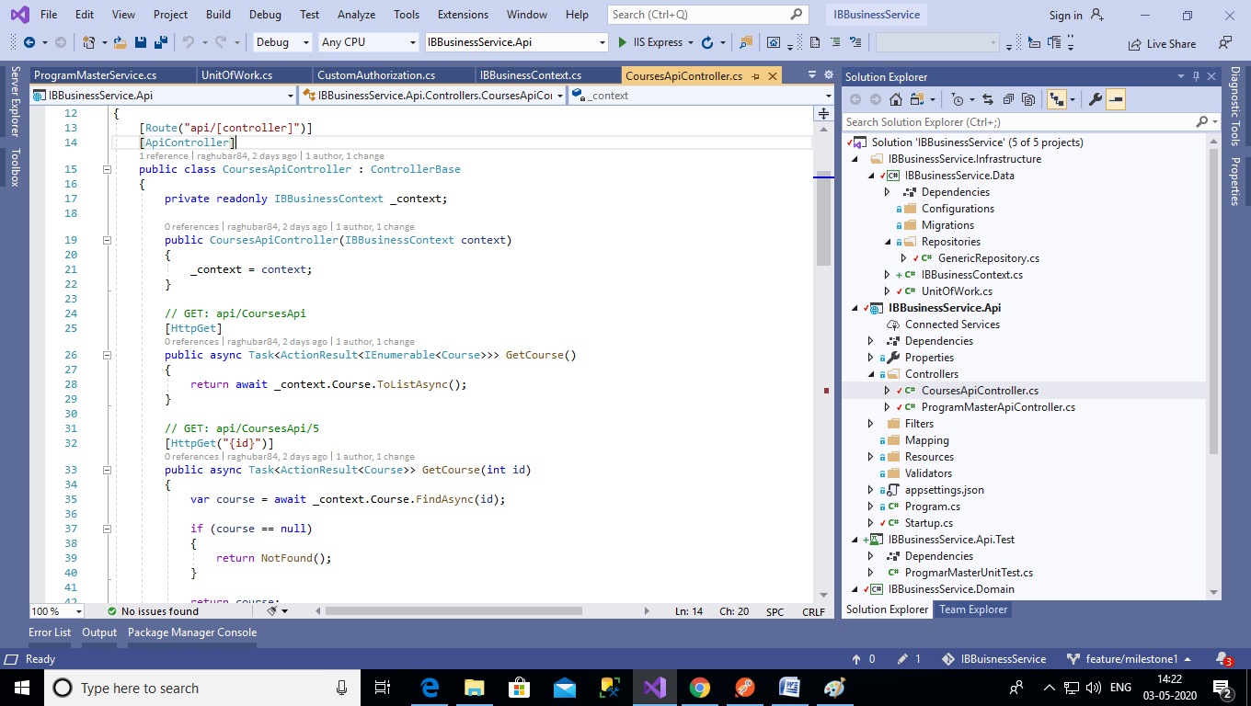

**Enabled Swagger definition:**

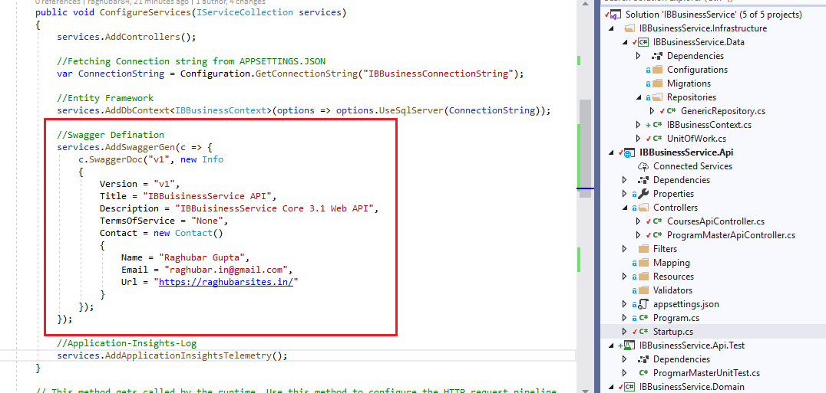

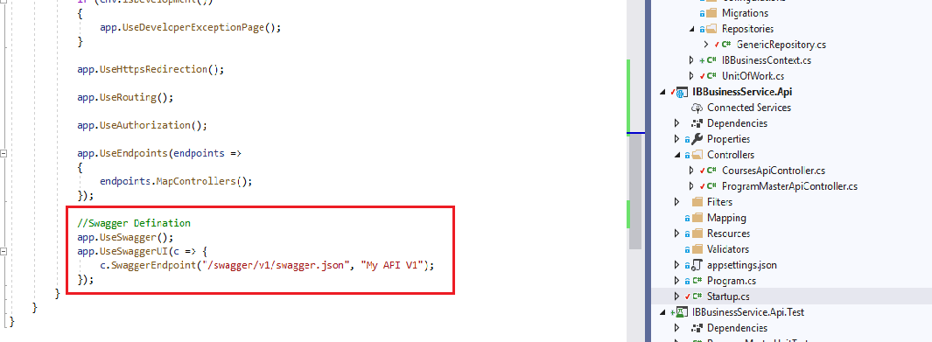

**Swagger definition in browser:**

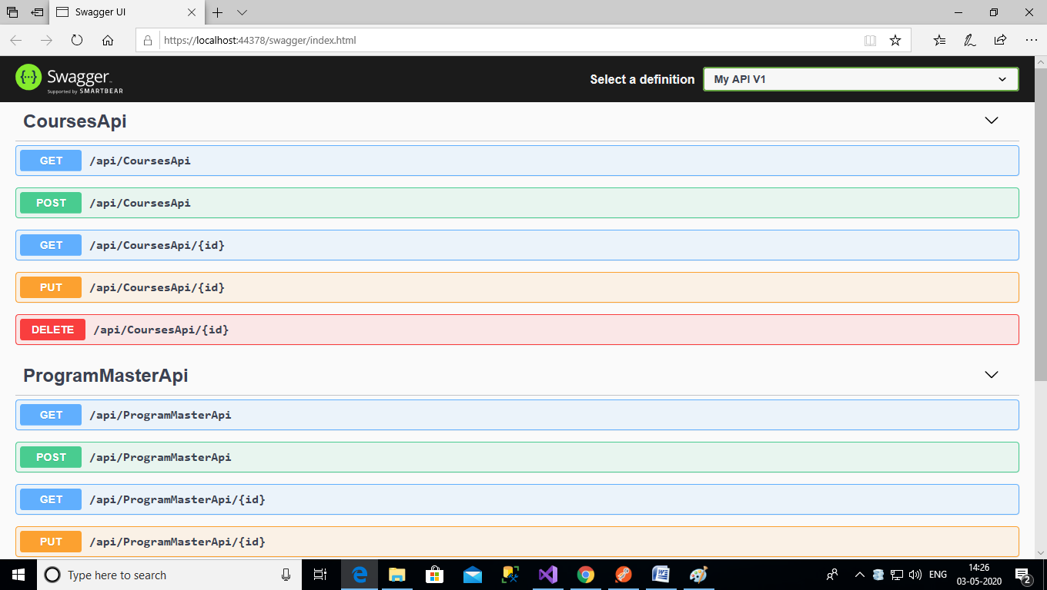

**Securiy:- Authorization Implementaion in progress:**

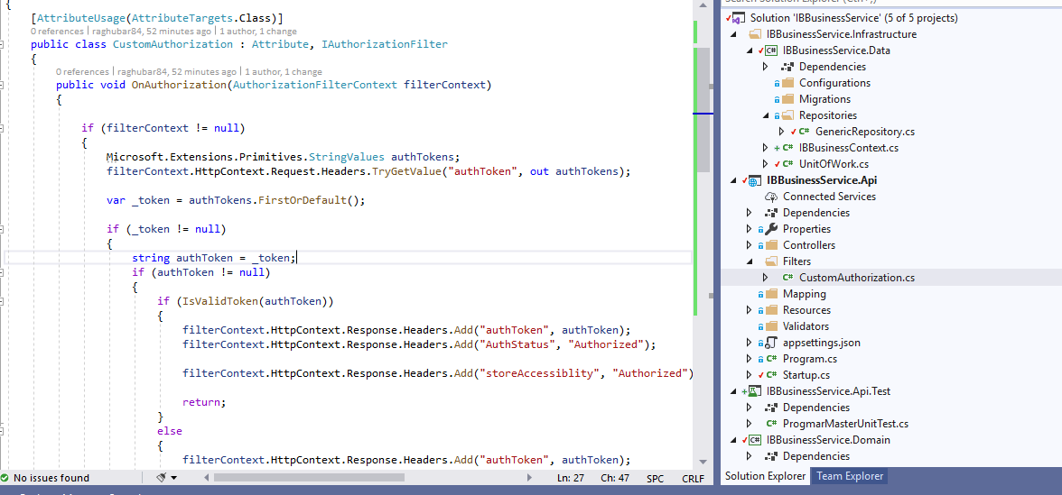

**Output in postman without passing token:**

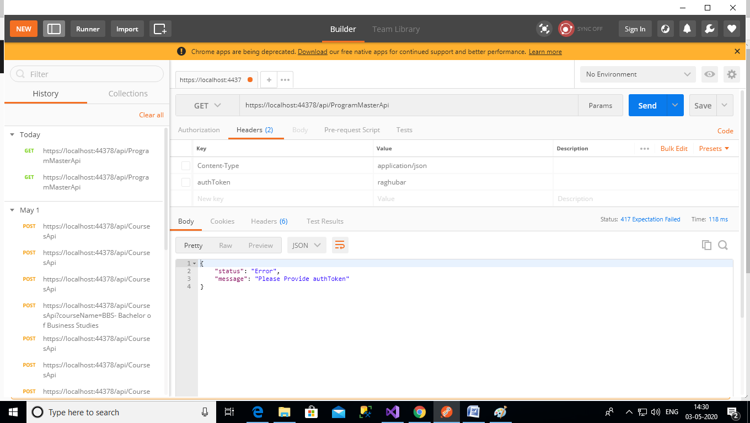

**Logging implemented for azure appinsight:** (not able to test as don’t have azure subscription)

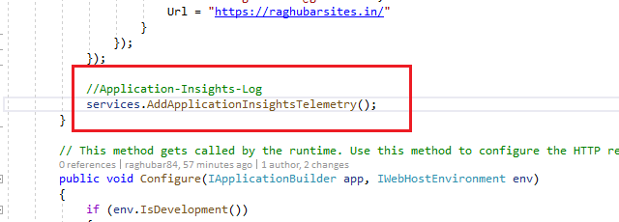

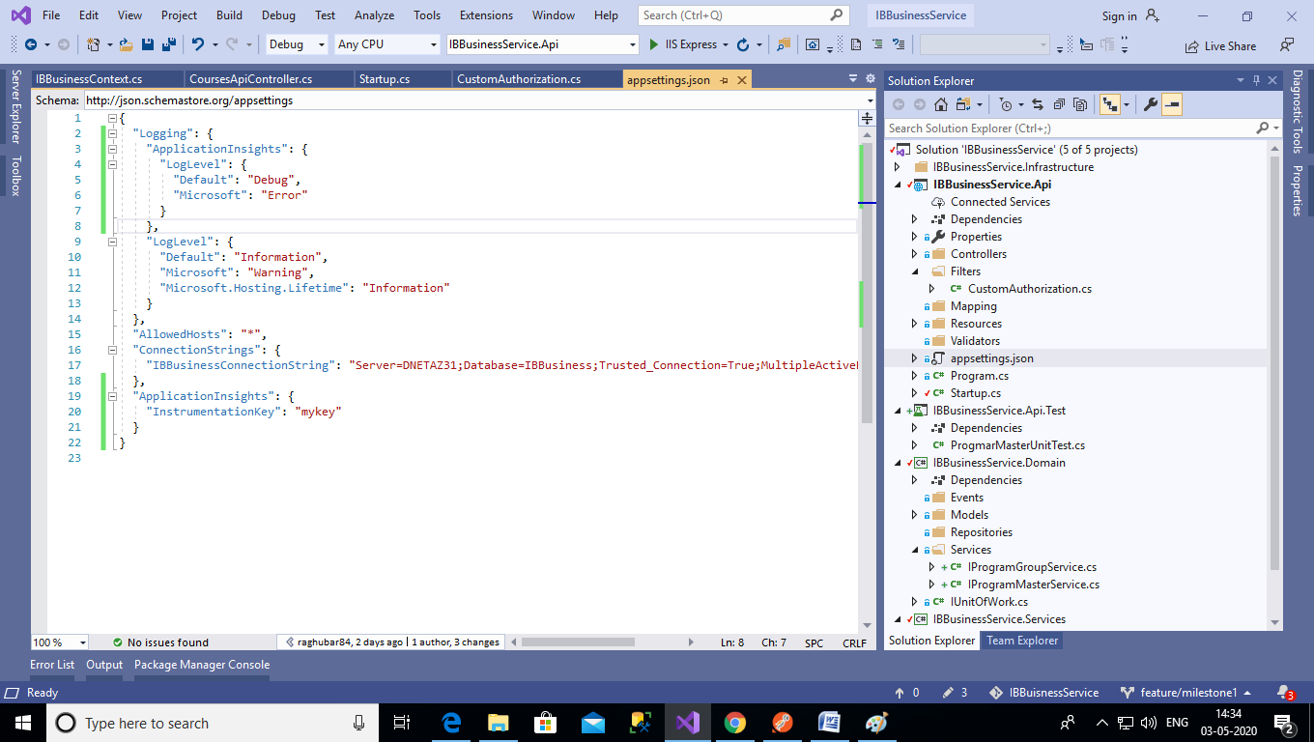

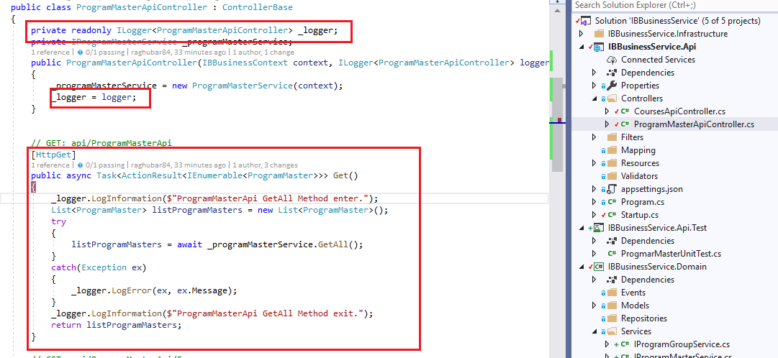

**Output of Api from Postman:**

Getting All Data

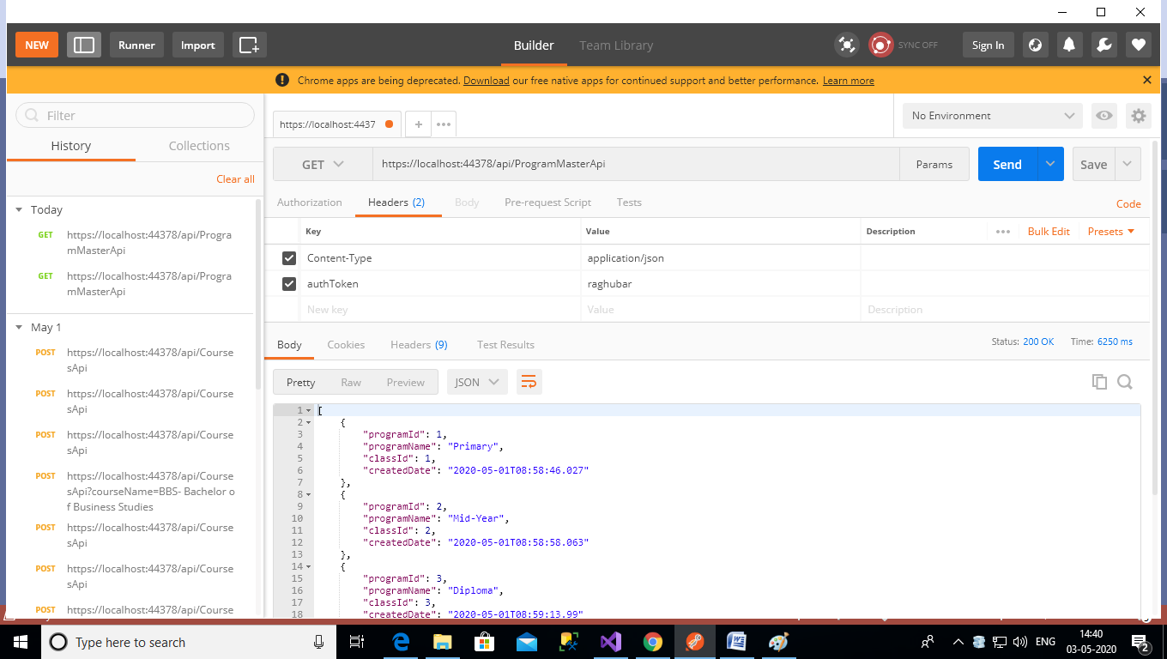

Getting single data:

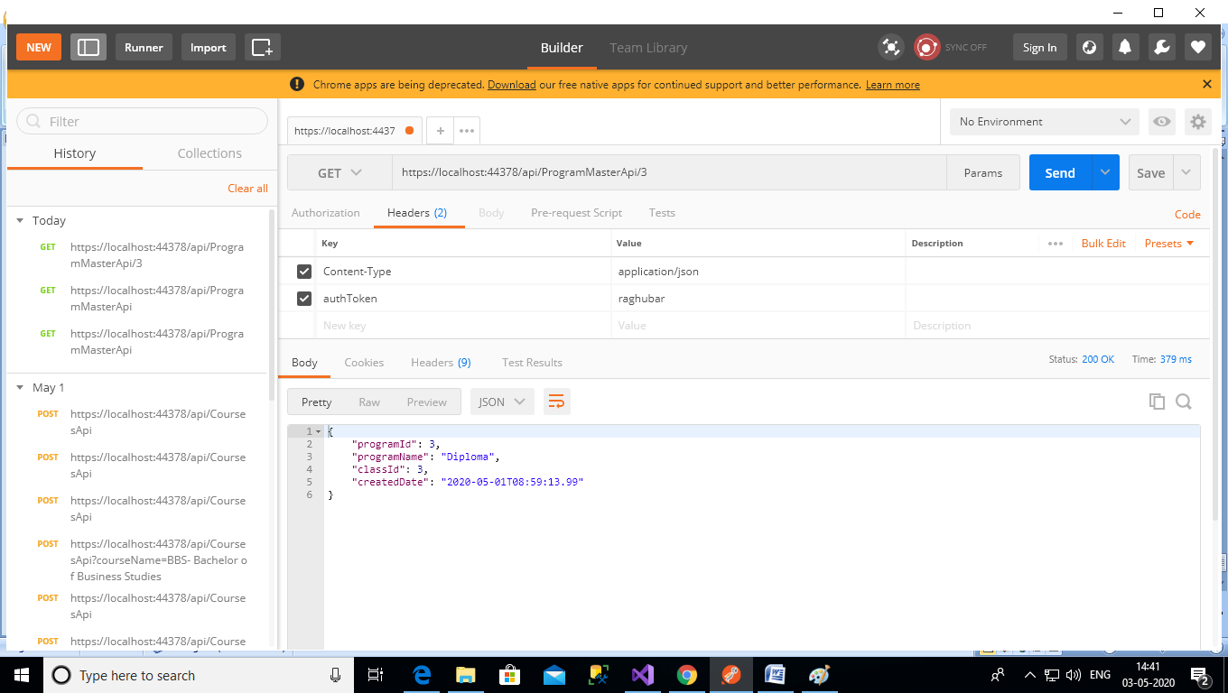

Saving data using Post Method:-

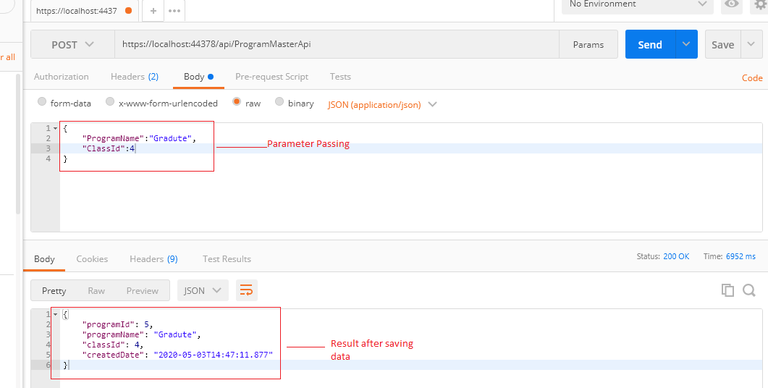

Data after saving in database:-

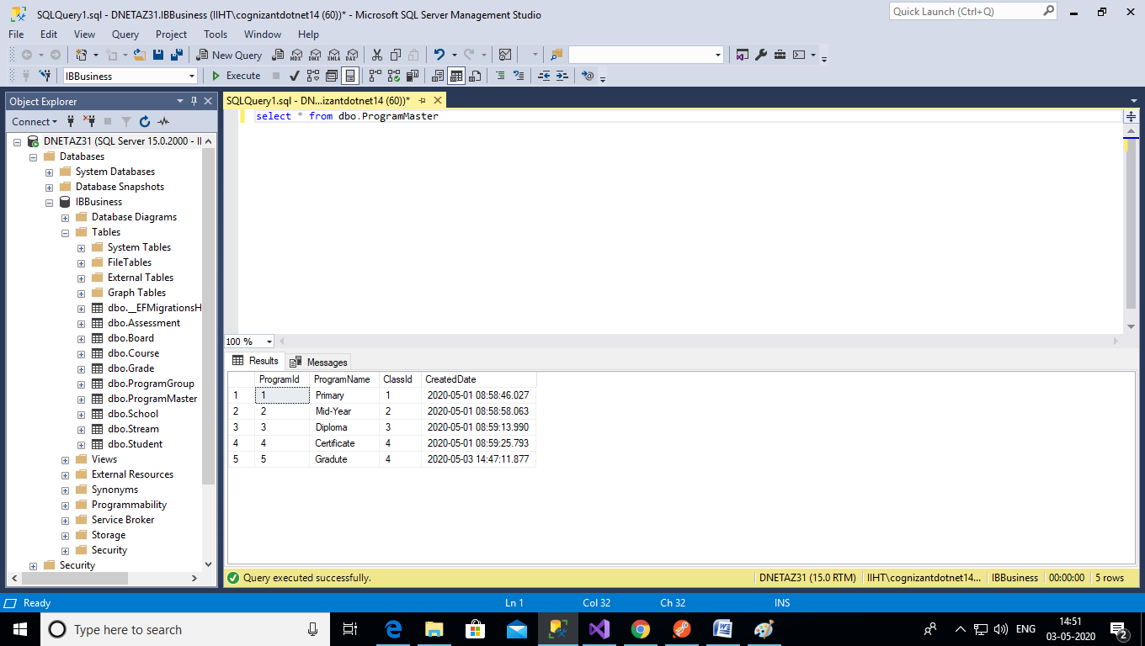

**Tables in database:-**

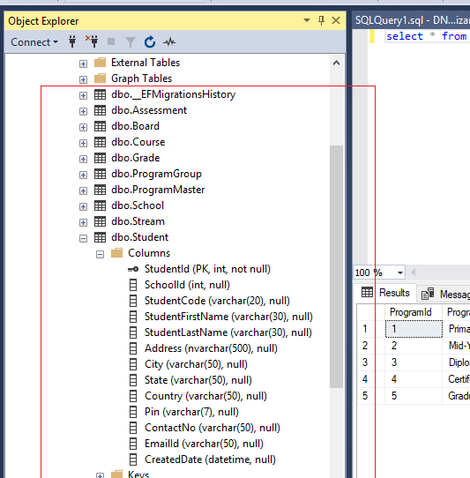

**Unit test project created implmentaion pending:**

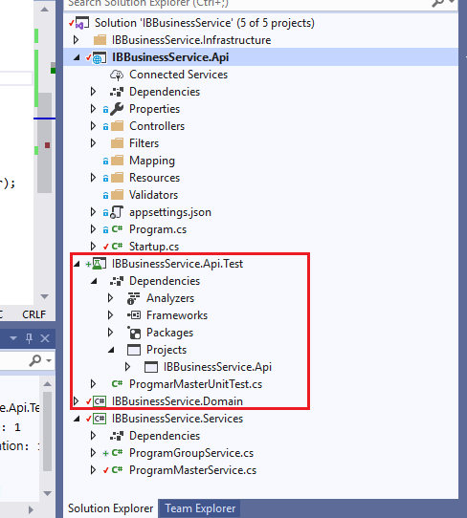

**Repository created in Git:**

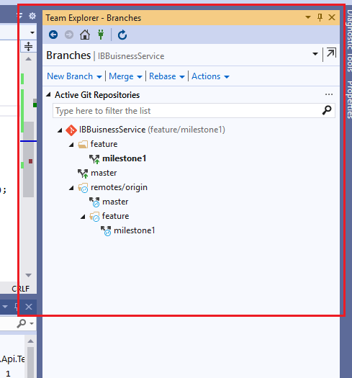

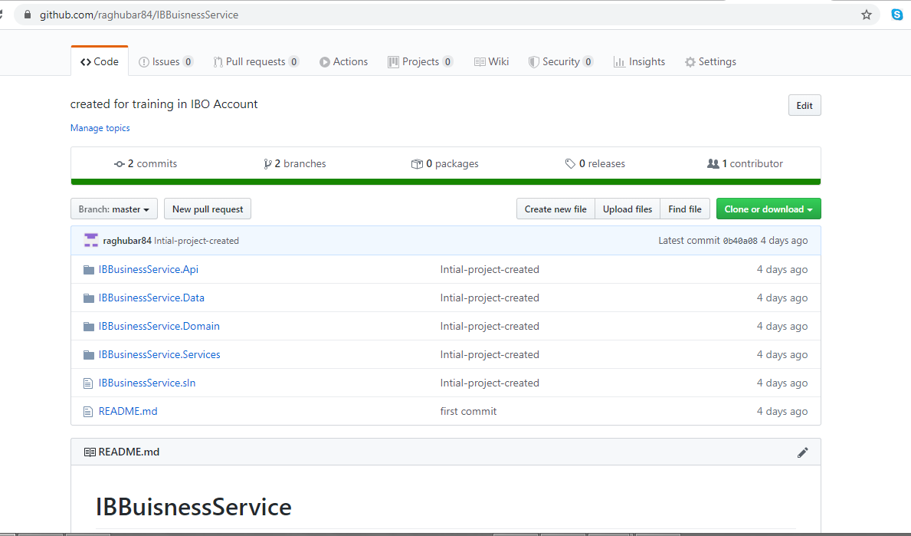

**Azure App Service configured for Publish:**

