**CS- 589 Homework1 Submission**

**Name: Raghunath Reddy B**

**CWID: A20332674**

**Email:** [**rbasired@hawk.iit.edu**](mailto:rbasired@hawk.iit.edu)

**Date of Submission: 09/24/2014**

**Problem I**

The following are the ranges for each grade which are related and specified in the given problem

|  |  |  |  |  |
| --- | --- | --- | --- | --- |
| **Grades** | **Exam-I** | **Exam-II** | **Project** | **Average =**  **(Exam-1 +Exam-II + Project)/3** |
| No Grade or Grade E | 0-49 | 0-59 | 0-49 | 0-74 |
| Grade C | 50-59 | 60-64 | 50-59 | 0-74 |
| Grade B | 60-100 | 65-100 | 60-100 | 0-74 |
| Grade A | - | **-** | **-** | 75-100 |
|  |  |  |  |  |
| **Valid Subdomains** | **3** | **3** | **3** | **2** |
| **Invalid Subdomains** | **2(<0, >100)** | **2(<0, >100)** | **2(<0, >100)** | **2(<0, >100)** |
|  |  |  |  |  |

**Assumptions**

* Exam I is Integer value.
* Exam II is Integer value.
* Project is Integer value.

**Input Conditions**

* 0<= Exam I <= 100
* 0<= Exam II <=100
* 0<= Project <=100
* The max size of the First Name is 12 characters
* The max size of Last Name is 20 characters
* Student# must be a 9 character string Format AXXXXXXXX.
* Student# must start with character “A”.
* X in Student# format is a digit.

**Tabular Representation of Valid and Invalid Subdomains**

|  |  |  |
| --- | --- | --- |
| **Input Conditions** | **Valid Sub Domains** | **Invalid Sub Domains** |
| **Exam I** | 0 – 49 (1)  50 – 59 (2)  60 – 100 (3) | < 0 (4)  > 100 (5) |
| **Exam II** | 0 – 59 (6)  60 – 64 (7)  65 – 100 (8) | < 0 (9)  > 100 (10) |
| **Project** | 0 – 49 (11)  50 – 59 (12)  60 – 100 (13) | < 0 (14)  > 100 (15) |
| **Average** | 0 – 74 (16)  75 – 100 (17) | < 0 (18)  > 100 (19) |
| **Size of First Name** | 1 – 12 (20) | = 0 (21)  > 12 (22) |
| **Size of Last Name** | 1 – 20 (23) | = 0 (24)  > 20 (25) |
| **Student# is a 9-character string** | Yes (26) | No (27) |
| **Student# starts with “A”** | Yes(28) | No (29) |
| **X is a digit** | Yes (30) | No (31) |
|  |  |  |

The related input conditions from the above table are

* Exam I – 3 Valid Sub Domains
  + 0 - 49 (A)
  + 50 - 59 (B)
  + 60 – 100 (C)
* Exam II – 3 Valid Sub Domains
  + 0 – 59 (A)
  + 60 – 64 (B)
  + 65 – 100 (C)
* Project – 3 Valid Sub Domains
  + 0 – 49 (A)
  + 50 – 59 (B)
  + 60 – 100 (C)
* Average – 2 Valid Sub Domains
  + 0 – 74 (A)
  + 75 – 100 (B)

Hence, the no of potential test case for **Strong Normal Equivalence Tests** are: 3 * 3 * 3 * 2 = 54 tests.

1. **Strong Normal Equivalence Test Cases**

The following are the possible Test cases which we can generate from afore mentioned sub domains for Exam I, Exam II, Project and Average.

|  |  |  |  |  |  |
| --- | --- | --- | --- | --- | --- |
| **Test Case** | **Exam I**  **(A/B/C)** | **Exam II (A/B/C)** | **Project**  **(A/B/C)** | **Average**  **(A/B)** | **Is Valid? (Yes/No)** |
| T#1 | A | A | A | A | Yes |
| T# | A | A | A | B | No |
| T#2 | A | A | B | A | Yes |
| T# | A | A | B | B | No |
| T#3 | A | A | C | A | Yes |
| T# | A | A | C | B | No |
| T#4 | A | B | A | A | Yes |
| T# | A | B | A | B | No |
| T#5 | A | B | B | A | Yes |
| T# | A | B | B | B | No |
| T#6 | A | B | C | A | Yes |
| T# | A | B | C | B | No |
| T#7 | A | C | A | A | Yes |
| T# | A | C | A | B | No |
| T#8 | A | C | B | A | Yes |
| T# | A | C | B | B | No |
| T#9 | A | C | C | A | Yes |
| T#10 | A | C | C | B | Yes |
| T#11 | B | A | A | A | Yes |
| T# | B | A | A | B | No |
| T#12 | B | A | B | A | Yes |
| T# | B | A | B | B | No |
| T#13 | B | A | C | A | Yes |
| T# | B | A | C | B | No |
| T#14 | B | B | A | A | Yes |
| T# | B | B | A | B | No |
| T#15 | B | B | B | A | Yes |
| T# | B | B | B | B | No |
| T#16 | B | B | C | A | Yes |
| T# | B | B | C | B | No |
| T#17 | B | C | A | A | Yes |
| T# | B | C | A | B | No |
| T#18 | B | C | B | A | Yes |
| T# | B | C | B | B | No |
| T#19 | B | C | C | A | Yes |
| T#20 | B | C | C | B | Yes |
| T#21 | C | A | A | A | Yes |
| T# | C | A | A | B | No |
| T#22 | C | A | B | A | Yes |
| T# | C | A | B | B | No |
| T#23 | C | A | C | A | Yes |
| T#24 | C | A | C | B | Yes |
| T#25 | C | B | A | A | Yes |
| T#44 | C | B | A | B | No |
| T#26 | C | B | B | A | Yes |
| T# | C | B | B | B | No |
| T#27 | C | B | C | A | Yes |
| T#28 | C | B | C | B | Yes |
| T#29 | C | C | A | A | Yes |
| T#30 | C | C | A | B | Yes |
| T#31 | C | C | B | A | Yes |
| T#32 | C | C | B | B | Yes |
| T#33 | C | C | C | A | Yes |
| T#34 | C | C | C | B | Yes |

From the above mentioned #54 test case some of them are Invalid as the sub domains of entities Exam I, Exam II, Project does not relate or intend to Sub Domain of Average; as average = (Exam I + Exam II + Project )/ 3;

Consider Test Case # 2 from above table

Exam I Domain: A (0 – 49)

Exam II Domain: A (0 – 59)

Project Domain: A (0 – 49)

Average Domain: B (74 – 100)

T#2: **Last name=Reddy, First name=Raghunath, Student #=A11112222, Exam-1=49, Exam-2 = 59, Project=49** this implies i.e.; Average = 52.34 (Which doesn’t fall in domain B). Hence this particular Test Case is not a valid one. Similarly we have other test cases which are not valid listed in the above table.

Hence, the no of potential strong equivalence test case are = 34 which are shown below.

|  |  |
| --- | --- |
| **Test Case #** | **Test Cases** |
| T#1 | Last name=Reddy, First name=Raghunath, Student #=A20332674, Exam-1=45, Exam-2 = 50, Project=45 |
| T#2 | Last name=Reddy, First name=Raghunath, Student #=A20332674, Exam-1=45, Exam-2 = 50, Project=55 |
| T#3 | Last name=Reddy, First name=Raghunath, Student #=A20332674, Exam-1=45, Exam-2 = 50, Project=70 |
| T#4 | Last name=Reddy, First name=Raghunath, Student #=A20332674, Exam-1=45, Exam-2 =63, Project=45 |
| T#5 | Last name=Reddy, First name=Raghunath, Student #=A20332674, Exam-1=45, Exam-2 = 63, Project=55 |
| T#6 | Last name=Reddy, First name=Raghunath, Student #=A20332674, Exam-1=45, Exam-2 = 50, Project=95 |
| T#7 | Last name=Reddy, First name=Raghunath, Student #=A20332674, Exam-1=45, Exam-2 = 99, Project=49 |
| T#8 | Last name=Reddy, First name=Raghunath, Student #=A20332674, Exam-1=45, Exam-2 = 99, Project=55 |
| T#9 | Last name=Reddy, First name=Raghunath, Student #=A20332674, Exam-1=45, Exam-2 = 99, Project=62 |
| T#10 | Last name=Reddy, First name=Raghunath, Student #=A20332674, Exam-1=45, Exam-2 = 99, Project=99 |
| T#11 | Last name=Reddy, First name=Raghunath, Student #=A20332674, Exam-1=55, Exam-2 = 50, Project=45 |
| T#12 | Last name=Reddy, First name=Raghunath, Student #=A20332674, Exam-1=55, Exam-2 = 50, Project=55 |
| T#13 | Last name=Reddy, First name=Raghunath, Student #=A20332674, Exam-1=55, Exam-2 = 50, Project=90 |
| T#14 | Last name=Reddy, First name=Raghunath, Student #=A20332674, Exam-1=55, Exam-2 = 63, Project=45 |
| T#15 | Last name=Reddy, First name=Raghunath, Student #=A20332674, Exam-1=55, Exam-2 = 50, Project=55 |
| T#16 | Last name=Reddy, First name=Raghunath, Student #=A20332674, Exam-1=55, Exam-2 = 50, Project=90 |
| T#17 | Last name=Reddy, First name=Raghunath, Student #=A20332674, Exam-1=55, Exam-2 = 90, Project=45 |
| T#18 | Last name=Reddy, First name=Raghunath, Student #=A20332674, Exam-1=55, Exam-2 = 90, Project=55 |
| T#19 | Last name=Reddy, First name=Raghunath, Student #=A20332674, Exam-1=55, Exam-2 = 70, Project=65 |
| T#20 | Last name=Reddy, First name=Raghunath, Student #=A20332674, Exam-1=55, Exam-2 = 99, Project=99 |
| T#21 | Last name=Reddy, First name=Raghunath, Student #=A20332674, Exam-1=65, Exam-2 = 50, Project=45 |
| T#22 | Last name=Reddy, First name=Raghunath, Student #=A20332674, Exam-1=65, Exam-2 = 50, Project=55 |
| T#23 | Last name=Reddy, First name=Raghunath, Student #=A20332674, Exam-1=65, Exam-2 = 50, Project=65 |
| T#24 | Last name=Reddy, First name=Raghunath, Student #=A20332674, Exam-1=85, Exam-2 = 50, Project=99 |
| T#25 | Last name=Reddy, First name=Raghunath, Student #=A20332674, Exam-1=65, Exam-2 = 62, Project=45 |
| T#26 | Last name=Reddy, First name=Raghunath, Student #=A20332674, Exam-1=65, Exam-2 = 62, Project=55 |
| T#27 | Last name=Reddy, First name=Raghunath, Student #=A20332674, Exam-1=65, Exam-2 = 62, Project=65 |
| T#28 | Last name=Reddy, First name=Raghunath, Student #=A20332674, Exam-1=65, Exam-2 = 62, Project=99 |
| T#29 | Last name=Reddy, First name=Raghunath, Student #=A20332674, Exam-1=65, Exam-2 = 70, Project=45 |
| T#30 | Last name=Reddy, First name=Raghunath, Student #=A20332674, Exam-1=95, Exam-2 = 95, Project=47 |
| T#31 | Last name=Reddy, First name=Raghunath, Student #=A20332674, Exam-1=65, Exam-2 = 70, Project=55 |
| T#32 | Last name=Reddy, First name=Raghunath, Student #=A20332674, Exam-1=95, Exam-2 = 95, Project=55 |
| T#33 | Last name=Reddy, First name=Raghunath, Student #=A20332674, Exam-1=65, Exam-2 = 70, Project=65 |
| T#34 | Last name=Reddy, First name=Raghunath, Student #=A20332674, Exam-1=95, Exam-2 = 90, Project=95 |

1. **Weak Robust Equivalence Testing**

From the above mentioned valid and invalid subdomains the following are the Invalid Sub Domains

|  |  |
| --- | --- |
| **Input Conditions** | **Invalid Sub Domains** |
| **Exam I** | < 0  > 100 |
| **Exam II** | < 0  > 100 |
| **Project** | < 0  > 100 |
| **Average** | < 0  > 100 |
| **Size of First Name** | = 0  > 12 |
| **Size of Last Name** | = 0  > 20 |
| **Student# is a 9-character string** | No |
| **Student# starts with “A”** | No |
| **X is a digit** | No |

Note: Average is dependent on Exam I, Exam II and Project. Hence a robust equivalent test cases can’t be designed for that input condition as the other input conditions will also fall into Invalid Sub Domains

Consider Average < 0 to achieve this.

Exam I = 0, Exam =0, Project = -10 (which violates the basic rule that only one input condition should be in its invalid sub domain)

So, the no of potential Weak Robust Equivalent test cases = 13

**Exam I**

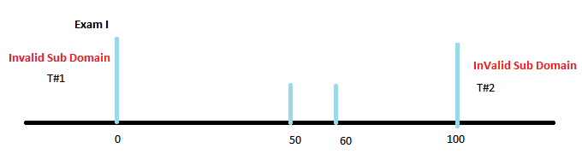

T#1: Last name=Reddy, First name=Raghunath, Student #=A20332674, Exam I =-10, Exam II = 62, Project=99

T#2: Last name=Reddy, First name=Raghunath, Student #=A20332674, Exam I =110, Exam II = 62, Project=99

**Exam II**

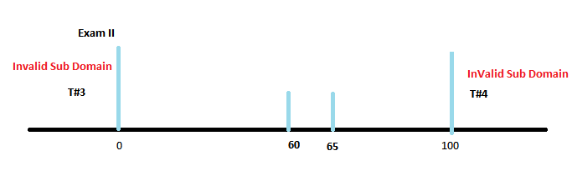

T#3: Last name=Reddy, First name=Raghunath, Student #=A20332674, Exam I =55, Exam II = -10, Project=99

T#4: Last name = Reddy, First name=Raghunath, Student #=A20332674, Exam I = 50, Exam II = 110, Project = 99

**Project**

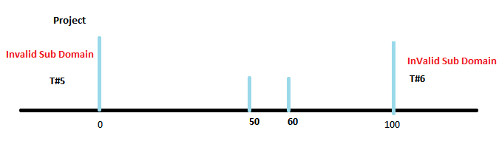

T#5: Last name=Reddy, First name=Raghunath, Student #=A20332674, Exam I =55, Exam II = 65, Project=-10

T#6: Last name = Reddy, First name=Raghunath, Student #=A20332674, Exam I = 50, Exam II = 65, Project = 110

**Average**

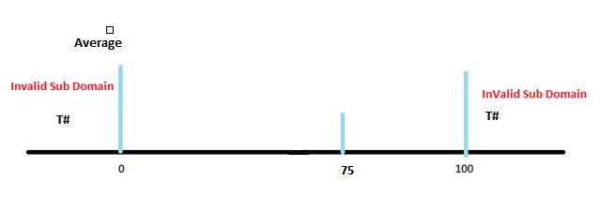

T#: Last name=Reddy, First name=Raghunath, Student #=A20332674, Exam I =-10, Exam II = -10, Project=-10 (Test Case not valid as Exam-I, Exam II, Project falls into invalid subdomains to check for average < 0 condition)

T#: Last name = Reddy, First name=Raghunath, Student #=A20332674, Exam I = 150, Exam II = 165, Project = 110

(Test Case not valid as Exam-I, Exam II, Project falls into invalid subdomains to check for average > 100 condition)

**Size of First Name**

T#7 Last name=reddy, First name=<empty>, Student #=A20332674, Exam I =55, Exam II = 65, Project=90

T#8 Last name=reddy, First name=RaghunathBasireddy, Student #=A20332674, Exam I =55, Exam II = 65, Project=90

**Size of Last Name**

T#9 Last name=<empty>, First name=Raghunath, Student #=A20332674, Exam I =55, Exam II = 65, Project=90

T#10 Last name=abcdefghijklmnopqrstuvw, First name=Raghunath, Student #=A20332674, Exam I =55, Exam II = 65, Project=90

**Student# is a 9-character string**

T#11 Last name=reddy, First name=Raghunath, Student #=A123456789, Exam I =55, Exam II = 65, Project=90

**Student# starts with “A”**

T#12 Last name=reddy, First name=Raghunath, Student #=B12345679, Exam I =55, Exam II = 65, Project=90

**X in Student# is a digit (AXXXXXXXX)**

T#13 Last name=reddy, First name=Raghunath, Student #=AA2345679, Exam I =55, Exam II = 65, Project=90

**Problem II**

1. **Normal Boundary – Value Analysis Test Cases**

From the identified input conditions in the problem I the following are the inputs which are eligible for Boundary – Value Analysis

Total no of Potential Test cases are = 42

The following are the valid intervals for the related inputs identified.

* Exam I – 3 Valid Sub Domains
  + 0 - 49
  + 50 - 59
  + 60 – 100
* Exam II – 3 Valid Sub Domains
  + 0 – 59
  + 60 – 64
  + 65 – 100
* Project – 3 Valid Sub Domains
  + 0 – 49
  + 50 – 59
  + 60 – 100
* Average – 2 Valid Sub Domains
  + 0 – 74
  + 75 – 100
* Length of First Name – 1 Valid Sub Domain
  + 0 – 12
* Length of Last Name – 1 Valid Sub Domain
  + 0 – 20
* Student#
  + 9

**Exam – I**

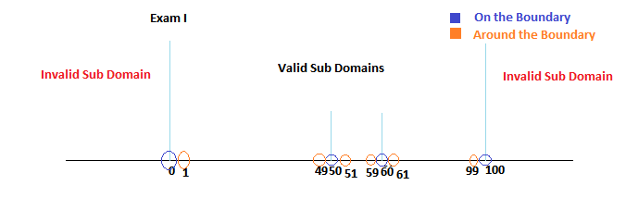

**On the Boundary**

|  |  |  |
| --- | --- | --- |
| **Test Case #** | **Consideration** | **Test Case** |
| T#1 | Exam I = 0 | Last name=reddy, First name=Raghunath, Student #=A22345679, Exam I =0, Exam II = 62, Project=90 |
| T#2 | Exam I = 50 | Last name=reddy, First name=Raghunath, Student #=A22345679, Exam I = 50, Exam II = 62, Project=90 |
| T#3 | Exam I = 60 | Last name=reddy, First name=Raghunath, Student #=A22345679, Exam I =60, Exam II = 62, Project=90 |
| T#4 | Exam I = 100 | Last name=reddy, First name=Raghunath, Student #=A22345679, Exam I =100, Exam II = 62, Project=90 |

**Around the Boundary**

|  |  |  |
| --- | --- | --- |
| **Test Case #** | **Consideration** | **Test Case** |
| T#5 | Exam I = 1 | Last name=reddy, First name=Raghunath, Student #=A22345679, Exam I =1, Exam II = 62, Project=90 |
| T#6 | Exam I = 49 | Last name=reddy, First name=Raghunath, Student #=A22345679, Exam I = 49, Exam II = 62, Project=90 |
| T#7 | Exam I = 51 | Last name=reddy, First name=Raghunath, Student #=A22345679, Exam I =51, Exam II = 62, Project=90 |
| T#8 | Exam I = 59 | Last name=reddy, First name=Raghunath, Student #=A22345679, Exam I =59, Exam II = 62, Project=90 |
| T#9 | Exam I = 61 | Last name=reddy, First name=Raghunath, Student #=A22345679, Exam I =61, Exam II = 62, Project=90 |
| T#10 | Exam I = 99 | Last name=reddy, First name=Raghunath, Student #=A22345679, Exam I =99, Exam II = 62, Project=90 |

**Exam – II**

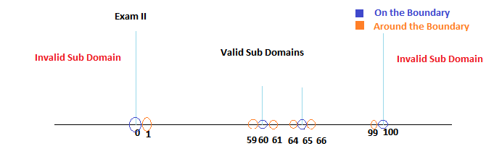

**On the Boundary**

|  |  |  |
| --- | --- | --- |
| **Test Case #** | **Consideration** | **Test Case** |
| T#11 | Exam II = 0 | Last name=reddy, First name=Raghunath, Student #=A22345679, Exam I =40, Exam II = 0, Project=90 |
| T#12 | Exam II = 60 | Last name=reddy, First name=Raghunath, Student #=A22345679, Exam I = 40, Exam II = 60, Project=90 |
| T#13 | Exam II = 65 | Last name=reddy, First name=Raghunath, Student #=A22345679, Exam I =40, Exam II = 65, Project=90 |
| T#14 | Exam II = 100 | Last name=reddy, First name=Raghunath, Student #=A22345679, Exam I =40, Exam II = 100, Project=90 |

**Around the Boundary**

|  |  |  |
| --- | --- | --- |
| **Test Case #** | **Consideration** | **Test Case** |
| T#15 | Exam II = 1 | Last name=reddy, First name=Raghunath, Student #=A22345679, Exam I =40, Exam II = 1, Project=90 |
| T#16 | Exam II = 59 | Last name=reddy, First name=Raghunath, Student #=A22345679, Exam I =40, Exam II = 59, Project=90 |
| T#17 | Exam II = 61 | Last name=reddy, First name=Raghunath, Student #=A22345679, Exam I =40, Exam II = 61, Project=90 |
| T#18 | Exam II = 64 | Last name=reddy, First name=Raghunath, Student #=A22345679, Exam I =40, Exam II = 64, Project=90 |
| T#19 | Exam II = 66 | Last name=reddy, First name=Raghunath, Student #=A22345679, Exam I =40, Exam II = 66, Project=90 |
| T#20 | Exam II = 99 | Last name=reddy, First name=Raghunath, Student #=A22345679, Exam I =40, Exam II = 99, Project=90 |

**Project**

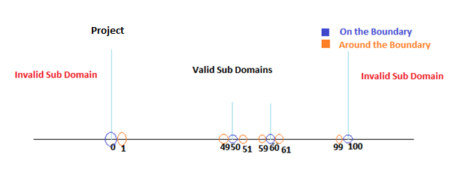

**On the Boundary**

|  |  |  |
| --- | --- | --- |
| **Test Case #** | **Consideration** | **Test Case** |
| T#21 | Project = 0 | Last name=reddy, First name=Raghunath, Student #=A22345679, Exam I =40, Exam II = 62, Project=0 |
| T#22 | Project = 50 | Last name=reddy, First name=Raghunath, Student #=A22345679, Exam I = 40, Exam II = 62, Project=50 |
| T#23 | Project = 60 | Last name=reddy, First name=Raghunath, Student #=A22345679, Exam I =40, Exam II = 62, Project=60 |
| T#24 | Project = 100 | Last name=reddy, First name=Raghunath, Student #=A22345679, Exam I =40, Exam II = 62, Project=100 |

**Around the Boundary**

|  |  |  |
| --- | --- | --- |
| **Test Case #** | **Consideration** | **Test Case** |
| T#25 | Project = 1 | Last name=reddy, First name=Raghunath, Student #=A22345679, Exam I =40, Exam II = 62, Project=1 |
| T#26 | Project = 49 | Last name=reddy, First name=Raghunath, Student #=A22345679, Exam I = 40, Exam II = 62, Project=49 |
| T#27 | Project = 51 | Last name=reddy, First name=Raghunath, Student #=A22345679, Exam I =40, Exam II = 62, Project=51 |
| T#28 | Project = 59 | Last name=reddy, First name=Raghunath, Student #=A22345679, Exam I =40, Exam II = 62, Project=59 |
| T#29 | Project = 61 | Last name=reddy, First name=Raghunath, Student #=A22345679, Exam I =40, Exam II = 62, Project=61 |
| T#30 | Project = 99 | Last name=reddy, First name=Raghunath, Student #=A22345679, Exam I =40, Exam II = 62, Project=99 |

**Average**

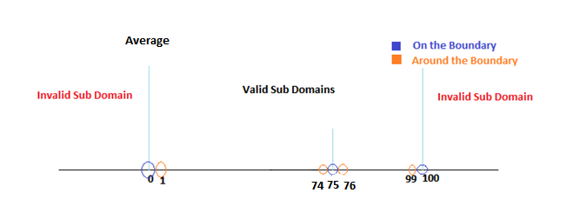

**On the Boundary**

|  |  |  |
| --- | --- | --- |
| **Test Case #** | **Consideration** | **Test Case** |
|  | Average = 0 | Not a valid test as the values for Exam I = 0, Exam II = 0 and Project = 0 are satisfying the On the boundary condition for other input conditions |
| T#31 | Average = 75 | Last name=reddy, First name=Raghunath, Student #=A22345679, Exam I = 75, Exam II = 75, Project=75 |
|  | Average = 100 | Not a valid test as the values for Exam I = 100, Exam II = 100 and Project = 100 are satisfying the On the boundary condition for other input conditions |

**Around the Boundary**

|  |  |  |
| --- | --- | --- |
| **Test Case #** | **Consideration** | **Test Case** |
|  | Average = 1 | Not a valid test as the values for Exam I = 1, Exam II = 1 and Project = 1 are satisfying the On the boundary condition for other input conditions |
| T#32 | Average = 74 | Last name=reddy, First name=Raghunath, Student #=A22345679, Exam I = 74, Exam II = 74, Project=74 |
| T#33 | Average = 76 | Last name=reddy, First name=Raghunath, Student #=A22345679, Exam I =76, Exam II = 76, Project=76 |
|  | Average = 99 | Not a valid test as the values for Exam I = 99, Exam II = 99 and Project = 99 are satisfying the On the boundary condition for other input conditions |

**Length of First Name**

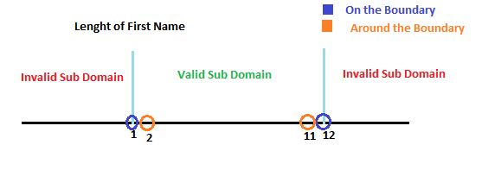

**On the Boundary**

|  |  |  |
| --- | --- | --- |
| **Test Case #** | **Consideration** | **Test Case** |
| T#34 | Length of First Name = 1 | Last name=reddy, First name=R, Student #=A22345679, Exam I = 85, Exam II = 80, Project=80 |
| T#35 | Length of First Name = 12 | Last name=reddy, First name=Raghunathabc, Student #=A22345679, Exam I = 85, Exam II = 80, Project=80 |

**Around the Boundary**

|  |  |  |
| --- | --- | --- |
| **Test Case #** | **Consideration** | **Test Case** |
| T#36 | Length of First Name = 2 | Last name=reddy, First name=Ra, Student #=A22345679, Exam I = 85, Exam II = 80, Project=80 |
| T#37 | Length of First Name = 11 | Last name=reddy, First name=Raghunathab, Student #=A22345679, Exam I = 85, Exam II = 80, Project=80 |

**Length of Last Name**

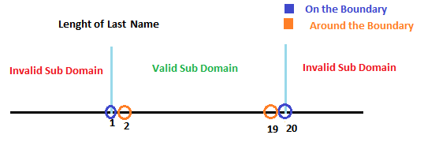

**On the Boundary**

|  |  |  |
| --- | --- | --- |
| **Test Case #** | **Consideration** | **Test Case** |
| T#38 | Length of Last Name = 1 | Last name=r, First name=Raghunath, Student #=A22345679, Exam I = 85, Exam II = 80, Project=80 |
| T#39 | Length of First Name = 20 | Last name=reddyabcdefghijklmno, First name=Raghunathabc, Student #=A22345679, Exam I = 85, Exam II = 80, Project=80 |

**Around the Boundary**

|  |  |  |
| --- | --- | --- |
| **Test Case #** | **Consideration** | **Test Case** |
| T#40 | Length of Last Name = 2 | Last name=re, First name=Ra, Student #=A22345679, Exam I = 85, Exam II = 80, Project=80 |
| T#41 | Length of Last Name = 19 | Last name= reddyabcdefghijklmn, First name=Raghunathab, Student #=A22345679, Exam I = 85, Exam II = 80, Project=80 |

**Student#**

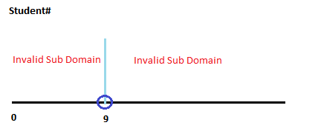

**On the Boundary**

|  |  |  |
| --- | --- | --- |
| **Test Case #** | **Consideration** | **Test Case** |
| T#42 | Student# must be 9 characters | Last name=Raghu, First name=Raghunath, Student #=A22345679, Exam I = 85, Exam II = 80, Project=80 |

1. **Robust Boundary – Value Analysis Test Cases**

From the identified input conditions in the problem I the following are the inputs which are eligible for Robust Boundary – Value Analysis with Invalid Sub Domains

* Exam I – 2 Invalid Sub Domains
  + < 0
  + > 100
* Exam II – 2 Invalid Sub Domains
  + < 0
  + > 100
* Project – 2 Invalid Sub Domains
  + < 0
  + > 100
* Average – 2 Invalid Sub Domains
  + < 0
  + > 100
* Length of First Name – 2 Invalid Sub Domains
  + = 0
  + > 12
* Length of Last Name – 2 Invalid Sub Domains
  + = 0
  + > 20
* Student# - 2 Invalid Sub Domains
  + <9
  + >9

Hence, the total no of potential test cases are: 12

**Exam I**

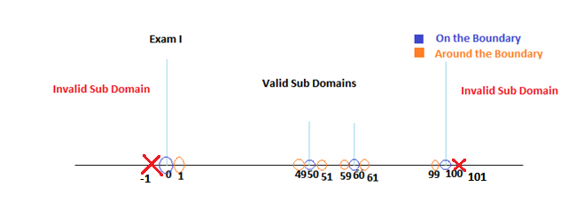

|  |  |  |
| --- | --- | --- |
| **Test Case #** | **Consideration** | **Test Case** |
| T#1 | Exam I = -1 | Last name=reddy, First name=Raghunath, Student #=A22345679, Exam I =-1, Exam II = 76, Project=76 |
| T#2 | Exam I = 101 | Last name=reddy, First name=Raghunath, Student #=A22345679, Exam I = 101, Exam II = 74, Project=74 |

**Exam II**

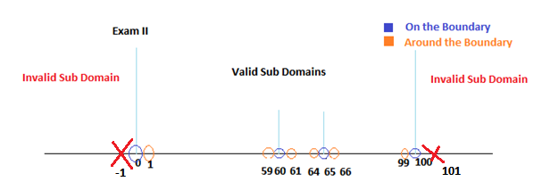

|  |  |  |
| --- | --- | --- |
| **Test Case #** | **Consideration** | **Test Case** |
| T#3 | Exam II = -1 | Last name=reddy, First name=Raghunath, Student #=A22345679, Exam I =76, Exam II = -1, Project=76 |
| T#4 | Exam II = 101 | Last name=reddy, First name=Raghunath, Student #=A22345679, Exam I = 76, Exam II = 101, Project=74 |

**Project**

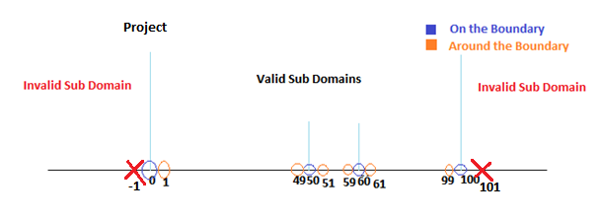

|  |  |  |
| --- | --- | --- |
| **Test Case #** | **Consideration** | **Test Case** |
| T#5 | Project = -1 | Last name=reddy, First name=Raghunath, Student #=A22345679, Exam I =76, Exam II = 76, Project=-1 |
| T#6 | Project = 101 | Last name=reddy, First name=Raghunath, Student #=A22345679, Exam I = 76, Exam II = 76, Project=101 |

**Average**

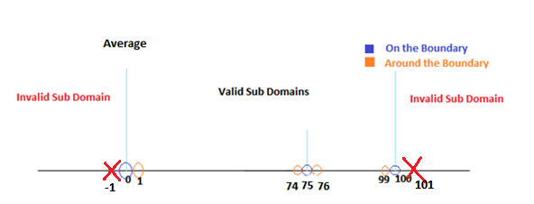

|  |  |  |
| --- | --- | --- |
| **Test Case #** | **Consideration** | **Test Case** |
|  | Average = -1 | Not a valid test as the values for Exam I = -1, Exam II = -1 and Project = - are satisfying the On the Invalid Sub Domain condition for other input conditions |
|  | Average = 101 | Not a valid test as the values for Exam I = 101, Exam II = 101 and Project = 101 are satisfying the On the boundary condition for other input conditions |

**Length of First Name**

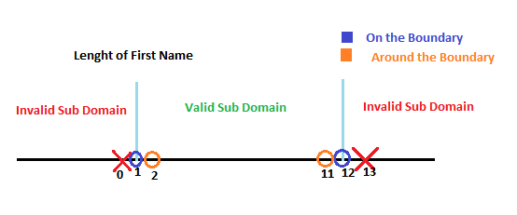

|  |  |  |
| --- | --- | --- |
| **Test Case #** | **Consideration** | **Test Case** |
| T#7 | Length of First Name = 0 | Last name=reddy, First name=<empty>, Student #=A22345679, Exam I =85, Exam II = 80, Project=80 |
| T#8 | Length of Last Name = 13 | Last name=reddy, First name=Raghunathabcd, Student #=A22345679, Exam I = 85, Exam II = 80, Project=80 |

**Length of Last Name**

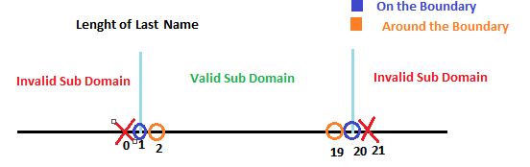

|  |  |  |
| --- | --- | --- |
| **Test Case #** | **Consideration** | **Test Case** |
| T#9 | Length of Last Name = 0 | Last name=<empty>, First name=Raghunath, Student #=A22345679, Exam I =85, Exam II = 80, Project=80 |
| T#10 | Length of Last Name = 21 | Last name=reddyabcdefghijklmnop, First name=Raghunath, Student #=A22345679, Exam I = 85, Exam II = 80, Project=80 |

**Student#**

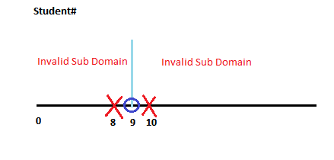

|  |  |  |
| --- | --- | --- |
| **Test Case #** | **Consideration** | **Test Case** |
| T#11 | Student# Characters = 8 | Last name=Reddy, First name=Raghunath, Student #=A2234567, Exam I =85, Exam II = 80, Project=80 |
| T#12 | Student# Characters = 10 | Last name=Reddy, First name=Raghunath, Student #=A223456790, Exam I = 85, Exam II = 80, Project=80 |

|  |  |
| --- | --- |
| **Problem III** |  |
|  |  |
| **Input Variables** | x1, y1, x2, y2, x3, y3 |
|  |  |
| **Co-Ordinates in XY Axis** | P1 (x1, y1), P2 (x2, y2), P3 (x3, y3) |
|  |  |
| **Input Conditions Given** |  |
|  | -100=x1< = 100' |
|  | -100=y1< = 100' |
|  | -100=x2< = 100' |
|  | -100=y2< = 100' |
|  | -100=x3< = 100' |
|  | -100=y3< = 100' |
|  |  |
| **Assumptions** |  |
|  | Let 'a' be the length of the side P2, P3 |
|  | Let 'b' be the length of the side P1, P3 |
|  | Let 'c' be the length of the side P1, P2 |
|  |  |
|  |  |

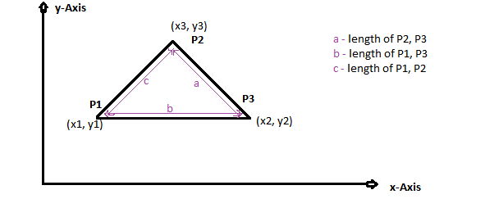

|  |  |
| --- | --- |
| **Input Conditions** | |
| C1: | -100=x1< = 100' |
| C2: | -100=y1< = 100' |
| C3: | -100=x2< = 100' |
| C4: | -100=y2< = 100' |
| C5: | -100=x3< = 100' |
| C6: | -100=y3< = 100' |
| C7: | a<b+c |
| C8: | b<a+c |
| C9: | c<a+b |
| C10: | a=b |
| C11: | a=c |
| C12: | b=c |
| C13: | a = Sqrt(b^2 + c^2) |
| C14: | b = Sqrt(a^2 + c^2) |
| C15: | c = Sqrt(a^2 + b^2) |

|  |  |  |  |
| --- | --- | --- | --- |
| **Actions** |  |  |  |
| A1: |  | Equilateral Triangle | |
| A2: |  | Isosceles Triangle | |
| A3: |  | Scalene Triangle | |
| A4: |  | Right Triangle | |
| A5: |  | Not a Triangle | |
| A6: |  | Invalid Input | |

|  |  |  |  |  |  |  |
| --- | --- | --- | --- | --- | --- | --- |
| Decision Table |  | Rule1 | Rule2 | Rule3 | Rule4 | Rule5 |
| C1: | -100=x1< = 100' | F | - | - | - | - |
| C2: | -100=y1< = 100' | - | F | - | - | - |
| C3: | -100=x2< = 100' | - | - | F | - | - |
| C4: | -100=y2< = 100' | - | - | - | F | - |
| C5: | -100=x3< = 100' | - | - | - | - | F |
| C6: | -100=y3< = 100' | - | - | - | - | - |
| C7: | a<b+c | - | - | - | - | - |
| C8: | b<a+c | - | - | - | - | - |
| C9: | c<a+b | - | - | - | - | - |
| C10: | a=b | - | - | - | - | - |
| C11: | a=c | - | - | - | - | - |
| C12: | b=c | - | - | - | - | - |
| C13: | a = Sqrt(b^2 + c^2) | - | - | - | - | - |
| C14: | b = Sqrt(a^2 + c^2) | - | - | - | - | - |
| C15: | c = Sqrt(a^2 + b^2) | - | - | - | - | - |
| A1: | Equilateral Triangle |  |  |  |  |  |
| A2: | Isosceles Triangle |  |  |  |  |  |
| A3: | Scalene Triangle |  |  |  |  |  |
| A4: | Right Triangle |  |  |  |  |  |
| A5: | Not a Triangle |  |  |  |  |  |
| A6: | Invalid Input | X | X | X | X | X |
| A7: | Not a Valid Scenario |  |  |  |  |  |

|  |  |  |  |  |  |  |  |  |  |  |
| --- | --- | --- | --- | --- | --- | --- | --- | --- | --- | --- |
| Rule6 | Rule7 | Rule8 | Rule9 | Rule10 | Rule11 | Rule12 | Rule13 | Rule14 | Rule15 | Rule16 |
| - | T | T | T | T | T | T | T | T | T | T |
| - | T | T | T | T | T | T | T | T | T | T |
| - | T | T | T | T | T | T | T | T | T | T |
| - | T | T | T | T | T | T | T | T | T | T |
| - | T | T | T | T | T | T | T | T | T | T |
| F | T | T | T | T | T | T | T | T | T | T |
| - | F | - | - | T | T | T | T | T | T | T |
| - | - | F | - | T | T | T | T | T | T | T |
| - | - | - | F | T | T | T | T | T | T | T |
| - | - | - | - | T | T | T | T | T | T | T |
| - | - | - | - | T | T | T | T | T | T | T |
| - | - | - | - | T | T | T | T | T | T | T |
| - | - | - | - | T | T | T | T | F | F | F |
| - | - | - | - | T | T | F | F | T | T | F |
| - | - | - | - | T | F | T | F | T | F | T |
|  |  |  |  |  |  |  |  |  |  |  |
|  |  |  |  |  |  |  |  |  |  |  |
|  |  |  |  |  |  |  |  |  |  |  |
|  |  |  |  |  |  |  |  |  |  |  |
|  | X | X | X |  |  |  |  |  |  |  |
| X |  |  |  |  |  |  |  |  |  |  |
|  |  |  |  | X | X | X | X | X | X | X |

|  |  |  |  |  |  |  |  |  |  |  |
| --- | --- | --- | --- | --- | --- | --- | --- | --- | --- | --- |
| Rule17 | Rule18 | Rule19 | Rule20 | Rule21 | Rule22 | Rule23 | Rule24 | Rule25 | Rule26 | Rule27 |
| T | T | T | T | T | T | T | T | T | T | T |
| T | T | T | T | T | T | T | T | T | T | T |
| T | T | T | T | T | T | T | T | T | T | T |
| T | T | T | T | T | T | T | T | T | T | T |
| T | T | T | T | T | T | T | T | T | T | T |
| T | T | T | T | T | T | T | T | T | T | T |
| T | T | T | T | T | T | T | T | T | T | T |
| T | T | T | T | T | T | T | T | T | T | T |
| T | T | T | T | T | T | T | T | T | T | T |
| T | T | T | T | T | T | T | T | T | T | T |
| T | T | T | T | T | T | T | T | T | F | F |
| T | F | F | F | F | F | F | F | F | T | T |
| F | T | T | T | T | F | F | F | F | T | T |
| F | T | T | F | F | T | T | F | F | T | T |
| F | T | F | T | F | T | F | T | F | T | F |
| X |  |  |  |  |  |  |  |  |  |  |
|  |  |  |  |  |  |  |  |  |  |  |
|  |  |  |  |  |  |  |  |  |  |  |
|  |  |  |  |  |  |  |  |  |  |  |
|  |  |  |  |  |  |  |  |  |  |  |
|  |  |  |  |  |  |  |  |  |  |  |
|  | X | X | X | X | X | X | X | X | X | X |

|  |  |  |  |  |  |  |  |  |  |  |
| --- | --- | --- | --- | --- | --- | --- | --- | --- | --- | --- |
| Rule28 | Rule29 | Rule30 | Rule31 | Rule32 | Rule33 | Rule34 | Rule35 | Rule36 | Rule37 | Rule38 |
| T | T | T | T | T | T | T | T | T | T | T |
| T | T | T | T | T | T | T | T | T | T | T |
| T | T | T | T | T | T | T | T | T | T | T |
| T | T | T | T | T | T | T | T | T | T | T |
| T | T | T | T | T | T | T | T | T | T | T |
| T | T | T | T | T | T | T | T | T | T | T |
| T | T | T | T | T | T | T | T | T | T | T |
| T | T | T | T | T | T | T | T | T | T | T |
| T | T | T | T | T | T | T | T | T | T | T |
| T | T | T | T | T | T | T | T | T | T | T |
| F | F | F | F | F | F | F | F | F | F | F |
| T | T | T | T | T | T | F | F | F | F | F |
| T | T | F | F | F | F | T | T | T | T | F |
| F | F | T | T | F | F | T | T | F | F | T |
| T | F | T | F | T | F | T | F | T | F | T |
|  |  |  |  |  |  |  |  |  |  |  |
|  |  |  |  |  |  |  |  |  |  |  |
|  |  |  |  |  |  |  |  |  |  |  |
|  |  |  |  |  |  |  |  |  |  |  |
|  |  |  |  |  |  |  |  |  |  |  |
|  |  |  |  |  |  |  |  |  |  |  |
| X | X | X | X | X | X | X | X | X | X | X |

|  |  |  |  |  |  |  |  |  |  |  |
| --- | --- | --- | --- | --- | --- | --- | --- | --- | --- | --- |
| Rule39 | Rule40 | Rule41 | Rule42 | Rule43 | Rule44 | Rule45 | Rule46 | Rule47 | Rule48 | Rule49 |
| T | T | T | T | T | T | T | T | T | T | T |
| T | T | T | T | T | T | T | T | T | T | T |
| T | T | T | T | T | T | T | T | T | T | T |
| T | T | T | T | T | T | T | T | T | T | T |
| T | T | T | T | T | T | T | T | T | T | T |
| T | T | T | T | T | T | T | T | T | T | T |
| T | T | T | T | T | T | T | T | T | T | T |
| T | T | T | T | T | T | T | T | T | T | T |
| T | T | T | T | T | T | T | T | T | T | T |
| T | T | T | F | F | F | F | F | F | F | F |
| F | F | F | T | T | T | T | T | T | T | T |
| F | F | F | T | T | T | T | T | T | T | T |
| F | F | F | T | T | T | T | F | F | F | F |
| T | F | F | T | T | F | F | T | T | F | F |
| F | T | F | T | F | T | F | T | F | T | F |
|  |  |  |  |  |  |  |  |  |  |  |
|  | X | X |  |  |  |  |  |  |  |  |
|  |  |  |  |  |  |  |  |  |  |  |
|  | X |  |  |  |  |  |  |  |  |  |
|  |  |  |  |  |  |  |  |  |  |  |
|  |  |  |  |  |  |  |  |  |  |  |
| X |  |  | X | X | X | X | X | X | X | X |

|  |  |  |  |  |  |  |  |  |  |  |
| --- | --- | --- | --- | --- | --- | --- | --- | --- | --- | --- |
| Rule50 | Rule51 | Rule52 | Rule53 | Rule54 | Rule55 | Rule56 | Rule57 | Rule58 | Rule59 | Rule60 |
| T | T | T | T | T | T | T | T | T | T | T |
| T | T | T | T | T | T | T | T | T | T | T |
| T | T | T | T | T | T | T | T | T | T | T |
| T | T | T | T | T | T | T | T | T | T | T |
| T | T | T | T | T | T | T | T | T | T | T |
| T | T | T | T | T | T | T | T | T | T | T |
| T | T | T | T | T | T | T | T | T | T | T |
| T | T | T | T | T | T | T | T | T | T | T |
| T | T | T | T | T | T | T | T | T | T | T |
| F | F | F | F | F | F | F | F | F | F | F |
| T | T | T | T | T | T | T | T | F | F | F |
| F | F | F | F | F | F | F | F | T | T | T |
| T | T | T | T | F | F | F | F | T | T | T |
| T | T | F | F | T | T | F | F | T | T | F |
| T | F | T | F | T | F | T | F | T | F | T |
|  |  |  |  |  |  |  |  |  |  |  |
|  |  |  |  |  | X |  | X |  |  |  |
|  |  |  |  |  |  |  |  |  |  |  |
|  |  |  |  |  | X |  |  |  |  |  |
|  |  |  |  |  |  |  |  |  |  |  |
|  |  |  |  |  |  |  |  |  |  |  |
| X | X | X | X | X |  | X |  | X | X | X |

|  |  |  |  |  |  |  |  |  |  |  |  |  |
| --- | --- | --- | --- | --- | --- | --- | --- | --- | --- | --- | --- | --- |
| Rule61 | Rule62 | Rule63 | Rule64 | Rule65 | Rule66 | Rule67 | Rule68 | Rule69 | Rule70 | Rule71 | Rule72 | Rule73 |
| T | T | T | T | T | T | T | T | T | T | T | T | T |
| T | T | T | T | T | T | T | T | T | T | T | T | T |
| T | T | T | T | T | T | T | T | T | T | T | T | T |
| T | T | T | T | T | T | T | T | T | T | T | T | T |
| T | T | T | T | T | T | T | T | T | T | T | T | T |
| T | T | T | T | T | T | T | T | T | T | T | T | T |
| T | T | T | T | T | T | T | T | T | T | T | T | T |
| T | T | T | T | T | T | T | T | T | T | T | T | T |
| T | T | T | T | T | T | T | T | T | T | T | T | T |
| F | F | F | F | F | F | F | F | F | F | F | F | F |
| F | F | F | F | F | F | F | F | F | F | F | F | F |
| T | T | T | T | T | F | F | F | F | F | F | F | F |
| T | F | F | F | F | T | T | T | T | F | F | F | F |
| F | T | T | F | F | T | T | F | F | T | T | F | F |
| F | T | F | T | F | T | F | T | F | T | F | T | F |
|  |  |  |  |  |  |  |  |  |  |  |  |  |
| X |  |  |  | X |  |  |  |  |  |  |  |  |
|  |  |  |  |  |  |  |  | X |  | X | X | X |
| X |  |  |  |  |  |  |  | X |  | X | X |  |
|  |  |  |  |  |  |  |  |  |  |  |  |  |
|  |  |  |  |  |  |  |  |  |  |  |  |  |
|  | X | X | X |  | X | X | X | X | X |  |  |  |

**Note:** Rule17, Rule40, Rule41, Rule55, Rule57, Rule61, Rule65, Rule69, Rule71, Rule72, Rule73 are valid and potential rules for which test cases can be considered.

**Other rules are not valid for the following reasons**

1. Triangle can never be both equilateral (a=b & b=c & a=c) and right(a = Sqrt(b^2 + c^2) Or b = Sqrt(a^2 + c^2) Or c = Sqrt(a^2 + b^2))  
2. Triangle can have only one right angle (a = Sqrt(b^2 + c^2) Or b = Sqrt(a^2 + c^2) Or c = Sqrt(a^2 + b^2))  
3. Triangle can never have such a case that length of a side equal to other two sides and the lengths of other two sides not equal (a=b, b=c, a<>c)   
4. In a Right triangle if length of two sides are equal the angle projected by those two equal sides is always right angle (90 degrees)

The following are the potential test cases retrieved from decision table.

|  |  |  |
| --- | --- | --- |
| **Test Cases #** | **Test Cases** | **Output Action** |
| Rule17: T#1 | x1=0, y1=0, x2=2, y2=2Sqrt(3), x3=4, y3=0 | Equilateral Triangle |
| Rule40: T#2 | x1=0, y1=4, x2=4, y2=0, x3=0, y3=0 | Right & Isosceles (a=b & c^2 = a^2 + b^2) |
| Rule41: T#3 | x1=-6, y1=0, x2=6, y2=0, x3=0, y3=7 | Isosceles (a = b) |
| Rule55: T#4 | x1=0, y1=4, x2=0, y2=0, x3=4, y3=0 | Right & Isosceles (a=c & b^2 = a^2 + c^2) |
| Rule57: T#5 | x1=-6, y1=0, x2=0, y2=7, x3=6, y3=0 | Isosceles (a = c) |
| Rule61: T#6 | x1=0, y1=0, x2=0, y2=4, x3=4, y3=0 | Right & Isosceles (b=c & a^2 = b^2 + c^2) |
| Rule65: T#7 | x1=0, y1=7, x2=-6, y2=0, x3=6, y3=0 | Isosceles (b = c) |
| Rule69: T#8 | x1=0, y1=0, x2=55, y2=0, x3=0, y3=75 | Right & Scalene |
| Rule71: T#9 | x1=-50, y1=0, x2=0, y2=0, x3=0, y3=-75 | Right & Scalene |
| Rule72: T#10 | x1=0, y1=80, x2=-90, y2=0, x3=0, y3=0 | Right & Scalene |
| Rule73: T#11 | x1=-3, y1=0, x2=5, y2=0, x3=0, y3=7 | Scalene |