Introduction to GIT
get init => Initialize git repository for our proj

3 parts
- Working Directory
- Staging Area
- Repository

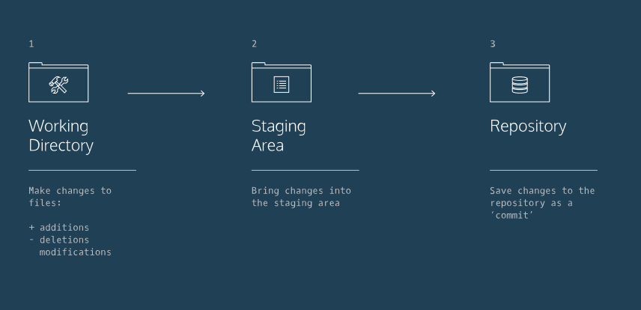

git status
Gives status of the current project.
Files marked in red are not being tracked.
Add to Staging area
In order for Git to track those files need to be added to staging area
git add filename
git add filename_1 filename_2 => //Add multiple file to Staging area

Now it’s added to staging area. Now check the status.

Check Difference
git provides options to see difference between files from working dir and staging dir.
git diff filename

Commit
Its last step
Our changes moved from Staging area to Working dir.
We can give message also.
git commit -m "Complete first line of dialogue"

Standard Conventions for Commit Messages:
- Must be in quotation marks
- Written in the present tense
- Should be brief (50 characters or less) when using -m

Log
We can see log info.
40-character code, called a SHA, that uniquely identifies the commit.

Head Commit
Latest commit is known as Head commit. Looks like its output of git log + git diff file
git show HEAD

Undo last changes
Get the latest changes from working dir to staging area.
git checkout HEAD filename

Reset
If we want to revert the changes before commit. Unstage a file.
git reset HEAD filename

Revert the changes to instead of Latest commit.
git reset SHA

Git Command | Description
git init | creates a new Git repository
git status | inspects the contents of the working directory and staging area
git add | adds files from the working directory to the staging area
git diff | shows the difference between the working directory and the staging area
git commit | permanently stores file changes from the staging area in the repository
git log | shows a list of all previous commits
git checkout HEAD filename | Discards changes in the working directory.
git reset HEAD filename | Unstages file changes in the staging area.
git reset SHA

Master – Branch
git branch => Get branch details.

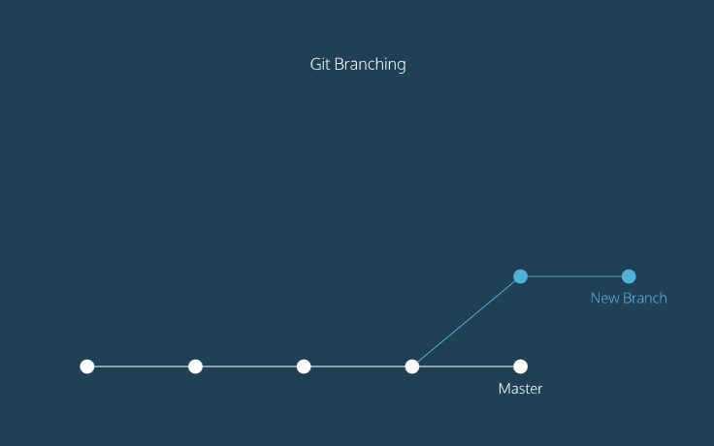
- The circles are commits, and together form the Git project's commit history.
- New Branch is a different version of the Git project. It contains commits from Master but also has commits that Master does not have.
Create New Branch
git branch branch_name=> Get branch details.

Switch to Branch from Master
git checkout branch_name

Git Command | Description
git init | creates a new Git repository
git status | inspects the contents of the working directory and staging area
git add | adds files from the working directory to the staging area
git diff | shows the difference between the working directory and the staging area
git commit | permanently stores file changes from the staging area in the repository
git log | shows a list of all previous commits
git checkout HEAD filename | Discards changes in the working directory.
git reset HEAD filename | Unstages file changes in the staging area.
git reset SHA
git branch | Lists all a Git project's branches.
git branch branch_name | Creates a new branch.
git checkout branch_name | Used to switch from one branch to another.
git merge branch_name | Used to join file changes from one branch to another.
git branch -d branch_name | Deletes the branch specified.

Work in Collaborate manner
Multiple work on the same project repository.
git clone remote_location clone_name

remote_location => webpath/file path to find which repository should be cloned
clone_name => Name of the directory where files will be cloned from remote_location.

git remote -v
It gives name of the remote address, path
By default it’s named as origin.

git fetch
See latest changes in the remote and bring the changes down to your local copy.

The workflow for Git collaborations typically follows this order:
- Fetch and merge changes from the remote
- Create a branch to work on a new project feature
- Develop the feature on your branch and commit your work
- Fetch and merge from the remote again (in case new commits were made while you were working)
- Push your branch up to the remote for review

git push origin your_branch_name
origin => Remote name
your_branch_name => name of the branch in our local
It will push our branch to remote(origin).

Git Command | Description
git clone | Creates a local copy of a remote.
git remote –v | Lists a Git project's remotes.
git fetch | Fetches work from the remote into the local copy.
git merge origin/master | Merges origin/master into your local branch.
git push origin <branch_name> | Pushes a local branch to the origin remote.

