1.Clone the project from the <https://github.com/raghugattu6/Rewards_Calculator>

2.Import the RewardPointsCalculatorApplication In the STS or Intellij.

3.Select build type as Maven

4.Once the maven dependency import done, try to run the application.

After running the application, open <http://localhost:8080/h2-console/> and run the queries mentioned in script.sql file so it will load data into database.

Db details :

spring.datasource.url=jdbc:h2:mem:default  
spring.datasource.driverClassName=org.h2.Driver

spring.datasource.username=sa

spring.datasource.password=sa

spring.jpa.database-platform=org.hibernate.dialect.H2Dialect

5.Try to hit the api <http://localhost:8080/customers/1001/rewards>

**Data loaded :**

INSERT INTO CUSTOMER(CUSTOMER_ID,CUSTOMER_NAME) values (1001,'Customer1');  
INSERT INTO TRANSACTION(TRANSACTION_ID,CUSTOMER_ID,TRANSACTION_DATE,AMOUNT) VALUES (10001,1001,'2024-02-12',120);

INSERT INTO TRANSACTION(TRANSACTION_ID,CUSTOMER_ID,TRANSACTION_DATE,AMOUNT) VALUES (10002,1001,'2024-01-09',85);

INSERT INTO TRANSACTION(TRANSACTION_ID,CUSTOMER_ID,TRANSACTION_DATE,AMOUNT) VALUES (10003,1001,'2024-01-15',85);

**Response:**

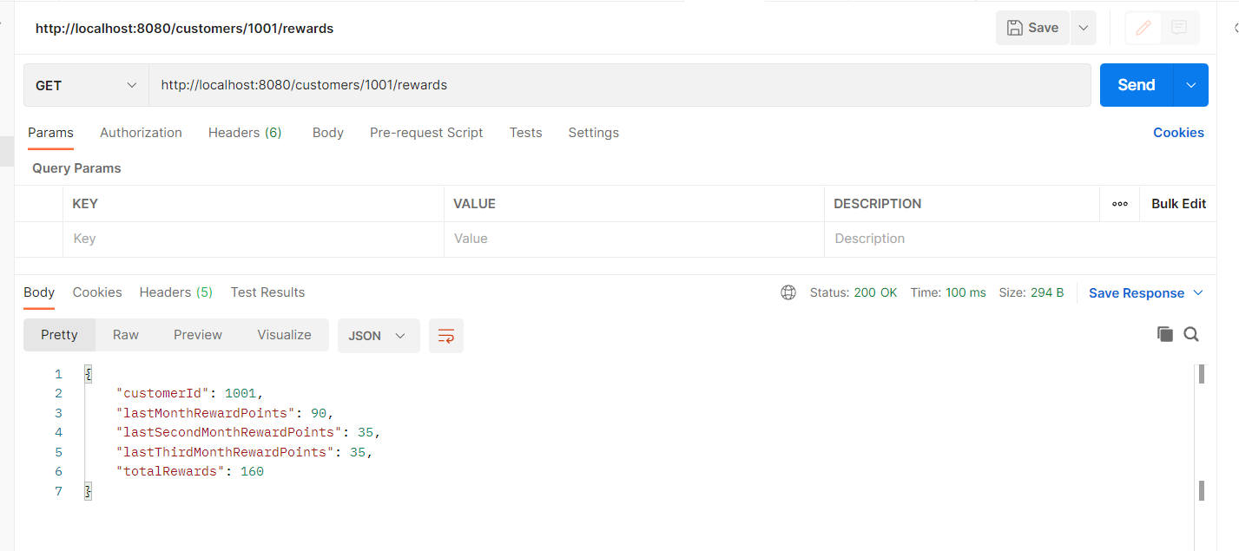

If customer is not found, it will throw the custom exception   
  
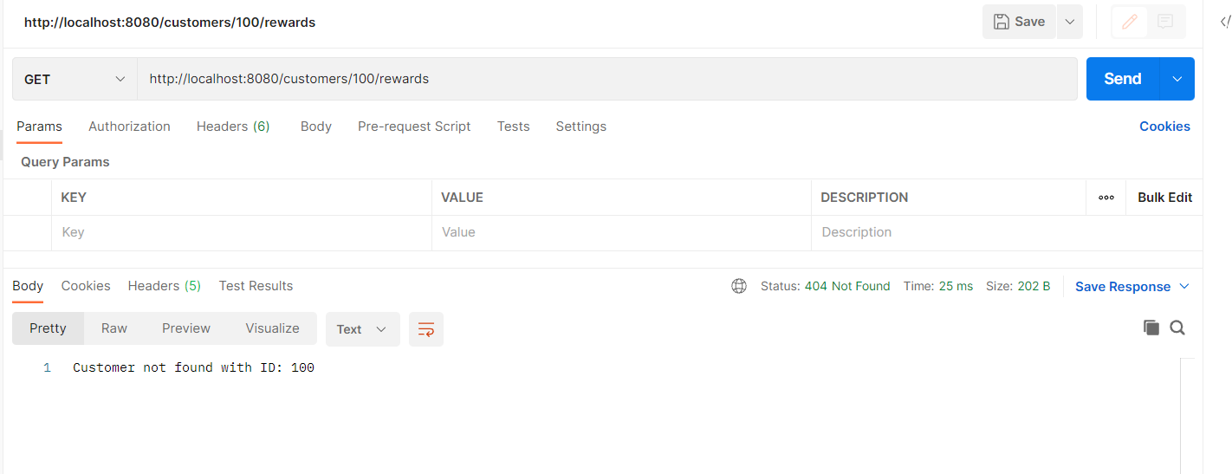

For checking the test cases, try to run junit in editor so we can see test cases passed

