Hibernate Tutorial

This hibernate tutorial provides in-depth concepts of Hibernate Framework with simplified examples. It was started in 2001 by Gavin King as an alternative to EJB2 style entity bean. The stable release of Hibernate till July 16, 2014, is [hibernate 4.3.6](http://hibernate.org/orm/downloads/). It is helpful for beginners and experienced persons.

An ORM tool simplifies the data creation, data manipulation and data access. It is a programming technique that maps the object to the data stored in the database.

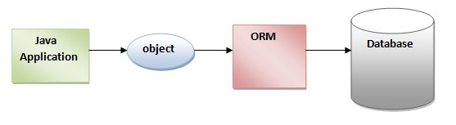

The ORM tool internally uses the JDBC API to interact with the database.

### Advantages of Hibernate Framework

There are many advantages of Hibernate Framework. They are as follows:

**1) Opensource and Lightweight:** Hibernate framework is opensource under the LGPL license and lightweight.

**2) Fast performance:** The performance of hibernate framework is fast because cache is internally used in hibernate framework. There are two types of cache in hibernate framework first level cache and second level cache. First level cache is enabled bydefault.

**3) Database Independent query:** HQL (Hibernate Query Language) is the object-oriented version of SQL. It generates the database independent queries. So you don't need to write database specific queries. Before Hibernate, If database is changed for the project, we need to change the SQL query as well that leads to the maintenance problem.

**4) Automatic table creation:** Hibernate framework provides the facility to create the tables of the database automatically. So there is no need to create tables in the database manually.

**5) Simplifies complex join:** To fetch data form multiple tables is easy in hibernate framework.

**6) Provides query statistics and database status:** Hibernate supports Query cache and provide statistics about query and database status.

# Hibernate Architecture

The Hibernate architecture includes many objects persistent object, session factory, transaction factory, connection factory, session, transaction etc.

There are 4 layers in hibernate architecture java application layer, hibernate framework layer, backhand api layer and database layer.Let's see the diagram of hibernate architecture:

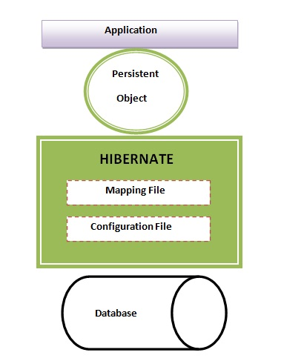

This is the high level architecture of Hibernate with mapping file and configuration file.

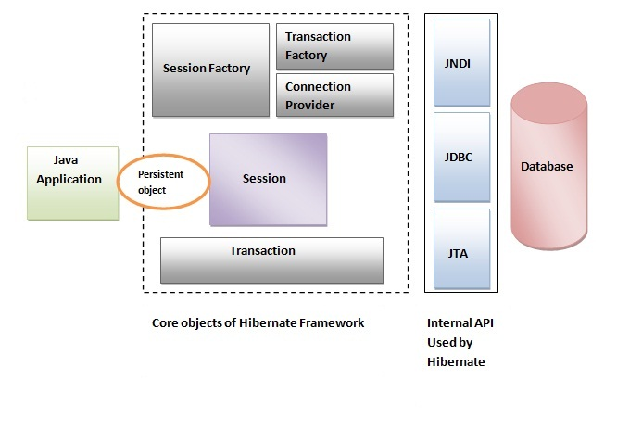

Hibernate framework uses many objects session factory, session, transaction etc. alongwith existing Java API such as JDBC (Java Database Connectivity), JTA (Java Transaction API) and JNDI (Java Naming Directory Interface).

## Elements of Hibernate Architecture

|  |
| --- |
| For creating the first hibernate application, we must know the elements of Hibernate architecture. They are as follows: |

#### SessionFactory

The SessionFactory is a factory of session and client of ConnectionProvider. It holds second level cache (optional) of data. The org.hibernate.SessionFactory interface provides factory method to get the object of Session.

#### Session

The session object provides an interface between the application and data stored in the database. It is a short-lived object and wraps the JDBC connection. It is factory of Transaction, Query and Criteria. It holds a first-level cache (mandatory) of data. The org.hibernate.Session interface provides methods to insert, update and delete the object. It also provides factory methods for Transaction, Query and Criteria.

#### Transaction

The transaction object specifies the atomic unit of work. It is optional. The org.hibernate.Transaction interface provides methods for transaction management.

#### ConnectionProvider

It is a factory of JDBC connections. It abstracts the application from DriverManager or DataSource. It is optional.

#### TransactionFactory

It is a factory of Transaction. It is optional.

# Hibernate First Application in Eclipse IDE

1. Create the java project
2. Add jar files for hibernate
3. Create the Persistent class
4. Create the mapping file for Persistent class
5. Create the Configuration file
6. Create the class that retrieves or stores the persistent object
7. Run the application

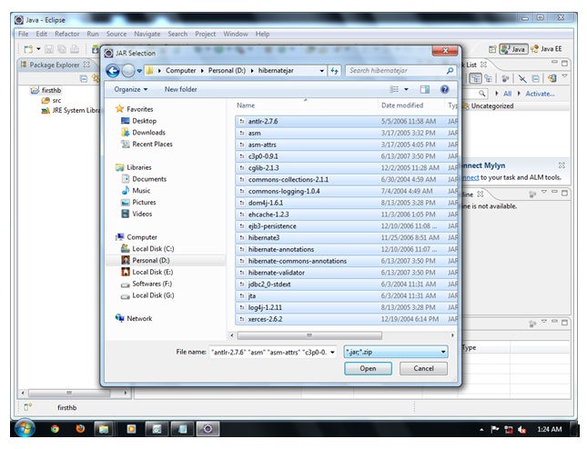

#### Note: You need to connect with the internet to run this example.

<https://www.javatpoint.com/web-application-with-hibernate> skipped we app

<https://www.javatpoint.com/hibernate-table-per-hierarchy-example-using-xml-file> skipped

<https://www.javatpoint.com/hibernate-table-per-hierarchy-using-annotation-tutorial-example> skipped

<https://www.javatpoint.com/table-per-concrete-class> skipped

<https://www.javatpoint.com/hibernate-table-per-concrete-class-using-annotation-tutorial-example> skipped

<https://www.javatpoint.com/table-per-subclass> skipped

<https://www.javatpoint.com/hibernate-table-per-subclass-using-annotation-tutorial-example> skipped

one to may - List available

one to many – Set not available in site

<https://www.javatpoint.com/many-to-many-mapping-in-hibernate-by-map-example>

continue link