**Test Cases:-**

**Test Case1:-**

Invalid Gmail Address:-

Action :- Prompt it is wrong and show a pop-up to try again

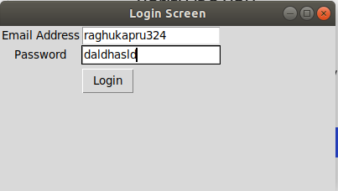

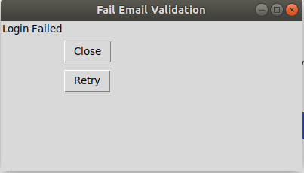

**Test Case 2:-**

Incorrect Password:-

Action:- Login Fail popup and msg to retry

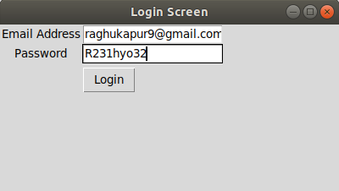

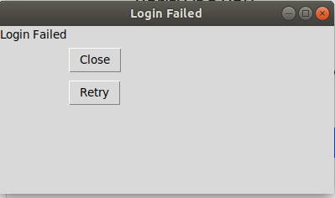

**Test Case 3:-**

Invalid To Email Address:-

Action :- Prompt it is wrong and show a pop-up to try again

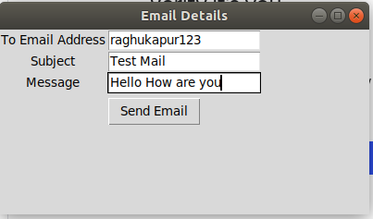



**Test Case 4:-**

All corrects Inputs Passed:-

Action:- Mail is sent

