Holland Mountain
Issue Date: 03/02/2026

File Upload Service
Version 1.0
Raghu Karnati
Sr. Full Stack Developer

Contents
Contents 2
1 INTRODUCTION 3
1.1 Key Features 3
1.1.1 Tech Stack 3
2 High-Level Architecture 3
3 Project Structure (Backend) 4
4 How It Works (End-to-End Flow) 5
5 API Endpoints 5
6 Running the Application Locally 5
6.1 Prerequisites 5
6.2 Backend (API) 6
6.3 Frontend (Angular) 6
7 Assumptions & Limitations 6
8 Extensibility & Future Improvements 6
9 Purpose of This POC 7
10 Application UI Screenshots 7

INTRODUCTION
This project is a proof of concept (POC) for a simple file upload service built as part of a data platform.
It allows users to upload files (e.g. PDFs, images), associate them with a record ID, persist the files locally, and view uploaded files along with their metadata.
The focus of this POC is clarity, modularity, and extensibility, rather than production-level robustness or UI polish.

Key Features
- Upload files via a web UI
- Associate uploads with a recordId
- Persist files to local disk
- Store and display file metadata
- Clean separation of concerns between API, storage, and UI

Tech Stack
Backend
- ASP.NET Core Web API (.Net 10 using Visual Studio 2026 Community Edition)
- C#
- Dependency Injection
- Local file system storage
- In-memory metadata persistence
Frontend
- Angular 20
- TypeScript
- HTML / CSS
- HTTP client for API communication

High-Level Architecture
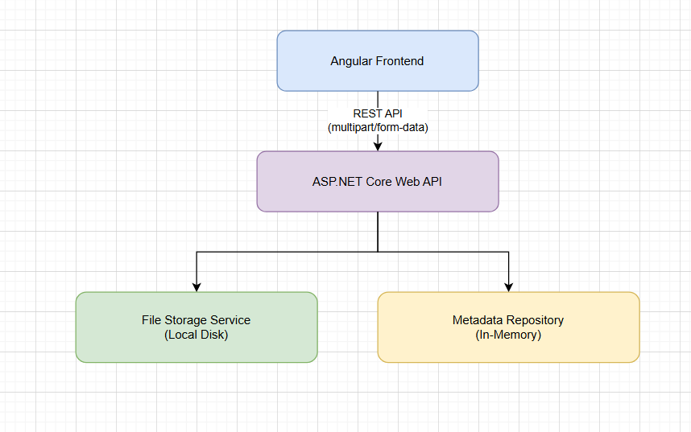

Project Structure (Backend)
This structure allows storage and persistence mechanisms to be swapped easily in the future.
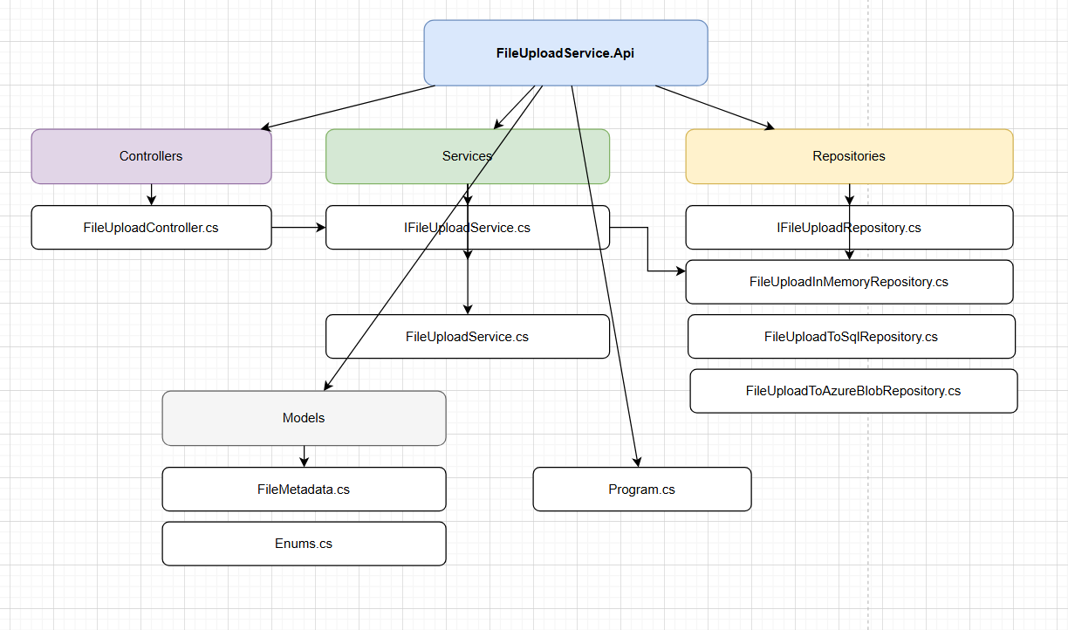

How It Works (End-to-End Flow)
- User selects a file and a recordId in the UI
- Frontend sends a multipart/form-data POST request to the API
- API saves the file using the storage service
- Metadata is stored separately from the binary file
- Metadata for the uploaded files is returned to the UI for display

API Endpoints

Upload File
POST /api/fileupload/UploadFile
Request
- file (multipart file)
- recordId (string)
Response
- Uploaded File Guid
- We can make improvements to return rest of the File metadata (id, name, size, content type, upload time)

Get Files by Record ID
GET /api/fileupload/GetFilesByRecordTypeId?recordTypeId=1
Response
- List of uploaded files associated with the given record ID

Get All Files
GET /api/fileupload/GetAllFiles
Response
- List of all the uploaded files

Running the Application Locally

Prerequisites
- .NET 10 SDK (or compatible)
- Node.js (v22+ recommended)
- Npm – 11.7.0
- Angular CLI – Angular 20

Backend (API)
- Download the Frontend and Backend projects from the GIT repository located at https://github.com/raghukarnati158/FileUploadService
- Open Command prompt (with Admin rights) and navigate to the folder where the slnx file is located. For example:
cd \GIT\FileUploadService\FileUploadServiceUI
- Run this command first: dotnet restore
- And then run this command: dotnet run
- The API will start on:
https://localhost:5161
- Uploaded files will be saved to:
/UploadedFiles

Frontend (Angular)
- Open another command prompt (with Admin rights) and navigate to the UI project folder where the package.json is located. For example:
cd \GIT\FileUploadService\FileUploadServiceUI
- npm install
- Now check if the API Url is configured correctly in the UI project. Go to this file: \GIT\FileUploadService\FileUploadServiceUI\src\app\services\file-upload.service.ts
- At line number 11, update the port number for the baseUrl variable if necessary. This baseUrl should match the WebApi Url that is running locally. You can get this UR from the Command Prompt where you are running the WebApi
- ng serve --open
- The UI will be available at:
- http://localhost:4200
- You should see the UI application running and also talking to the WebApi for File upload functionality.

Assumptions & Limitations
- No authentication or authorization
- Files are stored on local disk only
- Metadata is stored in memory and will reset on restart
- UI is functional but intentionally minimal
These trade-offs were made intentionally to keep the POC lightweight and focused.

Extensibility & Future Improvements
If this were to evolve into a production-ready service, the following enhancements would be considered:
Storage
- Replace local storage with Azure Blob Storage or AWS S3 Bucket
- Use pre-signed URLs for direct client uploads
- Add virus scanning and content validation
Backend (WebApi)
- Authentication (OAuth / Azure AD)
- Authorization at record level
- File type and size restrictions (Enhancements might be needed)
- File encryption
- Backend Validations
- Use CORS policies
- Error Handling
- Swagger for API Documentation
- Avoid hardcoded RecordTypes in Enums.cs and get RecordTypes from Database
- Handling multiple File uploads in a single request depending on the payload size
- Handling multiple uploads for multiple recordtypes in a single request
- Implement Caching to improve API efficiency.
UI
- Responsive pages
- Frontend validations
- Uploaded files table: Sorting, Pagination, Filtering
- Error Handling
- Get RecordTypes from Database
- Avoid hardcoded Recordtypes in dropdown lists and Get RecordTypes from Database
- File upload Progressbar
- Page spinner if anything is taking long to load
- Avoid any memory leaks in Angular application
- Download button for each record in the Uploaded Files UI table
- Page look and feel cab be improved

Scalability & Reliability
- Async/background processing
- Add Unit test cases in WebApi
- Chunked uploads for large files
- Retry logic and resiliency
- CDN for file downloads

Observability
- Structured logging
- Application monitoring (e.g. Application Insights)
- Audit trails for uploads

Purpose of This POC
This POC demonstrates:
- Clean API and service design
- Separation of concerns
- Forward-looking architecture
- Practical trade-offs appropriate for a proof of concept
It is intentionally simple while being easy to extend into a production-grade solution.

Application UI Screenshots
