**College Park FoodAdvisor**

**Data source**: Tripadvisor

**References**: <https://www.tripadvisor.com/Restaurants-g41078-College_Park_Maryland.html>

**Tools:** Microsoft SQL Server Management Studio, LucidChart

**Mission Statement:**

To analyze the reviews of various restaurants at College Park written by the customers who have visited the restaurants to help future customers decide on which restaurant to visit.

**Mission Objectives:**

* To find the restaurants that serve ‘American’ cuisine and what is their cuisine highlight
* To find the restaurant that serves ‘Sushi’ and has the highest review rating
* To find the restaurants that offer late night service and till what time will they be operating
* To find the the best affordable restaurants that offer takeout option for dinner in College Park
* To find the establishments in College Park that offer Bar service
* To find the latest reviews for every restaurant
* To find the mid-range restaurants that offer lunch service

**Steps for Database Design:**

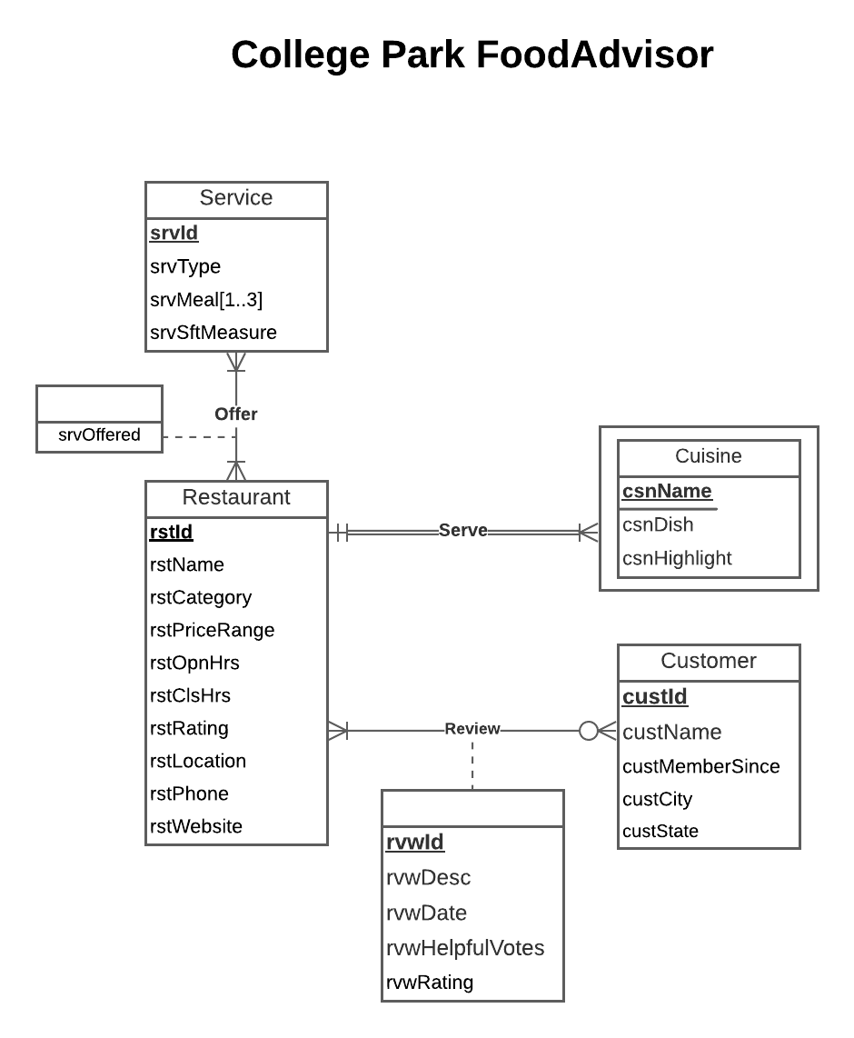

**LucidChart:**

1. First, I created a new blank document on Lucidchart.
2. Then, dragged the entity to the view and renamed it as ‘Restaurant'.
3. Then, added other entities, named them and made the primary key bold and underlined. If it’s a partial primary key, make it double underlined.
4. Added relationships between each entity depending on their relationship type. In a dependent relationship, the relationship should be denoted with a double line.
5. For the multivalued attribute, I used square brackets to present the possible number of values.
6. Added the attributes of the entities.
7. Also, edited the entity frame to be two layers for Cuisine because it's a dependent entity.
8. Explained the relationships between the entities and added the cardinality constraints for each relationship. For example: the relationship between Restaurant and Cuisine is one-to-many, the relationship between Cuisine and Restaurant is one-to-one.
9. Added the relationship attributes in a separate rectangle connecting the relation using dotted lines.

**DDL:**

1. First, opened the Microsoft SQL server on the VMware Virtual Machine.
2. Then, selected the SQL Server: doitsqlx.rhsmith.umd.edu,9703
3. Entered the credentials and started the SQL server and selected the project database: BUDT703_Project_0503_08
4. Created three files, one for DROP commands, one for CREATE commands and one for INSERT INTO commands
5. In the drop table sql file, created the DROP Tables command for each table dropping all the existing data for relations in the database.

1. In the create table sql file, I started by creating [FoodAdvisor.Restaurant] table using the CREATE TABLE command and defined the column/attributes names and their data types inside the command. This was done for all the other tables/relations as well.

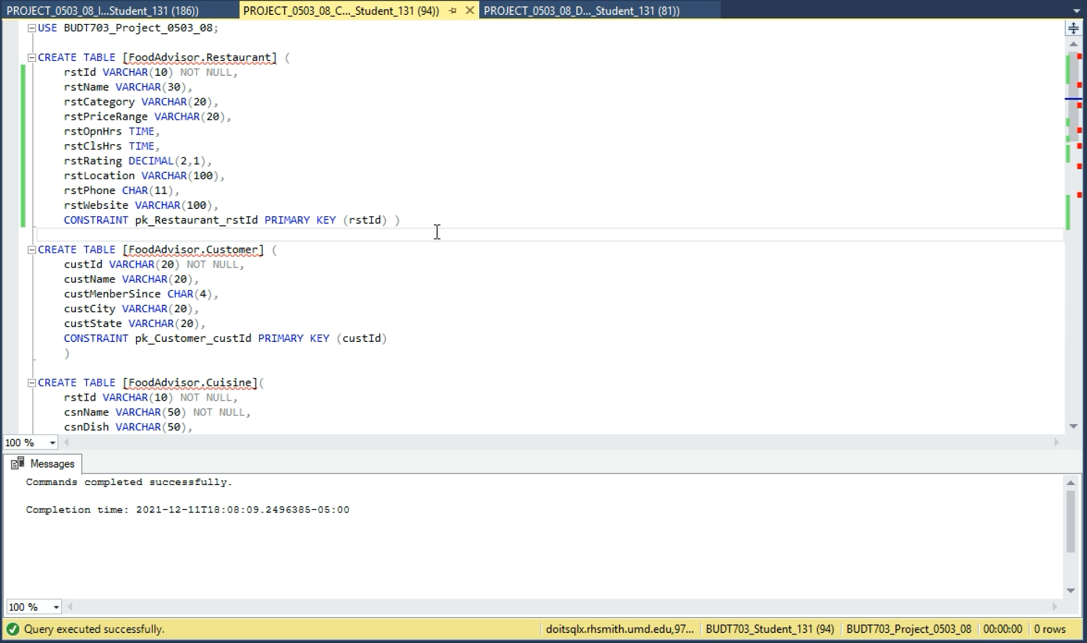

Following are the Relation, their attributes, data type and key constraints as defined in the database:

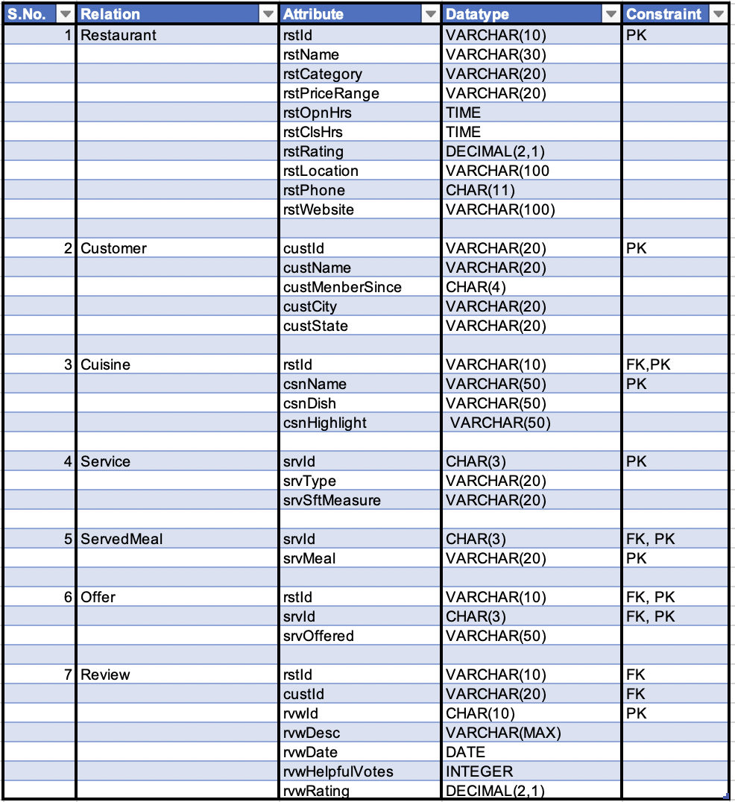

1. Then, inserted the data into the tables created, which was collected from tripadvisor’s website. This was done using the INSERT INTO command on sql for every relation.

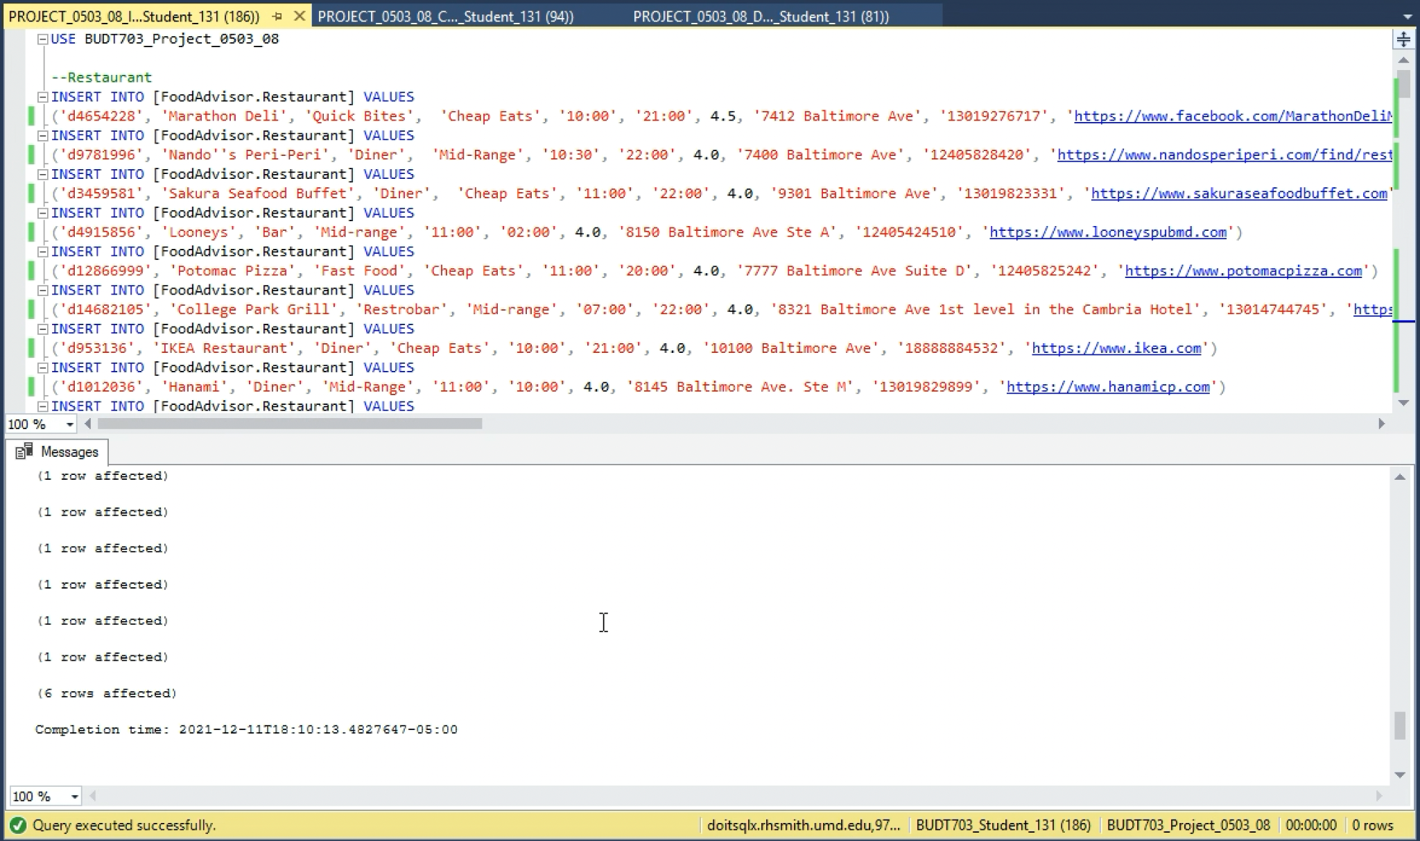

**DML:**

1. First, opened the Microsoft SQL server on the VMware Virtual Machine.
2. Then, selected the SQL Server: doitsqlx.rhsmith.umd.edu,9703
3. Then, entered the credentials and started the SQL server and selected the project database: BUDT703_Project_0503_08
4. Created a New Query
5. Based on the tables created previously and the values that were inserted into the DDL part of the project, I started writing the queries to execute the mission objectives mentioned in the proposal
6. Then, finally executed the queries to get the following outputs:

**What are the restaurants that serve ‘American’ cuisine and what is their cuisine highlight?**

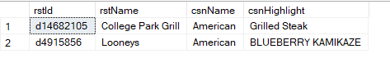

**Which restaurant serves 'Sushi' and has the best consumer ratings?**

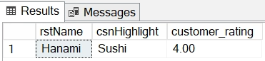

**What are the restaurants that offer late night service and till what time will they be operating?**

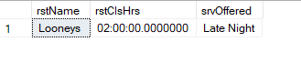

**Which are the best affordable restaurants that offer takeout options for dinner?**

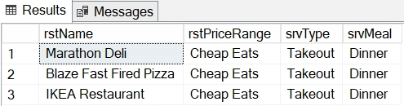

**Which establishments in College Park offer Bar service?**



**What are the latest reviews for every restaurant?**

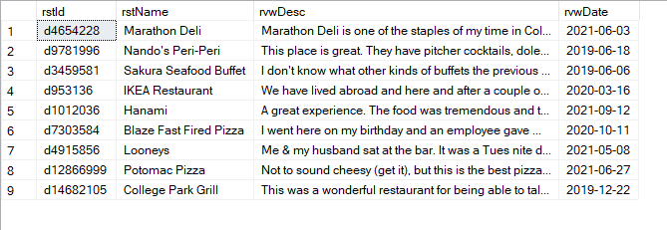

**Which mid-range restaurants offer lunch service?**

