**College Park FoodAdvisor**

**Project:** Raghul Balamurugan

**Business Transactions and processes:**

* Each restaurant is described by a unique restaurant Id, name, category, price range, opening hour, closing hour, rating, location, phone number and restaurant website.
* Each customer is described by a unique customer Id, name, membership information, city and state.
* Each customer should review at least one restaurant. There can be multiple customers reviewing a restaurant.
* Each restaurant may have several customers reviewing their restaurant. Because there can be multiple reviews written by a customer, the relationship between restaurant and customer is described by an attribute review; values are rvwId (unique), rvwDesc, rvwDate, rvwHelpfulVotes, rvwRating.
* Cuisines are not independent of restaurants, therefore each cuisine is described uniquely by a combination of the restaurant Id and the cuisine name, popular cuisine dish and a speciality/highlight food of that cuisine.
* Each restaurant serves one or more cuisines but each cuisine is served by a restaurant.
* Each service is described uniquely by the service Id, type of service provided by the restaurant and meals served.
* Each service can be provided by multiple restaurants. Because there can be multiple services offered by a restaurant, the relationship between restaurant and service is described by an attribute service offered; values are outdoor seating, live music, late night food, reservations, etc.
* Service type will have values like Dine-in, Takeout, Delivery and served meals will be a multivalued attribute with the values: Breakfast, Lunch, Dinner.

**Mission Statement:**

To analyse the reviews of various restaurants at College Park written by the customers who have visited the restaurants in order to help future customers decide on which restaurant to visit.

**Mission Objectives:**

* To find the restaurants that serve American cuisine and what is their cuisine highlight
* To find the restaurant that serves Sushi and has the highest review rating
* To find the restaurants that offer late night service and till what time will they be operating
* To find the the best affordable restaurants that offer takeout option for dinner in College Park
* To find the establishments in College Park that offer Bar service
* To find the latest reviews for every restaurant
* To find the mid-range restaurants that offer lunch service

**ER Schema:**

**Entities, Attributes and Primary Keys:**

Restaurant (**rstId**, rstName, rstCategory, rstPriceRange, rstOpnHrs, rstClsHrs, rstRating, rstLocation, rstPhone, rstWebsite)

Customer (**custId**, custName, custMemberSince, custCity, custState)

Cuisine (**csnName**, csnDish, csnHighlight)

Service (**srvId**, srvType, srvMeal[1..3], srvSftMeasure)

**Relationships, Attributes, Degrees, Participating Entities and Constraints**

Review (rvwId, rvwDesc, rvwDate, rvwHelpfulVotes, rvwRating) : Binary relationship

1 Customer to 1 or more Restaurants

1 Restaurant to 0 or more Customer

Serve : Binary relationship

1 Restaurant to 1 or more Cuisine

1 Cuisine to 1 Restaurant

Offer (srvOffered) : Binary relationship

1 Restaurant to 1 or more service

1 Service to 1 or more restaurants

**ER Diagram:**

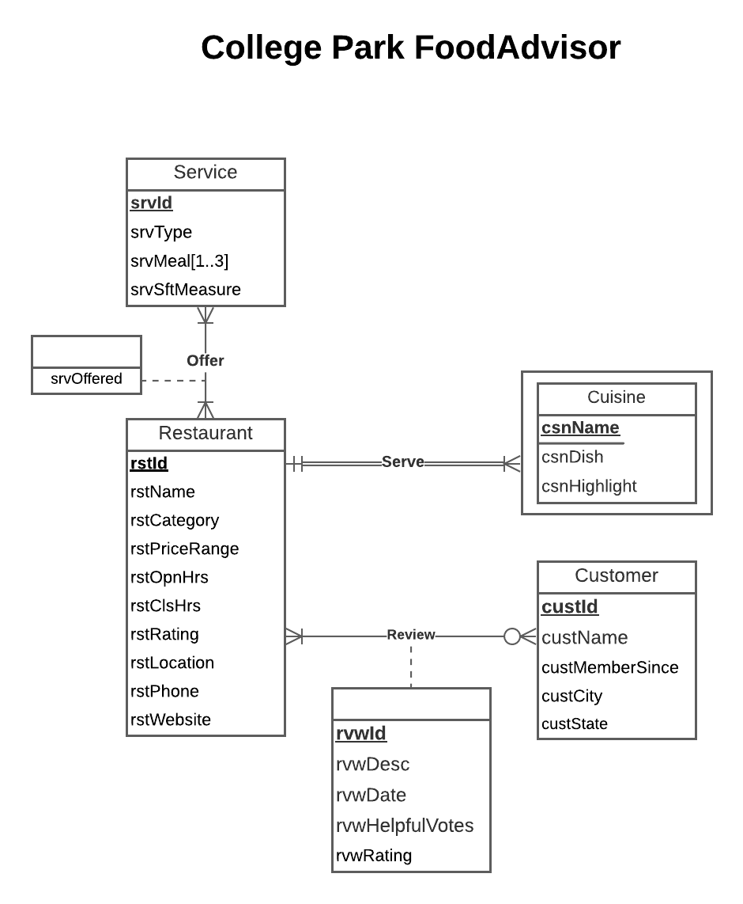

**Relations:**

Restaurant (**rstId**, rstName, rstCategory, rstPriceRange, rstOpnHrs, rstClsHrs, rstRating, rstLocation, rstPhone, rstWebsite)

Customer (**custId**, custName, custMemberSince, custCity, custState)

Cuisine (***rstId***, **csnName**, csnDish, csnHighlight)

Service (**srvId**, srvType, srvSftMeasure)

ServedMeal (***srvId***, **srvMeal**)

Offer (***rstId***, ***srvId***, srvOffered)

Review(**rvwId**, rvwDesc, rvwDate, rvwHelpfulVotes, rvwRating*, rstId*, *custId*)

**Functional dependency:**

rstId → rstName, rstCategory, rstPriceRange, rstOpnHrs, rstClsHrs, rstRating, rstLocation,

rstPhone, rstWebsite

custId → custName, custMemberSince, custCity, custState

rstId, csnName → csnDish, csnHighlight

srvId → srvType, srvSftMeasure

srvId, srvMeal →

rstId, srvId→ srvOffered

rvwId → rstId, custId, rvwDesc, rvwDate, rvwHelpfulVotes, rvwRating

The relation is normalized to 3NF form with no multivalued attributes, partial dependencies and transitive dependencies

**Business rules:**

[R1] When service information for a restaurant is deleted from the database, the corresponding served meals information should also be deleted.

[R2] When service information for a restaurant is changed in the database, the corresponding served meals information should also be changed accordingly.

[R3] When a restaurant is offering a service, the corresponding restaurant information cannot be deleted from the database.

[R4]When a restaurant offering a service is updated, the corresponding restaurant information should also be changed accordingly.

[R5] When a service is being offered by a restaurant, the corresponding service information cannot be deleted from the database.

[R6] When the service being offered by a restaurant is updated, the corresponding service information should also be changed accordingly.

[R7] When a restaurant is being reviewed by a customer, the corresponding restaurant information cannot be deleted from the database.

[R8] When a restaurant being reviewed by a customer is updated, the corresponding restaurant information should also be changed accordingly.

[R9] When a customer has reviewed a restaurant, the corresponding customer information cannot be deleted from the database.

[R10] When the information of a customer who has reviewed a restaurant is updated, the corresponding customer information should also be changed accordingly.

[R11] When a restaurant is out of business and deleted from the database, all cuisines for the restaurant should be deleted from the database as well.

[R12] When the restaurant information is changed in the database, the corresponding cuisine information for the restaurant should be changed accordingly.

**Referential integrity:**

|  |  |  |  |  |  |  |  |
| --- | --- | --- | --- | --- | --- | --- | --- |
| Relation | Foreign Key | Base Relation | Primary Key | Business Rule | Constraint: ON DELETE | Business Rule | Constraint: ON UPDATE |
| ServedMeal | srvId | Service | srvId | R1 | CASCADE | R2 | CASCADE |
| Offer | rstId | Restaurant | rstId | R3 | NO ACTION | R4 | CASCADE |
| Offer | srvId | Service | srvId | R5 | NO ACTION | R6 | CASCADE |
| Review | rstId | Restaurant | rstId | R7 | NO ACTION | R8 | CASCADE |
| Review | custId | Customer | custId | R9 | NO ACTION | R10 | CASCADE |
| Cuisine | rstId | Restaurant | rstId | R11 | CASCADE | R12 | CASCADE |

**Sample Data:**

Restaurant ('d1012036', 'Hanami', 'Diner', 'Mid-Range', '11:00', '10:00', 4.0, '8145 Baltimore Ave. Ste M', '13019829899', 'https://www.hanamicp.com')

Customer (‘timtraveler14’, ‘Tim’, ‘2016’, ‘Oklahoma City’, ‘Oklahoma’)

Cuisine ('d1012036', 'Japanese', 'Seafood', 'Sushi')

Service ('S05', 'Dine-in', 'Masks Required')

ServedMeal ('S05', [ 'Breakfast', ‘Lunch’ , ‘Dinner’])

Offer ('d1012036', 'S05', 'Wheelchair Accessible')

Review('R11', 'A great experience. The food was tremendous and the service was very friendly. A nice place to dine.', '2021-09-12',0,5.0, 'd1012036', 'timtraveler14')