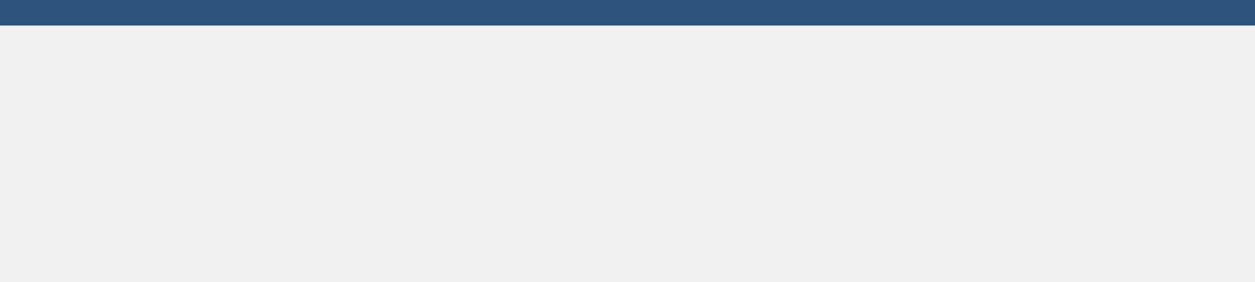

**Email:** <raghul081992@gmail.com>

**Phone:** +91-9940777096

**LinkedIn:** [raghul-muthu-ac](https://www.linkedin.com/in/raghul-muthu-ac-4a289790/)

Raghul Muthu AC

**PROFESSIONAL SUMMARY**



* 6+ of experience facilitating cutting-edge engineering solutions with a wide range of technology skills
* Proficient at designing and building reusable components, writing code in various languages, and feature development and implementation.
* Extensive expertise in large system architecture development and administration, as well as network design and configuration

**TECHNICAL SKILLS**



.Net Framework



.Net Core



ASP.NET MVC



C#



Razor Pages



WCF



Web Api



REST



JSON



Java Script(ES6)



JQuery



Bootstrap



CSS



HTML5



AJAX



Nunit Script(ES6)



Xunit



Wix



IIS



Git Hub



SQL Server



Entity Framework



Jira Script(ES6)



Core Java



Jenkins



Confluence



Tortoise SVN



Stash

**EXPERIENCE**



**J.C. Penney India / October 2017 – Present**

***Credit Services Modernization*** *October 2017 – present*

Payment Systems stores all the customer transactions into Database, this information is used by various business partners for reconciliation, dispute redressal, accounting etc. Around 14 desperate web applications were developed in ASP and ASP.net 1.1 were all are marked as flagged as non-compliant. As part of Credit services Modernization All disparate application was all migrated to a Unified portal which was developed using .Net 4.7.1 framework.

Environment: ASP.NET MVC, WCF, Entity Framework, jQuery, Bootstrap, Html, Oracle and IBM Db2.

Service Rendered

* Interaction with clients, product managers and developers to envision, model and design.
* Involved in analyzing the code of existing applications and that helped extensively in the story grooming.
* Led the team of three and delivered multiple user stories sprint wise.
* Collaboratively work with team to understand the skills and interests.
* Web Application development using C#, ASP.Net MVC architecture, Razor view engine, Bootstrap and jQuery.
* Web service development using WCF, Entity framework and LINQ.

Achievements: Got Best performer award for the year 2018.

***Point of Sale - JCPenney*** *August 2020 – Present*

JCPenney POS system is a .Net based application used to record sales and handle payments and it is typically used in all JCPenney stores. It includes hardware components such as computer , mobile devices and bar code scanner, and software to run the system.

Environment: ASP.NET Core, REST, Web Api, .Net Framework 4.6, C#, Web Services, XUnit

Service Rendered

* Team player and delivered multiple user stories sprint wise.
* Written Multiple endpoints in Web Api and integrated with the existing POS.
* Automated Web Api build and deployment using Wix toolset and Jenkins.
* Written unit test cases using XUnit.

**B.E Electronics and Communication Engineering (2009 – 2013)**

Velammal college of Engineering and Technology, Madurai Tamilnadu / CGPA: 7.4

**EDUCATION**



***CARRS Enhancement*** *September 2014 – September 2017*

CARRS is used to access, monitor, and track risk and risk mitigation activities associated with commercial lending relationships. It collects financial data of borrowers (dealers) and models the borrower’s credit risk rating, rate of recovery for loss, and probability of defaulting. CARRS is used by Ally Analysts, who will take data and deep dive into it to generate the ratings.

Environment: ASP.NET MVC, jQuery, CSS, Html and SQL Server 2012.

Service Rendered

* Converting the user requirements for the project into Technical Requirements.
* Responsible for reviewing and delivering the modules to client and managing the source code.
* Web Application development using ASP.Net MVC architecture, C#, Razor view engine, Bootstrap, jQuery, NHibernate and LINQ.
* Generated Reports using Crystal report.
* Generated the SQL Script for production deployment using SQL Compare.
* Worked on building store procedures, functions and triggers in SQL Server 2012.

Achievements: Got Appreciation and certificate from client for best performer of the year 2015.

**Cognizant technology solutions / April 2014 – September 2017**