**GOVERNMENT COLLEGE OF ENGINEERING, SALEM – 636 011**

(An Autonomous Institution Affiliated To Anna University, Chennai)

**DEPARTMENT OF COMPUTER SCIENCE AND ENGINEERING**

**UNIVERSITY PRACTICAL EXAMINATION –May/June 2022**

**18CS406-Object Oriented Programming Using C++ Laboratory**

**DATE: 20.06.2022**

**List of Experiments**

1. (a) Create a class for Student with register number, name, six subject marks, result, and percentage. Write the methods for reading register number, name, and six marks and calculate result and percentage and display all details. Create array of objects and access the methods.

(b)Write a program to overload the function to calculate volume of different shapes like cube, rectangle box, and cylinder.

1. (a) Create a class for Complex number with real part and imaginary part. Write methods for reading real part and imaginary part, addition of two Complex numbers, subtraction of two Complex numbers and display the Complex number.

(b) Write a program to calculate compound interest using function with call by value with default parameter as rate of interest with 12%.

1. (a) Create a class for String with name and length. Write the methods to read string, concatenate the string, reverse the string and display the string. Create the string objects and accesses all the methods.

(b) Write a program to interchange the values using function with call by reference.

1. (a) Create a class for Student with register number, name, six subject grades, and CGPA. Write the methods for reading register number, name, and six subject grades and calculate CGPA and display all details. Create array of objects and access the methods.

(b)Write a program to calculate factorial N using function with call by value.

1. (a) Create class for Item with code, name, and price. Write constructors (default, parameterized, and copy), display the details and static members to count the number of items created and display the count value.

(b) Write a program to swap the values using function with call by address.

1. (a) Create a class for Complex number with real part and imaginary part. Write methods for reading real part and imaginary part, display the Complex number and over load the operator + and – using member function.

(b) Write a program to calculate the area of triangle using inline function.

1. (a) Create a class for Date with date, month and year. Write constructors and over load the operator == and != using friend function.

(b)Write a program to check the number is prime number or not using function with call by value.

1. (a) Create a class for String with constructor and over load the operator < and > using member function.

(b) Write a program to check the number is Armstrong number or not using function with call by value.

1. (a) Create a class for String with constructor and over load the operator +, == and != using friend function.

(b) Write a program to calculate the area of circle using inline function.

1. (a) Create a class for Time with second, minute and hour. Write the methods to coveter type conversion from int to Time and Time to int.

(b) Create a class student with register number and name and inherit the student class into personal with father name, and address. Write methods for reading and displaying the details. Create the object and accesses the methods.

1. (a) Create the classes for distance in m and cm and feet and inch. Write the type conversion methods to convert distance from m and cm to feet and inch feet and inch into m and cm.

(b) Write inline function to calculate are of rectangle.

1. (a) Write a program to implement virtual function to calculate volume of different shapes.

(b) Write a program to create an exception for marks (<0 and>100) out of range and catch the exception.

1. (a)Write a program to implement virtual function to calculate area of different shapes.

(b) Write a program to create an exception for age (<18 and>21) out of range and catch the exception.

1. (a) Create a Student class with id, name, and percentage. Write the methods to over load the operator >> and << using friend function.

(b) Write a class template for Array to read, display and sort the values.

1. (a) Create a class for Complex number with real part and imaginary part. Write methods for reading real part and imaginary part, display the Complex number and over load the operator + using member function.

(b) Write a function template to add three values (including complex number).

1. (a) Create a Student class with id, name, and percentage. Write the methods to over load the operator <or > using member function.

(b) Write a function template to sort the values (including student).

1. (a) Create a class Account with number, name, and balance and inherit the class for Transaction with date, CR/DB type, amount and Load with date, interest. Write methods for reading and displaying and calculation Create object for Transaction and Loan classes and access the methods.

(b) Write a program to overload the function add().

1. (a) Create a Binary file and display the file contents.

(b) Write a program to create an exception for invalid gender and catch the exception.

**INTERNAL EXAMINER EXTERNAL EXAMINER**

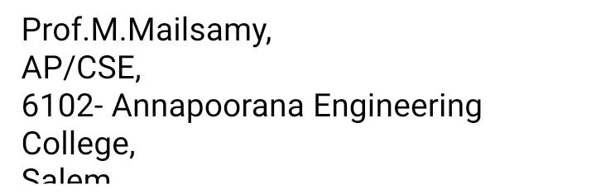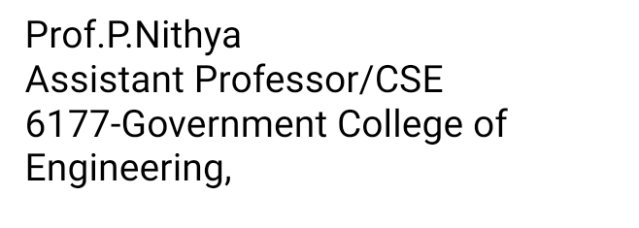

**GOVERNMENT COLLEGE OF ENGINEERING, SALEM – 636 011**

(An Autonomous Institution Affiliated To Anna University, Chennai)

**DEPARTMENT OF COMPUTER SCIENCE AND ENGINEERING**

**UNIVERSITY PRACTICAL EXAMINATION –May/June 2022**

**18CS406-Object Oriented Programming Using C++ Laboratory**

**Year/Sem: II/IV** **Date: 20.06.2022**

**MARK ALLOCATION**

Aim & Algorithm - 20

Program - 50

Output & Result - 20

Viva - 10



Total - 100



**INTERNAL EXAMINER EXTERNAL EXAMINER**

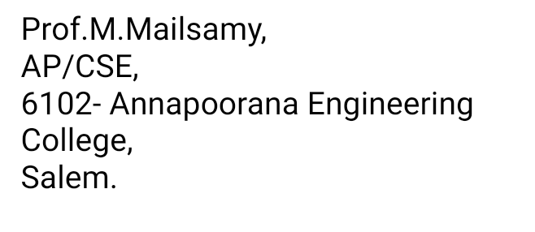

| **Government College of Engineering, Salem** | | | |
| --- | --- | --- | --- |
| **Department of Computer Science and Engineering** | | | |
| **UNIVERSITY PRACTICAL EXAMINATION –May/June 2022** | | | |
| **18CS406-Object Oriented Programming Using C++ Laboratory** | | | |
| **Year/Sem :II/IV** | | | |
| **Name list** | | | |
| **S.No** | **Reg.No** | **Student Name** | **Marks (10)** |
| 1 | 2021002 | AKASH S |  |
| 2 | 2021006 | DEEPAK RAJAN K |  |
| 3 | 2021007 | DHANEESKUMAR R |  |
| 4 | 2021008 | GIRI BAABU K G |  |
| 5 | 2021009 | HARI HARAN |  |
| 6 | 2021010 | HARISH R P |  |
| 7 | 2021012 | JAVID J |  |
| 8 | 2021015 | JEEVANANDHAM S |  |
| 9 | 2021016 | KESAVAN A |  |
| 10 | 2021018 | LAKSHITHA A |  |
| 11 | 2021019 | MITHUN KUMAR A |  |
| 12 | 2021020 | MOHAMEDELIYAS A |  |
| 13 | 2021021 | MOHANKUMAR G |  |
| 14 | 2021023 | NANDHINI D S |  |
| 15 | 2021024 | NARESHKUMAR E |  |
| 16 | 2021026 | NITHEESH KUMAR S |  |
| 17 | 2021028 | POOJA S |  |
| 18 | 2021030 | RAGUL T |  |
| 19 | 2021031 | RAJA NARMATHA K |  |
| 20 | 2021032 | SARANYA M N |  |
| 21 | 2021033 | SATHISH V |  |
| 22 | 2021034 | SHARMI SHRI S |  |
| 23 | 2021037 | SREEMATHI P |  |
| 24 | 2021039 | SUBAHARINI P |  |
| 25 | 2021040 | SUBATRA R |  |
| 26 | 2021041 | SUDHA V |  |
| 27 | 2021042 | SURYA R |  |
| 28 | 2021044 | SUTHEESH V |  |
| 29 | 2021045 | SWETHA G |  |
| 30 | 2021046 | UMESH S |  |
| 31 | 2021047 | VENKATESH R |  |
| 32 | 2121L01 | ATHIK MOHAMED M |  |
| 33 | 2121L02 | JOTHEESWARAN K.M |  |
| 34 | 2121L03 | LOKESH M |  |
| 35 | 2121L04 | MANOJ KUMAR |  |
| 36 | 2121L05 | NANDHINI J |  |
| 37 | 2121L06 | RIYA J |  |
| 38 | 2121T301 | DHARSHINI T |  |
| 39 | 2121T302 | GOKULAN S |  |
| 40 | 2121T303 | GUNASEELAN R |  |
| 41 | 2121T304 | KANISH S |  |
| 42 | 2121T305 | KARPAGAVALLI M |  |
| 43 | 2121T306 | KOWSALYA R |  |
| 44 | 2121T307 | MOULI KARTHIK S |  |
| 45 | 2121T308 | NIVETHA.K |  |
| 46 | 2121T309 | SARANYA S |  |
| 47 | 2121T310 | SHANKAR E P |  |
| 48 | 2121T311 | SUDHARSAN M |  |
| 49 | 2121T312 | VARSHINI S |  |
| 50 | 2121T313 | VISHALINI K |  |

**INTERNAL EXAMINER EXTERNAL EXAMINER**

