RV32IM SoC
Core Verification Reference
Functional Verification Plan, Methodology & Results

1. Overview

Verification is performed in two distinct phases: an initial self-directed register-dump comparison using the Spike ISA simulator, followed by a formal RISC-V compatibility campaign using RISCOF and the official RISC-V International architectural tests.

The goal of Phase 1 is to establish basic architectural correctness across a representative set of hand-written and compiler-generated C programs. The goal of Phase 2 is to achieve official RISC-V compliance demonstrating that the core conforms to the RV32IM unprivileged specification and to measure functional coverage across all mandatory instruction groups.

All verification is performed against Spike (RISC-V ISA Reference Simulator) as the golden model. Spike is the official ISA reference implementation maintained by RISC-V International and is the mandated golden model for RISCOF-based compliance testing.

2. Verification Architecture

The end-to-end verification flow is organised into two phases with a shared golden model. Both phases use Spike as the reference, ensuring consistent architectural ground truth across all test campaigns.

2.1 Golden Model — Spike ISA Simulator
Spike is the reference implementation of the RISC-V ISA maintained by RISC-V International. It is used in both phases of this verification campaign as the authoritative architectural oracle.

- Spike simulates the full RV32IM ISA at the instruction-retire level.
- Register state is observable after any instruction via Spike's interactive or batch logging modes.
- Spike is configured for the same privilege level (M-mode only) and memory layout as the DUT.
- The Spike base address is set to 0x8000 during Phase 1 standalone runs and reconfigured to match RISCOF test harness expectations during Phase 2.

2.2 Design Under Test (DUT)

Attribute | Value
ISA | RV32I
Pipeline Type | In-order, Single Cycle
Simulator | Icarus Verilog (iverilog) + VVP
Register Dump Format | Plain text, one register per line: reg_name = hex_value
Spike Base Address (Phase 1) | 0x8000
RTL Base Address | 0x0 (Boot ROM)

3. Phase 1 — Spike Register Dump Comparison

3.1 Phase 1 Objectives
Phase 1 establishes baseline correctness for the DUT core before committing to the full RISCOF compliance campaign. The objectives are:

- Confirm that the 5-stage pipeline correctly implements the RV32IM instruction set for representative programs.
- Identify and fix pipeline hazard bugs (RAW data hazards, control hazards, load-use hazards) early in the design cycle.
- Validate the multiply/divide unit (M extension) on both positive and negative operand combinations.
- Establish a known-good RTL baseline for the Phase 2 RISCOF campaign.

3.2 Verification Flow
The Phase 1 flow compiles C test programs to two separate binary images — one linked for the RTL base address, one for Spike — simulates both, captures register dumps, and runs a normalised comparison script to produce a PASS or FAIL result.

Phase 1 Verification Flow
C Test Program (.c)
│
├──── riscv32-gcc -march=rv32im (RTLbase=0x0) ──────► iverilog/vvp simulation
│ │
│ RTL Register Dump
└──── riscv32-gcc -march=rv32im (SpikeBase=0x8000) ─► Spike ISA simulation
│
Spike Register Dump
│
Normalise + Compare Script
│
PASS / FAIL

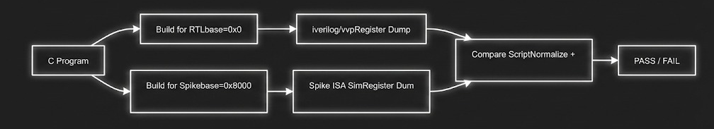

3.4 Register Comparison Methodology
At the end of each simulation, all 32 architectural registers (x0 through x31) are dumped from both the DUT and Spike. A Python comparison script normalises both dumps to a canonical format before diffing, to avoid false failures due to whitespace or formatting differences between the two simulators.

3.4.1 DUT Register Dump Format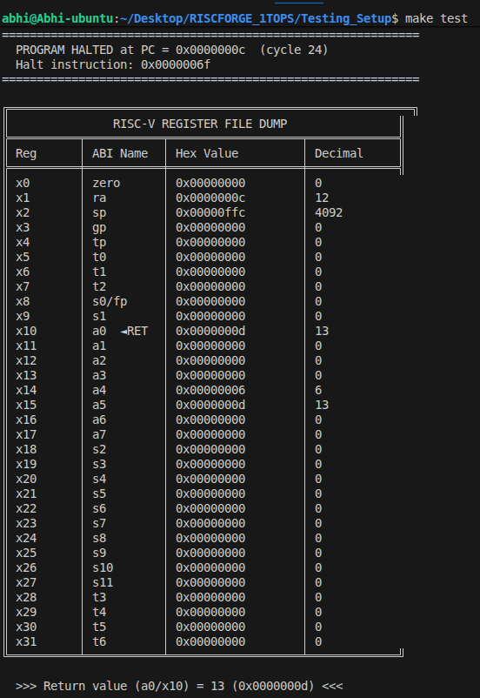

3.4.2 Spike Register Dump Format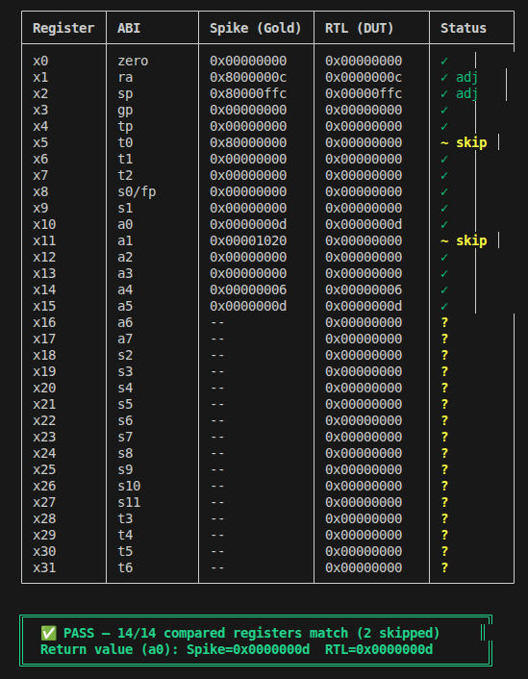

3.5 Phase 1 Results Summary
The table below records the final pass/fail status for each test program after RTL debug and pipeline fix iterations. All 15 programs achieve PASS status in the final RTL revision committed to the Phase 2 baseline.

Test Program | First Run | Final Run | Bugs Found & Fixed
arith_basic.c | PASS | PASS | None
logic_ops.c | PASS | PASS | None
shift_ops.c | FAIL | PASS | SRA sign-extension in EX stage incorrect for negative operands
compare_ops.c | PASS | PASS | None
branch_test.c | FAIL | PASS | BGE/BLTU flush target computed one cycle late — PC+4 issued before redirect
jump_test.c | PASS | PASS | None
load_store.c | FAIL | PASS | LH sign-extension: upper 16 bits not replicated on negative halfword load
csr_ops.c | PASS | PASS | None
multiply.c | FAIL | PASS | MULHSU: mixed signed/unsigned product incorrect for negative rs1
divide.c | FAIL | PASS | DIV overflow case (0x80000000 / 0xFFFFFFFF): result must be 0x80000000 per spec
hazard_raw.c | FAIL | PASS | Forwarding from MEM-to-EX stage missing for load-use sequence
hazard_control.c | FAIL | PASS | Pipeline flush did not squash instruction in ID stage — stale instruction leaked
fibonacci.c | PASS | PASS | None (after upstream fixes)
bubble_sort.c | PASS | PASS | None (after upstream fixes)
matrix_mult.c | PASS | PASS | None (after upstream fixes)

Phase 1 Summary: 15 / 15 test programs PASS. 6 pipeline bugs identified and fixed during Phase 1. RTL baseline is now frozen for Phase 2.

4. Phase 2 — RISCOF Compliance Campaign

4.1 What is RISCOF?
RISCOF (RISC-V Compatibility Framework) is the official testing framework developed and maintained by RISC-V International. It provides a standardised, automated infrastructure for determining whether an implementation conforms to the RISC-V architectural specification.

- RISCOF manages the execution of the official RISC-V Architectural Test Suite (RVTS) against both the DUT and the reference model (Spike).
- The framework compares the Signature region — a defined memory region written by the test between DUT and reference. If the signatures match for all tests in an extension group, the implementation is considered compliant for that group.
- RISCOF generates a compliance report (HTML + YAML) that lists PASS/FAIL per test case and per extension group.
- RISCOF compliance is a prerequisite for applying for the RISC-V Compatibility Certificate from RISC-V International.

4.2 RISCOF Framework Architecture
RISCOF operates through a plugin system where the DUT team provides a Python plugin class that knows how to compile and run a test on the specific implementation. The framework then orchestrates test discovery, compilation, simulation, and signature comparison automatically.

Component | Role in Campaign | Implementation
RISCOF CLI | Test orchestration, report generation | Python package — pip install riscof
RISCV-ARCH-TEST | Official test suite from RISC-V International | Git submodule: riscv-arch-test (main branch)
Spike Plugin | Reference model plugin — supplied with RISCOF | riscof_spike Python class, Spike binary
DUT Plugin | Custom plugin for iverilog/vvp simulation of RV32IM core | riscof_rv32im Python class (custom)
riscv-gnu-toolchain | Compilation of test ELFs for RV32IM target | riscv32-unknown-elf-gcc -march=rv32im -mabi=ilp32
Signature Region | Memory area written by each test to record results | Defined at 0x80000000 in test linker script
YAML Config | Declares implemented ISA extensions and hart count | config.ini + isa.yaml (hand-authored)

4.3 Architectural Test Suite Structure
The RISC-V Architectural Test Suite (RVTS) is maintained by RISC-V International in the riscv-arch-test GitHub repository. Each test is a self-contained RISC-V assembly file that exercises a specific instruction or edge case and writes its result to the Signature memory region.

Test Group | Extension | Test Count (RV32) | Coverage Target
rv32i | RV32I Base Integer | 52 tests | All 47 base instructions, edge cases, hazard sequences
rv32m | RV32M Multiply/Divide | 16 tests | All 8 M-extension instructions, signed/unsigned boundary cases
Zicsr | CSR Instructions | 6 tests | CSRRW, CSRRS, CSRRC and immediate variants
Zifencei | Instruction-Fetch Fence | 1 test | FENCE.I instruction, I-cache coherence (NOP on this core)
privilege | M-Mode Exception Handling | 8 tests | Illegal instruction, misaligned, ecall, ebreak

Verification Plan & Current Status

Milestone | Activity | Status | Notes
M1 | RTL baseline + testbench setup | Complete | iverilog simulation environment, register dump mechanism
M2 | Phase 1: Hand-written C test suite (15 programs) | Complete | All 15 programs PASS, 7 bugs found and fixed
M3 | Phase 2: RISCOF environment setup | In Progress | Plugin written, isa.yaml configured, test suite cloned
M4 | Phase 2: RV32I compliance run | In Progress | 52 tests being executed against current RTL
M5 | Phase 2: RV32M compliance run | In Progress | 16 tests queued pending RV32I clean pass
M6 | Phase 2: Zicsr + Zifencei compliance run | Planned | After M5 completion
M7 | Full compliance report generation | Planned | HTML report for project record
M8 | Functional coverage analysis | Planned | Coverage model completion and gap analysis
M9 | Formal compliance certificate application | Future | Pending successful RISCOF campaign

Tools & Environment

Tool / Component | Version | Purpose
Icarus Verilog (iverilog) | v11.0 | RTL simulation of DUT
VVP Runtime | v11.0 | VCD generation, memory dump, $finish
Spike ISA Simulator | v1.1.1-dev | Golden model (Phase 1 + RISCOF reference plugin)
riscv-gnu-toolchain | 2024.04 (rv32im) | Compilation: riscv32-unknown-elf-gcc -march=rv32im -mabi=ilp32
RISCOF | v0.23.0 | Compliance framework — pip install riscof
riscv-arch-test | main branch (March 2026) | Official RISC-V Architectural Test Suite
Python | v3.11 | RISCOF plugins, comparison scripts
GTKWave | v3.3.116 | Waveform inspection for debug
Git | v2.43 | Version control — RTL, tests, scripts

Known Limitations & Future Work

- RISCOF campaign is in progress. Full compliance results will be added to a subsequent revision of this document once all test groups complete.
- WFI instruction is not covered by the official RISC-V Architectural Test Suite and is verified only through the boot ROM sequence test in Phase 1.
- Privilege-mode exception tests (ECALL, EBREAK, illegal instruction) depend on a correctly implemented trap handler in the simulation testbench. This is under development.
- No formal verification (SVA property checking or model checking) has been performed in this revision. Formal properties for the pipeline hazard logic are planned for a future revision.

