RISCFORGE SOC · INTERRUPT SUBSYSTEM · DESIGN REVIEW

RISCFORGE IRQ Arbitration Plan
Interrupt priority, pulse capture and starvation control for the RISCFORGE SoC, with a phased fix plan
Scope | rtl/ips/riscv_core/rtl (core) and rtl/ips/RTL_SOC/riscforge_soc_subsystem.sv (SoC wiring)
Date | 24 September 2026
Status | Proposal for review. No RTL has been changed yet.
Reviewers | Malay (synthesis, SoC integration) · Yashraj (RTL review, DV)
CONTENTS
1 Executive summary
2 Current implementation
3 Findings
4 Options evaluated
5 Is a PLIC needed for MCU scope?
6 Proposed architecture
7 Fix plan
8 Latency and area budget
9 Verification plan
10 Bare-metal BSP
11 Future extensions
12 Sign-off checklist
13 References

1 Executive summary
The SoC routes UART, SPI, I2C and GPIO into the core's fast local interrupts (mip[19:16]) and Timer0's compare match into MTIP. A fixed if/else chain in top.v arbitrates them, ordered by cause number. There is no PLIC and no CLINT: ext_irq_i and sw_irq_i are tied to 0.
The review found one defect that will drop interrupts on silicon, one violation of the privileged spec, and one priority-policy problem. Peripheral starvation, the original concern, is real but secondary at MCU event rates. It needs a bounded fairness rule, not a heavyweight controller.
MUST FIX BEFORE TAPE-OUT
Three of the five live sources are single-cycle pulses: SPI events_o[0], Timer0 compare and GPIO in its reset mode. They feed a latch-free mip, so a pulse is lost whenever EX cannot accept it in that exact cycle. That happens inside any other ISR (mstatus.MIE = 0), during a divide stall, on a pipeline bubble, or behind an exception.

PHASE | WHAT | WHY | PRIORITY
A | Sticky edge capture per source (irq_gateway.v); spec order MEI > MSI > MTI; timer ahead of peripherals; threshold applied before selection | Stops lost interrupts; spec conformance for Spike/Sail | Must, pre-tape-out
B1 | 2-bit programmable level per source in custom CSRs 0x7C1/0x7C2; round-robin among equal levels; mintprio becomes a level threshold | Reconfigurable priority; bounded anti-starvation; reset values reproduce Phase A exactly | Recommended
B2 | Hardware level save/restore on trap entry and mret (NEST_EN) | Preemptive nesting: the only change that bounds latency for the highest level | Recommended if schedule allows
C | PULP rv_plic on MEIP | Only when a trigger in section 5 is met | Deferred

Estimated cost of A + B1 + B2: about 110 flops and 1–1.5 kGE, with zero added interrupt latency. All figures in this document marked "est." are engineering estimates; confirm them with Genus and with test IRQ17.

2 Current implementation
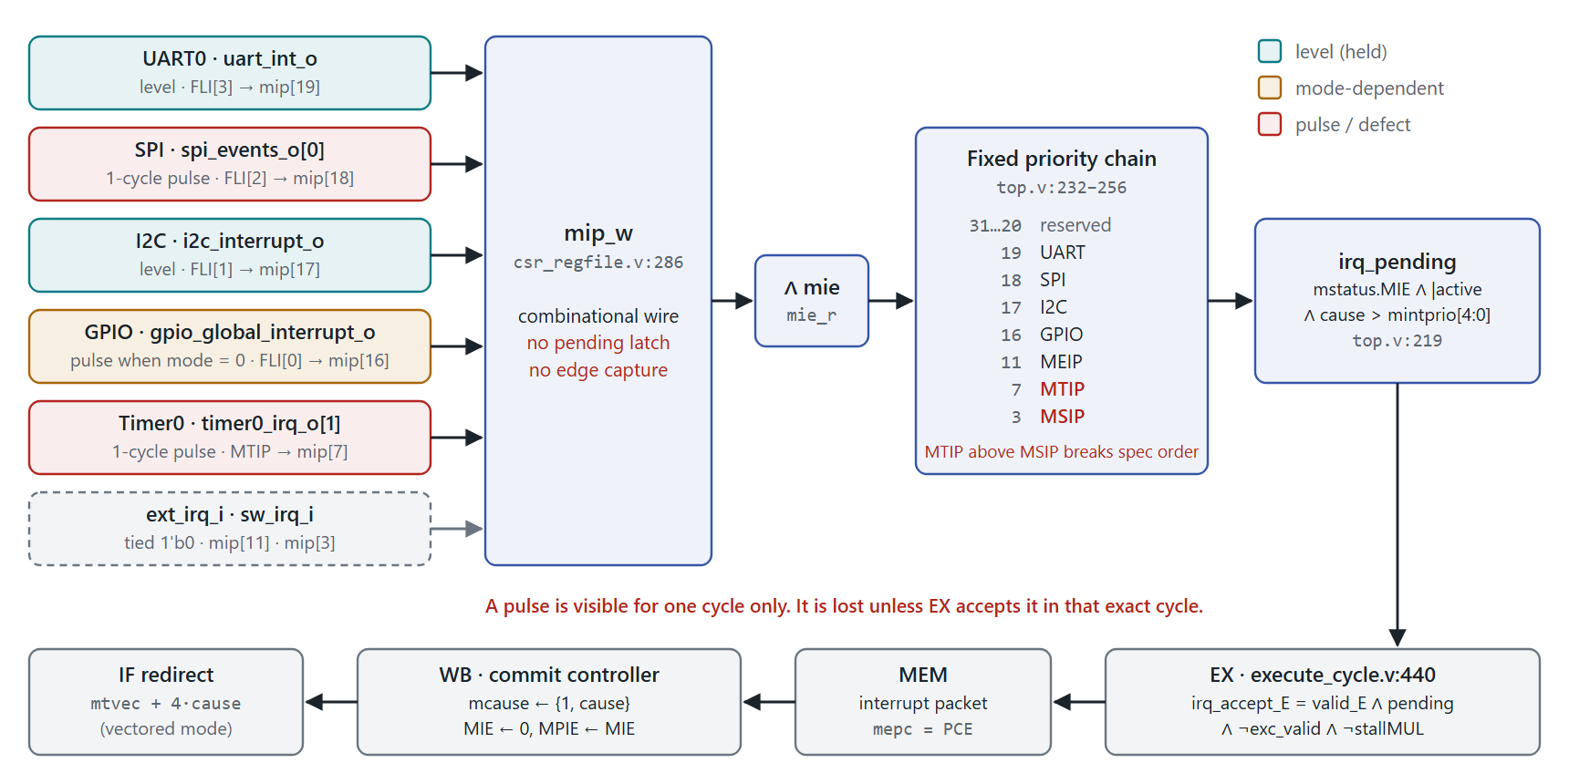
Figure 1 Interrupt path as implemented today. Red marks the pulse sources and the two defects in the priority chain.
The path from source to handler:
- csr_regfile.v:286 builds mip_w combinationally from the input pins: {fast_intr_i, 4'b0, ext_intr_i, 3'b0, timer_intr_i, 3'b0, msip, 3'b0}. Only MSIP is a register.
- top.v:215 computes active_irqs = mip & mie.
- top.v:232–256 selects one cause with a fixed chain, 31 down to 16, then 11, 7, 3.
- top.v:219 gates it: irq_pending = mstatus.MIE & |active & (cause > mintprio[4:0]).
- execute_cycle.v:440 accepts it only when valid_E & ~new_exc & ~exc_valid_E & ~stallMUL. The EX instruction becomes an interrupt packet with mepc = PCE and the front end is flushed.
- wb_trap_mret_commit_controller.v:62–84 commits at WB: writes mepc/mcause, clears MIE, and redirects to mtvec, or to mtvec + 4·cause in vectored mode.

Source behaviour, verified in the IP RTL
SOURCE | SOC SIGNAL | MIP / MCAUSE | WAVEFORM | EVIDENCE
UART0 | uart_int_o | 19 (FLI[3]) | Level: held until the IIR cause is serviced | apb_uart.sv:60 (16550 intr_o)
SPI | spi_events_o[0] | 18 (FLI[2]) | 1-cycle pulse: GEN_INT_TX/RX lasts one state | apb_spi_master.sv:116, 178–182, 219–222
I2C | i2c_interrupt_o | 17 (FLI[1]) | Level: registered, cleared by IACK | apb_i2c.sv:191–193
GPIO | gpio_global_interrupt_o | 16 (FLI[0]) | Pulse when glbl_intrpt_mode = 0 (reset), sticky level when 1 | gpio.sv:127–133
Timer0 | timer0_irq_o[1] | 7 (MTIP) | 1-cycle pulse on compare match; counter self-resets | timer.sv:53–65, 75–76
— | ext_irq_i, sw_irq_i | 11, 3 | Tied 1'b0 | riscforge_soc_subsystem.sv:1136–1137

Timer1 (timer1_irq_o) sits on APB slot 5 in place of the CLIC and is not connected to any interrupt input.

3 Findings
ID | FINDING | SEVERITY | LOCATION | FIX
F1 | Pulse interrupts are lost when EX cannot accept them in that cycle | Critical | csr_regfile.v:286 | A1
F2 | Standard order is MTI > MSI; the spec requires MEI > MSI > MTI | High | top.v:252–254 | A2
F3 | Timer ranks below every peripheral, so the RTOS tick is delayed by any peripheral burst | Medium | top.v:247–254 | A2
F4 | mintprio thresholds the cause number, not a priority, and nothing saves or restores it on a trap | Medium | top.v:219, csr_regfile.v:252 | A3, B1, B2
F5 | Starvation of low-ranked sources under a stuck or re-arming higher source | Low at MCU rates | policy | B1 (RR)

F1 — Pulse interrupts are lost
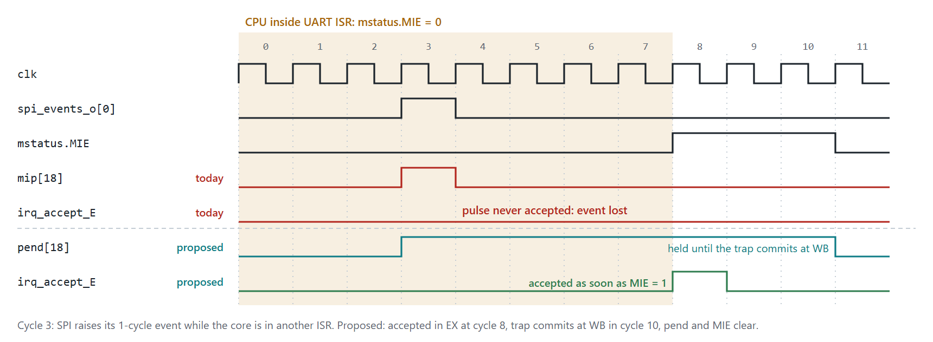
Figure 2 SPI event arriving while the core is inside the UART ISR. Today the pulse vanishes after cycle 3. With the gateway it is held until the trap commits.
irq_accept_E needs a valid, un-excepted, non-stalled instruction in EX and mstatus.MIE = 1 in the same cycle as the pulse. A pulse is dropped when any of these hold in that cycle:
- MIE = 0: the core is inside any other ISR. This is the dominant case. A Timer0 tick that lands in a UART ISR is gone, so the RTOS tick drifts.
- stallMUL: a multi-cycle divide is in EX (execute_cycle.v:440).
- valid_E = 0: a bubble from a branch flush, load-use stall, IF/ID flush, or a long lsu_mem_stall on an AXI-Lite MMIO access.
- An exception is already in EX (new_exc_valid_E or exc_valid_E).
The loss probability equals the fraction of cycles spent in those states, which rises with interrupt load. No existing test catches it. tb1_interrupts.sv holds each line high until the trap is taken, and the one single-cycle pulse (IRQ07, lines 736–740) is injected while MIE = 1 in straight-line code, so it is always accepted.

F2 / F3 — Priority order
The privileged spec fixes the order of the standard M-mode interrupts as MEI > MSI > MTI. top.v:253–254 checks MTIP before MSIP, and the SONIC-MCU summary repeats it as "MEIP > MTIP > MSIP". Spike and Sail follow the spec, so co-simulation diverges whenever MSIP and MTIP are pending together. Separately, all four FLIs outrank MTIP, which is backwards for a periodic tick. The spec leaves FLI order (causes ≥ 16) to the platform, so moving the timer above the FLIs is allowed.

F4 — mintprio is a cause threshold
Priority is welded to the cause ID. Applying the threshold after selection is correct only while priority order equals cause order. Any reordering, including the F2/F3 fix, makes a masked high-rank source hide an eligible lower-rank one. Nothing updates mintprio on trap entry or mret, so nesting is software-only and unsafe unless every ISR manages the threshold by hand.

F5 — How real is starvation?
On trap entry the hardware clears MIE, and priority is re-evaluated at every mret. A lower source starves only if a higher one is pending again at every mret. At 115,200 baud, UART delivers a byte every ~87 µs, which is ~8,700 cycles at 100 MHz. Even at 1 Mbaud it is ~1,000 cycles, against an ISR of ~100 cycles (est.). Legitimate traffic cannot starve anything. Starvation needs a fault: an ISR that does not clear its source, a chattering GPIO, or a missed I2C IACK.
Arbitration hardware should therefore bound the damage, not hide the bug. Round-robin among equal levels gives a provable bound. Weighted schemes add cost without changing that conclusion (section 4).

4 Options evaluated
OPTION | AREA (EST.) | ADDED LATENCY | BARE-METAL EFFORT | CORE CHANGE | VERIFICATION RISK | VERDICT
A. Fixed priority + fixes | +0.2–0.3 kGE | 0 | Best: mcause = source, vectored mtvec | csr_regfile.v, top.v | Low | Required
B. CSR levels + RR (+ nesting) | +0.8–1.2 kGE on top of A | 0 (1 with IRQ_ARB_REG) | Good: same vectors, one csrw per source | +irq_arbiter.v; B2 touches the EX→WB tval path | Medium: custom CSRs are outside Sail; FPV-friendly | Recommended
C. PULP rv_plic on MEIP | 3–5 kGE + bus adapter | +1–2 HW, +15–30 SW for claim/complete | Standard drivers; claim/complete boilerplate | None | Medium: new SV deps, large address window | Not now
D. PULP CLIC (clic-master/) | 5–8 kGE + core | Best with SHV, but adds a vector-table load on the data port | GCC/Spike support partial | Heavy: mintstatus, mtvt, mnxti, level save, SHV fetch | High | Not for this tape-out

Area does not decide this. Every option except D is well under 1% of an RV32IM 5-stage core (est.). The deciding factors are verification risk, spec conformance (RISCOF and Sail must stay clean) and latency.

Policies considered and rejected
- Weighted round-robin (per-peripheral weights): needs a credit counter per source (4–8 flops each) plus refill logic. Interrupts are events, not bandwidth streams, so weights give no better latency bound than levels plus RR, and they make the bound depend on runtime weight settings.
- Aging (priority boost while waiting): latency becomes history-dependent, which is hard to specify and to prove formally. It also masks the stuck-source bugs that cause starvation.
- Full CLIC now: the right long-term shape, but it changes trap entry (hardware vectoring loads a table entry through the data port) and needs CSRs that neither RISCOF nor mainline Spike checks. Too much risk this close to tape-out. Phase B keeps the same concepts so a later migration is mechanical (section 11).

5 Is a PLIC needed for MCU scope?
No. A PLIC solves problems this SoC does not have:
- It routes many sources to multiple harts and privilege contexts. There is one hart and M-mode only.
- Five live sources fit in the 16 FLI slots, with 12 spare (mip[31:20]).
- FLIs identify the source in mcause and vector directly. A PLIC funnels everything into cause 11, then the handler reads claim and writes complete over LSU → AXI-Lite → axi_lite_to_apb. That adds roughly 15–30 cycles per interrupt (est.).
What the PULP IP is, for the record: pulp-platform/rv_plic, forked from lowRISC, Apache-2.0, marked as an unstable development fork. plic_top takes parameters N_SOURCE, N_TARGET, MAX_PRIO, and reg_req_t/reg_rsp_t (the PULP register-bus interface). Ports are irq_sources_i, le_i (0 = level, 1 = edge per source) and eip_targets_o. It instantiates rv_plic_gateway, rv_plic_target per target and plic_regs. The rtl directory carries prim_subreg*, tlul_pkg.sv and top_pkg.sv, and the register map is generated by gen_plic_addrmap.py.
Revisit the PLIC when any of these becomes true:
- More than 16 interrupt sources, beyond the FLI width.
- A second hart, or S-mode for an OS.
- A requirement to run unmodified Zephyr or Linux PLIC drivers.
- Many slow sources, such as individual GPIO pins or an ADC, where 15–30 extra cycles do not matter.
The core already has the attachment point: ext_irq_i → mip[11]. Adding a PLIC later changes no core RTL.

6 Proposed architecture
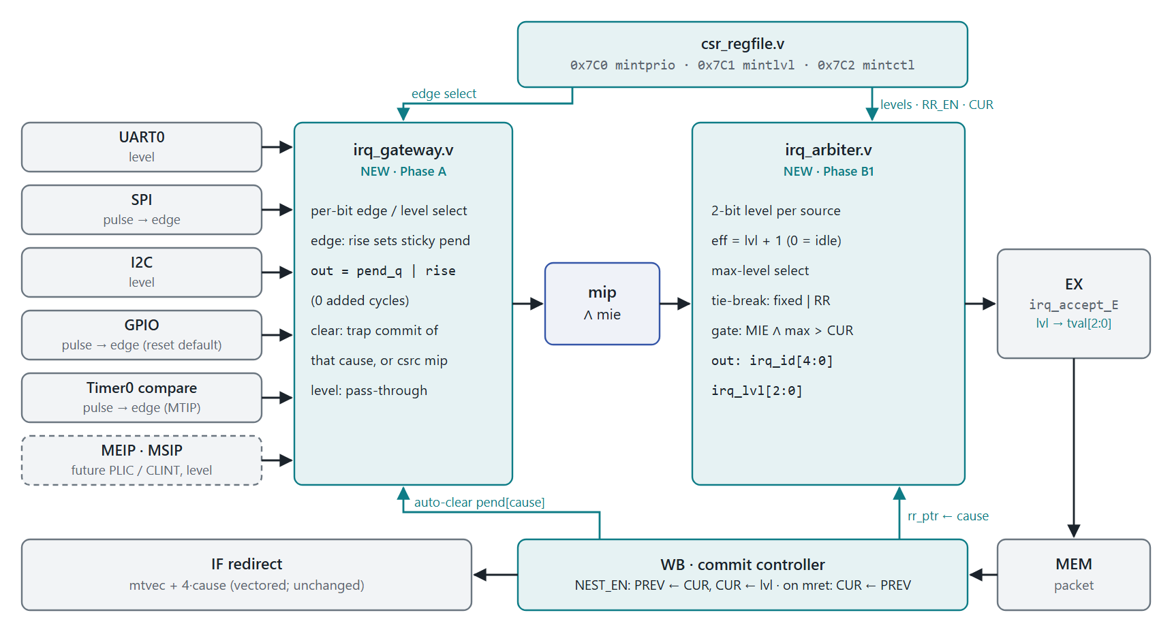
Figure 3 Target design after Phases A and B. New blocks in teal. Vectoring, fetch and the pipeline are unchanged.

Gateway: irq_gateway.v (Phase A)
- One bit per mip position. edge_sel = 1: a rising edge sets a sticky pend bit. edge_sel = 0: the input passes straight through (level).
- The output is pend_q | rise, so an edge is visible in the same cycle it arrives. The gateway adds no latency.
- Clear happens when the interrupt trap for that cause commits at WB, or when software writes 0 to that mip bit (csrc mip). Clearing at commit rather than at EX accept means that if an older instruction's exception flushes the interrupt packet, the interrupt stays pending and is retaken.
- A new edge in the same cycle as a clear wins, so back-to-back events are not merged away.
- Software cannot set MTIP or FLI bits: mip writes are clear-only for edge bits and ignored otherwise.
- All sources are on clk_i, so no synchroniser is needed. Pad-level GPIO is already synchronised inside gpio.sv.
New file riscv_core/rtl/irq_gateway.v
// irq_gateway.v: per-bit edge capture for pulse interrupt sources (Verilog-2001)
module irq_gateway (
input wire clk_i,
input wire rst_n_i,
input wire [31:0] irq_raw_i, // {fast[15:0], 4'b0, meip, 3'b0, mtip, 7'b0}
input wire [31:0] edge_sel_i, // 1 = edge-triggered (sticky), 0 = level
input wire take_i, // interrupt trap committed at WB
input wire [4:0] take_cause_i, // mcause[4:0] of that trap
input wire [31:0] sw_clr_i, // edge bits written 0 through mip
output wire [31:0] irq_pend_o
);
reg [31:0] raw_q, pend_q;
wire [31:0] rise = irq_raw_i & ~raw_q;
wire [31:0] take_m = take_i ? (32'h1 << take_cause_i) : 32'h0;

always @(posedge clk_i or negedge rst_n_i) begin
if (!rst_n_i) begin
raw_q <= 32'h0;
pend_q <= 32'h0;
end else begin
raw_q <= irq_raw_i;
// a new edge in the same cycle as a clear wins
pend_q <= ((pend_q & ~take_m & ~sw_clr_i) | rise) & edge_sel_i;
end
end

// (pend_q | rise): edge sources are seen in the cycle they arrive
assign irq_pend_o = (edge_sel_i & (pend_q | rise)) | (~edge_sel_i & irq_raw_i);
endmodule

CSR interface (Phase B1)
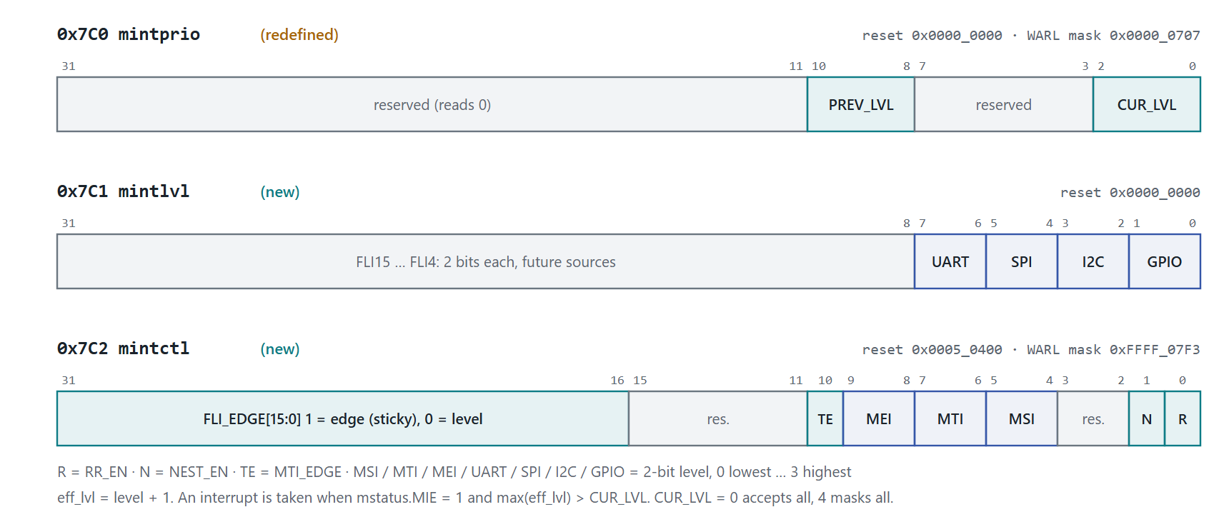
Figure 4 Custom CSRs, all in the custom M-mode read/write range 0x7C0–0x7FF, so no standard CSR is touched.
CSR | FIELD | BITS | RESET | MEANING
0x7C0 mintprio | CUR_LVL | [2:0] | 0 | Current threshold. An interrupt is taken only if its effective level is greater than CUR_LVL. 0 accepts all, 4 masks all.
 | PREV_LVL | [10:8] | 0 | Written by hardware on trap entry when NEST_EN = 1; copied back to CUR_LVL on mret.
0x7C1 mintlvl | FLIn level | [2n+1:2n] | 0 | Level 0–3 for fast interrupt n (cause 16+n). GPIO [1:0], I2C [3:2], SPI [5:4], UART [7:6]. [31:8] are for future sources.
0x7C2 mintctl | RR_EN | [0] | 0 | 1 = round-robin among sources tied at the highest level; 0 = fixed order MEI > MSI > MTI > 31…16.
 | NEST_EN | [1] | 0 | 1 = hardware level save/restore (Phase B2).
 | MSI / MTI / MEI level | [5:4] [7:6] [9:8] | 0 | Levels of the standard interrupts.
 | MTI_EDGE | [10] | 1 | Treat MTIP as edge-triggered. Set because Timer0 compare is a pulse. Clear it when a real CLINT, which holds MTIP as a level, replaces Timer0.
 | FLI_EDGE | [31:16] | 0x0005 | Bit n = 1 makes FLI n edge-triggered. The reset value covers GPIO (FLI0) and SPI (FLI2).

RESET COMPATIBILITY
With all levels at 0, RR_EN = 0 and NEST_EN = 0, every pending source ties at effective level 1 and the fixed order decides. Phase B at reset therefore behaves exactly like Phase A, so every Phase A test runs unchanged on Phase B.

GPIO MODE AND EDGE SETTING MUST AGREE
If the BSP switches GPIO to glbl_intrpt_mode = 1 (sticky status, level output), it must also clear FLI_EDGE[0]. Otherwise a pin event that arrives while another status bit is still set produces no new rising edge and is missed.

Arbiter: irq_arbiter.v (Phase B1)
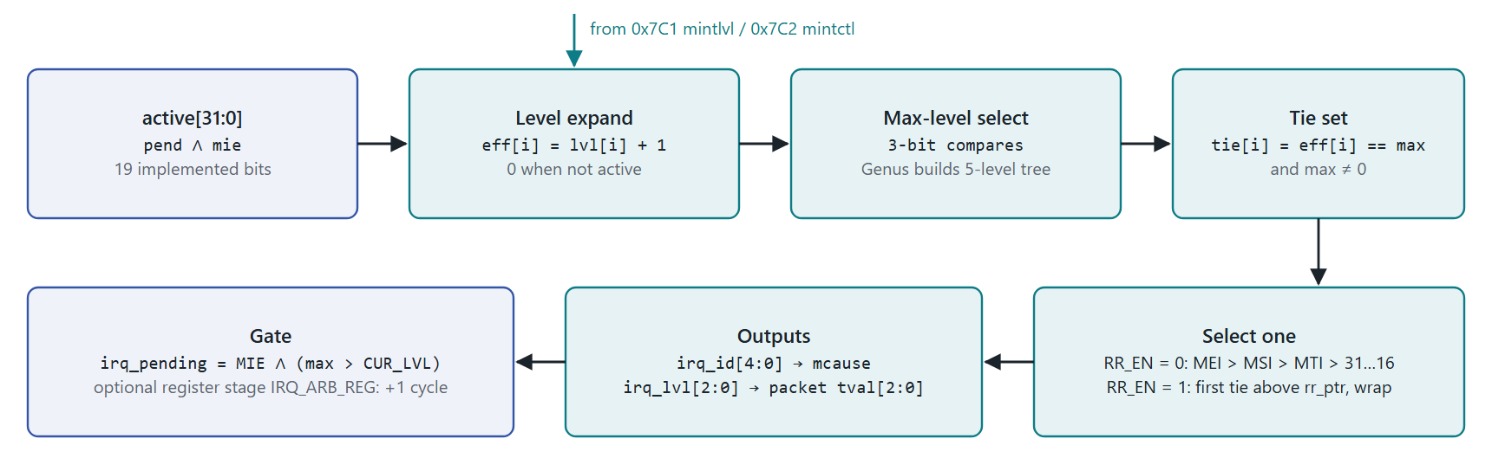
Figure 5 Arbiter datapath. Purely combinational. Only 19 of the 32 positions are implemented; synthesis removes the rest.
New file riscv_core/rtl/irq_arbiter.v
// irq_arbiter.v: level-based interrupt selection (Verilog-2001, combinational)
module irq_arbiter (
input wire [31:0] active_i, // gateway pend & mie
input wire [31:0] mintlvl_i, // CSR 0x7C1
input wire [31:0] mintctl_i, // CSR 0x7C2
input wire [2:0] cur_lvl_i, // mintprio[2:0]
input wire mie_i, // mstatus.MIE
input wire [4:0] rr_ptr_i, // cause of the last interrupt taken
output reg [4:0] irq_cause_o,
output reg [2:0] irq_lvl_o,
output wire irq_pending_o
);
// 1. effective level: lvl + 1 when requesting, 0 when idle
wire [95:0] eff;
genvar g;
generate for (g = 0; g < 32; g = g + 1) begin : g_eff
if (g >= 16) begin : g_fli
assign eff[3*g +: 3] = active_i[g] ? ({1'b0, mintlvl_i[2*(g-16) +: 2]} + 3'd1) : 3'd0;
end else if (g == 3) begin : g_msi
assign eff[3*g +: 3] = active_i[g] ? ({1'b0, mintctl_i[5:4]} + 3'd1) : 3'd0;
end else if (g == 7) begin : g_mti
assign eff[3*g +: 3] = active_i[g] ? ({1'b0, mintctl_i[7:6]} + 3'd1) : 3'd0;
end else if (g == 11) begin : g_mei
assign eff[3*g +: 3] = active_i[g] ? ({1'b0, mintctl_i[9:8]} + 3'd1) : 3'd0;
end else begin : g_none
assign eff[3*g +: 3] = 3'd0;
end
end endgenerate

integer i;
reg [2:0] max_lvl;
reg [31:0] tie;
reg [4:0] rr_pick, fx_pick;

// 2. highest level present (synthesis balances the chain into a tree)
always @(*) begin
max_lvl = 3'd0;
for (i = 0; i < 32; i = i + 1)
if (eff[3*i +: 3] > max_lvl) max_lvl = eff[3*i +: 3];
end

// 3. sources tied at that level
always @(*)
for (i = 0; i < 32; i = i + 1)
tie[i] = (max_lvl != 3'd0) && (eff[3*i +: 3] == max_lvl);

// 4a. round-robin: first tie above rr_ptr, else wrap to the lowest tie
wire [31:0] above_ptr = tie & ~((32'h2 << rr_ptr_i) - 32'h1);
wire [31:0] rr_pool = (|above_ptr) ? above_ptr : tie;
always @(*) begin
rr_pick = 5'd0;
for (i = 31; i >= 0; i = i - 1)
if (rr_pool[i]) rr_pick = i; // lowest set bit wins
end

// 4b. fixed order: MEI > MSI > MTI > 31 ... 16 (last assignment wins)
always @(*) begin
fx_pick = 5'd0;
for (i = 16; i < 32; i = i + 1)
if (tie[i]) fx_pick = i;
if (tie[7]) fx_pick = 5'd7;
if (tie[3]) fx_pick = 5'd3;
if (tie[11]) fx_pick = 5'd11;
end

always @(*) begin
irq_cause_o = mintctl_i[0] ? rr_pick : fx_pick;
irq_lvl_o = max_lvl;
end
assign irq_pending_o = mie_i && (max_lvl > cur_lvl_i);
endmodule

Starvation bound. With RR_EN = 1, a source that stays pending at the highest pending level is taken within N−1 grants, where N is the number of sources at that level. Property P4 proves this. A higher level can still starve a lower one, and that is intended: that is what a priority means. Choosing levels is the integrator's job, and section 10 gives a default.

Nesting (Phase B2)
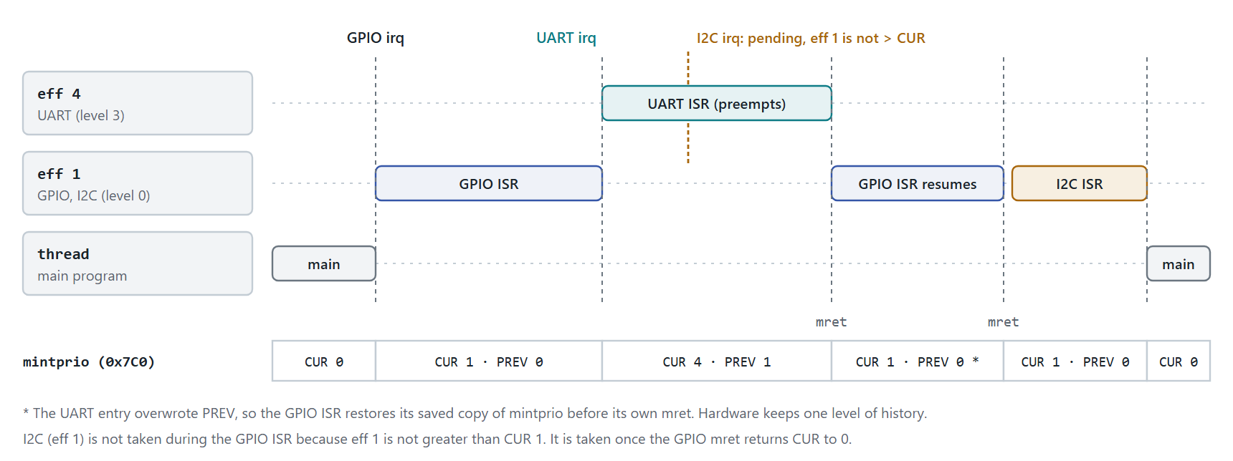
Figure 6 Preemptive nesting with NEST_EN = 1. UART at level 3 preempts the GPIO ISR; I2C at the GPIO level waits.
- On any trap entry: PREV_LVL ← CUR_LVL. On an interrupt trap, also CUR_LVL ← level taken.
- On mret: CUR_LVL ← PREV_LVL.
- The hardware keeps one level of history, so an ISR that re-enables MIE must save mintprio together with mepc and mstatus. That is the same rule the spec already imposes for mepc (section 10 has the wrapper).
- Equal-level sources never preempt each other, because the take condition is strictly greater. This prevents same-level ping-pong.
- With NEST_EN = 0, CUR_LVL is purely software-controlled. That is Phase B1 behaviour.

7 Fix plan
Apply every change first to rtl/ips/riscv_core/rtl (the SoC core), then mirror it into 5_stage/ and the RISCOF DUT tree rv32im_zicsr_5stage_exc_nointr/. AGENTS.md warns that these trees drift.

Phase A: correctness (required)
STEP | FILE : LINE | CHANGE | DONE WHEN
A1 | new irq_gateway.v; csr_regfile.v:274–286 | Instantiate the gateway inside csr_regfile with edge_sel = 32'h0005_0080 (GPIO, SPI, MTIP), take_i = trap_valid_i & trap_is_interrupt_i, take_cause_i = trap_cause_i[4:0]. Build mip_w from irq_pend_o; keep msip_r as is. | IRQ08, IRQ09, IRQ10 pass
A2 | top.v:232–256 | Reorder the chain: MEI, MSI, MTI, then 31…16. | IRQ03 (updated order) and IRQ11 pass; Spike co-sim agrees
A3 | top.v:216–219 | Apply the mintprio threshold as a mask before selection (snippet below). The current test4_mintprio.S semantics are unchanged. | IRQ04 passes unchanged
A4 | csr_regfile.v:276–283 | On mip writes (both ports), drive sw_clr_i = edge_sel & ~wdata. Hardware bits stay read-only for set. | IRQ16 passes
A5 | all three RTL trees | Mirror A1–A4; run lint and RISCOF. | RISCOF 100%; Verilator lint clean

Phase A priority chain
// top.v, replaces lines 216-256: threshold first, then spec order
wire [31:0] above_thr = ~((32'h2 << csr_mintprio_sb[4:0]) - 32'h1); // bits > mintprio
wire [31:0] eligible = active_irqs & above_thr;
assign irq_valid = |eligible;
assign irq_pending = csr_mstatus_mie_sb & irq_valid;

always @(*) begin
if (eligible[11]) irq_cause_enc = 5'd11; // MEIP (spec: MEI > MSI > MTI)
else if (eligible[3]) irq_cause_enc = 5'd3; // MSIP
else if (eligible[7]) irq_cause_enc = 5'd7; // MTIP (tick ahead of peripherals)
else if (eligible[31]) irq_cause_enc = 5'd31; // FLI 31..20 reserved
// ... 30 down to 20 unchanged ...
else if (eligible[19]) irq_cause_enc = 5'd19; // UART
else if (eligible[18]) irq_cause_enc = 5'd18; // SPI
else if (eligible[17]) irq_cause_enc = 5'd17; // I2C
else if (eligible[16]) irq_cause_enc = 5'd16; // GPIO
else irq_cause_enc = 5'd0;
end

Phase A gateway hookup
// csr_regfile.v, replaces line 286
localparam [31:0] EDGE_SEL_A = 32'h0005_0080; // FLI0 GPIO, FLI2 SPI, MTIP
wire mip_wr = (csr_write_en_normal_i && csr_waddr_normal_i == MIP_ADDR) ||
(csr_write_en_mret_i && csr_waddr_mret_i == MIP_ADDR);
wire [31:0] mip_wdat = csr_write_en_normal_i ? csr_wdata_normal_i : csr_wdata_mret_i;
wire [31:0] irq_pend;

irq_gateway u_irq_gateway (
.clk_i (clk_i),
.rst_n_i (rst_n_i),
.irq_raw_i ({fast_intr_i, 4'b0, ext_intr_i, 3'b0, timer_intr_i, 7'b0}),
.edge_sel_i (EDGE_SEL_A), // Phase B1: from mintctl_r
.take_i (trap_valid_i & trap_is_interrupt_i),
.take_cause_i (trap_cause_i[4:0]),
.sw_clr_i (mip_wr ? (EDGE_SEL_A & ~mip_wdat) : 32'h0),
.irq_pend_o (irq_pend)
);

assign mip_w = (irq_pend & 32'hFFFF_0880) | {28'b0, (msip_r | msft_intr_i), 3'b0};

Phase B1: programmable levels and round-robin (recommended)
STEP | FILE : LINE | CHANGE | DONE WHEN
B1.1 | csr_regfile.v:82, 103, 135–142, 183–189, 246–252, 305–317 | Add mintlvl_r (0x7C1, reset 0) and mintctl_r (0x7C2, reset 0x0005_0400, WARL 0xFFFF_07F3). Mask mintprio writes with 0x0000_0707. Add read-mux entries, csr_valid_o terms and output ports. Gateway edge_sel = {mintctl_r[31:16], 8'b0, mintctl_r[10], 7'b0}. | IRQ16 passes
B1.2 | new irq_arbiter.v; top.v:204–258 | Replace the chain with the arbiter instance. irq_cause_enc becomes a wire. | IRQ04, IRQ12–IRQ14 pass
B1.3 | top.v (new register) | irq_rr_ptr <= trap_commit_cause[4:0] when trap_commit_valid & trap_commit_is_interrupt. | IRQ13 passes
B1.4 | top.v:258 | Pack the level into the existing bus: irq_id = {23'b0, irq_lvl, irq_cause_enc}. execute_cycle.v:450 only reads [4:0], so there is no port change. | build clean
B1.5 | Verification/asm/test4_mintprio.S | Rewrite for level semantics: set UART to level 1, mintprio = 2, check UART is blocked and MTI at level 3 is taken. | IRQ04 passes
B1.6 | Sw/bsp/irq.h (new) | BSP API from section 10. | IRQ12–IRQ15 use it

Phase B1 top.v wiring
// top.v, B1.2 / B1.3 / B1.4
reg [4:0] irq_rr_ptr;
wire [2:0] irq_lvl;

always @(posedge clk or negedge rst)
if (!rst) irq_rr_ptr <= 5'd0;
else if (trap_commit_valid & trap_commit_is_interrupt) irq_rr_ptr <= trap_commit_cause[4:0];

irq_arbiter u_irq_arbiter (
.active_i (csr_mip_sb & csr_mie_sb),
.mintlvl_i (csr_mintlvl_sb),
.mintctl_i (csr_mintctl_sb),
.cur_lvl_i (csr_mintprio_sb[2:0]),
.mie_i (csr_mstatus_mie_sb),
.rr_ptr_i (irq_rr_ptr),
.irq_cause_o (irq_cause_enc),
.irq_lvl_o (irq_lvl),
.irq_pending_o (irq_pending)
);

assign irq_id = {23'b0, irq_lvl, irq_cause_enc}; // [7:5] level, [4:0] cause

Phase B2: hardware nesting (recommended if schedule allows)
The interrupt packet already carries a 32-bit tval that is always 0 for interrupts: execute_cycle.v:454, and trap_addr_valid_o is 0 for interrupts at wb_trap_mret_commit_controller.v:73, so mtval is written 0 regardless. B2 uses tval[2:0] to carry the level from EX to WB, which needs no new pipeline registers.
STEP | FILE : LINE | CHANGE | DONE WHEN
B2.1 | execute_cycle.v:454 | irq_accept_E ? {29'b0, irq_id_i[7:5]} : instead of 32'h0. | build clean
B2.2 | wb_trap_mret_commit_controller.v | New output trap_irq_lvl_o = exc_tval_W[2:0]. mtval stays 0 because trap_addr_valid_o is already 0 for interrupts. | IRQ15 passes
B2.3 | csr_regfile.v:203–211, 216–240 | Level save on trap entry and restore on mret (snippet below). New input trap_irq_lvl_i. | IRQ15 passes
B2.4 | TB monitors | Check that commit_monitor.sv and the scoreboard do not compare the internal packet tval for interrupts; the architectural mtval is still 0. | regression clean

Phase B2 level save/restore
// csr_regfile.v, inside write_ports_bc
if (trap_valid_i) begin
// ... existing mepc / mcause / mtval / mstatus updates ...
if (mintctl_r[1]) begin // NEST_EN
mintprio_r[10:8] <= mintprio_r[2:0]; // PREV <- CUR
if (trap_is_interrupt_i)
mintprio_r[2:0] <= trap_irq_lvl_i; // CUR <- level taken
end
end
else if (csr_write_en_mret_i) begin
// ... existing case (MSTATUS via port C) ...
if (mintctl_r[1])
mintprio_r[2:0] <= mintprio_r[10:8]; // CUR <- PREV on mret
end

Sequence and effort
PHASE | EFFORT (EST.) | DEPENDS ON | EXIT CRITERIA
A | 2–3 d RTL + 2 d tests | — | IRQ08–IRQ11, IRQ16 pass; RISCOF rv32i_m I/M/Zicsr/privilege 100%; Verilator lint clean
B1 | 3–4 d RTL + 3 d tests and FPV | A | IRQ04, IRQ12–IRQ14 pass; P1–P4 proven in JasperGold; Genus timing met on the irq path
B2 | 2–3 d RTL + 2 d tests | B1 | IRQ15 passes; RISCOF 100%; Spike co-sim masks updated
C | deferred | a section 5 trigger | —

8 Latency and area budget
METRIC | TODAY | AFTER A | AFTER B1 | AFTER B2 | PLIC (C)
Arbitration cycles added | 0 | 0 | 0 (1 with IRQ_ARB_REG) | 0 | +1–2 (gateway, target)
Accept → redirect | EX + 2 (MEM, WB) | same | same | same | same, then claim/complete
Pulse capture window | 1 cycle | until taken | until taken | until taken | until claimed
Worst case, highest-priority source | longest other ISR + longest EX stall | same | same | longest EX stall + prologue | as today + ~15–30 cycles (est.)
Software dispatch | vectored mtvec | same | same | same | claim read → table → complete write
New flops (est.) | — | ~34 | ~+70 | ~+3 | ~70–100 + bus
Area (est.) | ~0.1 kGE encoder | +0.2–0.3 kGE | +0.8–1.1 kGE | +0.1 kGE | 3–5 kGE

B2 is the only change that bounds the highest-priority latency without depending on how long other ISRs run. It is the real latency win, not the arbiter. The arbiter sits on the mip → irq_pending → irq_accept_E → FlushD path. If Genus shows negative slack at the target clock, set IRQ_ARB_REG = 1, which registers irq_pending/irq_id and adds one cycle. mintprio_r shrinks from 32 flops to 6, which offsets part of the B1 cost.

9 Verification plan

Directed tests (extend Verification/tb1_interrupts.sv and Verification/asm/; IRQ01–IRQ07 already exist)
ID | SCENARIO | PASS CRITERION | PHASE
IRQ03 | Existing priority test: update expected_order to 11, 3, 7, 19, 18, 17, 16 | Passes with the Phase A order | A
IRQ08 | SPI 1-cycle pulse while inside the UART ISR (MIE = 0) | SPI ISR runs once, after the UART mret | A
IRQ09 | Timer0 pulse during a div in EX (stallMUL) | Taken after the divide; mepc is the next instruction | A
IRQ10 | Two Timer0 pulses, one while pending (edge in the same cycle as the clear) | Two MTIP traps, not one | A
IRQ11 | MEIP, MSIP and MTIP raised together (force ext_irq_i, write MSIP) | Order MEI → MSI → MTI | A
IRQ04 | Existing test 4 rewritten for level semantics | Level ≤ CUR blocked; higher taken | B1
IRQ12 | GPIO level 3, UART level 0, both pending | GPIO first, overriding the reset order | B1
IRQ13 | UART and I2C both held high at level 1, RR_EN = 1 | Grants alternate; no source waits more than 1 grant | B1
IRQ14 | Same with RR_EN = 0 | Fixed order: UART every time until cleared | B1
IRQ15 | GPIO ISR (level 0) re-enables MIE; UART (level 3) arrives; I2C (level 0) arrives | UART preempts; I2C waits; CUR/PREV match figure 6 | B2
IRQ16 | CSR access: reset values, WARL masks, mip write clears edge bits and cannot set them | Readbacks match the section 6 table | A/B1
IRQ17 | Latency measurement: cycles from IRQ assert to the first ISR instruction retiring | Number recorded in the sign-off table | all

Formal properties (JasperGold FPV on irq_arbiter and irq_gateway standalone)
ID | PROPERTY | TYPE
P1 | irq_pending_o → eff[irq_cause_o] == max over all active eff | assert
P2 | irq_pending_o → mie_i && eff[irq_cause_o] > cur_lvl_i | assert
P3 | !RR_EN && tie has several bits → irq_cause_o is the fixed-order winner | assert
P4 | With rr_ptr updated on every grant, a source continuously in tie is granted within N−1 grants | assert (liveness bound)
P5 | Edge bit: a rise sets irq_pend_o in the same cycle, and it stays set until take_m or sw_clr for that bit | assert
P6 | Level bit: irq_pend_o == irq_raw_i | assert
C1–C3 | Each of the 19 sources granted; RR wrap-around; rise and clear in the same cycle | cover

Regression and co-simulation
- RISCOF rv32i_m I, M, Zicsr, privilege must stay at 100%. The new CSRs live in the custom range, which the arch tests do not touch. mip stays read-only-for-set, so its readback is unchanged.
- Spike co-simulation: exclude CSRs 0x7C0–0x7C2 and mip[31:16] from state comparison, or add a Spike custom extension. The MEI > MSI > MTI fix removes the order divergence.
- Functional coverage (SV covergroup): cause × level, RR grant sequences, nesting depth 0/1/2, and pulse arriving while MIE = 0 or during stallMUL.
- Lint: the Verilator command from AGENTS.md plus SpyGlass on the three new or changed files.

10 Bare-metal BSP
One header covers everything. The CSR numbers are stringified into the instruction, so plain GCC works without a custom toolchain.
Sw/bsp/irq.h
/* Sw/bsp/irq.h: RISCFORGE interrupt control (custom CSRs 0x7C0-0x7C2) */
#ifndef RISCFORGE_IRQ_H
#define RISCFORGE_IRQ_H
#include <stdint.h>

#define CSR_MINTPRIO 0x7C0
#define CSR_MINTLVL 0x7C1
#define CSR_MINTCTL 0x7C2

#define _S(x) #x
#define S(x) _S(x)
#define csr_read(c) ({ uint32_t __v; __asm__ volatile ("csrr %0, " S(c) : "=r"(__v)); __v; })
#define csr_write(c, v) __asm__ volatile ("csrw " S(c) ", %0" :: "r"((uint32_t)(v)))
#define csr_set(c, v) __asm__ volatile ("csrs " S(c) ", %0" :: "r"((uint32_t)(v)))
#define csr_clear(c, v) __asm__ volatile ("csrc " S(c) ", %0" :: "r"((uint32_t)(v)))

enum irq_src { IRQ_MSI = 3, IRQ_MTI = 7, IRQ_MEI = 11,
IRQ_GPIO = 16, IRQ_I2C = 17, IRQ_SPI = 18, IRQ_UART = 19 };

#define MINTCTL_RR_EN (1u << 0)
#define MINTCTL_NEST_EN (1u << 1)
#define MINTCTL_MTI_EDGE (1u << 10)

static inline void irq_enable(unsigned src) { csr_set(mie, 1u << src); }
static inline void irq_disable(unsigned src) { csr_clear(mie, 1u << src); }
static inline void irq_clear_pending(unsigned src) { csr_clear(mip, 1u << src); }
static inline void irq_global_enable(void) { csr_set(mstatus, 8u); }

/* level 0 (lowest) .. 3 (highest) */
static inline void irq_set_level(unsigned src, unsigned lvl)
{
if (src >= 16) {
unsigned sh = 2u * (src - 16u);
uint32_t v = csr_read(CSR_MINTLVL);
csr_write(CSR_MINTLVL, (v & ~(3u << sh)) | ((lvl & 3u) << sh));
} else {
unsigned sh = (src == IRQ_MSI) ? 4u : (src == IRQ_MTI) ? 6u : 8u;
uint32_t v = csr_read(CSR_MINTCTL);
csr_write(CSR_MINTCTL, (v & ~(3u << sh)) | ((lvl & 3u) << sh));
}
}

/* edge = 1 latches pulses; use 0 for sources that hold a level until cleared.
FLI n is mintctl[16+n], which is bit 'src' itself. */
static inline void irq_set_edge(unsigned src, int edge)
{
uint32_t bit = (src >= 16) ? (1u << src) : MINTCTL_MTI_EDGE;
if (edge) csr_set(CSR_MINTCTL, bit); else csr_clear(CSR_MINTCTL, bit);
}

static inline void irq_round_robin(int on)
{
if (on) csr_set(CSR_MINTCTL, MINTCTL_RR_EN); else csr_clear(CSR_MINTCTL, MINTCTL_RR_EN);
}

static inline void irq_nesting(int on)
{
if (on) csr_set(CSR_MINTCTL, MINTCTL_NEST_EN); else csr_clear(CSR_MINTCTL, MINTCTL_NEST_EN);
}

/* sources with (level + 1) <= cur are masked; 0 masks none, 4 masks all */
static inline void irq_set_threshold(unsigned cur) { csr_write(CSR_MINTPRIO, cur & 7u); }
#endif

Board initialisation
/* Recommended default: tick first, UART next (small RX FIFO), SPI and I2C share a level */
void board_irq_init(void)
{
irq_set_level(IRQ_MTI, 3);
irq_set_level(IRQ_UART, 2);
irq_set_level(IRQ_SPI, 1);
irq_set_level(IRQ_I2C, 1);
irq_set_level(IRQ_GPIO, 0);
irq_round_robin(1); /* SPI and I2C alternate when both pend */
irq_nesting(1); /* Phase B2 hardware */

irq_enable(IRQ_MTI); irq_enable(IRQ_UART); irq_enable(IRQ_SPI);
irq_enable(IRQ_I2C); irq_enable(IRQ_GPIO);
irq_set_threshold(0);
irq_global_enable();
}

Nested ISR wrapper for crt0.S (vectored mtvec: entry at base + 4·cause jumps here)
# Preemptible ISR wrapper (NEST_EN = 1). Only levels above this one can enter handler.
.macro NESTED_ISR name, handler
\name:
addi sp, sp, -80
sw ra, 0(sp)
sw t0, 4(sp)
sw t1, 8(sp)
sw t2, 12(sp)
sw a0, 16(sp)
sw a1, 20(sp)
sw a2, 24(sp)
sw a3, 28(sp)
sw a4, 32(sp)
sw a5, 36(sp)
sw a6, 40(sp)
sw a7, 44(sp)
sw t3, 48(sp)
sw t4, 52(sp)
sw t5, 56(sp)
sw t6, 60(sp)
csrr t0, mepc
sw t0, 64(sp)
csrr t0, mstatus
sw t0, 68(sp)
csrr t0, 0x7C0 # mintprio: this ISR's CUR and PREV
sw t0, 72(sp)
csrsi mstatus, 8 # MIE = 1: higher levels may preempt
call \handler
csrci mstatus, 8 # MIE = 0 before restoring trap state
lw t0, 72(sp)
csrw 0x7C0, t0
lw t0, 68(sp)
csrw mstatus, t0
lw t0, 64(sp)
csrw mepc, t0
lw ra, 0(sp)
lw t0, 4(sp)
lw t1, 8(sp)
lw t2, 12(sp)
lw a0, 16(sp)
lw a1, 20(sp)
lw a2, 24(sp)
lw a3, 28(sp)
lw a4, 32(sp)
lw a5, 36(sp)
lw a6, 40(sp)
lw a7, 44(sp)
lw t3, 48(sp)
lw t4, 52(sp)
lw t5, 56(sp)
lw t6, 60(sp)
addi sp, sp, 80
mret # hardware: CUR <- PREV
.endm

ISRs that do not need preemption keep the existing plain __attribute__((interrupt("machine"))) form. crt0.S already writes mintprio = 0, which still means "accept all" under the new semantics.

11 Future extensions
- More sources: FLI slots 20–31 are free. Adding Timer1 compare as FLI[4] (cause 20) is SoC wiring only. Set its level, edge bit and mie bit in software; the core RTL is untouched.
- PLIC on MEIP (Phase C, figure 7) when a section 5 trigger is met. Latency-critical sources stay on direct FLIs and slow ones fan in through the PLIC.
- CLIC migration: the Phase B fields map one-to-one onto CLIC concepts. mintlvl corresponds to the level bits of clicintctl, CUR_LVL to mintthresh/mintstatus.mil, PREV_LVL to mcause.mpil, and FLI_EDGE to clicintattr.trig. Keeping the irq.h API stable means drivers do not change. The PULP CLIC is already in rtl/ips/clic-master/.
- Trim for area: a NUM_FLI parameter on the gateway and arbiter (default 16) lets the tape-out build implement only the sources that exist.
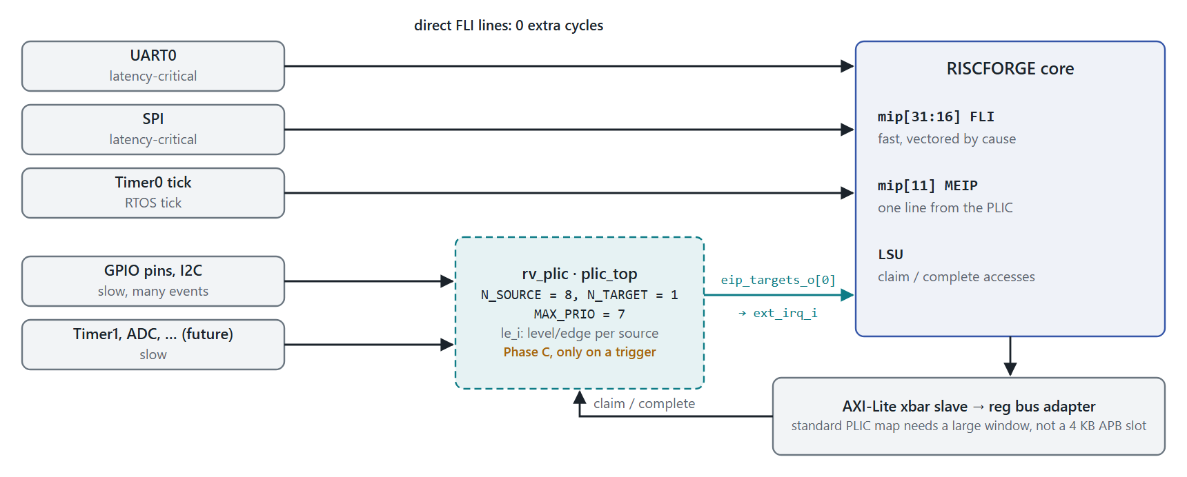
Figure 7 Phase C, only if triggered: PLIC fan-in on MEIP, with latency-critical sources kept on direct FLI lines.

12 Sign-off checklist
ITEM | OWNER | STATUS
Pulse capture verified (IRQ08–IRQ10) with the gateway in place | DV (Yashraj) | Open
Spec interrupt order (IRQ11) and Spike co-sim clean | DV (Yashraj) | Open
RISCOF rv32i_m I/M/Zicsr/privilege at 100% after each phase | RTL | Open
Verilator lint and SpyGlass clean on changed files | RTL | Open
FPV P1–P6 proven, covers C1–C3 hit | DV (Yashraj) | Open
Genus: area delta and slack on the mip → irq_accept_E → FlushD path at the target clock | Synthesis (Malay) | Open
IRQ17 latency numbers recorded in this table | DV | Open
irq.h added; test4_mintprio.S rewritten; GPIO mode vs FLI_EDGE documented | RTL / SW | Open
Changes mirrored to 5_stage/ and rv32im_zicsr_5stage_exc_nointr/ | RTL | Open

13 References
- Core: riscv_core/rtl/top.v:204–258, csr_regfile.v:180–317, execute_cycle.v:439–459, wb_trap_mret_commit_controller.v:62–84
- SoC: RTL_SOC/riscforge_soc_subsystem.sv:1060–1138
- IP sources: apb_spi_master.sv:116, 166–223; apb_timer-master/rtl/timer.sv:53–76; gpio-master/gpio.sv:127–133; apb_i2c-master/apb_i2c.sv:191–193
- Tests: Verification/tb1_interrupts.sv, Verification/asm/test4_mintprio.S, Sw/bsp/crt0.S
- RISC-V Privileged Architecture: machine interrupt registers (mip/mie) and standard interrupt priority order
- PULP rv_plic: github.com/pulp-platform/rv_plic (rtl/plic_top.sv)

