**Data Flow Diagram (DFD) for E-Commerce Application**

**Level 0 (Context Diagram)**

At the highest level, the **E-Commerce System** interacts with external entities such as **Users** and **Admins**, processing transactions, managing products, and handling payments.

**Context Diagram Representation:  
  
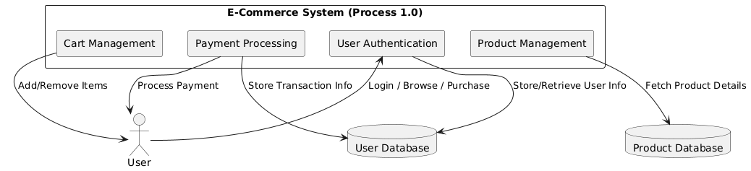**

**Explanation:**

* **External Entity (User):** The user interacts with the system by browsing products, adding items to the cart, and making purchases.
* **External Entity (Admin):** Admins manage products, inventory, and user data.
* **Process (E-Commerce System):** The main system handles authentication, product management, cart management, and payment processing.
* **Data Stores:** Various databases store user information, product details, cart data, and payment transactions.

**Level 1 (Detailed Process Breakdown)**

This level provides a breakdown of the main **E-Commerce System** into smaller processes.

**Detailed Data Flow Representation:  
  
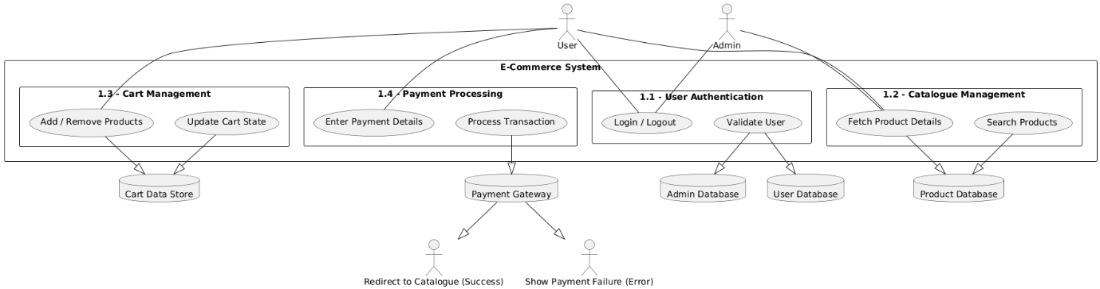**

**Explanation:**

* **Process 1.1 (User Authentication):** Handles user login, logout, and validation.
* **Process 1.2 (Catalogue Management):** Fetches and displays product details for users to browse and search.
* **Process 1.3 (Cart Management):** Manages adding/removing products from the shopping cart.
* **Process 1.4 (Payment Processing):** Handles transactions through a secure payment gateway.
* **Data Stores:** Store relevant information such as user data, product listings, cart data, and payment records.

**Conclusion**

This structured **Data Flow Diagram (DFD)** provides a clear representation of how data moves within the E-Commerce system, ensuring smooth functionality and efficient data handling. Future enhancements may include additional features such as order tracking, customer reviews, and automated recommendations.