**Data Flow Diagram (DFD) for React Theme and Lazy Loading App**

**Level 0: Context Diagram**

At the highest level, the system consists of user interactions with the theme and lazy loading functionality.

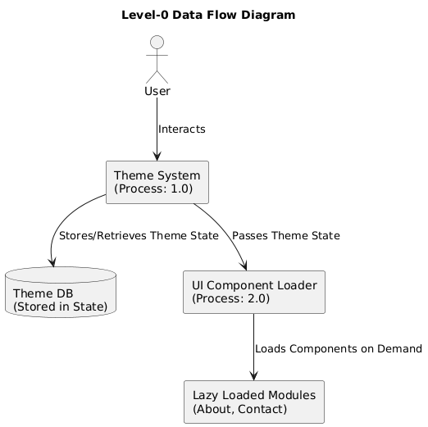

**Explanation:**

* **External Entity (User):** The user interacts with the system to toggle the theme and load components.
* **Process (Theme System):** Manages theme preferences and UI component states.
* **Data Store (Theme DB):** Stores the user's theme preference in the application state.

**Level 1: Detailed DFD**

**Breakdown of the Theme System and UI Component Loader**

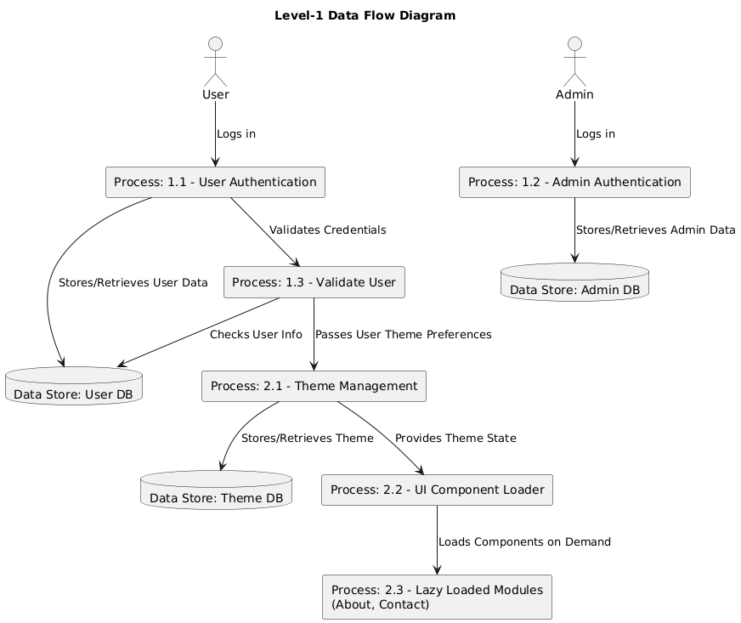

**Explanation:**

* **Process 1.1 (User Theme Selection):** The user toggles between light and dark themes.
* **Process 1.2 (Admin Theme Management):** Admin manages default themes for users.
* **Data Store (Theme DB):** Stores the theme preference in the app state.
* **Process 1.3 (UI Component Loader):** Loads necessary UI components based on user interaction.
* **Process 1.4 (Lazy Loaded Modules):** Dynamically loads the About and Contact components as needed.

**Data Flow Summary**

1. **User Interaction:** The user selects a theme or requests a component.
2. **Theme Management:** The system updates the stored theme preference.
3. **Lazy Loading:** If the user clicks "Show About" or "Show Contact," the respective component loads asynchronously.
4. **UI Update:** The app updates dynamically based on user preferences and loaded modules.

This structured DFD ensures **efficient performance, modularity, and an enhanced user experience** through dynamic loading and centralized state management.