**Data Flow Diagram (DFD) for Flower Viewer App**

**Introduction**

A Data Flow Diagram (DFD) provides a graphical representation of the data movement within a system. It helps developers understand the flow of information between various components, including external entities, processes, and data stores. This document outlines the DFD for the Flower Viewer App, which allows users to navigate through different flowers with descriptions and images.

**Level 0 DFD (Context Diagram)**

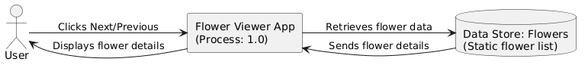

**Explanation:**

* **External Entity (User):** Interacts with the system by clicking Next or Previous.
* **Process (Flower Viewer App):** Processes user interactions and fetches flower details.
* **Data Store (Flowers):** Contains a static list of flower data.

**Level 1 DFD (Detailed Breakdown)**

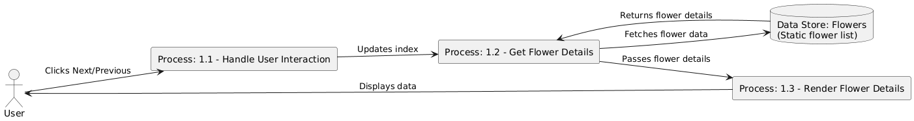

**Explanation:**

* **Process 1.1 - Handle User Interaction:** Captures user actions (Next/Previous button clicks) and updates the currentIndex.
* **Process 1.2 - Get Flower Details:** Uses the updated index to fetch flower details from the data store.
* **Process 1.3 - Render Flower Details:** Displays the selected flower's information in the UI.
* **Data Store (Flowers):** Serves as a static repository for flower details.

**Conclusion**

The Flower Viewer App efficiently manages user interactions, data retrieval, and rendering. The Level-0 and Level-1 DFDs illustrate how data flows from user actions to processing and display. This structured approach ensures a clear understanding of system functionality, aiding in further development and optimization.