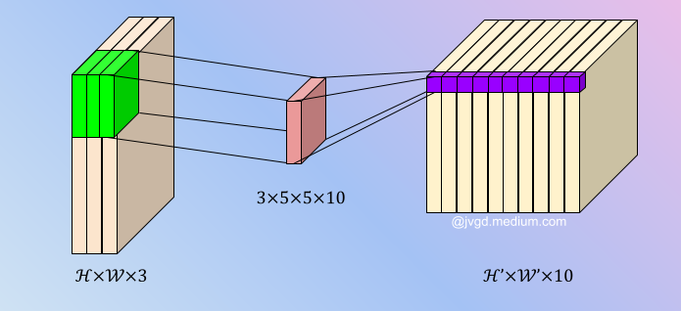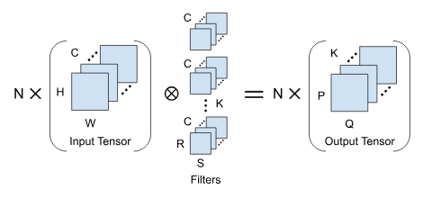

1. convert img to 3d matrix (R, G, B)

2. extract features from img

3. use convolution 2d with kernels

4. each kernel has same size lets say 3x3

5. each kernel will exract different features, so eac h kernel would be different.

6. so if we extract n features we need n kernel.

7.

Above is 3D tensor convolution

Above is 3D tensor convolution

4D tensor convolution

Implementing tensor for N images

N x C x H x W

N – Dimensions

C – Channels

H – height

W – Width