Brush DC Motor:

1. Iron Core Brushed DC motor
2. Ironless Brushed DC motor

Iron Core vs Ironless Brushed DC motor:

1. Efficiency, battery concern, very low inertia, low mechanical time constant– Ironless Brushed DC motor as they have no iron losses and very low inductance.
2. 2.Achieve efficiency up to 90%

Brushless DC motor:

1. Slotted
2. Slot less

Slotted vs Slot less:

1. Slot less design has the advantage of no cogging or detent torque, and has less iron loss than the slotted design.
2. New high-energy magnets are making BLDC slot less design the preference in small motors.
3. BLDC slot less design can offer the best efficiencies and reliability necessary for medical pumps due to the double-fold advantage of slot less and brushless features combined with ball bearings.
4. Furthermore, fluid/vial deliveries are sometimes made of short pulses and very small quantities. During these “start-stop” operations, slot less as well as brushless motors are best suited due to their above-mentioned advantages.

Brushed vs Brushless DC motor:

1. Brushed DC motors are low in cost.
2. Brushed motors are Less efficient
3. Brushed DC motors are Electrically noisy: The switching action of the commutators constantly creating and breaking inductive circuits creates a great deal of electrical and electromagnetic noise.
4. Brushed DC motor has less life span as they are in perpetual physical contact with the shaft, brushes and commutators wear out.
5. Brushless has longer lifespan as it has no brushes to wear out.
6. Brushless DC motor provides High efficiency
7. Brushless DC motor are high in cost.
8. Brushless motors are typically 85-90% efficient whereas brushed DC motor are around 75-80% efficient.

Stepper motors:

Stepper are DC motors that move in discrete steps. The operation of this motor works on the principle that unlike poles attract each other and like poles repel each other.

Advantages:

1. Stepper motor has the advantage of having many stable positions (steps) per revolution.
2. Stepper motor provides high torque for a given size (versus a regular DC or BLDC motor)

Disadvantages:

1. Stepper motor does not able to run at high speed, due to inductance combined with commutation frequency, and due to iron losses (current reversed so many times).

Different technologies in Stepper motor:

1. Variable reluctance stepper motor
2. Permanent magnet stepper motor
3. Hybrid stepper motor
4. Disc magnet stepper motor

Comparatively best:

1. For battery applications such as infusion pumps, disc magnet technology is the best, as it carries lower inertia and iron losses than other steppers, resulting in higher efficiency
2. For small portable pumps, stepper motors are the primary selection if at low speed, they can be used in full step mode, and detent torque is sufficient to hold the load.
3. They are driven like a watch motor-the correct quantity of energy is delivered to move one step to the next, while at the stall position, no current is applied in the phase.
4. When does it need to run at high speed?

At high speeds, there are two options: either the motor has to run at high speed intermittently (Reservoir change), then driven as a regular stepper

1. In some applications, a stepper solution with a gearbox may be the most economical design, since no encoder is required. In addition, at stall position, no energy is needed if detent torque is strong enough to maintain position.
2. What is confusing:

Each of these technologies presents some advantages and disadvantages. A stepper motor could be an economical and reliable solution, but at the same time, less efficient. A BLDC is the most reliable and efficient, but is expensive. A brush DC motor solution is constrained due to commutation life and usually is preferred due to its simplicity.

Motors from Portescap:

**Brush DC:**

Model : 08GS61

Different series:

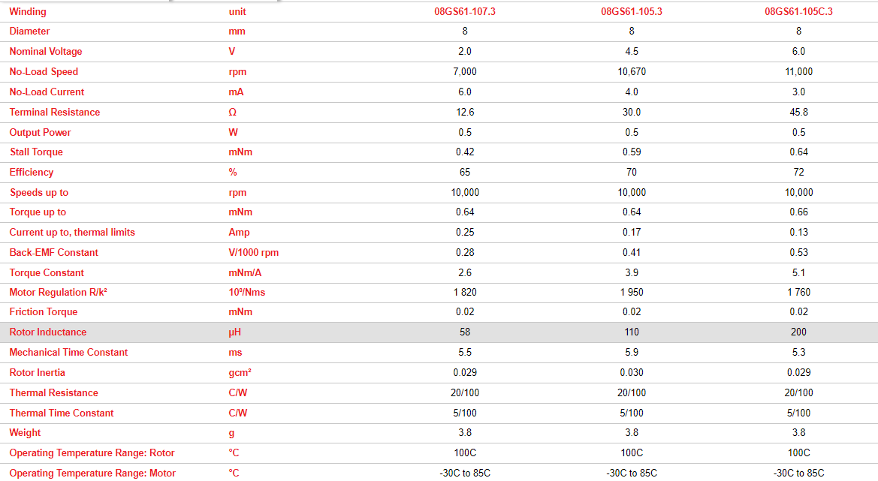

Model: 10NS61 Athlonix

Different Series:

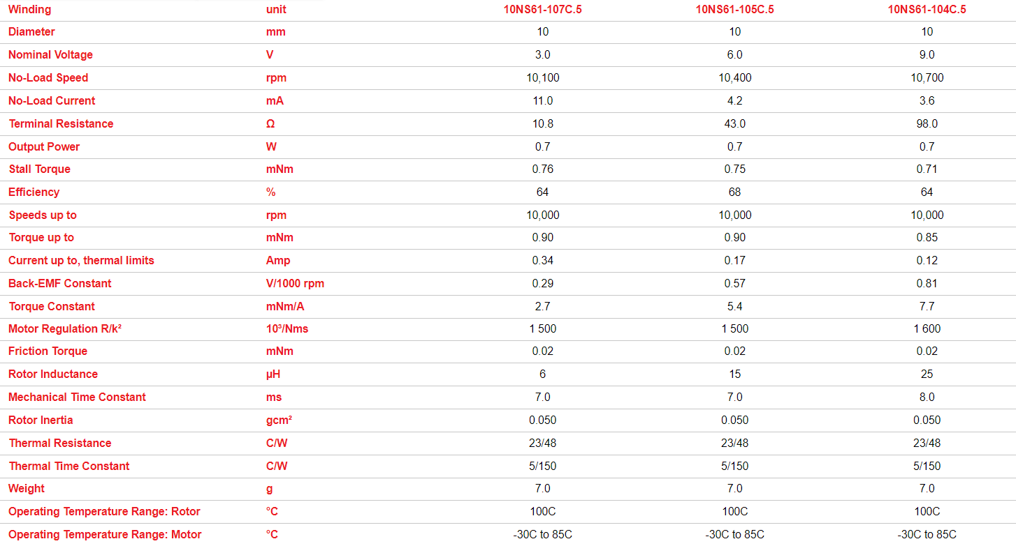

**Disc Magnet Stepper motor:**

Model: P010 064

Different series:

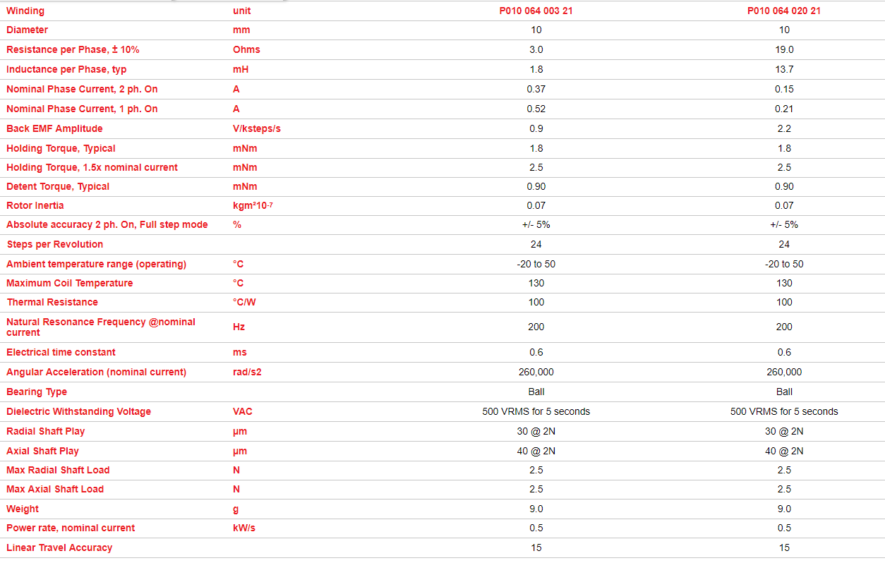

Model: P010 104

Different Series:

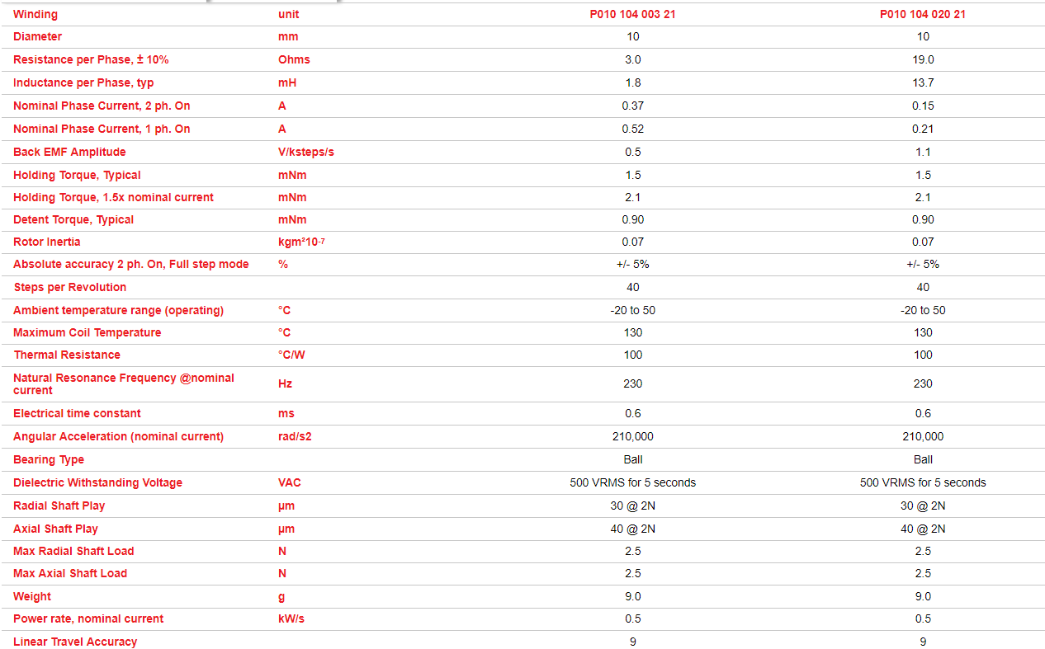

Model:PH010 064 Disc Magnet High Speed Step Motor

Different Series:

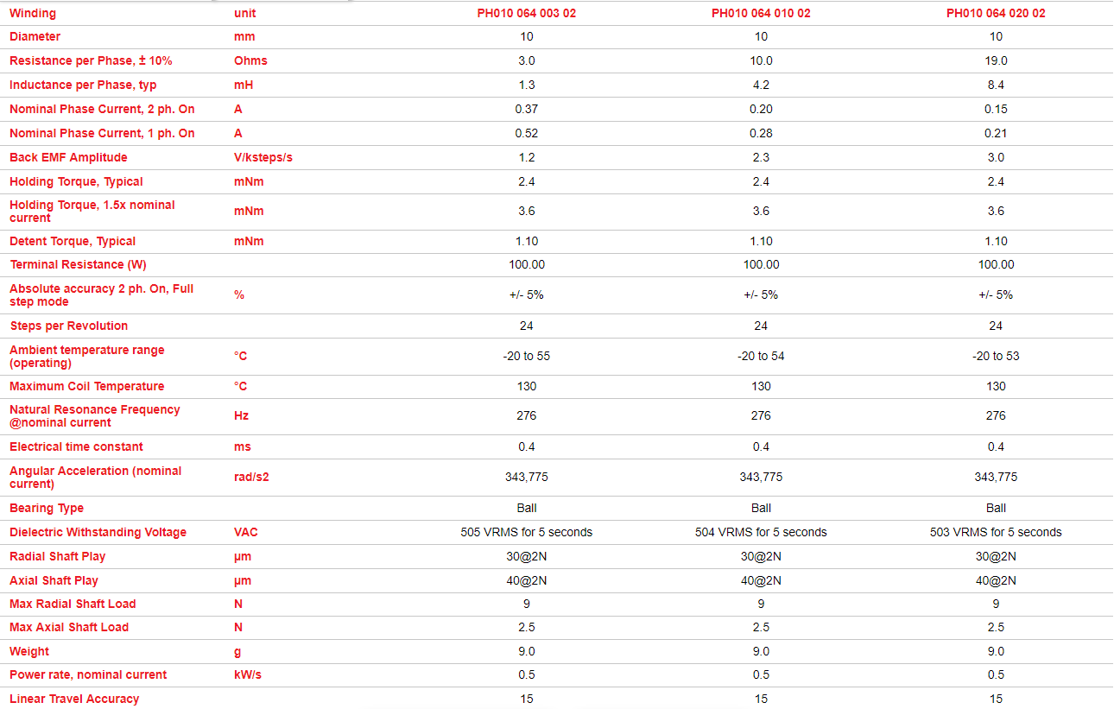

Model:PH010 104 Disc Magnet High Speed Step Motor

Different series:

