Islet Cell Transplant Costs $20000 and may not be a permanent solution

Inhalers Cause Asthmatic problems and affect lungs

Incretin Mimetic are, mainly used for Type-2 Diabetes and not effective for type-1 Diabetes

Swelling of arms and other physical complications

Insulin pumps are too costly and not user friendly also prone to malfunctions

Compact device for mobility

User Friendly UI

To inject insulin without causing swelling

Relief from hyper/hypo-glycemia

Free from pain caused by injections and glucose tests

Peace of mind

Lead a free diabetic management throughout the life cycle

Being able to blend with friends and lead a normal life

Able to have little extra food potions sometimes and not stick to a particular diet

Taking insulin using pills/inhalers

Incretin mimetics

Islet cell transplant

Insulin injections

Insulin Pumps

Insulin Patches

Insulin Pumps

Doing regular exercise

Difficulties in maintaining blood glucose levels on a daily basis

Giving less/no or more insulin causes hyper/hypo-glycemia

Blood glucose checks throughout the night

Social awkwardness while taking injections/shots in public places

When blood glucose level is not maintained it leads to:

Hyper/hypoglycemia

DKA

Microvascular Diseases (eye, kidney, nerve)

MacroVascular Diseases (Heart Disease)

Type1 diabetic patients reach a 10-year risk of fatal CVD of 5% about 10 to 15 years

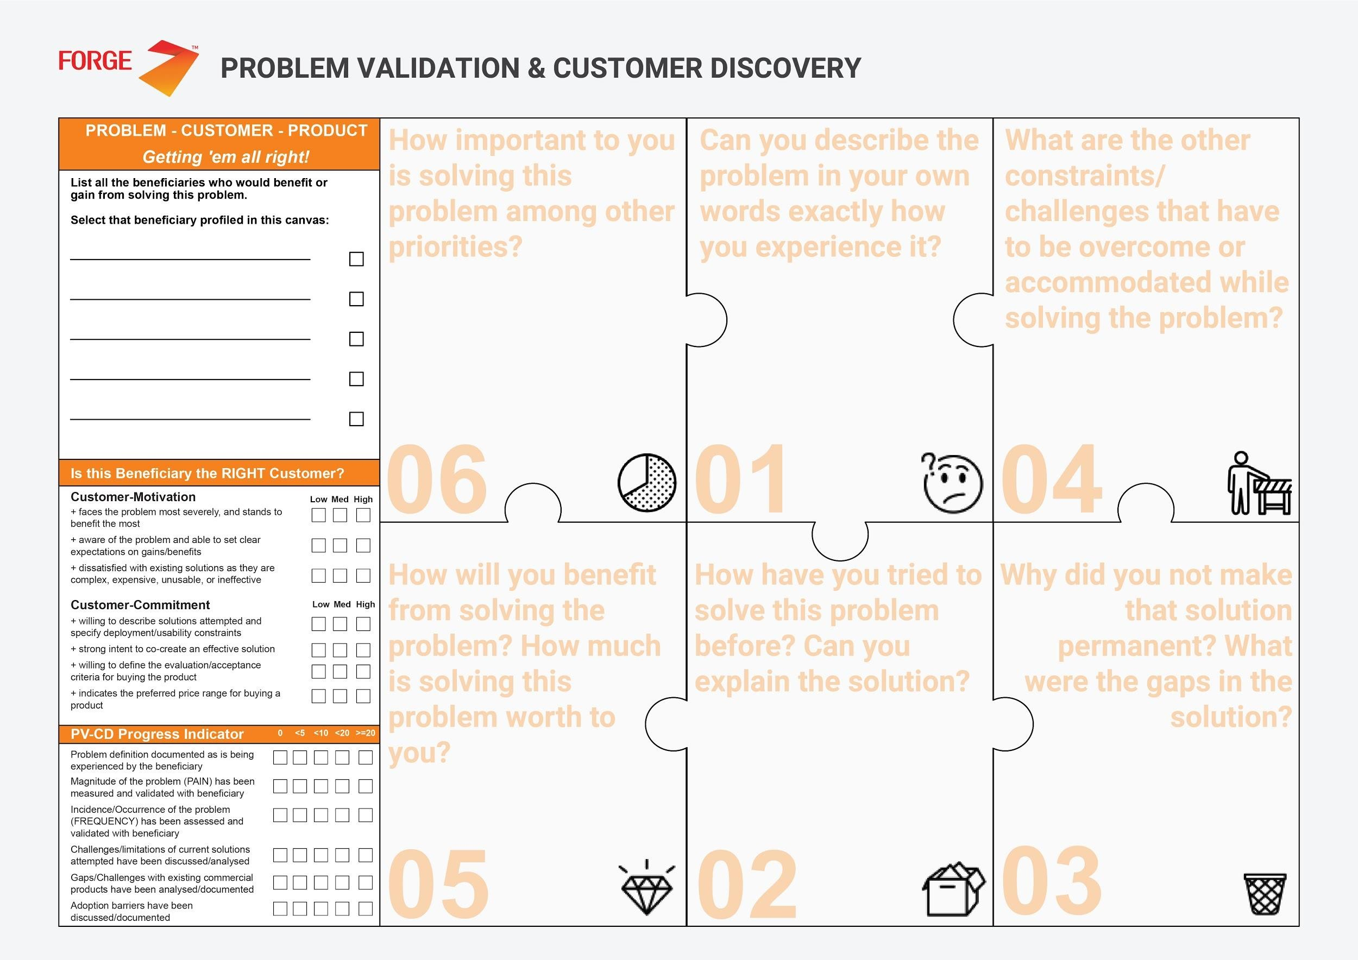

<https://www.ncbi.nlm.nih.gov/pmc/articles/PMC4413385/>

<https://dlife.com/the-best-insulin-pumps-on-the-market/>

<https://health.costhelper.com/insulin-pump.html>

<https://www.mayoclinic.org/diseases-conditions/type-1-diabetes/symptoms-causes/syc-20353011>

<https://www.endocrineweb.com/conditions/type-1-diabetes/type-1-diabetes-complications>

Medtronics Minimed 630G/670G

T-slim X2 by Tandem

OmniPod

Roche:Accu-Check

## ****Roche: Accu-Chek****

Maintained/balanced blood glucose level by semi-automated insulin injection

Reduced pain from pricks of glucose tests by continuous glucose monitoring

Total Cost of ownership

Maintenance and services

Installation/integration

Product Training (Minimal Knowledge of Technology)

Change of habits (Change of practice from their existing solution to the new one)

Physical or personal risk

Peace of mind

Diabetic management throughout the lifecycle

Accuracy of injecting insulin

Effectiveness of monitoring

Pain Caused by the insulin injections to be reduced

Social Awkwardness is to be relieved

Time for diabetic management to be reduced

Preventing inferiority Complex

To maintain the blood glucose levels by injecting insulin with less pain

Reduce the diabetic management which consumes most of the time

Costly

These Products aren’t available in India, needs to be imported.

Insulin Injections/Syringes Insulin Patches, Nasal insulin, Islet Cell Transplant, Insulin pumps, Insulin pens/shots

Injection or pens cause pains leading to stress and injury

Patches, nasal, Oral insulins aren’t effective

Insulin Pumps are too costly

Type-1 Diabetic Patients

Continuous blood glucose monitoring and regulation|

Maintaining or Balancing the blood glucose levels and leading a personal life tends to be difficult along with the hefty process of diabetic management

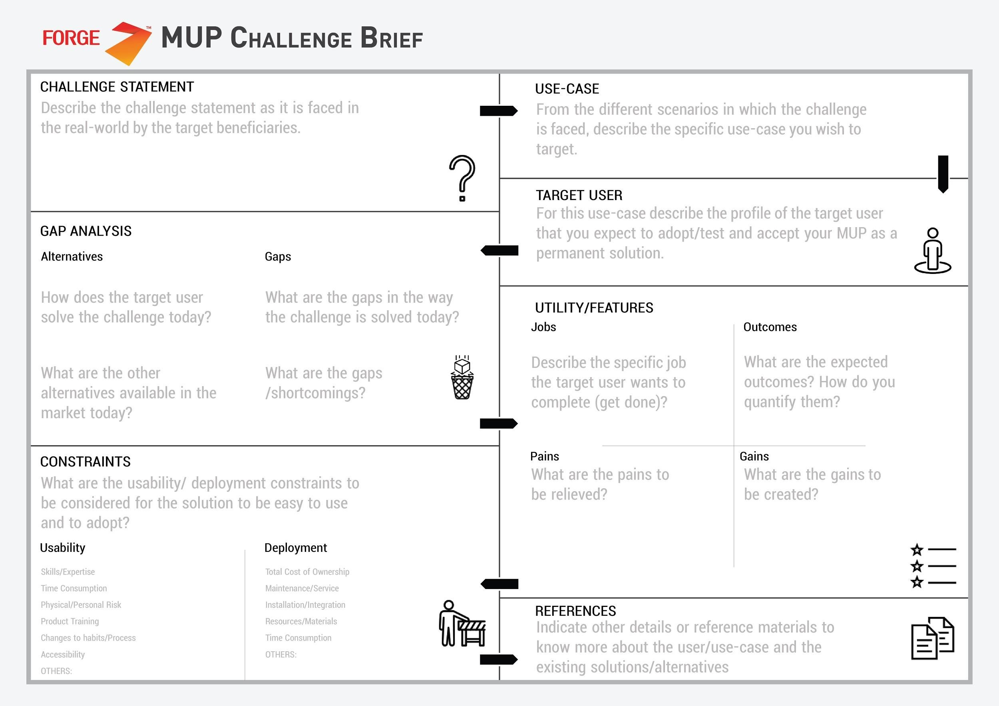

Type-1 Diabetic patients

Affordability

Availability

User-friendly

Insulin injections creating complications in regular life comprising pain (Average of 4 injections/day), social awkwardness, inferiority complex (Confidence level reduces) and other solutions such as islet cell transplantations and insulin pump which are too costly.

A semi-automated mechanism to inject insulin which provides relief from pain provided at low cost and also provides a sense of confidence to the patient

IOT-Intelligent Machines

So the solution is to provide Type-1 diabetic patients with continuous flow of insulin in a systematic manner lowering the number of pricks or injections in the ratio of appromximately 12:1 i.e. an Insulin pump

Find it difficult to maintain/balance blood glucose levels and to lead a personal life along with the hefty process of diabetic management



Glucose Monitoring device (Technology yet to be determined)

Semi-Automated Injection of insulin from the reservoir

Different profiles for different circumstances

Easy Diabetic management throughout the life cycle

No injections anymore-Time reduced, confidence, safe, peace of mind

Knowing blood glucose level at anytime

Easy management of diet and exercise

Gradual increase in health performance

Effectiveness of monitoring

Accuracy of injecting insulin

Simplified UI

Pain of pricking skin for the process of glucose test

Pain and swelling due to frequent injections

Parents have to worry about their kids all the time

During travel and other unexpected circumstances missing injections/shots

Stress and insecurity

Monitoring blood glucose periodically

Injecting accurate dosage of insulin whenever necessary

Reduced inxx\

injection to once in three days (Injection ratio 12:1)

Simplified usage of button instead of injections/shots

