CKA --> Certified Kubernetes Administrative

Exam --> 3 hours

Below are some references:
Certified Kubernetes Administrator: https://www.cncf.io/certification/cka/
Exam Curriculum (Topics): https://github.com/cncf/curriculum
Candidate Handbook: https://www.cncf.io/certification/candidate-handbook
Exam Tips: http://training.linuxfoundation.org/go//Important-Tips-CKA-CKAD

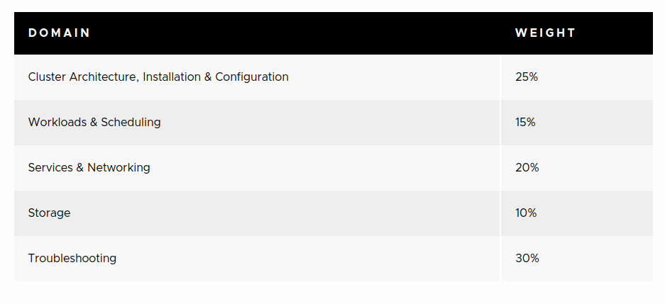
Focus more on cluster architechture,installation and configuration,
troubleshooting,scheduling,cluster maintainance,security, networking sections.

* Read CKAD notes for K8s cluster architechture and details of each component.

* To know more about the docker and containerd,read CKAD notes.

ETCD:

ETCD is a distributed,reliable key-value store,simple secure and fast.
ETCD store the information about the cluster such node details,persistent details,pods,configs,secrets,roles,bindings etc

key-value store means:
Basicaly database store data as table that are rows and colums
column will represent the type of info,row will represent actual info
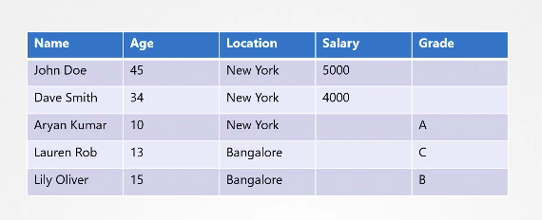
Key-value form will store the infomation in the form page or document.each indiviual get the page or document to store their information.
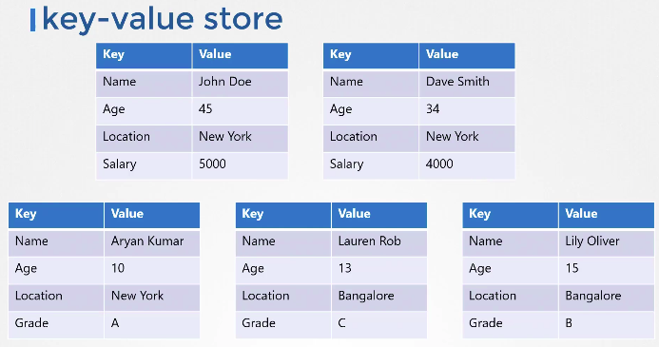
You can add any additional details into indivisual page without updating others page.

ETCD Installation:
1) Download the binary(tar file) based on your OS
2)Extract
3)Run ETCD service,once tar file extracted,run the $ etcd , this will start ETCD service

ETCD service listen on 2379,we can attach any client to store and retrieve the data.
Default client is etcdctl(ectdcontroller).
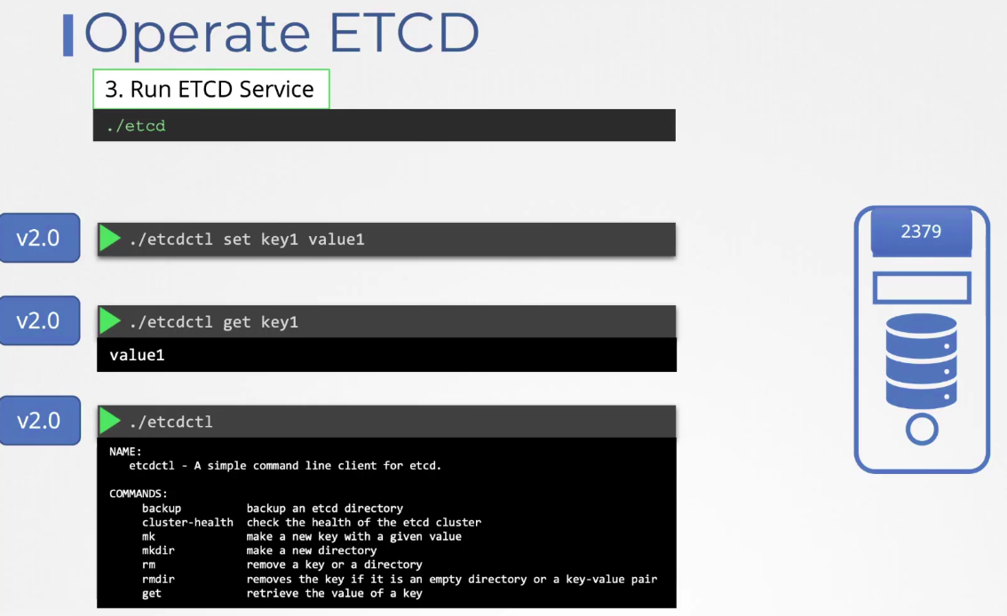

ETCD Versions:

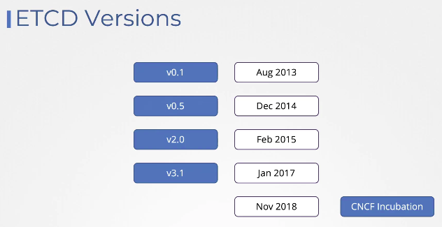
Configure etcdctl to work with ETCD:

ETCDCTL is the CLI tool used to interact with ETCD.
ETCDCTL can interact with ETCD Server using 2 API versions - Version 2 and Version 3. By default its set to use Version 2. Each version has different sets of commands.

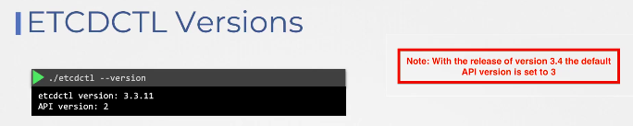
we can configure API Version 3 to work with ETCD by exporting ETCDCTL_API=3
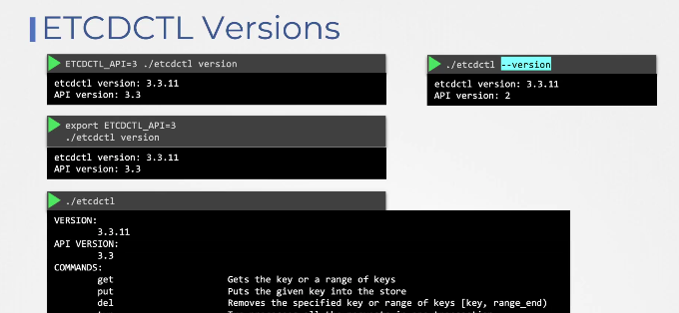

ETCDCTL_API will accept 2 or 3 as value to work with etcd.

etcdctl commands will different based on API version which are working.

etcdctl put key1 value1 --> storing the key value

etcdctl get key1 --> getting the value of key1

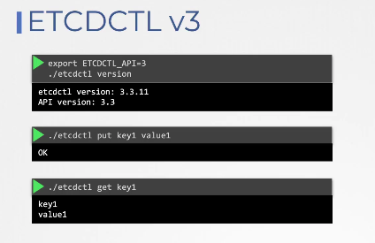

From etcdctl version 3.4, by default API version is setting to 3,etcdctl will use api version 3 to interfact with ETCD.

For example ETCDCTL version 2 supports the following commands:

etcdctl backup
- etcdctl cluster-health
- etcdctl mk
- etcdctl mkdir
- etcdctl set

Whereas the commands are different in version 3

etcdctl snapshot save
- etcdctl endpoint health
- etcdctl get
- etcdctl put

Setting up ETCD Manually:
ETCD will run on system level,we can use etcdctl to interact with etcd.

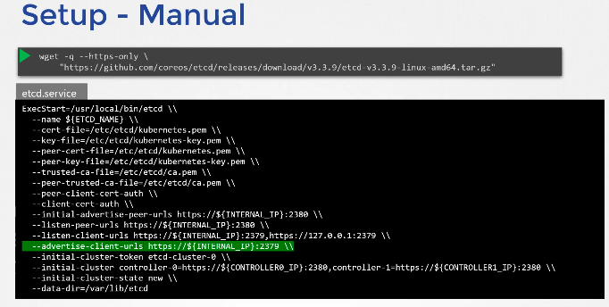
We can set ETCD cluster when we are creating k8s cluster as HA.
We have mention in kube-api server option the server ip and 2379 port where ETCD installed.

Setting up ETCD using kubeadm:
If you deploy the etcd using kubeadm,it will run etcd as pod in kube-system namespace.
To list all keys stored in etcd,run below command
kubectl -n kube-system exec etcd-master etcdctl get / --prefix --keys-only

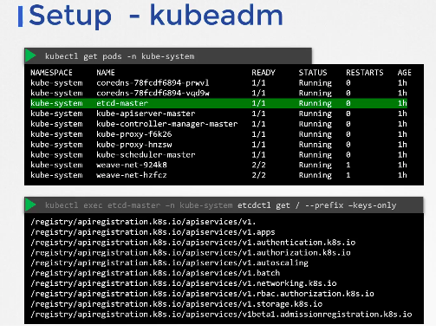
When we setup k8s as HA,etcd in each server must know about each other.we enable this by adding etcd details in etcd.service file

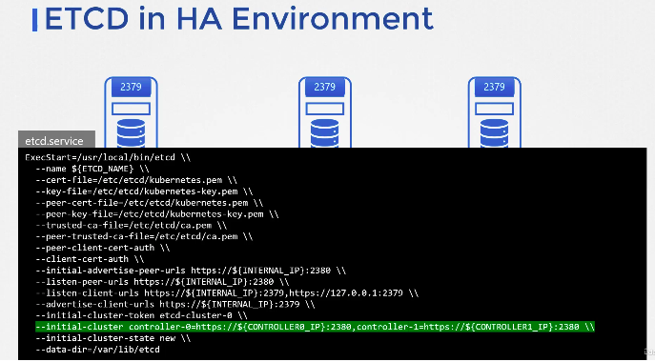

Root directory is registry,under root directory have each resources folders to store data.
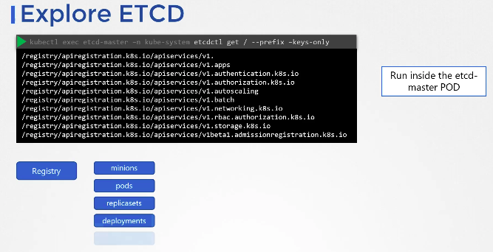

Kube-API Server:
Kube-API Server is central to operation of kubernetes cluster, command line interfaces will interact with API server to get the details of aplication,cluster info,deploying the application,updating application.
kube-api server is resposible for following
*Authenticate user
*Validate request
*Retrieve data
*Update ETCD
*Communicate with other components

When we run kubectl command,kubectl utility interfact with kube-api server,kube-api server will authenticate user,validate request and retrieve data.

Without kubectl uility,we can directly interact with kube-api server apis by sending post request.

Ex: Creating pod.
When we request to create pod, kube-api server update etcd database,scheduler continuesly monitor etcd,scheduler send request to kube-api server to schedule pod on node,kube-api server update etcd and will communicate with kubelet,kubelet will interact with container runtime to create pod which have containers.

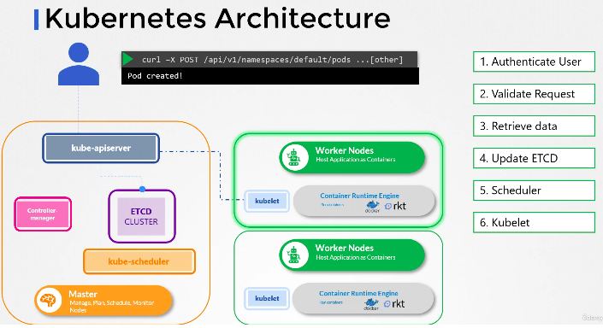
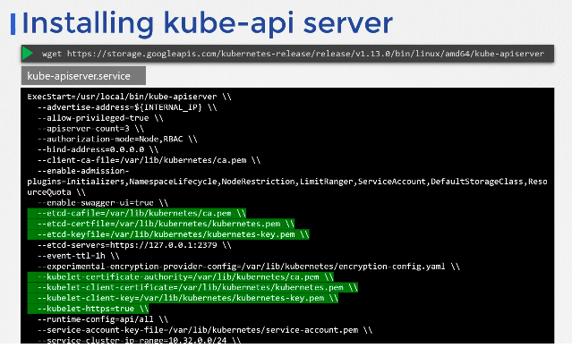

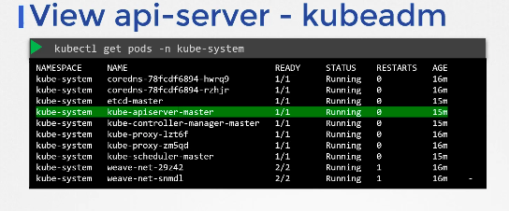
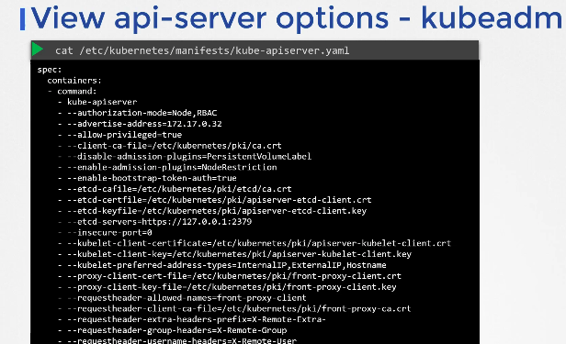
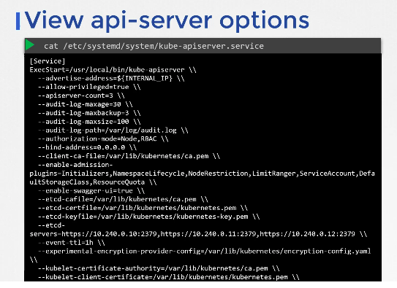

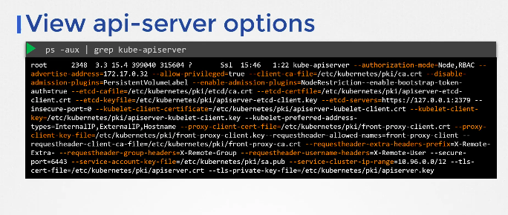
Kube-Controller Manager:

kube-controller manager manages various controllers(such node controller,replicaset controller etc)

controller in k8s is process,continuously monitor its component(node controller monitor nodes) and bring back to its original state when component go down.

Ex: node cotroller continuously monitor the nodes and take necessary steps when nodes go down. It does through kube-api server.
Node controller monitor nodes for every 5 seconds,when node controller does not receive heart beat from node,it will mark node as unreachable after 40seconds,wait for 5minutes to check node status.
After 5min start removing the pods from node if pods have replicaset and start assiging to healthy node.
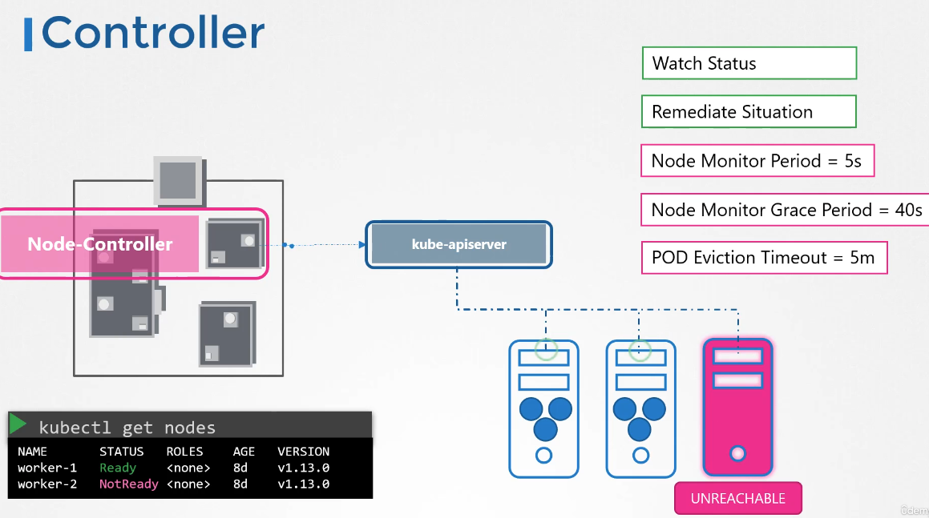
Replicaset controller monitors the status of replicaset and to ensure desired number of pods are running.

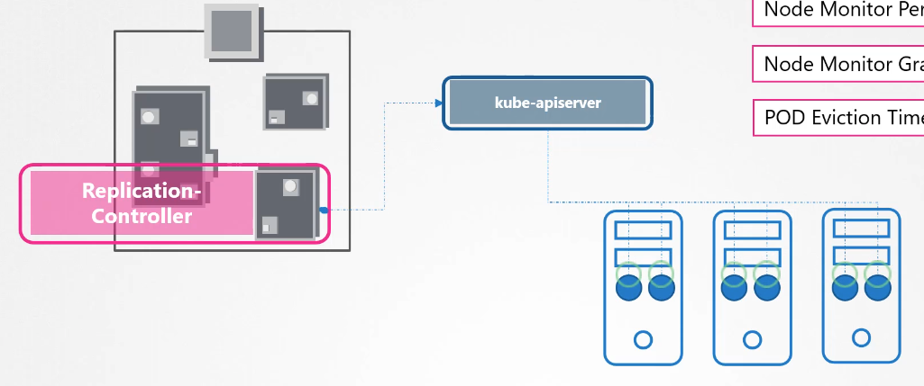
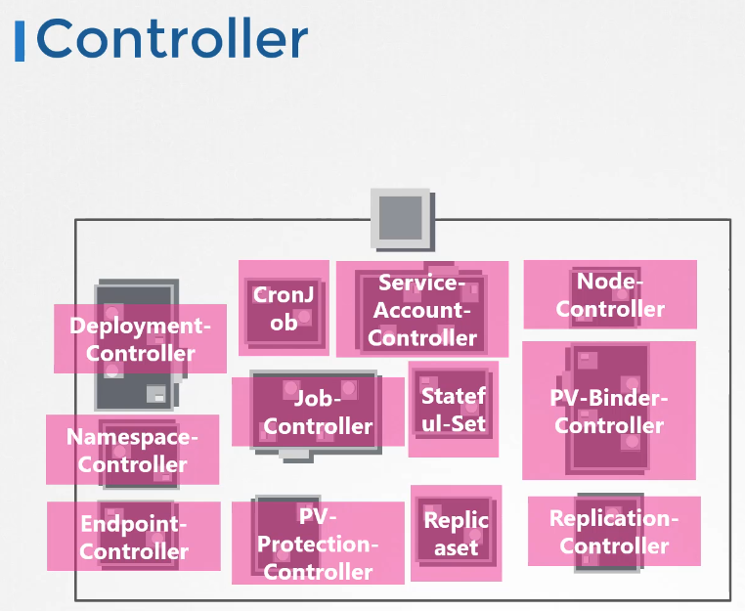

Whatever resources implemented in k8s, which build through controllers.

All packages are bundled into single binary called kube-control manager.when we install controll manager,all controllers will come.

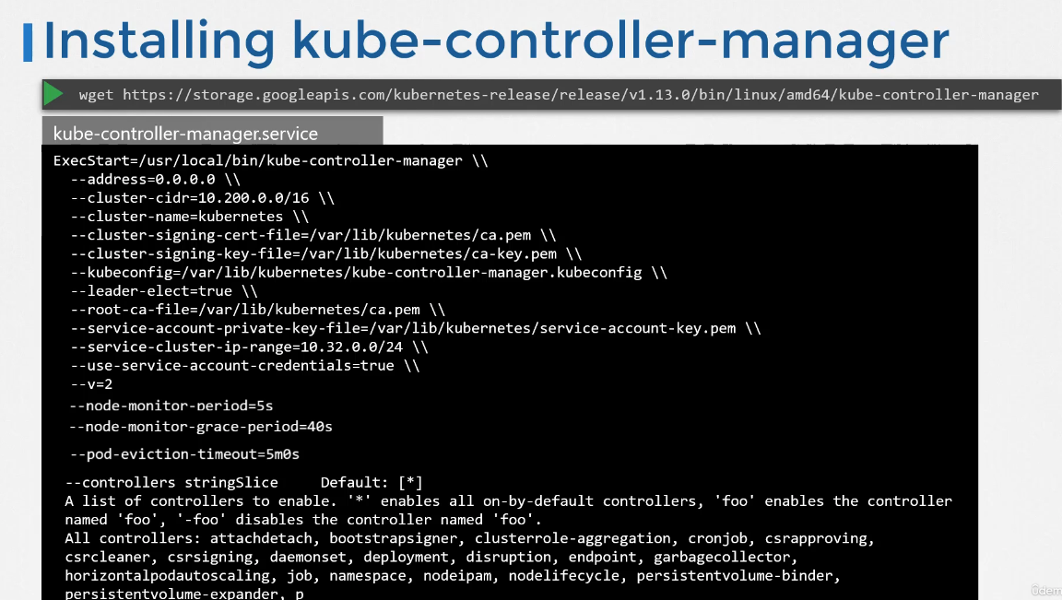
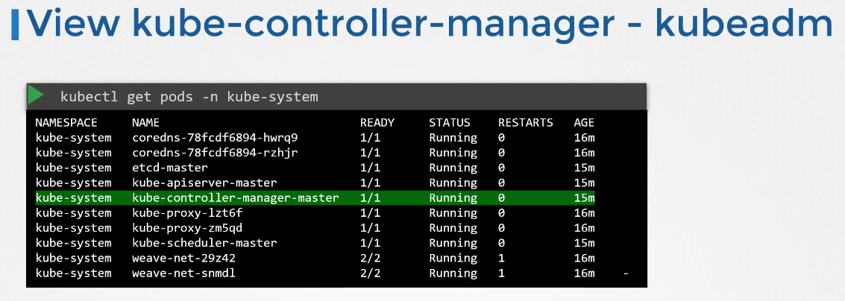

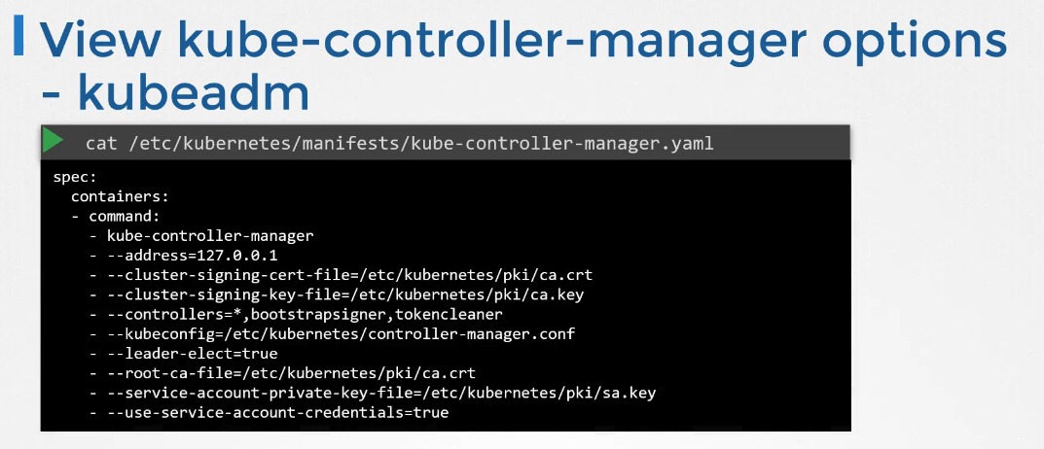
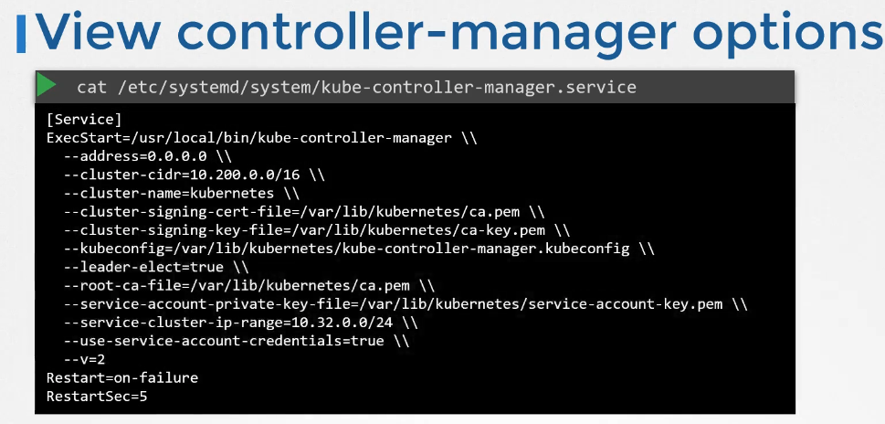
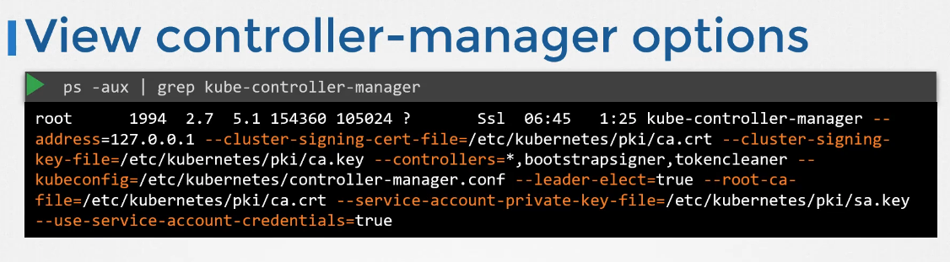

Kube-scheduler:

kube-scheduler is only resposible to decide which pod will go to which node based on different criterios.kubelet will interact with container runtime to create pod.

Criterios are resource requirement of pod,taint and tolerations,labels,node afffinity,and ranking

kube-scheduler check each pod resource to identify node.
First filter out node which will not fit for node,then rank the node by checking the resource availabilty once pod is placed.

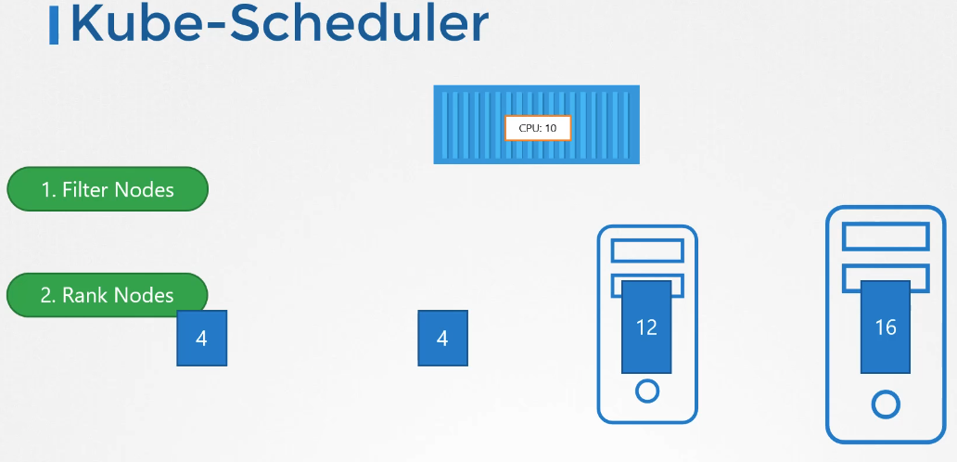
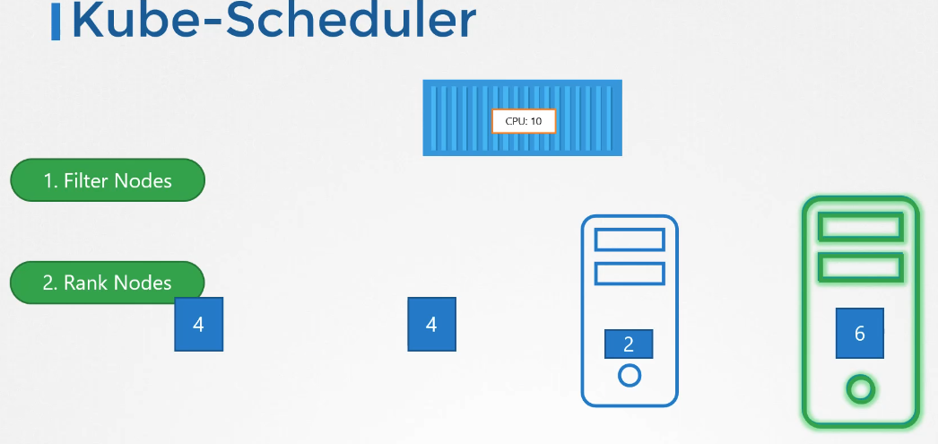

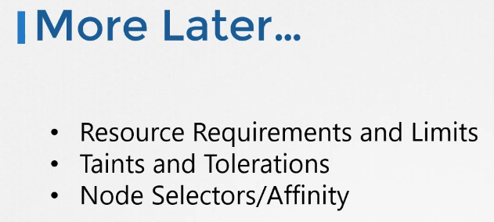
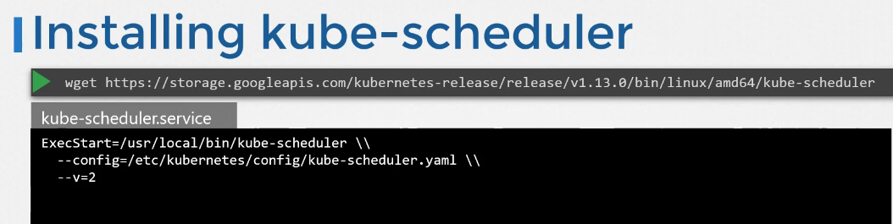
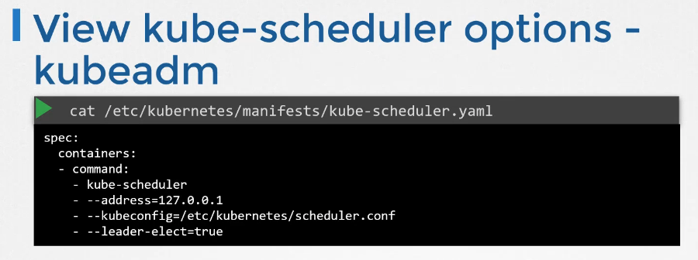
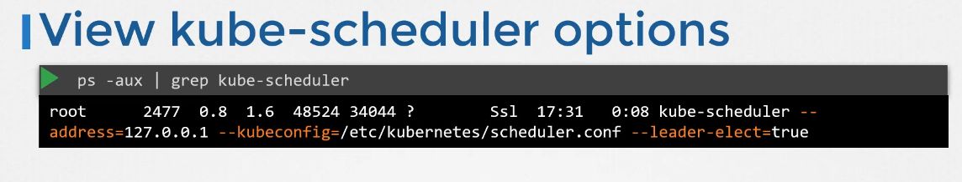
Kubelet:
kubelet is a agent runs in each node and it will register worker node,when request from kube-api server to create pod,kubelet will interact with container runtime to pull required image,create containers. Continously monitor nodes and pods,report to kube-api server.

K8s Cluster Architecture:

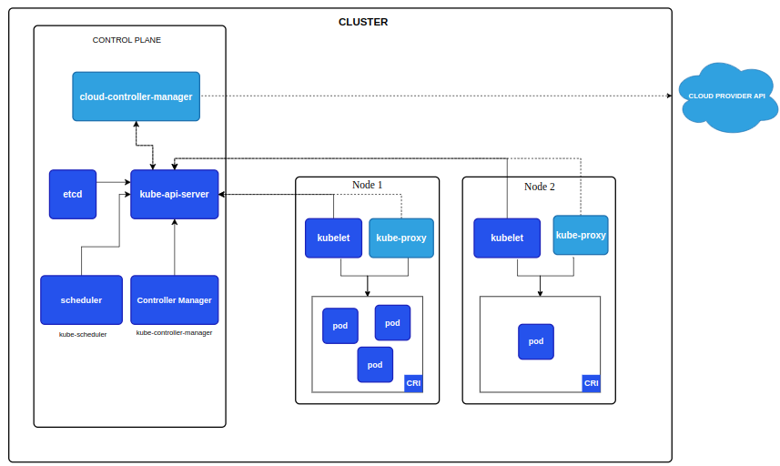
Source: k8s official document

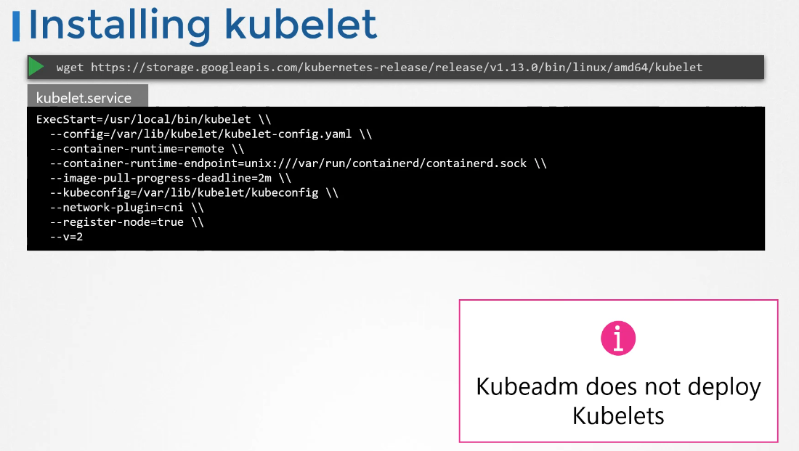
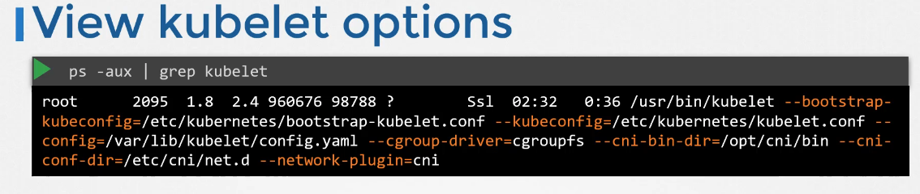

Kubepoxy:
Every pod can communicate with each other pod even pod in different node,this can can accomplished with Pod networking but ip of pod will change when it go down and come back. Create service to communicate between pods using service name/ip.

How service get the ip?service is not any process which is running in node.
Service is virtual components,it only leaves in k8s memory.

Kubeproxy is process,it runs in each node,it continuous watches for new services,whenever new service created,create appropriate rule in each node.
When request comes to service,redirect to appropriate pod.

One way of doing rule creation is using ip table.

