AI-INTERVIEW PREPARATION COACH

Abstract
The AI Interview Preparation Coach is a web-based application designed to help job seekers improve their interview skills through artificial intelligence. The system simulates real interview scenarios by generating role-specific questions based on the selected job role and interview type, such as HR, Technical, or Behavioral interviews. Users respond to the questions in real time, and the AI evaluates their answers to provide structured feedback, including a performance score, strengths, areas for improvement, and a suggested improved response.
The application is developed using Python and Streamlit, offering a simple and user-friendly interface that can be accessed through a web browser. By automating interview practice and evaluation, the system reduces dependency on human interviewers while delivering personalized guidance. The AI Interview Preparation Coach is especially useful for students, fresh graduates, and professionals preparing for job interviews, demonstrating the effective use of artificial intelligence in career development and skill enhancement.

INTRODUCTION
In the rapidly evolving technology sector, effective interview preparation is fundamental to securing competitive job roles. Traditional methods of preparation often lack personalization, real-time feedback, and contextual relevance to specific job roles or company standards. To address these gaps, AI Interviewer: Customized Interview Preparation introduces an AI-powered, interactive platform that simulates realistic interview environments. It supports various interview formats, including company-specific, behavioral, professional, and resume-based sessions, driven by Google Gemini AI. This paper presents the platform’s architecture, design, and evaluation, emphasizing its capability to enhance user readiness through adaptive learning. The use of real-time feedback and structured evaluation mechanisms not only improves user performance but also enhances confidence in handling diverse interview scenarios. Furthermore, the platform's integration with resume-based questioning allows for personalized simulations that mirror real interview dynamics. Through its interactive approach, AI Interviewer is designed to address the gaps of static question banks and generic mock interviews, offering a more engaging and effective learning experience. By leveraging advanced Natural Language Processing (NLP) and machine learning techniques, it ensures that the responses are evaluated accurately and contextually. The platform's modular architecture also enables seamless updates and scalability, ensuring it remains relevant as industry standards evolve. This
adaptability makes AI Interviewer a sustainable solution for long-term skill development in interview preparation.

LITERATURE SURVEY

Existing solutions like AI Bot for Interview Preparation, Development of an AI-Based Interview System for Remote Hiring, and Skillup Bot highlight different approaches to AI-driven mock interviews. These platforms are designed to simulate basic interview scenarios but lack advanced customization and context-aware questioning. Additionally, they do not provide robust feedback mechanisms or track user progress effectively. Unlike these solutions, AI Interviewer dynamically generates context-aware questions, evaluates responses instantly, and maintains a detailed history of interview attempts. This allows for more personalized and effective learning,bridging the gap between conventional methods and modern AI-driven simulations. Furthermore, existing systems often depend heavily on predefined question banks, limiting the scope of adaptation to specific company requirements. AI Interviewer overcomes this limitation by integrating Google Gemini AI, enabling real-time question generation that aligns with company-specific standards. This adaptability ensures that users are prepared not only for generic questions but also for role-specific challenges, enhancing their interview readiness. Additionally, the platform's integration with resume-based questioning sets it apart from traditional mock interview systems, offering a personalized experience that reflects real interview expectations.

PROPOSED SYSTEM

The AI Interviewer platform is designed with a multi-layered architecture to enhance user experience and performance in interview simulations. Streamlit Web Interface serves as the frontend, providing an interactive interface where users can seamlessly navigate through different interview modules. Google Gemini AI is integrated into the backend for dynamic question generation and real-time response evaluation, ensuring contextual relevance and industry alignment. Data storage is managed using CSV for question banks and JSON for user session data, supporting secure login, interview history, and performance tracking. The AI Interviewer supports four main types of interviews:
• Behavioral Interview: Focuses on evaluating past experiences and decision-making skills.
• Professional Interview: Assesses domain-specific knowledge and technical expertise.
• Resume-Based Interview: Generates questions based on user-uploaded resumes for a personalized experience.
• Company-Specific Interview: Simulates real-world interview scenarios for companies
like TCS, Amazon, Accenture, and Microsoft. The platform dynamically adapts question complexity based on user responses, providing a personalized and progressive interview experience.

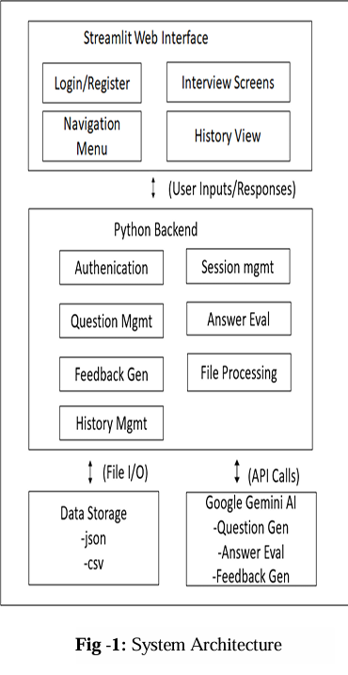

METHODOLOGY
The AI Interviewer platform follows a structured and modular workflow designed to simulate real-world interview experiences with precision and interactivity. The methodology encompasses several critical stages that collectively enhance the user experience and ensure effective learning outcomes. These stages are detailed as follows:

i. User Inputs: The interview process begins with user inputs, where the user is prompted to upload their resume and select the preferred type of interview. The platform supports four main categories: Behavioral, Professional, Resume-based, and Company-specific interviews. This initial step is crucial as it allows the system to understand user expectations and customize the experience accordingly.

ii. Processing Input: Once the inputs are provided, the platform initiates a preprocessing stage. During this phase, PyPDF2 is employed to extract text from the user's uploaded resume. This text is analyzed to identify key skills, experiences, and role-specific terminology. Simultaneously, Google Gemini AI processes the input data to establish a contextual understanding of the candidate's background. This preprocessing step enables the platform to tailor the interview questions effectively, ensuring they are relevant to the user's profile and career aspirations.
iii. Question Generation: The AI Interviewer dynamically generates interview questions using Google Gemini AI and CSV-based datasets. These datasets are meticulously
curated to include domain-specific questions aligned with the user's selected interview type and company preferences. The question generation process is driven by semantic analysis, which ensures that the questions are contextually appropriate and aligned with industry standards. Unlike static question banks, this real-time generation mechanism adapts based on user inputs and prior responses, making each session unique and highly interactive.

iv. Interactive Interview The platform then proceeds to the interactive interview phase, where users engage with the system in a simulated environment. During this session, the system presents questions in a structured format, allowing users to respond as they would in an actual interview. The platform supports four main types of interviews: Behavioral, Professional, Resume Based, and Company-Specific, covering key areas like past experiences, technical expertise, resume-driven insights, and role-specific challenges.

v. Real-Time Feedback and Scoring: One of the defining features of the AI Interviewer is its ability to provide real-time feedback. As the user responds to questions, Google Gemini AI evaluates the responses instantaneously. The scoring mechanism is based on multiple parameters including semantic relevance, clarity of expression,

completeness, and alignment with ideal responses. Feedback is provided in a structured format, highlighting areas of strength and offering suggestions for improvement. This real-time loop helps users understand their performance, correct mistakes, and build confidence over multiple sessions.
vi. Saving History: To enhance the learning experience, the platform saves all user interactions, including questions asked, responses given, and feedback received. This data is securely stored using JSON files, enabling users to revisit their past attempts, analyze their progress, and identify recurring patterns or mistakes. Through real-time processing, interactive simulations, and personalized feedback, the platform transforms traditional interview preparatiointo an engaging and effective learningjourney

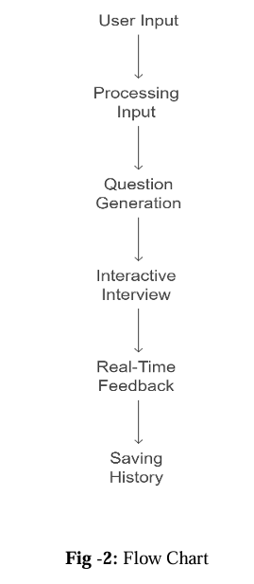

RESULTS

The AI Interviewer platform is designed to evaluate user responses across four distinct interview categories: Behavioral, Professional, Resume-Based, and Company-Specific. Each of these categories consists of 10 carefully curated questions aimed at assessing the user's understanding, clarity, and relevance in answering. For Company Specific interviews, the questions are strategically divided into three levels of difficulty: 3 low, 4 medium, and 3 high, ensuring a balanced evaluation of both foundational and advanced concepts. Upon completing each interview session, users receive a score out of 10, along with the display of ideal answers for each question, enabling them to understand the expectations clearly. At the end of the session, the platform generates a comprehensive feedback report that highlights strengths and areas for improvement, giving users actionable insights for refinement. This archival capability not only helps users reflect on their growth over time but also enables strategic preparation for future attempts.

CONCLUSION

The Streamlit Web Interface, paired with a robust Python Backend, Data Storage, and Google Gemini AI integration, has successfully delivered a comprehensive platform for interview management and evaluation. The system supports diverse interview sections, including professional
skills assessments, company-specific questions tailored for top companies like Google, Amazon, and Microsoft, behavioral evaluations to gauge soft skills, and resume-based queries to align with candidates’ experiences. By combining an intuitive front-end with powerful backend processing and AI driven features, the system ensures seamless authentication, dynamic question generation, accurate answer evaluation, and insightful feedback generation. The ability to manage user history and support file processing with scalable data storage in JSON and CSV formats highlights its versatility. This project not only demonstrates the potential of integrating modern web technologies with AI but also sets a benchmark for creating user-centric tools for interview preparation across varied domains. Its modular architecture allows for easy scalability and future enhancements, such as incorporating more advanced AI models or expanding to include additional company-specific datasets. The focus on professional, behavioral, and resume-based sections ensures a holistic approach to candidate preparation, making it highly relevant for diverse industries. Ultimately, this platform stands as a valuable asset for improving interview processes, emphasizing usability, accuracy, and innovation.

REFERENCES

1. Vinutha K, Manjunath T N, S. Nithyashri, Anaya Singh Gopal, Sinchana R P, "Dynamic Content Generation for Learning Management System Using Generative AI", 2025 International Conference on Computing for Sustainability and Intelligent Future (COMP-SIF), pp.1-7, 2025.

2. Rupali Umbare, Amit Budhodkar, Sakshi Suryawanshi, Shubham Udgirkar, Pradnya Aher, Sonali Rangdale, "From Practice to Perfection: AI-Driven Mock Interviews for Career Success", 2024 International Conference on Sustainable Communication Networks and Application (ICSCNA), pp.1250-1257, 2024.

3. S Sivaramakrishnan, Amiya Anand, Bheda Hemang, Fatima Zehra Minni, Angelika Sahoo, "Real Time Mock Interview Evaluation using CNN", 2024 4th International Conference on Data Engineering and Communication Systems (ICDECS), pp.1-4, 2024.

4. Nelum Amarasena, Samadhi Chathuranga Rathnayaka, Shamin Fernando, Tharindu Deiyagala, Hansaka Biyon, Nirmal Chandrasiri, "Enhancing Employability Through an Advanced Mock Interview Platform for

5. Fresh IT Graduates", 2024 7th International Seminar on Research of Information Technology and Intelligent Systems (ISRITI), pp.540-545, 2024.
6. Balasaheb Jadhav, Avadhut Sawant, Arnav Shah, Pranamya Vemula, Abhijeet Waikar, Srushti Yadav, "A Comprehensive Study and Implementation of the Mock Interview Simulator with AI and Pose-Based Interaction", 2024 1st International Conference on Cognitive, Green and Ubiquitous Computing (IC-CGU), pp.01 05, 2024.
7. Anggit Dwi Hartanto, Ema Utami, Kusrini, Arief Setyanto, "A Survey of Semantic Approaches in Personality Traits Profiling Analysis", 2024 International Conference on Smart Computing, IoT and Machine Learning (SIML), pp.35-42, 2024.

8. Rajeswari A M, Ahamed R, Vasanth P, "InterviewIQ: AI-Powered Chatbot for Upskilling Candidates in Technical and HR Interviews", 2025 International Conference on Intelligent Control, Computing and Communications (IC3), pp.392-397, 2025.

9. Tharaka Ramu, Nenavath Srinivas Naik, "Interview Preparation Guide Generation Leveraging GPT-4, ZSL and Hybrid Techniques", 2024 IEEE International Conference on Intelligent Signal Processing and Effective Communication Technologies (INSPECT), pp.1-6, 2024.

10. Sarawana Kumar L Krishnasamy, Chien-Sing Lee, "AI Chatbots in the Office: Unveiling the Social Impacts on Future Workplace Harmony", 2024 International Conference on ICT for Smart Society (ICISS), pp.1-6, 2024.

