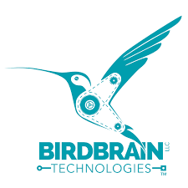 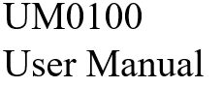

Description of Python Driver for Hummingbird Bit V0_1

**Introduction:**

Hummingbird Bit is the next generation of the Hummingbird Robotics Kit. It can be interfaced with various softwares like Make Code , Snap , Scratch , Birdblox , Java and Python. This document contains a detailed description of how to use the python driver.

**Contents**

**1. Requirements**

**2. API**

**i. Classes**

**ii.set**

**3. Examples**

**i.Single device**

**ii.Multi device**

Requirements, API UM0100

1.Requirements

Python Version 3.2 or greater

Bluebird Connector 1.0 or greater

Operating Systems tested on Windows 10, iOS , Ubuntu 14.0.4 LTS

2.API

a. **setLED(port_no,intensity)**

|  |  |
| --- | --- |
| First argument – port_no | Select the port (1-3) of the LED to be changed. |
| Second argument -- intensity | Select the intensity value (0-100).  0 off  100 full intensity |
| Return | 1/0. TBD |
| Description | Change the LED intensity attached any three ports corresponding to LED. |
| Example | setLED(1,50) -- LED on 50% intensity  setLED(2,0) -- LED off  setLED(3,100) -- LED full intensity |