# Hello World

This is a sample word document that needs to be converted directly into a blog entry!!

ऊं नमः शिवाय

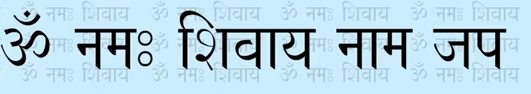



## Youtube Video Link

<https://www.youtube.com/watch?v=7RafBWzb21g>