System Architecture Design
Version 1.1 | September 2026

1. Purpose and scope
This document defines the <research prototype> that helps an educator connect an existing curriculum topic to supported sustainability concepts and then convert an accepted recommendation into a ready-to-use Educator Kit.

In scope | Architecture position
Recommendation Core | Interprets structured and free-text educator input, establishes technical scope, evaluates evidence, ranks eligible Sustainability Concept Repository (SCR) candidates, handles secondary promotion/negation and records the recommendation trace.
Educator Kit | Selects a compatible pedagogical template, resolves required output elements, teaching material and framework context, generates bounded content, validates the Kit, creates an immutable snapshot and supports the in-app Kit view plus PDF export.
UI | Provides the public educator workflow, recommendation/Kit/evidence views, complete Knowledge Graph Explorer and a protected V1 Administration shell limited to static/read-only/prototype functions.
Infrastructure Services | Builds runtime repositories and provides common models, configuration, persistence, access control, audit, generation-provider integration and application errors.

Detailed field-level interfaces, data-flow diagrams, algorithm pseudocode and module contracts are documented separately. This architecture document stays at system/component level.

2. Architecture Choice

Why an Ontology-Driven Knowledge Graph Architecture?
The system is intended to recommend sustainability concepts for existing curriculum content. At first sight, this could appear to be a conventional rule-based recommendation problem: store courses and sustainability concepts in tables, define mappings such as “if Topic X occurs, recommend Sustainability Concept Y”, and retrieve the corresponding result.

That approach is suitable when the relationship between an input and an output is known, stable and largely one-to-one or rule definable. It is not sufficient for this problem. A technical curriculum topic does not, by itself, determine its sustainability relevance. The same topic can lead to different sustainability recommendations depending on how the knowledge is being applied, what mechanism is involved, which resource or stakeholder is affected, what outcome is sought, and what boundary conditions apply. Conversely, the same sustainability concept may legitimately apply to technical topics from several disciplines through different mechanisms.

The architecture therefore must represent not merely records but meaning and relationships between records. For example, a curriculum subtopic may be connected to one or more reusable technical concepts (KCR), governing principles (KPR) and functions or mechanisms (KFR). These, together with an Application Context, provide the evidence needed to determine whether a Sustainability Concept Repository (SCR) entity is relevant. The recommendation is therefore based on an evidence path rather than a direct Topic → SCR lookup. A conventional rule system could encode these combinations explicitly, but the number and complexity of rules would increase rapidly as courses, disciplines, application contexts, sustainability concepts and exceptions are added. More importantly, such rules would tend to embed interpretation inside procedural code—for example:

If course = Civil Engineering AND topic contains “flow” AND context contains “water conservation”, recommend SCR-X.

Such a rule does not explain whether the recommendation arose because of resource efficiency, demand reduction, reuse, resilience, equity, pollution prevention or another mechanism. It is also difficult to reuse when equivalent concepts appear under different terminology or in another discipline.

The ontology-driven architecture addresses this by keeping the relevant entities semantically distinct and connecting them through curated, typed relationships. The Knowledge Graph is the runtime representation of those relationships. This enables the system to start from the educator's selected Course → Module → Subtopic, follow only supported semantic relationships, and preserve the evidence path used to reach a recommendation. Natural-language input introduces another problem. Educators may describe essentially the same application in different words. A purely keyword- or rule-based system would require an expanding synonym dictionary or increasingly complex text rules. The system therefore uses semantic embeddings through Semantic Engine to interpret free-text application evidence and retrieve semantically similar candidates. However, semantic similarity alone is also insufficient. Two statements can be linguistically similar while implying different technical or sustainability mechanisms. Similarity can therefore discover and rank possibilities, but it cannot establish that a relationship is valid. The architecture consequently combines three forms of evidence:
Curated semantic knowledge defines what entities mean and which relationships are explicitly supported.
Natural-language semantic retrieval helps interpret educator wording and discover relevant candidates even when terminology differs.
Deterministic recommendation logic evaluates technical scope, Application Context, mechanism evidence, boundaries, guardrails and explicit exclusions before a candidate can be recommended.

The central architectural principle is therefore: Ontology and curated relationships define meaning; semantic retrieval discovers relevant evidence; Application Context and mechanism evidence establish sustainability relevance; deterministic rules determine eligibility; ranking operates only on eligible candidates.

The graph representation also supports a requirement that is difficult to express cleanly as a flat mapping table: the recommendation should normally use the most specific available evidence. A relationship supported directly at Subtopic level should be preferred to an equally plausible inference made only from a broader Module or Course. Broader evidence is used only when narrower evidence is insufficient. The graph therefore supports controlled hierarchical expansion rather than unrestricted similarity search. The architecture must also support multiple legitimate sustainability mechanisms. An educator's Application Context may contain more than one independently supported mechanism, allowing more than one SCR to be relevant. Conversely, an explicit exclusion such as the absence of a particular mechanism must be capable of vetoing a secondary recommendation even when the surrounding text is semantically similar. This is difficult to represent safely using a simple keyword or global-similarity approach. Also, the recommendation system must be able to explain and reproduce its decisions. The architecture retains the resolved curriculum anchor, semantic evidence, graph relationships, Application Context, candidate scores, exclusions, selected SCRs and relevant repository/model versions. The recommendation can therefore be inspected as an evidence chain, rather than presented as an unexplained score or generated answer.

Requirement | Conventional rule-based / relational recommendation | Ontology-driven Knowledge Graph recommendation
Representation of curriculum knowledge | Rows, foreign keys and predefined mappings | Distinct Course, Module, Subtopic, KCR, KPR, KFR, Application Context and SCR entities connected through typed semantic relationships
Typical recommendation logic | IF input condition → output | Traverse supported evidence → establish mechanism/context → determine eligibility → rank supported SCRs
Handling the same topic in different applications | Requires additional rules for each context | Application Context changes the mechanism/evidence while the technical anchor remains explicit
Cross-disciplinary sustainability relationships | Requires manually enumerated discipline-specific rules | Reusable semantic entities and typed relationships allow a supported mechanism to connect different disciplines to the same SCR
Different terminology for similar meaning | Synonym lists, keyword rules or manual mappings | Semantic Engine uses sentence-level semantic similarity to discover related evidence
Authority of text similarity | May become part of the rule/match itself | Similarity can retrieve/rank candidates but cannot create ontology truth or eligibility
Hierarchy | Usually implemented through explicit joins and procedural rules | Controlled Course → Module → Subtopic traversal with broader fallback only when narrower evidence is insufficient
Context and mechanism | Often encoded indirectly in increasingly complex rules | Represented explicitly through Application Context and mechanism evidence
Negative/exclusion evidence | Requires case-specific exception rules | Explicit exclusions are retained separately and may veto unsupported secondary recommendations
Multiple valid recommendations | Requires multiple overlapping rule sets | Independently supported mechanisms may promote multiple SCRs while retaining a primary recommendation
Explainability | “Rule X matched” or database rows matched | Evidence path can show anchor → semantic entities/context → eligible SCR → ranking/promotion decision
Evolution of knowledge | Adding concepts often requires editing many procedural rules | New curated entities/relationships can extend the knowledge model without rewriting the complete decision procedure
Role of a relational database | Often used both as storage and as the implicit reasoning model | Still appropriate for operational persistence; it is not required to carry the complete semantic reasoning model
Representation of curriculum knowledge | Rows, foreign keys and predefined mappings | Distinct Course, Module, Subtopic, KCR, KPR, KFR, Application Context and SCR entities connected through typed semantic relationships
Typical recommendation logic | IF input condition → output | Traverse supported evidence → establish mechanism/context → determine eligibility → rank supported SCRs
Handling the same topic in different applications | Requires additional rules for each context | Application Context changes the mechanism/evidence while the technical anchor remains explicit

3. System overview
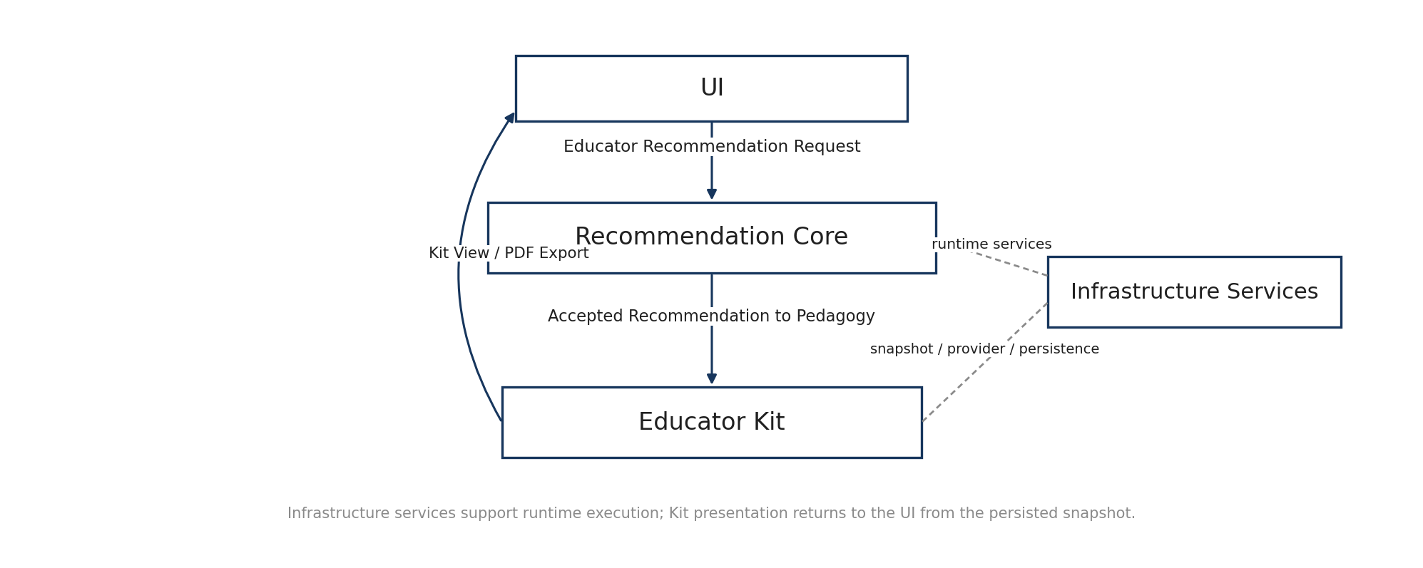
Figure 1. System context and functional domains
Domain | Primary responsibility | Principal output
UI | Collect educator input and present recommendations, evidence, Kits, complete graph views and protected read-only/prototype Administration functions. | Recommendation request, educator decisions, in-app Kit presentation and PDF export.
Recommendation Core | Transform curriculum/application input into a supported sustainability recommendation using curated graph evidence, semantic retrieval and deterministic controls. | Recommendation Result and recommendation trace.
Educator Kit | Transform an accepted SCR recommendation into a structured, validated teaching package. | EducatorKitSnapshot, in-app Kit view and PDF export.
Infrastructure Services | Provide repository build, common schemas, configuration, persistence, access control, audit, external generation-provider integration and errors. | Validated runtime artifacts and operational services.

3.1 Key terminology
Term | Meaning in V1
KCR | Knowledge Concept Repository entity: a reusable technical concept.
KPR | Knowledge Principle Repository entity: a reusable governing or explanatory principle.
KFR | Knowledge Function Repository entity: a reusable function, purpose or mechanism.
SCR | Sustainability Concept Repository entity: a reusable sustainability principle/mechanism that can be recommended.
Application Context | Problem/action/mechanism/outcome evidence describing where the technical concept is being applied. In V1 the educator-facing context is either educator-entered or an accepted system-generated alternative; curated repository contexts remain retrieval/evidence support.
Pedagogical Template | Reusable teaching, assessment or resource pattern associated with an accepted SCR.
PKCR | PKCR: resolves the output elements required by the selected pedagogical template.
FCR | FCR: resolves which mapped sustainability/learning-framework items are active for the selected teaching activity.
Design-8a | Validated V1 recommendation behavior preserved by Design8a_Reference_Runtime.

4. Recommendation Core architecture
Recommendation Core is the deterministic decision subsystem. It begins with the educator’s selected curriculum scope and application evidence, constructs a controlled semantic representation, evaluates compatible context and sustainability evidence, ranks only supported SCR candidates, and records how the result was obtained.
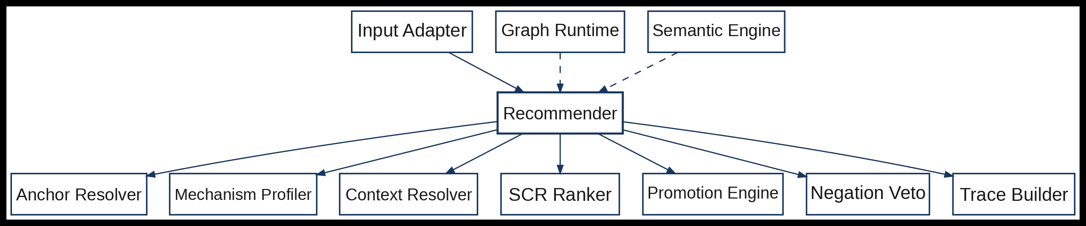

Figure 2. Recommendation Core component structure
Component | Role
Graph Runtime | Loads compiled entities/relationships and provides controlled graph access for curriculum, KCR/KPR/KFR, Application Context, SCR and Guardrail evidence.
Semantic Engine | Loads sentence-transformers/all-MiniLM-L6-v2, uses precomputed repository embeddings and encodes new educator text at runtime.
Input Adapter | Applies the validated input routes, preserves raw educator text and builds the normalized RecommendationRequest.
Anchor Resolver | Validates or resolves the technical anchor and prevents uncontrolled scope broadening.
Mechanism Profiler | Builds field-aware application/mechanism facets while keeping positive and explicit-negation evidence separate.
Context Resolver | Retrieves and scores compatible curated Application Context evidence after scope is established.
SCR Ranker | Ranks supported SCR candidates using the validated Design-8a evidence logic.
Promotion Engine | Promotes additional SCRs only when independently supported mechanism facets justify them.
Negation Veto | Blocks secondary promotion when explicit excluded/negated evidence matches the candidate.
Recommender | Orchestrates the end-to-end recommendation path and returns RecommendationResult.
Trace Builder | Creates structured recommendation evidence, ranking, veto and version provenance.

4.1 Input routes and evidence precedence
Route | Input condition | Architecture behavior
Selected curriculum anchor | Course/Module/Subtopic is selected; application text may be absent. | The selected anchor is authoritative. When application evidence is insufficient, the system may surface compatible Application Context alternatives but does not invent an authoritative context.
Selected anchor + educator application text | Structured anchor and free text are both present. | The anchor controls technical scope; educator application evidence is primary. A material mismatch is surfaced rather than silently overriding the anchor.
Text-only anchor route (future / V2–V3) | No Course/Module/Subtopic hierarchy is selected. | Not exposed as a V1 product route. V1 requires Course → Module → Subtopic. A future version may resolve a safe anchor first; ambiguity must block and free text must never go directly to SCR ranking.
Controlled traversal. Reasoning begins at the most specific supported curriculum evidence. Related KCR/KPR/KFR evidence may expand the scope; Module/Course broadening is a controlled fallback when narrower evidence is insufficient. Prerequisite concepts indicate readiness/preparation and do not automatically become topical evidence.

5. Curated semantic repositories and runtime knowledge
The architecture relies on curated content rather than asking a model to invent the knowledge structure. The source repositories carry stable identifiers, definitions and typed relations; Repository Build validates them and produces runtime artifacts. The runtime graph and semantic embeddings are derived from these controlled sources.
In this architecture, the ontology is the controlled semantic model: it distinguishes curriculum occurrences, KCR/KPR/KFR entities, Application Context, SCR and Guardrail evidence and defines the meaning of their typed relationships. The ontology is therefore a design and repository concern; it does not require a dedicated ontology database at runtime.
Controlled artifact | Architecture use
Semantic_Repository | Curriculum hierarchy; KCR/KPR/KFR; SCR; Application Context; Guardrail and typed semantic relationships.
SCR_Framework_Mapping | Governed SCR-to-SDG/ESD/Commonwealth mappings used only after recommendation.
SCR_Pedagogical_Repository | 295 reusable pedagogical templates across 16 controlled types.
Template_Output_Element_Contract | 75 controlled output-element definitions and 5,013 template-contract rows defining Kit completeness.
Framework_Context_Resolver | 5,695 template/framework resolver rows controlling ACTIVE_DIRECT, ACTIVE_CONTEXT and EXCLUDED use.
Teaching_Case_Evidence_Repository | Teaching references, structured starting evidence and governed Reference↔SCR use.

6. Educator Kit architecture
Educator Kit begins only after Recommender has produced an accepted SCR recommendation. This boundary prevents teaching frameworks or generated text from changing the sustainability recommendation. The Kit subsystem converts that accepted recommendation into a practical teaching activity under the educator’s stated teaching context.
Teaching-context boundary. Changes limited to Teaching Context—such as learner level, delivery mode, class size, available time, assessment preference, site/data/stakeholder/equipment access or other practical constraints—may re-rank or recontextualize pedagogy and create a new EducatorKitSnapshot without rerunning sustainability recommendation eligibility. A material change to the Course/Module/Subtopic anchor or accepted Application Context requires a new recommendation context and recommendation execution.
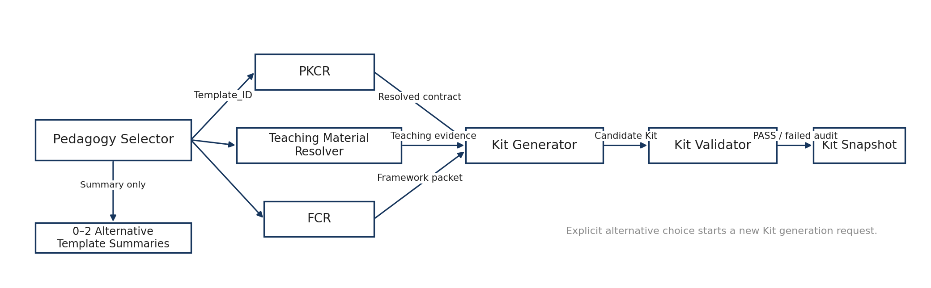
Figure 3. Educator Kit component structure
Component | Role
Pedagogy Selector | Selects one primary Template_ID and up to two materially distinct alternative summaries using SCR fit, template applicability and teaching constraints. Only the chosen primary/explicitly selected alternative is fully generated.
PKCR | Resolves REQUIRED and triggered CONDITIONAL output elements for the selected Template_ID.
Teaching Material Resolver | Chooses educator-provided or system-suggested starting material while preserving real-source/generated provenance.
FCR | Resolves mapped sustainability/learning-framework items to ACTIVE_DIRECT, ACTIVE_CONTEXT or EXCLUDED without changing SCR eligibility or pedagogy.
Kit Generator | Builds the bounded generation packet and invokes Generation Provider only after template, contract, evidence and framework context are resolved.
Kit Validator | Checks that every required/triggered output element is concrete, ready to use and provenance-compliant. A validation failure is retained for audit; it does not invalidate the accepted SCR or trigger automatic repair/regeneration.
Kit Snapshot | Creates the immutable EducatorKitSnapshot and associated version/provenance state, including failed-validation provenance when generation has completed.
Kit View / PDF Renderer | Renders the in-app Kit view and on-demand PDF from the same persisted EducatorKitSnapshot. V1 does not require downloadable HTML or Excel Kit exports.
Generation boundary. The external generation service structures content from resolved evidence and contracts. It does not resolve the curriculum anchor, traverse the knowledge graph, create SCR eligibility, apply guardrails, rank candidates or choose the final SCR.
Validation boundary. A failed Kit validation does not invalidate the accepted sustainability recommendation. The failed validation result and provenance are retained for audit, the Kit is not presented as ready to use, and V1 does not initiate an automatic repair or regeneration loop.

7. UI and Infrastructure Services
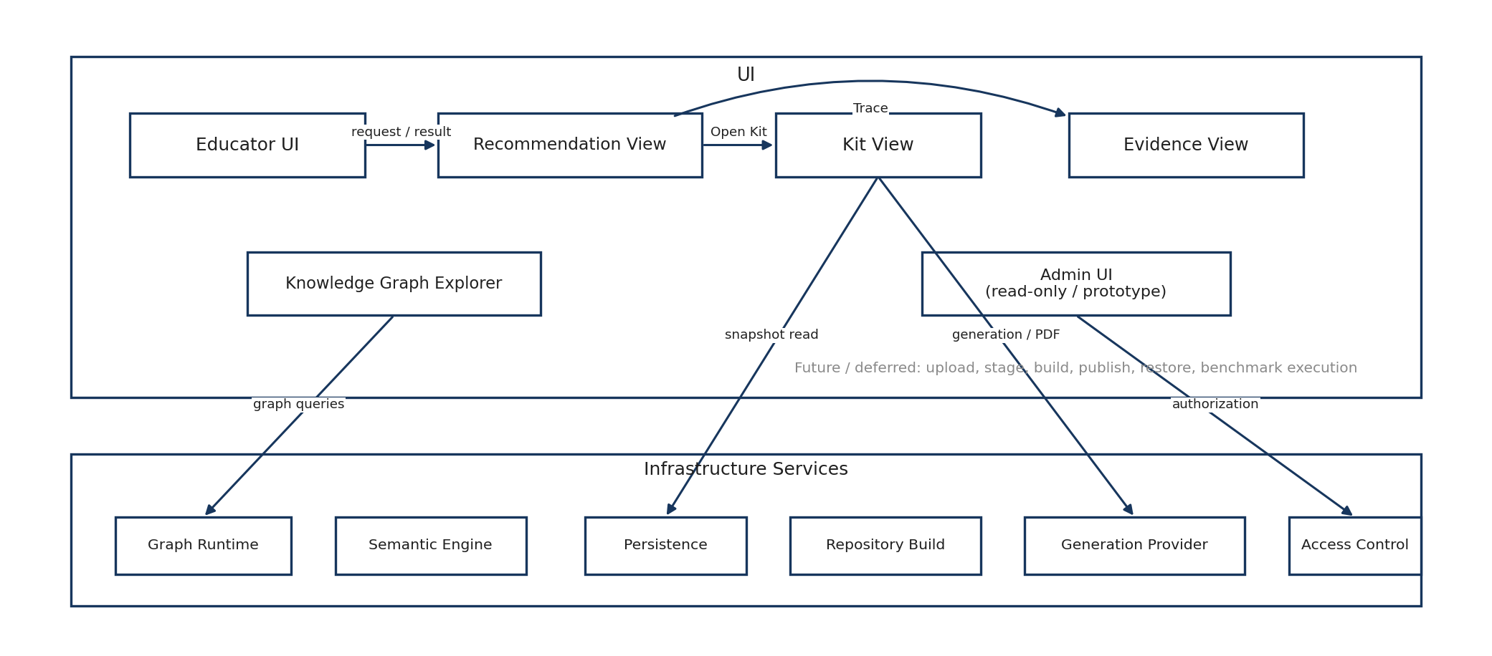
Figure 4. UI and Infrastructure Services component structure
Area | Architecture intent
Educator UI | Guided Course → Module → Subtopic → Application Context → Teaching Context → Generate workflow with progressive disclosure.
Recommendation View | Shows the selected sustainability concept, concise fit explanation and access to evidence and Kit generation.
Kit View | Presents the ready-to-use Kit in-app and provides on-demand PDF export from the same immutable snapshot.
Evidence View | Exposes evidence, framework details and recommendation trace on demand.
KG Explorer | Explores the complete active compiled governed graph. A lean initial view, focus and filters reduce visual density but do not restrict semantic availability or Recommendation Core behavior.
Admin UI | Protected V1 entry point for static workflow guidance and read-only repository/runtime inspection where available.
Repository Admin (Future / Deferred) | Upload, staging, candidate validation/build, publication and restore workflows are retained as future-state architecture reference and are not functional V1 interfaces.
Validation & Benchmark UI (Future / Deferred execution) | Approved validation/regression evidence may be reviewed where available; running release/benchmark workflows is not a functional V1 Administration capability.
Infrastructure Services | Provide repository build, common domain models, configuration, persistence, access control, audit, generation-provider isolation and stable error handling.

8. Repository build and runtime architecture
Controlled workbooks are governed source artifacts, not runtime query stores. Repository Build validates schema, controlled values and referential integrity, then compiles runtime-ready structures during development/deployment preparation. Graph Runtime and Semantic Engine load those compiled artifacts into memory at application startup.
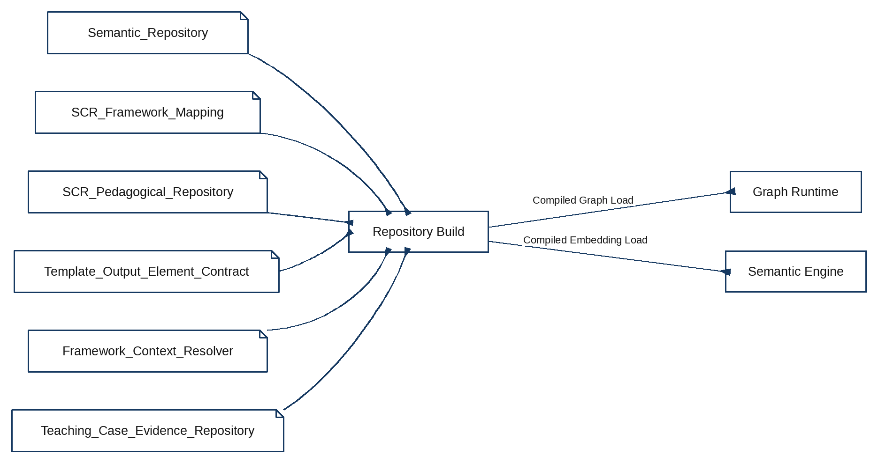
Figure 5. Repository build and runtime-load architecture
Layer | V1 implementation
Authoring / governed source | Versioned Excel repositories listed in the Artifact Register.
Validation / compilation | Pandas + Pydantic implementation in Repository Build.
Compiled runtime data | Parquet and Python runtime objects; repository embeddings are precomputed during development/deployment build and loaded at application startup.
Graph processing | Graph Runtime maintains the in-memory graph; NetworkX may implement the graph interface.
Semantic processing | Semantic Engine loads sentence-transformers/all-MiniLM-L6-v2 and the compiled embedding matrix.
Operational persistence | Persistence uses SQLite locally and Supabase PostgreSQL when hosted.

9. Persistence and provenance
The architecture keeps canonical knowledge separate from operational evidence. Runtime recommendations and Kits are persisted for replay and audit but never written back as new ontology truth.
Operational object | Purpose | Mutability
RecommendationEvent | Records the delivered recommendation, selected/promoted SCRs, versions and linked evidence. | Append-only event record.
RecommendationContextSnapshot | Captures the immutable runtime context/evidence state used for a recommendation. | Immutable; changed input creates a new snapshot.
EducatorKitSnapshot | Stores the structured generated Kit plus contract, teaching-evidence, framework and validation provenance. | Immutable; source for in-app Kit rendering and PDF export.
EducatorDecision | Records use/adapt/alternative/reject/save decisions independently from system output. | New decision records do not overwrite system snapshots.

10. Interface and execution architecture
Internal V1 interactions are primarily typed in-process Python interfaces. HTTPS is used only where an external service is called. The figures below show the three order-sensitive flows that materially affect architecture behavior.
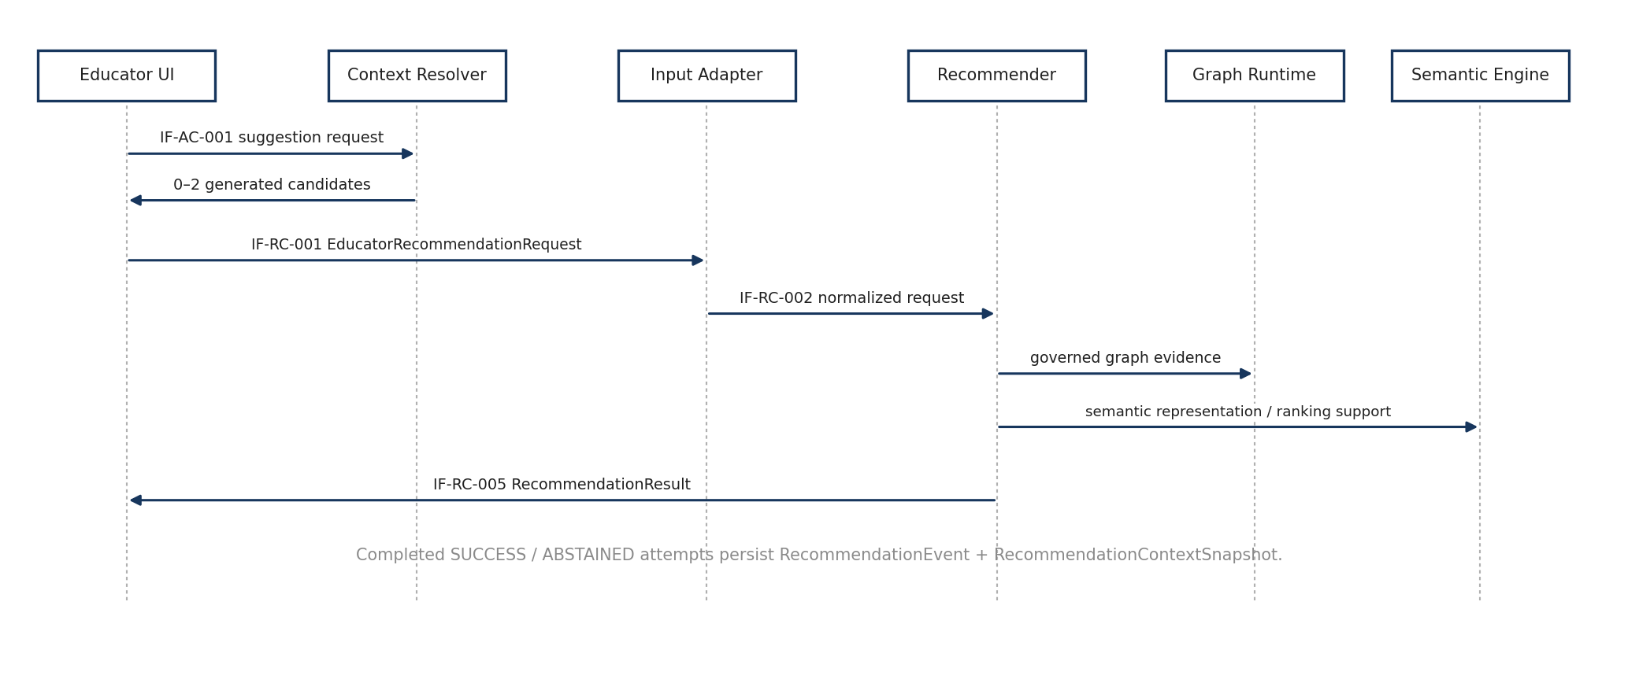
Figure 6. Recommendation request sequence
The educator request is normalized before deterministic recommendation. Recommender uses the graph and semantic engines as evidence services, persists the resulting event/snapshot through Persistence, and returns RecommendationResult to the UI.

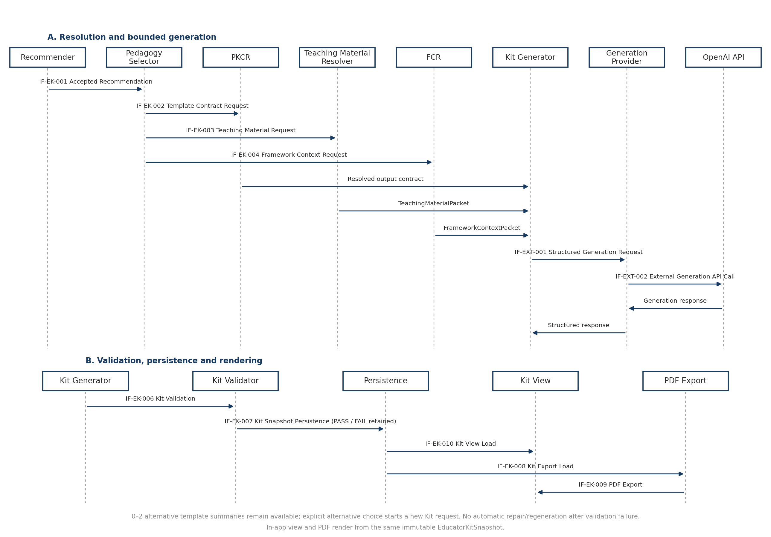
Figure 7. Educator Kit generation sequence
The two-part sequence preserves the order-sensitive V1 boundary: accepted recommendation first; pedagogical selection and deterministic resolvers next; external generation only after the bounded generation packet exists; validation before snapshot persistence; and both in-app view and PDF rendering from the persisted EducatorKitSnapshot. Alternative templates remain summaries until an educator explicitly selects one, which starts a new Kit generation request.

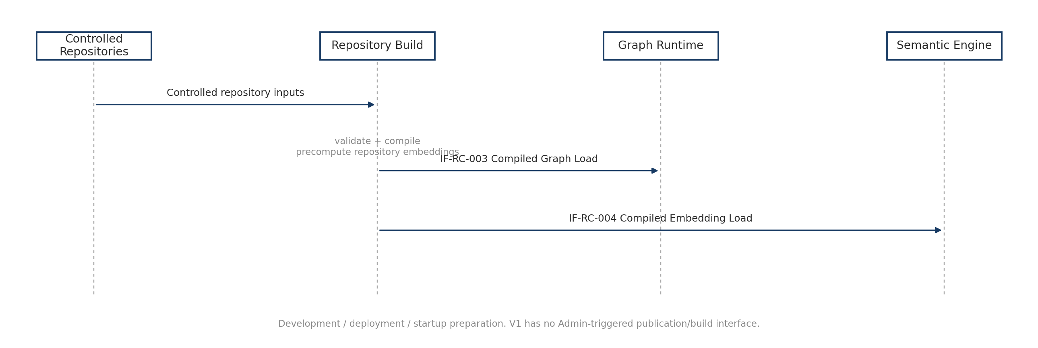
Figure 8. Repository build and runtime-load sequence
Controlled repository updates become runtime truth only after validation/compilation through the development/deployment build process. The compiled graph and embedding artifacts are loaded separately into Graph Runtime and Semantic Engine; V1 does not require an Admin-triggered publication/build flow.
Interface | Purpose
Application Context Suggestion | Educator UI ↔ Application Context Resolver; returns 0–2 generated alternatives while repository contexts remain internal evidence.
Educator Recommendation Request | Educator UI → Input Adapter.
Normalized Recommendation Request | Input Adapter → Recommender.
Recommendation Result | Recommender → Recommendation View; SUCCESS or ABSTAINED.
Recommendation Trace | Evidence View → Trace Builder/Persistence by Recommendation_Event_ID.
Accepted Recommendation to Pedagogy | Recommender → Pedagogy Selector.
Kit Generation Packet Assembly | Resolved output contract, teaching material and framework context → Kit Generator.
Structured Generation Request | Kit Generator → Generation Provider.
External Generation API Call | Generation Provider → OpenAI API.
Kit Snapshot Persistence | Kit Validator → Persistence.
Kit View Load | Persistence → Kit View from Educator_Kit_Snapshot_ID.
Kit PDF Export | Kit Renderer → UI; on-demand from the same immutable snapshot.
Compiled Graph Load | Development/deployment Repository Build → Graph Runtime.
Compiled Embedding Load | Development/deployment Repository Build → Semantic Engine.
Knowledge Graph Explorer Read Interfaces | KG Explorer ↔ Graph Runtime for load, search, entity/relationship inspection and deterministic directed path query.
Privileged Access Check | Protected Admin UI → Access Control.

11. Internet deployment and access architecture
V1 is deliberately deployed as an internet-accessible academic research prototype rather than an enterprise platform. The deployment keeps the application stack simple while preserving durable operational records and controlled administrative access.
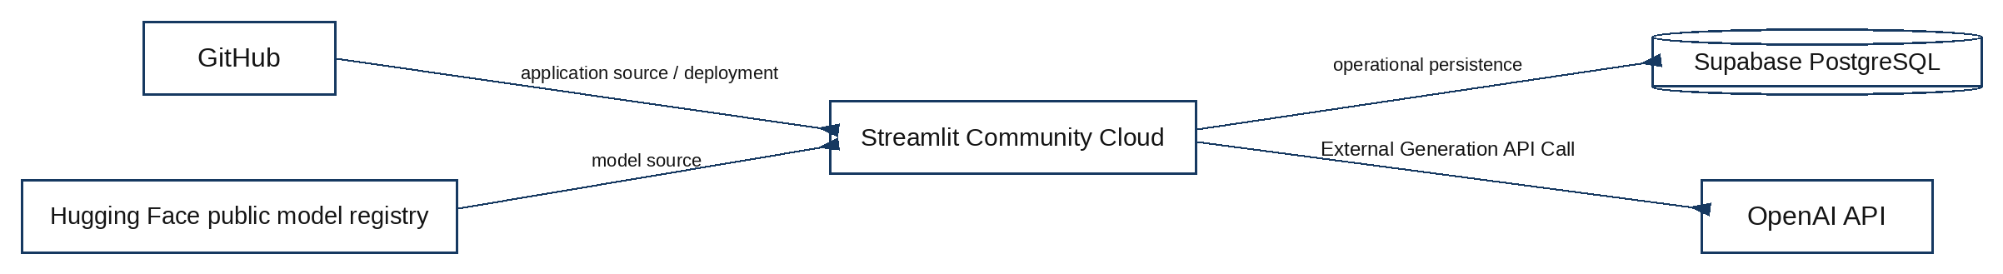
Figure 9. Internet deployment architecture
External service | V1 role
GitHub | Private source/version-control repository and deployment source.
Streamlit Community Cloud | Initial public host for the Python/Streamlit application.
Supabase PostgreSQL | Hosted persistent store for RecommendationEvent, RecommendationContextSnapshot, EducatorKitSnapshot, EducatorDecision and other operational/audit records as implemented.
OpenAI API | Bounded structured text generation for Educator Kit content after deterministic resolution.
Hugging Face public model registry | Source of sentence-transformers/all-MiniLM-L6-v2 model files; runtime embedding is local, not a per-request hosted embedding call.
Access boundary. Educator-facing functions may be publicly accessible. The protected V1 Administration shell and any privileged operational/log functions are gated through Access Control. Repository publication/build/restore/benchmark execution is deferred beyond functional V1 Administration. Secrets are deployment configuration, not source code.

12. Performance, reliability and verification
Concern | Architecture response
Interactive latency | Load Graph Runtime and Semantic Engine once at application startup; precompute repository embeddings; embed only new educator context at request time.
Repository scale | V1 repositories are compiled before runtime; graph processing is in memory and sized for an academic prototype rather than enterprise-scale concurrency.
Determinism | Recommendation ranking, promotion, negation, template selection, framework resolution and validation are deterministic/versioned functions around the semantic retrieval layer.
Model availability | If the frozen MiniLM backend is unavailable, the published application reports a runtime/model error rather than silently substituting another semantic backend.
Reference behavior | Design8a_Reference_Runtime is the parity authority for the Recommendation Core migration.
Release evidence | Unit, integration, Design-8a parity, Educator Kit contract/source-integrity, persistence, export-consistency and UI/security-smoke suites form the release gate.

13. V1 technology baseline
Layer | Selected V1 implementation
Application language | Python
Web UI | Streamlit
Graph processing | In-memory Graph Runtime with NetworkX behind the registered graph interface
Repository build | Pandas + Pydantic validation/compilation
Compiled data | Parquet + Python runtime objects
Semantic model | sentence-transformers/all-MiniLM-L6-v2
Vector comparison | NumPy/scikit-learn cosine similarity for V1
Local persistence | SQLite
Hosted persistence | Supabase PostgreSQL
Generation provider | OpenAI API through Generation Provider
Initial public hosting | Streamlit Community Cloud
Source/version control | GitHub

14. Architectural boundaries
- Curated repositories and typed relationships define semantic authority; similarity scores do not create ontology truth.
- Recommendation eligibility is established before ranking; free text does not bypass technical-anchor resolution.
- Explicit negative/excluded mechanism evidence can veto secondary promotion but cannot positively promote an SCR.
- Framework mappings and pedagogical templates are downstream of the SCR recommendation and cannot rescue or create SCR eligibility.
- Generated Kit content is operational output, not canonical repository content; educator decisions remain separate from system output.
- The V1 application is a research demonstrator. It does not require a dedicated graph database, microservice decomposition or enterprise identity platform.
- Future implementation changes may replace hosting/storage details when registered interfaces and validated recommendation behavior remain intact.

Appendix A. Registered component summary
Short title | Canonical component name
Graph Runtime | Runtime Knowledge Graph
Semantic Engine | Semantic Embedding Engine
Input Adapter | Educator Input Adapter
Anchor Resolver | Technical Anchor & Scope Resolver
Mechanism Profiler | Application Mechanism Profiler
Context Resolver | Application Context Resolver
SCR Ranker | SCR Candidate Scoring & Ranking Engine
Promotion Engine | Secondary SCR Promotion Engine
Negation Veto | Explicit Negation Veto Evaluator
Recommender | Recommendation Orchestrator
Trace Builder | Recommendation Trace Builder
Pedagogy Selector | Pedagogical Template Selector
PKCR | Pedagogy Kit Contract Resolver
Teaching Material Resolver | Teaching Material Resolver
FCR | Framework Context Resolver
Kit Generator | Educator Kit Generation Orchestrator
Kit Validator | Educator Kit Validator
Kit Snapshot | Educator Kit Snapshot Service
Kit Renderer | Educator Kit View & PDF Renderer
Educator UI | Public Educator Application
Recommendation View | Recommendation Result View
Kit View | Educator Kit View
Evidence View | Evidence & Recommendation Trace View
KG Explorer | Knowledge Graph Explorer
Admin UI | Administration Console — read-only/prototype in V1
Repository Admin | Repository Publication View — Future / Deferred
Validation UI | Validation & Benchmark View — Future / Deferred execution
Repository Build | Repository Build & Validation Service
Domain Models | Common Domain Models & Schemas
Configuration | Configuration & Version Service
Persistence | Persistence Service
Access Control | Authentication & Access Control
Audit | Audit & Logging Service
Generation Provider | Generation Provider Adapter
Error Model | Application Error Model

Appendix B. Registered interface summary
Interface | Primary path
Application Context Suggestion | Educator UI ↔ Application Context Resolver
Educator Recommendation Request | Educator UI → Input Adapter
Normalized Recommendation Request | Input Adapter → Recommender
Compiled Graph Load | Development/deployment Repository Build → Graph Runtime
Compiled Embedding Load | Development/deployment Repository Build → Semantic Engine
Recommendation Result | Recommender → Recommendation View
Recommendation Trace | Evidence View → Trace Builder / Persistence
Accepted Recommendation to Pedagogy | Recommender → Pedagogy Selector
Template Contract Request | Pedagogy Selector → PKCR
Teaching Material Request | Pedagogy Selector → Teaching Material Resolver
Framework Context Request | Pedagogy Selector → FCR
Kit Generation Packet Assembly | PKCR / Teaching Material Resolver / FCR → Kit Generator
Structured Generation Request | Kit Generator → Generation Provider
External Generation API Call | Generation Provider → OpenAI API
Kit Validation | Kit Generator → Kit Validator
Kit Snapshot Persistence | Kit Validator → Persistence
Kit View Load | Persistence → Kit View
Kit PDF Export | Kit Renderer → UI
Knowledge Graph Explorer read interfaces | KG Explorer ↔ Graph Runtime
Persistence Interface | Functional domains → Persistence
Privileged Access Check | Protected Admin UI → Access Control
Repository publication/build/restore/benchmark execution | Future / Deferred beyond functional V1 Administration

