UI Design

Ontology and Knowledge Graph-Driven Sustainability Principles Recommendation System
To integrate sustainability principles into existing curricula.
Version 0.3 | September 2026

Item | Decision
UI implementation stack | Streamlit (Python)
Graph visualization | Cytoscape.js integrated within Streamlit
Styling | Centralized theme/CSS; production implementation through the registered UI theme module
Wireframe form | Executable Streamlit design prototypes plus embedded visual previews

1. Purpose and scope
This document defines the user-interface design for the educator application, recommendation workflow, Recommendation Result and Educator Kit, Knowledge Graph Explorer, protected Administration functions, and cross-cutting interaction requirements. It is used together with the System Component & Artifact Register, System Architecture Design, Technical Interface Design and governed repositories during implementation.
The wireframes define structure, interaction intent, visual tokens, contextual-help behavior, responsive expectations, accessibility constraints and repository/runtime bindings. Exact V1 typed request/response behavior is defined in Technical_Interface_Design_v0.1 and the reconciled SEQ-04 decision baseline.

2. UI technology baseline
Layer | V1 decision | Implementation implication
Application UI | Streamlit (Python) | Primary UI pages and interaction logic remain in Python; this is not a standalone HTML application.
Styling | Centralized theme and controlled CSS | Visual tokens must be defined once and reused; screen files must not scatter independent colour/spacing literals.
Reusable UI patterns | Registered UI components module | Page headers, status treatments, Kit sections and other repeated patterns are implemented once and reused.
Knowledge Graph | Cytoscape.js within Streamlit | Use a Streamlit component boundary for the interactive graph; the complete governed graph remains explorable.
Context-sensitive help | Governed Help Content Repository | UI code resolves help by stable Help_Key; static help wording is not embedded in page logic.
HTML | Not the primary application stack | HTML/CSS may support Streamlit rendering and Educator Kit export, but navigation/business UI remains Streamlit.

3. Foundation principles
Area | Group A decision
Visible product name | Ontology and Knowledge Graph-Driven Sustainability Principles Recommendation System
Purpose | To integrate sustainability principles into existing curricula.
Primary educator capabilities | Create a Recommendation; Knowledge Graph Explorer
Administration | Protected and visually separate from the normal educator workflow.
Internal IDs | Do not appear in the normal educator UI. They are retained only for technical traceability and, where necessary, administration/audit.
Curriculum input | Course → Module → Subtopic. No separate Topic input.
Knowledge Graph | Complete governed graph available for exploration; visual filters/focus improve usability but do not restrict the accessible graph.
Recommendation vs exploration | Free graph exploration does not alter controlled Recommendation Core traversal.
Information hierarchy | Use → Understand → Inspect/Audit through progressive disclosure.
Visual character | Clean, restrained, academic, spacious, accessible; avoid a crowded dashboard appearance.

4. Visual design tokens
Token | V1 value
Page background | #F7F8FA
Content surface | #FFFFFF
Primary accent | #2F5D8C
Primary hover / active | #254A70
Primary text | #1F2937
Secondary text | #667085
Border / divider | #D0D5DD
Subtle surface | #F2F4F7
Success | #2E7D32
Warning | #8A5A00
Error / hard block | #B42318
Information | #315E9A
Focus ring | #2563EB
Border radius | 8 px
Minimum control height | 44 px
Educator content width | 1160 px maximum
Body text | 16 px
Help / secondary text | 14 px minimum
Page title | 32 px
Section heading | 24 px
Subsection heading | 20 px
Spacing scale | 8 / 16 / 24 / 32 / 48 px
Theme | One light theme for V1; dark mode not required.

Implementation rule: these values are semantic theme tokens, not independent per-screen styling decisions. Later changes should be made centrally.

5. Home
Tracking component: UI-01 — Public Educator Application
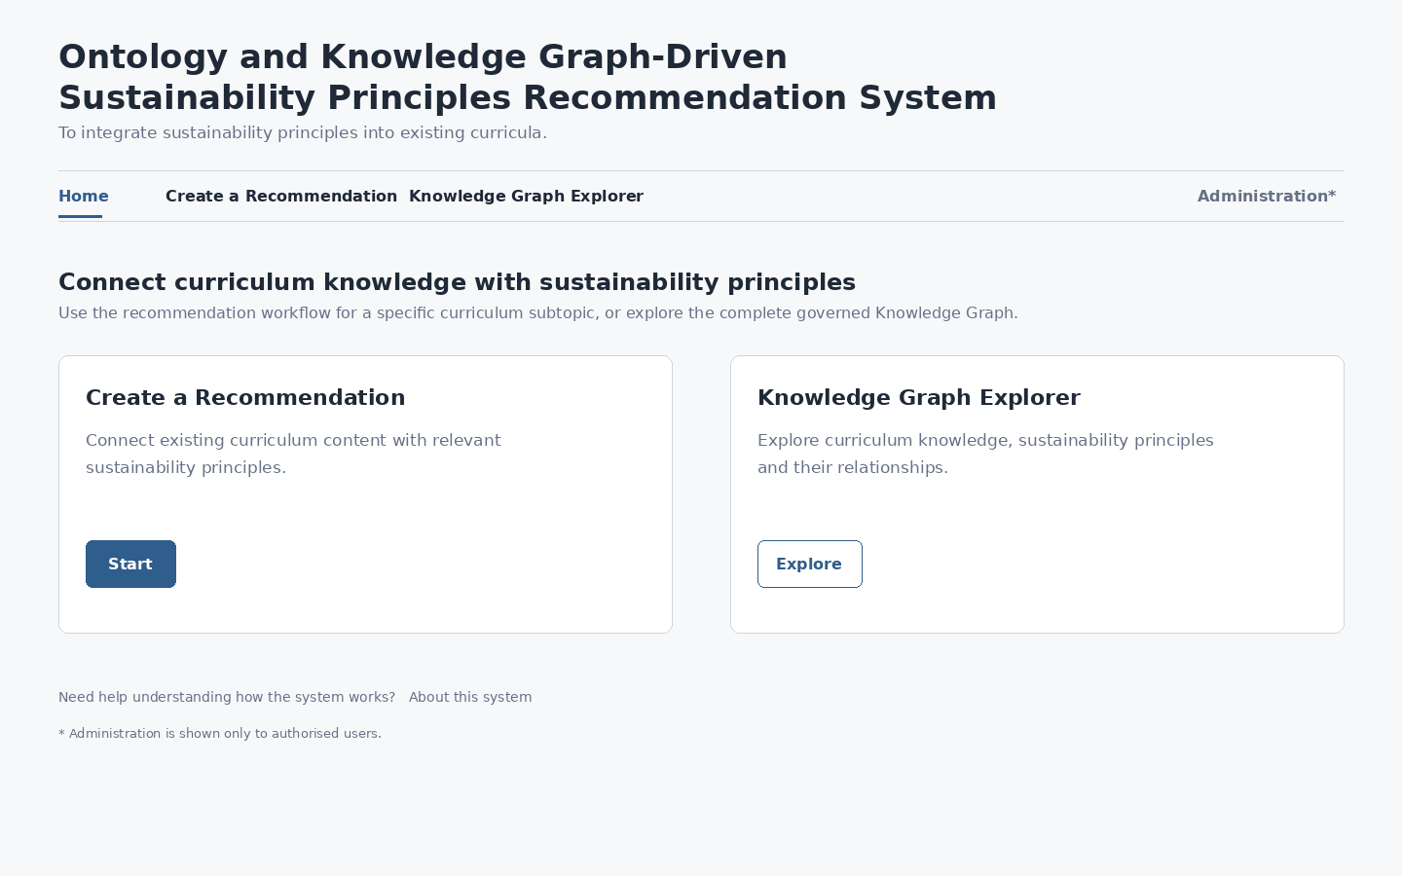
Figure 1. Home foundation wireframe
Specification | V1 definition
Purpose | Orient the educator and expose the two principal user capabilities without requiring architecture knowledge.
Primary actions | Start → Create a Recommendation; Explore → Knowledge Graph Explorer.
Home hierarchy | Full formal product title and purpose statement appear here; working pages use a compact title.
Entry cards | Two equal first-class choices. Create a Recommendation appears first.
Administration | Shown only for authorised users.
Context-sensitive help | About this system plus Help_Key-backed help for the two entry choices.
Data binding | Product title/purpose are UI Design constants; contextual help is read from Help_Content using stable Help_Key values.
Responsive behavior | Cards appear side-by-side on desktop and stack vertically on narrow screens.
Accessibility | Cards retain explicit labelled buttons; keyboard navigation follows visible order.
Acceptance criterion | A first-time educator can identify how to start a recommendation or explore the graph without knowing repository terminology.

6. Standard educator application shell
Tracking component: UI-01 — Public Educator Application
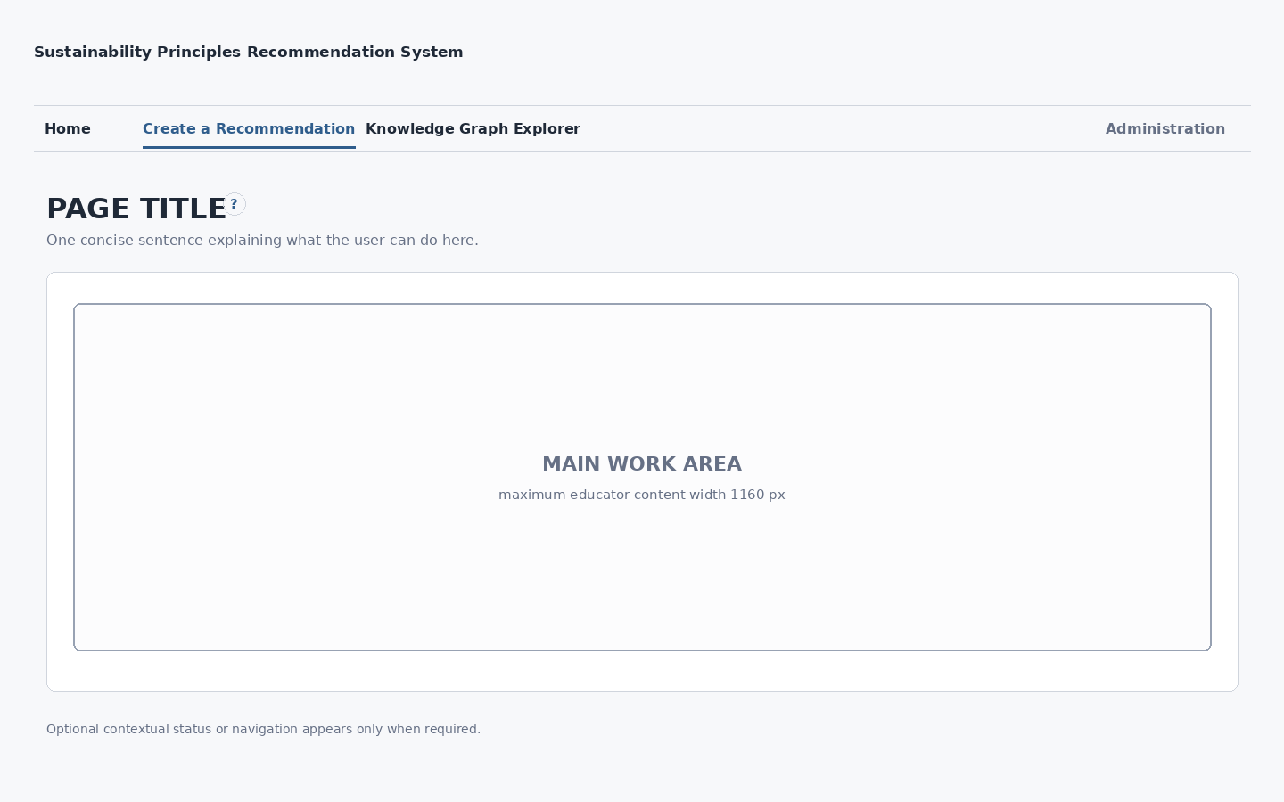
Figure 2. Standard educator application shell
Specification | V1 definition
Purpose | Provide a consistent shell for Create a Recommendation, Recommendation Result, Educator Kit and evidence-oriented views.
Global navigation | Home; Create a Recommendation; Knowledge Graph Explorer; Administration when authorised.
Page title | One clear page heading, with optional context-sensitive help.
Guidance | One concise sentence by default; detailed guidance moves to contextual help.
Content width | 1160 px maximum and centred for educator workflows.
Primary actions | Located consistently at the end of the active decision region.
Data binding rule | Every functional control/result must map to an exact governed repository field or runtime object in the UI Data Binding Matrix; readable labels never replace canonical IDs internally.
Responsive behavior | Content becomes fluid; multi-column controls stack when required.
Accessibility | Logical heading structure, keyboard sequence matches visual sequence, visible focus required.
Acceptance criterion | All educator screens can reuse the shell without embedding business-specific logic in the shell itself.

7. Knowledge Graph Explorer shell
Tracking component: UI-05 — Knowledge Graph Explorer
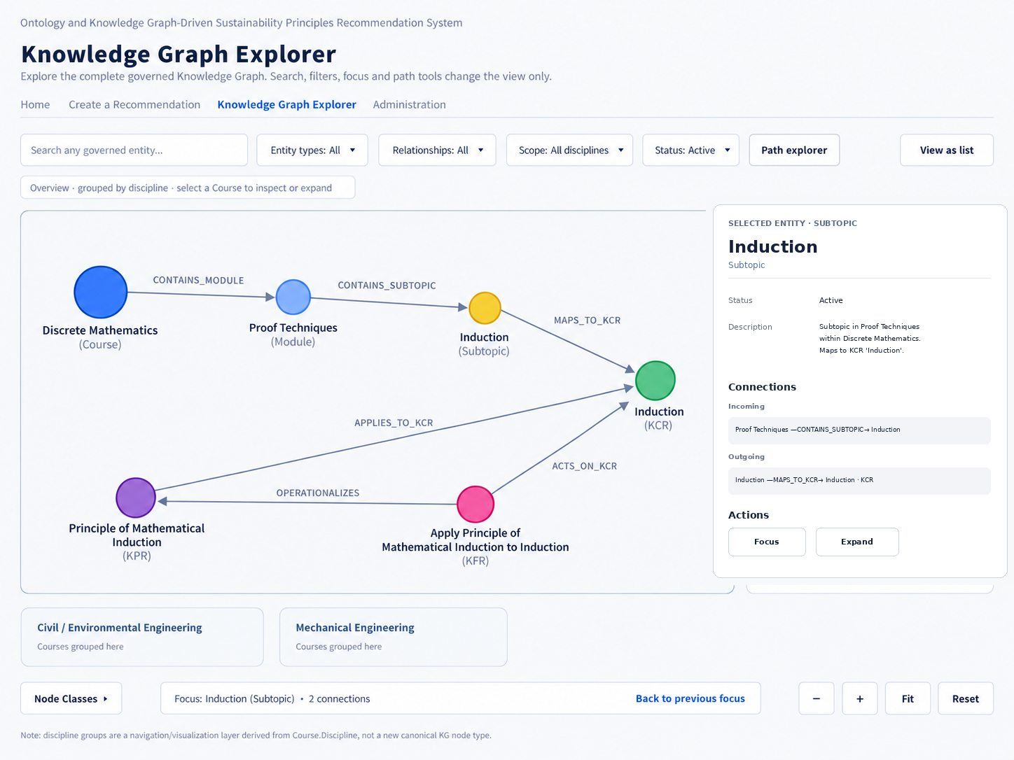
Figure 3. Knowledge Graph Explorer foundation wireframe — Computer Science example
Specification | V1 definition
Purpose | Explore the complete governed Knowledge Graph independently of recommendation generation; the standalone Explorer opens with an informative overview rather than a blank canvas.
Primary regions | Compact search/filter/path control band; dominant graph canvas; collapsible Node Classes legend; contextual selected-item inspector; graph utility controls; optional secondary View as list.
Complete graph | The full governed graph is available. Standalone entry groups Courses visually by Course.Discipline; this grouping is a UI navigation layer, not a new canonical KG node type. Clustering/focus/filtering remain display strategies.
Search | Find governed entities by readable terms and focus/highlight the selected result while retaining its canonical ID internally.
Filters | Entity type, relationship type, discipline/scope and status where useful; filters alter display only.
Node inspection | Readable title, type, authoritative description, status and incoming/outgoing connections. Read-only actions are Focus and Expand/Collapse; no per-node path-start/write action.
Relationship inspection | Expose source, target, direction, typed relationship label and governed meaning. Directed relationships render visible arrowheads.
Path exploration | Optional read-only capability opened from the top graph-control area using governed start/end selectors; it does not execute Recommendation Core traversal.
Technology | Cytoscape.js within Streamlit; the graph remains the primary surface and supporting controls are compact/contextual.
Data source | Compiled runtime graph derived from the Semantic Repository. Entry grouping uses the governed Course.Discipline field; entity inspector fields resolve to authoritative Course/Module/Subtopic/KCR/KPR/KFR/SCR/Application Context/Guardrail records.
Responsive behavior | Desktop/laptop canvas is primary; narrow layouts may move the inspector below the graph and reduce manipulation while retaining textual inspection.
Accessibility | Entity/relationship/path information is available textually. Node classes use readable labels plus shape/color cues, and View as list provides a secondary text-first representation of the same graph state.
Acceptance criterion | User enters an informative discipline-grouped overview, can identify a Course, inspect/focus/expand governed relationships, follow directed arrows/path detail and return to the broader graph without changing recommendation state.

8. Administration Console shell
Tracking component: UI-06 — Administration Console
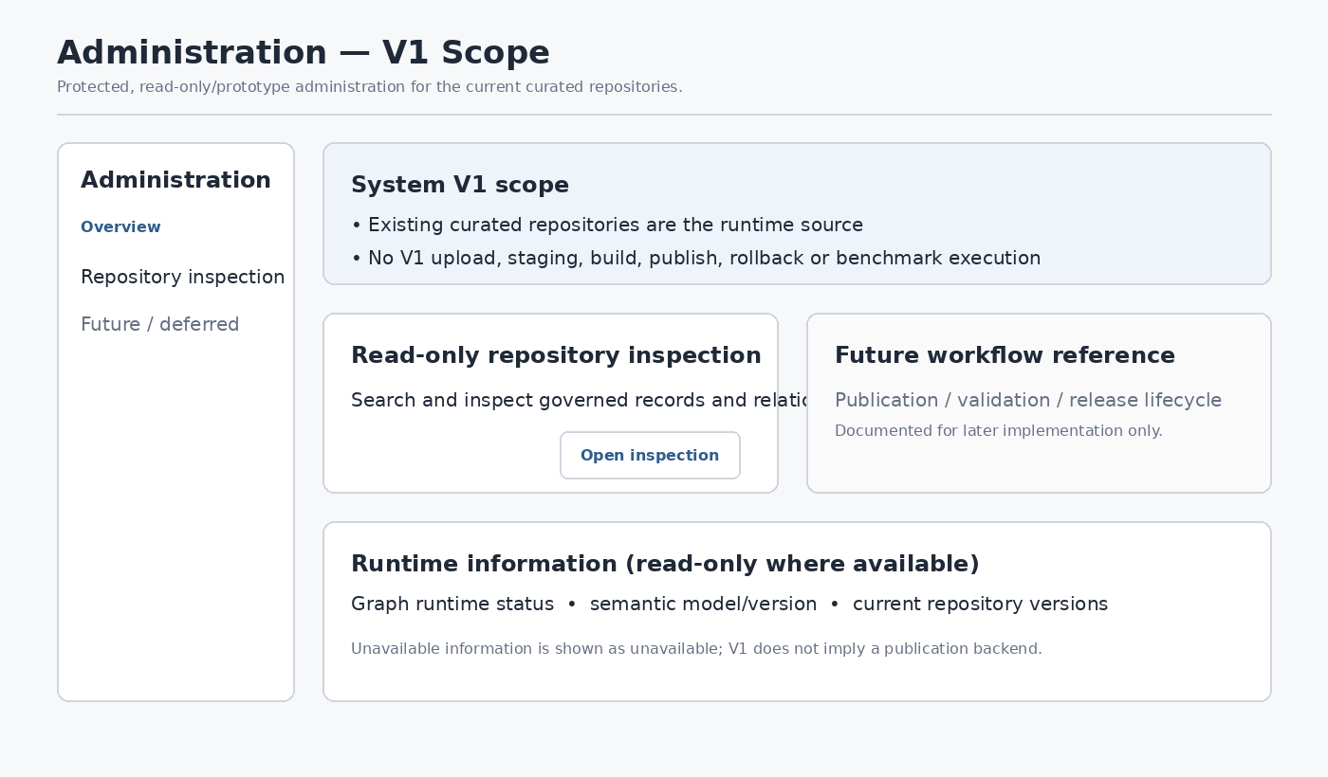
Figure 4. Administration Console foundation wireframe — reconciled V1 read-only/prototype scope
Specification | V1 definition
Purpose | Provide protected access to V1 scope guidance, read-only repository inspection and runtime/configuration information where available; future publication/validation workflows remain deferred reference material.
Access | Authentication/authorisation required before administrative content is rendered.
Navigation | Global navigation plus Administration secondary navigation appropriate to implemented V1 read-only/prototype functions.
Initial sub-navigation | Overview; Repository inspection / Prepare-Edit demonstration; Future / Deferred reference. Functional Publication and Validation & Benchmark execution are not V1 capabilities.
Information density | May be denser than educator pages while preserving clarity and accessibility.
Technical identifiers | No functional V1 publication/build/rollback action is exposed. Future consequential actions remain documented separately for later implementation.
Consequential actions | Read-only repository/runtime metadata comes from governed repositories and runtime state where available; unavailable future lifecycle data is not fabricated.
Data binding | Repository metadata comes from the System Component & Artifact Register and governed repositories; detailed Validation & Benchmark field mapping is deferred until that screen is designed.
Access denied | Render a clear access-denied state; do not partially expose protected content.
Responsive behavior | Desktop primary; secondary navigation may collapse on narrow screens.
Acceptance criterion | Educator and administrative work are clearly separated without creating a visually unrelated second application.

9. Context-sensitive help foundation
Static guidance is content-driven. UI page code should request help by stable Help_Key and render the appropriate help treatment; it should not embed long help paragraphs inside presentation logic.
Information | Authoritative source
General field/feature guidance | Help Content Repository
Course / Module / Subtopic description | Curriculum / Knowledge Graph repository
Sustainability Principle description | SCR repository
Selected graph entity or relationship detail | Governed Knowledge Graph repository
Recommendation-specific explanation | Recommendation trace/evidence
Validation-state explanation | Runtime validation state with governed user-facing wording

Help presentation modes may include short inline guidance, an information control, expandable detail, selection-sensitive context, validation guidance and result explanation. The appropriate mode is decided screen by screen.

10. Responsive and accessibility foundation
Concern | Foundation rule
Desktop/laptop | Reference layout and primary target for full graph and administration work.
Narrow/tablet | Columns stack where needed; navigation remains legible; no horizontal dependence for ordinary educator workflows.
Mobile | Recommendation and Kit content remain readable; graph inspector moves below the graph and complex graph manipulation may be reduced without hiding textual entity information.
Keyboard | Every actionable control must be reachable and operable by keyboard.
Focus | Visible focus treatment uses the defined focus token.
Colour | Colour reinforces meaning but never carries meaning alone.
Labels | Persistent labels are required for fields; placeholder text is not a replacement for a label.
Graph accessibility | Selected entity/relationship information is always available as text in addition to the graphical view.

11. Implementation use
The wireframe images communicate layout, while the accompanying Streamlit prototype files communicate intended implementation structure. Production implementation should use the following sources together:
Source | Role in implementation
UI Design v0.2 | Layout, visual tokens, screen behavior, states, responsive/accessibility rules and acceptance criteria.
System Component & Artifact Register v0.3 | Canonical file names, public functions, repository structure, coding standards and implementation invariants.
System Architecture Design v1.0 | System boundaries and responsibility separation.
Technical Interface Design v0.1 | Field-level requests/responses, failures and contracts between UI and backend components.
Help Content Repository | Runtime context-sensitive help text resolved by Help_Key.
Governed repositories | Actual curriculum, SCR, pedagogy, framework and Knowledge Graph data.

The Streamlit wireframe files are design prototypes, not production modules. When production UI coding starts, implementation must use the canonical repository structure, registered UI code files and typed interfaces rather than copying the prototype files into production unchanged.

12. UI data binding and repository mapping
UI implementation must bind each functional control, displayed entity and result to an explicit governed repository field or runtime object. The companion matrix UI_Data_Binding_Matrix_v0.3.xlsx is the detailed coding/QA source for these bindings and is extended screen-by-screen during SEQ-03.
Core binding rule: the interface shows readable labels but retains canonical IDs internally. Joins, filtering, request construction and persistence must use the canonical ID whenever one exists; display text must not become the key.
UI use | Authoritative source | Key / display fields | Binding rule
Course selection | Semantic Repository — Course_Repository | Course_ID / Course_Title | Show Course_Title; retain Course_ID; default to active records.
Module selection | Semantic Repository — Module_Repository | Module_ID / Module_Name | Filter by selected Course_ID; retain Module_ID.
Subtopic selection | Semantic Repository — Subtopic_Repository | Subtopic_ID / Subtopic | Filter by selected Module_ID; retain Subtopic_ID.
Subtopic description | Semantic Repository — Subtopic_Repository | Subtopic_ID / Subtopic_Description | Read the governed description exactly; do not synthesize missing canonical text.
Application Context | Semantic Repository — Application_Context | Application_Context_ID / Application_Context_Name | Runtime compatibility determines eligible contexts; repository membership alone is not compatibility.
Knowledge Graph Explorer | Compiled graph from Semantic Repository | Canonical entity ID / readable entity title | Graph display resolves entity properties from authoritative repository fields.
Context-sensitive help | Help Content Repository — Help_Content | Help_Key / Short_Help, Detailed_Help, Action_Guidance | Help wording is external to page code.
Teaching Context | StageF Educator Kit Design — Runtime_Input_Contract | Learner_Level, Delivery_Mode, Class_Size, Available_Time, Assessment_Preference, Site_Access, Data_Availability, Stakeholder_Access, Lab_or_Equipment_Access, Additional_Constraints | These are runtime inputs; unknown/not specified is valid where the design permits it.
Recommendation display | Semantic Repository — SCR + runtime recommendation trace | SCR_ID / Sustainability_Concept; runtime evidence path | Runtime selects the SCR; repository supplies canonical human-readable content.
Pedagogy / Kit | Pedagogy, Output Contract, Framework Resolver and Teaching Evidence repositories | Template_ID, Element_ID, Framework_Element_ID, Reference_ID | Canonical repositories supply content; runtime services decide applicability, activation and presentation.

Schema verification requirement: the canonical V1 Semantic Repository is registered as v1.1. Repository-build validation must confirm that the canonical v1.1 headers satisfy every field required by the binding matrix before implementation release. Later schema variants are not authoritative for the V1 interface contract.
SEQ-04 — Technical Interface Design now supplies the typed V1 request/response fields for these UI bindings. SEQ-09 remains responsible for the physical persistence schema for operational objects.

13. Group B — Create a Recommendation
Tracking component: UI-01 — Public Educator Application
Group B defines the educator input workflow that precedes the Recommendation Result. It uses the Group A shell, visual tokens, help architecture, accessibility rules and data-binding principles without replacing them.
Step | Purpose | Completion condition
1. Curriculum | Establish the governed Course → Module → Subtopic hierarchy and preferred technical anchor. | Course, Module and Subtopic are all selected; Subtopic is the preferred anchor.
2. Application Context | Capture or accept the application evidence used to evaluate sustainability relevance. | One educator-entered or educator-accepted Application Context exists with provenance.
3. Teaching Context | Capture optional teaching constraints that influence activity practicality and Educator Kit adaptation. | Known values are supplied; unknown/not specified values remain valid.
4. Review | Show exactly what will be used when the recommendation request is generated. | No blocking input state remains; educator selects Generate Recommendation.
The normal hierarchy path has no Course-only or Course+Module shortcut. Those selections may expose useful governed information, but final recommendation reasoning starts only after a Subtopic establishes the explicit technical anchor. Module and Course remain controlled internal fallbacks.

13.1 Curriculum selection
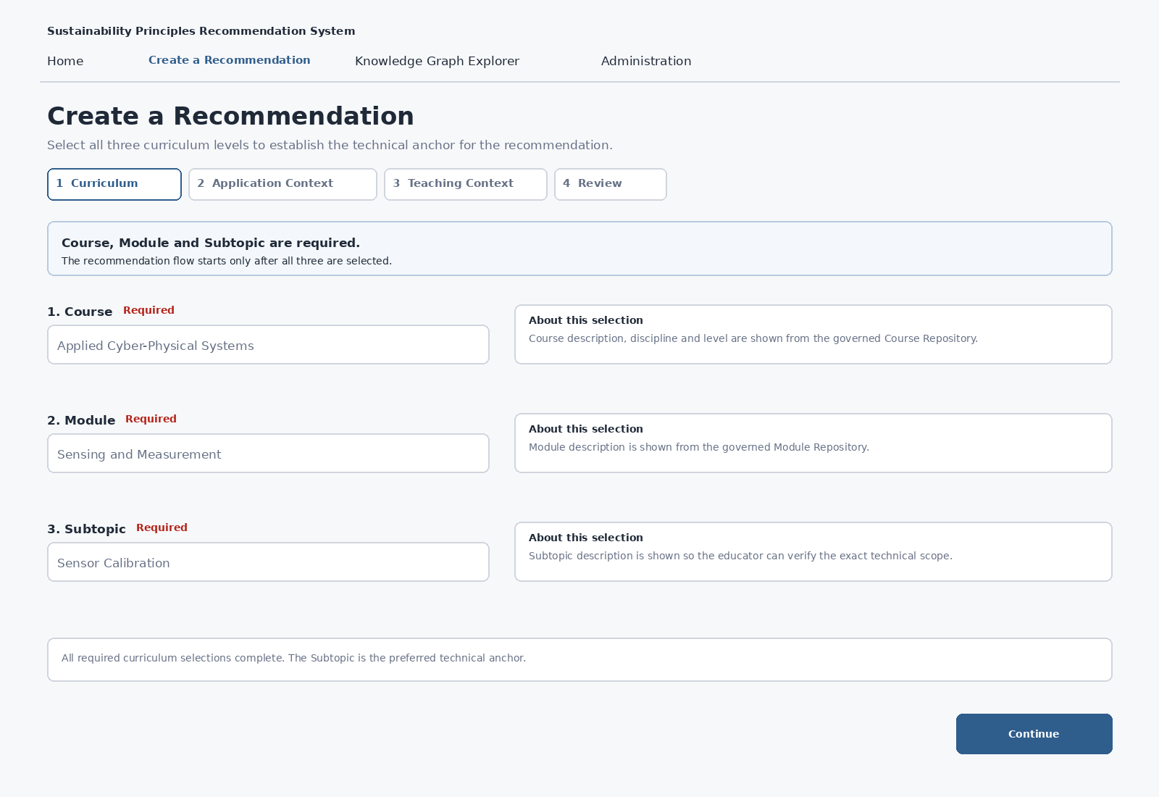
Figure 5. Create a Recommendation — Curriculum selection wireframe
The screen must make the mandatory sequence visually unmistakable. Course, Module and Subtopic are separately labelled Required. Module is disabled until Course is selected; Subtopic is disabled until Module is selected; Continue is disabled until Subtopic is valid.
UI element | Repository / field binding | Behavior
Course | Course_Repository: Course_ID → Course_Title; Course_Description, Discipline, Level | Show governed Course details immediately after selection. Changing Course clears Module, Subtopic and downstream Application Context state.
Module | Module_Repository: Module_ID → Module_Name; filter by selected Course_ID; Module_Description | Show governed Module details after selection. Changing Module clears Subtopic and downstream Application Context state.
Subtopic | Subtopic_Repository: Subtopic_ID → Subtopic; filter by selected Module_ID; Subtopic_Description | Establish the preferred technical anchor and display the governed description for scope verification.
Continue | Workflow state | Enabled only when all three mandatory hierarchy levels are selected and the Subtopic is valid.
Data rule: readable titles are shown to the educator, but Course_ID, Module_ID and Subtopic_ID are retained internally. Display labels are never used as join or persistence keys.
Help keys: recommendation.curriculum_selection, recommendation.course, recommendation.module, recommendation.subtopic, recommendation.selected_course_description, recommendation.selected_module_description and recommendation.selected_subtopic_description.

13.2 Application Context
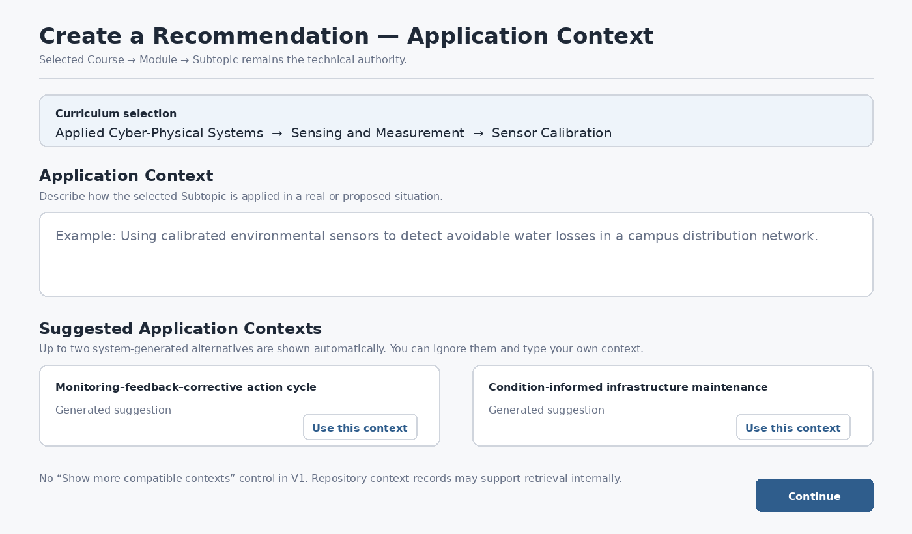
Figure 6. Create a Recommendation — Application Context wireframe
When Step 2 opens, the selected Course → Module → Subtopic is shown prominently so the educator can see the anchor from which compatible Application Contexts are being derived.
The educator may type an Application Context directly. Below the free-text field, the system automatically shows at most one or two strongest system-generated suggestions. Repository Application Context records may support retrieval and evidence internally, but they are not a third educator-selectable provenance path and there is no Show more compatible contexts control in V1.
Path | UI behavior | Authority / provenance | Field reference
Educator entered | Free-text area is always available. | Primary when supplied; exact text preserved. | Runtime_Input_Contract.Application_Context_Text
Automatic compatible suggestions | Top 0–2 system-generated suggestions appear automatically after a valid Course/Module/Subtopic anchor; educator free text remains immediately available. | Optional until educator selects Use this context; repository context records may support retrieval/evidence internally. | ApplicationContextSuggestionResponse: Context_Candidate_ID, Context_Title, Application_Context_Text, Display_Rank, optional Why_Suggested.
Suggestion set retained for Generate | The UI retains the final 0–2 candidates actually shown and the selected candidate ID, if any, until hierarchy changes or suggestions are refreshed. | UI/session provenance only; not a curated-context browse path. | EducatorRecommendationRequest.Suggested_Context_Candidates_Shown[]
Accepted context source | Shown as visually secondary provenance. | Exactly EDUCATOR_ENTERED or ACCEPTED_SYSTEM_GENERATED. | EducatorRecommendationRequest.Application_Context_Source
Accepted generated candidate ID | Not shown in normal educator UI. | Retained only when a system-generated suggestion is accepted. | EducatorRecommendationRequest.Accepted_Context_Candidate_ID; null for EDUCATOR_ENTERED.
Precedence rule: educator-entered Application Context is primary. If the educator types their own context after accepting a suggestion, the educator-entered context supersedes that suggestion on the main recommendation path while provenance remains available.
Compatibility is determined from the selected curriculum anchor, governed knowledge relationships, mechanism/boundary evidence and controlled semantic ranking among eligible candidates. Repository membership or semantic similarity alone does not establish compatibility.
SEQ-04 fixes Application_Context_Source to exactly EDUCATOR_ENTERED or ACCEPTED_SYSTEM_GENERATED. A generated suggestion carries a runtime Context_Candidate_ID; educator-entered text has no accepted candidate ID. If educator text already exists when suggestions are evaluated, it may contribute application/mechanism evidence while the selected Subtopic remains the technical authority.
Help keys: recommendation.application_context, recommendation.suggested_contexts, recommendation.context_source and recommendation.context_acceptance. The earlier recommendation.show_more_contexts key is retained only as deprecated historical help content.

13.3 Teaching Context
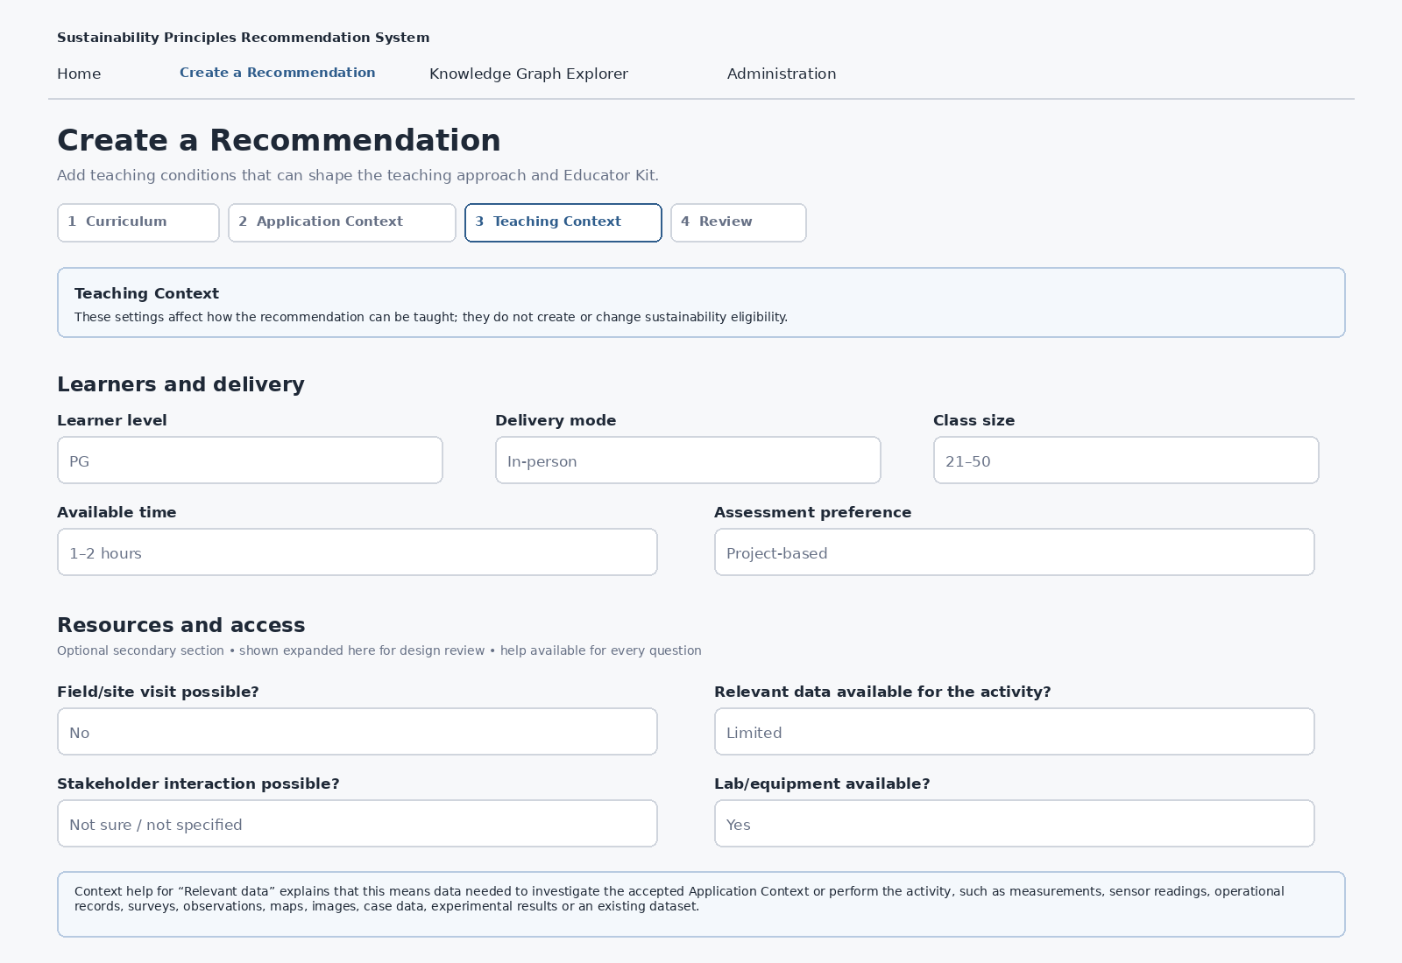
Figure 7. Create a Recommendation — Teaching Context wireframe
Teaching Context is optional field-by-field. Unknown, Not specified and No preference are valid states where appropriate. These inputs shape pedagogical fit, activity practicality and Educator Kit adaptation; they do not create or change sustainability eligibility.
Educator-facing label | Canonical runtime field | Purpose / help behavior
Learner level | Learner_Level | Tailors activity depth and teaching guidance; unknown/not specified is valid.
Delivery mode | Delivery_Mode | Influences activity format; unknown/not specified is valid.
Class size | Class_Size | Influences grouping/facilitation; approximate range is sufficient.
Available time | Available_Time | Constrains feasible teaching activity duration.
Assessment preference | Assessment_Preference | Shapes pedagogy/presentation only; No preference is valid.
Field/site visit possible? | Site_Access | Asks whether learners can visit/access a relevant real-world setting. Help explains examples and why this affects field-based activity practicality.
Relevant data available for the activity? | Data_Availability | Means data needed to investigate the accepted Application Context or perform the activity. Help gives examples such as measurements, sensor readings, operational records, surveys, observations, maps, images, case data, experimental results or datasets.
Stakeholder interaction possible? | Stakeholder_Access | Asks whether relevant users/operators/community/other stakeholders can participate where useful.
Lab/equipment available? | Lab_or_Equipment_Access | Asks whether needed facilities, instruments, sensors, software or equipment are available.
Additional constraints | Additional_Constraints | Optional free text; preserve exact educator wording.
The four access/resource questions are grouped under a secondary “Resources and access” section. The production UI keeps this section collapsed by default; the wireframe displays the expanded state for specification clarity. Each question has Help_Key-backed contextual help.
The visible wording is intentionally educator-facing. The underlying Stage-F runtime field names remain unchanged and are mapped explicitly in UI_Data_Binding_Matrix_v0.3.xlsx.

13.4 Review and Generate
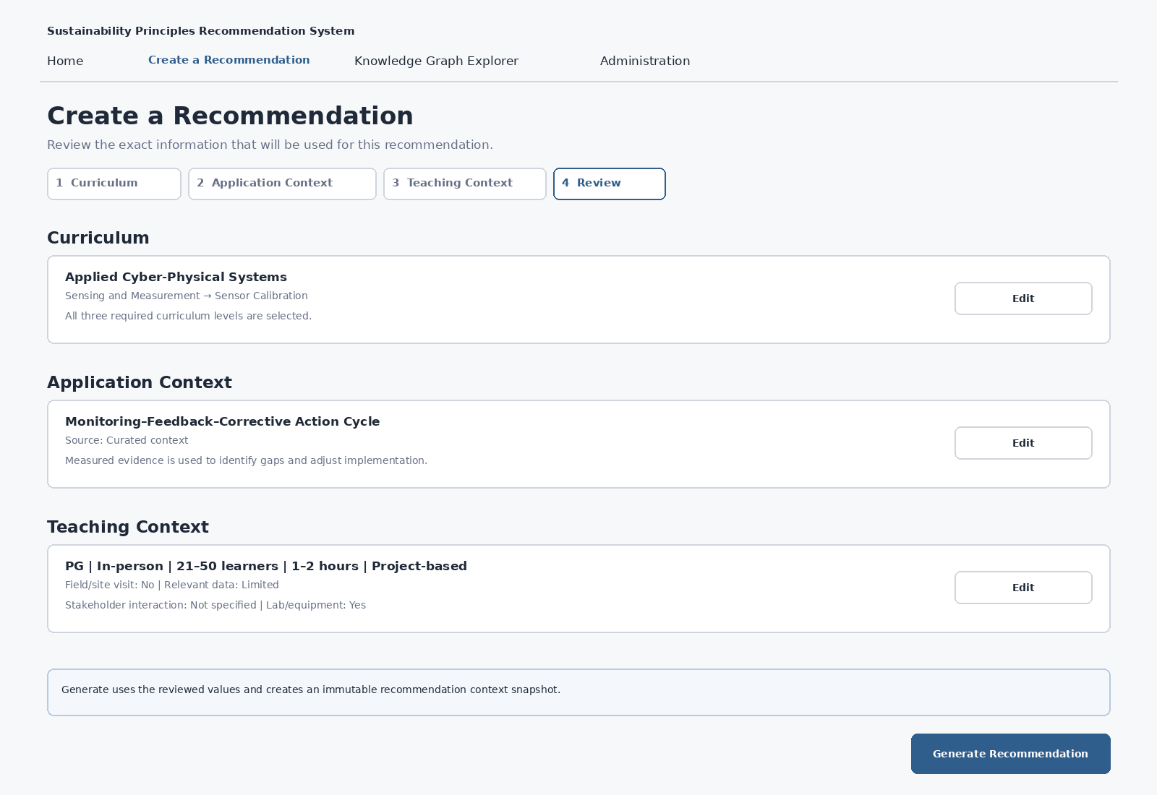
Figure 8. Create a Recommendation — Review and Generate wireframe
Review block | Displayed content | Edit / execution behavior
Curriculum | Course, Module and Subtopic labels resolved from retained canonical IDs. | Edit returns to Curriculum. Hierarchy changes invalidate dependent context state.
Application Context | Exact accepted context text/title plus restrained source/provenance. | Edit returns to Application Context; changing context invalidates prior context validation.
Teaching Context | Concise summary using educator-facing labels; unspecified values remain unspecified or are omitted from the concise summary. | Edit returns to Teaching Context without changing recommendation anchor/context unless those inputs are separately edited.
Generate Recommendation | Uses the reviewed curriculum anchor, accepted Application Context and current Teaching Context. | Creates an immutable RecommendationContextSnapshot and invokes the registered Recommendation Core interface.
During generation, the primary action is disabled and replaced by an explicit “Generating recommendation…” state to prevent duplicate submission. A successful execution moves to the Recommendation Result flow in Group C.

13.5 Input and routing states
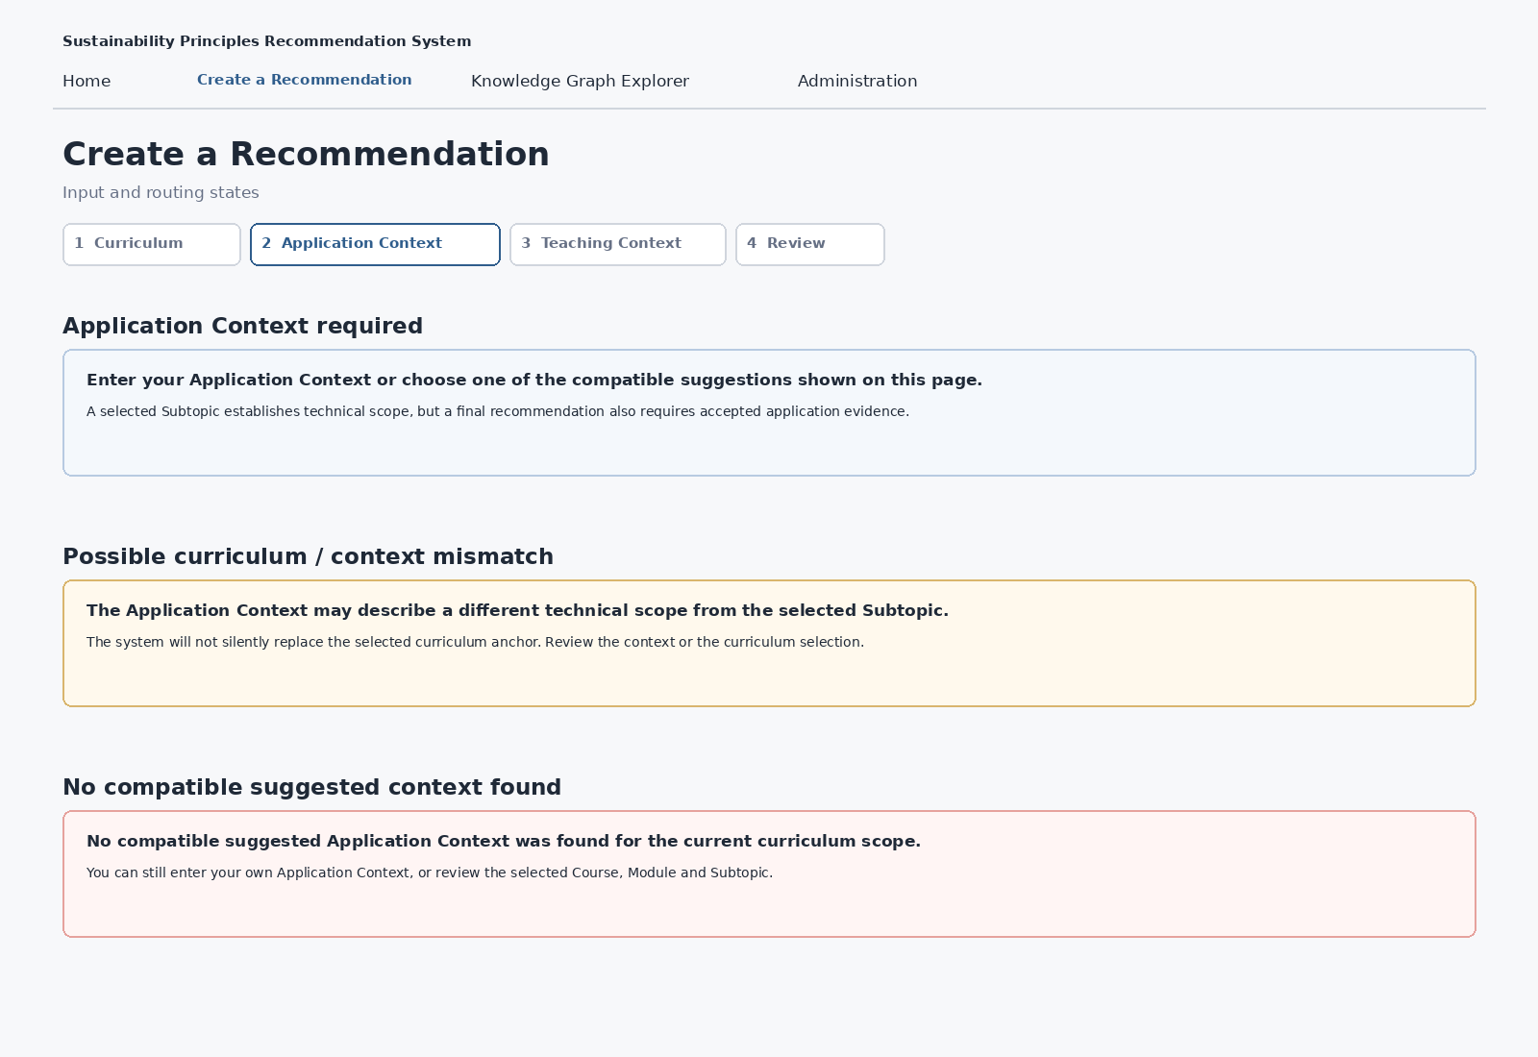
Figure 9. Group B input and routing states
State | System behavior | Educator action
Application Context required | Block Continue/Generate when no Application Context has been entered or accepted. | Type an Application Context or select one of the already displayed suggestions.
Possible curriculum/context mismatch | Do not silently replace the selected curriculum anchor. | Edit Application Context or review Course/Module/Subtopic selection.
No compatible suggested context | Do not force a generated context. Keep educator free-text entry available. | Enter own Application Context or review the curriculum selection.

13.6 Group B binding, help and state rules
Rule | Group B requirement
Mandatory hierarchy | Course, Module and Subtopic are visibly mandatory in the normal path.
Downstream invalidation | Changing Course clears Module/Subtopic and dependent context; changing Module clears Subtopic and dependent context; changing Subtopic invalidates suggestions/accepted context tied to the old anchor.
Automatic suggestions | Application Context suggestions are evaluated automatically after a valid Course → Module → Subtopic anchor; no separate Suggest button.
Canonical identifiers | Readable labels are shown; canonical IDs are retained internally.
Help | Static explanatory text is resolved from UI_Help_Content_Repository_v0.3.xlsx using stable Help_Key values.
Entity descriptions | Course/Module/Subtopic descriptions come from governed repositories, not the Help repository.
Teaching Context | Visible educator wording may differ from canonical runtime field names; mapping is explicit and deterministic.
Interface boundary | Exact UI ↔ backend request/response schema and curated-context provenance serialization are defined in SEQ-04.

14.7 Controlled companion artifacts
Artifact | Combined Group A + Group B role
UI_Design_v0.3.docx | UI foundation and educator recommendation workflow, including wireframes, behavior, state rules, accessibility/responsive requirements and conformance criteria.
UI_Foundation_Decisions_v0.3.xlsx | Decision register for Group A foundation, Group B workflow and visual tokens.
UI_Data_Binding_Matrix_v0.3.xlsx | Foundation and field-level repository/runtime/state/help mappings for the educator workflow.
UI_Help_Content_Repository_v0.3.xlsx | Context-sensitive help content and validation guidance for the educator workflow.

13.8 Group B design conformance checklist
- Course, Module and Subtopic are visibly mandatory and hierarchy-filtered; Continue is unavailable until a valid Subtopic is selected.
- Governed Course, Module and Subtopic descriptive context is shown at the appropriate selection stage.
- Application Context suggestions are shown automatically from the selected Course → Module → Subtopic anchor; the redundant Browse/Suggest primary actions are absent.
- At most one or two system-generated suggestions are shown; zero suggestions is valid and there is no curated-context Show more control in V1.
- Educator-entered Application Context remains primary; accepted generated-suggestion provenance and the exact final suggestion set shown are preserved for the Generate request/snapshot.
- A final recommendation cannot be generated without an accepted Application Context.
- Teaching Context uses educator-facing labels while preserving canonical runtime field mappings.
- Field/site visit, relevant data, stakeholder interaction and lab/equipment questions have context-sensitive help that explains meaning and purpose.
- Resource/access questions are secondary and collapsed by default in production.
- Changing hierarchy selections invalidates dependent Application Context state rather than silently reusing stale context.
- Review displays the exact values used for execution and Generate creates an immutable context snapshot.
- All Group B controls/states are represented in UI_Data_Binding_Matrix_v0.3.xlsx and relevant help is represented in UI_Help_Content_Repository_v0.3.xlsx.
- Application Context provenance is fully resolved by SEQ-04: exactly EDUCATOR_ENTERED or ACCEPTED_SYSTEM_GENERATED; repository contexts remain internal evidence/retrieval support.
Group B is complete at the SEQ-03 level when the checklist and companion artifacts are mutually consistent.

14. Group C — Educator Kit and explainability
Group C begins after the Group B recommendation request has produced either an accepted sustainability recommendation or a valid abstention/insufficient-evidence state. It defines how the accepted recommendation is presented, how an educator can inspect why it was produced, and how the downstream Educator Kit is presented without changing Recommendation Core semantics.
Group C principle | UI consequence
Accepted recommendation remains authoritative | The result/Kit UI does not re-anchor curriculum, substitute another SCR or allow framework alignment to create recommendation eligibility.
Use → Understand → Inspect/Audit | Primary result and teaching use are visible first; evidence path, IDs, scores and provenance move progressively into deeper views.
Pedagogy is downstream | Teaching-template selection occurs only after the SCR is accepted. Default display is one primary approach plus up to two materially distinct alternatives.
Ready-to-use means contract-complete | The selected Template Output Element Contract defines required/conditional Kit content and the validator determines PASS/FAIL.
Educator authority remains explicit | The educator can use, adapt, choose another approach, not use, or save for later; these decisions never overwrite canonical repositories.
The wireframes use the Stage-F water-resources worked example to illustrate structure. Internal IDs are omitted from educator-facing examples.

14.1 Recommendation Result
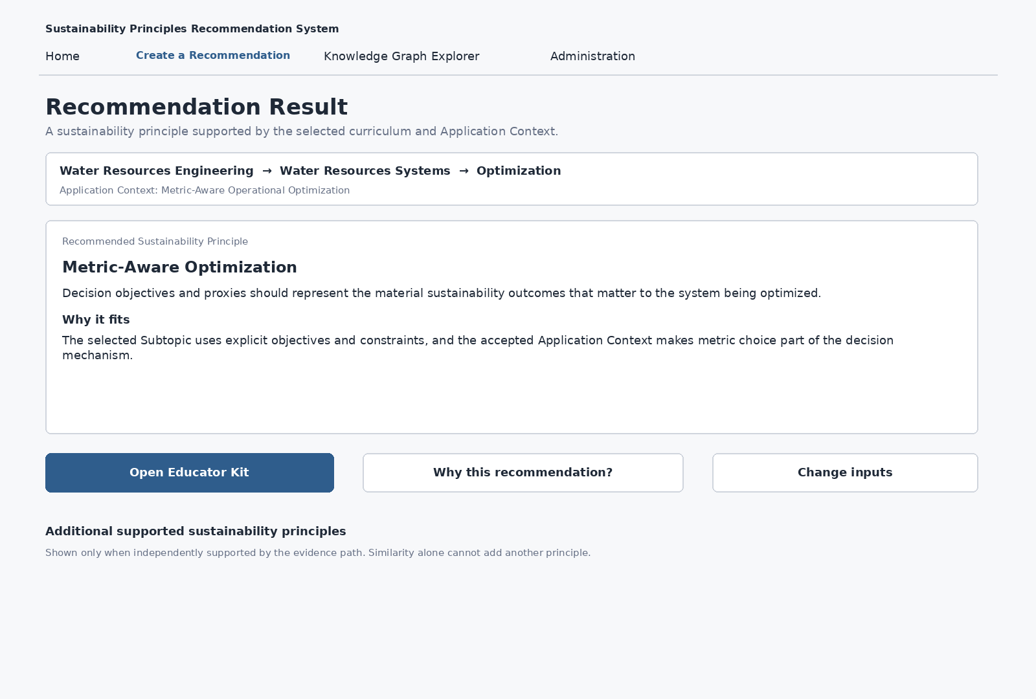
Figure 10. Recommendation Result wireframe
Element | Design rule | Authority / binding
Curriculum/Application Context strip | Show the selected Course → Module → Subtopic and accepted Application Context in compact readable form so the recommendation remains grounded. | Current RecommendationContextSnapshot plus authoritative curriculum/context labels.
Recommended Sustainability Principle | Dominant result object. Show canonical title and concise definition/summary; do not expose SCR_ID as primary content. | Accepted runtime SCR_ID → Semantic Repository SCR.Sustainability_Concept / Definition.
Why it fits | One concise explanation tied to the actual anchor/context/evidence path. | Stage-F Why_This_Fits / recommendation trace; not a new eligibility decision.
Open Educator Kit | Primary action after a successful recommendation. | Invokes Educator Kit generation/opening against the accepted recommendation and current Teaching Context.
Why this recommendation? | Secondary explainability action. | Loads persisted recommendation trace/evidence.
Additional supported principles | Collapsed/hidden by default and shown only when independently supported by promotion/evidence rules. | Runtime promoted SCRs resolved to canonical SCR labels.
Scores | Not part of the primary educator result. | May appear only in audit/diagnostic detail when useful.
The Recommendation Result must also support explicit abstention outcomes. “No defensible sustainability mechanism” is shown when a technical anchor exists but the selected/entered application evidence does not establish a sustainability-relevant action or mechanism; the educator is directed to clarify the Application Context or review the curriculum selection. Generic insufficient-evidence/no-recommendation remains a separate outcome when a mechanism may exist but the repository/evidence path is still insufficient. In either state there is no accepted SCR, no normal Open Educator Kit action, and the interface must not force a sustainability principle from semantic similarity.

14.2 Why this recommendation? — explainability
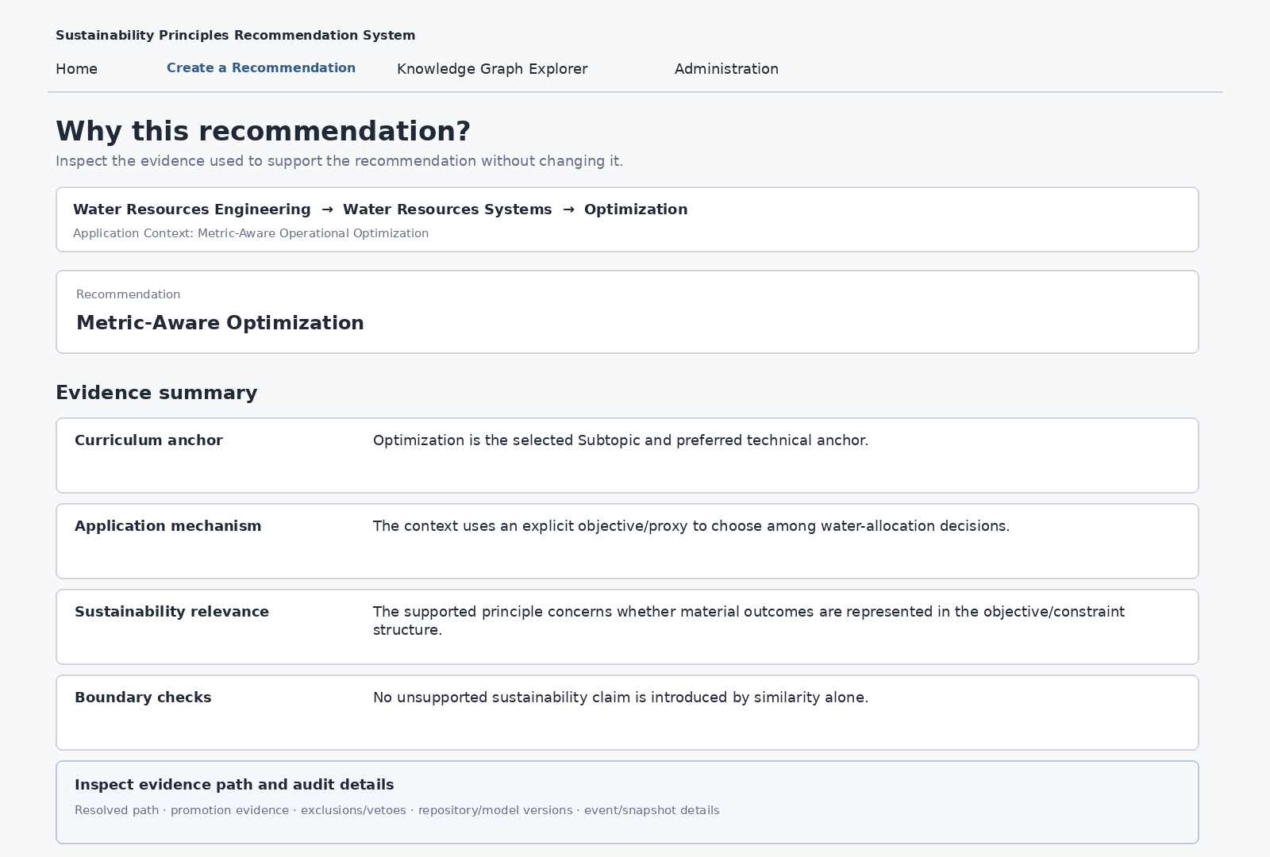
Figure 11. Recommendation explainability wireframe
Layer | Educator-facing content | Progressive detail
Curriculum anchor | Most specific selected anchor and its role in the recommendation. | Resolved graph entities/path remain behind audit detail.
Application mechanism/context | What problem/action/mechanism in the accepted Application Context made sustainability relevance meaningful. | Normalized facets may be inspectable but raw runtime jargon stays secondary.
Supporting evidence | Human-readable explanation of the evidence supporting the accepted principle and any independently promoted principle. | Candidate/ranking detail appears only in Inspect/Audit.
Boundary / negation checks | Material exclusions, vetoes or boundary conditions that constrained the result. | Exact technical rule evidence may be shown in audit.
Audit provenance | Repository/model versions, RecommendationEvent, context snapshot, resolved entities, candidate/ranking/exclusion information. | Expandable technical section; not the default result view.
Critical rule: when the persisted trace cannot be loaded, the UI shows a trace-unavailable state. It must not generate a plausible-sounding explanation from the result title alone.

14.3 Educator Kit overview
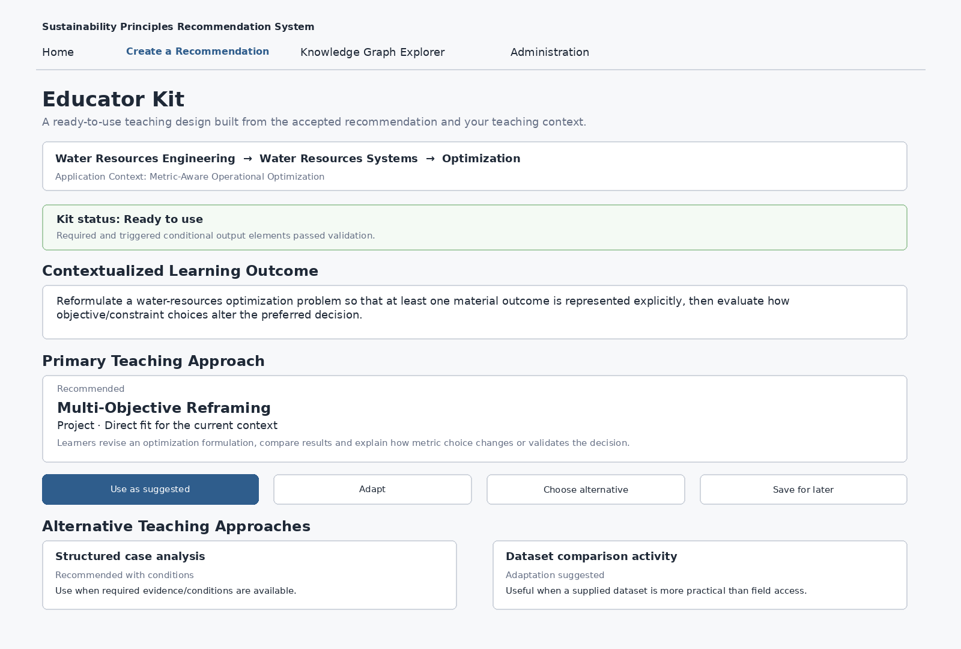
Figure 12. Educator Kit overview wireframe
Section | V1 behavior | Source
Kit status | Show concise output-contract validation state near the top. “Ready to use” requires PASS; absence of validation cannot be treated as PASS. | Template Output Element Contract validation result.
Contextualized Learning Outcome | One or more context-specific learner outcomes derived from the accepted SCR, selected template and current curriculum/application context. | EducatorKitSnapshot.Contextualized_Learning_Outcome[].
Primary Teaching Approach | One dominant option with title/type, applicability state, concise fit/condition explanation and practical description. | Stage-E template metadata + runtime Pedagogy_Options[].
Alternative Teaching Approaches | Up to two materially distinct alternatives when available. | Runtime ordered options; canonical metadata resolves from Stage-E repository.
Educator controls | Use as suggested, Adapt, Choose alternative, Not use, Save for later. | EducatorDecision persisted separately.
Framework mappings must not select or re-rank the teaching approach. Template selection is downstream from the accepted SCR but upstream from Framework Context Resolver enrichment.

14.4 Educator Kit — teaching activity and educator guidance
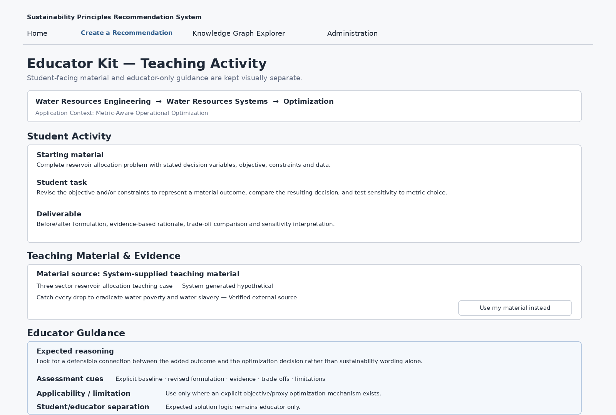
Figure 13. Educator Kit teaching-content wireframe
Content layer | Examples of governed/runtime elements | UI rule
Student Activity | Starting context/material, student task, task steps, dataset/scaffold where required, deliverable, justification/synthesis requirements and learner-facing references. | Render from selected template contract; complete enough to use without asking learner/educator to invent essential missing content.
Teaching Material & Evidence | Real external source, system-generated hypothetical/scaffold, structured case/data inputs and learner-use instructions. | Source-derived and generated content must remain explicitly distinguishable.
Educator Guidance | Expected reasoning, assessment cues, common misinterpretations, applicability/limitation, educator action required and safety/ethics/access notes when triggered. | Visually separate from Student Activity so expected solution logic does not leak.
Material source | System-supplied material by default when resolved; educator may choose Use my material instead. | USE_SYSTEM_SUGGESTION / USE_MY_MATERIAL are provenance modes within the Kit, not separate top-level journeys.
The version-controlled Template Output Element Contract is the completeness specification. It contains 75 controlled output-element definitions and 5,013 template-element contract rows across 295 templates. The contract does not determine which Template_ID is selected.

14.5 Sustainability & Learning Framework Alignment and sources
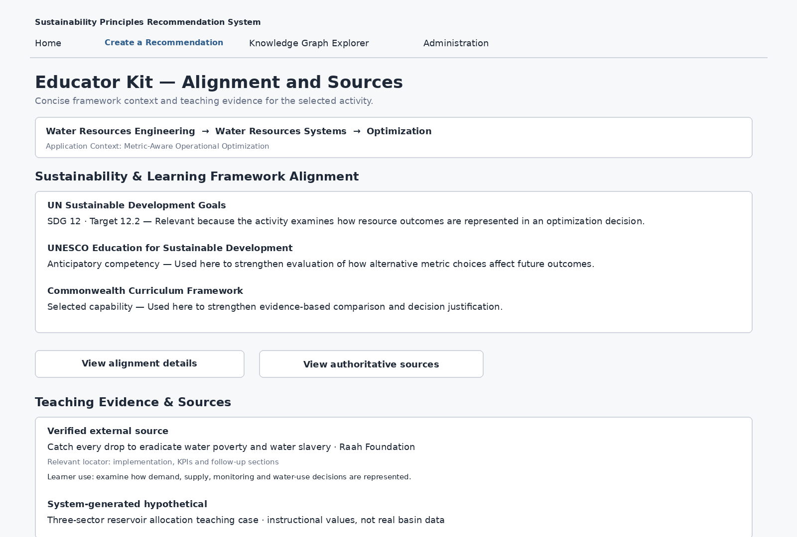
Figure 14. Framework alignment and teaching-evidence wireframe
Area | Primary educator display | Detailed / audit behavior
SDG alignment | Normally 1–2 active items; prefer the most specific relevant Target. Goal may provide parent context; Indicator only when useful. | Retain relationship type and full source/mapping provenance in details. Do not imply an SDG Indicator measures learner achievement unless that is actually supported.
UNESCO ESD | At most one most relevant active objective/competency by default unless a second is materially distinct and essential. | Full active packet available through View alignment details.
Commonwealth Curriculum Framework | At most one most relevant active Knowledge/Skill/Value/Competency by default unless a second adds a distinct capability. | Full active packet available through View alignment details.
Relevance text | One sentence specific to how the item contributes inside the selected activity. | Do not substitute generic framework definitions for activity-specific relevance.
Teaching evidence/source | Readable source title, author/organization, date/version when material, link/DOI, exact relevant locator where available, plain-language summary and learner-use instruction. | Reference_ID and other internal IDs remain audit-only.
Generated material | Clearly label system-generated hypothetical/scaffold and its instructional status. | Never present generated instructional values as real data or real actors.
Framework alignment is enrichment after both SCR and pedagogical-template selection. If no active framework item resolves, the summary is omitted rather than fabricated.

14.6 Applicability, validation, educator decisions and export
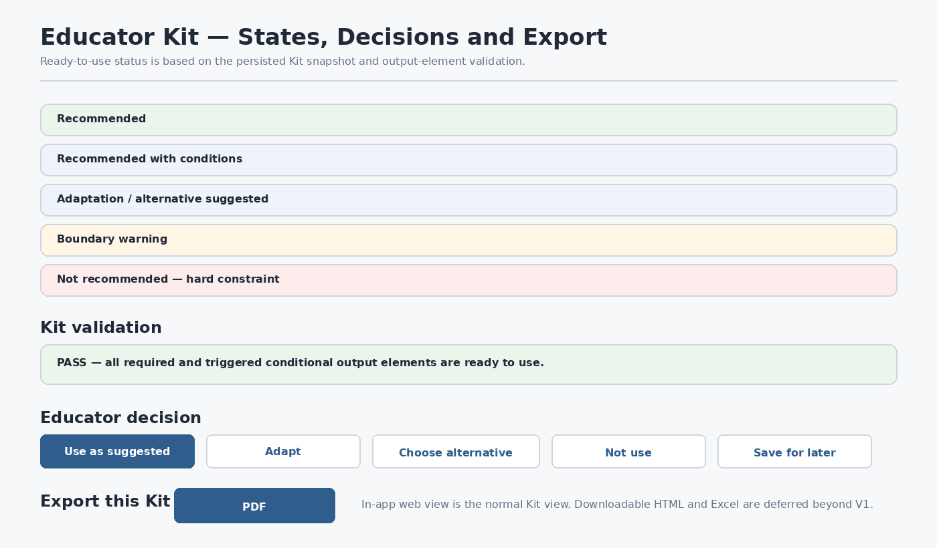
Figure 15. Educator Kit states, decisions and export wireframe
State / control | Meaning | Required UI behavior
Recommended | Direct fit for known context. | Present as primary/strong option with concise rationale.
Recommended with conditions | Valid only when a stated requirement is satisfied/confirmed. | Show condition explicitly; never assume unknown evidence exists.
Adaptation / alternative suggested | Pedagogy is valid but current logistics make original form inconvenient. | Keep original visible and show practical adaptation/alternative.
Boundary warning | Use risks drifting from the supported mechanism or overclaiming evidence. | Show warning prominently and explain required mechanism/evidence.
Not recommended — hard constraint | Safety/legal impossibility, unavailable essential evidence or canonical boundary violation. | Do not present as a normal recommendation; preserve reason in audit.
Kit validation PASS/FAIL | PASS only if every required and triggered conditional output element passes. | Show concise status; element-level failures are inspectable. V1 does not perform hidden automatic repair/regeneration.
Educator decision | Use as suggested / Adapt / Choose alternative / Not use / Save for later. | Persist separately from canonical template and generated Kit snapshot.
Export | PDF is the required V1 downloadable export; normal Kit use is the in-app web/HTML view. | PDF is rendered on demand from the same persisted immutable EducatorKitSnapshot; no regeneration. Downloadable HTML and Excel are deferred beyond V1.

14.7 Group C repository/runtime data binding
The complete field-level mapping is maintained in UI_Data_Binding_Matrix_v0.3.xlsx. The principal Group C authorities are:
UI object | Authority | Important fields / rule
Recommended Sustainability Principle | Semantic Repository — SCR + accepted RecommendationResult | SCR_ID → Sustainability_Concept / Definition / mechanism / boundary fields. Runtime chooses; repository supplies canonical text.
No-mechanism / abstention state | RecommendationResult mechanism/eligibility state | No accepted SCR. Recommendation_Status = ABSTAINED with Abstention_Reason = NO_DEFENSIBLE_SUSTAINABILITY_MECHANISM or INSUFFICIENT_EVIDENCE.
Why this recommendation? | RecommendationEvent / RecommendationContextSnapshot + Stage-F Why_This_Fits / Evidence_Path_Summary | Explanation must come from the current persisted trace.
Teaching approaches | SCR_Pedagogical_Repository_Lean_v1.0_FROZEN + EducatorKitSnapshot.Pedagogy_Options[] | Primary Template_ID is fully generated/validated. Up to two alternative Template_IDs are initially summary-only until explicitly selected.
Kit content | Template_Output_Element_Contract_Repository_Lean_v0.2_FROZEN + generated EducatorKitSnapshot | Element_ID, Element_Order, layer, requiredness and Ready_to_Use_Test control completeness.
Teaching material/evidence | Teaching_Case_Evidence_Repository_Lean_v0.2_OutputContract_Aligned | Teaching_Reference and Teaching_Case_Input preserve source/generated provenance and exact locators.
Framework alignment | Framework_Context_Resolver_Repository_All295_v0.2_FROZEN + authoritative framework repositories | Only resolved active items appear; concise display follows Educator_Display_Contract.
Validation | Template Output Element Contract Validation_Persistence_Schema | Overall_Status PASS/FAIL plus element-level PASS/FAIL/NOT_APPLICABLE and failure reason.
Educator decision | Stage-F Educator_Kit_Schema | Educator_Decision, Chosen_Template_ID, adaptation text/note stored separately.
Export | Persisted EducatorKitSnapshot via registered export renderer | V1: in-app web view plus on-demand PDF from the same immutable snapshot. Downloadable HTML/Excel are deferred.

14.8 Group C help, accessibility and responsive behavior
Concern | Group C rule
Context-sensitive help | All static Group C help resolves from UI_Help_Content_Repository_v0.3.xlsx by Help_Key. Entity/template/source content continues to come from its authoritative repository/runtime object.
Student vs educator layers | Use visible section labels and semantic structure, not color alone, so content remains distinguishable for keyboard/screen-reader users.
Applicability/status | Always include readable status text; semantic color/icon is reinforcement only.
Sources | Links have meaningful labels; source identity and learner-use instruction remain visible without hover.
Responsive layout | Primary Kit content remains single-column/readable on narrow screens; alternative approach cards stack; audit/detail tables may use controlled horizontal space only when unavoidable.
Keyboard/focus | All actions, expanders, export controls and source/detail links are keyboard reachable with visible focus.

14.9 Group C companion-artifact updates
Artifact | Group C additions
UI_Foundation_Decisions_v0.3.xlsx | C-series decisions for result hierarchy, explainability, pedagogy, Kit structure, applicability, framework display, evidence, validation, educator authority and export.
UI_Data_Binding_Matrix_v0.3.xlsx | Field-level bindings for Recommendation Result, trace, Stage-E templates, output-element contract, teaching evidence, Framework Context Packet, validation, decisions, export and audit.
UI_Help_Content_Repository_v0.3.xlsx | Result/Kit help keys covering recommendation explanation, teaching approaches, applicability states, student/educator sections, sources, framework alignment, validation, decisions and export.

14.10 Group C design conformance checklist
- Recommendation Result clearly presents the accepted sustainability principle without exposing internal IDs or ranking scores as the primary result.
- Recommendation Result distinctly supports no defensible sustainability mechanism and generic insufficient-evidence/abstention outcomes without forcing an SCR or exposing a normal Open Educator Kit action.
- Why this recommendation? is trace-derived and provides curriculum, Application Context/mechanism, evidence, boundary/negation and audit layers.
- Additional sustainability principles appear only when independently supported by the governed promotion and evidence rules.
- Educator Kit presents one fully generated and validated Primary Teaching Approach plus up to two materially distinct alternative summaries when available; choosing an alternative explicitly triggers a new Kit generation/snapshot.
- All five applicability states have defined educator-facing behavior, including boundary warning and hard block.
- Student-facing activity content and educator-only guidance are visually and semantically separated.
- The 75-element output-element catalog and 5,013 contract rows govern Kit completeness without participating in Template_ID selection.
- Teaching Material & Evidence distinguishes verified external sources from system-generated hypothetical/scaffold content and exposes exact source/locator/use information.
- Sustainability & Learning Framework Alignment is concise, post-selection enrichment and cannot create SCR eligibility or choose/re-rank pedagogy.
- Kit PASS/FAIL is based on deterministic output-element validation; no hidden automatic repair/regeneration loop exists in V1.
- Educator decisions and adaptations are persisted separately from canonical templates and original Kit snapshots.
- V1 provides the normal in-app web/HTML Kit view and an on-demand PDF export from the same persisted EducatorKitSnapshot. Downloadable HTML and Excel Kit exports are deferred beyond V1; rendering never independently regenerates content.
- Every functional Group C control/state has an entry in UI_Data_Binding_Matrix_v0.3.xlsx and every static help point is resolved by UI_Help_Content_Repository_v0.3.xlsx.
Group C defines the downstream Recommendation Result, explainability and Educator Kit interface. Group D specifies the Knowledge Graph Explorer and protected Administration interactions, while Group E defines cross-cutting requirements and end-to-end flow documentation.

15. Group D — Knowledge Graph and Administration
Group D converts the Group A Knowledge Graph Explorer and Administration shells into implementation-oriented screen behavior. It preserves the complete-graph requirement, protected administrator boundary, governed help model and canonical-ID/data-binding rules already established in Groups A–C. The Knowledge Graph Explorer is read-only and canvas-first: the graph is the primary working surface, while search/filter/path controls, legend and inspection detail remain compact and contextual.
The standalone Explorer does not open as a blank canvas. It presents Courses grouped visually by the governed Course.Discipline value; these discipline groups are a UI-derived navigation layer rather than new canonical Knowledge Graph entities. In reconciled V1, Administration is protected but limited to static/read-only/prototype functions over the existing curated repositories; repository onboarding/edit persistence, publication/build/rollback and benchmark execution are deferred.
Area | System V1 behavior
Knowledge Graph Explorer | Functional complete-graph exploration with discipline-grouped entry overview, search, filters, collapsible legend, focus/expand, entity/relationship inspection, directed path inspection and optional secondary list representation.
Administration Overview | Protected V1 scope guidance and read-only runtime/repository information where available; no functional release-management backend is implied.
Repository Prepare / Edit | Demonstrative/static workflow in V1 with read-only repository inspection where practical; no direct canonical writes.
Repository Publication | Future/Deferred beyond V1. Lifecycle retained as reference only; no upload/stage/build/publish action is functional in V1.
Validation & Benchmark | Future/Deferred beyond V1. Approved validation/benchmark concepts remain reference material, not an executable V1 administration workflow.

15.1 Knowledge Graph Explorer — entry overview and focused exploration
Figure 16. Knowledge Graph Explorer — Computer Science example
Figure 16 illustrates only a small readable subset of the governed graph using Course, Module, Subtopic, KCR, KPR and KFR examples and six relationship types. This illustration is not an availability boundary. Production Explorer entity classes, relationship types and governed details are derived dynamically from all registered graph-participating controlled repositories and curated compiled runtime artifacts. Initial rendering may be lean for performance/readability, while search, focus, expansion and inspection can expose every valid curated node, relationship and relevant governed field available in the active compiled graph.
Control / region | V1 design rule
Search | Search registered entity types by readable term; retain the resolved canonical ID internally.
Entry overview | Group Courses by Course.Discipline for navigation. Discipline grouping is UI-derived only and must not be persisted as a new canonical KG node.
Entity / relationship filters | Change only what is drawn; never change stored graph data or recommendation eligibility.
View as list | Secondary accessibility/inspection action using the same graph/filter/focus state; not an equal-weight top-level tab.
Graph canvas | Cytoscape.js within Streamlit; zoom, pan, fit, focus, expand/collapse, back-to-previous-focus and reset.
Node Classes legend | Collapsed by default; expandable on demand. Node classes use contrast color plus shape/readable labels, and Course nodes are marginally larger.
Entity inspector | Contextual drawer/overlay with readable title, type, authoritative description, status and incoming/outgoing connections. Read-only actions are Focus and Expand/Collapse.
Relationship direction | Directed relationships show arrowheads from governed source to target; typed relationship labels remain readable/inspectable.
Layout stability | Preserve spatial orientation through focus/expand transitions where practical instead of unnecessarily re-randomizing the layout.
Accessibility | Entity, relationship and path information is available textually; optional View as list is a text-first alternative to the same graph state.

15.2 Relationship and path inspection
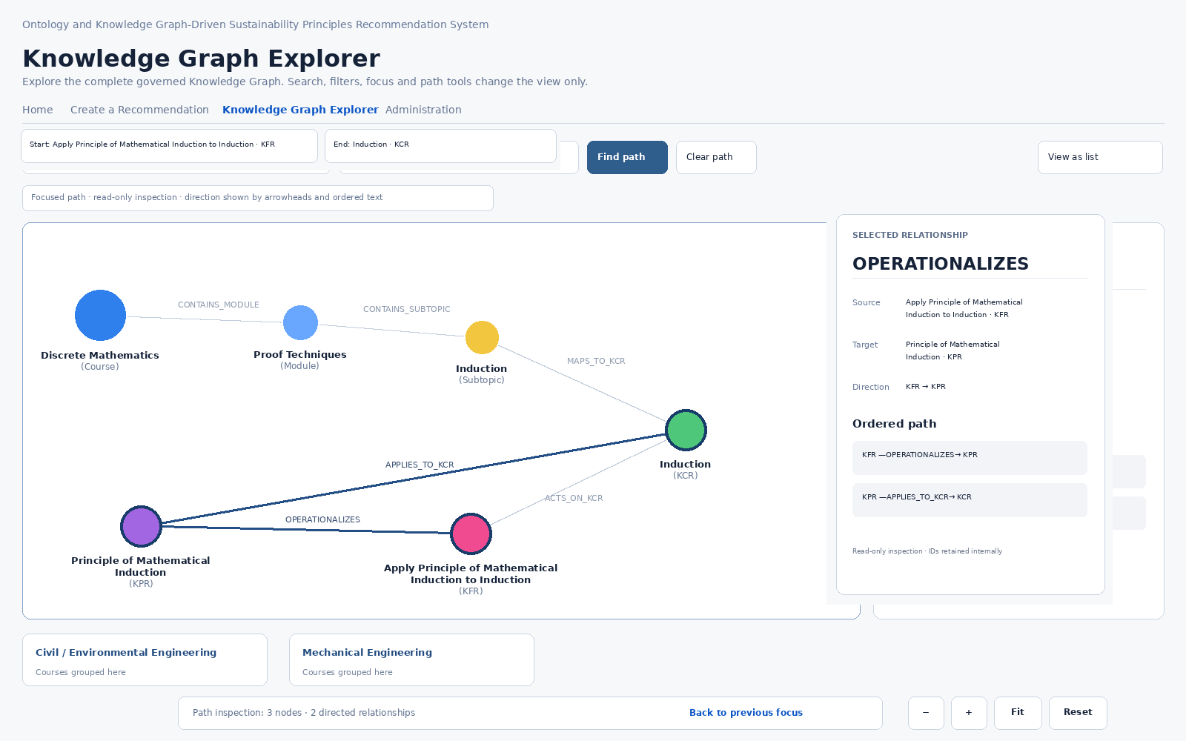
Figure 17. Knowledge Graph Explorer — directed path inspection
Relationship inspection exposes source, target, direction, exact compiled relationship type and governed meaning without implying recommendation sufficiency. Figure 17 is illustrative only. Path exploration uses governed canonical start/end entities and returns one deterministic shortest directed governed path by hop count when one exists; NO_GOVERNED_PATH is a valid result. Canvas display filters remain presentation state and do not silently change path calculation.
Feature | UI behavior | Boundary
Path start / end | Resolve governed entities from the top Path explorer control by readable label while retaining canonical IDs. | Both endpoints must resolve in the active compiled graph; no node-level path-start action is exposed.
Find path | Return and highlight the governed directed path; visually de-emphasize unrelated context when useful. | Inspection only; not a Recommendation Core execution path.
Arrow direction | Render directed edges with visible source→target arrowheads and typed relationship labels. | Arrow direction must match the governed relationship metadata.
Ordered textual path | Show entity and relationship sequence in path order. | Available even when graphical interpretation is difficult.
Relationship inspection | Show readable source/target, direction, type and governed meaning. | A visible edge does not by itself establish recommendation eligibility.
Clear / reset | Remove path emphasis and return to broader graph state. | No canonical graph mutation occurs.

15.3 V1 Administration information architecture and read-only overview
Figure 18. Administration Overview wireframe — reconciled V1 scope
Administration is rendered only after a privileged access check. V1 may expose scope guidance, read-only repository inspection and runtime/configuration information where available. It does not provide functional repository upload/staging, candidate validation/build, publication, activation/restore or benchmark execution. Those workflows are retained in the following sections only as clearly labelled Future/Deferred design references.
Overview question | Displayed answer
What is active? | Current repository/runtime version information where directly available; absence is shown as unavailable rather than inferred.
Is runtime healthy? | Graph Runtime and Semantic Engine readiness; unavailable required components are reported rather than silently replaced.
Are release gates current? | Future/deferred release-gate information is not required as a functional V1 state.
What needs attention? | Read-only repository/runtime integrity information where implemented; no staged-candidate state is implied.
What happened recently? | V1 need not maintain publication activity/history; future release-history concepts remain deferred.

15.4 Repository Prepare / Edit — System V1 boundary
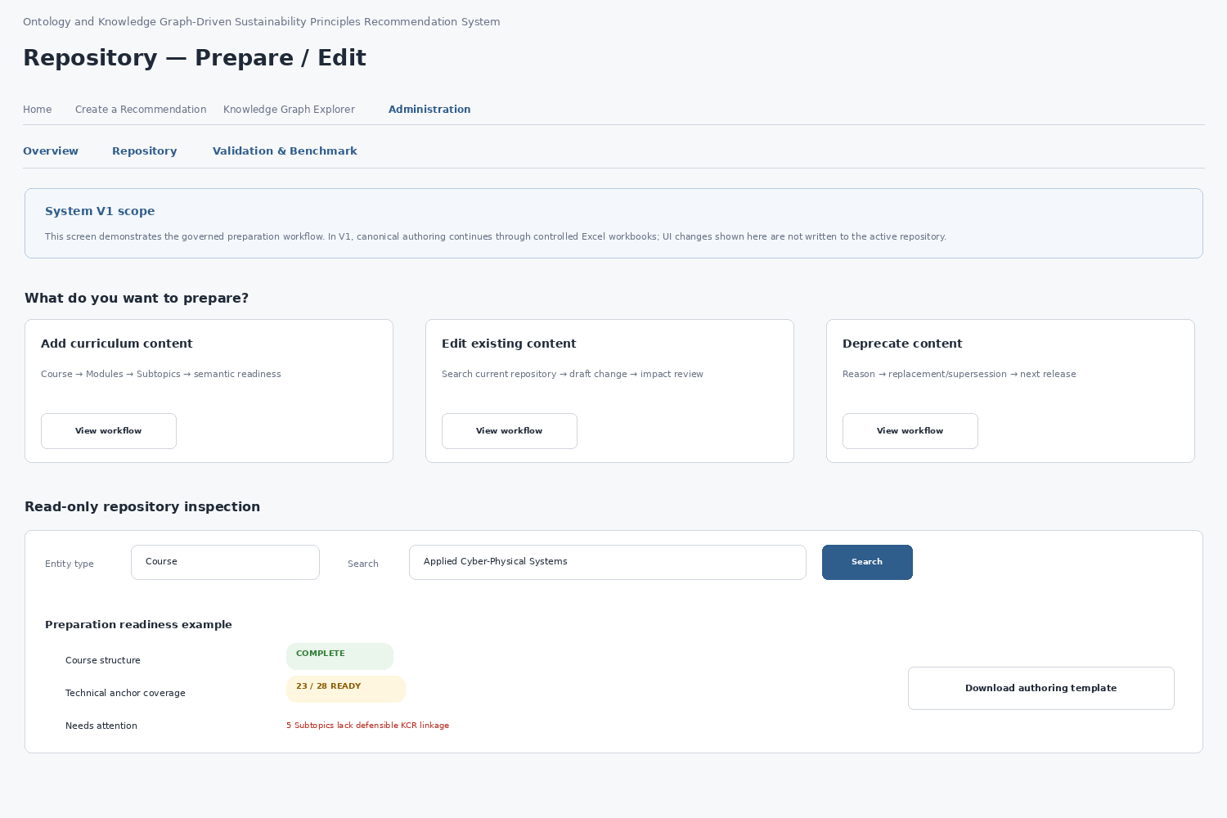
Figure 19. Repository Prepare / Edit wireframe
The preparation UI is future-capable but is not required to persist canonical repository edits in System V1. V1 may provide read-only inspection and static interactive demonstrations for Add, Edit and Deprecate workflows. The screen must state this limitation clearly and must not expose a Save to Repository action that appears functional when it is not.
Preparation workflow | Intended behavior
Add curriculum content | Course → Modules → Subtopics → semantic preparation → relationship/constraint review → readiness review.
Edit existing content | Search canonical entity → draft change → current-versus-draft comparison → impact review → change set.
Deprecate content | Reason → optional replacement/supersession → candidate release; published canonical data are not casually deleted.
Recommendation readiness | Separate structural repository completeness from defensible technical-anchor coverage.
Semantic reuse | Search/reuse existing KCR/KPR/KFR entities before proposing new canonical semantic entities.
Adding a Course does not trigger automatic SCR mappings, framework mappings, pedagogical templates or output contracts. Sustainability relevance remains established at runtime from technical and Application Context evidence.

15.5 Future / Deferred reference — Repository Publication: select and stage
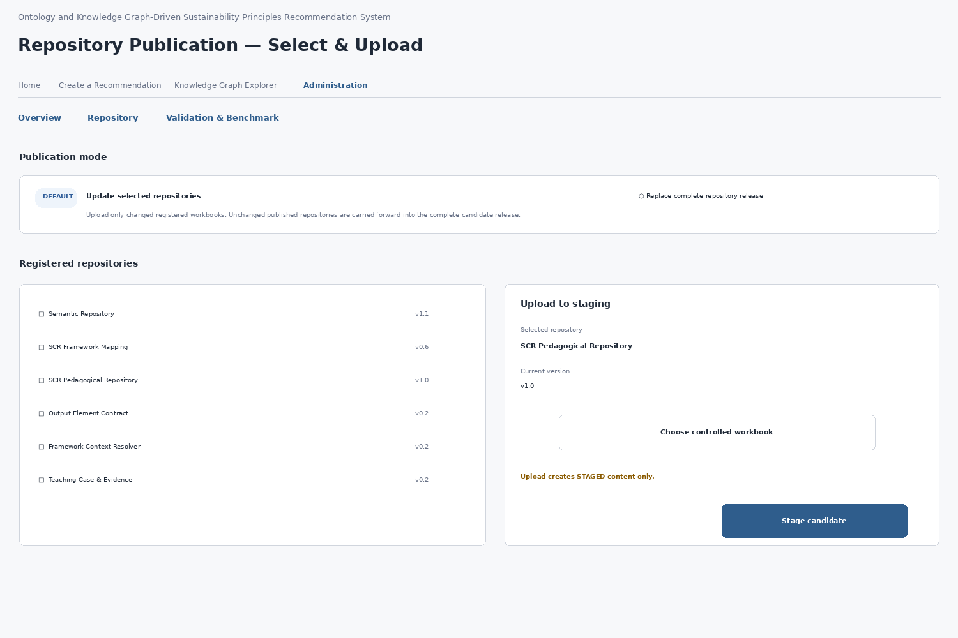
Figure 20. Repository Publication — select and upload wireframe
Future/deferred design reference; not a functional V1 interface. The default publication mode is Update selected repositories. An administrator supplies only the changed registered workbook(s); unchanged repositories are carried forward from the current active release into a complete candidate release. Replace complete repository release is available for coordinated full replacement or recovery. Repository identity, filename pattern, version and owner metadata come from the System Component & Artifact Register; arbitrary uploads cannot become canonical by filename inference.
Publication element | Required behavior
Mode | Update selected repositories by default; complete replacement for coordinated release/recovery.
Registered artifact | Select from governed artifact metadata; do not infer repository identity from arbitrary file names.
Upload | Creates STAGED candidate content only.
Pre-check | Verify registered identity, readability and expected schema before deeper validation.
Runtime truth | Uploading or staging never changes the active release.

15.6 Future / Deferred reference — Candidate comparison and impact review
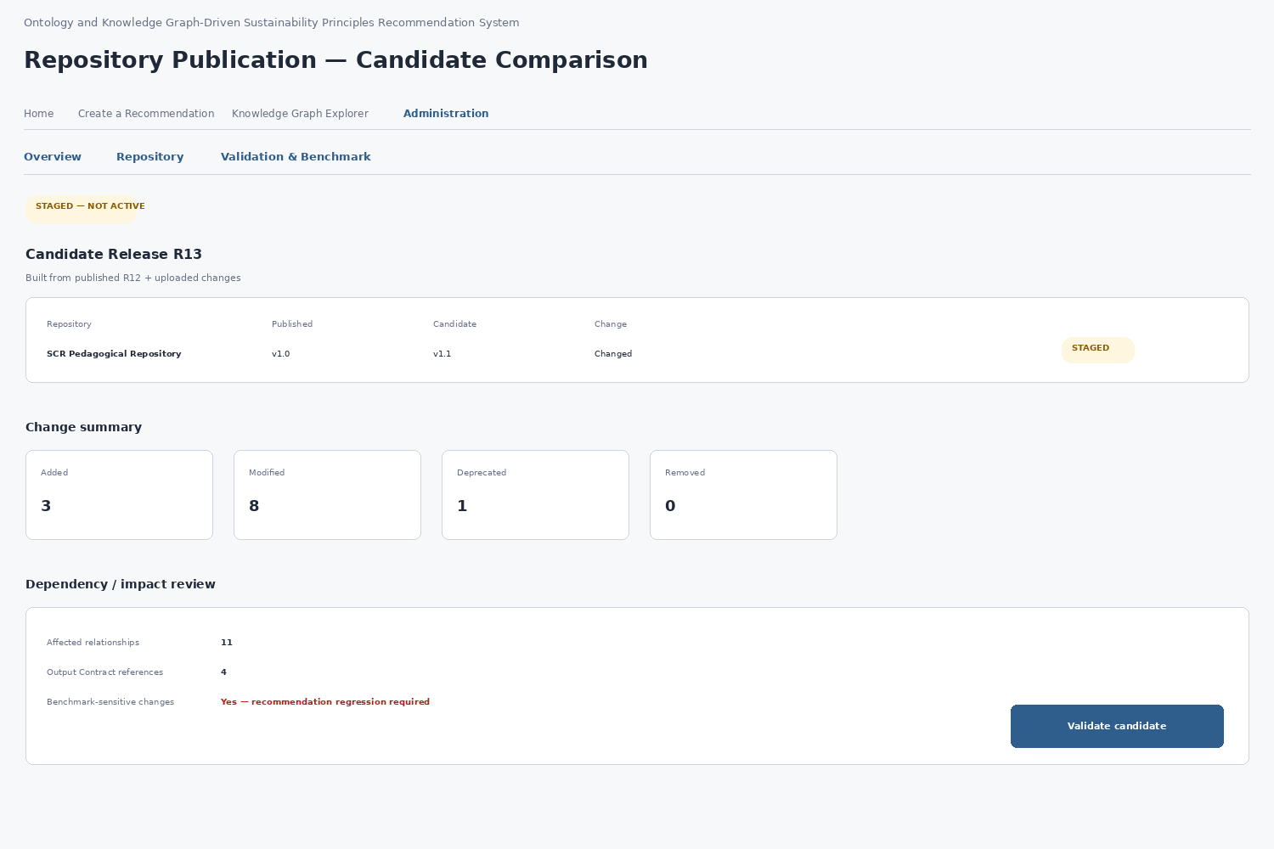
Figure 21. Repository Publication — candidate comparison wireframe
Future/deferred design reference; not a functional V1 interface. The candidate is compared against the active release before publication. The primary summary distinguishes Added, Modified, Deprecated and Removed records and provides dependency/impact information. Impact may include graph relationships, embedding rebuilds, guardrails, output-contract/framework/pedagogy dependencies and benchmark-sensitive behavior.
Change category | Review expectation
Added | Confirm new records and references are intentional and governed.
Modified | Show field-level change detail where needed and identify dependent graph/runtime artifacts.
Deprecated | Preserve historical traceability and replacement/supersession information where applicable.
Removed | Treat unexpected removal as high-risk; require explicit destructive-change review.
Impact summary | Determine graph/embedding rebuilds and the validation/benchmark suites required by the candidate.

15.7 Future / Deferred reference — Candidate validation and build
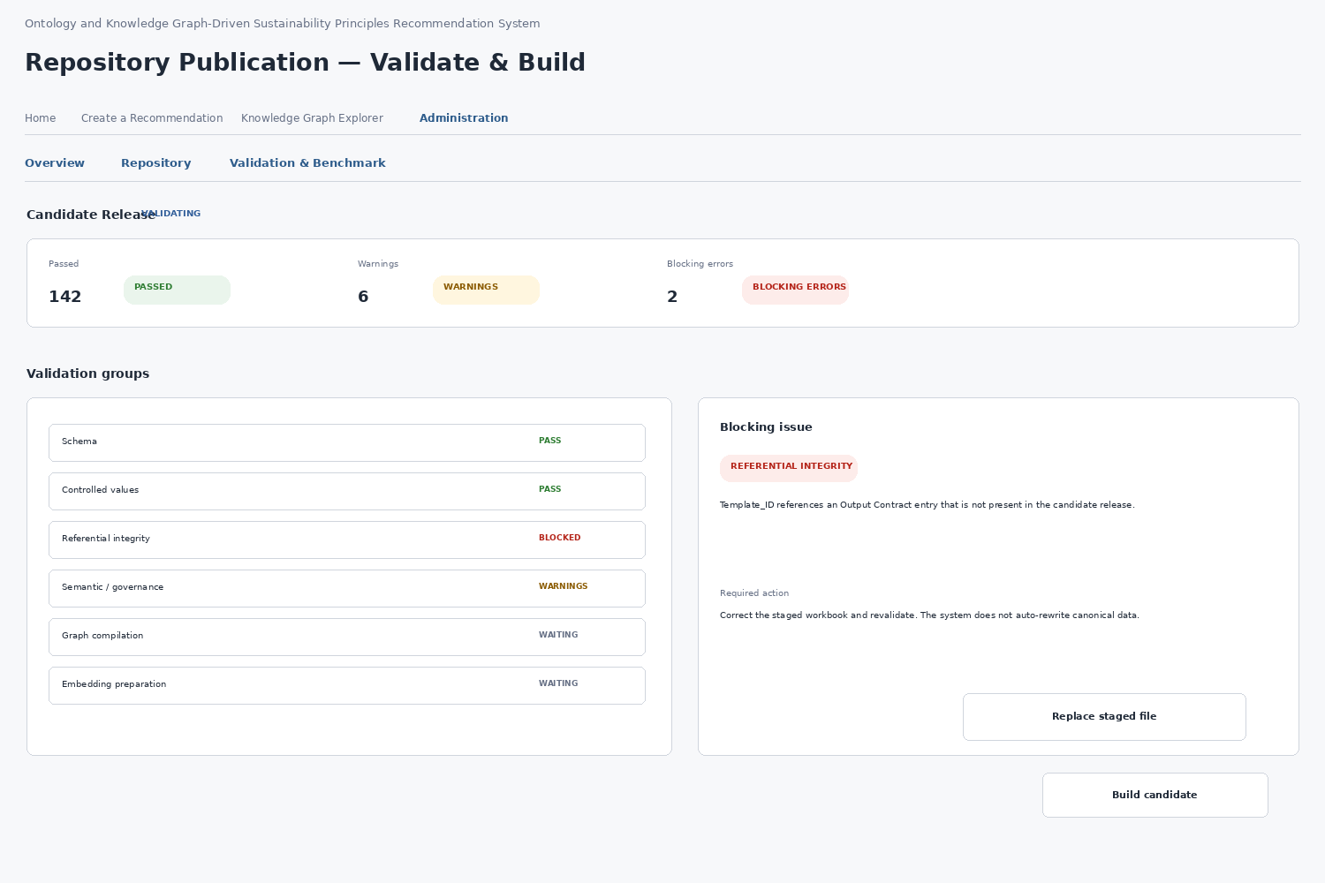
Figure 22. Repository Publication — validate and build wireframe
Validation layer | Examples / behavior
File / schema | Registered artifact identity, workbook readability, expected sheets/headers and version metadata.
Controlled values | Allowed status/enum/identifier forms and required-field checks.
Referential integrity | Referenced KCR/KPR/KFR/SCR/Template/Framework and other governed IDs must resolve.
Semantic / governance | Illegal status transitions, prohibited canonical links, deprecation/supersession and invariant checks.
Build readiness | Compile runtime tabular objects, graph structures, manifests and embedding artifacts.
Future/deferred design reference; not a functional V1 interface. Validation outcomes distinguish pass/information, warning and blocking error. Blocking errors disable build and publication. Warnings may proceed only when the governing rule permits them and must remain reviewable. The build service compiles runtime-ready artifacts; raw Excel workbooks remain authoring/release sources rather than the live query store.

15.8 Future / Deferred reference — Release review, atomic publication and recovery
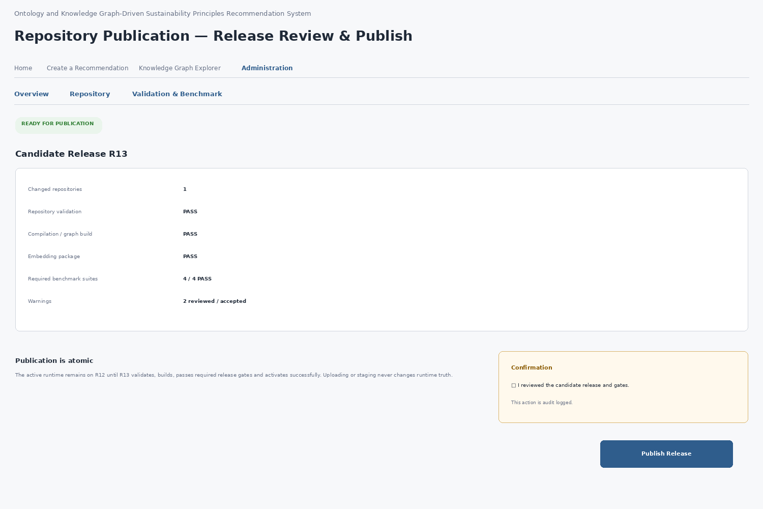
Figure 23. Repository Publication — release review and publish wireframe
Future/deferred design reference; not a functional V1 interface. Repository input may be incremental, but publication is versioned and atomic. Publish Release is enabled only when required validation, build and impact-driven release gates are satisfied and the administrator explicitly confirms the action. The previous active release remains in service until the candidate activates and passes runtime health verification.
State / action | Required behavior
Ready to publish | All required candidate validation, build and release gates satisfy the configured policy.
Publish confirmation | Show complete candidate-release summary and require explicit authorized confirmation.
Activation succeeds | Candidate becomes ACTIVE and a publication/audit event is recorded.
Activation fails | Candidate is marked activation-failed; previous release remains active; no half-published runtime.
Rollback / restore | Controlled activation action with preserved release history; exact persistence semantics remain SEQ-09.

15.9 Future / Deferred reference — Validation & Benchmark
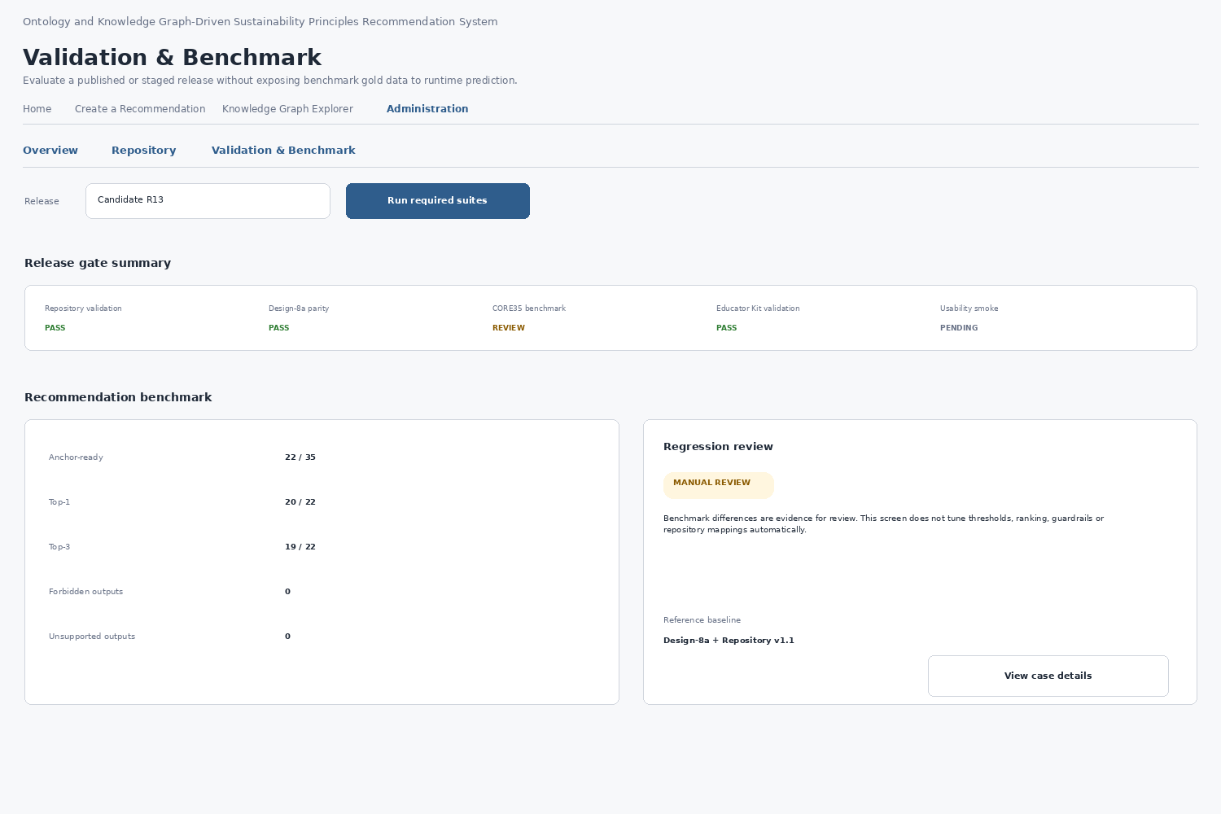
Figure 24. Validation & Benchmark wireframe
Future/deferred design reference; not a functional V1 interface. Validation & Benchmark evaluates a selected published or staged release. It may show repository validation, Design-8a parity, recommendation benchmark/regression, educator-input routing, Educator Kit validation and release-smoke evidence depending on candidate impact and implemented suites. Gold/expected outputs remain evaluation-only and are never passed into runtime prediction.
Rule | UI consequence
Impact-based gates | Run the suites required by the changed repository/component while preserving mandatory release controls.
Reference parity | Design-8a reference runtime remains immutable evaluation authority for core migration/regression.
No auto-tuning | A benchmark difference is evidence for review; do not alter thresholds, ranking, guardrails or mappings to make it pass.
Population/version context | Show metrics with their benchmark suite/release context; do not present historical populations as universal current performance.
Case-level review | Classify evidence using the defined failure taxonomy before changing algorithm or repository data; ambiguity remains a review state.

15.10 Future / Deferred reference — Administration exceptional and recovery states
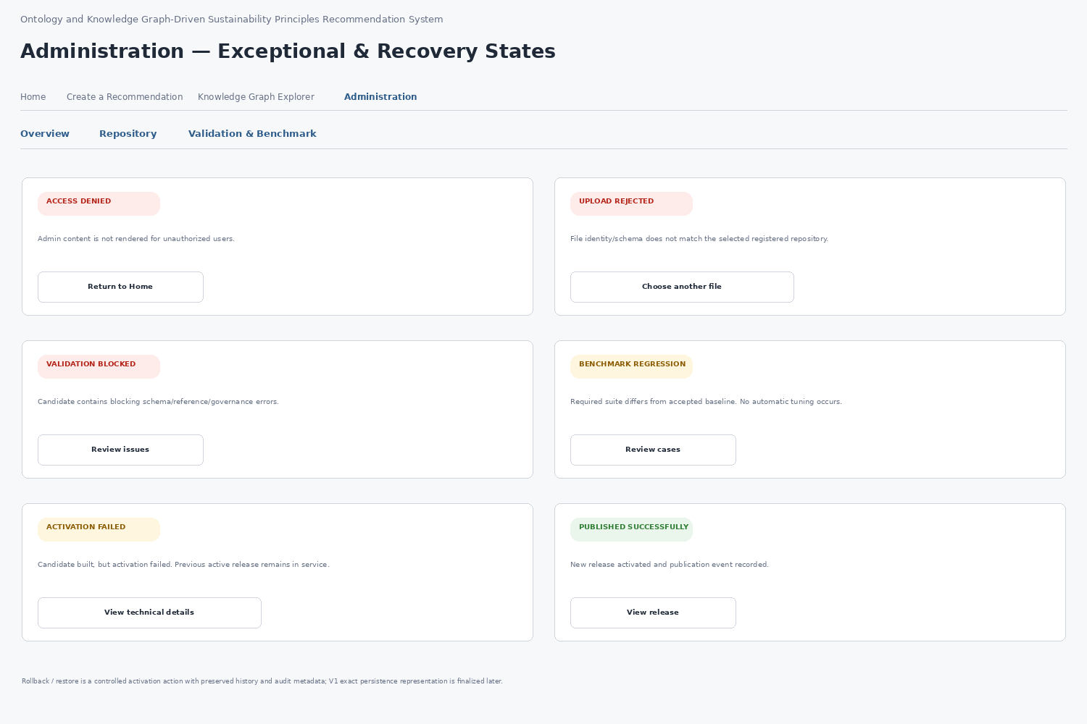
Figure 25. Administration exceptional and recovery states wireframe
Future/deferred design reference; not a functional V1 interface. Group D defines explicit administrator states rather than relying on generic error banners. At minimum the V1 design covers:
State | System behavior | Administrator action
Access denied | Protected content is not rendered. | Return to public application or use an authorized session.
Upload rejected | Identity/file/schema pre-check failed; candidate and active release are unchanged. | Review reason, correct the controlled input and upload again.
Validation blocked | Blocking repository errors remain; Build/Publish disabled. | Open issue detail and correct the candidate source.
Benchmark regression / review | Difference requires analysis; no automatic tuning occurs. | Open case evidence and classify the difference before governed change.
Activation failed | Candidate did not activate; previous release remains active. | Inspect technical detail and use the governed retry/recovery path.
Published successfully | New release is active after health verification; publication event is auditable. | View release/history or return to overview.
Rollback / restore | Recovery remains a controlled activation event with preserved history. | Select prior valid release, review impact and confirm restoration.

15.11 Group D data-binding, help and interface boundaries
UI_Data_Binding_Matrix_v0.3.xlsx records the complete Knowledge Graph Explorer contracts and the protected V1 Administration read-only/prototype scope. Publication, candidate build/activation/restore and benchmark execution rows are retained only as DEFERRED_V2_V3 reference bindings, not active V1 interfaces.
UI_Help_Content_Repository_v0.3.xlsx contains active V1 help for complete-graph exploration and protected read-only/prototype Administration. Publication/build/recovery/benchmark help keys are retained as deferred historical/future references. Static help remains external to page code; authoritative entity descriptions remain in governed repositories.

15.12 Group D design conformance checklist
- The Knowledge Graph Explorer is canvas-first, read-only and never opens as an unexplained blank canvas; standalone entry presents discipline-grouped Course context while the complete governed graph remains explorable.
- Discipline grouping is derived from Course.Discipline for navigation only and does not introduce a new canonical KG node or relationship.
- Course nodes are marginally larger/more strongly outlined; node classes use higher-contrast restrained colors plus shape/readable-label cues; the Node Classes legend is collapsed by default.
- The graphical Explorer is primary. View as list is a secondary text-first accessibility/inspection action using the same graph/filter/focus state, not an equal-weight top-level tab.
- Search, filters, focus, expand/collapse, graph utilities, entity inspection, relationship inspection and path exploration have explicit behavior and bindings; runtime-derived entity/relationship catalogues are not hard-coded to the illustrative subset.
- Directed graph relationships render arrowheads and typed labels; relationship/path details also state source, target and direction textually.
- Entity inspector actions are read-only view operations; no per-node Use as path start or authoring control is exposed.
- Path explorer is opened from the graph control band using governed start/end selectors, returns one deterministic shortest directed path when available, and cannot mutate Recommendation Core traversal, eligibility, guardrails or ranking.
- Administration is access-controlled before protected content is rendered, and every action label remains contained within its control boundary at the defined visual-token conventions.
- V1 Administration uses only implemented protected static/read-only/prototype functions; functional Repository Publication and Validation & Benchmark execution are not part of V1 navigation.
- System V1 Repository Prepare / Edit remains demonstrative/read-only where practical; controlled curated repositories/workbooks remain the source of truth and no misleading persistence control is exposed.
- Future authoring/publication lifecycle material is retained only as deferred design reference for later versions.
- Upload/staging, candidate comparison, validation/build, publication/activation/restore and release-gate execution are deferred beyond V1 and must not be represented as active interfaces.
- Future validation/benchmark workflows remain evaluation/governance design references; they do not imply a V1 administrative execution backend.
- Repository metadata shown in V1 read-only inspection comes from governed repositories/registers where available; unavailable future release metadata is not guessed.
- All Group D static help and field/source/state bindings are represented in the Help Content Repository and UI Data Binding Matrix; the Foundation Decisions register records the corresponding design rules.
- Knowledge Graph examples use governed node labels, canonical identifiers and source-to-target relationship types. UI-only grouping elements are visually distinguished from canonical graph entities.
- The Knowledge Graph Explorer shell defined in this specification remains stable across graph-data updates unless the UI specification itself is revised.

15.13 Cross-artifact completeness
A functional screen is complete at the SEQ-03 level only when its wireframe, interaction behavior, states and errors, data bindings, help bindings and conformance criteria are defined consistently.
Screen / state | Wireframe | Behavior / states | Data binding | Help binding | SEQ-03 conformance
KG entry overview / Course focus | Yes | Defined | Defined | Defined | Conformant
KG entity / relationship inspection | Yes | Defined | Defined | Defined | Conformant
KG path inspection | Yes | Defined | Defined | Defined | Conformant
Administration Overview | Yes | Defined — V1 read-only/prototype scope | Defined | Defined | Conformant after SEQ-04 reconciliation
Repository Prepare / Edit | Yes | Defined incl. V1 boundary | Defined | Defined | Conformant
Publication: select / stage | Yes | Future / Deferred reference | Deferred beyond V1 | Deferred help/reference | Not a functional V1 screen
Publication: compare / impact | Yes | Future / Deferred reference | Deferred beyond V1 | Deferred help/reference | Not a functional V1 screen
Publication: validate / build | Yes | Future / Deferred reference | Deferred beyond V1 | Deferred help/reference | Not a functional V1 screen
Publication: release / activate / restore | Yes | Future / Deferred reference | Deferred beyond V1 | Deferred help/reference | Not a functional V1 screen
Validation & Benchmark | Yes | Future / Deferred reference | Deferred beyond V1 | Deferred help/reference | Not a functional V1 screen
Exceptional / recovery states | Yes | Future / Deferred reference | Deferred beyond V1 | Deferred help/reference | Not a functional V1 screen
Group D defines the V1 Knowledge Graph Explorer and protected read-only/prototype Administration baseline. Figures 20–25 are retained as Future/Deferred design references only. Typed active V1 interfaces are resolved in SEQ-04; persistence remains SEQ-09 and security remains SEQ-10.

16. Group E — cross-cutting requirements and end-to-end flows
Group E defines cross-cutting requirements that apply across the existing Groups A–D screens. It standardizes common state, accessibility and responsive behavior and documents end-to-end journeys for implementation and QA traceability. The flow diagrams in this section are specification views and are not additional application screens.

16.1 Cross-cutting requirements
Requirement | Area | Specification | Status
E-01 | Educator identifier display | Normal educator-facing screens show readable labels/types; canonical IDs remain internal and may appear only in advanced audit or administration detail. | Defined
E-02 | Knowledge Graph relationship direction | Selected entity detail separates Incoming and Outgoing connections or shows the complete source —RELATIONSHIP→ target sequence. | Defined
E-03 | Help-content lifecycle | Help entries required by the SEQ-03 baseline use the repository's defined review status and version fields. | Defined
E-04 | Primary action naming | The educator-facing generation action is consistently labelled Generate Recommendation; stable internal keys remain unchanged. | Defined
E-05 | Common UI states | Processing/Loading, Empty/No Data, Recoverable Error, Blocking Error and Success use consistent cross-cutting behavior. | Defined
E-06 | Accessibility and responsive behavior | All major screen families follow consistent requirements for keyboard access, visible focus, readable status, text alternatives and narrow-layout behavior. | Defined
E-07 | End-to-end flows | Four specification flow diagrams document screen transitions and invariants without introducing additional application pages. | Defined

16.2 Common UI state model
State | UI behavior | Cross-cutting rule
Processing / Loading | Show concise progress feedback and disable the initiating consequential action while its request is processing. | Prevent duplicate submission; preserve current context.
Empty / No data | State that no governed data/result is available for the current view or filter. | Provide a clear reset/change-input action when applicable; do not show an unexplained blank region.
Recoverable error | Explain the failed operation in educator/admin language and provide a retry/correction action. | Retain valid entered/selected context whenever safe.
Blocking error | Explain why the next consequential action is unavailable. | Disable the blocked action and identify what must be corrected or reviewed.
Success | Confirm the completed state and expose the next normal action. | Do not infer PASS/success when required validation or evidence is unavailable/unrun.

16.3 Educator normal journey
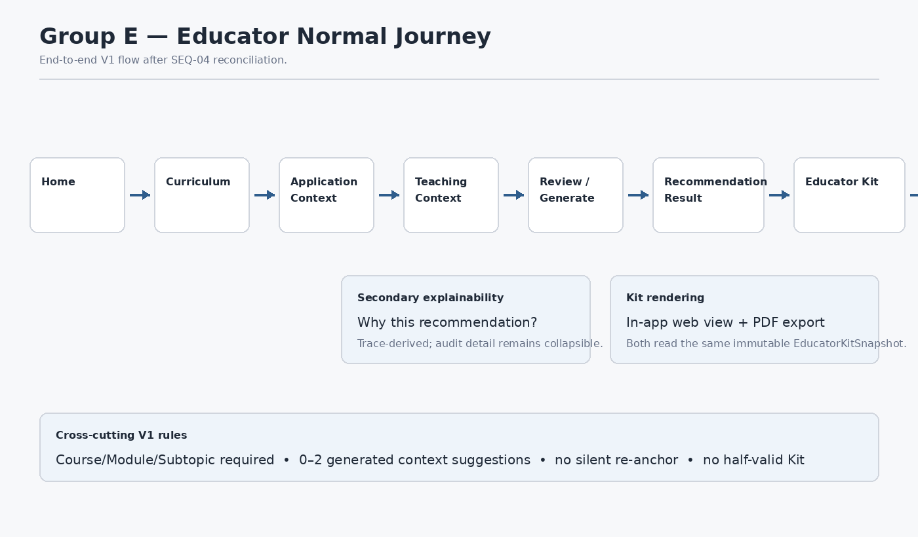
Figure 26. Group E documentation flow — educator normal journey
This flow documents the Home → Curriculum → Application Context → Teaching Context → Review/Generate → Recommendation Result → Educator Kit → PDF Export journey. It is an end-to-end specification view rather than an additional horizontal workflow screen. Why this recommendation? remains a secondary explainability action. The normal Kit view and PDF both read the same immutable EducatorKitSnapshot; downloadable HTML and Excel are deferred beyond V1.

16.4 Educator exception and abstention journey
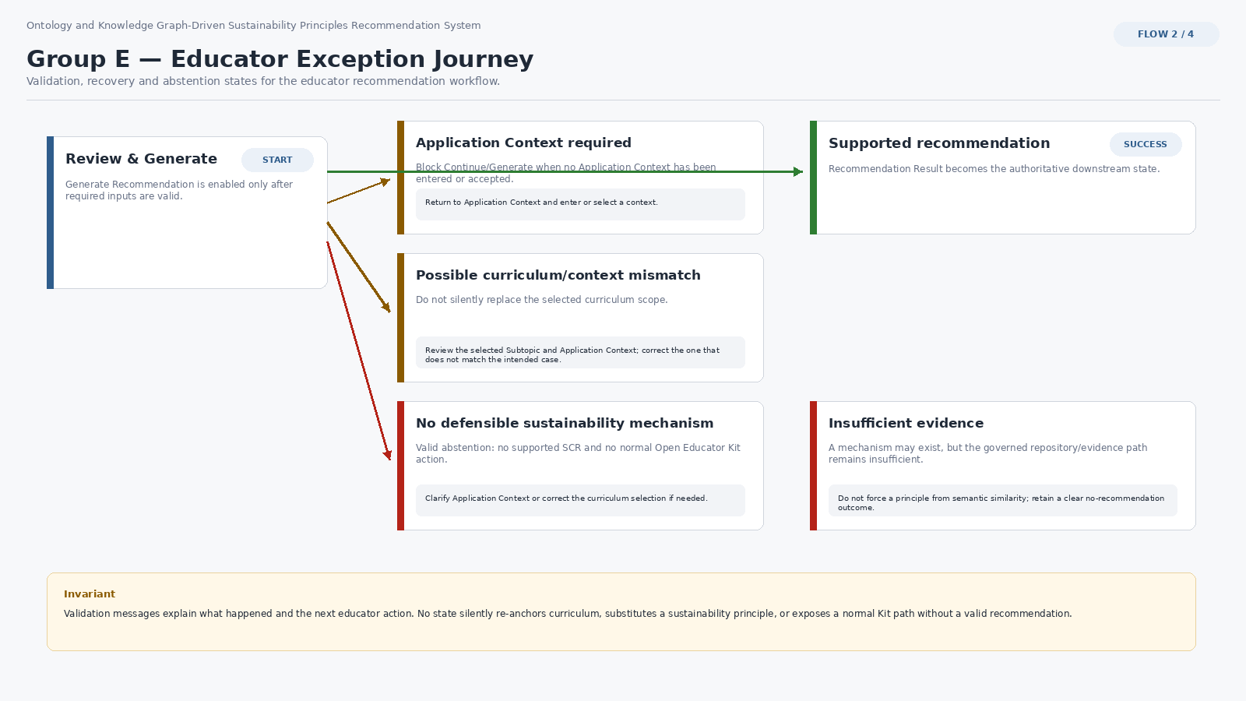
Figure 27. Group E documentation flow — educator exception journey
This flow documents Application Context required, curriculum/context mismatch, no defensible sustainability mechanism, insufficient evidence and successful recommendation routing. The interface never silently replaces curriculum, forces a sustainability principle or exposes a normal Educator Kit path without a valid recommendation.

16.5 Knowledge Graph exploration journey
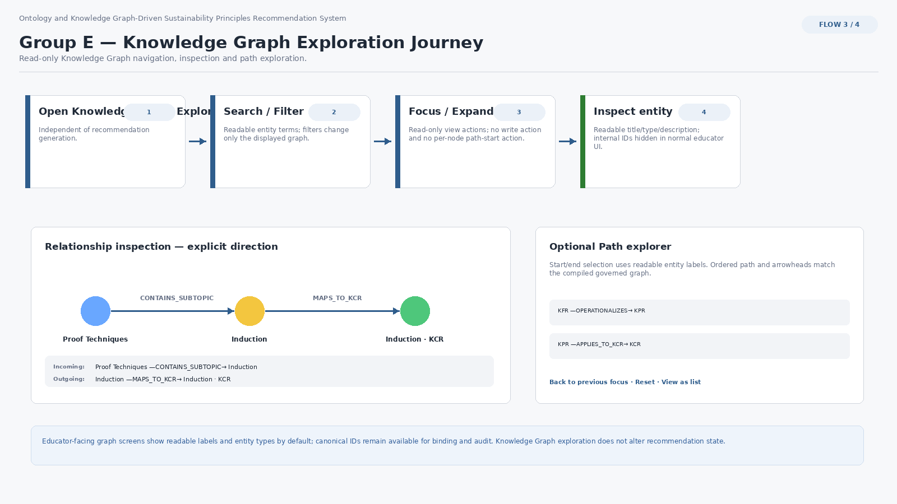
Figure 28. Group E documentation flow — Knowledge Graph exploration
This flow documents read-only Knowledge Graph exploration independently of recommendation generation. Normal educator-facing detail hides canonical IDs, connection direction is explicit, and path inspection remains a governed read-only view operation.

16.6 Future / Deferred administrator release journey
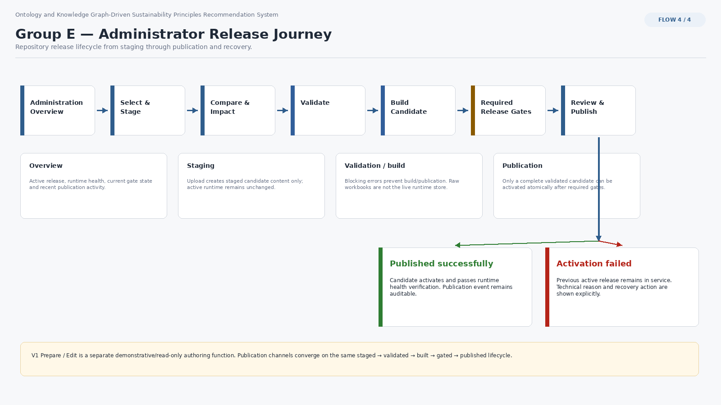
Figure 29. Group E documentation flow — future/deferred administrator release journey
This flow is retained as a future-state design reference for a later Administration lifecycle. It is not a functional V1 journey. System V1 uses existing curated repositories and may expose only protected static/read-only/prototype administration; staging, build, publish, activation/restore and benchmark execution are deferred.

16.7 Final accessibility and responsive acceptance matrix
Screen family | Accessibility acceptance | Responsive acceptance
Home / shell | Keyboard-reachable navigation and primary actions; visible focus; concise readable guidance. | Cards/columns stack without hiding the primary entry actions.
Create a Recommendation | All selections, context controls and Generate Recommendation are keyboard reachable; blocking states are announced/readable. | Step content stacks; reviewed values and primary action remain visible without horizontal dependence.
Recommendation Result / Educator Kit | Primary result, explainability, Kit sections, source/detail links and exports are keyboard reachable and labelled. | Sections stack vertically; student-facing and educator-only content remain distinct.
Knowledge Graph Explorer | Graph has readable labels, explicit arrow direction, textual entity/relationship/path detail and View as list; no color-only meaning. | Desktop/laptop canvas is primary; inspector may move below graph and manipulation may reduce while textual inspection remains available.
Administration | Protected content is not rendered before authorization; statuses/actions are text-labelled and keyboard reachable. | Operational tables/steppers remain readable with stacking/controlled scrolling; consequential action labels remain contained.

16.8 Cross-artifact synchronization and design baseline
- UI_Design_v0.3.docx, UI_Foundation_Decisions_v0.3.xlsx, UI_Data_Binding_Matrix_v0.3.xlsx and UI_Help_Content_Repository_v0.3.xlsx form the post-SEQ-04 reconciled SEQ-03 artifact set. The original v0.2 set remains the historical SEQ-03 baseline.
- Group E decisions E-01–E-10 define the cross-cutting rules; no Group E runtime screen or persistence object is introduced.
- Every major application screen/state remains governed by the same completeness rule: wireframe/behavior, states/errors, data binding, help binding and acceptance criteria must agree.
- Typed V1 request/response contracts are resolved in SEQ-04; operational persistence remains SEQ-09; upload/security controls remain SEQ-10. Deferred administration lifecycle material does not imply V1 implementation.
- The reconciled SEQ-03 UI baseline comprises Groups A–E with SEQ-04 supersessions applied. Implementation should use this v0.3 set together with Technical_Interface_Design_v0.1 and Interface_Contract_Registry_v0.1.

