DATA FLOW DESIGN
Ontology and Knowledge Graph-Driven
Sustainability Principles Recommendation System
SEQ-05 | Version 0.1 | September 2026
Purpose
Define the logical movement, transformation, transient state, persistence points and provenance of V1 data across the educator workflow, Recommendation Core, Educator Kit subsystem, Knowledge Graph Explorer and runtime infrastructure, while preserving the frozen architecture and interface contracts.

Document control
Item | Value
Document | Data_Flow_Design_v0.1.docx
Sequence | SEQ-05 — Data Flow Design
Status | V1 implementation baseline; logical data-flow design only
Primary architecture | System_Architecture_Design_v1.1_Final.docx
Primary interface specification | Technical_Interface_Design_v0.2.docx
Interface registry | Interface_Contract_Registry_v0.1.xlsx
UI baseline | UI_Design_v0.3.docx + synchronized UI v0.3 companion workbooks
Decision register | SEQ05_Decision_Register_v0.1.xlsx
Companion data-flow registry | Data_Flow_Registry_v0.1.xlsx
Persistence boundary | Physical SQLite/PostgreSQL schema, keys, indexes and constraints remain SEQ-09.

Contents and reading order
- 1–4 define scope, sources, notation, invariants and the master data-object/authority model.
- 5–8 define the educator recommendation path: curriculum/Application Context, Recommendation Core transformation, persistence and trace.
- 9–10 define the Educator Kit generation path and the snapshot-driven view/PDF/educator-decision flows.
- 11–12 define the read-only Knowledge Graph Explorer and repository compilation/runtime-load flows.
- 13–17 define provenance, exception handling, interface coverage, deferred V2/V3 scope and implementation acceptance.
- Appendices provide a quick data-object and logical-store reference; the companion XLSX carries the full machine-readable flow registry.

1. Purpose and scope
This document translates the frozen V1 architecture and typed interface contracts into an implementation-oriented logical data-flow model. It identifies the authoritative source of each major data object, the component that transforms it, the consumer that receives it, the point at which it becomes durable operational provenance, and the normal or exceptional outcomes that may occur along the path.
SEQ-05 does not change Recommendation Core eligibility, ranking, promotion, negation, pedagogy selection, framework resolution or Kit validation semantics. It also does not define the physical database model. Those behaviors remain governed by the architecture, validated runtime and Technical Interface Design.

1.1 In scope
- Canonical-source → compiled-runtime → transient/derived runtime → persisted operational data movement.
- Application Context suggestion, acceptance and reviewed Generate request state.
- Recommendation normalization, evidence transformation, eligibility/ranking/promotion/veto and result persistence.
- Recommendation trace retrieval from persisted event/snapshot evidence.
- Educator Kit deterministic resolution, bounded generation, validation, snapshot, view, PDF and educator action flows.
- Knowledge Graph Explorer load/search/inspect/path data access and local display state.
- Development/deployment repository compilation and runtime-load flows.
- Logical persistence/provenance linkages and domain-versus-technical exceptional flows.

1.2 Out of scope
- Physical SQL table/column/index/foreign-key design and migration strategy (SEQ-09).
- Detailed authentication/session protocol, secret management and file-upload security (SEQ-10).
- Algorithm pseudocode or new ranking mathematics.
- Functional V1 repository onboarding, staging, publication, rollback or benchmark-execution workflows.
- New V1 text-only curriculum-anchor route or downloadable Kit HTML/Excel export.

2. Source baseline and authority
The data-flow baseline is subordinate to the reconciled architecture and Technical Interface Design. Where an earlier UI or architecture assumption differs from the current V1 baseline, the later reconciled artifacts govern.
Source artifact | Role in SEQ-05
System_Architecture_Design_v1.1_Final.docx | System domains, component ownership, build/runtime architecture, persistence objects and architectural boundaries.
Technical_Interface_Design_v0.2.docx | Typed V1 request/response contracts, controlled outcomes, error separation, Kit/graph interfaces and deferred scope.
Interface_Contract_Registry_v0.1.xlsx | Machine-readable interface and object-contract authority used for flow coverage.
UI_Design_v0.3.docx + v0.3 companion workbooks | UI state origin, user-visible flow, data-binding and help-source expectations.
SEQ04_Decision_Register_v0.9.xlsx | Traceability for reconciled SEQ-04 decisions.
SEQ05_Decision_Register_v0.1.xlsx | SEQ-05-specific data-flow decisions and implementation consequences.

3. Data-flow notation and invariants

3.1 Data classes
Data class | Meaning | Examples
Canonical Source | Governed repository truth with stable identifiers, definitions and typed relationships. | Course/Module/Subtopic, KCR/KPR/KFR, SCR, Guardrail, templates, output contracts, framework mappings, teaching evidence.
Compiled Runtime | Versioned runtime artifact derived from governed source. | Compiled graph, graph manifest, embedding matrix/model package.
Transient Interaction State | UI/session/request state that can change before a durable action boundary. | Selected hierarchy, typed Application Context, shown candidate list, accepted candidate, Teaching Context, graph focus/filter state.
Derived Runtime Object | Normalized/resolved/scored/generated object created during execution. | NormalizedRecommendationRequest, mechanism profile, eligible candidates, FrameworkContextPacket, KitValidationResult.
Persisted Operational Object | Durable runtime provenance that is not ontology truth. | RecommendationContextSnapshot, RecommendationEvent, EducatorKitSnapshot, EducatorDecision.

3.2 Core invariants
- Canonical repository content flows into compiled/runtime processing; recommendation and Kit outputs never flow back as canonical ontology truth.
- Every arrow in a SEQ-05 diagram represents actual data movement or a read/write dependency, not merely component adjacency.
- Raw educator Application Context and Additional Constraints are preserved exactly; normalized semantic/mechanism data is derived separately.
- Eligibility is established before ranking; similarity may discover/rank evidence but cannot create ontology truth or SCR eligibility.
- Domain outcomes remain distinct from TechnicalError. No-suggestion, abstention, trace-unavailable and no-path states are not infrastructure failures.
- No component may silently re-anchor curriculum, substitute semantic models, fabricate graph entities/relationships, synthesize missing trace or repair a failed Kit.
- Operational records retain UTC time and the version provenance required for historical replay and audit.

4. Master data-object and authority model
The companion Data Flow Registry contains the complete object inventory. The table below identifies the principal objects that establish the logical lifecycle.
Object | Class | Authority / creation point | Lifecycle
CurriculumAnchor | Transient Interaction | Governed hierarchy selection | Retained in UI/session; persisted inside recommendation snapshot at Generate.
ContextCandidate | Derived Runtime | Application Context Resolver | 0–2 displayed; candidate ID is operational, not canonical.
EducatorRecommendationRequest | Transient Interaction | Reviewed Generate action | Validated/normalized; not a persistent canonical object.
NormalizedRecommendationRequest | Derived Runtime | Input Adapter | Consumed by Recommendation Core.
ApplicationMechanismProfile / evidence sets | Derived Runtime | Mechanism/Context/Graph processing | Used for eligibility/ranking; persisted only as provenance.
RecommendationContextSnapshot | Persisted Operational | Completed recommendation attempt | Immutable.
RecommendationEvent | Persisted Operational | Completed recommendation attempt | Append-only event.
Kit resolver packets | Derived Runtime | Pedagogy/PKCR/Material/FCR | Assemble bounded generation input; provenance retained in Kit snapshot.
EducatorKitSnapshot | Persisted Operational | Completed Kit generation/validation | Immutable source for web view and PDF.
EducatorDecision | Persisted Operational | Explicit educator action | Separate from system output; append/new record semantics.
GraphViewState | Transient Interaction | KG Explorer UI | Presentation only; never graph/recommendation truth.

5. System-level logical data-flow context
Figure 1 shows the V1 data lifecycle at system level. Governed source artifacts are validated and compiled into runtime structures. Educator interaction drives the Recommendation Core and downstream Educator Kit flow. Recommendation and Kit outputs are written only to operational persistence, while the Knowledge Graph Explorer remains a read-only consumer of the compiled graph.
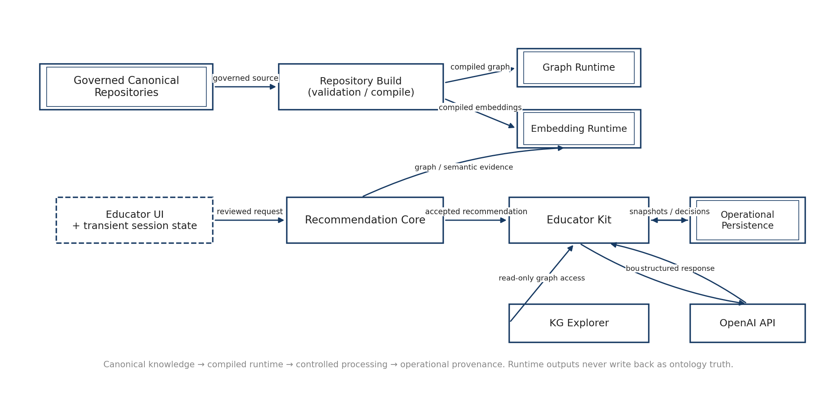
Figure 1. System-level logical data-flow context
The external generation provider is downstream of deterministic resolution: it receives a bounded generation packet and returns structured content, but it does not resolve the technical anchor, create SCR eligibility, choose the primary recommendation, select framework mappings or alter canonical repository truth.

6. Curriculum and Application Context data flow
The educator workflow begins with governed curriculum selection. Course, Module and Subtopic are all required in the V1 product route, and the selected Subtopic is the authoritative technical anchor. Application Context suggestions are assistance around that anchor rather than an alternative source of technical scope.
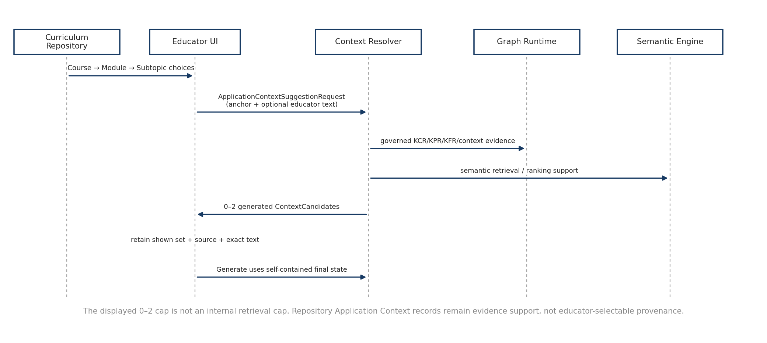
Figure 2. Curriculum and Application Context data flow

6.1 Curriculum hierarchy
- Course choices are read from active governed Course records.
- Module choices are filtered by Course_ID; Subtopic choices are filtered by Module_ID.
- Changing Course, Module or Subtopic invalidates dependent Application Context suggestions and any accepted generated candidate tied to the previous anchor.
- Readable labels/descriptions are displayed; canonical IDs remain the data-flow identity.

6.2 Suggestion request and internal evidence
After the hierarchy is valid, the UI may call the Application Context Resolver automatically. The request carries Course_ID, Module_ID, Subtopic_ID and, when already present, the educator-entered Application_Context_Text. The educator text contributes application/mechanism evidence while the selected Subtopic remains the technical authority.
Internally, the resolver may inspect a broader eligible pool using controlled KCR/KPR/KFR relationships, curated repository Application Context evidence, mechanism/boundary compatibility and semantic ranking. The UI display limit of 0–2 generated candidates is therefore not a retrieval limit.

6.3 Transient UI state and Generate boundary
The UI retains the exact final candidate set shown, the accepted Context_Candidate_ID when applicable, Application_Context_Source, exact Application_Context_Text and Teaching Context until Generate. Exploratory clicks are not individually persisted. At Generate, this final interaction state is assembled into the self-contained EducatorRecommendationRequest and becomes eligible for durable provenance through RecommendationContextSnapshot.
Application Context path | Source value | Candidate ID | Persisted text
Educator enters own context | EDUCATOR_ENTERED | null | Exact educator text
Educator accepts generated candidate | ACCEPTED_SYSTEM_GENERATED | Context_Candidate_ID | Exact generated candidate text

7. Recommendation Core data transformation flow
Recommendation processing is a controlled transformation pipeline rather than a direct lookup. The Input Adapter validates and normalizes the reviewed request, the Mechanism Profiler separates positive and explicit-negative evidence, graph/context services retrieve supported evidence, eligibility/guardrail checks establish the candidate set, and ranking operates only within that eligible set.
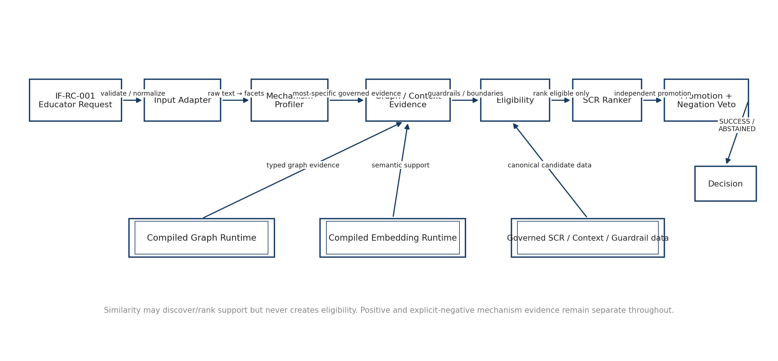
Figure 3. Recommendation Core data transformation flow

7.1 Input Adapter
- Validates Course→Module→Subtopic consistency, Application Context source/candidate consistency and blocking mismatch state.
- Preserves raw educator text separately from normalized semantic/mechanism evidence.
- Produces NormalizedRecommendationRequest for internal execution; it does not mutate the public request in place.

7.2 Evidence construction and eligibility
Mechanism evidence and graph evidence are deliberately distinct. Reasoning begins at the most specific supported curriculum evidence; broader Module/Course evidence is a controlled fallback only when narrower evidence is insufficient. Prerequisite concepts indicate readiness/preparation and do not automatically become topical evidence.
The Context Resolver combines scope/mechanism evidence with curated repository Application Context evidence. These repository records support retrieval and eligibility evidence but do not create a third educator provenance type. Deterministic eligibility, guardrail and boundary checks then establish the SCR candidates that are allowed to reach ranking.

7.3 Ranking, promotion and negation
- SCR Ranker orders only eligible candidates using the frozen Design-8a behavior and versioned semantic support.
- Promotion Engine may add additional SCRs only when an independently supported mechanism facet justifies them.
- Explicit Negation Veto may remove a secondary promotion when negated/excluded evidence matches; negative evidence never becomes positive support.
- Raw candidate diagnostics remain audit/provenance data rather than the normal educator result payload.

8. Recommendation persistence and trace flow
A completed SUCCESS or ABSTAINED recommendation is durable before the completed RecommendationResult is returned. This makes the IDs in the result immediately valid for trace retrieval and downstream Kit generation.
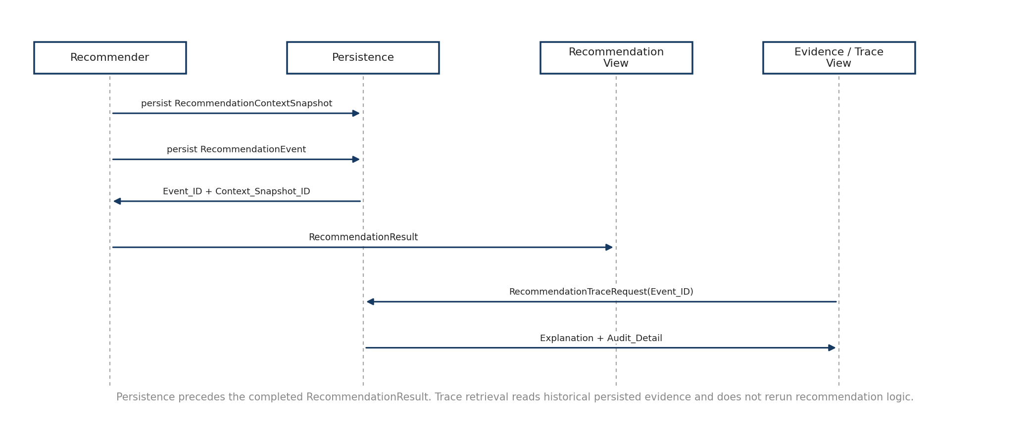
Figure 4. Recommendation persistence and trace flow

8.1 RecommendationContextSnapshot
The immutable RecommendationContextSnapshot captures the final reviewed recommendation context and the actual runtime evidence state used for the execution. It includes the selected hierarchy, exact Application Context provenance/text, final generated suggestions shown, relevant normalized/mechanism/context evidence and the version references needed for replay.

8.2 RecommendationEvent
The append-only RecommendationEvent records the delivered decision, selected/promoted SCRs or abstention outcome, evidence links and versions, and links directly to the exact RecommendationContextSnapshot. SUCCESS and ABSTAINED are both completed attempts and therefore both produce durable provenance.

8.3 Trace retrieval
RecommendationTraceRequest uses Recommendation_Event_ID. Trace Builder/Persistence reads the historical event and linked snapshot and returns the educator-readable Explanation plus collapsed Audit_Detail. The trace is not generated by rerunning recommendation logic or by asking an LLM for a fresh rationale.

9. Educator Kit data flow
The Educator Kit subsystem starts only from an accepted SUCCESS recommendation. Recommendation_Event_ID and Recommendation_Context_Snapshot_ID are the authority for the accepted SCR/context; the UI does not resend a different SCR or Application Context as alternate authority.
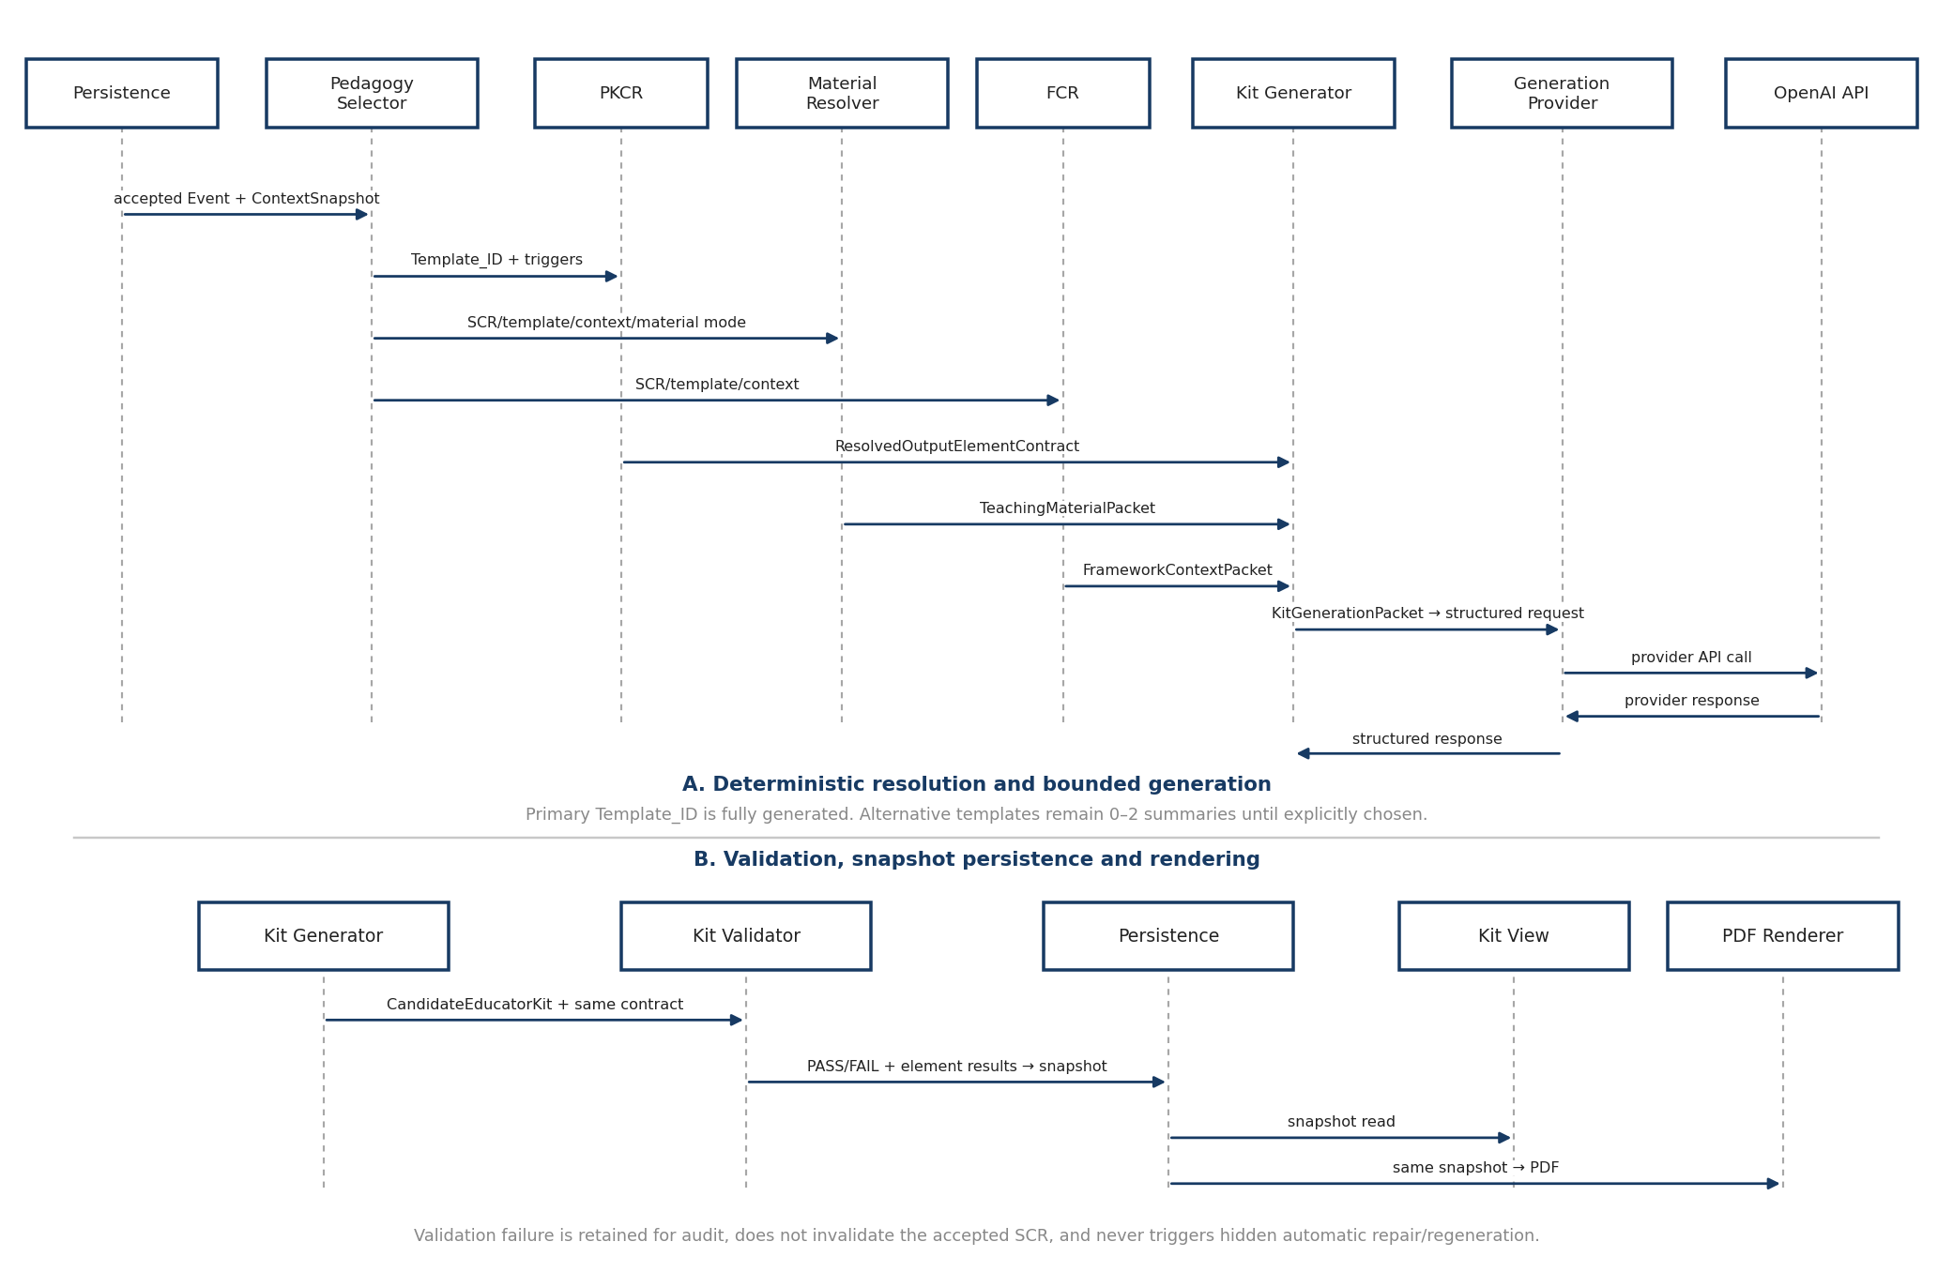
Figure 5. Educator Kit data flow

9.1 Pedagogy and deterministic resolvers
Stage | Input | Output | Data-flow rule
Pedagogy Selector | Accepted SCR + current Teaching Context | Primary Template_ID + 0–2 alternative summaries | Only primary or explicitly chosen alternative is fully generated.
PKCR | Selected Template_ID + trigger state | ResolvedOutputElementContract | Completeness contract; never selects Template_ID.
Teaching Material Resolver | SCR + template + context + material mode | TeachingMaterialPacket | Preserve real-source/generated/educator provenance.
FCR | SCR + template + context | FrameworkContextPacket | Downstream enrichment; cannot create SCR eligibility or select pedagogy.
Kit Generator | Resolved contract + evidence + framework + context | KitGenerationPacket / CandidateEducatorKit | External model receives bounded structured input only.
Kit Validator | Candidate Kit + same output contract | KitValidationResult | Required/triggered elements validated deterministically.

9.2 Teaching Context recontextualization
Changes limited to Teaching Context—learner level, delivery mode, class size, time, assessment preference and resource/access constraints—may re-rank/recontextualize pedagogy and create a new EducatorKitSnapshot without rerunning SCR eligibility. A material change to Course/Module/Subtopic or accepted Application Context requires a new recommendation execution.

9.3 Generation and validation boundaries
The generation provider structures content from a resolved KitGenerationPacket. It does not determine curriculum scope, traverse the ontology, create SCR eligibility, apply guardrails, rank SCRs or choose the final recommendation. Validation uses the same selected output-element contract that bounded generation.
If validation fails, the failed validation/provenance is retained for audit, the Kit is not presented as ready to use, the accepted recommendation remains valid and V1 does not initiate an automatic repair/regeneration loop.

10. Kit snapshot, view, PDF and educator-decision flow
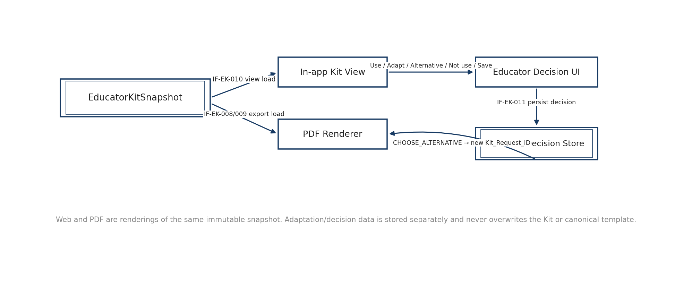
Figure 6. Kit snapshot → view / PDF / educator-decision flow

10.1 Snapshot authority
EducatorKitSnapshot is immutable and is the sole semantic content source for both the normal in-app Kit presentation and PDF export. Opening, refreshing or exporting the Kit does not invoke the generation provider, reselect pedagogy, re-resolve frameworks or rerun Recommendation Core.

10.2 PDF export
PDF is rendered on demand from the same snapshot. V1 does not require a separately persisted PDF/export-history entity. Renderer version metadata is retained/returned for reproducibility, but the export does not create a new content snapshot.

10.3 Educator decisions and adaptation
USE_AS_SUGGESTED, ADAPT, CHOOSE_ALTERNATIVE, NOT_USE and SAVE_FOR_LATER are educator actions persisted separately from the immutable system Kit. Adaptation text is educator-origin operational data. Choosing an alternative starts a new explicit Kit_Request_ID and Kit generation flow for the chosen Template_ID; it is not a hidden repair loop.

11. Knowledge Graph Explorer data-access flow
The Knowledge Graph Explorer is a read-only consumer of the complete active compiled governed graph. The initial payload/view may be lean to preserve responsiveness, but every valid curated node, relationship and governed entity detail present in the active compiled graph remains available through search, focus, expansion and inspection.
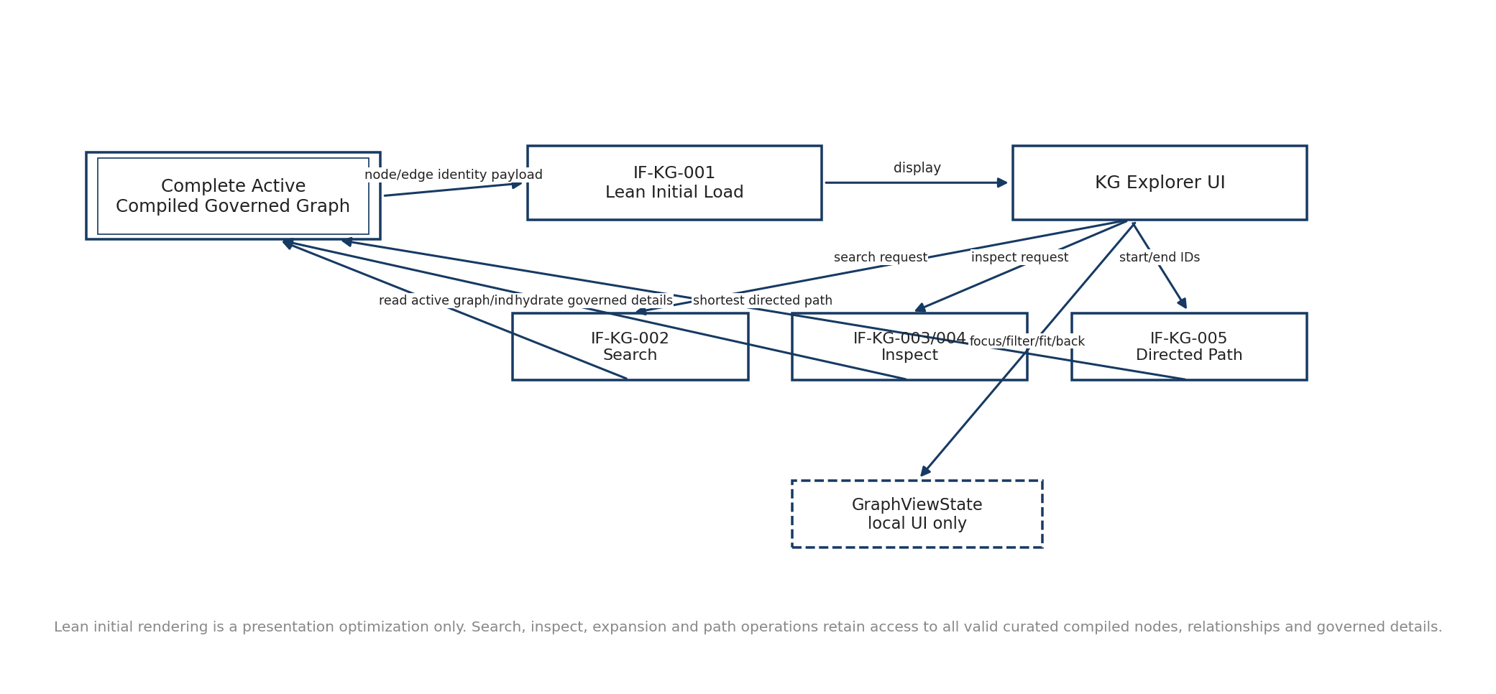
Figure 7. Knowledge Graph Explorer read-only data-access flow

11.1 Initial load and search
- IF-KG-001 may return a lean node/edge identity payload while preserving the complete graph as the semantic backend.
- IF-KG-002 searches governed active entities by readable text and returns canonical entity IDs plus readable labels.
- NO_MATCHES is a normal search outcome; no entity is fabricated to fill the view.

11.2 Inspection and path
- IF-KG-003 hydrates authoritative type-specific entity properties and incoming/outgoing compiled relationships on demand.
- IF-KG-004 preserves exact compiled relationship type, source, target and direction; governed meaning is shown only when source metadata supplies it.
- IF-KG-005 returns one deterministic shortest directed governed path by hop count, or NO_GOVERNED_PATH.
- Current display filters do not silently constrain path semantics. A future relationship-constrained path would require an explicit request field.

11.3 Local display state
Focus, reset, fit, back-to-focus, expand/collapse, entity filters, relationship filters and View as list are transient GraphViewState. These operations change presentation only and do not mutate the compiled graph, canonical repositories or Recommendation Core state.

12. Repository compilation and runtime-load flow
Controlled repositories are governed source artifacts rather than the live runtime query store. During development/deployment preparation, Repository Build validates source structure and compiles versioned runtime artifacts. Application startup loads the graph and embedding packages separately.
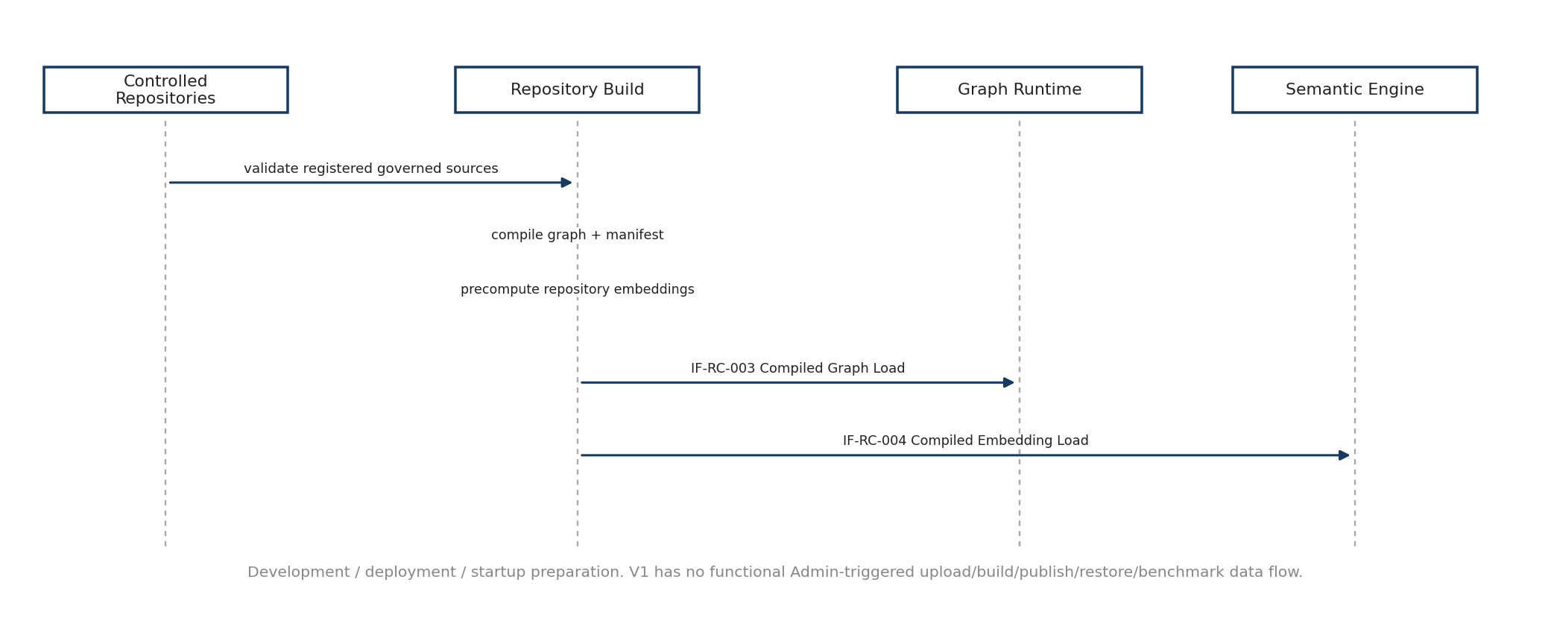
Figure 8. Repository compilation and runtime-load data flow

12.1 Build outputs
- CompiledGraphArtifact contains the graph/runtime representation and manifest needed by Graph Runtime.
- CompiledEmbeddingArtifact contains the precomputed repository embedding matrix plus frozen model/version metadata needed by Semantic Engine.
- Invalid source data does not silently become runtime truth; validation/compilation must fail explicitly.

12.2 Startup readiness
Graph Runtime and Semantic Engine load the compiled artifacts once at startup/readiness initialization. Recommendation and KG Explorer flows depend on these runtime services being ready. If the frozen MiniLM backend is unavailable, the application reports a technical runtime/model error rather than silently substituting another semantic backend.

12.3 V1 Administration boundary
V1 Administration may provide protected static guidance and read-only repository/runtime inspection where available. Upload, staging, candidate diff, validation/build execution, publication/activation, rollback/restore and benchmark execution are not active V1 data flows and remain future/deferred architecture reference.

13. Persistence and end-to-end provenance
Operational provenance is intentionally separate from canonical knowledge. The primary chain allows a delivered recommendation and any downstream teaching Kit/action to be traced back to the exact input/evidence state and versioned repository/runtime context used at the time.
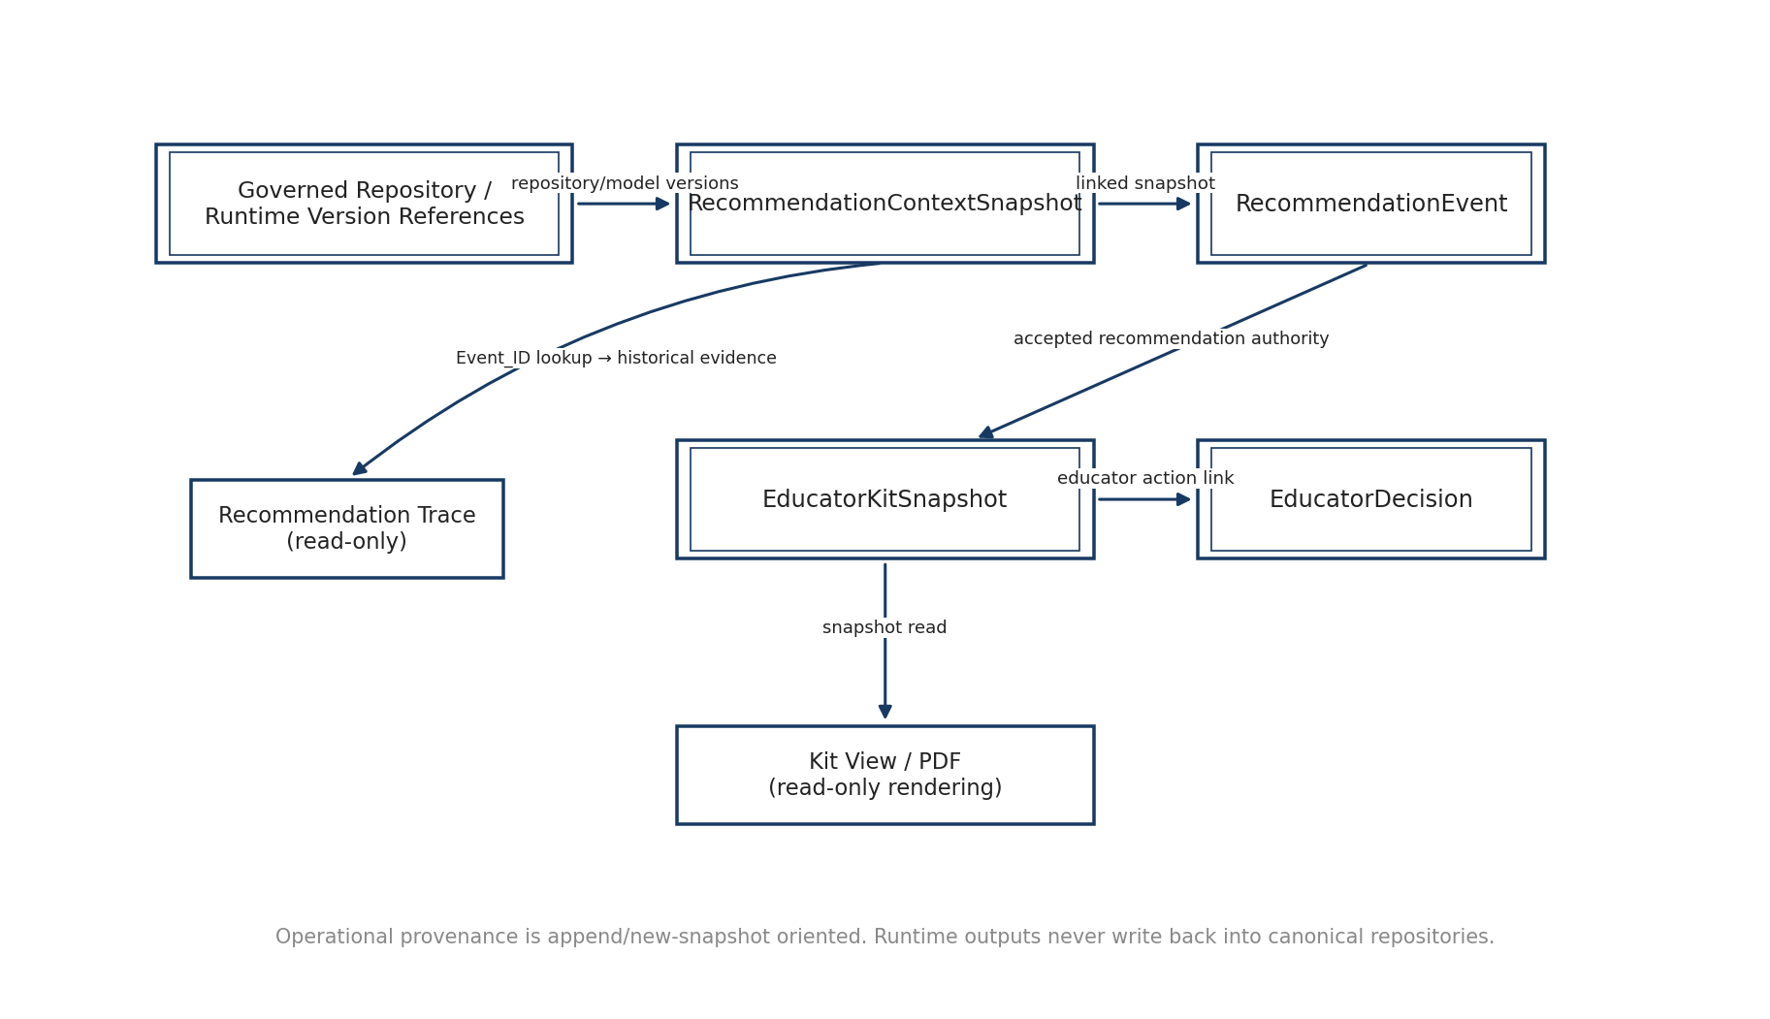
Figure 9. End-to-end operational provenance chain
Object | Creation trigger | Mutability | Key linkage / downstream use
RecommendationContextSnapshot | Completed recommendation attempt | Immutable | Referenced by RecommendationEvent; later Kit request uses the exact context authority.
RecommendationEvent | Completed recommendation attempt | Append-only | Returns Event_ID; primary trace lookup; accepted recommendation authority for Kit.
EducatorKitSnapshot | Completed Kit generation/validation | Immutable | Linked to Event/Context; source for Kit view, PDF and educator action.
EducatorDecision | Explicit educator action | New records / append history | Linked to Kit snapshot; may initiate explicit alternative Kit request.

13.1 Version provenance
Recommendation and Kit operational records retain the version identifiers that materially affect replay: canonical repository/runtime versions, embedding/model version, template/output-contract/framework versions, prompt/generation-provider configuration where relevant, validator version and renderer version for PDF. Historical replay must not silently substitute the latest available versions.

13.2 Physical persistence handoff
SEQ-05 defines the logical object boundaries, creation triggers, linkage and immutability rules. SEQ-09 will map these objects into SQLite/Supabase PostgreSQL tables, keys, indexes, constraints and transaction semantics without changing the lifecycle defined here.

14. Error and exceptional data flows
Condition | Type | Returned/visible state | Persistence behavior | Required user/system behavior
Missing/invalid hierarchy | Blocking validation | Input validation state | No completed RecommendationEvent | Return to curriculum selection; do not infer anchor.
Anchor/context mismatch | Blocking validation | Mismatch guidance | No completed RecommendationEvent | Edit context or curriculum; no silent re-anchor.
No compatible context suggestion | Domain outcome | NO_COMPATIBLE_SUGGESTIONS | No standalone record required | Keep free-text Application Context available.
Insufficient evidence | Domain outcome | ABSTAINED / INSUFFICIENT_EVIDENCE | Persist ContextSnapshot + Event | No Kit action; do not force SCR.
No defensible mechanism | Domain outcome | ABSTAINED / NO_DEFENSIBLE_SUSTAINABILITY_MECHANISM | Persist ContextSnapshot + Event | No Kit action; no similarity-only recommendation.
Trace absent | Domain outcome | NOT_AVAILABLE | No replacement trace | Keep result visible; do not synthesize explanation.
No eligible template | Domain outcome | NO_ELIGIBLE_TEMPLATE | Recommendation remains valid | Do not invent pedagogy.
Kit validation fails | Domain outcome | VALIDATION_FAILED | Retain failed snapshot/audit provenance | Do not show ready Kit; no automatic repair.
No KG path | Domain outcome | NO_GOVERNED_PATH | No persistence required | Show no-path state; do not fabricate/undirect path.
Provider/model/graph/persistence failure | Technical error | TechnicalError / explicit unavailable state | Optional operational logging | Do not convert technical failure into normal domain outcome.

15. Interface-to-data-flow coverage
Every active V1 interface from Interface_Contract_Registry_v0.1 is represented in the companion Data Flow Registry. The summary below highlights the principal coverage groups.
Interface group | Primary SEQ-05 flows | Coverage
IF-UI-001 / IF-AC-001 / IF-RC-001 / IF-RC-002 | DF-001–DF-009 | Curriculum, context suggestion, reviewed Generate request and normalization.
Recommendation execution / IF-RC-005 / IF-RC-006 | DF-010–DF-021 | Mechanism/evidence, eligibility/ranking/promotion/veto, persistence, result and trace.
IF-EK-001–IF-EK-011 / IF-EXT-001–002 | DF-022–DF-037 | Pedagogy, deterministic resolvers, provider, validation, snapshot, view/PDF and decisions.
IF-KG-001–005 / UI-STATE-001 | DF-038–DF-043 | Complete-graph load, search, inspection, directed path and local display state.
IF-RC-003 / IF-RC-004 | DF-044–DF-048 | Development/deployment compilation and startup runtime load.
IF-PLAT-001 / IF-PLAT-002 / IF-UI-002 | DF-018/019/032/036/049/051/052 | Operational persistence, protected Administration authorization and static help lookup.

The companion registry also maps each persisted object to its creation trigger and each UI state to a defined producer, eliminating undefined data origins between SEQ-03 and SEQ-04.

16. Deferred V2/V3 data flows
Deferred capability | V1 position | Future data-flow work
Text-only curriculum anchor | Not exposed in V1; hierarchy is mandatory. | Anchor resolution, ambiguity handling and safe confirmation before any SCR path.
Downloadable Kit HTML | In-app web rendering only. | Optional renderer/export interface if later required.
Kit Excel export | Not active in V1. | Structured export object/renderer if later required.
Repository edit/onboarding | Controlled external repositories remain canonical authoring route. | Draft/change-set/canonical-write governance.
Admin upload/stage/build/publish/restore | No functional V1 Admin release lifecycle. | Release objects, candidate-state transitions, activation and rollback flows.
Admin benchmark execution | Not active V1 release-management flow. | Test orchestration, result persistence and release-gate state.
Automatic Kit repair/regeneration | Explicitly excluded. | Future repair policy and bounded retry orchestration only if separately designed.

17. Implementation readiness and acceptance checklist
- Every major V1 runtime object has a defined source, producer, consumer and data class.
- Every active interface in Interface_Contract_Registry_v0.1 maps to at least one registered SEQ-05 flow.
- Course→Module→Subtopic remains the V1 technical-anchor route; no direct text→SCR data path exists.
- Application Context suggestions remain system-generated educator-facing alternatives while curated repository contexts remain internal evidence support.
- RecommendationContextSnapshot and RecommendationEvent are distinct durable objects and are persisted before the completed result is returned.
- Trace reads historical persisted evidence and never reruns the recommendation or asks a model for a replacement explanation.
- Pedagogy/framework/output-contract/teaching-material data remains downstream of accepted SCR recommendation.
- Kit generation is bounded; validation failure is retained without invalidating the SCR and without automatic repair/regeneration.
- In-app Kit and PDF render from the same immutable EducatorKitSnapshot; educator decisions are stored separately.
- Knowledge Graph Explorer is read-only over the complete active compiled governed graph; local view state does not change semantic/path/recommendation behavior.
- Repository compilation/runtime-load is a development/deployment/startup path rather than a functional V1 Admin publication path.
- Physical persistence design remains deferred to SEQ-09 and can be implemented without changing the logical object lifecycle defined here.
When these conditions are maintained during implementation, SEQ-05 is complete and provides the stable logical handoff to persistence/data-model design and implementation planning.

Appendix A — Logical store quick reference
Store | Class | Principal contents | Runtime write rule
Governed Canonical Repositories | Canonical Source | Curriculum, KCR/KPR/KFR, SCR, Application Context evidence, Guardrails, mappings/templates/contracts/framework/evidence. | No runtime recommendation/Kit write-back.
Compiled Graph Runtime | Compiled Runtime | Active compiled nodes, typed directed relationships, lookup metadata. | Read-only after startup load.
Compiled Embedding Runtime | Compiled Runtime | Repository embeddings + frozen semantic model/version metadata. | Read-only after startup load except new request embeddings in working memory.
Transient Educator Session State | Transient Interaction | Selections, typed context, shown candidates, teaching context, graph display state. | Replaceable until Generate/Save.
Recommendation Operational Store | Persisted Operational | RecommendationContextSnapshot + RecommendationEvent + trace/version references. | Immutable snapshot + append-only event semantics.
Kit Operational Store | Persisted Operational | EducatorKitSnapshot + validation/contract/evidence/framework/model/prompt provenance. | Immutable snapshots.
Educator Decision Store | Persisted Operational | Use/adapt/alternative/not-use/save decisions and adaptation text. | New records; never overwrite Kit.

Appendix B — Key object quick reference
Object | Producer | Consumer | Persisted?
ApplicationContextSuggestionResponse | Application Context Resolver | Educator UI | No standalone
EducatorRecommendationRequest | Educator UI | Input Adapter | No standalone
NormalizedRecommendationRequest | Input Adapter | Recommender | No
ApplicationMechanismProfile / evidence sets | Recommendation Core components | Eligibility/Ranker/Trace | Embedded provenance only
RecommendationContextSnapshot | Persistence | Trace / Kit / replay | Yes — immutable
RecommendationEvent | Persistence | Result / Trace / Kit / audit | Yes — append-only
PedagogySelection / resolver packets | Educator Kit deterministic resolvers | Kit Generator / snapshot | Provenance in Kit snapshot
KitGenerationPacket | Kit Orchestrator | Generation Provider | No
KitValidationResult | Kit Validator | Persistence / result | Persisted in Kit provenance
EducatorKitSnapshot | Persistence | Kit View / PDF / decisions | Yes — immutable
EducatorDecision | Educator UI/Persistence | Audit / alternative flow | Yes — separate record
KnowledgeGraphLoad/Search/Inspect/Path responses | Graph Runtime | KG Explorer | No

