PROCESS FLOW SPECIFICATION
Ontology and Knowledge Graph-Driven
Sustainability Principles Recommendation System
SEQ-06 | Version 0.1 | September 2026
Purpose
Formalize V1 operational processes, state transitions, decision points, branching, prerequisites, termination conditions and exceptional paths without changing the data flows or algorithms already established.

Document control
Item | Value
Sequence | SEQ-06
Version | 0.1
Status | V1 process-flow baseline
Date | September 2026
Upstream baseline | System Architecture Design v1.1 Final; UI Design v0.3; Technical Interface Design v0.2; Interface Contract Registry v0.1; Data Flow Design v0.1 Final; Data Flow Registry v0.1; SEQ-04/05 decision registers.
Change rule | This specification formalizes already agreed behavior; it must not silently alter architecture, UI, interface, data-flow or validated recommendation semantics.

Contents and reading order
- 1–3 define scope, notation and cross-process invariants.
- 4–7 define recommendation and Application Context processes.
- 8–11 define Educator Kit, Knowledge Graph and runtime-startup processes.
- 12–15 define persistence/replay, exceptional states, process registry and acceptance.

1. Purpose and scope
SEQ-06 converts the frozen UI, interface and data-flow design into executable behavioral processes. It answers what happens next, which branch is taken, what blocks progress, what persists, and when a process terminates. It does not define scoring mathematics or physical database schema.

1.1 In scope
- Educator recommendation journey and Application Context acceptance.
- Recommendation execution, abstention, trace retrieval and persistence ordering.
- Educator Kit generation, explicit alternative selection, validation failure, view/export and educator decisions.
- Knowledge Graph Explorer process and repository/runtime startup.
- Domain outcomes versus technical failures, idempotent retries and replay.

1.2 Out of scope
- Algorithm scoring/threshold derivation — SEQ-07.
- Module/package ownership — SEQ-08.
- Physical tables/transactions — SEQ-09.
- Authentication/secrets/security controls — SEQ-10.
- Deferred text-only V1 anchor route and functional Admin publication lifecycle.

2. Process notation and state conventions
Notation | Meaning
Rectangle | Action, state transition or component-owned process step.
Diamond | Decision/gate with explicit branches.
Arrow | Permitted process transition; labels describe conditions where useful.
Data store box | Persisted or governed state read/written by the process.
Domain outcome | Expected business/domain state such as ABSTAINED, NO_COMPATIBLE_SUGGESTIONS or NO_GOVERNED_PATH.
TechnicalError | Infrastructure/runtime failure outside the normal domain-state branch.

3. Cross-process invariants
- Course → Module → Subtopic is mandatory in V1 and Subtopic is the authoritative technical anchor.
- One accepted Application Context is required before final Recommendation Core execution.
- Educator-entered Application Context supersedes generated suggestions on the main path; the exact text is preserved.
- A material anchor/context mismatch blocks execution and returns the educator to review; V1 does not silently re-anchor.
- Eligibility and guardrail checks precede SCR ranking.
- Educator Kit starts only from a successful accepted recommendation; downstream pedagogy/framework/generation cannot create SCR eligibility.
- Failed Kit validation is retained but never shown as a ready Kit; no hidden repair/regeneration loop exists.
- Knowledge Graph Explorer is read-only and does not invoke or change Recommendation Core state.
- Operational outputs never write back into canonical repositories.
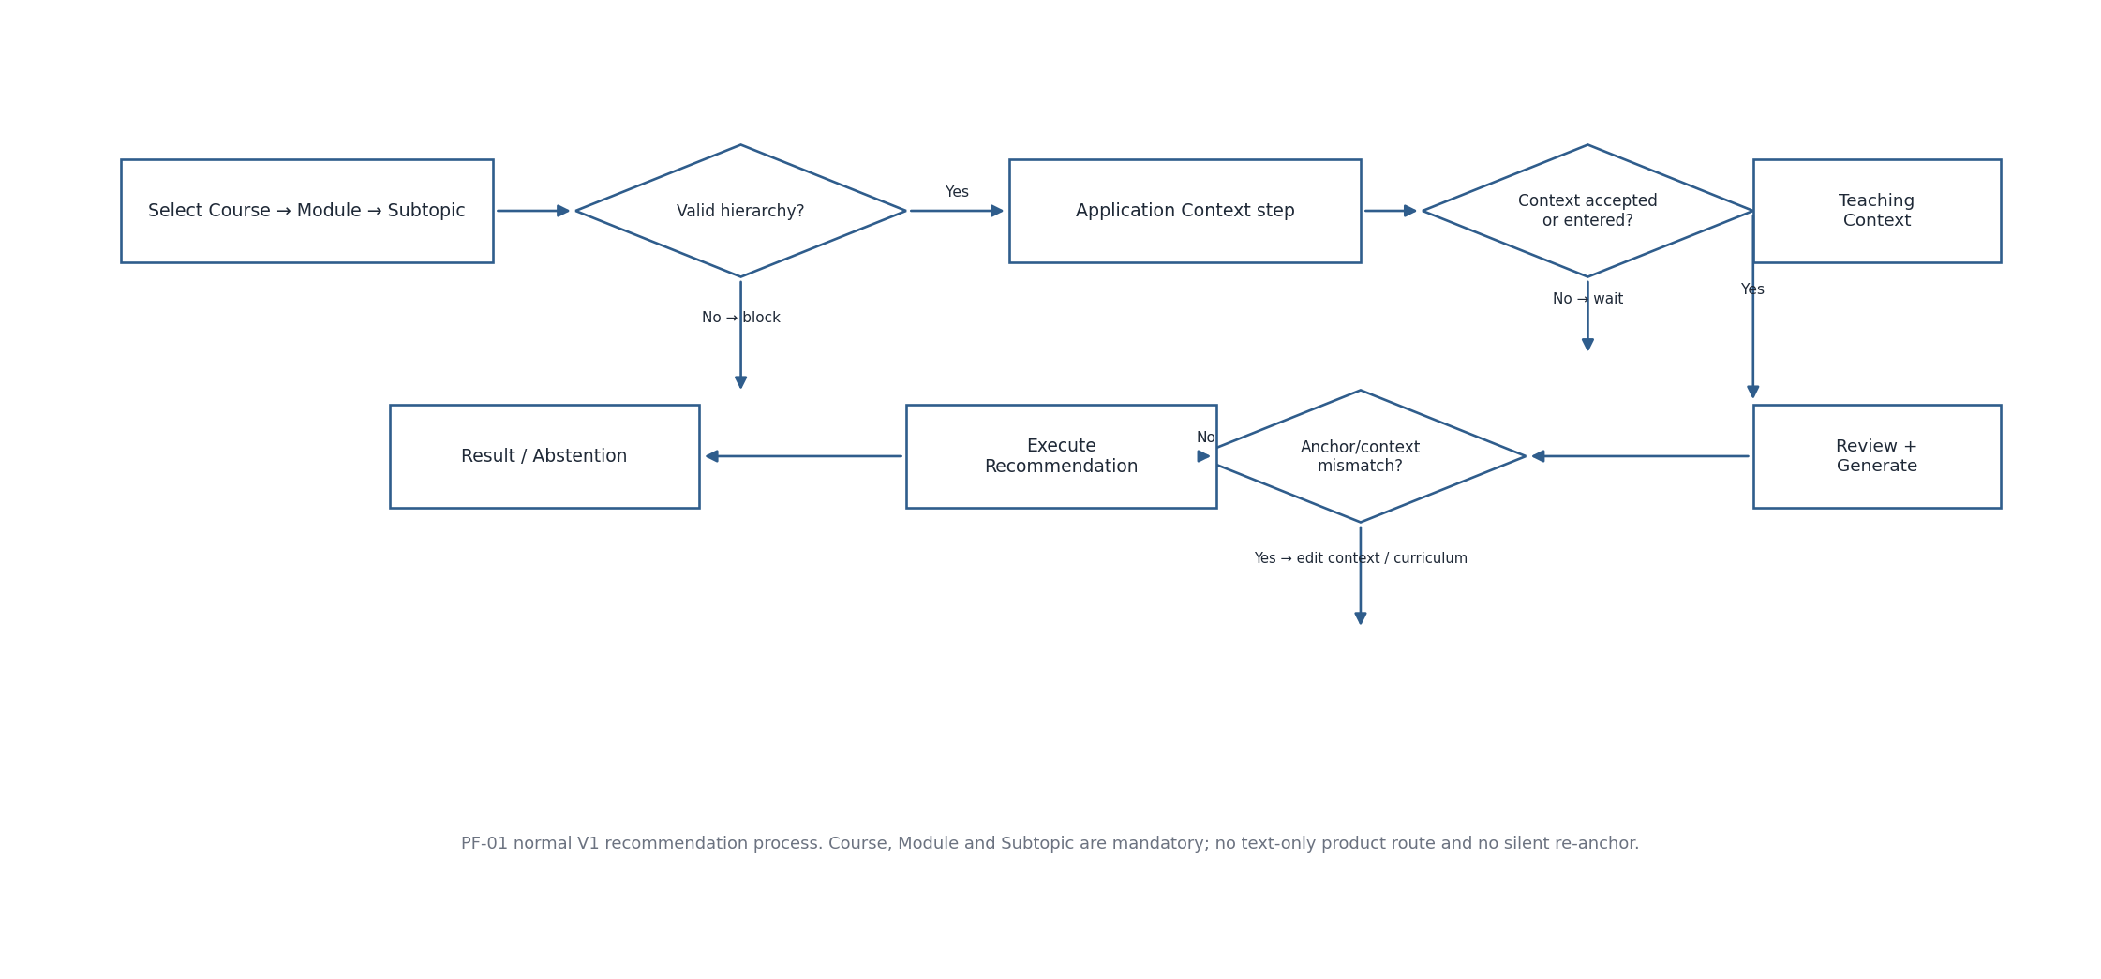
Figure 1. PF-01 V1 recommendation creation process

4. PF-01 — Recommendation creation
Step | Actor / owner | Process rule | Next state
1 | Educator UI | Select active Course; load Modules filtered by Course_ID. | Module selection
2 | Educator UI | Select Module; load Subtopics filtered by Module_ID. | Subtopic selection
3 | Educator UI | Select Subtopic; retain canonical hierarchy IDs. | Application Context
4 | Application Context process | Automatically evaluate suggestions; educator field is immediately usable. | Accepted/entered context or wait
5 | Educator UI | Collect optional Teaching Context. | Review
6 | Review/Generate | Validate hierarchy, accepted context, candidate provenance and mismatch. | Block or execute
7 | Recommendation Core | Execute deterministic recommendation and persistence. | RecommendationResult
8 | UI | Render SUCCESS or ABSTAINED; Kit action only for SUCCESS. | End / trace / Kit

4.1 Process gates
- Changing Course invalidates Module, Subtopic, suggestion and accepted-context state.
- Changing Module invalidates Subtopic, suggestion and accepted-context state.
- Changing Subtopic invalidates the suggestion set and accepted generated candidate tied to the old anchor.
- Changing educator Application Context invalidates prior mismatch validation; educator-entered text becomes primary.
- During Generate, the primary action is disabled; duplicate Request_ID is handled idempotently.
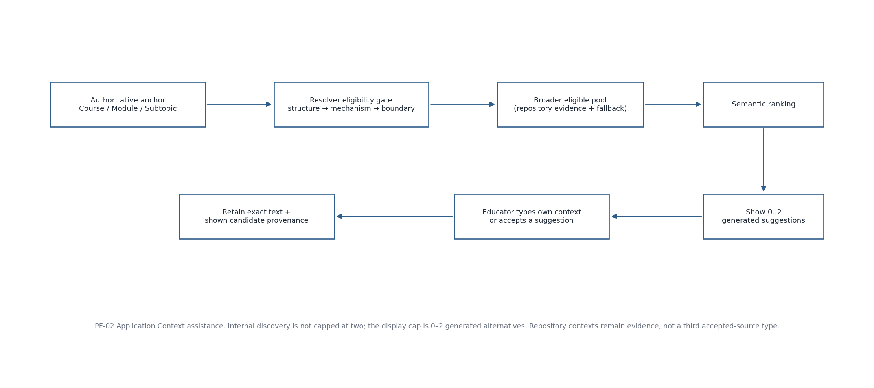
Figure 2. PF-02 Application Context suggestion and acceptance process

5. PF-02 — Application Context suggestion and acceptance
Branch | Behavior
Anchor available, no educator text yet | Resolver uses the selected hierarchy and governed semantic evidence to generate candidate alternatives.
Anchor + educator text already present | Send the existing text as application/mechanism evidence; the anchor remains technical authority.
Compatible candidate pool | Evaluate structural/metadata plus mechanism/boundary compatibility before semantic ranking.
No direct structural candidate | Controlled semantic fallback may be used under the same mechanism/scope checks.
Suggestions available | Display at most 1–2 system-generated alternatives; retain their runtime candidate IDs and final shown set in session state.
No compatible suggestions | Return NO_COMPATIBLE_SUGGESTIONS; keep free-text entry available.
Educator enters own context | Set source EDUCATOR_ENTERED; accepted generated candidate ID must be null.
Educator accepts generated suggestion | Set source ACCEPTED_SYSTEM_GENERATED; retain exact candidate text and Context_Candidate_ID.

6. PF-03/PF-04 — Recommendation execution and abstention
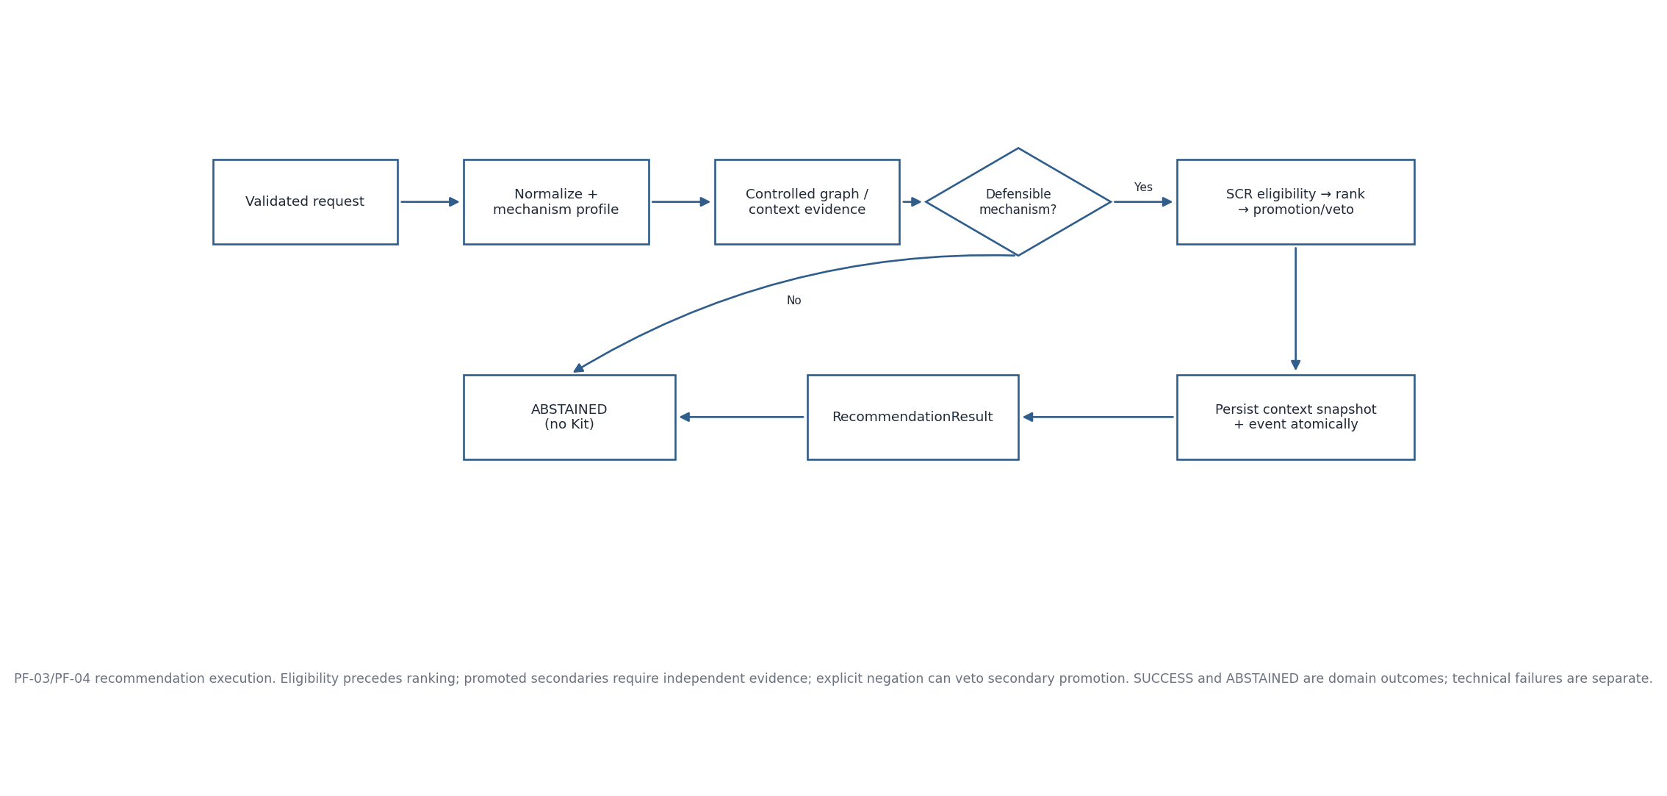
Figure 3. PF-03/PF-04 recommendation execution and abstention process
Stage | Required behavior
Input Adapter | Validate canonical hierarchy and source/candidate consistency; preserve raw context; material mismatch blocks before core execution.
Mechanism profile | Build positive and explicit-negative facets separately.
Evidence | Use controlled graph/context evidence; narrower evidence normally precedes broader fallback.
No defensible mechanism | Return ABSTAINED / NO_DEFENSIBLE_SUSTAINABILITY_MECHANISM and persist completed event/snapshot.
Eligibility/ranking | Apply technical scope, mechanism, guardrail/boundary and evidence rules before ranking eligible SCRs.
Secondary promotion | Only independently supported mechanism facets may add secondary SCRs; explicit negation can veto.
Persistence | RecommendationContextSnapshot and RecommendationEvent commit before completed RecommendationResult is returned.
Insufficient evidence | Return ABSTAINED / INSUFFICIENT_EVIDENCE and no Kit action.

7. PF-05 — Recommendation trace retrieval
Step | Behavior
1 | UI receives Recommendation_Event_ID with completed result.
2 | On Why this recommendation?, call trace lookup by event ID.
3 | Resolve exact persisted RecommendationEvent and linked ContextSnapshot/version references.
4 | Build educator-readable Explanation and collapsed Audit_Detail from persisted provenance only.
5 | If trace record is unavailable, return NOT_AVAILABLE; do not recompute recommendation or synthesize rationale.

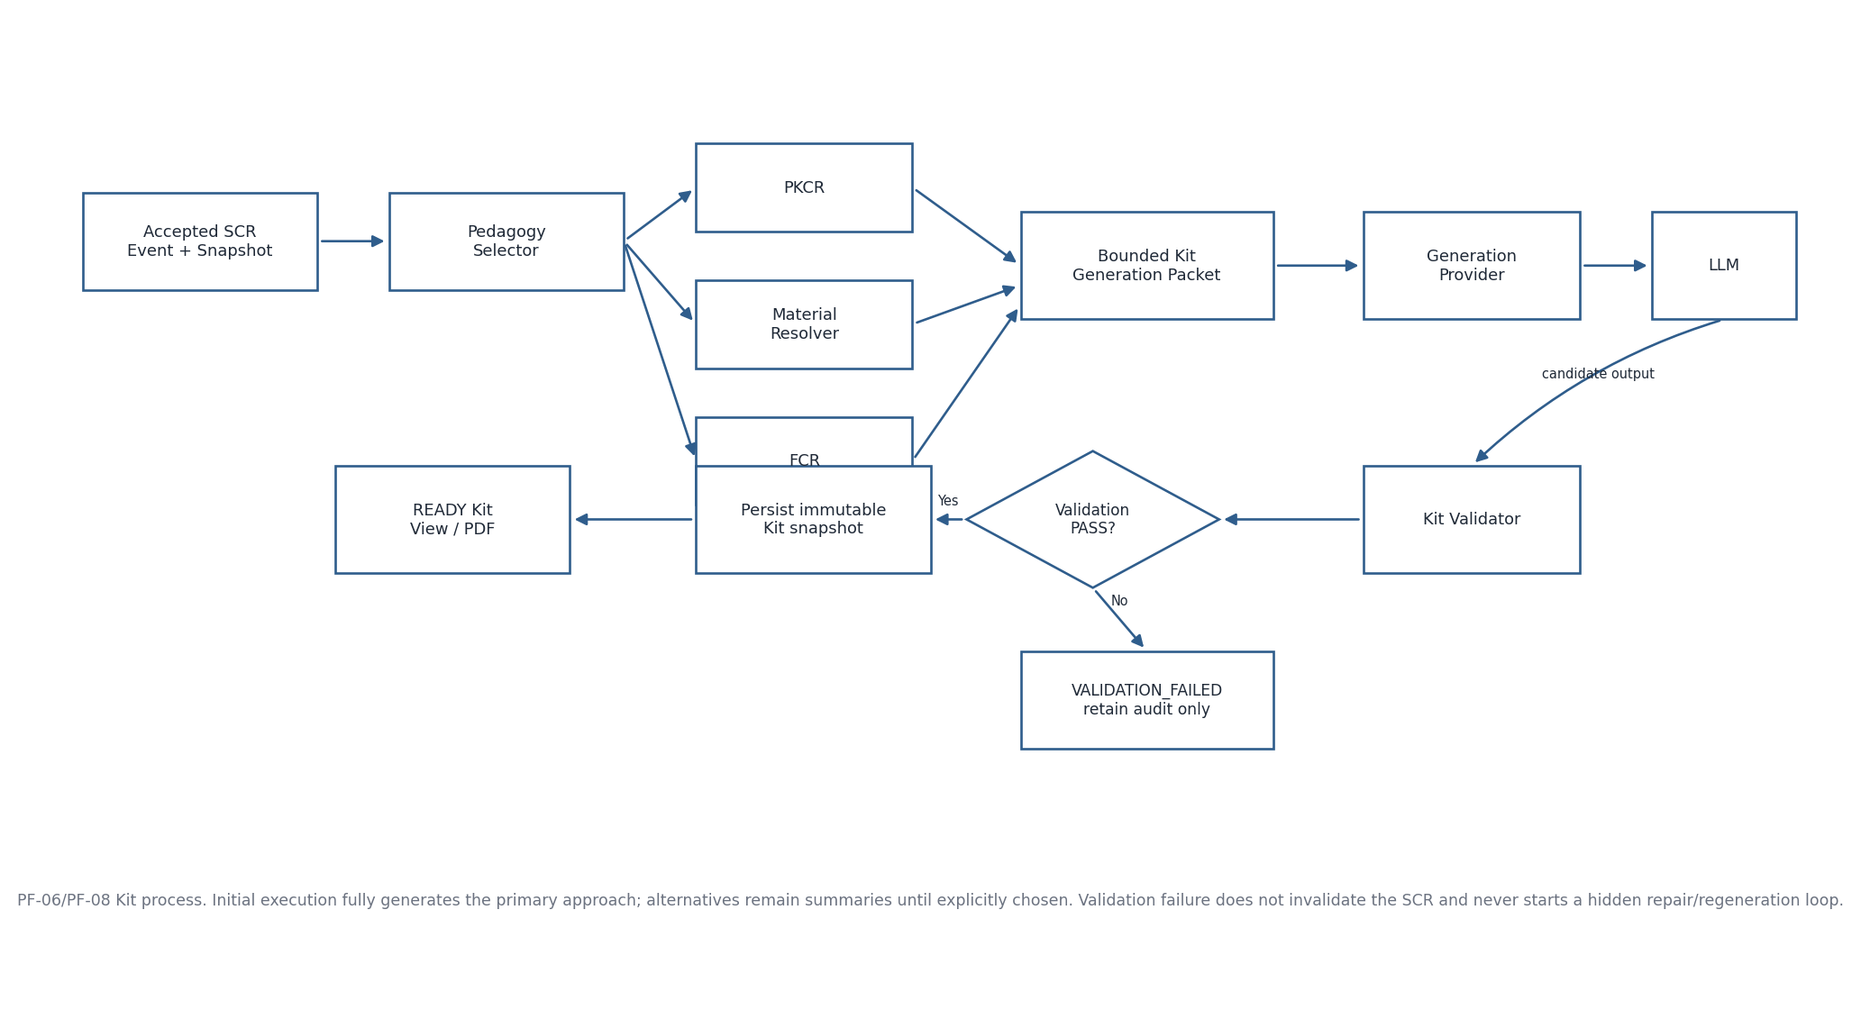
Figure 4. PF-06/PF-08 Educator Kit generation and validation process

8. PF-06/PF-07/PF-08 — Educator Kit lifecycle

8.1 Initial primary Kit generation
- Start only from Recommendation_Status = SUCCESS and a valid accepted primary SCR.
- Pedagogy Selector determines one primary Template_ID and up to two materially distinct alternative summaries.
- Only the primary template is fully resolved/generated/validated on initial Kit generation.
- PKCR resolves REQUIRED and triggered CONDITIONAL output elements.
- Teaching Material Resolver and FCR produce provenance-preserving packets; framework mappings cannot alter SCR eligibility or choose/re-rank Template_ID.
- Generation provider receives only the bounded packet after deterministic resolution.
- Validator checks every required/triggered element against the same contract.

8.2 Explicit alternative flow
- Choosing an alternative is an explicit educator action, not automatic regeneration.
- The chosen alternative Template_ID becomes Requested_Template_ID in a new Kit request.
- A new immutable EducatorKitSnapshot is produced if generation reaches persistence.

8.3 Validation failure
- VALIDATION_FAILED retains failed element/reason and provenance.
- The accepted SCR recommendation remains visible/valid.
- The failed Kit is not presented as ready-to-use.
- No hidden automatic repair/regeneration loop runs.

9. PF-09/PF-10 — Kit view, PDF and educator decision
Action | Process
Open Kit | Read EducatorKitSnapshot by ID; render in-app web view only from persisted content.
Export PDF | Render PDF on demand from the same immutable snapshot; no LLM call, no new export entity required.
Use as suggested | Append EducatorDecision linked to current Kit snapshot.
Adapt | Store educator adaptation separately; do not overwrite original Kit snapshot/template.
Choose alternative | Start PF-07 new explicit Kit generation.
Not use / Save for later | Append decision record; no canonical repository mutation.

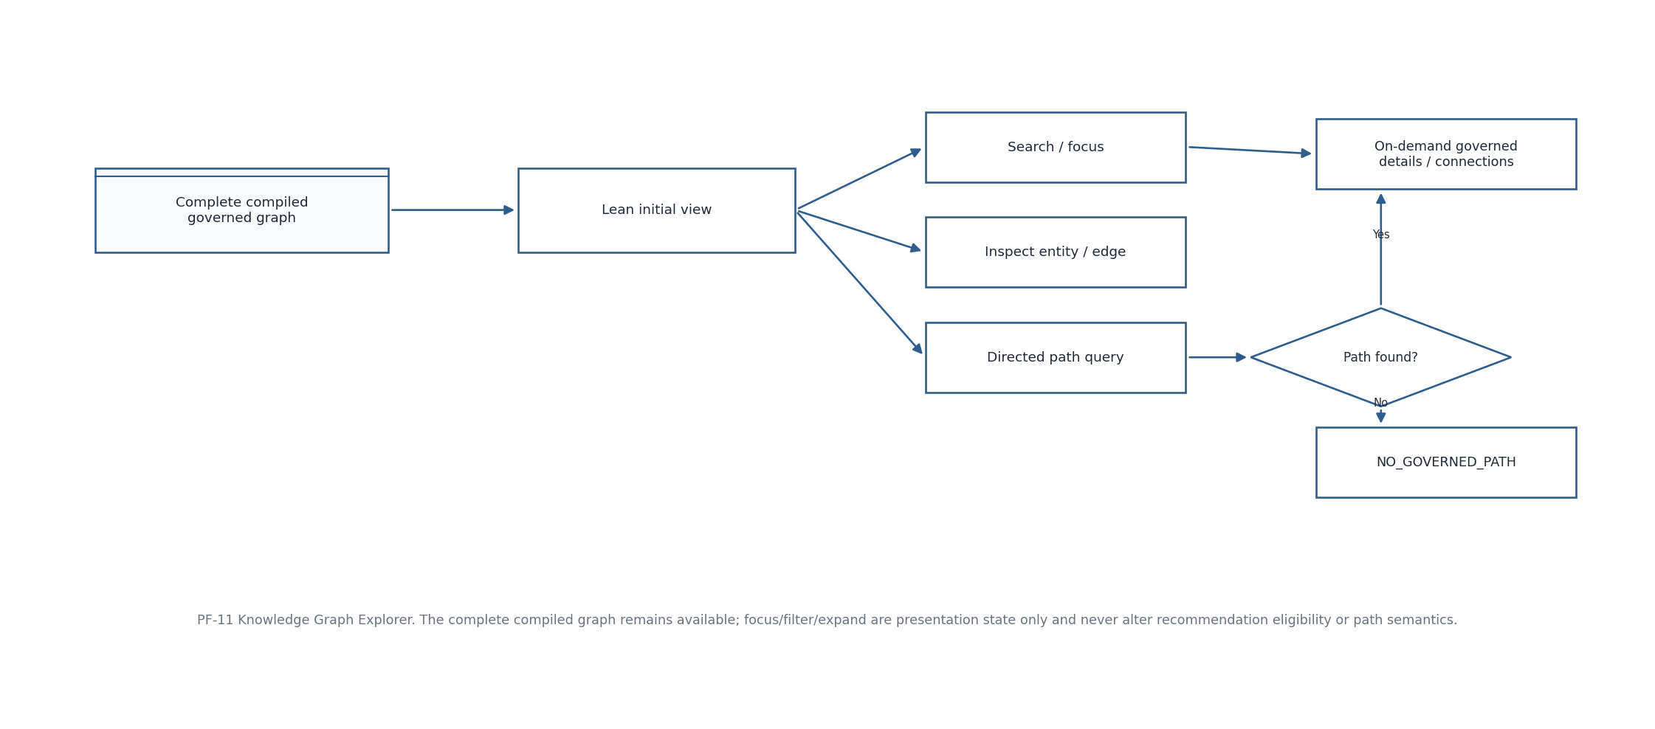
Figure 5. PF-11 Knowledge Graph Explorer process

10. PF-11 — Knowledge Graph Explorer
- Initial entry may be lean/grouped for readability, but semantic availability remains the complete active compiled governed graph.
- Search resolves readable terms to canonical entity IDs; NO_MATCHES is a normal outcome.
- Entity/relationship inspection loads governed details on demand and never generates missing authoritative descriptions.
- Path query uses canonical endpoints, directed governed edges and returns one deterministic shortest path or NO_GOVERNED_PATH.
- Focus, reset, fit, expand/collapse and display filters are local view state and do not change path semantics or Recommendation Core traversal.
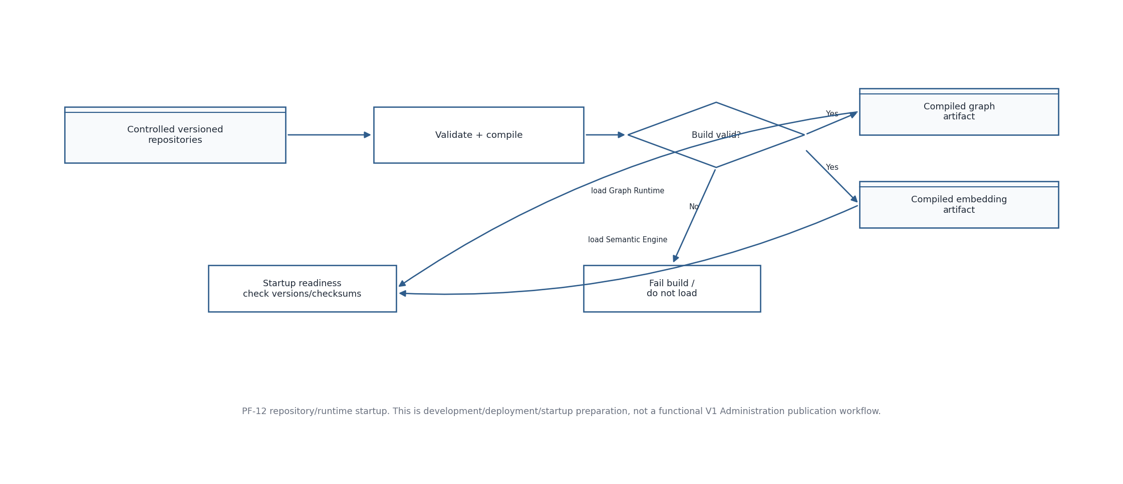
Figure 6. PF-12 repository compilation and runtime startup process

11. PF-12 — Repository build and runtime startup
- Controlled repositories are versioned authoring/governance artifacts; they are not live query tables.
- Repository Build validates schema, controlled values, referential integrity and build invariants.
- Invalid source fails the build; active runtime truth is not silently replaced.
- Compile separate graph and embedding artifacts with version/checksum metadata.
- Graph Runtime and Semantic Engine load approved artifacts at startup and expose readiness.
- This process is deployment/development preparation; V1 Administration does not expose upload/build/publish/rollback execution.
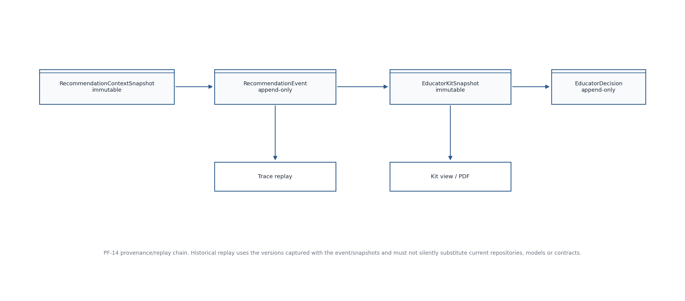
Figure 7. PF-14 operational provenance and replay process

12. PF-13/PF-14 — Exceptional flow, persistence and replay
Condition | Outcome type | Required behavior
Missing/invalid hierarchy | Blocking validation | Return to Curriculum; no completed event.
Anchor/context mismatch | Blocking validation | Return to review; no silent re-anchor.
No compatible context suggestion | Domain outcome | Allow educator text; no fabricated suggestion.
Recommendation abstention | Domain outcome | Persist context snapshot + event; no Kit.
Trace unavailable | Domain outcome | Keep recommendation; do not synthesize trace.
No eligible template | Domain outcome | Keep recommendation; no Kit snapshot because no generated Kit exists.
Kit validation failed | Domain outcome | Persist failure provenance; no ready Kit/no auto-repair.
Provider/model/database failure | TechnicalError | No fake success/domain-state substitution; sanitized operational logging as configured.
No KG path | Domain outcome | Return NO_GOVERNED_PATH; do not fabricate/undirect path.

13. Process registry
Process_ID | Process | Input / trigger | Terminal output
PF-01 | Create Recommendation | Course→Module→Subtopic→Context→Teaching→Review→Generate | Result/Abstention
PF-02 | Application Context Resolution | Anchor + optional educator text | 0..2 generated suggestions / accepted context state
PF-03 | Recommendation Execution | Validated request | SUCCESS or ABSTAINED
PF-04 | Recommendation Abstention | Mechanism/evidence state | Governed abstention reason
PF-05 | Trace Retrieval | Recommendation_Event_ID | Explanation + Audit_Detail / NOT_AVAILABLE
PF-06 | Primary Kit Generation | Accepted recommendation | READY / NO_ELIGIBLE_TEMPLATE / VALIDATION_FAILED
PF-07 | Alternative Kit Generation | Explicit chosen Template_ID | New Kit snapshot/result
PF-08 | Kit Validation Failure | Candidate Kit + contract | Persist failure, no ready Kit
PF-09 | Kit View/PDF | Kit snapshot ID | In-app view / PDF
PF-10 | Educator Decision | Kit snapshot + action | Append decision
PF-11 | KG Exploration | Compiled graph + UI request | Read-only explorer state/results
PF-12 | Runtime Startup | Controlled repositories | Loaded graph/embedding runtime
PF-13 | Error Handling | Domain/technical condition | Typed domain outcome or TechnicalError
PF-14 | Persistence/Replay | Persisted provenance IDs | Historical trace/replay using recorded versions

14. Process-to-interface reconciliation
Process | SEQ-04 interfaces / objects
PF-01/PF-02 | IF-UI-001; IF-AC-001; IF-RC-001; ApplicationContextSuggestionRequest/Response; EducatorRecommendationRequest
PF-03/PF-04 | IF-RC-002; IF-RC-005; RecommendationContextSnapshot; RecommendationEvent; RecommendationResult
PF-05 | IF-RC-006; RecommendationTraceRequest/Response
PF-06–PF-10 | IF-EK-001..011; IF-EXT-001/002; EducatorKitSnapshot; EducatorDecision
PF-11 | IF-KG-001..005; local GraphViewState
PF-12 | IF-RC-003; IF-RC-004; compiled graph/embedding artifacts
PF-13/PF-14 | TechnicalError; IF-PLAT-001; persisted operational objects

15. Acceptance checklist
- Every active V1 user journey has an explicit start, decision gates, domain outcomes and terminal state.
- No process introduces text-only V1 anchoring, curated-context browsing, automatic Kit repair or functional Admin publication.
- Persistence order matches SEQ-05/09 boundaries and does not create new canonical truth.
- Process branches preserve domain outcome versus TechnicalError separation.
- Process diagrams and registry are consistent with SEQ-04 interfaces and SEQ-05 data flows.

