ALGORITHM SPECIFICATION
Ontology and Knowledge Graph-Driven
Sustainability Principles Recommendation System
SEQ-07 | Version 0.1 | September 2026
Purpose
Formalize the deterministic and semantically assisted algorithms that implement the frozen V1 recommendation, context-assistance, Educator Kit and Knowledge Graph behavior, with explicit inputs, outputs, decision rules, parity parameters, tie-breaking and failure conditions.

Document control
Item | Value
Sequence | SEQ-07
Version | 0.1
Status | V1 algorithm baseline / Design-8a parity
Date | September 2026
Upstream baseline | System Architecture Design v1.1 Final; Technical Interface Design v0.2; Data Flow Design v0.1 Final; SEQ-06 Process Flow Specification v0.1; Design8a Reference Runtime / hybrid_runtime_v5.py; README_DESIGN8; Validation Benchmark Master Register v1.8 Lean; Stage-E/F governed repositories.
Change rule | This specification formalizes already agreed behavior; it must not silently alter architecture, UI, interface, data-flow or validated recommendation semantics.

Contents and reading order
- 1–3 define authority, algorithm classes and invariants.
- 4–10 specify recommendation/context algorithms and frozen parity parameters.
- 11–14 specify downstream Kit, validation, graph path and idempotency algorithms.
- 15–17 define pseudocode, regression/benchmark linkage and acceptance.

1. Purpose and scope
SEQ-07 is the implementation behavior authority between process design and module implementation. Recommendation algorithms must preserve validated Design-8a behavior; the specification does not invite new optimization or tuning to match individual benchmark gold labels.

1.1 In scope
- Hierarchy/scope validation and controlled evidence expansion.
- Mechanism profiling and Application Context suggestion eligibility/ranking.
- SCR scoring/ranking, independent secondary promotion and explicit-negation veto.
- Abstention and trace construction.
- Pedagogy/PKCR/material/framework/Kit validation algorithms.
- Deterministic KG shortest-path and request idempotency rules.

1.2 Out of scope
- Changing frozen model/weights/thresholds without revalidation.
- Using gold benchmark labels or RELATED_TO_SCR as prediction shortcuts.
- Text-only V1 anchor product route, though legacy/reference runtime behavior may remain in regression fixtures.
- LLM-based ontology, SCR, pedagogy or framework eligibility decisions.

2. Algorithm classes and authority
Class | Examples | Authority rule
Deterministic | Hierarchy validation, eligibility gates, promotion conditions, negation veto, PKCR, FCR, validation, path tie-break | Must be reproducible for same inputs/versions.
Semantic-assisted | Context/SCR similarity retrieval and ranking with frozen MiniLM | Similarity is a signal only; it never creates canonical truth or bypasses eligibility.
Generative | Educator Kit content structuring | Occurs only after deterministic resolution and is always validated; model has no decision authority over IDs/eligibility.

3. Global algorithm invariants
- Use the most specific supported curriculum evidence first; controlled broadening only when narrower evidence is insufficient.
- Prerequisite concepts indicate readiness/preparation and do not automatically become topical recommendation evidence.
- Compatibility/eligibility precedes semantic ranking for generated Application Contexts and SCR candidates.
- Primary Top-1 ranking path remains unchanged by Design-8/8a secondary-promotion refinements.
- Positive mechanism facets may support promotion; explicit-negation/exclusion facets perform conflict/veto only and never create positive evidence.
- Raw global rank and promoted/display rank remain separately traceable.
- Framework and pedagogy are downstream of the accepted SCR recommendation.
- Gold/reference labels are never read by prediction code.
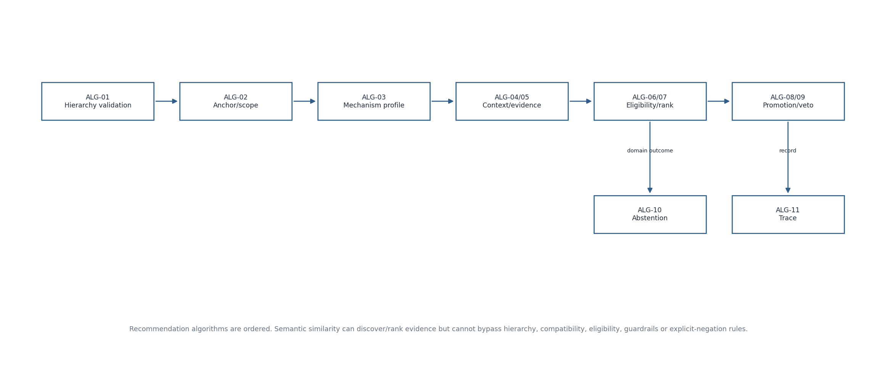
Figure 1. Recommendation algorithm execution order

4. ALG-01 — Hierarchy validation
Input | Rule
Course_ID | Must resolve to active governed Course.
Module_ID | Must resolve and belong to Course_ID.
Subtopic_ID | Must resolve and belong to Module_ID; authoritative V1 technical anchor.
Application Context source | Exactly EDUCATOR_ENTERED or ACCEPTED_SYSTEM_GENERATED.
Accepted_Context_Candidate_ID | Required only for ACCEPTED_SYSTEM_GENERATED; null for EDUCATOR_ENTERED.
Shown candidate set | Accepted generated ID must belong to the final shown candidate set for the same anchor.

Failure is blocking validation before final Recommendation Core execution. The V1 algorithm does not infer a missing hierarchy from free text.
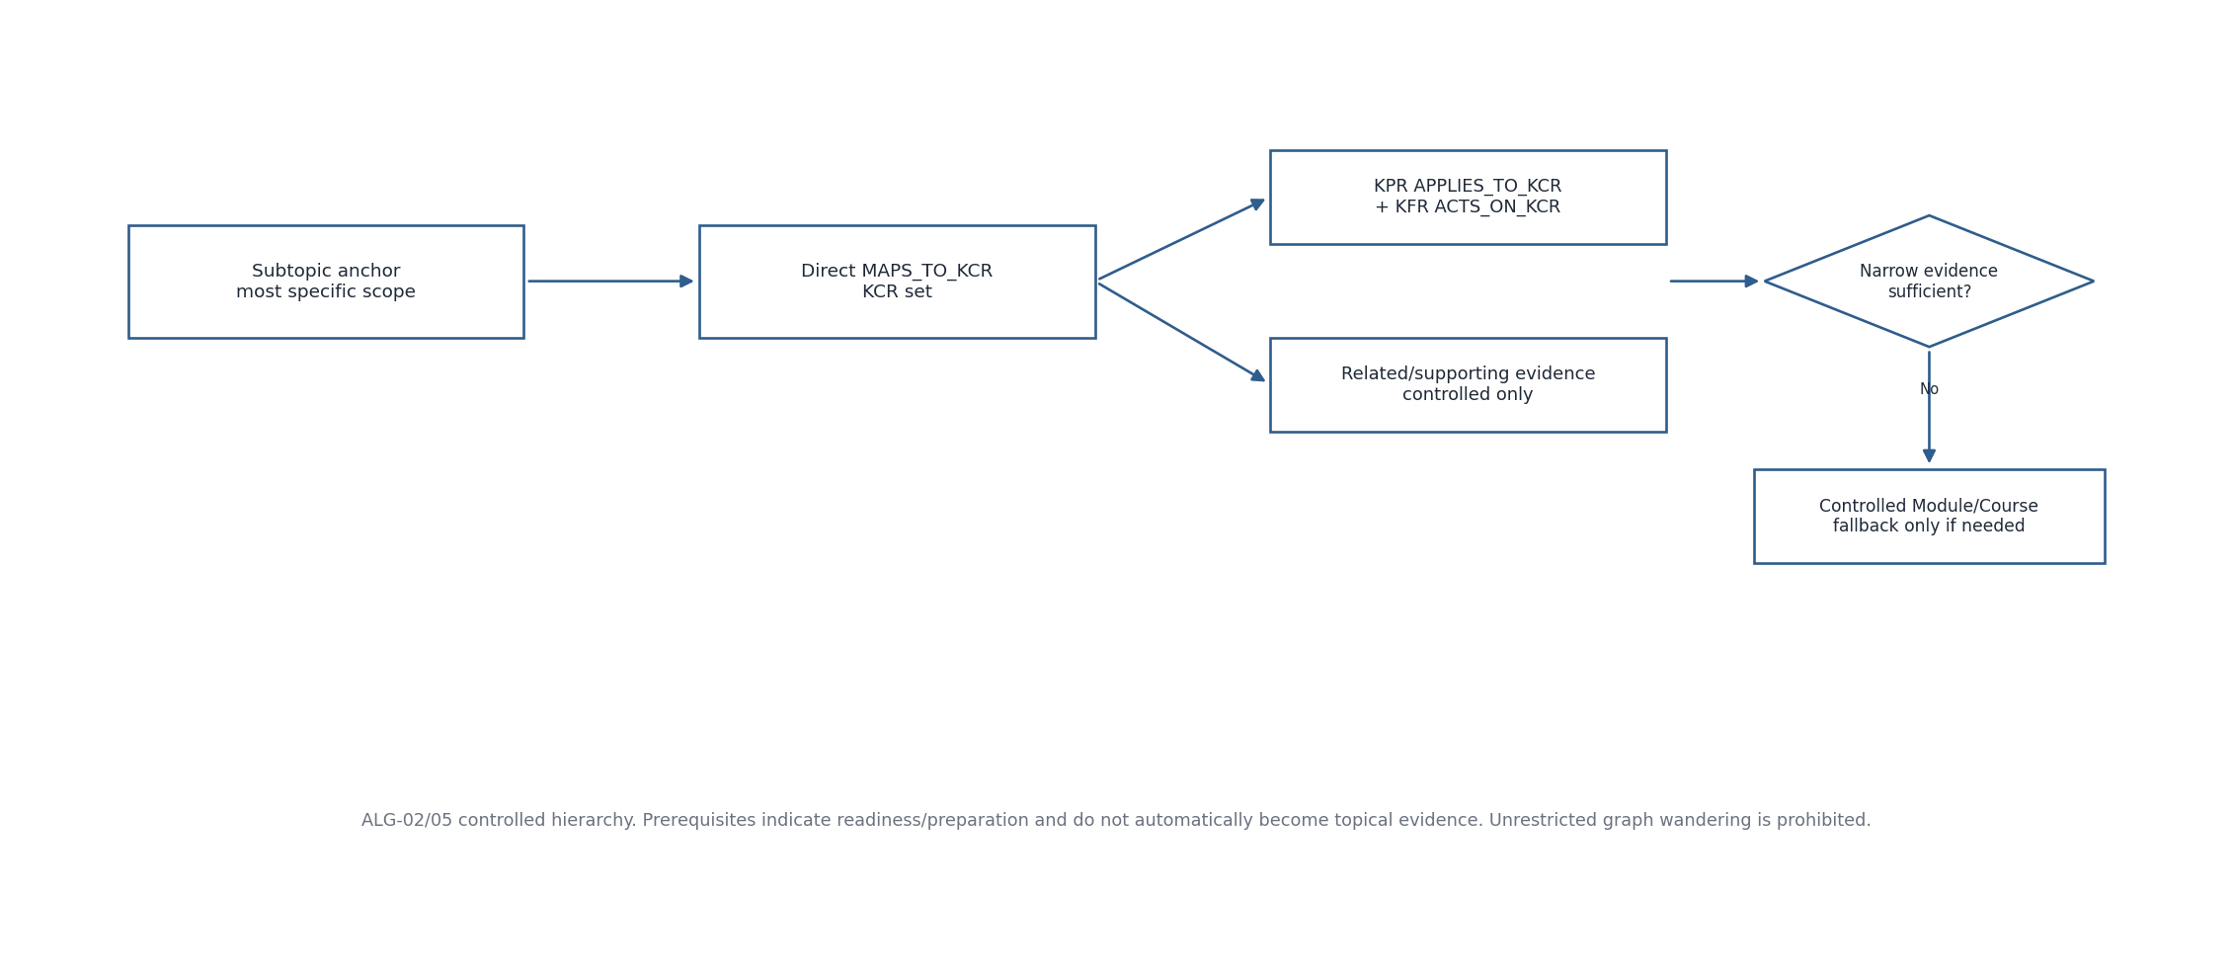
Figure 2. ALG-02/05 controlled hierarchy and evidence expansion

5. ALG-02/ALG-05 — Technical anchor, scope and evidence retrieval
Rule | Specification
Subtopic scope | Resolve direct KCRs through MAPS_TO_KCR.
Module scope | Resolve contained Subtopics then their KCRs only when the product/process explicitly uses broader fallback.
Course scope | Resolve contained Modules/Subtopics/KCRs only as controlled fallback.
KCR enrichment | Add governed KPR via APPLIES_TO_KCR and KFR via ACTS_ON_KCR; preserve originating path.
Related evidence | Use only governed/curated related evidence under controlled expansion; no unrestricted graph wandering.
Readiness | Prerequisite_Concepts inform preparation/readiness and do not automatically become topical evidence.

5.1 Reference-runtime mismatch detector
The Design-8a parity runtime contains a Subtopic sibling-scope mismatch detector with subtopic_scope_mismatch_min_sibling = 0.45 and subtopic_scope_mismatch_margin = 0.12. In the V1 product contract, a material mismatch is surfaced as blocking input validation before final recommendation rather than as a normal RecommendationResult abstention.

6. ALG-03 — Application Mechanism Profiling
Facet source | Rule
Mechanism | Conservatively split explicit coexistence/contrast clauses; do not fragment every “and”.
Operational_Action | Add as a mechanism/action facet when present.
Stakeholder_or_Ecological_Context + Affected_Resource_or_Function | Combine into a facet when either is present.
Fallback | If no derived facet exists, use Application_Context text.
Deduplication | Preserve order and remove near-identical normalized duplicates.
Promotion polarity | Partition promotion facets into positive and explicit-negative/excluded sets before secondary promotion.

Reference runtime explicit-negation detection is deliberately conservative: clause-initial no/without/never/not markers and explicit absence/not-invoked constructions are negative; ordinary counterfactual/outcome phrases are not globally treated as exclusions.
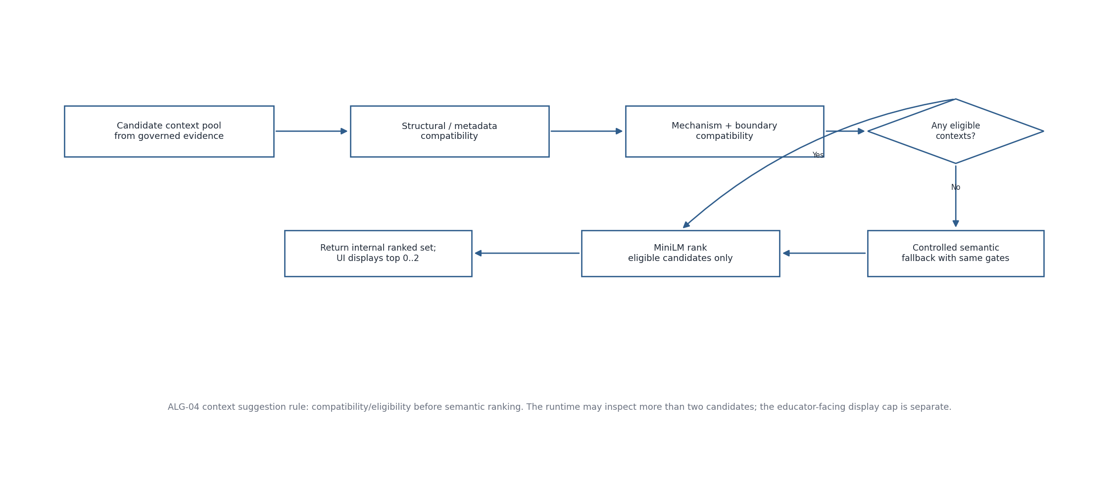
Figure 3. ALG-04 Application Context suggestion algorithm

7. ALG-04 — Application Context suggestion
Stage | Algorithm rule
1. Anchor | Use selected Course/Module/Subtopic as authoritative technical scope.
2. Candidate discovery | May examine a broader governed context/evidence pool than the display set.
3. Eligibility gate | Apply structural/metadata compatibility then mechanism/boundary compatibility.
4. Fallback | If no direct structural match exists, allow controlled semantic fallback under the same scope/mechanism checks.
5. Semantic ranking | Rank eligible candidates using frozen semantic backend; zero lexical overlap alone is not rejection, and high cosine alone cannot create eligibility.
6. Display | Return maximum 0–2 generated alternatives to UI; zero is valid.
7. Provenance | Assign runtime Context_Candidate_ID; supporting repository-context IDs remain internal evidence, not a third source type.

7.1 Reference-runtime context similarity formula
context_score(cid) = 0.65 * similarity(mechanism_focused_profile, cid)
+ 0.35 * max_facet_similarity(cid)
The mechanism-focused context query uses Operational_Action, Mechanism, Stakeholder_or_Ecological_Context, Affected_Resource_or_Function and Boundary_Conditions. The reference runtime intentionally excludes Technical_Query/Technical_System from this context query so domain nouns do not dominate context retrieval. Structural Design-7.5b eligibility remains upstream of ranking in the product algorithm.

8. ALG-06/ALG-07 — SCR eligibility and primary ranking
The product algorithm applies technical scope, mechanism presence, guardrail/boundary compatibility and governed evidence before candidate ranking. The frozen Design-8a reference runtime then scores active SCR candidates using mechanism, full-profile and curated-context semantic evidence while preserving the primary Top-1 path.
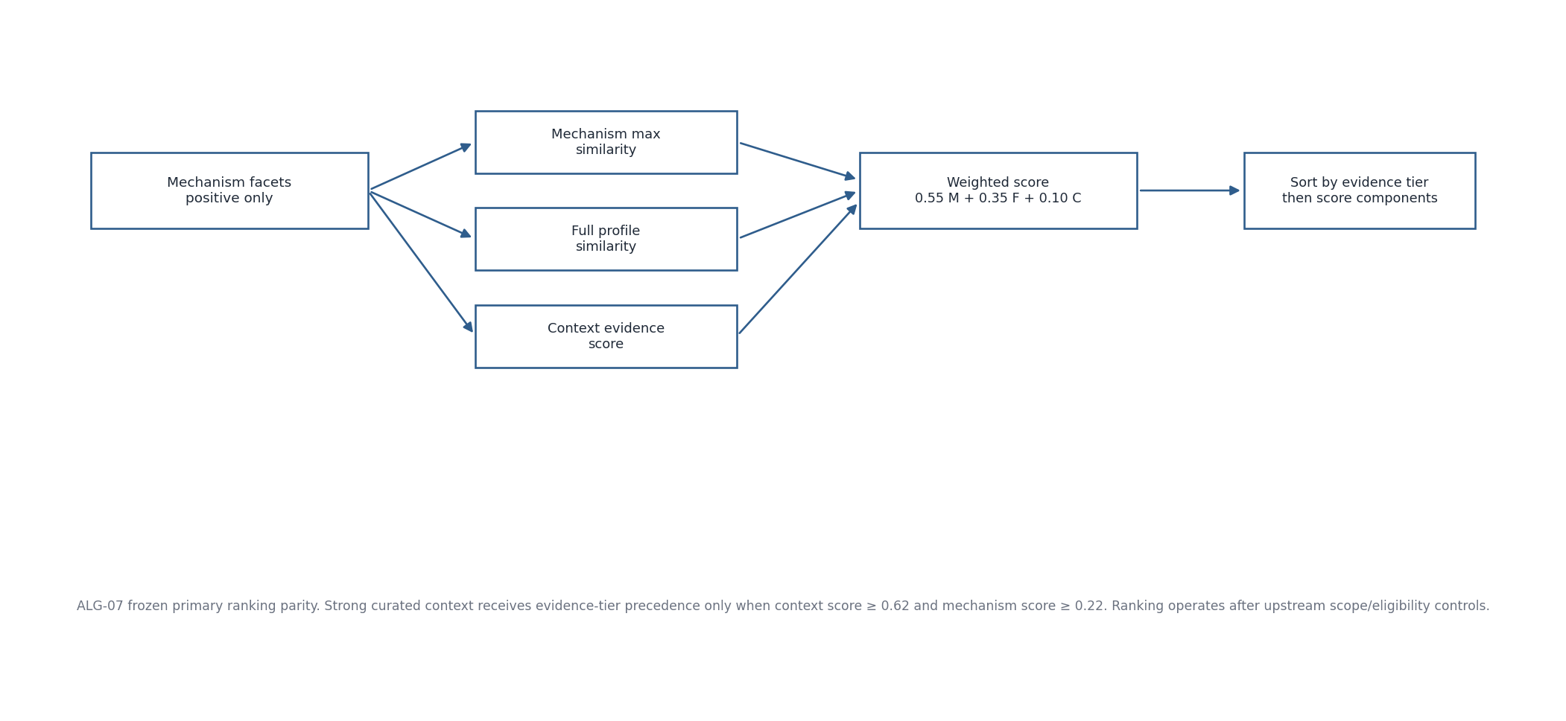
Figure 4. ALG-07 frozen primary ranking parity

8.1 Frozen reference-runtime parameters
Parameter | Value | Meaning
semantic_anchor_top_k | 10 | Legacy/reference semantic-anchor inspection; V1 text-only product route is deferred.
technical_scope_top_k | 5 | Broader Module/Course technical-scope candidate cap in reference runtime.
scr_candidate_top_k | 5 | Trace/candidate presentation depth in reference runtime.
context_top_k | 5 | Internal ranked context depth; not the educator-facing 0–2 display cap.
strong_context_threshold | 0.62 | Strong curated-context evidence threshold.
moderate_context_threshold | 0.44 | Reference configuration soft context threshold; does not override eligibility.
min_context_supported_mechanism_score | 0.22 | Minimum mechanism support for strong-context evidence tier.
mechanism_weight | 0.55 | Primary weighted-score component.
full_profile_weight | 0.35 | Primary weighted-score component.
context_evidence_weight | 0.10 | Primary weighted-score component.

weighted_score = 0.55 * mechanism_max
+ 0.35 * full_profile_similarity
+ 0.10 * context_evidence_score
ranking key (descending):
evidence_tier → weighted_score → mechanism_max → context_score → full_profile_score
Strong context receives evidence_tier = 2 only when context_score ≥ 0.62 and mechanism_max ≥ 0.22; otherwise the reference entry receives tier 0. Deprecated SCR aliases are redirected to active merged targets and collapsed to the strongest evidence representation. These numeric values are parity configuration, not UI constants.
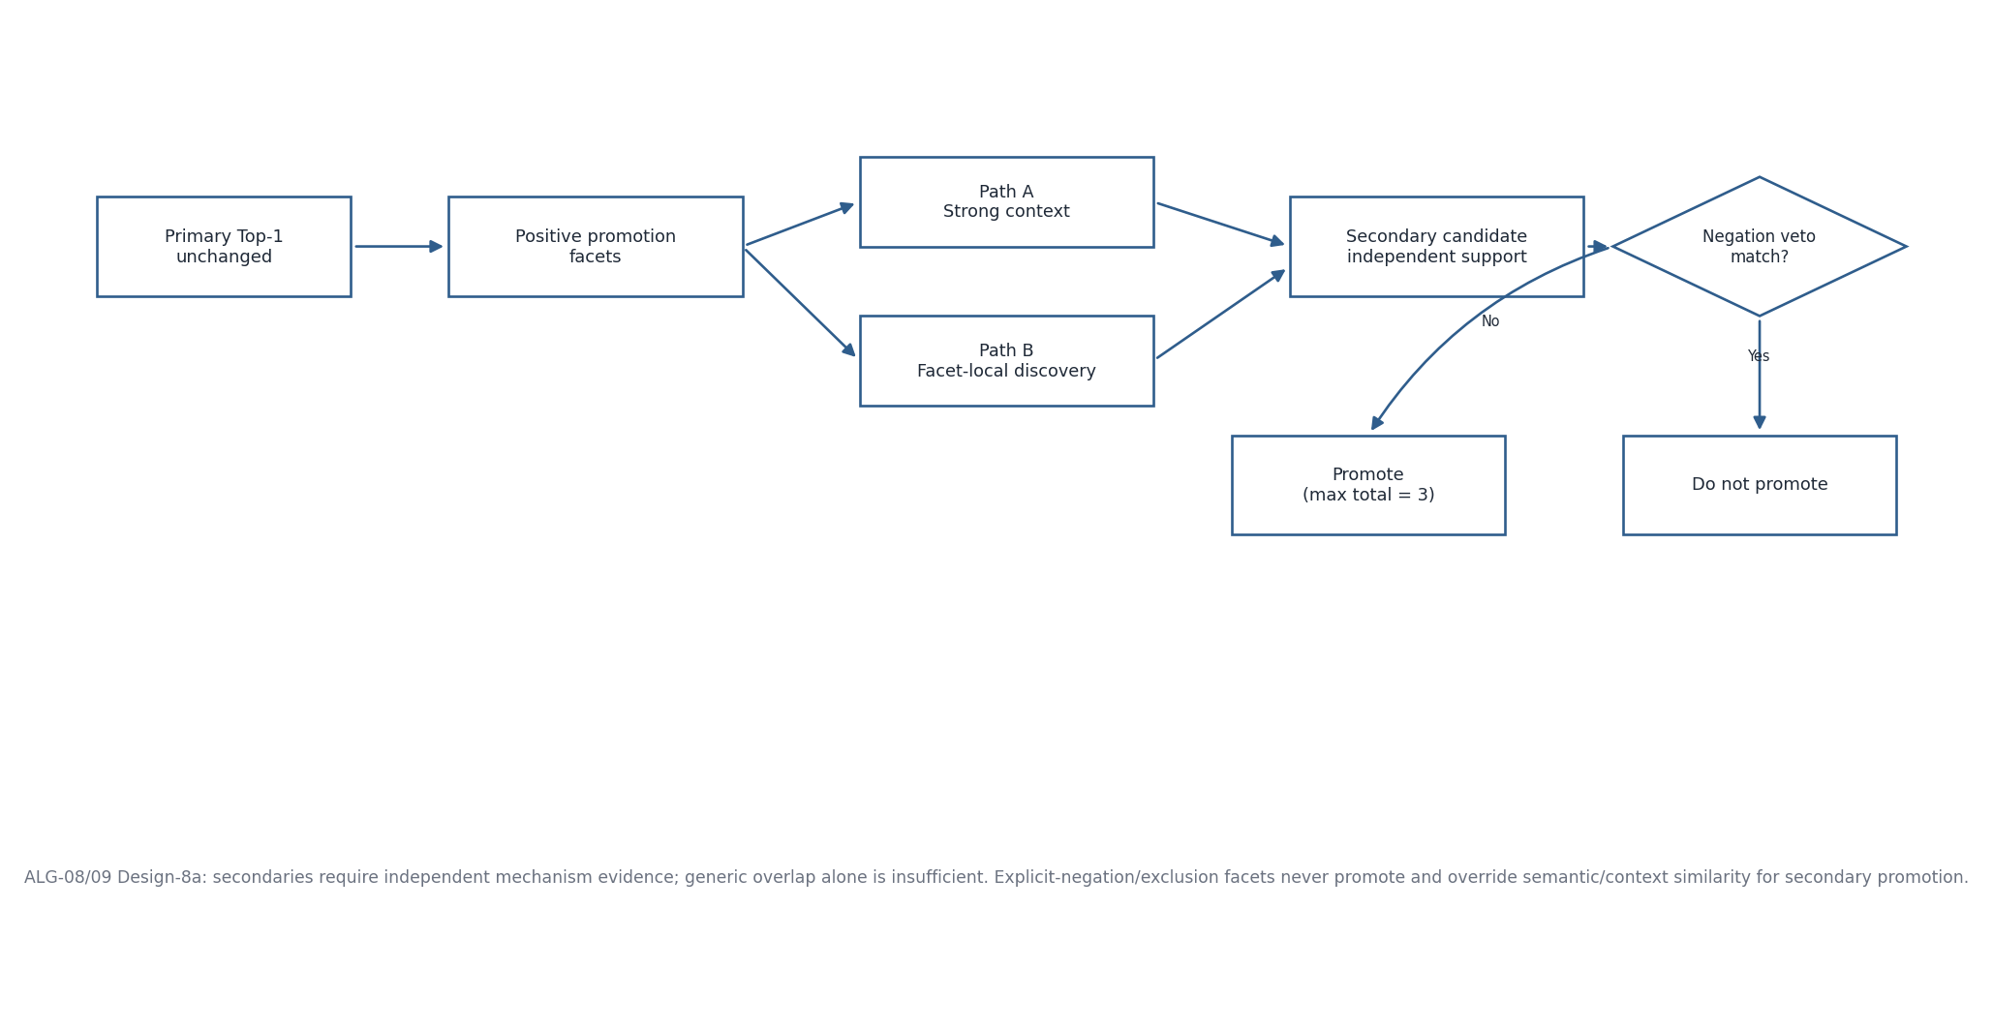
Figure 5. ALG-08/ALG-09 Design-8a secondary promotion and explicit-negation veto

9. ALG-08/ALG-09 — Secondary promotion and explicit-negation veto

9.1 Frozen Design-8a principles
- Primary Top-1 is always the first promoted SCR and its ranking is unchanged by secondary logic.
- The primary claims its strongest positive promotion facet and may claim additional facets when its own canonical evidence specifically explains them and no alternative has a materially stronger case.
- Path A preserves validated strong-context secondary promotion.
- Path B searches locally within unclaimed positive mechanism facets so a narrow valid secondary need not be globally Top-N.
- Generic lexical overlap alone is insufficient; candidate needs facet-specific semantic support plus specificity-aware canonical evidence or strong curated-context support.
- Any candidate matching an explicit-negative/exclusion facet under the veto rule is excluded from secondary promotion.
- Total promoted set is capped at promotion_max = 3, i.e. primary plus at most two secondaries.

9.2 Frozen promotion/veto parameter set
Parameter | Value
promotion_min_evidence_tier | 2
promotion_score_margin | 0.16
promotion_max | 3
promotion_candidate_pool | 10
promotion_facet_local_top_k | 12
promotion_independent_min_facet_score | 0.26
promotion_independent_context_floor | 0.40
promotion_specific_rare_df_ratio | 0.18
promotion_specific_min_idf_score | 0.075
promotion_independent_facet_advantage | 0.025
promotion_independent_facet_ratio_over_primary | 1.08
promotion_independent_weighted_ratio | 0.52
promotion_independent_score_margin | 0.34
negation_veto_min_semantic | 0.30
negation_veto_min_idf_score | 0.10
negation_veto_min_rare_matches | 1

9.3 Path A — strong-context secondary
for candidate in ranked[1:promotion_candidate_pool]:
reject if negation_veto
promote when:
evidence_tier >= 2
AND mechanism_max >= min_context_supported_mechanism_score
AND top.weighted_score - candidate.weighted_score <= 0.16

9.4 Path B — facet-local secondary
for each unclaimed positive facet:
build facet-local pool ordered by facet score / raw rank
require candidate facet score to be near its own strongest facet
require facet_score >= 0.26
require weighted_score >= 0.52 * primary.weighted_score
require primary.weighted_score - candidate.weighted_score <= 0.34
require strong context support OR specificity-aware canonical lexical evidence
require material facet advantage over the primary
reject if explicit-negation veto fires
choose the strongest eligible candidate for the facet
The implementation must retain raw global rank, promotion path, facet index/text/score, context support and negation-veto evidence for audit. Do not simplify this into “take Top-N by cosine”.

10. ALG-10/ALG-11 — Abstention and trace construction
Condition | V1 product outcome
Material anchor/context mismatch | Block before final Recommendation Core execution; educator reviews curriculum/context.
No defensible sustainability mechanism | Recommendation_Status = ABSTAINED; Abstention_Reason = NO_DEFENSIBLE_SUSTAINABILITY_MECHANISM.
Insufficient governed evidence | Recommendation_Status = ABSTAINED; Abstention_Reason = INSUFFICIENT_EVIDENCE.
Successful decision | SUCCESS with exactly one primary SCR plus only independently promoted supported additional principles.

Trace Builder is deterministic: it records the actual anchor, exact Application Context source/text, mechanism facets, positive/negative evidence, ranked diagnostics, promotions/vetoes, governed paths/evidence references and repository/model/runtime versions. It does not ask an LLM to create a post-hoc explanation.
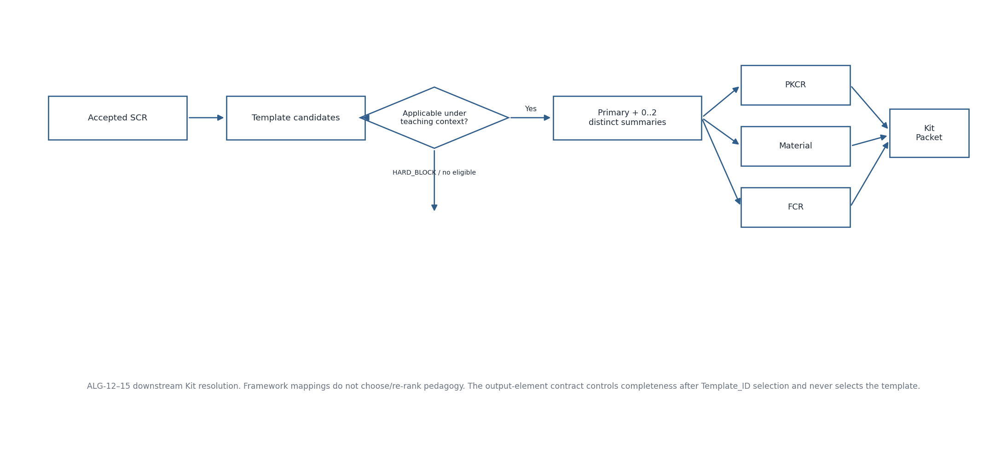
Figure 6. ALG-12–ALG-15 deterministic Educator Kit resolution algorithms

11. ALG-12 — Pedagogy selection
Rule | Specification
Input authority | Accepted SCR + active Stage-E templates + template applicability + current teaching context/constraints.
Framework exclusion | Framework mappings never participate in Template_ID selection or re-ranking.
Applicability states | RECOMMENDED; RECOMMENDED_WITH_CONDITIONS; ADAPTATION_SUGGESTED; BOUNDARY_WARNING; HARD_BLOCK.
Hard block | Use only genuine safety/legal/essential-evidence/canonical-boundary problems; do not present blocked template as normal recommendation.
Output | One primary eligible/adaptable template plus up to two materially distinct alternatives; do not return near-duplicate alternatives.
Initial generation | Only primary is fully generated/validated initially; alternatives are summaries until explicitly selected.

12. ALG-13/ALG-14/ALG-15 — PKCR, teaching material and framework resolution
Algorithm | Deterministic rule
PKCR | Given selected Template_ID and trigger state, return exact REQUIRED plus triggered CONDITIONAL output elements in contract order. Output contract never selects Template_ID.
Teaching Material Resolver | If USE_MY_MATERIAL, preserve educator-source provenance; if USE_SYSTEM_SUGGESTION, resolve governed teaching evidence/reference or clearly labelled generated hypothetical/scaffold. Never merge real/generated values without provenance.
Framework Context Resolver | Resolve mapped items to ACTIVE_DIRECT, ACTIVE_CONTEXT or EXCLUDED using mapping role, applicability condition, education level/context and output-contract intersection. Send only active packet to generation; retain exclusions/reasons in audit.

13. ALG-16 — Educator Kit validation
Step | Rule
Enumerate contract | Use same ResolvedOutputElementContract that governed generation.
Element applicability | Evaluate REQUIRED and triggered CONDITIONAL elements; untriggered conditional element is NOT_APPLICABLE.
Content test | Required/triggered element must contain concrete, ready-to-use content satisfying Ready_to_Use_Test/provenance requirements; generic placeholder statements fail.
Per-element status | PASS | FAIL | NOT_APPLICABLE.
Overall status | PASS only when every required/triggered applicable element passes; otherwise FAIL.
Failure behavior | Persist failed validation provenance as governed; no ready Kit and no automatic repair/regeneration.

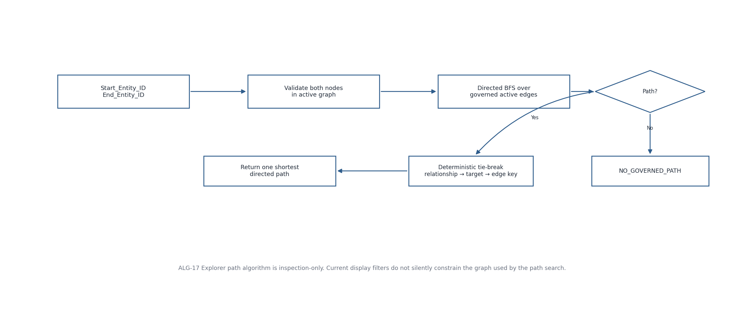
Figure 7. ALG-17 deterministic Knowledge Graph shortest-path algorithm

14. ALG-17/ALG-18/ALG-19 — Graph path, repository build and idempotency

14.1 ALG-17 governed shortest path
- Resolve both canonical endpoints in active compiled graph.
- Search only stored active governed relationship directions.
- Return one shortest directed path by hop count.
- For equal shortest paths, use stable traversal ordering Relationship_Type → Target_Entity_ID → Edge_Key.
- Return NO_GOVERNED_PATH when none exists; do not search undirected/invented edges.
- Canvas display filters do not alter the graph used by the algorithm unless a future explicit constrained-path parameter is introduced.

14.2 ALG-18 repository build
- Validate registered workbook/schema identity and required fields.
- Validate controlled values and referential integrity.
- Validate semantic/governance invariants required by build.
- Compile runtime tabular objects, graph artifact, embeddings and manifest/checksums.
- Fail closed: invalid source does not silently become active runtime truth.

14.3 ALG-19 idempotency
- Recommendation Request_ID uniquely identifies one Generate semantic action.
- Kit_Request_ID uniquely identifies one explicit Kit generation action.
- Duplicate key + same canonical request hash returns/reuses stored result rather than duplicating execution.
- Duplicate key + different hash is an idempotency conflict and must be rejected.

15. Consolidated pseudocode — recommendation path
validate_v1_hierarchy_and_context(request)
if blocking_mismatch(request): return BLOCK
normalized = normalize_preserving_raw_text(request)
facets_pos, facets_neg = build_mechanism_profile(normalized)
if no_defensible_mechanism(facets_pos): persist_abstention(NO_DEFENSIBLE...); return ABSTAINED
evidence = controlled_graph_and_context_evidence(anchor, facets_pos)
eligible = apply_scope_mechanism_guardrail_boundary_evidence_gates(evidence)
if eligible is empty/insufficient: persist_abstention(INSUFFICIENT_EVIDENCE); return ABSTAINED
ranked = frozen_primary_rank(eligible, facets_pos, context_evidence)
primary = ranked[0]
secondaries = design8a_promote(ranked, facets_pos, facets_neg)
trace = build_trace_from_actual_decision_state(...)
atomically_persist(context_snapshot, recommendation_event)
return RecommendationResult(primary, supported_secondaries, trace_available)

16. Regression and benchmark linkage
Regression obligation | Required condition
Primary ranking parity | Design-8/8a must preserve the validated pre-Design-8 primary Top-1 path.
Educator input controls | Design-7.5b generated-context eligibility-before-ranking and input precedence remain frozen.
Negation | Explicit negation never becomes positive secondary evidence; forbidden promoted violations remain zero under frozen regression.
Context quality | Off-scope generated context must be removed by compatibility gate before semantic ranking.
Benchmark ambiguity | Cases already identified as expert-review/ambiguous are not tuning targets merely to force gold.
Model/version change | Changing MiniLM/model/thresholds/weights requires a new frozen benchmark/parity validation rather than silent substitution.

17. Acceptance checklist
- Each algorithm has defined inputs, outputs, preconditions, decision rules and failure/domain outcomes.
- Exact Design-8a ranking/promotion parameters are configuration-owned and covered by parity tests.
- No algorithm reads benchmark gold labels during prediction.
- Application Context and SCR semantic similarity never bypass eligibility/compatibility.
- Positive and negated promotion facets remain separate.
- Downstream Kit algorithms cannot modify accepted SCR eligibility.
- Graph path is deterministic and inspection-only.
- SEQ-08 modules can implement these algorithms without adding new cross-domain authority.

