MODULE INTERFACE SPECIFICATION
Ontology and Knowledge Graph-Driven
Sustainability Principles Recommendation System
SEQ-08 | Version 0.2 | September 2026
Purpose
Translate the frozen architecture, typed interface contracts and data flows into implementation-level Python module boundaries, public module interfaces, dependency rules, lifecycle responsibilities and test seams for the V1 research prototype.

Document control
Item | Value
Sequence | SEQ-08
Version | 0.2
Status | V1 implementation baseline
Date | September 2026
Upstream baseline | System Architecture Design v1.1 Final; Technical Interface Design v0.2; Interface Contract Registry v0.1; Data Flow Design v0.1 Final; Data Flow Registry v0.1; SEQ-06 Process Flow Specification v0.1; SEQ-07 Algorithm Specification v0.1
Change rule | This specification refines implementation detail without changing frozen recommendation semantics or V1 product scope.

Contents and reading order
- 1–3 define purpose, source authority and module-design principles.
- 4–8 define package structure and public interfaces for educator/recommendation, Educator Kit, Knowledge Graph and infrastructure modules.
- 9–12 define dependency rules, startup lifecycle, errors/idempotency and test seams.
- 13–15 provide cross-specification reconciliation, deferred scope and implementation acceptance.

1. Purpose and scope
SEQ-08 defines the implementation module boundary beneath SEQ-04 logical interfaces and SEQ-05 data flows. A module may be a Python file, package, protocol, facade or adapter; the specification does not require a microservice deployment model.

1.1 In scope
- Python package/module ownership and dependency direction.
- Public application-facade methods and internal ports/protocols.
- Which SEQ-04 contract objects cross each module boundary.
- Stateful versus stateless responsibilities, startup-loaded runtime dependencies and persistence side effects.
- Error propagation, idempotency ownership and test seams.

1.2 Out of scope
- Physical SQL tables, indexes and migrations — SEQ-09.
- Authentication provider, secrets, RLS and detailed threat controls — SEQ-10.
- Changes to recommendation scoring, eligibility, promotion, negation, pedagogy selection or output contracts.
- Functional V1 repository publication/admin mutation modules.

2. Source baseline and authority
Source | SEQ-08 authority
System Architecture Design v1.1 Final | Canonical component boundaries, V1 runtime/deployment boundaries and downstream-only Kit architecture.
Technical Interface Design v0.2 | Typed logical requests/responses, statuses, errors and interface IDs.
Interface Contract Registry v0.1 | Field-level contract registry and deferred interface inventory.
Data Flow Design v0.1 Final | Ownership, transformations, transient state and persistence points.
Data Flow Registry v0.1 | Object inventory, transformations, exceptional flows and logical stores.

3. Module design principles
- Contract-first: public methods consume/return SEQ-04 contract/domain objects rather than unstructured dictionaries at boundaries.
- Dependency inversion: domain/application modules depend on ports/protocols; infrastructure adapters implement them.
- No UI/database coupling: Streamlit pages never issue SQL or provider calls directly.
- Read-only semantic authority: Graph Runtime and canonical repositories are read-only during educator requests.
- Orchestrators coordinate; resolvers decide only within their registered responsibility.
- No circular dependencies: lower-layer modules do not import UI or application facade packages.
- No hidden fallbacks: alternative model/provider, re-anchoring, invented graph entities and automatic Kit repair are prohibited unless explicitly governed.
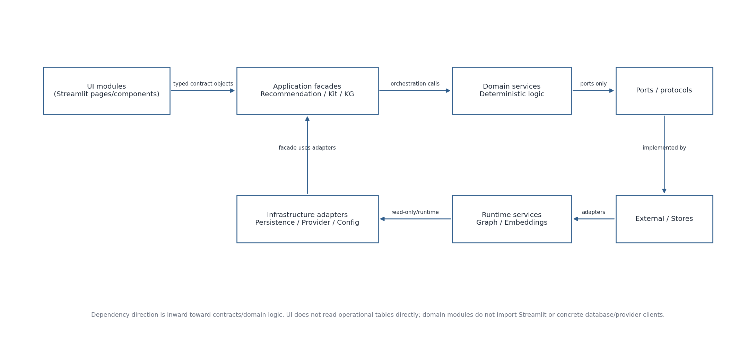
Figure 1. V1 module dependency layers

4. Recommended Python package structure
Package | Principal modules | Responsibility
app.ui | shell, recommendation_page, result_view, kit_view, kg_explorer_page, admin_readonly_page | Streamlit presentation/session state only.
app.contracts | recommendation, kit, graph, errors, controlled_values | Typed request/response/domain DTOs mirroring SEQ-04.
app.curriculum | catalog_service, help_service | Governed curriculum/help reads used by UI.
app.recommendation | facade, input_adapter, mechanism_profiler, context_resolver, eligibility, ranker, promotion, negation_veto, recommender, trace_service | Recommendation request validation, controlled evidence, deterministic decision orchestration and trace.
app.kit | facade, pedagogy_selector, pkcr, material_resolver, framework_resolver, generation_orchestrator, validator, renderer, decision_service | Accepted recommendation to validated Kit, view/PDF and educator decision.
app.graph | runtime, explorer_facade, search, inspector, path_service | Complete read-only compiled graph runtime and Explorer operations.
app.infrastructure.persistence | port, sqlite_adapter, postgres_adapter | Operational persistence behind one domain-facing port.
app.infrastructure.generation | provider_port, openai_adapter | Provider isolation for bounded structured generation.
app.infrastructure.runtime | repository_loader, embedding_runtime, startup_health | Load compiled graph/embedding artifacts and expose readiness.
app.infrastructure.security | access_control, session_guard | Privileged-access boundary; detailed controls in SEQ-10.
app.infrastructure.common | config, audit, errors, clock, id_factory | Cross-cutting implementation utilities with no domain decision authority.

5. Application facades and public module interfaces
Facade / service | Public method | Input | Output | Side effect
CurriculumCatalog | list_courses(); list_modules(course_id); list_subtopics(module_id); get_entity(entity_id) | Canonical IDs / filters | Readable governed records | None
ApplicationContextService | suggest(request) | ApplicationContextSuggestionRequest | ApplicationContextSuggestionResponse | None; transient only
RecommendationFacade | generate(request) | EducatorRecommendationRequest | RecommendationResult or TechnicalError | Atomic snapshot + event on completed attempt
TraceService | get_trace(event_id) | RecommendationTraceRequest | RecommendationTraceResponse | None
KitFacade | generate(request) | EducatorKitGenerationRequest | EducatorKitGenerationResult | Kit snapshot for generated/validated attempt
KitFacade | get_view(snapshot_id) | EducatorKitViewRequest | EducatorKitViewResponse | None
KitFacade | export_pdf(snapshot_id) | EducatorKitPdfExportRequest | EducatorKitPdfExportResult | No PDF persistence
EducatorDecisionService | record(request) | EducatorDecisionRequest | EducatorDecisionResult | Append decision record
KnowledgeGraphFacade | load/search/inspect/find_path | IF-KG request types | IF-KG response types | None; local GraphViewState stays UI-side
AccessControl | check(action, session) | AccessCheckRequest | AccessCheckResult | Optional security audit only

6. Recommendation module interfaces
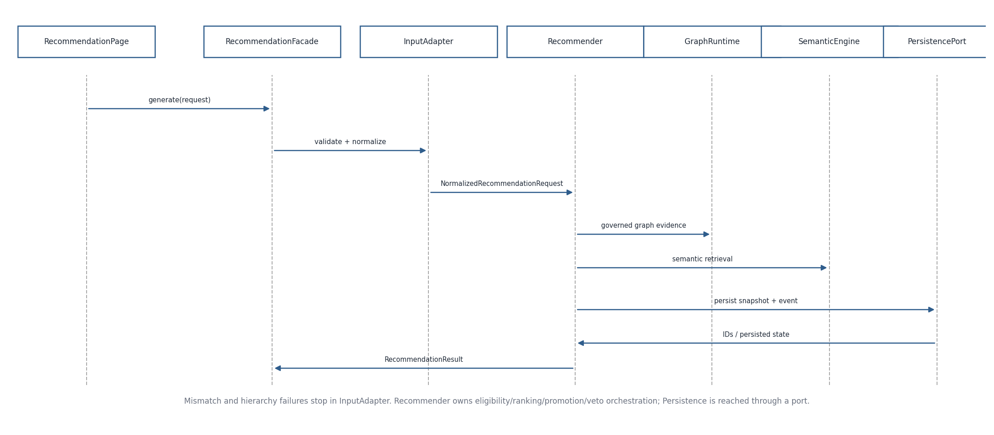
Figure 2. Recommendation module call sequence
Module | Consumes | Produces / calls | Invariant
input_adapter | EducatorRecommendationRequest | NormalizedRecommendationRequest or blocking validation | Hierarchy/source/candidate/mismatch checks; preserves exact raw text.
mechanism_profiler | normalized request + Application Context | positive and explicit-negative mechanism facets | Negated evidence never becomes positive support.
context_resolver | anchor + facets + governed context evidence | eligible/ranked context evidence and generated suggestions | Compatibility before semantic ranking; broader internal pool allowed.
eligibility | graph/context/mechanism evidence | EligibleSCRCandidateSet | Only governed rules create eligibility.
scr_ranker | eligible candidates | ranked candidates + primary | Ranks only eligible set.
promotion | primary + independent facets | additional supported SCRs | No similarity-only promotion.
negation_veto | promotions + negative facets | retained/vetoed promotions | Negative evidence only vetoes.
recommender | normalized request + above services | decision + event/snapshot payload | Owns orchestration, not individual scoring semantics.
trace_service | persisted event/snapshot | RecommendationTraceResponse | No fresh recommendation or free-form rationale.

7. Educator Kit module interfaces
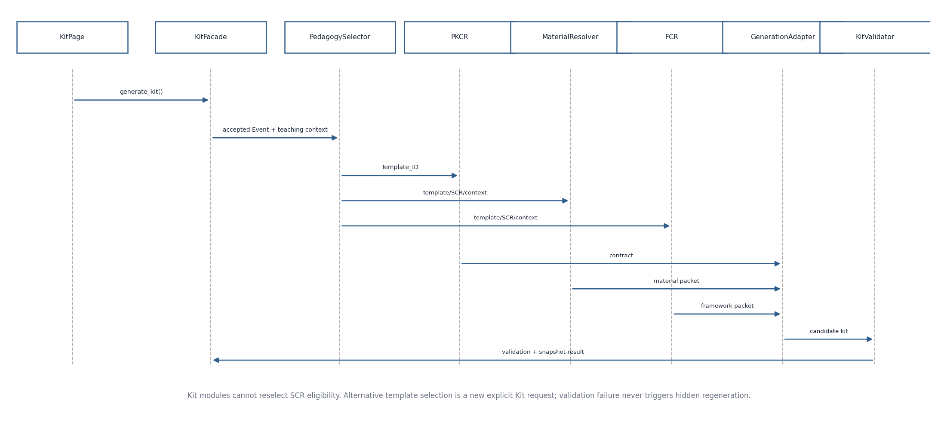
Figure 3. Educator Kit module call sequence
Module | Input | Output | Prohibited responsibility
pedagogy_selector | accepted SCR + teaching context | primary Template_ID + 0..2 alternative summaries | Cannot change SCR eligibility or use framework to rescue fit.
pkcr | selected Template_ID + trigger state | ResolvedOutputElementContract | Cannot select template.
material_resolver | SCR/template/context/material mode | TeachingMaterialPacket | Cannot hide generated/real/educator provenance.
framework_resolver | SCR/template/context | FrameworkContextPacket | Cannot change accepted SCR or select pedagogy.
generation_orchestrator | resolved contract/material/framework + context | CandidateEducatorKit | Cannot invent canonical IDs or ontology truth.
validator | candidate Kit + same resolved contract | KitValidationResult | No automatic repair/regeneration.
renderer | immutable EducatorKitSnapshot | web view / PDF | No regeneration, re-resolution or database mutation.
decision_service | Kit snapshot + educator action | append-only EducatorDecision | Cannot overwrite original snapshot or canonical template.

8. Knowledge Graph and runtime modules
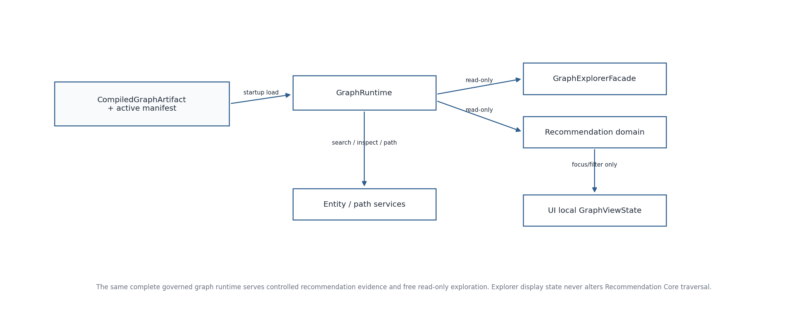
Figure 4. Graph runtime and Explorer module boundaries
Module | Public responsibility | State
graph.runtime | Load/version complete compiled directed multigraph; canonical ID/edge lookups | Stateful startup-loaded, read-only during requests.
graph.search | Search registered active entity classes by readable text | Stateless over runtime/index.
graph.inspector | Resolve entity properties and exact edge metadata | Stateless; may hydrate from governed repositories/runtime metadata.
graph.path_service | One deterministic shortest directed governed path | Stateless; no recommendation side effects.
graph.explorer_facade | Compose IF-KG-001..005 operations for UI | Stateless facade.
embedding_runtime | Load frozen MiniLM + repository embeddings; encode new request text | Stateful startup-loaded, read-only artifact set.

9. Persistence, provider and common ports
Port / protocol | Required operations | Primary consumers
PersistencePort | save_recommendation(snapshot,event); get_event; get_snapshot; save_kit_snapshot; get_kit_snapshot; append_decision; optional audit append | RecommendationFacade; TraceService; KitFacade; DecisionService
GenerationProviderPort | generate(structured_request) | Kit generation orchestrator
Clock | utcnow() | All persisted operational records
IdFactory | new_request/event/snapshot/decision IDs | UI/application services
AccessControlPort | authorize(session, action/resource) | Protected Admin and any protected read routes
ConfigProvider | read frozen runtime/version/config values | Startup + orchestrators; never educator-controlled

10. Dependency and import rules
- app.ui may import app.contracts and application facades; it must not import concrete persistence, OpenAI client, SQL driver or Graph internals.
- app.recommendation and app.kit may depend on app.contracts plus ports/protocols, not on Streamlit.
- app.kit must not call recommendation ranking/eligibility modules after an accepted RecommendationEvent exists.
- app.graph Explorer modules are read-only and cannot call recommendation orchestration.
- Concrete adapters depend on ports/contracts; ports/contracts never import concrete adapters.
- Repository build/startup code is outside protected Admin mutation flow in V1.

11. Startup and request lifecycle
Phase | Module behavior | Failure behavior
Startup | Load configuration → validate/compile artifacts as deployment step → load GraphRuntime → load EmbeddingRuntime → initialize persistence/provider adapters → run readiness checks | Graph/model/config failure marks affected capability unavailable; never silently substitutes backend.
Educator request | UI constructs typed request → facade → domain modules → atomic persistence → typed result | Blocking validation returns before Recommendation Core; technical failures use TechnicalError.
Kit request | Resolve accepted event/snapshot → deterministic Kit resolvers → provider → validator → snapshot → view/export | Provider failure is TechnicalError; validation failure is domain result and audit state.
Explorer request | Use already-loaded graph runtime | Graph unavailable shown explicitly; no fake empty graph.

12. Errors, idempotency and test seams
Concern | Owner | Rule
Recommendation idempotency | RecommendationFacade + PersistencePort | Request_ID uniquely identifies Generate action; duplicate same hash returns/reuses stored outcome, conflicting hash is rejected.
Kit idempotency | KitFacade + PersistencePort | Kit_Request_ID uniquely identifies explicit Kit generation.
Domain outcomes | Domain modules | ABSTAINED, NO_COMPATIBLE_SUGGESTIONS, NOT_AVAILABLE, NO_GOVERNED_PATH, VALIDATION_FAILED are not TechnicalError.
Unit testing | Each deterministic resolver | Pure inputs/outputs with in-memory fixtures.
Integration testing | Facades | Use in-memory persistence/provider/graph adapters and validate interface objects.
Parity/regression | Recommendation package | Design-8a reference behavior remains authority; module refactoring must not change accepted behavior.
Security testing | UI/facades/adapters | Detailed controls and negative cases defined in SEQ-10.

13. Cross-specification reconciliation
Upstream decision | SEQ-08 implementation consequence
Subtopic authoritative V1 anchor | No module may replace it from free text; mismatch blocks in InputAdapter.
Generated-only educator-facing context suggestions | ContextResolver may use repository contexts internally but returns runtime ContextCandidate objects.
Trace is persisted provenance | TraceService reads event/snapshot; no LLM explanation module.
Primary Kit fully generated; alternatives summaries | KitFacade generates alternative only after explicit new request.
Complete KG available | ExplorerFacade discovers entity/relationship classes from runtime rather than hard-coded subset.
V1 Admin read-only/prototype | No repository writer/publisher module is exposed from UI package.

14. Deferred V2/V3 module scope
- Text-only curriculum anchor resolution UI/facade route.
- Repository authoring/onboarding/change-set/publication/rollback/benchmark-execution services.
- Async job/queue API for recommendation or Kit generation.
- Persisted PDF/export-history service.
- Automatic Kit repair/regeneration orchestrator.

15. Implementation acceptance checklist
- Every active SEQ-04 interface maps to exactly one owning facade/module boundary.
- No UI page contains SQL/provider/model-selection logic.
- No domain module imports Streamlit or concrete persistence/provider implementation.
- Recommendation and Kit writes occur only through PersistencePort.
- Graph and embedding runtimes are startup-loaded/versioned and read-only during requests.
- All prohibited cross-domain dependencies are covered by tests/linting where practical.

16. SEQ-06/SEQ-07 reconciliation verification
SEQ-08 was originally drafted before SEQ-06/07. After formalizing the process and algorithm specifications, module ownership remains valid. No new runtime module is required; the existing recommendation, Kit, graph and infrastructure boundaries cover all PF/ALG responsibilities.
Process / algorithm | Verified module ownership
PF-01/PF-02; ALG-01/04 | Recommendation UI + ApplicationContextService + RecommendationFacade/InputAdapter.
PF-03/PF-04; ALG-02/03/05–11 | Recommendation domain modules already specified: scope/context/mechanism/eligibility/ranker/promotion/veto/recommender/trace.
PF-06–PF-10; ALG-12–16 | KitFacade + PedagogySelector + PKCR + MaterialResolver + FCR + GenerationAdapter + KitValidator + renderer/decision service.
PF-11; ALG-17 | KnowledgeGraphFacade + GraphRuntime/search/inspector/path service.
PF-12; ALG-18 | Repository build/startup tooling + runtime loaders; not Admin mutation flow.
ALG-19 | RecommendationFacade/KitFacade idempotency + PersistencePort atomic lookup/insert.

- No cross-domain dependency prohibition changed.
- Design-8a numeric parameters remain algorithm configuration, not UI/facade constants.
Verification outcome: the specification remains semantically compatible after SEQ-06/07. Version 0.2 records this reconciliation and updates the upstream baseline; it does not redesign the frozen V1 behavior.

